Jose Capestany

Sayaf Almeri

EE215

2/18/2016

LAB2 Report

The purpose of this lab was to get familiar with comparisons and subroutines. The lab asks us to sort twenty random number in ascending order. We approached the problem logically and were able to come up with a flowchart to describe our approach.



The reason for the inner counter being set to 19 is that is the worst possible scenario to get a number to its correct place. A number will be in its correct place in at least 19 swaps. The reason the outer counter is 20 is because of the same reasoning. In the worst possible scenario it will take 19 runs to get all the numbers in the correct order. When the inner counter is set to 0 it will start again at the beginning and when the outer counter reaches 0 the program will end. The following picture is how we translated it to code.

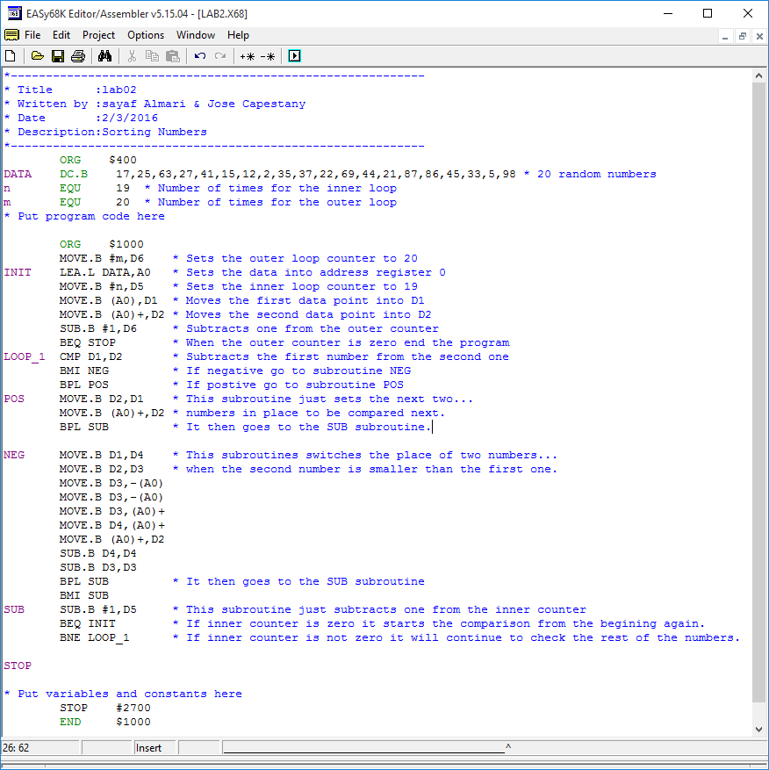

The following two pictures are the memory location of the 20 random numbers we used before and after the program execution. The first picture shows the number in an unsorted list and the second pictures shows them sorted in ascending order.

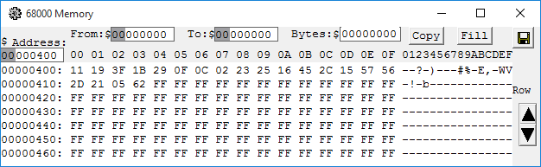

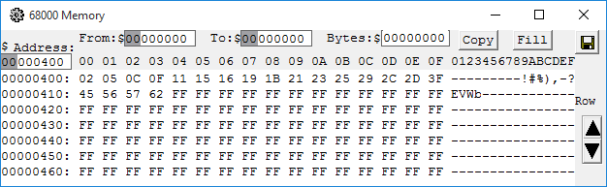

*The results of LAB2.*

We were able to successfully complete this lab after a few minor hiccups. The results that came from this lab were relatively simple. We mainly had problems trying to figure out to switch two numbers and then keep going. Once we had it figured out we just had to find out how long the program should run for. After those two problems were solved we were able to easily complete the rest of the lab.