Jose Capestany

Sayaf Almeri

EE215

2/25/2016

LAB3 Report

The purpose of this lab was to get familiar with subroutines and TRRAP #15. The lab had us ask the user for two numbers and then do a calculation based on the two numbers and display the result. The following is a flowchart of our approach.



We solved this by using a subroutine in our program. The program asks the user to input M and stores it in D5. We then used CMP to see if the number in D5 was equal to 0. If it is, then the program ends. If it is not, the user is then asked to input N and stores it in D6. The program then jumps to the subroutine Y. In this this subroutine the value of Y is calculated and stored in D7. Then, it jumps out of the subroutine and displays the result to the user.

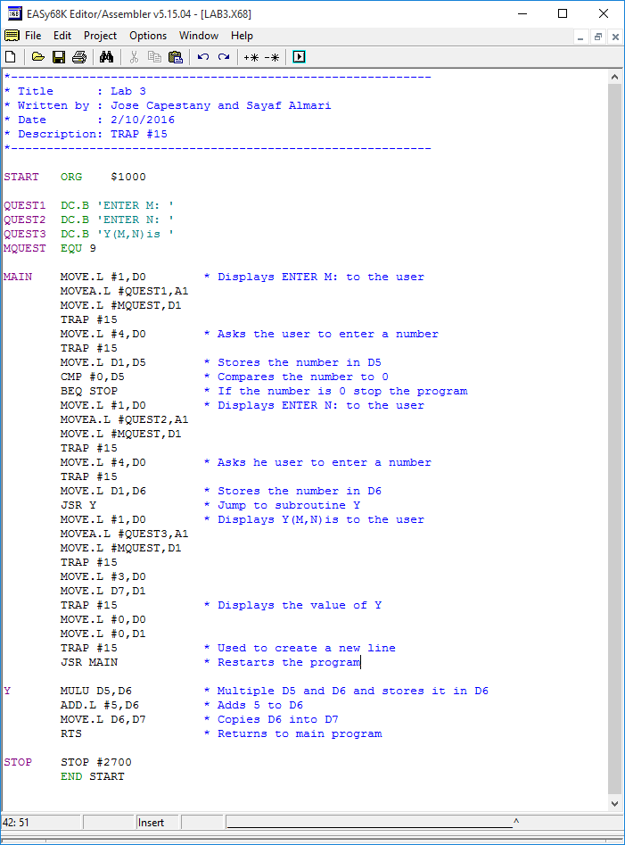

The following picture is how our program operates. It continues to prompt the user for inputs and calculates Y until M has a value of 0.

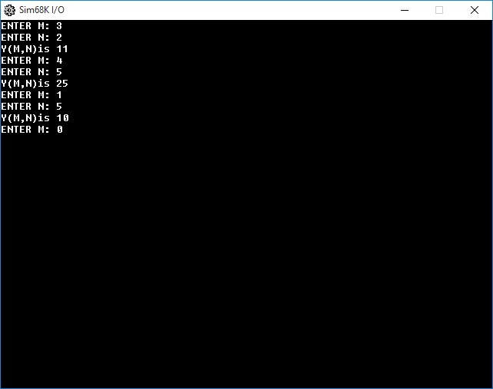

*The result of LAB3.*