Jose Capestany

Sayaf Almeri

EE215

3/3/2016

LAB4 Report

The purpose of this lab was to get used to recursive subroutines and how to properly manage subroutines when using assembly language. The lab asked us to input two numbers *M* and *N* and calculate Y(M,N) using  and . We developed a flowchart.

C:\Users\Jose Capestany\Downloads\LAB4.png

We solved this by using a subroutine in our program. The program asks the user to input M and stores it in D7. The program then goes to a subroutine and adds M into D6. We subtract 1 from D7 and if it isn’t equal to one it will then continue to add D7 into D6 until D7 is 1. It then adds 1 to D6 and returns to the main program. The program then asks the user to enter another input N and stores it in D7. The program then jumps to the same subroutine and continues adding into D6 until D7 is 1. It then adds 1 and returns to the main program. Then the result that is stored in D6 is displayed to the user. The following picture is our program.

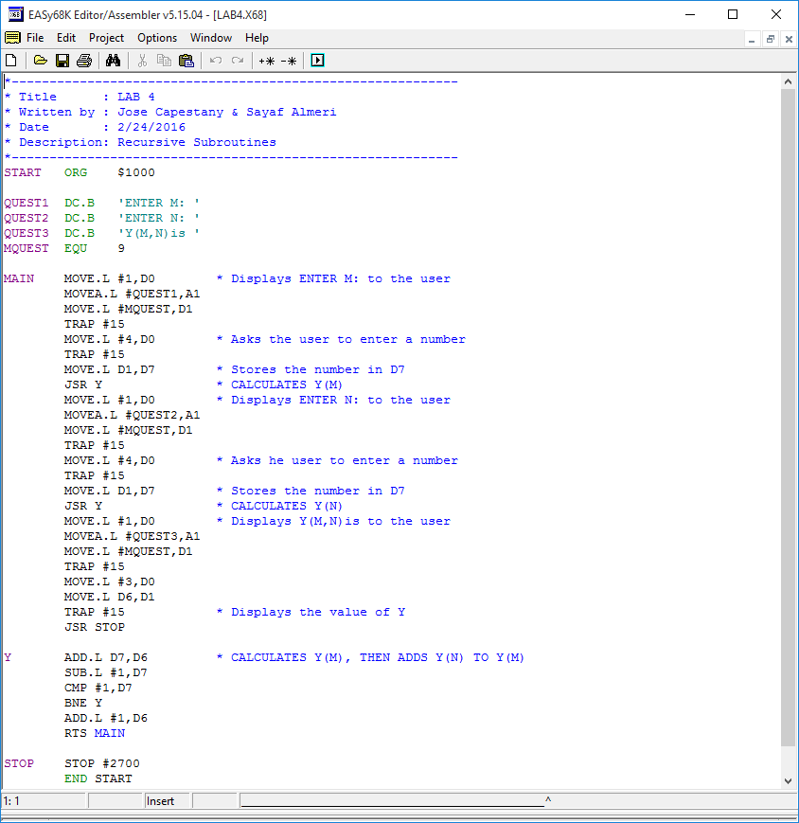

The following picture is how our program operates. It only prompts the user for M and N once.

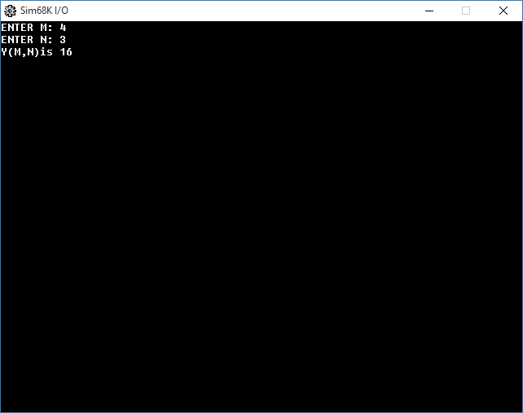

*The result of LAB4.*

In conclusion we realized the importance of structuring our subroutines and proper use of data registers is important. We could also modify the program to allow the user to continue to add more numbers, but since we were only asked to do M and N once that is what we did. It did take us a while to get subroutines down until we remembered how to use JSR and RTS.