# Introduction to databases

Today’s lab is all about navigating the tables and relationships in databases.

This is essential knowledge for all data-related careers including:

* Data analyst
* Database administrator
* Data scientist
* Data engineer

In today’s lab, you will answer questions about database tables.

## Exercise 1: Bird database

Here are three related tables from a database about birds.

* Sightings contains information about bird sightings
* Birds contains information about birds
* Spotters contains information about the people spotting the birds.

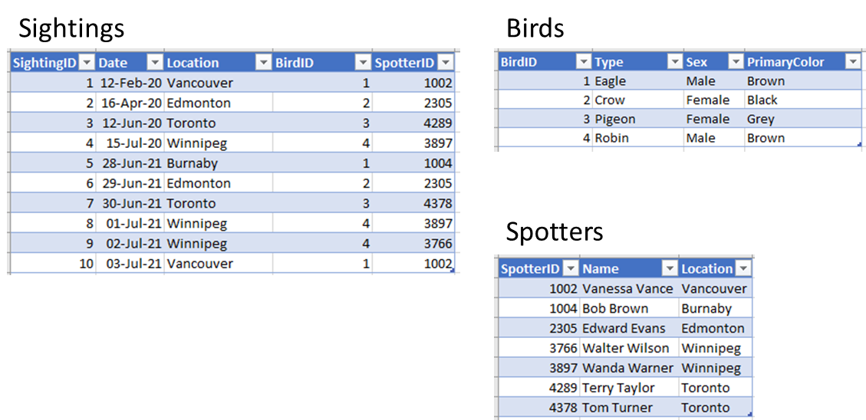

Answer the following questions using the database tables shown above.

1. What is the primary key in the Sightings table? SightingsID
2. What is the primary key in the Birds table? BirdID
3. What is the primary key in the Spotters table? SpotterID
4. There are two foreign keys in the Sightings table. What are their column names? BirdID and SpotterID
5. Tom Turner is a new spotter.
   1. Where is he from? Toronto
   2. What is his SpotterID number? 4378
   3. How many bird sightings does he have? 1
   4. What kind of bird or birds did he spot? Pigeon
6. Eagle sightings:
   1. How times have eagles been sighted? 3
   2. What are the locations of eagle sightings? Vancouver, Burnaby
   3. What are the names of the people who saw the eagles? Vanessa Vance, Bob Brown
7. How many times have male birds been spotted? 6
8. How many times have female birds been spotted? 4

## Exercise 2: Chinook database

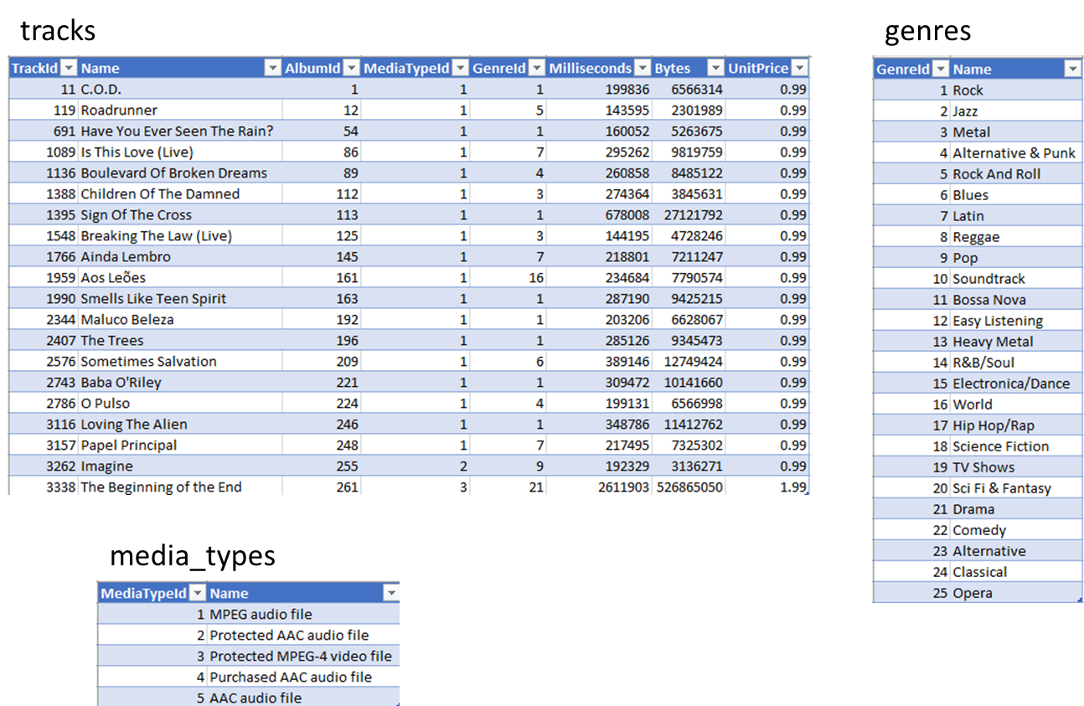

Here are three related tables from the chinook database.

* Tracks contains information about media tracks.
* Genres contains information about musical and other media genres.
* Media_types contains information about digital formats.

Answer the following questions using the database tables shown above.

1. What is the primary key in the tracks table? TrackID
2. What is the primary key in the genres table? GenreID
3. What is the primary key in the media_types table? MediaTypeID
4. There are three foreign keys in the tracks table. What are their column names? MediaTypeID, GenreID, AlbumID
5. Out of the 20 tracks, 19 are audio and 1 is video.
   1. What is the name of the video track? The Beginning of the End
   2. What is the genre of the video track? Drama
6. Genre:
   1. What is the name of the most common genre in the tracks table? Rock
   2. How many tracks are of that genre? 7