Computer Architecture Tutorial 6
Jack Cassidy 1432 0816

Program Summary
My cache simulation program was written in Python. It contains a Cache class, which is initialized with the L, K and N parameters. We instantiate two Cache objects, one to represent an Instruction Cache and another for a Data Cache. Each Cache object contains datastructures to simulate the sets and directories and other operations of a real cache. All of the sets are stored as an (n x k) 2D resizable-array (list in Python terms) in the ‘sets’ class variable, all cache lines in the set are initialized to null (None in Python terms). All of the directories are stored as an (n x k x l) 3D list in the ‘dirs’ class variables. Each set maps to K possible lines in a directory. Each directory entry stores L bytes, in the form of the innermost list in our 3D list, which are all initialized to boolean False for the purposes of simulation. When a byte is accessed in the cache it is flipped to boolean True. There is also a LRU Queue (deque in Python terms) which keeps the least recently used tag at the front of the queue for each set. The tag, set and offset masks are also initialized as class variables, which extract the tag, set number and cache line offset from each incoming address from the trace file.
The trace file is read in using the xxd command line utility. Xxd performs a hex dump on the trace file, which requires parsing to extract the useful address information.
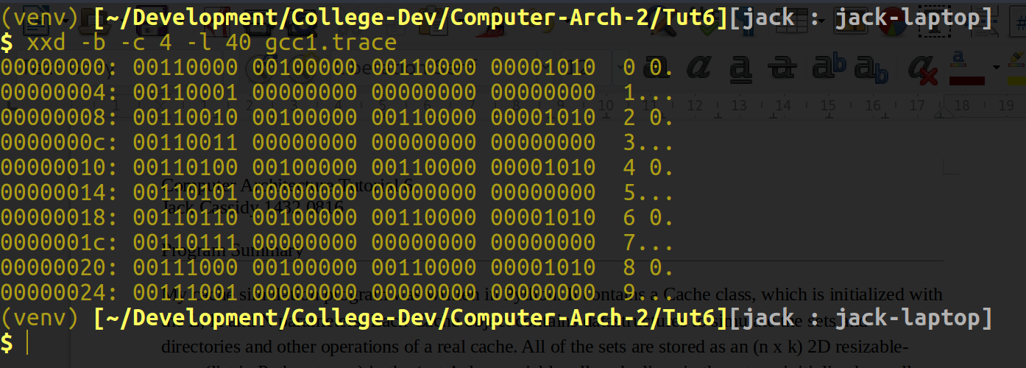
Unparsed xxd command line output
As can be seen in the image above, the xxd output requires the leftmost and rightmost columns to be stripped out so we can access the useful bytes between them. This is done in the ‘read_trace’ function. According to the project spec, the records in the trace file are structured in a way that the first word contains the useful information, the physical address, burst count and access type, whereas the second word stores an interval count that is not required for use in this program. Hence, while parsing each record we only extract every odd numbered word.
After the trace file is parsed, we begin analysis of the trace records. The address, access type and burst count masks are ANDed with the record to extract that relevant information. We are only interested in the Intruction Read and Data Read/Write access types. Depending on the access type, we pass the address and the burst count to the ‘read’ or ‘write’ functions.
In the read and write functions, we extract the tag, set number and line offset from the incoming address by ANDing it with the masks we set up as class variables previously. The algorithm then progresses as follows:
- Check the set, identified by the set number, if the specified tag is present. If not, then there is a cache miss and we execute the ‘tag_miss’ function.
- For reads only check the cache line identified by the set number and the index of the tag in it’s set to see if there is data there, symbolized by having a True value. If the line has a False value, there is a cache miss and we execute the ‘offset_miss’ function.
- Otherwise, there is a cache hit. We execute the ‘lru_reshuffle’ function, which extracts the just accessed tag from the LRU Queue and replaces it at the end of the queue.
- On a cache miss, we increment the ‘misses’ counter by 1 and the ‘hits’ counter by the burst count.
- On a cache hit, we increment the ‘hits’ counter by the burst count + 1.

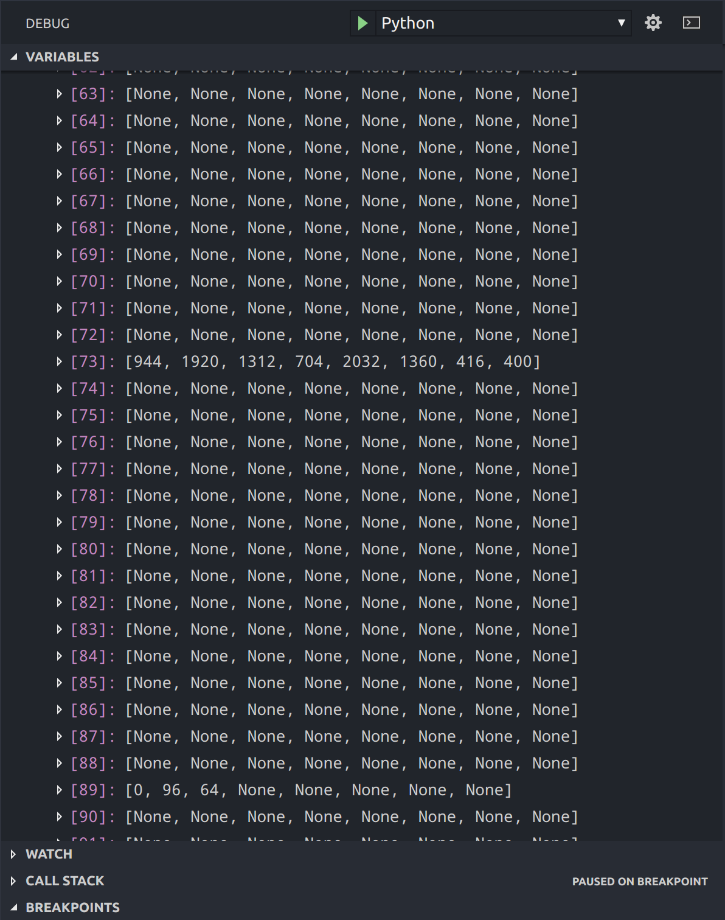
A snapshot of the internal layout of the list of sets for the data cache, on a reduced size of the trace file. Note that set 73 is easily seen as a hot set
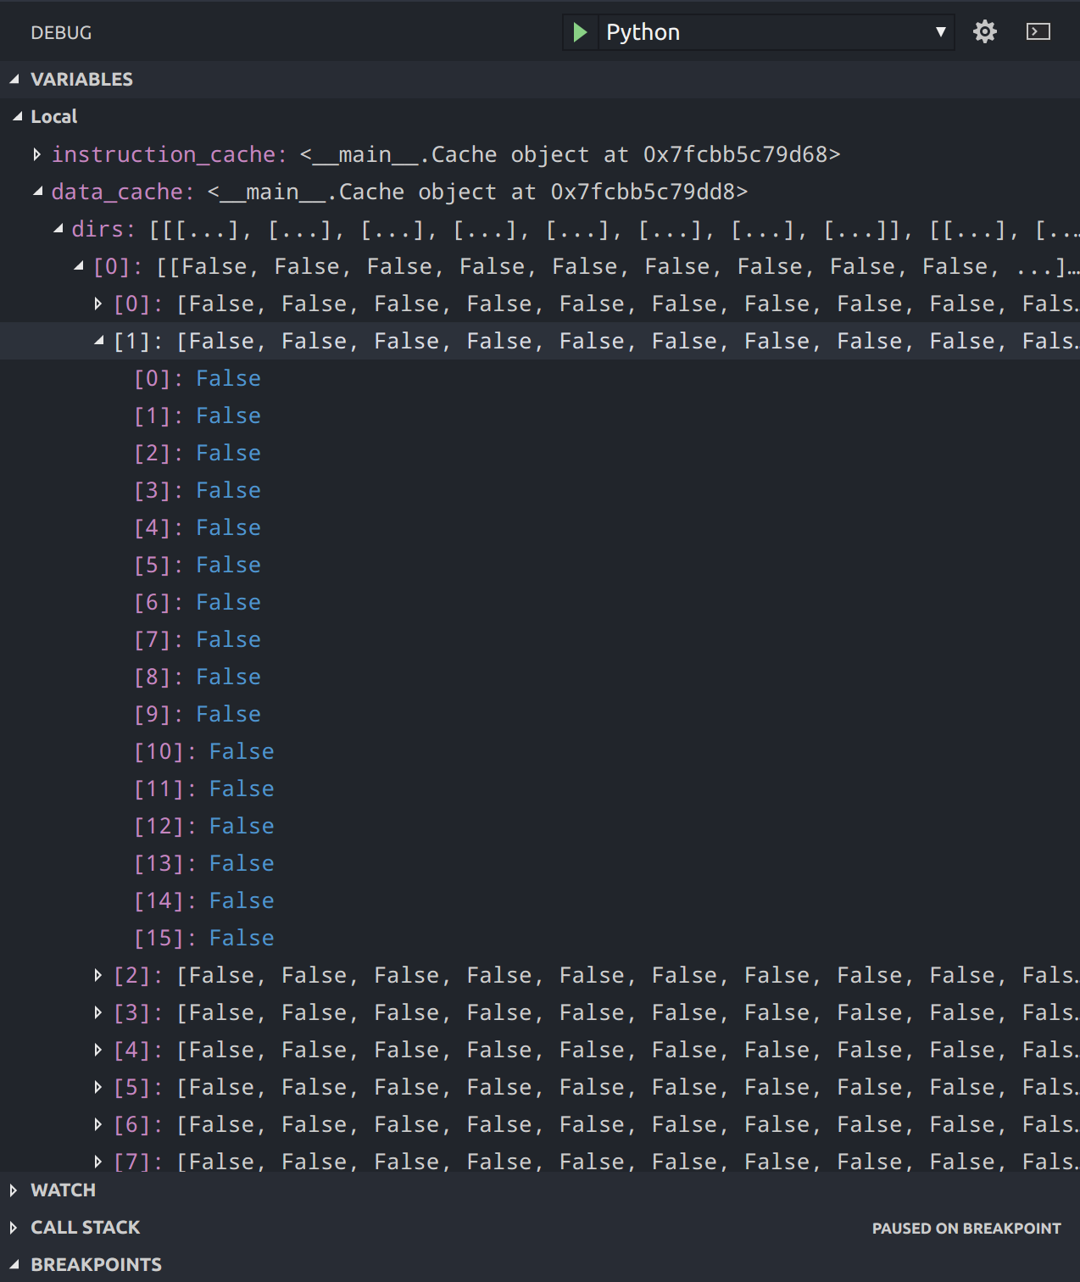
Drawing 1: A similar snapshot as the previous image, but this one shows the structure of the directories. Shown is the directory for set 0, with the lines corresponding to tag at index 1 in the set. None have been accessed yet as they are all set to False
Results
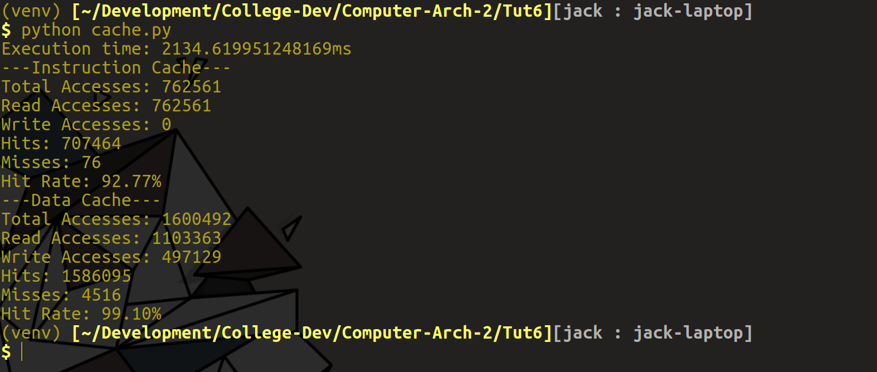
Above is a terminal screenshot of the results gathered from processing the entire trace file. There is an excellent hit rate for both the Instruction and Data caches, however execution time leaves a lot to be desired.
There could be a number of reasons for this long execution time. My model of the cache structure was very verbose and contained some complex datastructures, which would have led to longer search times, for example while searching through sets of the 8-way data cache for the desired tag. However I felt that the complexity of my model gave me a much greater understanding of the internals of a cache.

