406MCA Sensor Measurement Issue
and Buffer Solution
Readable explanation of the original LabJack measurement problem, the AM 502 clue, and the unity-gain buffer fix
Bottom line
The LabJack was not just struggling because the signal was small. The stronger evidence is that the AM 502 gave the correct reading even at 1x gain. That points to a source-impedance / settling / buffering problem. A unity-gain buffer should give the LabJack a low-impedance signal while preserving the 0.667 V DC offset and the small AC waveform.

1. Quick facts
Item | Value / meaning
Expected sensitivity | About 5.76 to 6.56 mV peak-to-peak.
DC offset | About 0.667 V. This offset must be preserved for this test.
Bad direct readings | Direct LabJack readings were too high, around 15 mV in one setup and around 33 mVpp with the +/-1 V range setting.
Known-good clue | AM 502 at 1x gave the correct sensitivity reading, which means the AM 502 was mainly helping as a buffer.

Measurement goal
Measure the small peak-to-peak sensor waveform accurately with the LabJack T7-Pro while still measuring the 0.667 V DC offset. The first fix should not add gain. It should only buffer the signal.

2. What the original measurements showed
The measurements tell a very specific story. Direct connection to the LabJack produced a sensitivity value that was too high. The AM 502 produced the correct value even when set to 1x. That is the key evidence: the AM 502 was not mainly solving the problem by amplifying the voltage. It was isolating the sensor from the LabJack input and driving the LabJack from a stronger, lower-impedance source.
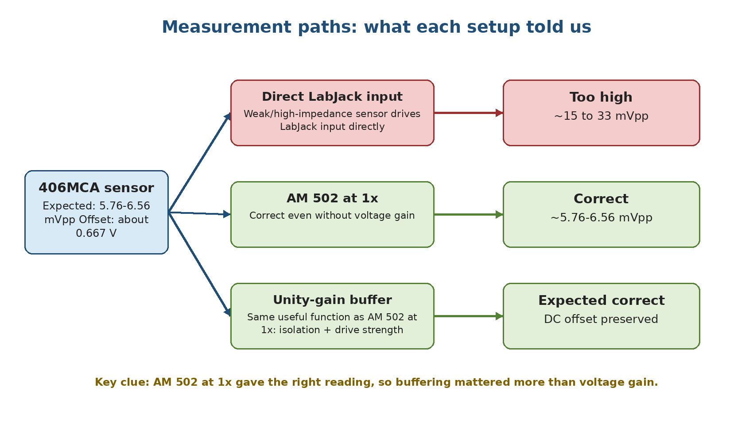
Figure 1. Comparison of the direct LabJack reading, the AM 502 at 1x, and the intended unity-gain buffer path.

3. Why the AM 502 result matters
Setup | Observed result | What it means
Sensor directly into LabJack | Measured too high: about 15 mV in one setup and about 33 mVpp with the +/-1 V input range. | The direct sensor output was not being measured cleanly.
Sensor through AM 502 at 1x | Measured the expected sensitivity range. | The AM 502 helped even without voltage gain, so the useful function was buffering.
Sensor through unity-gain buffer | Expected to match AM 502 at 1x. | This removes the bench amplifier while keeping the important isolation/drive function.

Plain-English version
The AM 502 proved the problem was not simply, "the signal is too small." If that were the whole issue, 1x gain would not have helped. The more likely issue is that the sensor output is too weak/high-impedance for the LabJack input behavior during streaming.

4. Likely root cause: LabJack input settling/loading behavior
The LabJack T7 analog inputs are sampled through an internal multiplexer and ADC input network. During streaming, the ADC input has to settle to the correct voltage every time a channel is sampled. If the source connected to AIN0 has high impedance, it may not charge or discharge the ADC input capacitance fast enough. The result is settling error.
That kind of error matters a lot here because the useful AC signal is only a few millivolts peak-to-peak. A small settling error can become large compared with the real waveform, so the software calculates an artificially high peak-to-peak sensitivity.
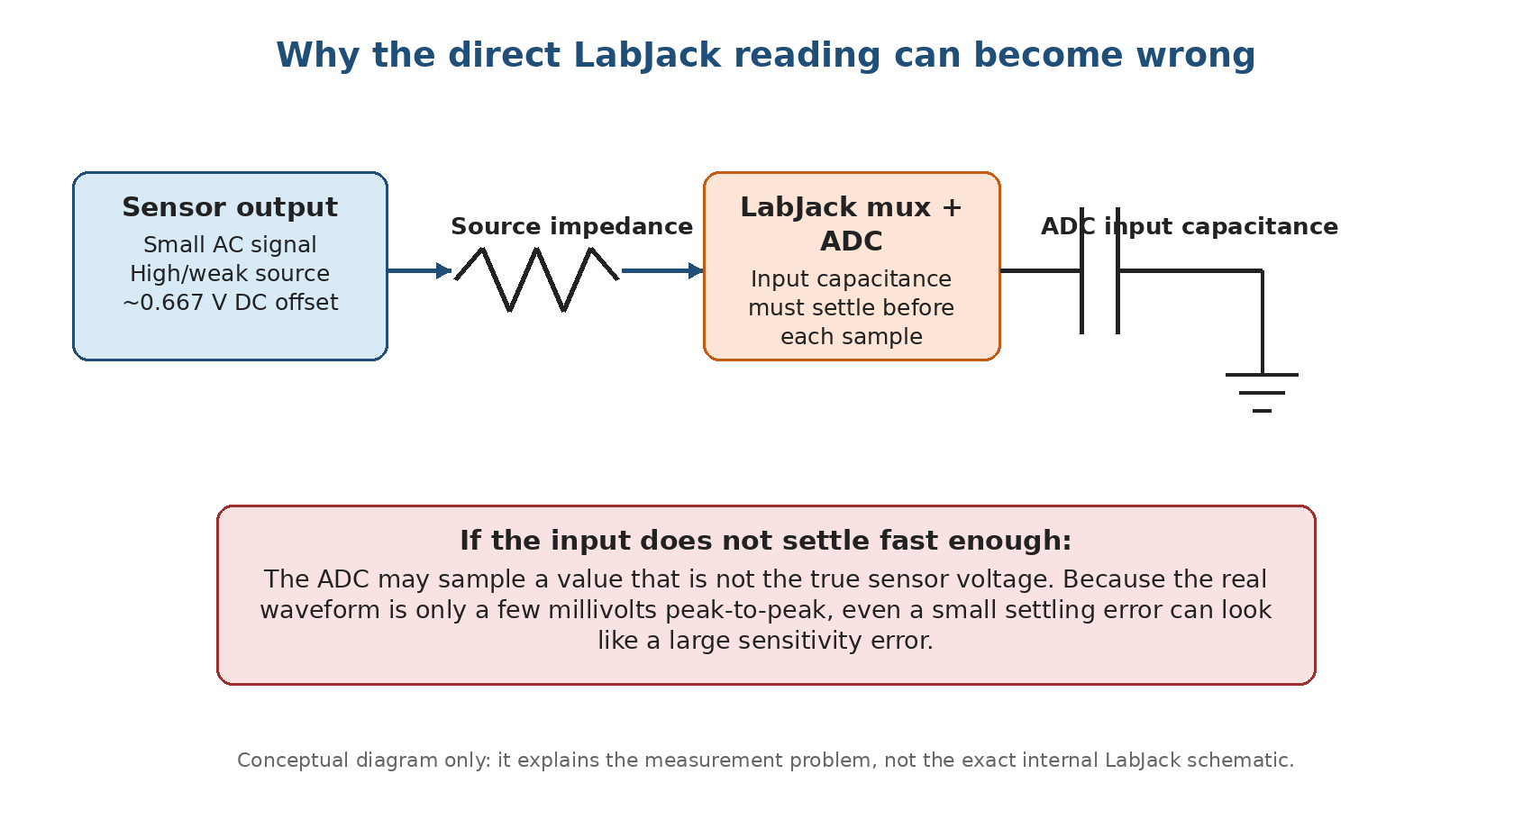
Figure 2. Conceptual explanation of how a weak/high-impedance source can cause ADC settling error.

5. Why changing the LabJack range did not solve it
Setting / idea | What it helps | Why it does not solve this problem
+/-1 V input range | Improves usable resolution compared with a wider range. | It does not make the sensor output lower impedance. The LabJack still has to be driven cleanly.
+/-0.1 V input range | Would give more resolution for a centered small signal. | Not usable here because the sensor sits at about 0.667 V DC offset, which is already outside +/-0.1 V.
External gain in tester app | Corrects the math if a real external amplifier is used. | For the unity-gain buffer test, leave this at 1x because the buffer should not amplify the signal.

Important
Do not use the +/-0.1 V range for the first buffer test unless the 0.667 V offset has been removed or level-shifted. For the first test, use +/-1 V and keep the app external gain at 1x.

6. Unity-gain buffer solution
A unity-gain buffer is also called a voltage follower. Its gain is 1, so the output voltage follows the input voltage. The point is not to make the signal bigger. The point is to make the signal easier for the LabJack to measure.
- Very high input impedance: the buffer barely loads the 406MCA sensor output.
- Low output impedance: the buffer can drive the LabJack input, cable capacitance, and ADC front end more cleanly.
- DC-coupled path: the 0.667 V offset is preserved.
- No first-stage gain: the first test should prove the buffering fix before adding any amplification.
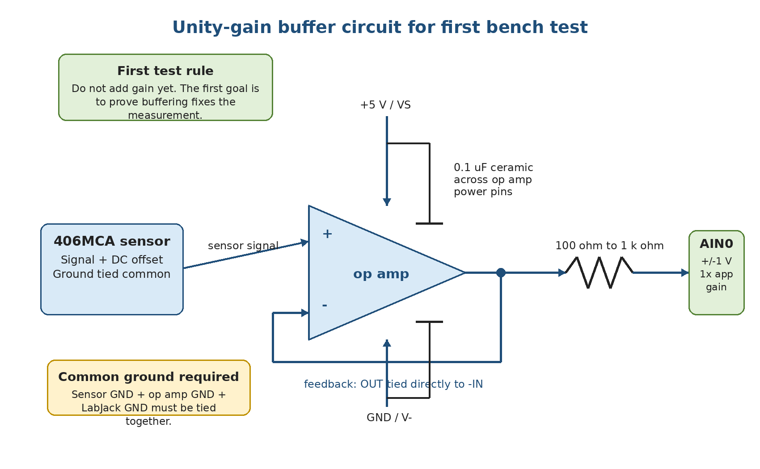
Figure 3. First-test unity-gain buffer wiring. The 0.1 uF capacitor should be placed close to the op amp power pins.

7. Bench wiring checklist
Connection / setting | Instruction
Sensor output | Connect to the op amp non-inverting input (+IN).
Op amp feedback | Connect op amp output directly back to the inverting input (-IN). This makes it a unity-gain buffer.
Buffer output to LabJack | Send the op amp output through a 100 ohm to 1 k ohm series resistor into LabJack AIN0.
Grounds | Tie sensor ground, op amp ground, and LabJack GND together.
Op amp power | Use LabJack VS/GND or a clean external 5 V supply with grounds tied together.
Bypass capacitor | Place a 0.1 uF ceramic capacitor directly across the op amp power pins, physically close to the IC.
LabJack settings | AIN0 range = +/-1 V. Tester app external gain = 1x for the buffer-only test.

What "close to the op amp pins" means
The 0.1 uF capacitor should be connected directly across the op amp power pins with the shortest practical leads/traces. For an MCP6002 DIP-8, that means between pin 8 (+5 V/VDD) and pin 4 (GND/VSS), placed right beside the chip on the breadboard or PCB.

8. Op amp requirements
Requirement | Why it matters
CMOS or FET input preferred | Keeps input bias current very low so the buffer does not load the sensor.
Very low input bias current | Important for weak/high-impedance sensor outputs.
Unity-gain stable | Required because this first stage is configured as a voltage follower.
Works from 5 V supply | Allows simple bench testing from LabJack VS/GND or a clean external 5 V source.
Input range includes 0.667 V | The op amp must correctly accept the sensor DC offset.
Stable driving the LabJack/cable | The output should not oscillate when connected through the 100 ohm to 1 k ohm resistor into the LabJack input path.
Example families mentioned for this type of test: LMC6061, MCP6002, OPA320, TLV9062/TLV9064, and similar CMOS/FET-input op amps. The first bench test does not require gain.

9. Verification plan
The buffer should be treated as a hypothesis test. The clean way to prove the root cause is to measure the same sensor using the same blade/sync setup in three paths:
Step | Path | Pass/fail meaning
1 | Direct to LabJack | This is the bad comparison path. It has already read too high.
2 | Through AM 502 at 1x | This is the known-good reference path.
3 | Through the new unity-gain buffer | This should match the AM 502 at 1x if the issue is source impedance / settling / buffering.

Expected outcome
If the new buffer matches the AM 502 at 1x, the root cause is strongly confirmed. If it does not, check the op amp wiring, power bypass capacitor, common ground, output oscillation/ringing, and LabJack stream/channel settings before changing the signal-processing code.

10. Scaling toward many sensors
For a larger fixture, the preferred architecture is to buffer each sensor before multiplexing or before feeding the DAQ input path. This is better than using one buffer after a mux because each individual sensor is isolated from mux leakage, charge injection, cable capacitance, and LabJack input settling behavior.
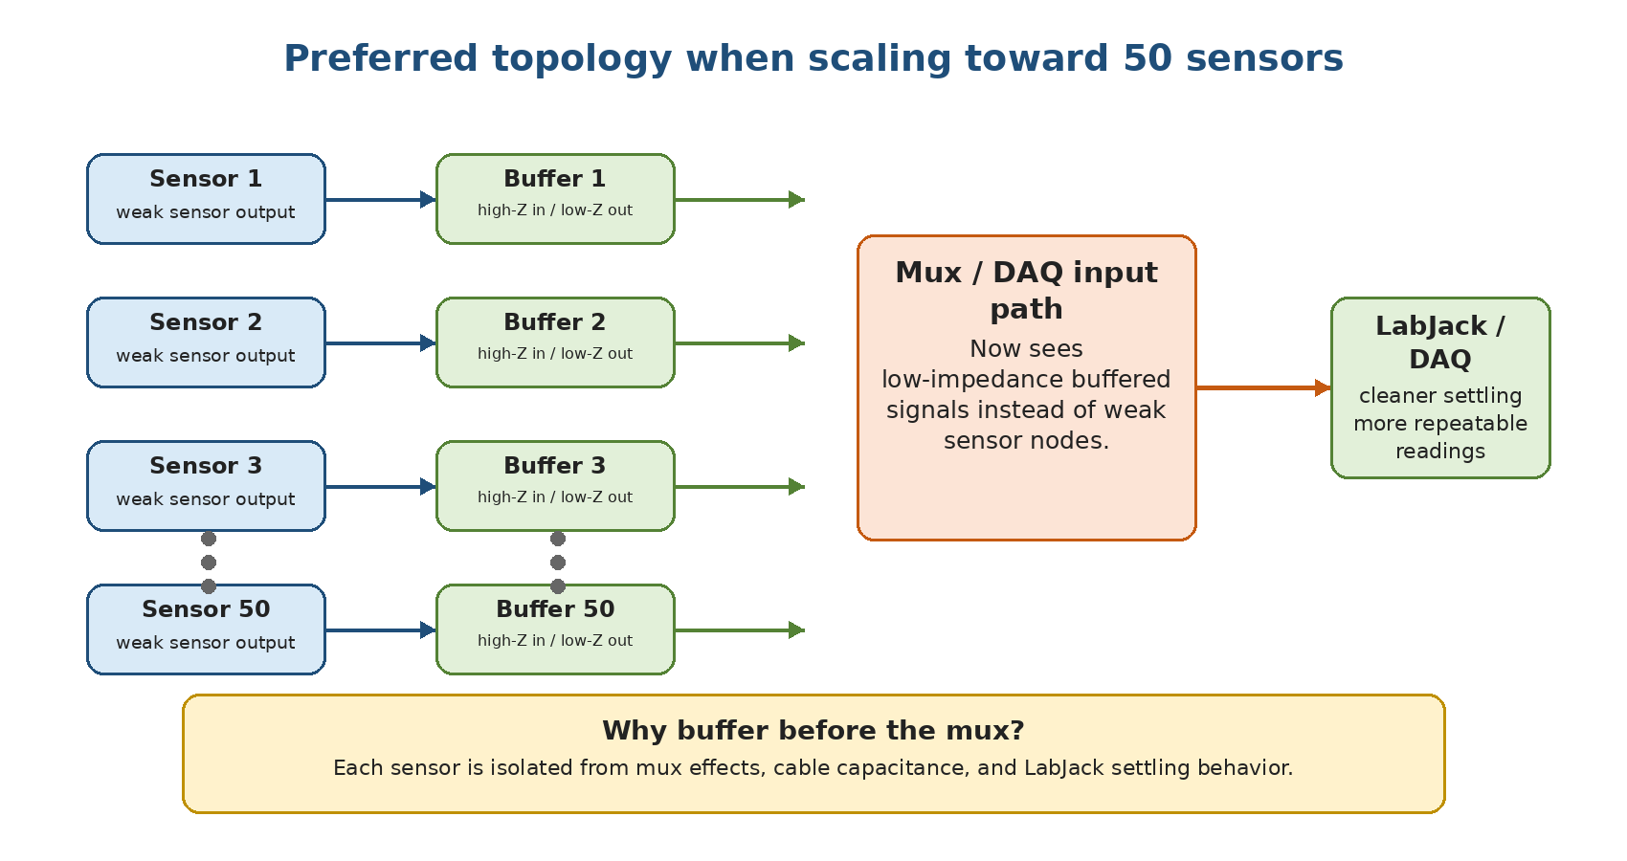
Figure 4. Preferred topology for scaling: each weak sensor output gets its own buffer before the mux/DAQ path.

11. Final summary
- The expected sensor output is only about 5.76 to 6.56 mVpp on top of a 0.667 V DC offset.
- The direct LabJack reading was too high, which means the direct input path was not measuring the waveform cleanly.
- The AM 502 at 1x gave the correct reading, which is the key evidence that the missing function is buffering, not necessarily gain.
- Changing the LabJack range improves resolution, but it does not make the sensor output easier to drive or fix source-impedance/settling behavior.
- A unity-gain op amp buffer gives the sensor a light load and gives the LabJack a low-impedance source. That is the first fix to test.

12. References
- LabJack analog input settling/source impedance note
- LabJack T7 analog input datasheet
- TI LMC6061 datasheet

