LabJack T7-Pro / 406MCA Sensor Buffer Handoff
Purpose: Build and test a small DC-coupled unity-gain buffer so the LabJack T7-Pro can read the 406MCA sensor output directly, without relying on the AM 502 bench amplifier.
Main issue | The direct LabJack reading is much higher than expected: about 33.31 mVpp instead of about 5.76 to 6.56 mVpp.
Most likely cause | The AM 502 at 1x is probably acting as a buffer. The LabJack input may be seeing high source impedance / ADC settling error.
First prototype | Use a DC-coupled unity-gain voltage follower. Do not add gain on the first test.
Pass condition | The new buffer should match the AM 502 at 1x while preserving the ~0.667 V DC offset.

What is in this handoff
1. Problem summary
2. What the buffer must do
3. Prototype circuit and connections
4. LabJack test settings
5. Suggested op amps
6. Scaling to around 50 sensors
7. Bench verification plan
8. Layout and build checklist
9. What to decide after the first test
10. References

1. Problem summary
What we expected: The 406MCA sensor should be around 5.76 to 6.56 mV peak-to-peak, riding on about 0.667 V DC offset.
What the LabJack direct reading showed: The direct LabJack measurement was about 33.31 mV peak-to-peak, which is too high compared with the expected sensitivity.
What the AM 502 result suggests: The AM 502 gives the correct reading even when set to 1x. That means it is likely helping because it presents a high input impedance to the sensor and a low output impedance to the measurement system. In plain language: it is probably acting as a buffer, not just as an amplifier.
Likely failure mode: The LabJack T7 input is multiplexed into an ADC front end. With a weak or high-source-impedance signal, the input capacitance and mux switching may not settle fast enough, causing the measured waveform to look wrong.

2. What the buffer must do
Requirement | Meaning | Why it matters
DC-coupled | The DC offset passes through. | The ~0.667 V offset is part of the signal that must be preserved.
Unity gain | Vout = Vin. | The first test should prove buffering only, not mix in gain-stage problems.
High input impedance | The buffer does not load the sensor output. | Protects the weak sensor signal.
Low output impedance | The LabJack sees a strong source. | Helps the ADC/mux input settle correctly.
Do not add gain yet. The first prototype is only meant to answer one question: does buffering make the LabJack match the AM 502 at 1x?

Signal chain overview
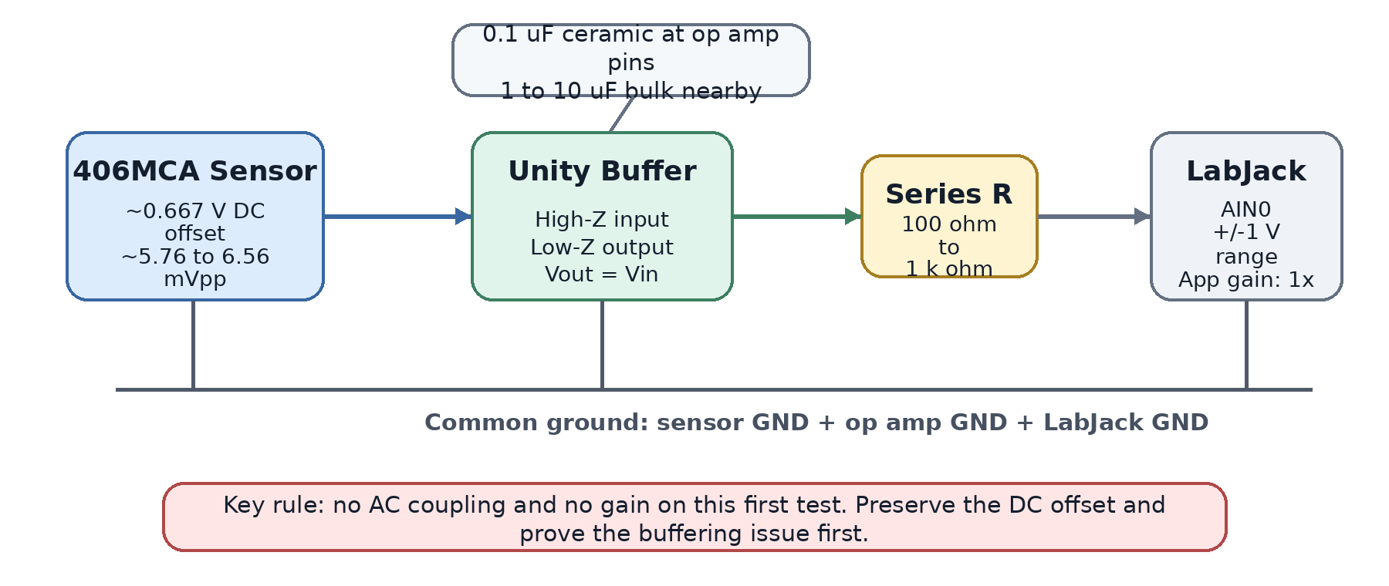
Figure 1. First-test signal chain. The buffer should not change the voltage waveform; it should only make the source easier for the LabJack input to measure.

3. Prototype circuit and connections
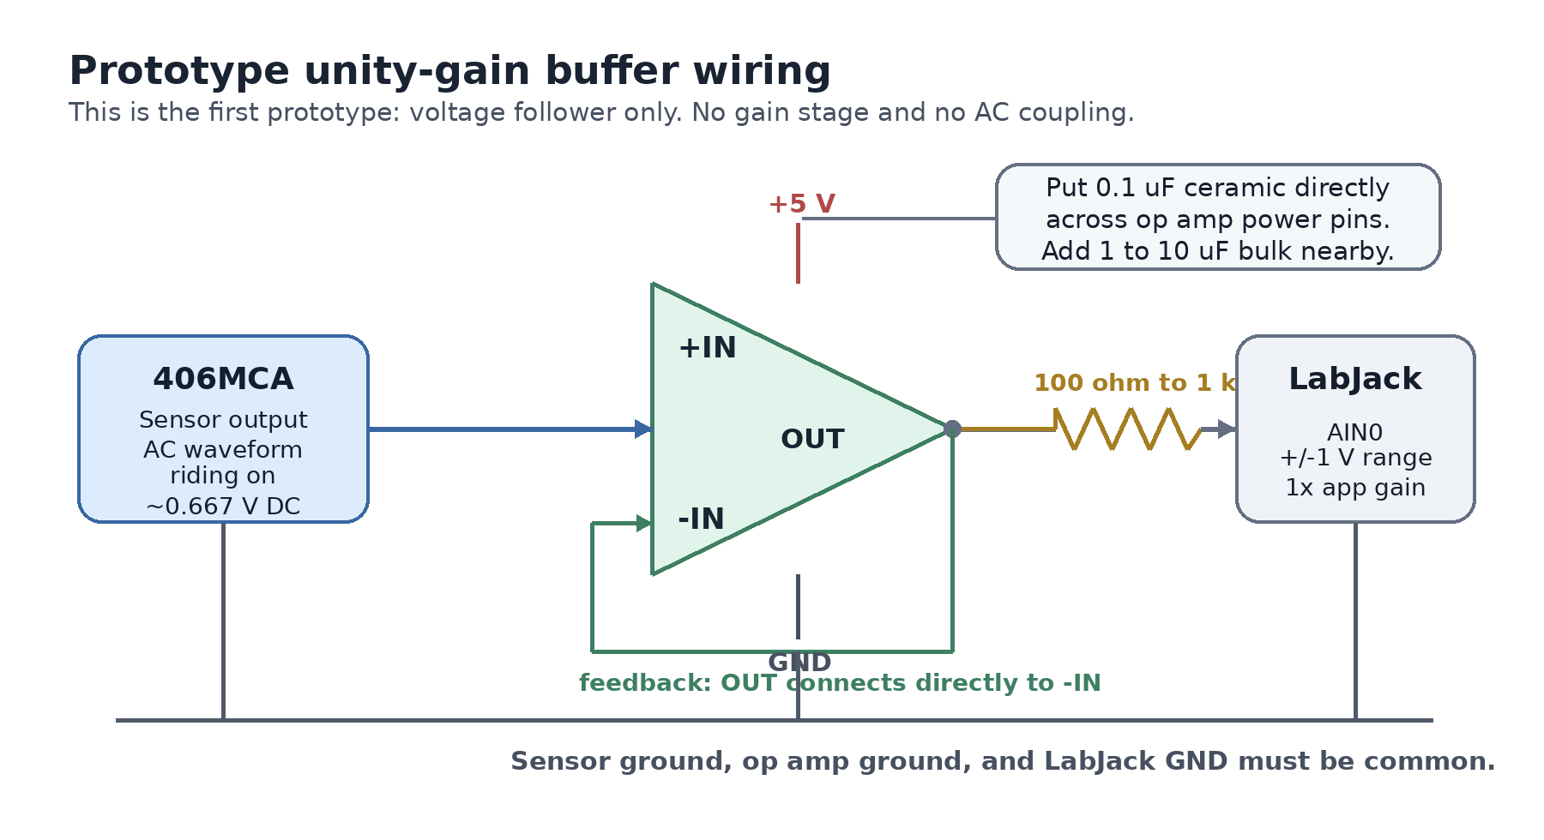
Figure 2. Unity-gain buffer wiring. The op amp output feeds back directly to the inverting input, so the output follows the sensor voltage.

Connection table
Connection | Where it goes | Notes
Op amp power | LabJack VS/GND or clean external 5 V supply | If using an external supply, tie grounds together.
Bypass capacitor | 0.1 uF ceramic across op amp power pins | Place it physically close to the op amp pins.
Bulk capacitor | 1 uF to 10 uF across 5 V and GND nearby | Helps stabilize the local supply.
Sensor signal | Op amp non-inverting input (+IN) | Keep this trace/wire short and clean.
Feedback | Op amp output directly back to inverting input (-IN) | This makes the circuit a voltage follower.
Output to LabJack | Op amp output -> 100 ohm to 1 k ohm resistor -> LabJack AIN0 | The series resistor helps isolate the op amp from cable/input capacitance.
Ground | Sensor ground + op amp ground + LabJack GND | All grounds must be common.
Important: Do not AC-couple this prototype. AC-coupling would remove the DC offset, and the whole point is to verify that the LabJack can read the real sensor output through a buffer.

4. LabJack test settings
Setting | Use this
AIN0 range | +/- 1 V, shown as x10 range setting in the tester app
External gain in tester app | 1x
Expected result through buffer | Approximately the same sensitivity as the AM 502 at 1x
Do not use | +/- 0.1 V range (x100) for this first test, because the ~0.667 V DC offset is already outside that range

5. Suggested op amps
Recommended first bench test: Start with MCP6002 or TLV9062. If the buffered reading matches the AM 502 at 1x, then move to a scalable quad-op-amp layout such as TLV9064.
Part family | Strength | Best use | Comment
MCP6002 | Cheap, easy, DIP-8 available, rail-to-rail I/O | First proof-of-concept | Good starting point because it is easy to breadboard.
OPA320 / OPA2320 | Lower-noise CMOS, rail-to-rail option | Cleaner measurement path | Better part if the simple proof-of-concept works and noise matters.
TLV9062 / TLV9064 | Good scaling choice; TLV9064 is quad | Multi-channel build | 13 TLV9064 chips can buffer up to 52 sensors.
OPA392 / OPA2392 / OPA4392 | Precision, very low input bias and offset | Highest technical confidence | More expensive; use if leakage/offset becomes a real limitation.

6. Scaling to around 50 sensors
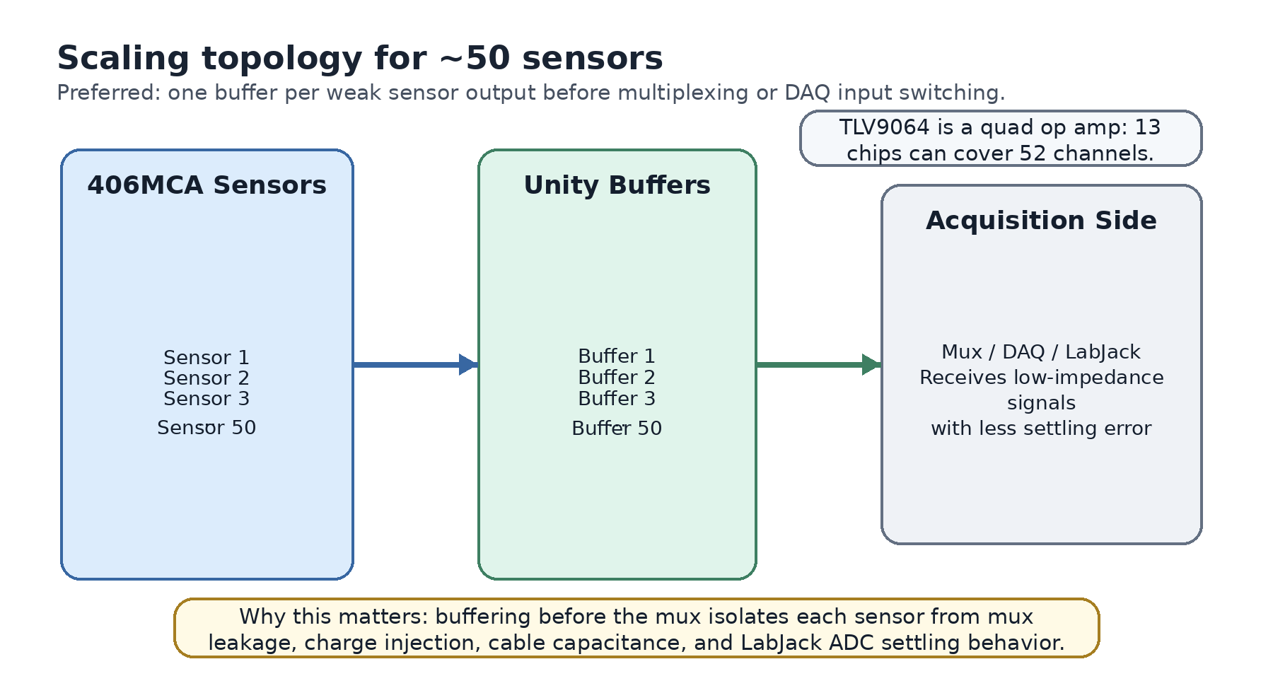
Figure 3. Preferred production direction: buffer each sensor before the mux/DAQ path. This protects the weak sensor output from mux leakage, charge injection, cable capacitance, and ADC settling effects.
Preferred production topology: Sensor -> buffer -> mux/DAQ.
Why not one buffer after the mux? One buffer after the mux may help the LabJack input, but it does not isolate each weak sensor output from the mux itself. For a 50-sensor test system, the safer design is to buffer before multiplexing or before each DAQ input path.

7. Bench verification plan
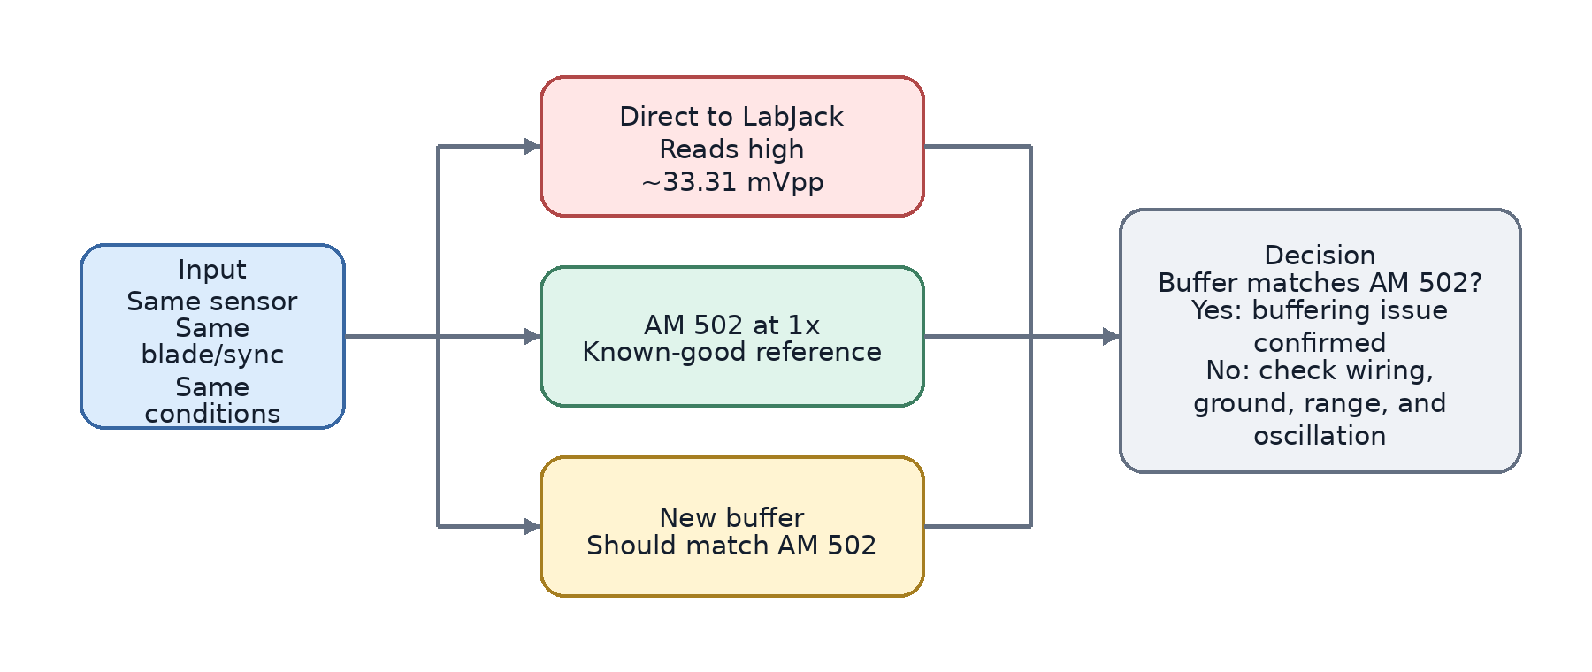
Figure 4. Verification plan. The new buffer passes the first test if it agrees with the AM 502 at 1x under the same sensor and chopper setup.
Path | What to measure | Expected result | What it tells us
Direct to LabJack | mV peak-to-peak and DC offset | Currently about 33.31 mVpp | Baseline problem measurement.
Through AM 502 at 1x | mV peak-to-peak and DC offset | Known-good comparison; expected about 5.76 to 6.56 mVpp | Reference measurement.
Through new buffer | mV peak-to-peak and DC offset | Should match AM 502 at 1x | Confirms or rejects the source-impedance / settling hypothesis.

Measurement rules
- Use the same sensor for all three paths.
- Use the same blade/sync setup and the same test conditions.
- Record peak-to-peak signal, DC offset, and any obvious waveform distortion.
- Before trusting the LabJack reading, check the buffer output on a scope for oscillation or ringing.

8. Layout and build checklist
Check | Why it matters
Keep the sensor input trace into the op amp short and clean. | This is the highest-impedance node and the easiest place to pick up noise or leakage.
Put the buffer physically close to the sensor connector or mux input. | Reduces cable capacitance and noise before the signal is made low impedance.
Use input protection carefully. | Leakage on a high-impedance node can corrupt a millivolt-level signal.
Place the 0.1 uF bypass capacitor very close to each op amp IC power pins. | Prevents supply noise and reduces the chance of oscillation.
Keep the 100 ohm to 1 k ohm output resistor in series with the LabJack input. | Helps isolate the op amp from cable and ADC input capacitance.
Scope the buffer output before relying on the LabJack number. | A buffer can oscillate or ring if layout, load, or decoupling is poor.

9. What to decide after the first test
If the new buffer matches the AM 502 at 1x: The source-impedance / LabJack settling explanation is very likely correct. Move toward a multi-channel buffered design.
If the new buffer does not match: Check wiring, common ground, op amp power, bypass capacitor placement, oscillation/ringing, LabJack range, and tester app gain.
Only after unity-gain buffering works: Decide whether gain is needed. Do not add gain until the basic buffer behavior is proven.

If gain is added later
Use a level-shifted gain stage instead of multiplying the whole 0.667 V offset:
Vout = Vref + G * (Vin - Vref)
Where: Vin is the buffered sensor voltage, Vout is the amplified output, Vref is the reference voltage around the DC offset, and G is the AC gain. This amplifies the small waveform around the offset instead of pushing the entire DC level upward.

10. References
Reference | Link
LabJack analog input settling / source impedance note | Open source
LabJack T7 analog input datasheet | Open source
TI buffer / follower circuit | Open source
Microchip voltage follower walkthrough | Open source
TI OPA320 product page | Open source
TI TLV9064 product page | Open source
TI OPA392 datasheet | Open source

