Juliette Chirol Hill

Professor Nayeon Kim

ITP 104 – Monday 5:00-7:50pm

23 March 2018

Final Project Proposal

Topic and Mission: I hope to make a website that shares information about language-learning techniques following some of the latest research in cognitive science and provide the means for fulfilling the wish of many to learn a language.

Audience: The target audience would be anyone from an English-speaking audience hoping to learn another language independently.

Content: The website first covers why someone would even want or should pursue what seems like the massive task of learning a foreign language by explaining the benefits that both have been proven socially and scientifically. This data can be covered using infographics to make the material more easily and quickly accessible. I will then detail on another separate page a method that I have developed which works incrementally to allow people to learn a language despite a busy schedule by only dedicating fifteen minutes a day to the language study. I will describe on another page how to deal with the difficulty of staying motivated and maintaining one’s goals, which is typically the main reason why people do not fulfill their wish to learn another language. Finally, the last page will mention several tips that I have learned from my own language-learning journeys, some of which I wish I had known as I was just beginning to learn a new language.

Design: For the color scheme, I am thinking of using a dominant color as a shade of teal, and a navy blue as an accent color. The website’s background will be a simple light grey, so as to not distract the reader from the content. The actual background for text material (or the divs containing the text content for the site) would be closer to white. I am thinking for the layout of having a menu bar across the top with the site name. Below it will be the hero with the purpose of the website in the form of an interesting infographic. Right below the hero would be the bar with links to the other pages with content. Below would house the content in a one column format.

Layout: The format of the website would most likely be a traditional one column format.

Site Map:

*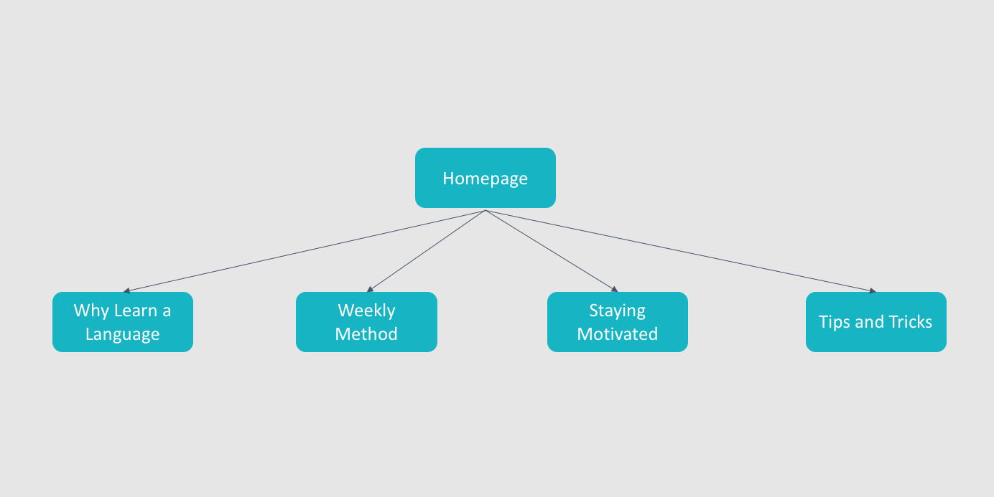*

Page Count: I am expecting approximately five pages, as listed above in the site map. A homepage will lead to all the other content pages. These content pages may later on provide outgoing links to some of the other pages, but I am not yet sure about the specifics, although this format is likely.