**Eye-To-Eye DataBase Documentation**



**Table of Contents**

PURPOSE 3

HOW TO CREATE A NEW ATHLETE 3

ATHLETE ACCOUNT PAGE 4

Preload Workout 5

Enter Notes 6

Todays Workout 7

SAVE BUTTON 7

**Purpose:**

The purpose of this program is to monitor and store information regarding athlete sessions and scores during, as well as ways to view improvements throughout the summer and beyond. It is set up with a generic front page with three options, “Search Existing Athlete”, “Enter New Athlete”, and “Save File”. This documentation will go over all these functions and what they do and some guidelines when using them. There will be a known issue section at the bottom of this documentation but if other arise please feel free to reach out.

**How to create a new athlete**

When clicking the new athlete button, a page will pop up with an entry bar and an enter button, like this:

Enter the name of the new athlete joining in the text entry bar and hit the save and close button to create a new page in the spreadsheet dedicated to that Athlete, the program will automatically create the sections needed for each athlete. The categories of data for each athlete are DATE, SESSION, WORKOUTS, NOTES, and NT SCORE. What data will be entered where will be explained later in Preload Workout section. Once the button is pressed a message box will appear saying that the data has been entered. Click ‘OK’ and the message box will close.

Important note regarding how to enter Athlete name: **For the program to read the name properly, there cannot be any spaces while entering name, it is recommended that the be entered “FirstnameLastname”, for example: “Logan Jones” will be entered as “LoganJones”.**

Known issues: When pressing the “save and close button”, the window to enter the data does not disappear, be sure to press the ‘x’ in the top right corner of the “New Athlete” page once pressing the button and leaving the message box.

**Athlete Account page**

Once an athlete is created, their accounts will be able to be searched in the “Search Existing Athlete” button, begin to enter the athlete’s name and the program will match up the entry to the name of the athlete saved in the data field. Once entered the athlete’s account page will pop with a few options, these are the buttons and functions for the athlete at launch:

The next section of the documentation will explain each button and what they do in order from top to bottom.

**Preload Workout**

This button is used when you would like to fill in a workout for a certain date. When you click the button, this page should pop up:

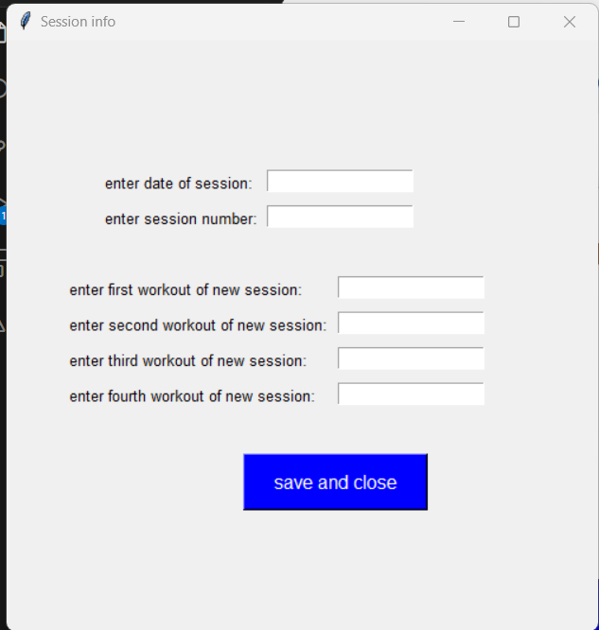

This is where you will enter the data for the upcoming workout, the first entry bar is where you enter the date of the upcoming session, **IT is very important to enter in the date of the session in MM/DD/YYYY** or else it can lead to very inconsistent behavior from the program. Once you are finished entering all the data fields, click save and close for the program to write the information to the correct fields.

**Enter Notes**

The enter notes button leads you to this page:

enter in the notes of a workout, you must first enter in the correctly formatted date in “enter date session entry box” to enter the notes, when entering the notes, be sure to enter the notes in the order of the workouts done in the session from first to last. Press Enter notes button to save to the file.

**Today’s Workout**

This button will show you the upcoming workout scheduled for the athlete.

Important note regarding the functionality: **The program just reads what is at the top of the spreadsheet for that specific athlete, so only enter one new session at a time for now until this is resolved.**

Here is an example of what the page could look like:

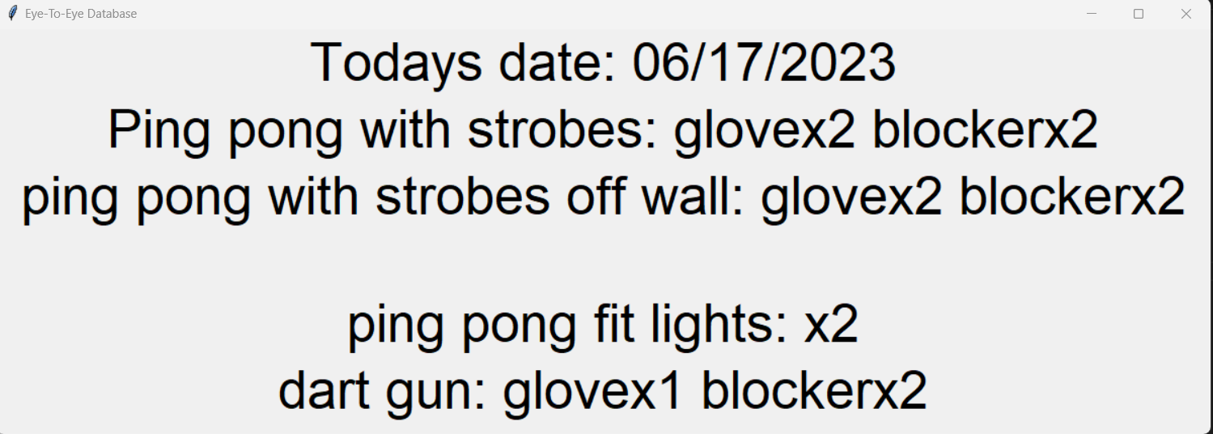

**Save Button**

After entering all the data needed, be sure to press the “Save File” button to ensure that all entered data is properly saved into the program. That is the only function of this button.