**HOW TO DOWNLOAD and INSTALL software from DREAMSPARK**

1. Download and install 7-zip from [www.7-zip.org](http://www.7-zip.org). This will be used later on to unzip your software.
2. Go to the DreamSpark GGC WebStore (use your GGC login):

<http://e5.onthehub.com/WebStore/Welcome.aspx?ws=52fc29d5-619f-e111-9b64-f04da23e67f6>

1. Search to find the programs you want or click “Dreamspark Premium”.

Find your program and click “Add to Cart”. Do this for each program that you need. For ITEC 3200, you will need **Microsoft Access 2016** and **Microsoft Visio 2010**. When you find all of the programs that you want, click CHECK OUT, and follow the check out procedure.

1. Before you start the download, make a copy of the product key.

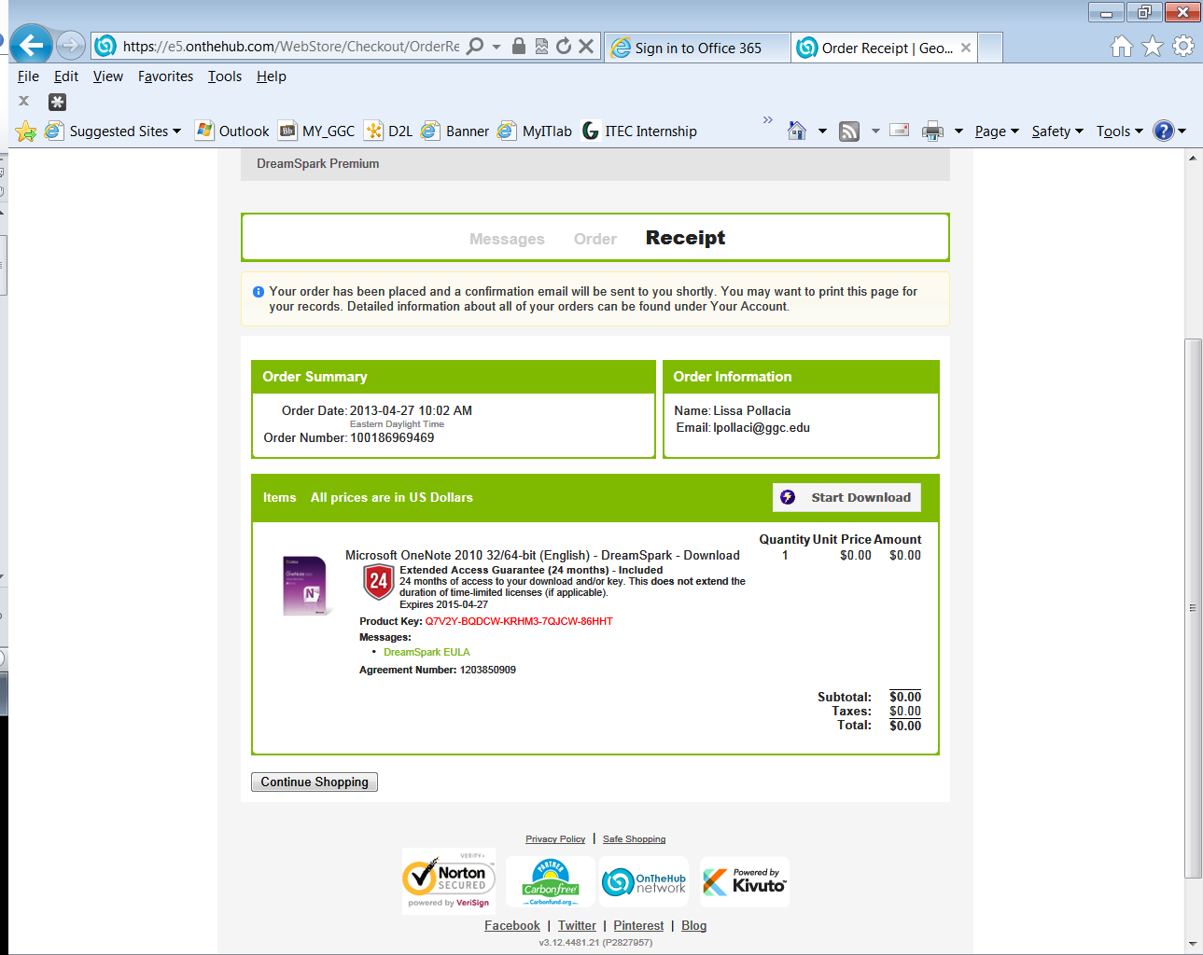

PRODUCT KEY

1. Download the secure Download manager (SDM):

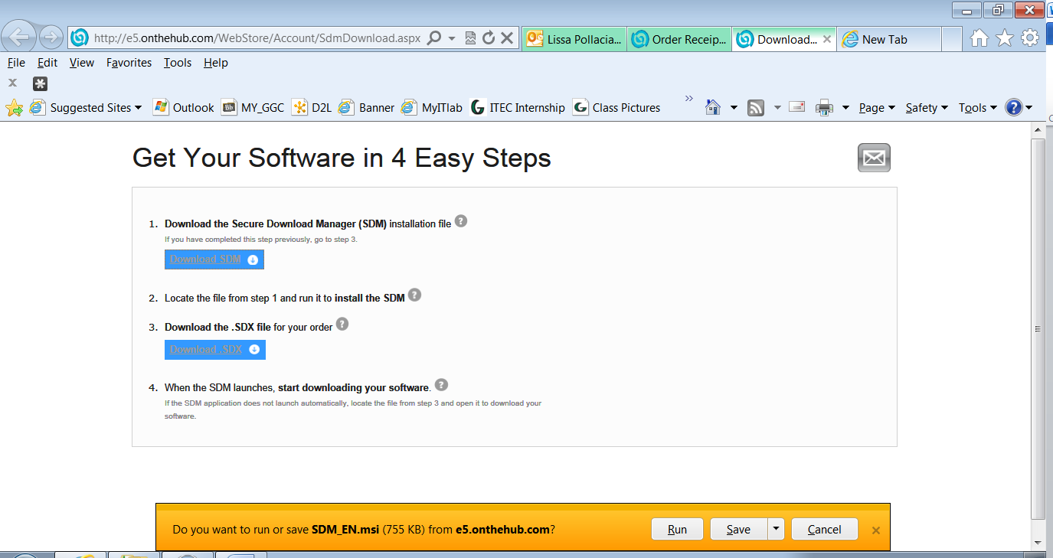

1. Run the SDM.

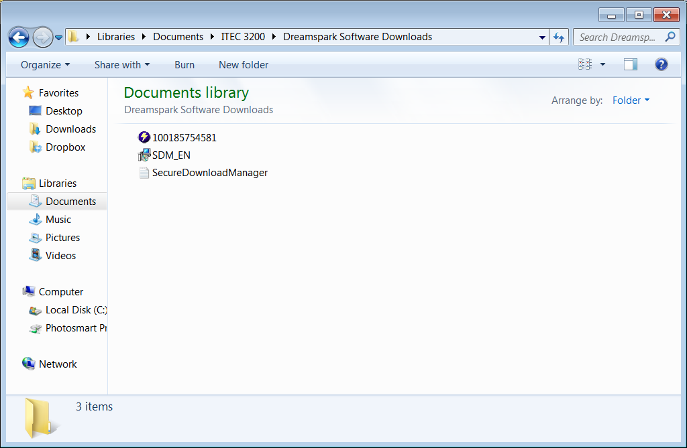 🡨 Click the file that looks like this

1. Click Start download. (do not close this page)

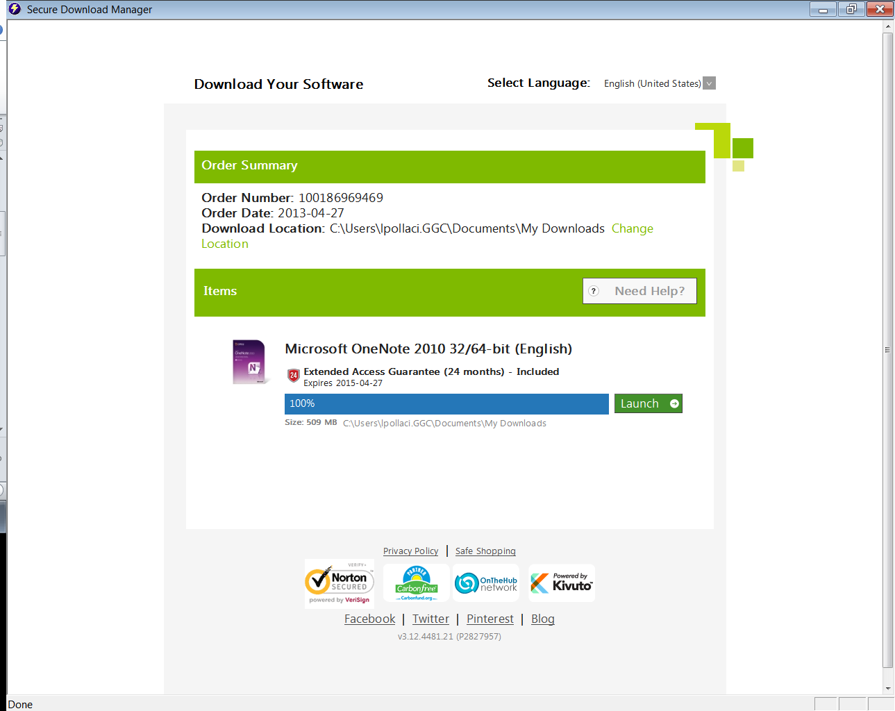

Click Launch

It will download a file that looks something like this:

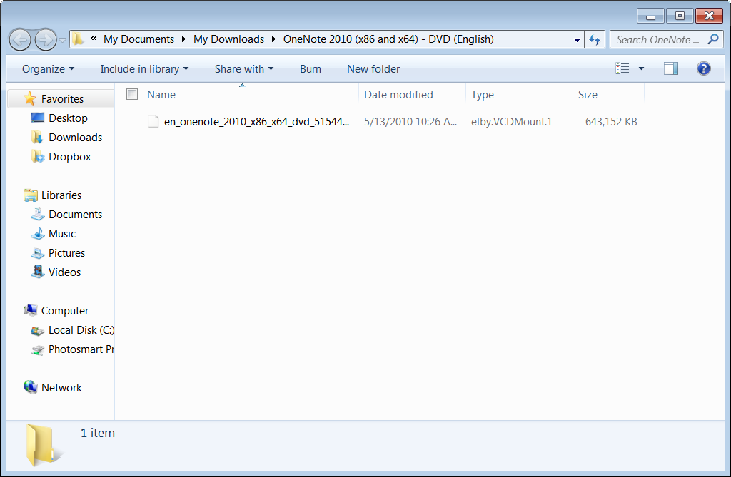

1. Run 7-zip. Locate the file shown above, and click EXTRACT. Close 7-zip.

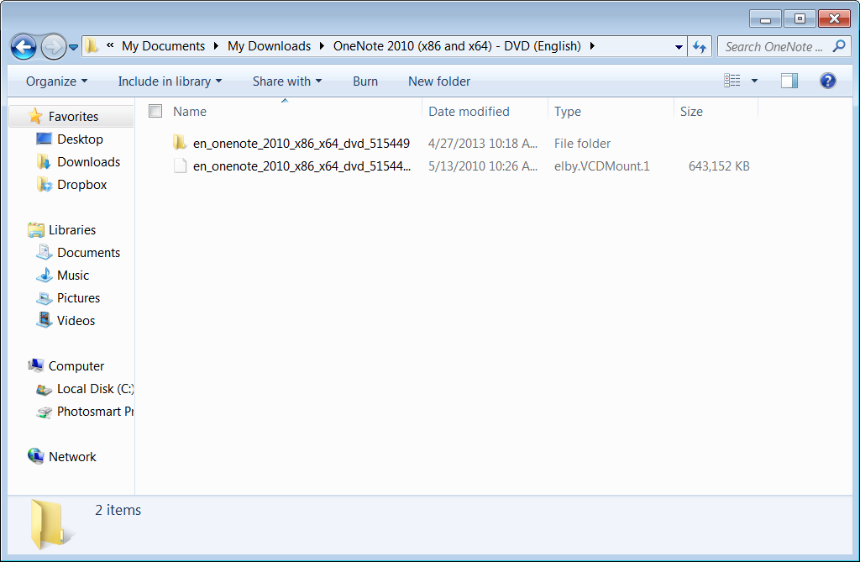

Extracted file folder

1. Go to the Extracted file folder, and run SETUP. You will have to enter your product key. You can find the product key on the Order Receipt page in DreamSpark.
2. You should see something like this window when you are through. The installed file will be in ALL PROGRAMS menu.   
     
   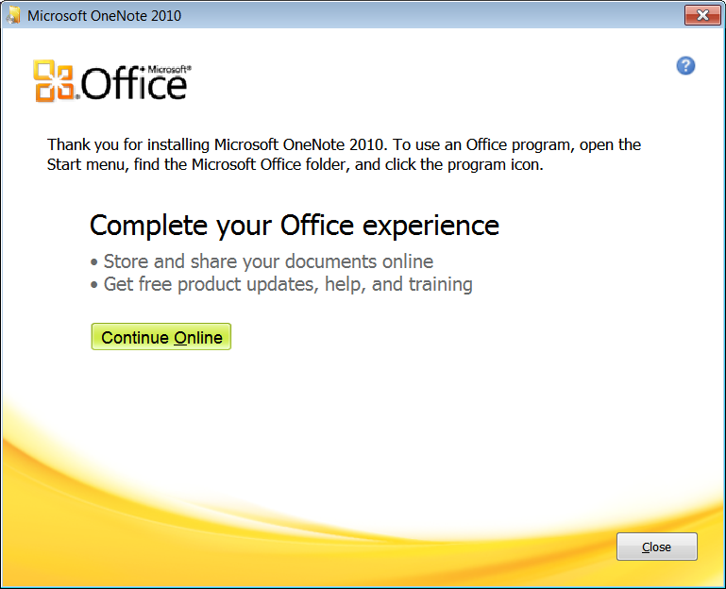
3. Logout of DreamSpark.