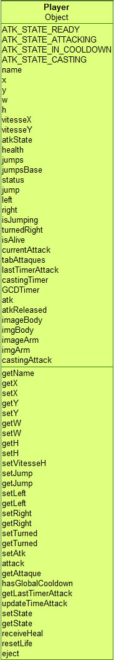C:\Users\MT3 Aurora\Desktop\zzz\buffe.jpg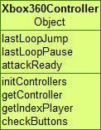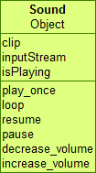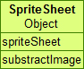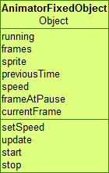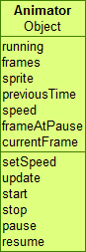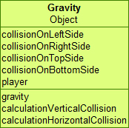C:\Users\MT3 Aurora\Desktop\zzz\level.jpg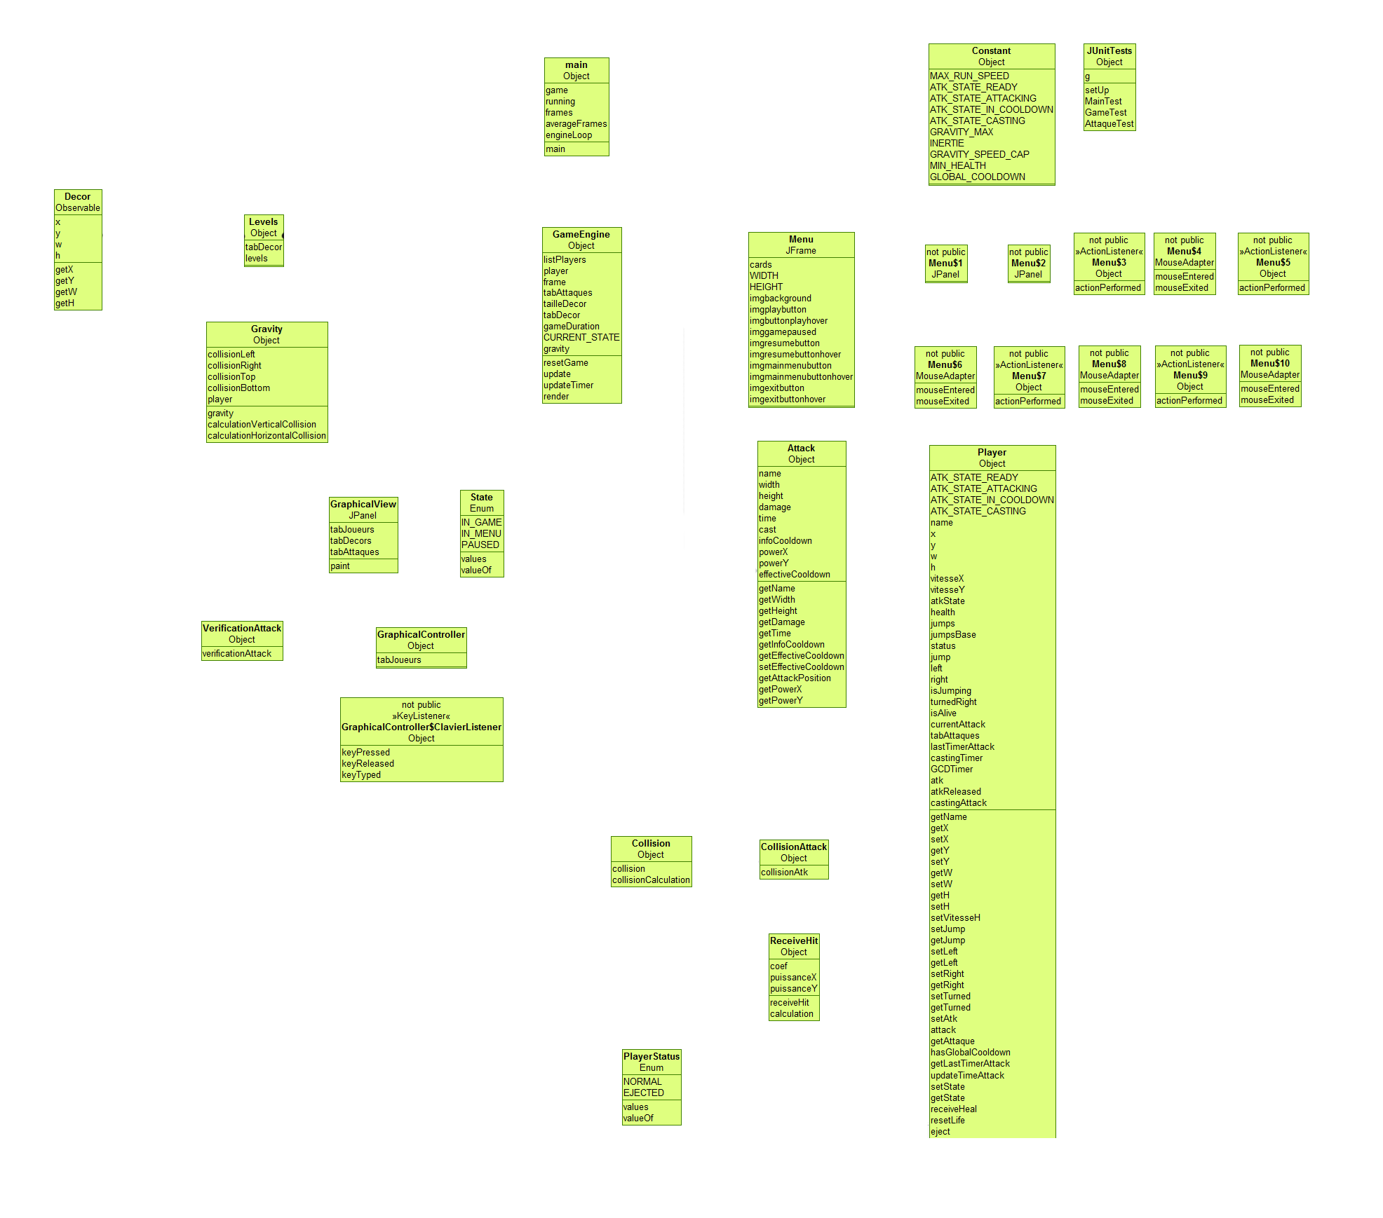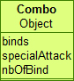C:\Users\MT3 Aurora\Desktop\zzz\ground.jpgC:\Users\MT3 Aurora\Desktop\zzz\plat.jpg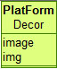D:\Java\Workspace\SuperStreetMelee\images\ground.jpgD:\Java\Workspace\SuperStreetMelee\images\levels.jpg