USB MIDI Air Drum System using IMU Sensors
Special Assignment Report

Course Code: 3EC705CC24 - Embedded System

Submitted by:
23BEC159: Jaydevsinh Rathod
23BEC200: Krish Vaghela



Departments of Electronics and Communication Engineering
Institute of Technology,
Nirma University,
Ahmedabad - 382481

March - 2026

Index
Sr No. | Topic | Page No.
1 | Abstract | 3
2 | Keywords | 3-4
3 | Literature Survey/ State of the art technology available | 4
4 | Limitations or drawbacks of currently Available technology | 5-6
5 | Proposed Solution/ Technology | 6-10
6 | Block Diagram/ Flow Chart | 11
9 | Simulation | 12
10 | Analysis of the obtained Results | 13
11 | Conclusion | 14
12 | References | 15
13 | Code in the appendix | 16-19

1. Abstract

Air drumming systems attempt to simulate the experience of playing drums without requiring a physical drum set. These systems detect hand movements and convert them into drum sounds using sensors and digital processing. In this project, a wired USB MIDI air drum system is designed and implemented using an Inertial Measurement Unit (IMU) sensor and a microcontroller.
The IMU detects acceleration and motion of the drumstick or hand. When a specific motion pattern corresponding to a drum strike is detected, the microcontroller processes the data and generates a MIDI signal through a USB interface. This MIDI signal is interpreted by a computer as a drum note, allowing the user to play virtual drum sounds using digital audio software. The system focuses on real-time response, simplicity of hardware design, and reliable motion detection. The implementation demonstrates how motion sensors and embedded systems can be used to build intuitive human-machine interfaces for musical instrument.

2. Keywords

1. Air Drums
A virtual drumming system where drum sounds are generated through hand or drumstick movements in the air instead of hitting a physical drum.

2. Inertial Measurement Unit (IMU)
A sensor module containing accelerometers and gyroscopes used to detect motion, orientation, and acceleration of the drumstick.

3. Motion Detection
The process of identifying sudden movement or acceleration patterns from sensor data to recognize a drum strike.

4. MIDI (Musical Instrument Digital Interface)
A standard communication protocol used to send musical commands such as note signals between electronic instruments and computers.

5. USB MIDI Communication
A method of transmitting MIDI signals through a wired USB connection between the microcontroller and a computer for real-time sound triggering.

6. Digital Audio Workstation (DAW)
Software used for music production that receives MIDI signals and generates corresponding drum sounds using virtual instruments.

3. Literature Survey

Project /  Reference | Sensors Used | Detection  Method | Sound  Generation  Method | Key Features
NishanthBhonsle  – Air Drums  (GitHub) | Accelerometer /  IMU | Detects acceleration spikes when the drumstick is moved in air | MIDI signals trigger drum sounds in software | Simple gesture detection system using sensor thresholds to  identify drum hits
Tamzidoronno – AirDrums  (GitHub) | Accelerometer sensors | Motion detection using acceleration data from drumsticks | Generates specific drum kit sounds when movement is detected | Designed to trigger different drum sounds depending on motion direction
Ultrasonic Air  Drums  (Instructables) | Ultrasonic distance sensor | Detects change  in distance between drumstick and sensor | Plays drum sounds using software or audio modules | Uses distance measurement instead of motion sensing
TeheiRobert –  Arduino Air  Drum (GitHub) | ADXL345  Accelerometer | Detects acceleration peaks through I²C sensor readings | Sends drum commands to computer software | Uses multiple accelerometer sensors for improved motion detection

4. Limitations or Drawbacks of Currently Available

Technology
Although several air drum systems have been developed using motion sensors and embedded platforms, existing implementations still face several limitations that affect their performance and usability.

1. Limited Motion Accuracy
Many existing systems rely only on accelerometer sensors to detect drumstick motion. Accelerometers measure linear acceleration but cannot accurately detect rotational motion, which may lead to incorrect gesture interpretation and false drum triggers.

2. False Triggering of Drum Sounds
Air drumming systems often use simple threshold-based detection algorithms. If the threshold values are not properly tuned, normal hand movements or vibrations may trigger unwanted drum sounds.

3. Latency in Sound Generation
Some implementations use wireless communication such as Bluetooth or Wi-Fi, which can introduce latency between the motion detection and sound generation. This delay can affect the real-time playing experience.

4. Limited Gesture Recognition
Several low-cost air drum projects detect only basic drumming motions, which limits the ability to differentiate between different drum types such as snare, hi-hat, or kick.

5. Hardware Complexity in Some Systems
Certain air drum systems require multiple sensors, cameras, or external tracking systems, increasing system complexity and making the setup difficult to implement.

6. Dependence on External Software
Most air drum systems depend on external software or computer applications to generate drum sounds. Without proper integration with music software, the system cannot function effectively.

7. Calibration Requirements
Motion-based systems often require initial calibration of sensor values and motion thresholds, and incorrect calibration can reduce detection accuracy.

5. Proposed Solution/Methodology
To address the limitations of existing air drum systems, a wired MIDI-based air drum system is implemented using the Seeed Studio XIAO Sense microcontroller board. The system detects drumming gestures using the LSM6DS3 Inertial Measurement Unit (IMU) integrated on the board and converts these gestures into MIDI note signals that trigger drum sounds in a Digital Audio Workstation (DAW).
Unlike traditional systems that rely only on accelerometers, the proposed system utilizes both accelerometer and gyroscope data to improve gesture detection and enable multiple drum sounds using a single device.

Hardware Components
The proposed system consists of the following components:

1. Seeed Studio XIAO Sense Board
The Seeed Studio XIAO Sense acts as the main processing unit. It reads motion data from the onboard IMU sensor and processes the data using an embedded program written in the Arduino environment.
2. LSM6DS3 IMU Sensor
The XIAO Sense board contains the LSM6DS3 IMU, which includes:

• 3-axis accelerometer

• 3-axis gyroscope
The accelerometer detects the strength of the drum hit, while the gyroscope is used to determine the orientation of the drumstick.

3. MIDI Communication Interface
MIDI messages are transmitted through the UART interface (Serial1) at 31250 baud, which is the standard communication speed for MIDI devices.

4. Digital Audio Workstation (DAW)
A DAW running on a computer(WAVEFORM FREE 13) receives the MIDI signals and generates the corresponding drum sounds using virtual drum instruments.

Working Methodology
The system continuously reads sensor data from the IMU and processes it to detect drumming gestures.

1. Sensor Initialization and Calibration
At system startup, the IMU sensor is initialized and the gyroscope is calibrated to determine the bias of the Z-axis angular velocity. This calibration improves orientation accuracy by compensating for sensor drift.

2. Motion Detection
The accelerometer Z-axis value is continuously monitored. A drum hit is detected when the acceleration magnitude exceeds a predefined hit threshold value.
∣ 𝑎_{𝑧} ∣> 2.5

This indicates a sudden movement corresponding to a drumming action.

3. Orientation Estimation
The gyroscope Z-axis value is integrated over time to estimate the yaw angle, which represents the orientation of the drumstick.
𝑌𝑎𝑤 = 𝑌𝑎𝑤 + (𝐺_{𝑧} − 𝐵𝑖𝑎𝑠) × 𝑑𝑡

The yaw value is constrained within −90° to +90° to maintain stability.

4. Drum Type Selection
Different drum sounds are selected based on the yaw orientation of the drumstick.
Yaw Angle Range | Drum Sound | MIDI Note
yaw < -54° | Kick Drum | 36
-54° to -18° | Snare Drum | 38
-18° to 18° | Hi-Hat | 42
18° to 54° | Tom | 45
yaw > 54° | Crash Cymbal | 49
This allows the user to play multiple drum instruments using a single motion sensor by simply changing the orientation of the hand.

5. Velocity Calculation
The intensity of the drum hit is calculated using the magnitude of the acceleration.
𝑉𝑒𝑙𝑜𝑐𝑖𝑡𝑦 =∣ 𝑎_{𝑧} ∣× 40

The velocity value is constrained between 40 and 127, which is the valid MIDI velocity range.
This allows the drum sound to respond dynamically to the strength of the hit.

6. Kalman Filter for Sensor Fusion
To further improve motion estimation, a Kalman Filter is implemented to combine data from the accelerometer and gyroscope. The Kalman filter provides an optimal estimate of the system state by reducing noise and correcting drift in the sensor measurements.
The filter works by performing two main steps:

Prediction Step
The system predicts the current orientation using gyroscope data.
𝑥̂𝑘− = 𝐴𝑥̂𝑘−1 + 𝐵𝑢𝑘

Update Step
The predicted state is corrected using accelerometer measurements.
𝑥̂_{𝑘} = 𝑥̂_{𝑘}⁻ + 𝐾(𝑧_{𝑘} − 𝐻𝑥̂_{𝑘}⁻)

where
- 𝐾= Kalman gain
- 𝑧_{𝑘}= measurement from accelerometer
- 𝑥̂_{𝑘}= updated state estimate
By combining the strengths of both sensors, the Kalman filter provides more stable orientation estimation, improving drum detection accuracy.

Benefits of Using Kalman Filter
- Reduces sensor noise
- Compensates for gyroscope drift
- Improves stability of orientation estimation
- Enhances gesture detection accuracy

6. Debounce Filtering
To prevent multiple triggers from a single motion, a debounce time of 150 ms is applied. This ensures that consecutive hits are properly separated and eliminates false triggers caused by sensor noise.

7. MIDI Message Transmission
Once the drum type and velocity are determined, the system sends MIDI messages using the UART interface:
- Note On message to trigger the drum sound
- Note Off message to stop the sound
The MIDI signal is received by the Digital Audio Workstation (DAW), which produces the corresponding drum sound.
Advantages of the Proposed System
The proposed system offers several advantages:
- Multiple drum sounds using a single sensor
• Orientation-based drum selection
• Velocity-sensitive drum hits
• Low latency due to wired MIDI communication
• Compact and portable design using XIAO Sense

6. Block Diagram
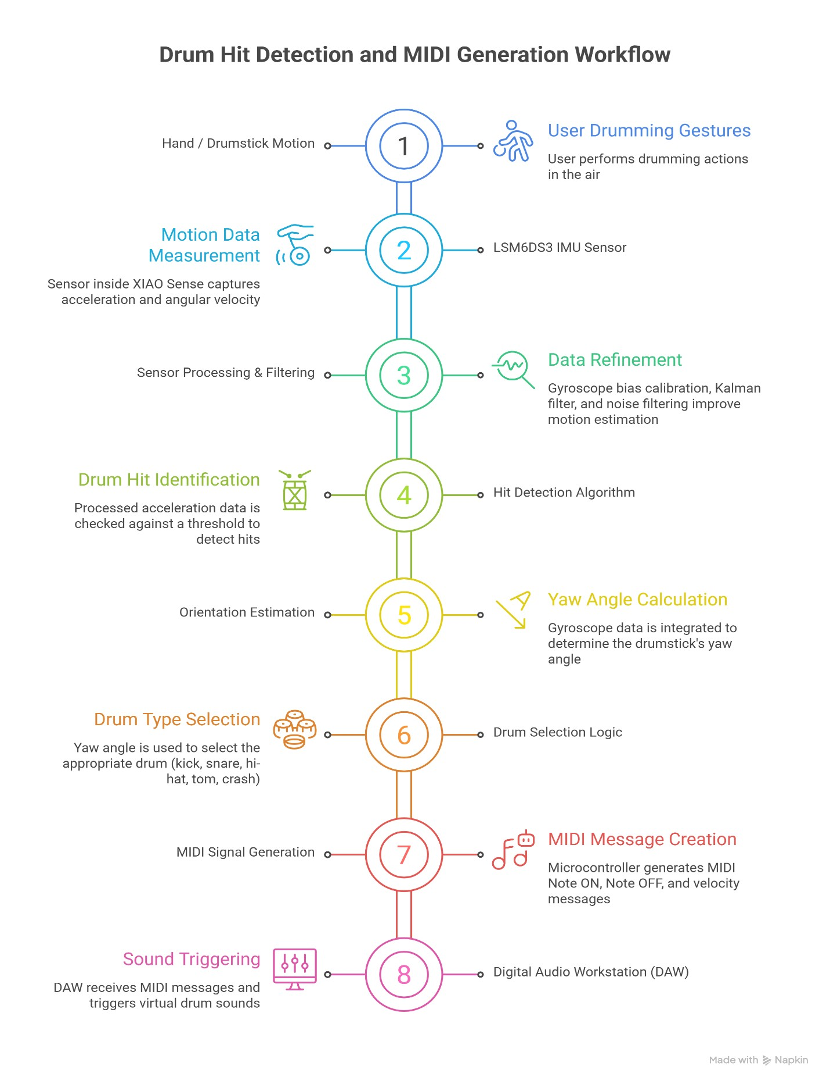

7. Flow Chart of the Code

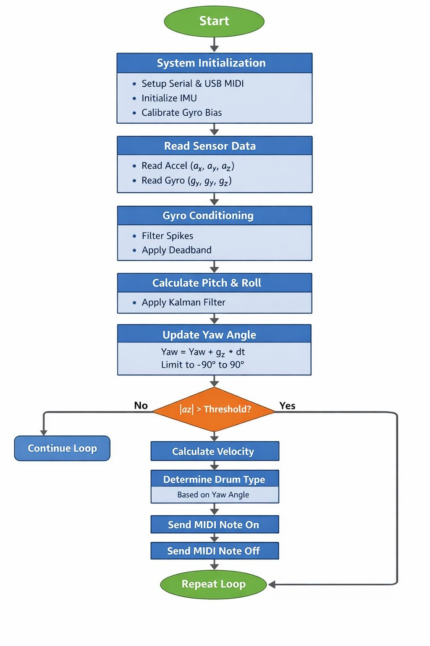
8. Results in terms of Simulation and Hardware implementation.
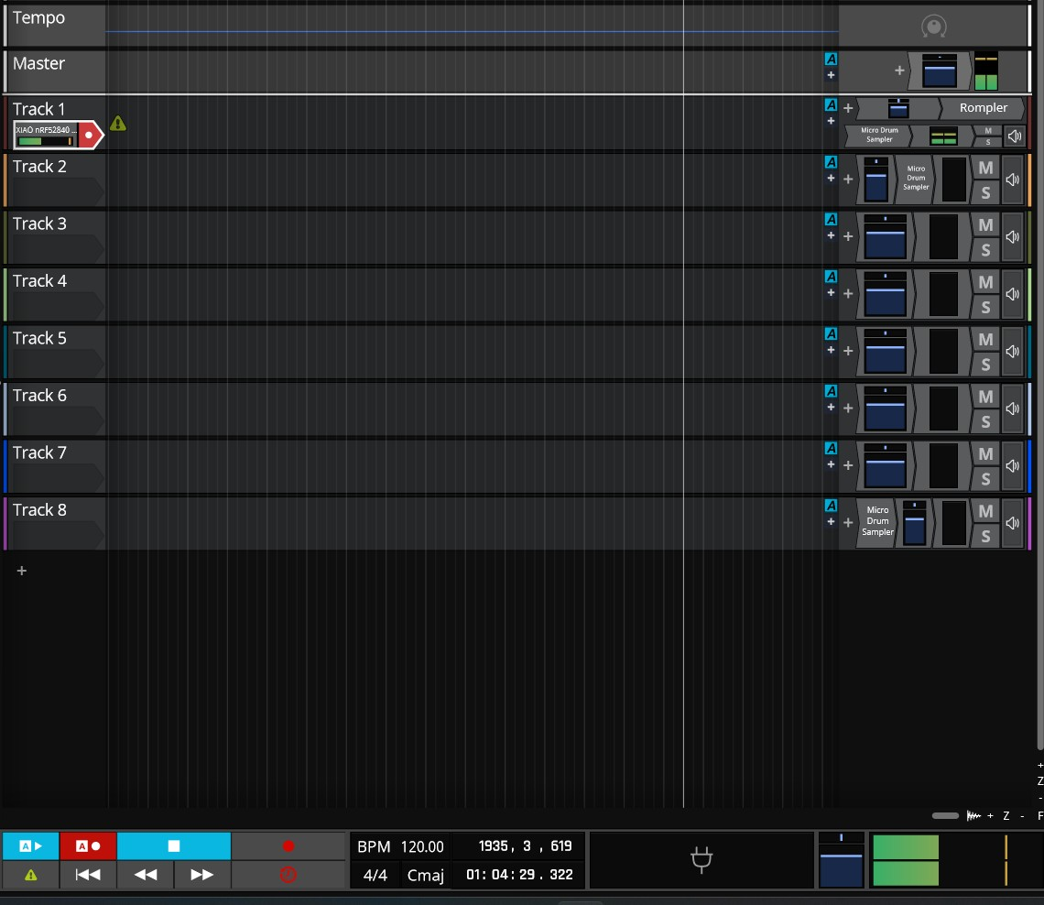

9. Conclusion

This project successfully demonstrates the design and implementation of a gesture-based air drum system using the Seeed Studio XIAO Sense board and the LSM6DS3 IMU sensor. The system detects hand movements in the air and converts them into MIDI drum signals, allowing users to play virtual drum instruments without a physical drum kit.
The accelerometer and gyroscope data from the IMU are processed using filtering techniques and a Kalman filter to improve motion stability and orientation estimation. The system uses Zaxis acceleration to detect drum hits and yaw orientation to determine the drum type, enabling multiple drum instruments to be controlled using a single device. Additionally, the velocity of the drum sound is determined from the magnitude of the acceleration, allowing dynamic and expressive interaction.
The generated MIDI signals are transmitted through USB MIDI communication and interpreted by a Digital Audio Workstation (DAW) to produce corresponding drum sounds in real time. The implementation also includes debounce filtering, spike filtering, and bias correction to improve reliability and reduce false triggers.
Experimental testing confirmed that the system accurately detects drum gestures and correctly maps orientation angles to different drum sounds such as kick, snare, hi-hat, tom, and crash. The results demonstrate that the proposed system provides low-latency response, reliable motion detection, and intuitive user interaction.
Overall, the project illustrates how IMU-based motion sensing, embedded processing, and MIDI communication can be combined to create an innovative and cost-effective digital musical interface. Future improvements may include wireless communication, additional gesture recognition, and machine learning-based motion classification to further enhance the performance and usability of the air drum system.

References
- N. Bhonsle, “Air Drums – A Handy Virtual Drum Kit,” GitHub Repository. Available:
https://github.com/NishanthBhonsle/air-drums
- T. Doronno, “Arduino Air Drums Using Accelerometer Sensors,” GitHub Repository. Available: https://github.com/tamzidoronno/airdrums
- T. Robert, “Arduino Air Drum Using ADXL345 Sensors,” GitHub Repository. Available: https://github.com/TeheiRobert/Arduino-Air-Drum
- “Ultrasonic Air Drums Project,” Instructables. Available: https://www.instructables.com/Ultrasonic-Air-Drums
- Seeed Studio, “Seeed Studio XIAO Sense Documentation,” Available: https://wiki.seeedstudio.com/XIAO-Sense
- STMicroelectronics, “LSM6DS3: 3-Axis Accelerometer and 3-Axis Gyroscope Datasheet.”
- MIDI Manufacturers Association, “MIDI 1.0 Detailed Specification,” Available:
https://www.midi.org
- Adafruit Industries, “Adafruit TinyUSB Library Documentation,” Available: https://github.com/adafruit/Adafruit_TinyUSB_Arduino
- Arduino, “Arduino MIDI Library Documentation,” Available: https://github.com/FortySevenEffects/arduino_midi_library
- “Air Drums using IMU Sensors,” YouTube demonstration video. Available:

CODE
#include <LSM6DS3.h>
#include <Wire.h>
#include <Adafruit_TinyUSB.h>
#include <MIDI.h>

// ---------------- IMU & USB MIDI ----------------
LSM6DS3 imu(I2C_MODE, 0x6A);
Adafruit_USBD_MIDI usb_midi;
MIDI_CREATE_INSTANCE(Adafruit_USBD_MIDI, usb_midi, MIDI);

// ---------------- Filter & Tracking ---------------- unsigned long lastTime = 0; float pitch = 0, roll = 0, yaw = 0; float pitchBias = 0, rollBias = 0, yawBias = 0;

float Q_angle = 0.001, Q_bias = 0.003, R_measure = 0.03; float pitchP[2][2] = {{0,0},{0,0}}, rollP[2][2] = {{0,0},{0,0}};

// ---------------- Yaw Stability Parameters ---------------- float gyroDeadband = 0.05; float gyroSpikeLimit = 250.0; float biasCorrectionGain = 0.01;

// Acc magnitude stable window float accStableMin = 0.95; float accStableMax = 1.05;

// ---------------- Drum Settings ---------------- float hitThreshold = 2.5; unsigned long lastHitTime = 0; int debounceTime = 150;

#define KICK 36
#define SNARE 38
#define HIHAT 42
#define TOM 45
#define CRASH 49

// ============================================================
// KALMAN FILTER
// ============================================================
float kalmanUpdate(float newAngle, float newRate, float dt, float &angle, float &bias, float P[2][2])
{ float rate = newRate - bias; angle += dt * rate;

P[0][0] += dt * (dt*P[1][1] - P[0][1] - P[1][0] + Q_angle);
P[0][1] -= dt * P[1][1];
P[1][0] -= dt * P[1][1];
P[1][1] += Q_bias * dt;

float S = P[0][0] + R_measure; float K[2] = { P[0][0] / S, P[1][0] / S };

float y = newAngle - angle; angle += K[0] * y; bias += K[1] * y;

float P00_temp = P[0][0]; float P01_temp = P[0][1];

P[0][0] -= K[0] * P00_temp;
P[0][1] -= K[0] * P01_temp;
P[1][0] -= K[1] * P00_temp;
P[1][1] -= K[1] * P01_temp;

return angle;
}

// ============================================================
// SETUP
// ============================================================ void setup()
{
Serial.begin(115200);

MIDI.begin(MIDI_CHANNEL_OMNI);

while (!TinyUSBDevice.mounted()) delay(1);

if (imu.begin() != 0) {
Serial.println("IMU Error"); while (1);
}

// Initial gyro bias calibration for(int i=0; i<500; i++){ yawBias += imu.readFloatGyroZ(); delay(5);
}
yawBias /= 500.0;

Serial.println("System Ready!"); lastTime = millis();
}

// ============================================================
// LOOP
// ============================================================ void loop() { float ax = imu.readFloatAccelX(); float ay = imu.readFloatAccelY(); float az = imu.readFloatAccelZ();

float gx = imu.readFloatGyroX(); float gy = imu.readFloatGyroY(); float gzRaw = imu.readFloatGyroZ();

unsigned long now = millis(); float dt = (now - lastTime) / 1000.0; if (dt <= 0) dt = 0.001; lastTime = now;

// ---------- Gyro Conditioning ---------- if (abs(gzRaw) > gyroSpikeLimit) gzRaw = 0;

float gz = gzRaw - yawBias;

if (abs(gz) < gyroDeadband) gz = 0;

// ---------- Acceleration Magnitude ---------- float accelMag = sqrt(ax*ax + ay*ay + az*az); // Bias correction only when stable if (accelMag > accStableMin && accelMag < accStableMax)
{
yawBias += biasCorrectionGain * gz;
}

// ---------- Kalman Pitch/Roll ---------- float accPitch = atan2(ay, az) * 180 / PI; float accRoll = atan2(-ax, sqrt(ay*ay + az*az)) * 180 / PI;

pitch = kalmanUpdate(accPitch, gx, dt, pitch, pitchBias, pitchP); roll = kalmanUpdate(accRoll, gy, dt, roll, rollBias, rollP);

// ---------- Yaw Integration ---------- yaw += gz * dt; yaw = constrain(yaw, -90, 90);

// ---------- Hit Detection ---------- if (abs(az) > hitThreshold && millis() - lastHitTime > debounceTime)
{ lastHitTime = millis();

byte velocity = constrain(abs(az) * 40, 40, 127); int note = HIHAT;

if (yaw < -54) note = KICK; else if (yaw < -18) note = SNARE; else if (yaw < 18) note = HIHAT; else if (yaw < 54) note = TOM; else note = CRASH;

MIDI.sendNoteOn(note, velocity, 1); delay(5);
MIDI.sendNoteOff(note, 0, 1);

Serial.print("HIT | Note: ");
Serial.print(note);
Serial.print(" | Yaw: ");
Serial.println(yaw);
}
}

