# Binary Search Trees (BST) Assignment

1. Draw all possible BSTs for the data elements 5, 9, and 12.

5

9

12

9

5 12

12

5

9

1. Assume that data are inserted into a **binary search tree** in the order: D B A C F E G.  
   Which of the following is the resulting tree:

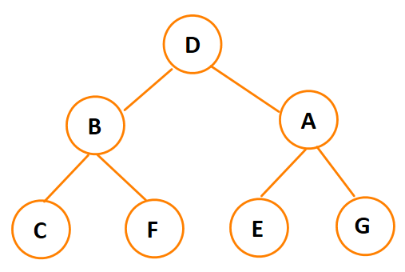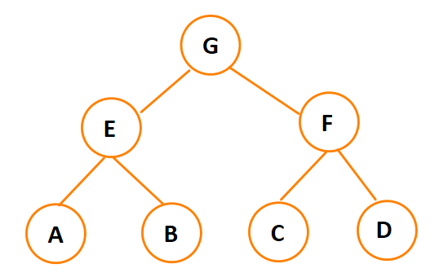

a) b)

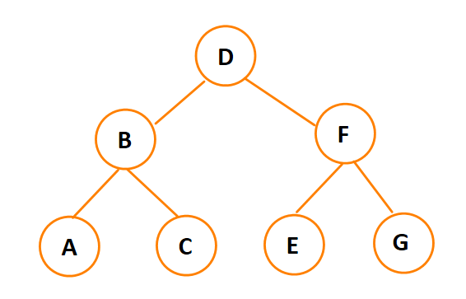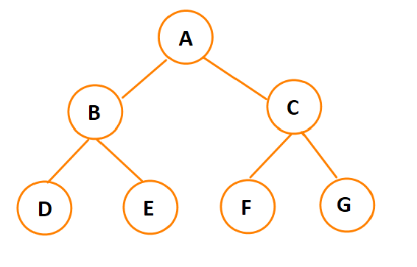

c) d)

**Answer: D**

1. Draw a BST using the following data, entered in this order: 14, 23, 7, 10, 33, 56, 80, 66, 70
2. Insert 44 and 50 into the tree created in exercise 3.

14

7 23

10 33

56

44

50 80

66

70

1. Draw a BST using the following data, entered in this order: 7, 10, 14, 23, 33, 56, 66, 70, 80

7

10

14

23

33

56

66

70

80

1. Insert 44 and 50 into the tree created in exercise 5.

7

10

14

23

33

44

50

56  
 66

70  
 80

1. Consider the following binary search tree. An *inorder traversal* of this BST will return the data in the following order: 1, 3, 4, 9, 15, 24. List the order returned by a *preorder traversal* of the above BST.

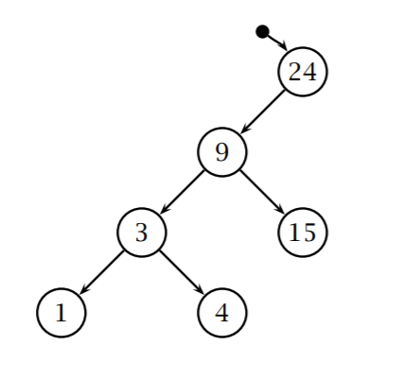

**Answer: 24, 9, 3, 1, 4, 15**

1. Insert the following data values to the above BST: 6, 45, 32, 98, 55, and 69, in this order. Draw the resulting BST.

24

9 45

3 32 98

1 4 55

69

1. Next, delete 9 and 45 from the BST you drew in question 8. Draw the resulting BST.

24

3 32

1 4 98

6 55

69

1. List the order returned by an *inorder traversal* of the BST you drew in question 9.

1, 3, 4, 6, 24, 32, 55, 69, 98