**M2-HW1**

Customer(custId, firstName, lastName, street, city, state, zip, creditLimit, areaCode,number)



Order(orderNo, date, totalAmount, tax, deliverStreet, deliverCity, deliverState, deliverZip,

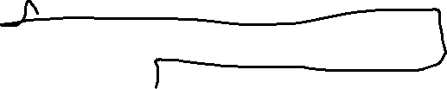

deliverAreaCode, deliverNumber, *custId*)



Contains(*orderNo, ItemNo*, Quantity)



Item(itemNo, itemName, unitPrice, qtyOnHand, reorderPoint)



Supplies(*supplierNo, itemNo*,unitCost)



Supplier(supplierNo, supName, countryCode, areaCode , number, street, city, state, zipPostalCode, Country, contactName)