Member(memID, dateJoined, firstName, lastName, street, *zip*, areaCode, phoneNumber, currentOfficeHeld)



Zip(zip, city, state)

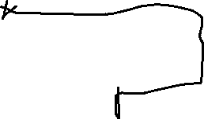

Play(title, author, numberOfActs, setChanges)



Sponsor(sponID, name, street, *zip*, areaCode, phoneNumber)



Subscriber(subID, firstName, lastName, street, *zip*, areaCode, phoneNumber)



Production(year, seasonStartDate, seasonEndDate, *title)*

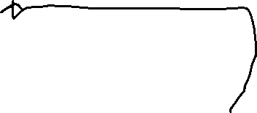

Performance(date, year, time, seasonSta*rtDate*)



TicketSale(saleID, saleDate, totalAmount, *perfDate, perfYear*, *subID*)



DuesPayment(*memberID*, duesYear, amount, datePaid)



Donation(*sponsorID*, donationDate, donationType, donationValue, *year, seasonStartDate*)



Ticket(*saleID*, seatLocation, price, type)



Member-Production(*memberID, year, seasonStartDate*, role, task)