**OUTPUT**

**1.a) Print odd numbers in an array**

**Anonymous function**

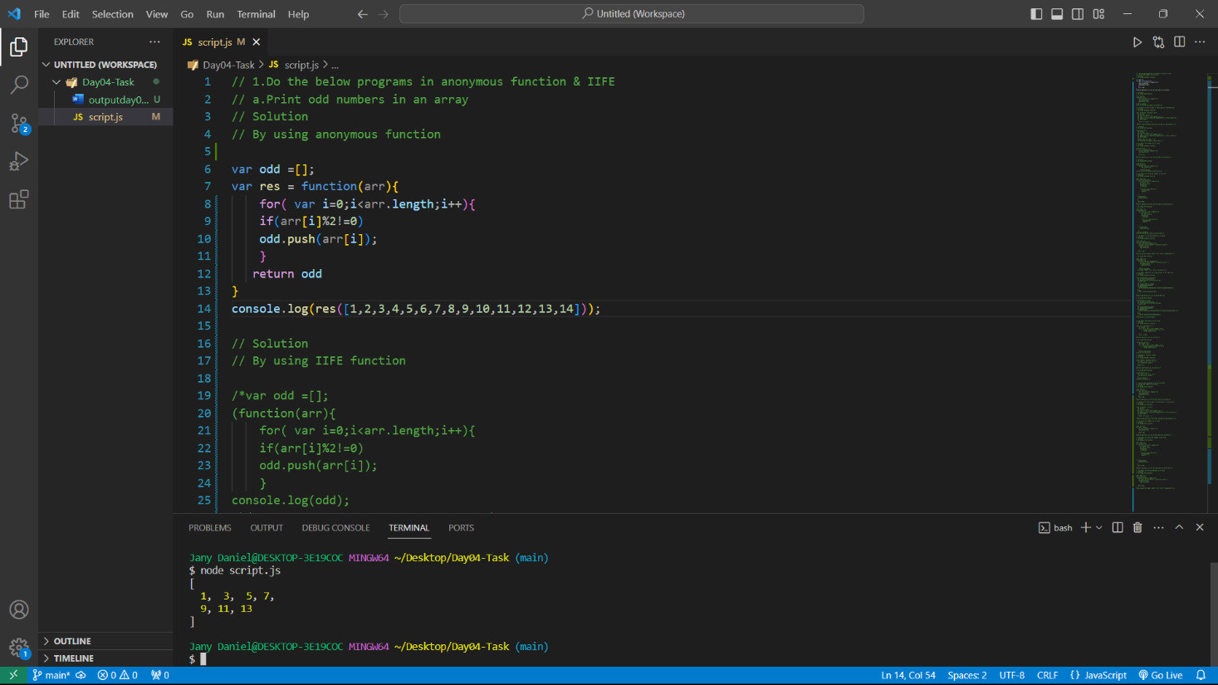

**IIFE function**

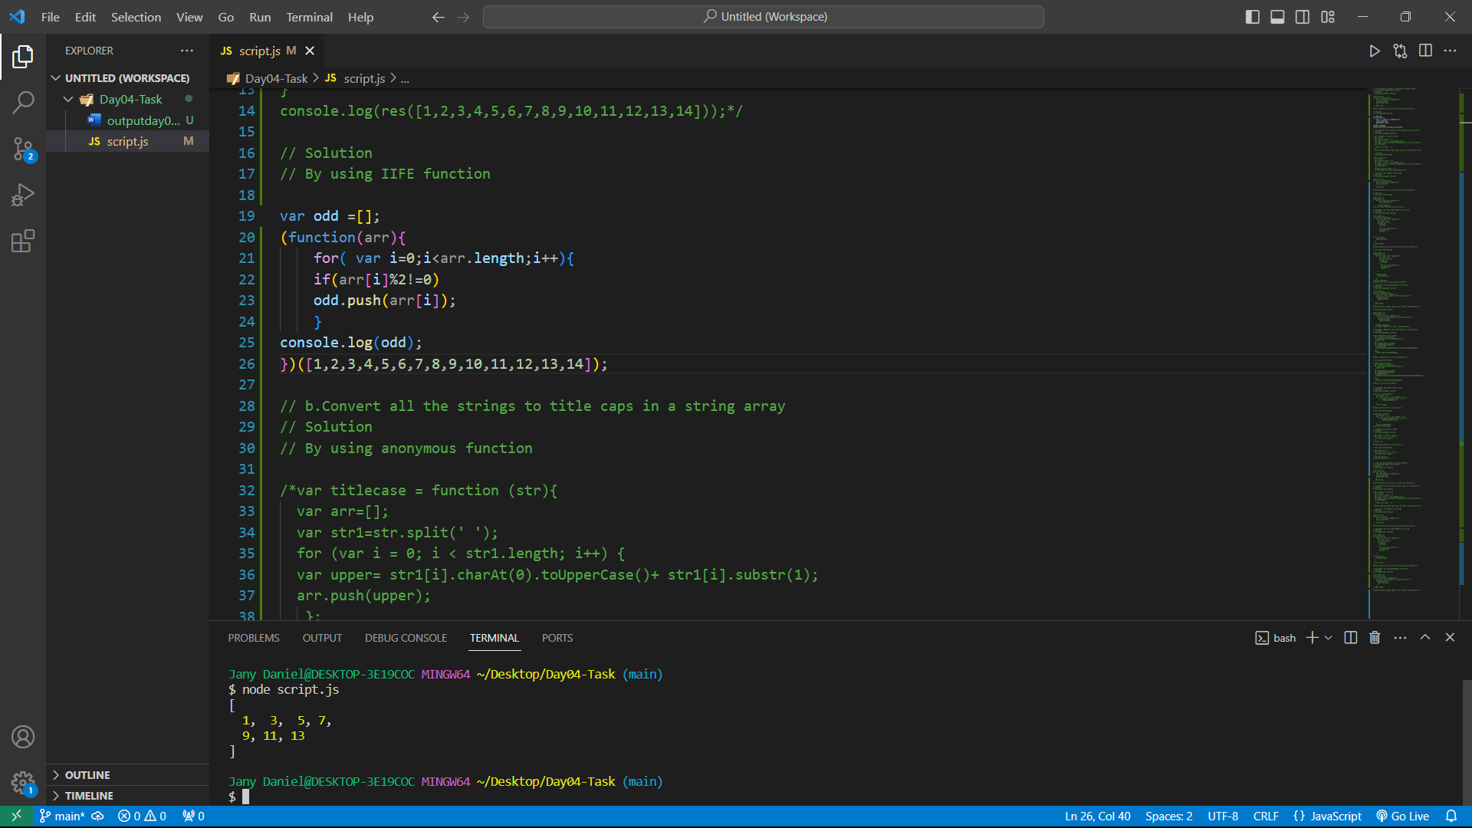

**1.b) Convert all the strings to title caps in a string array**

**Anonymous function**

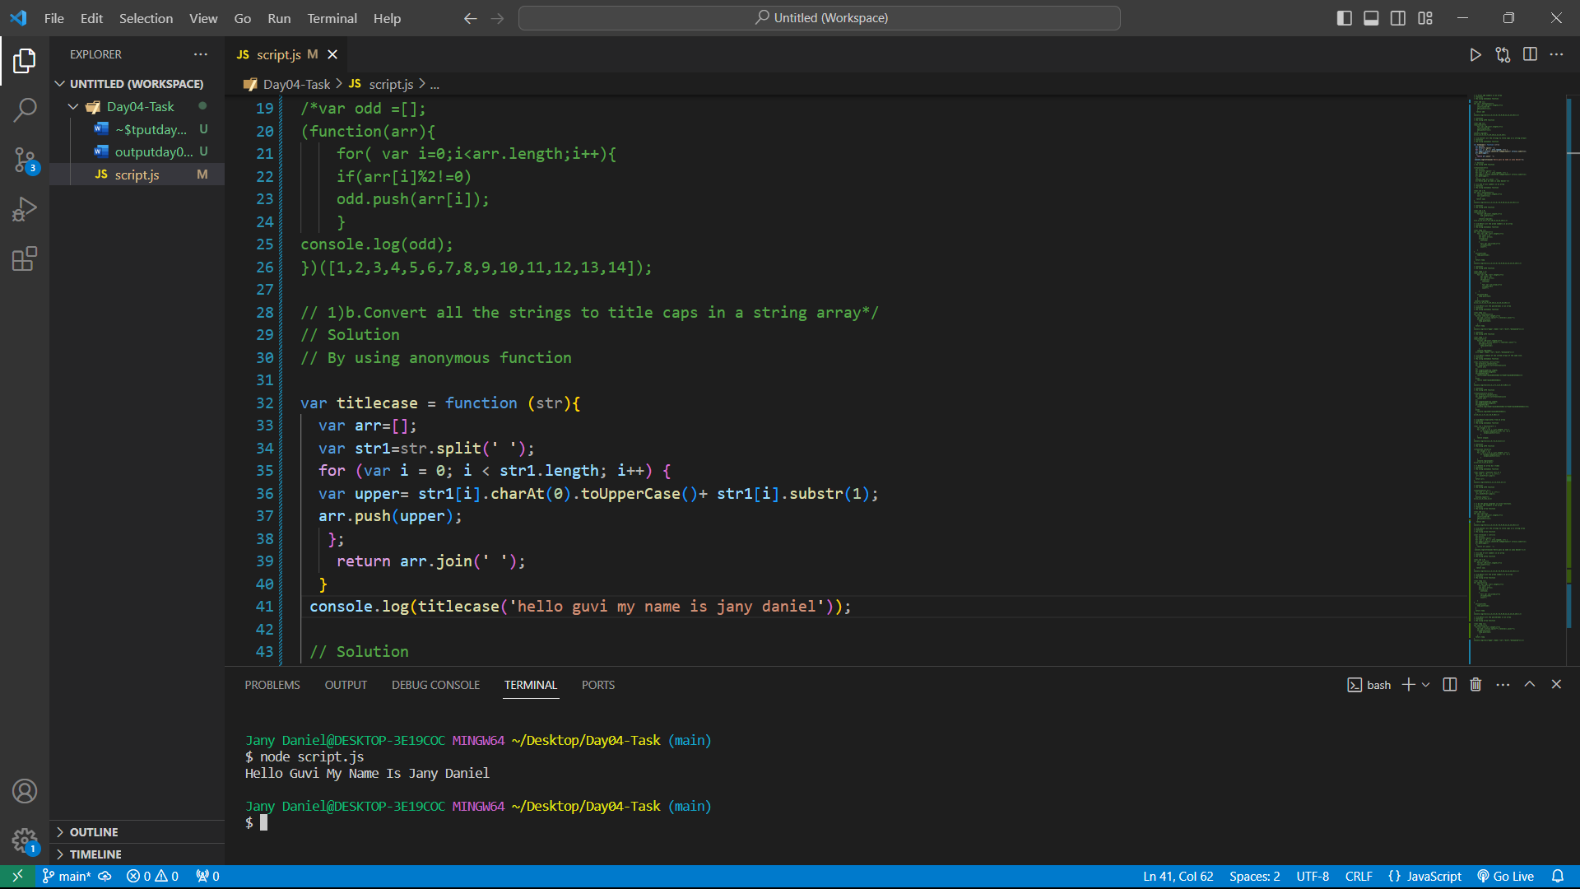

**IIFE function**

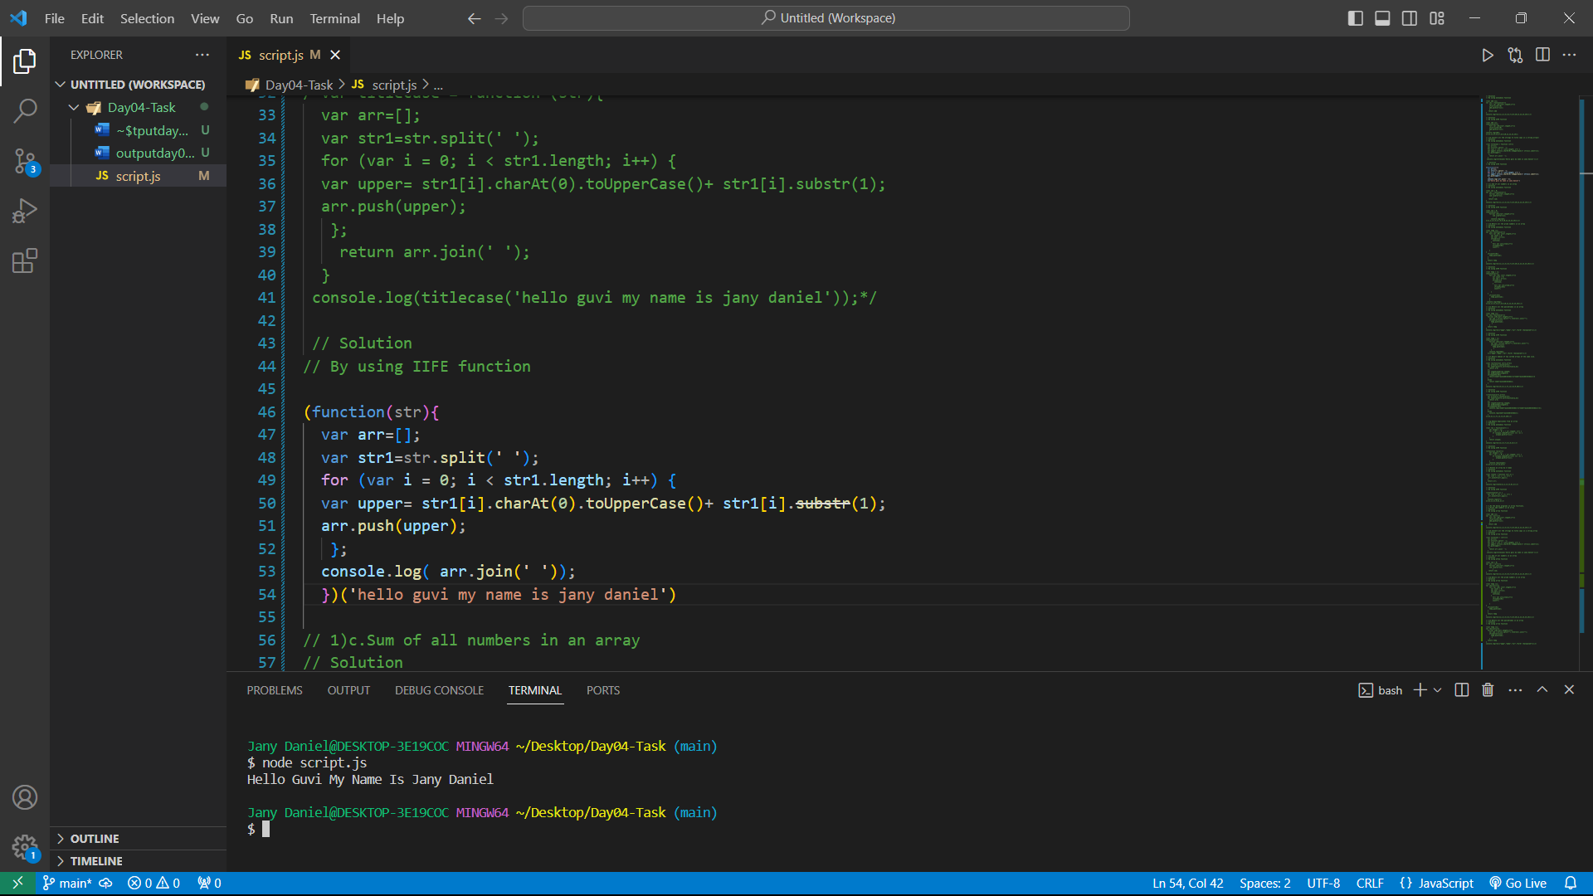

**1.c) Sum of all numbers in an array**

**Anonymous function**

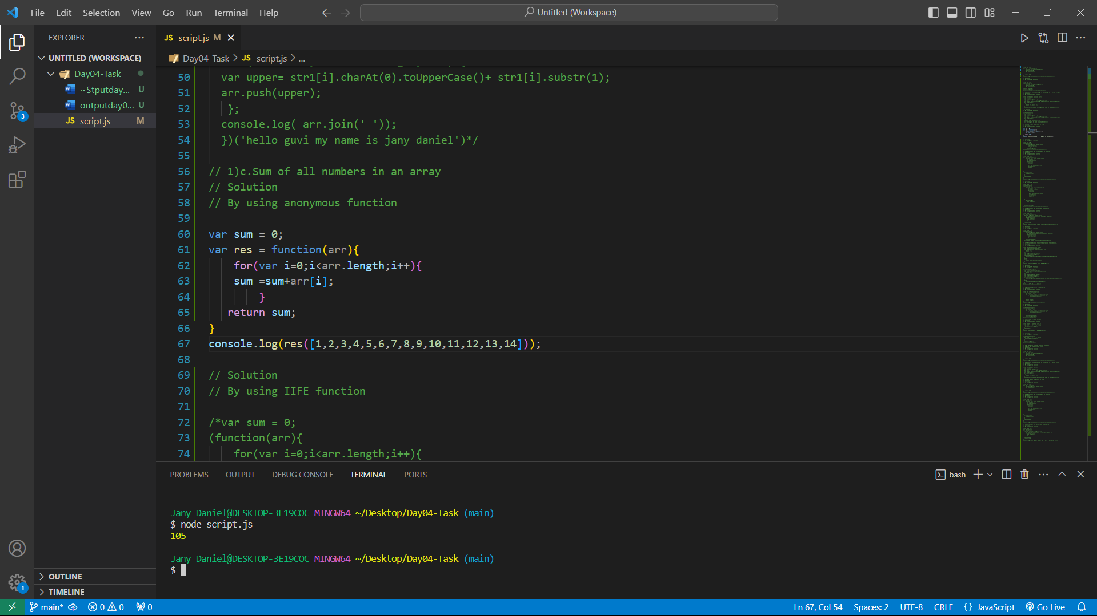

**IIFE function**

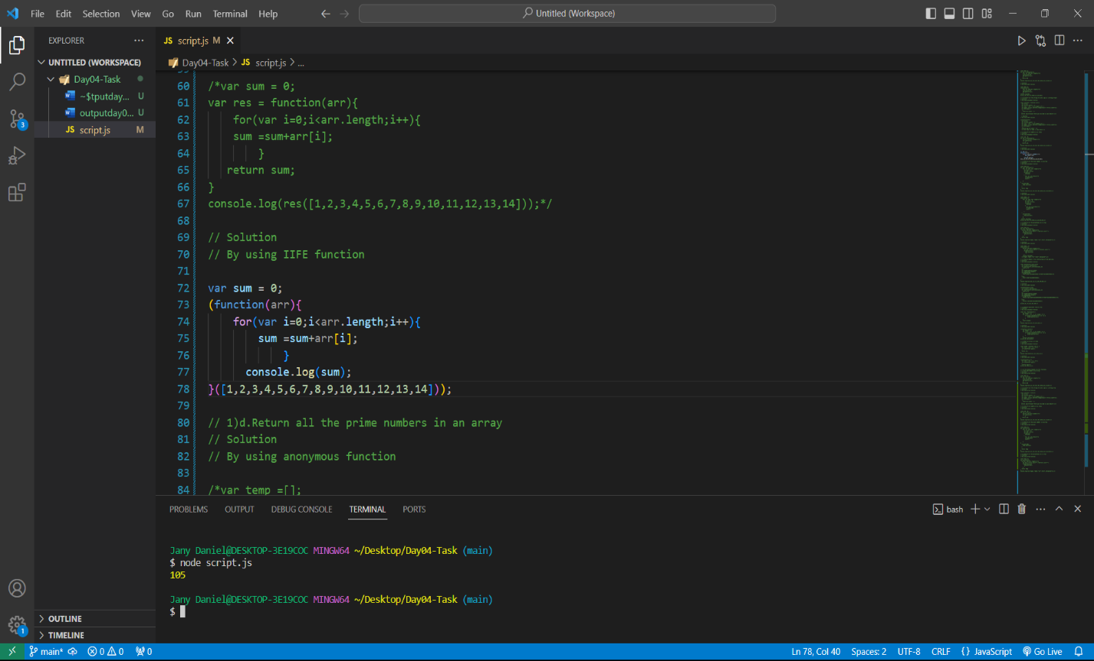

**1.d) Return all the prime numbers in an array**

**Anonymous function**

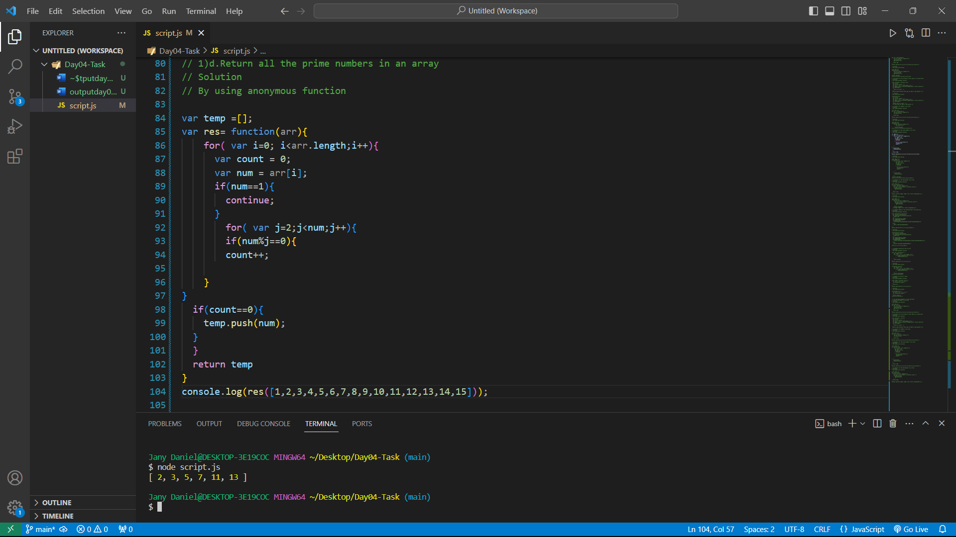

**IIFE function**

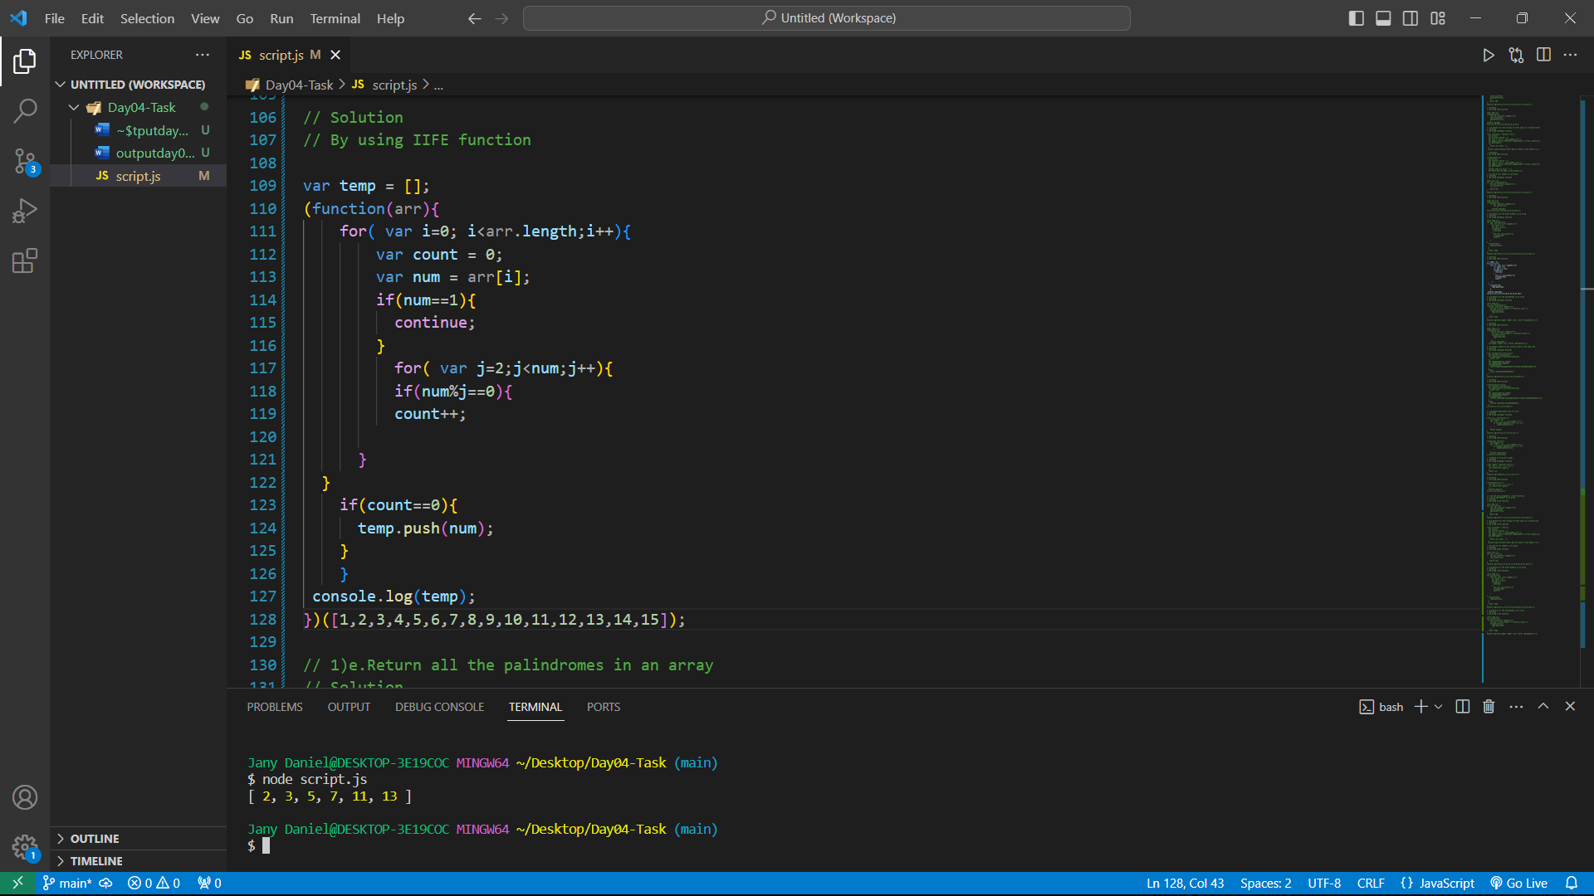

**1.e) Return all the palindromes in an array**

**Anonymous function**

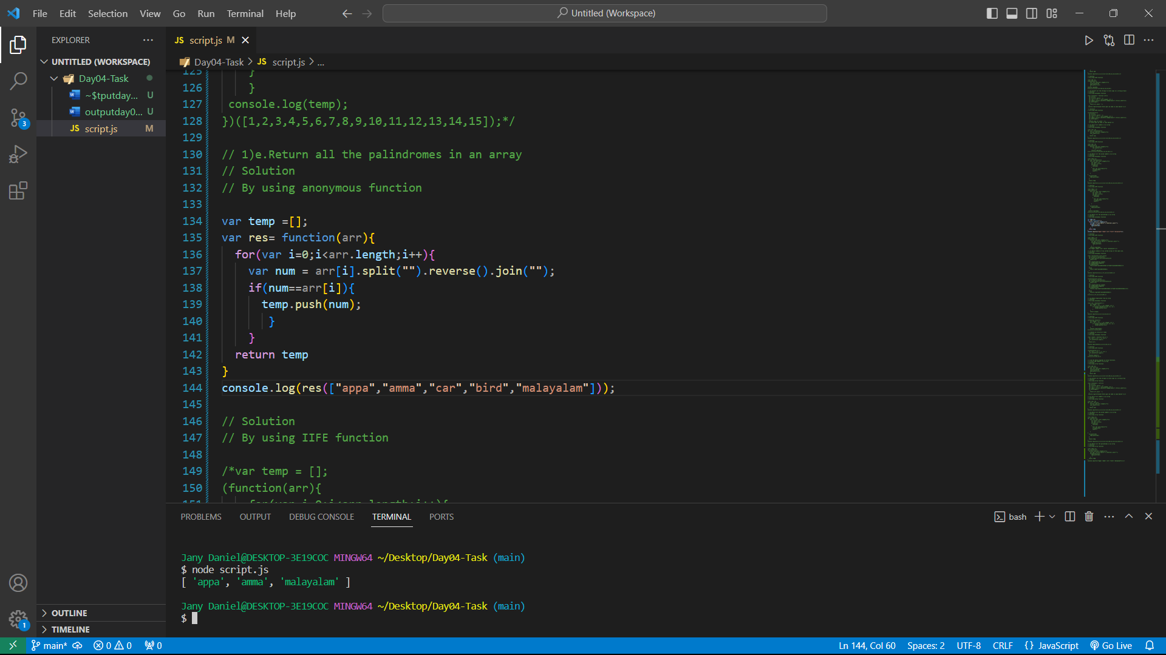

**IIFE function**

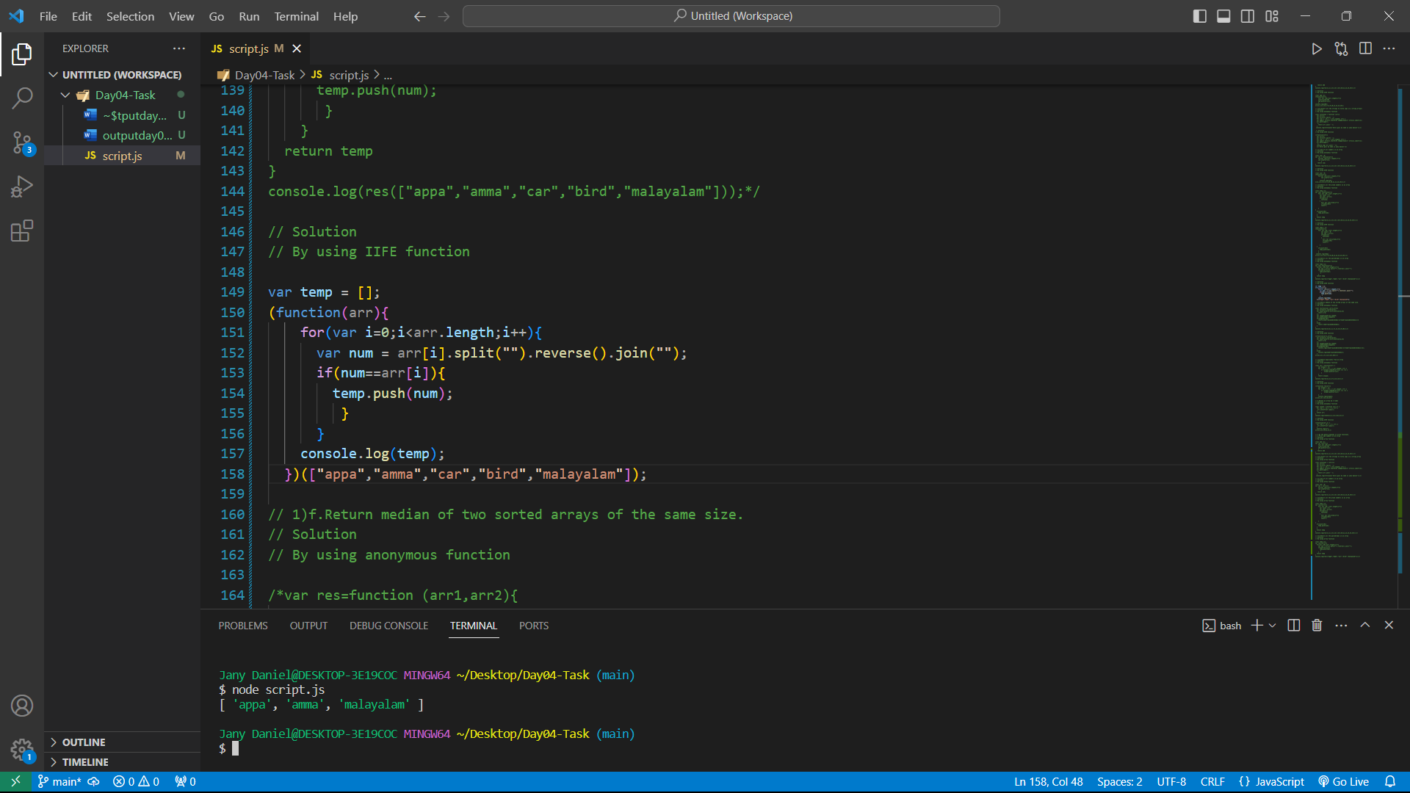

**1.f) Return median of two sorted arrays of the same size.**

**Anonymous function**

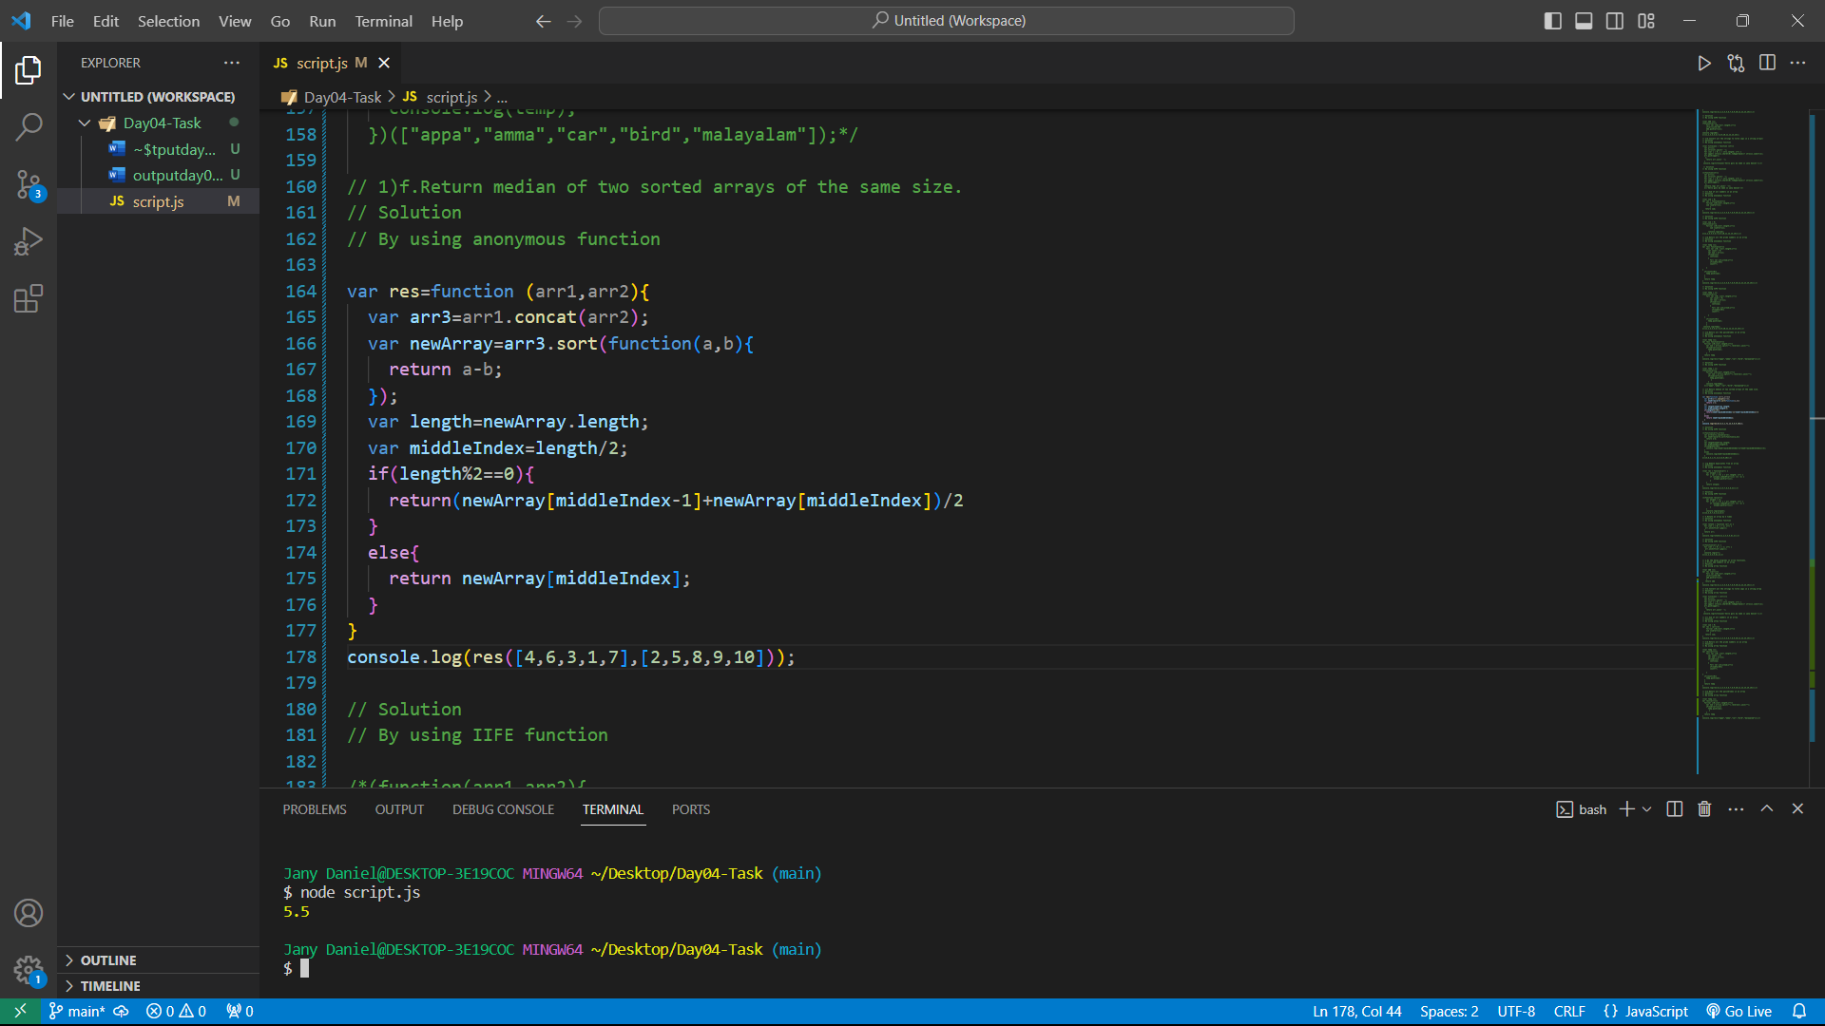

**IIFE function**

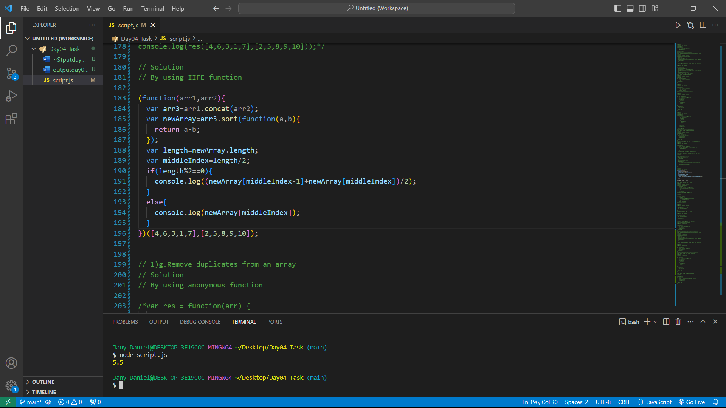

**1.g) Remove duplicates from an array**

**Anonymous function**

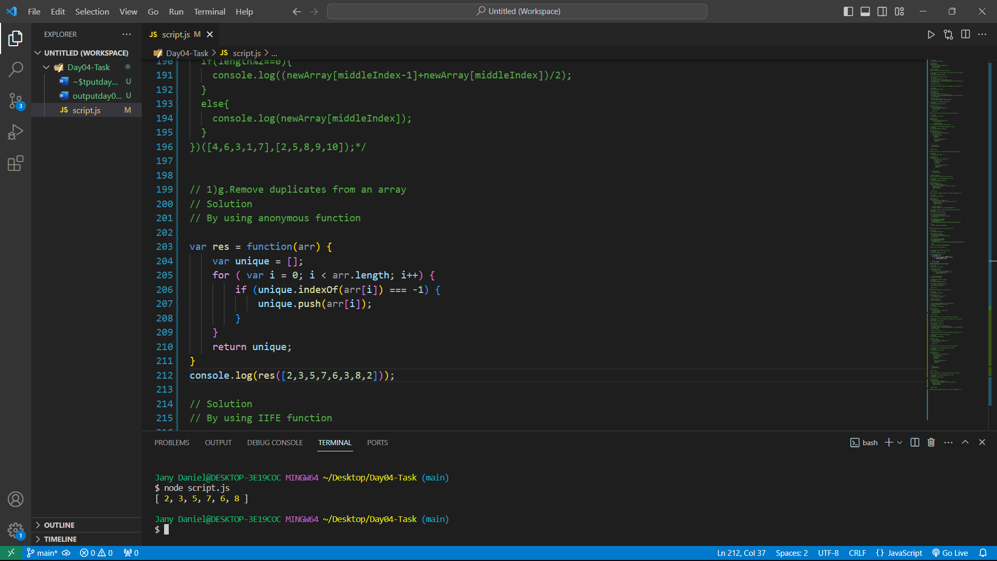

**IIFE function**

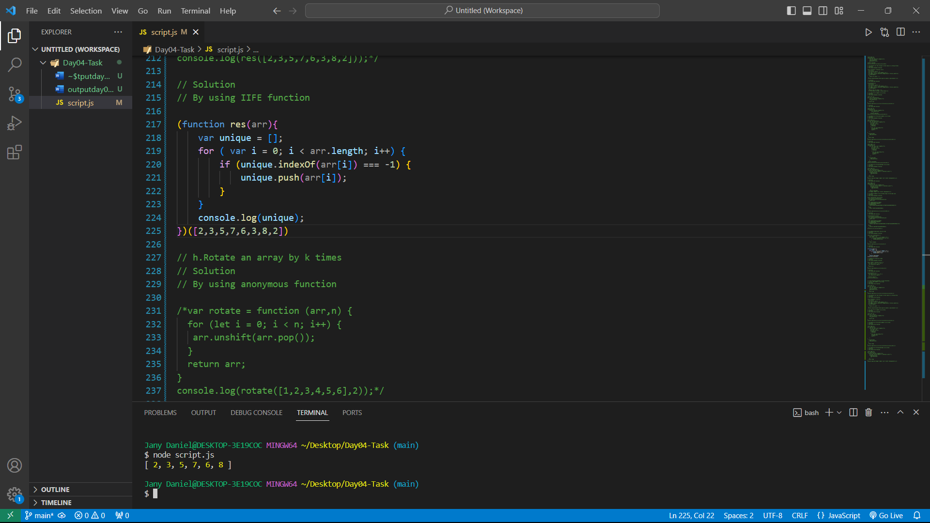

**1.h) Rotate an array by k times**

**Anonymous function**

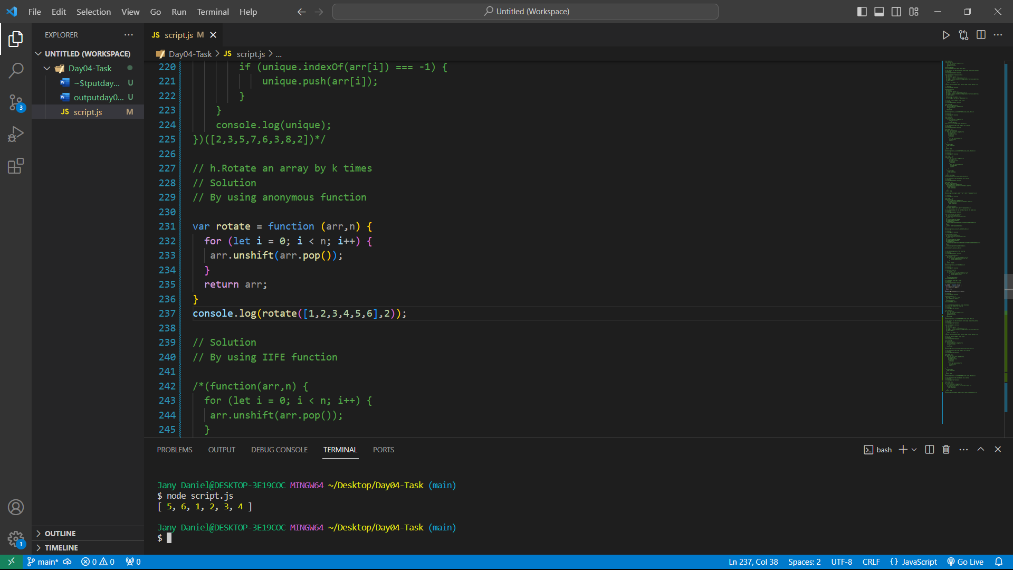

**IIFE function**

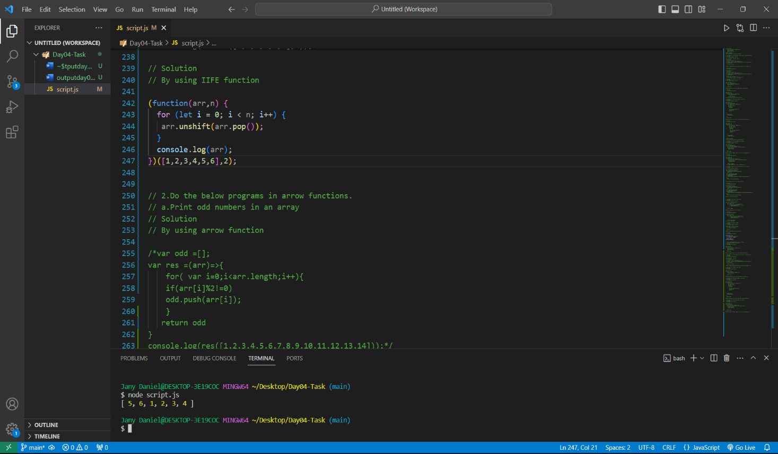

**2.a) Print odd numbers in an array**

**Arrow function**

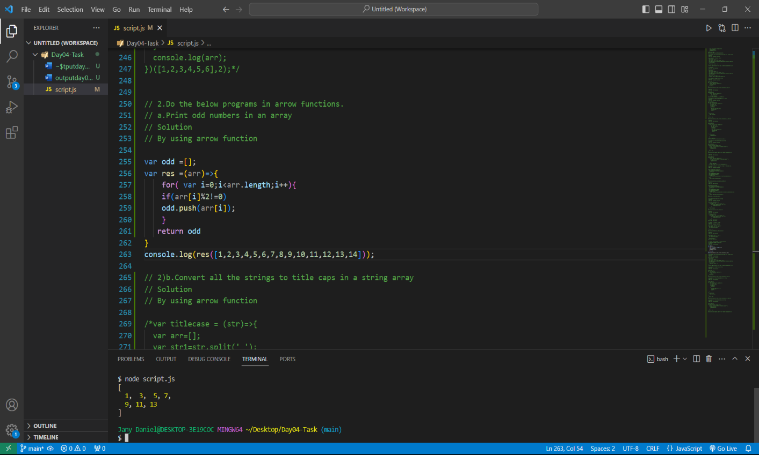

**2.b) Convert all the strings to title caps in a string array**

**Arrow function**

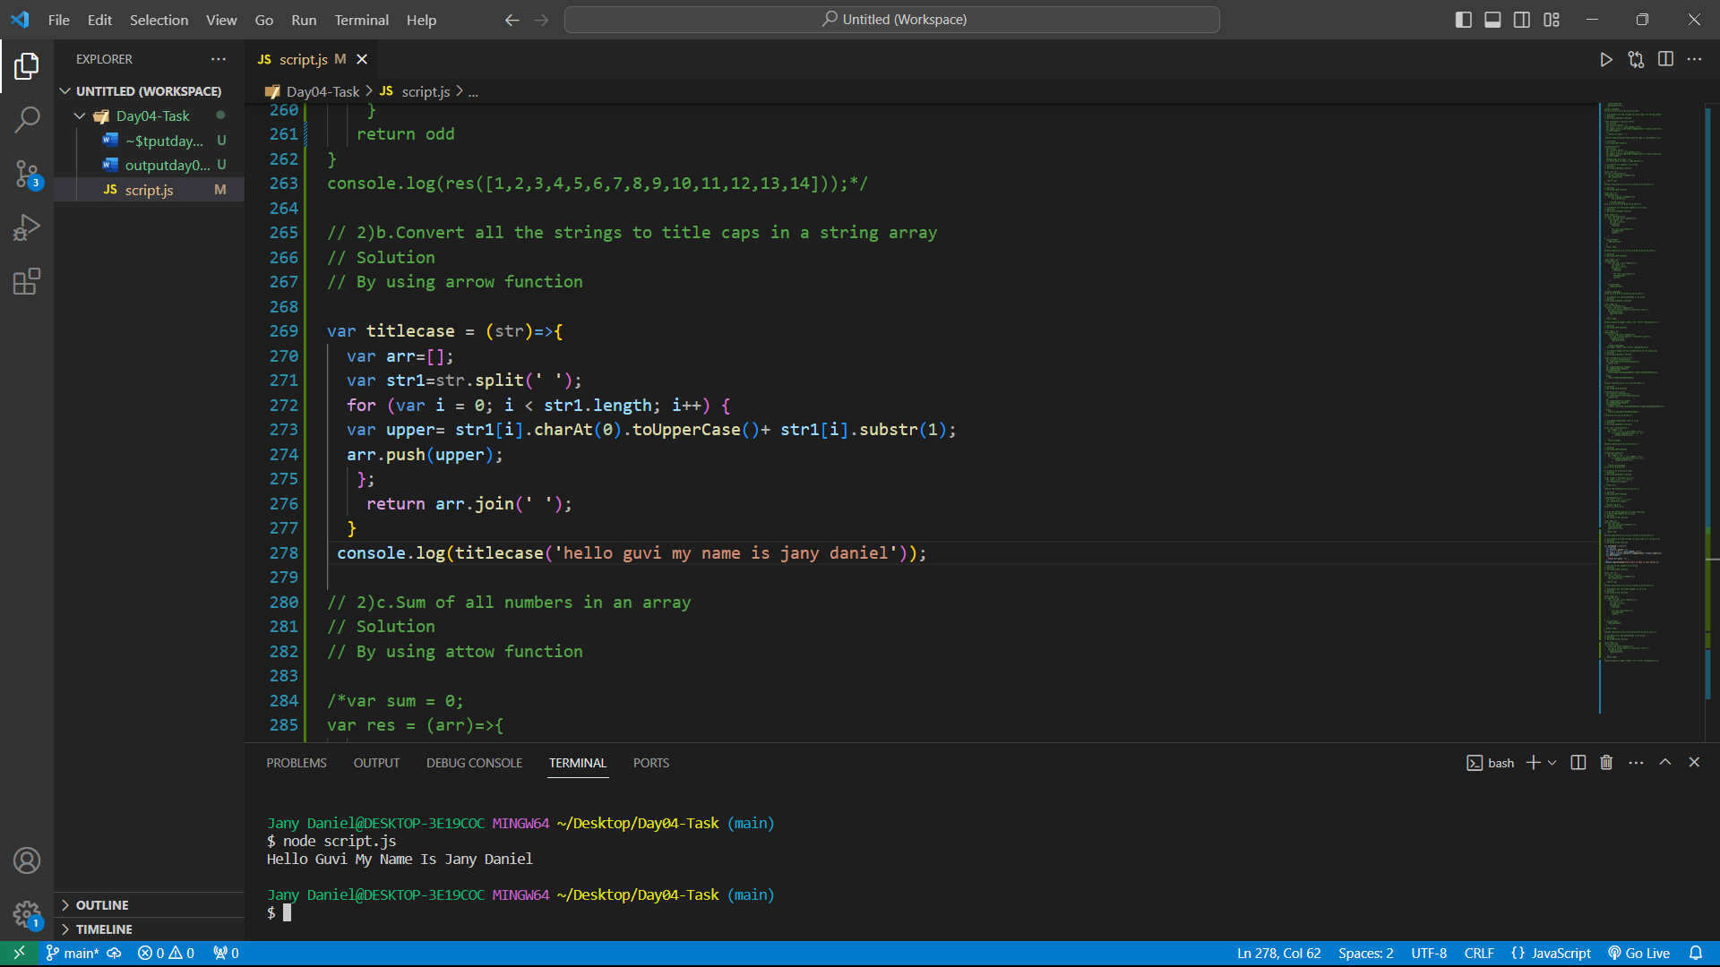

**2.c) Sum of all numbers in an array**

**Arrow function**

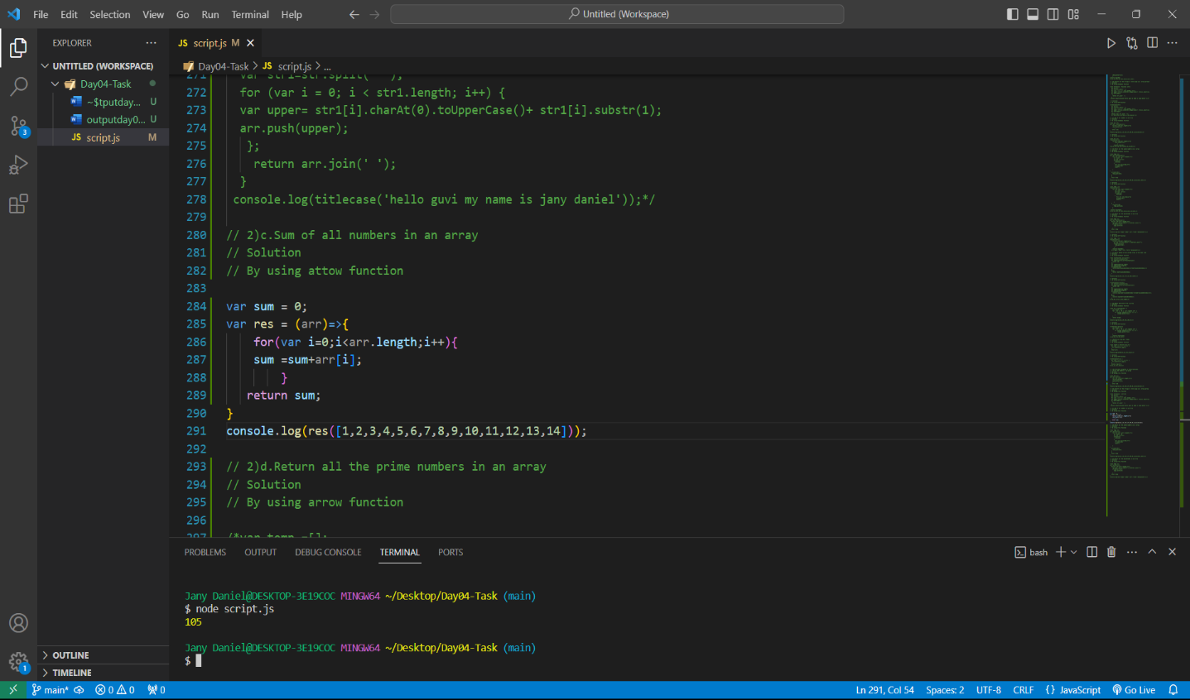

**2.d) Return all the prime numbers in an array**

**Arrow function**

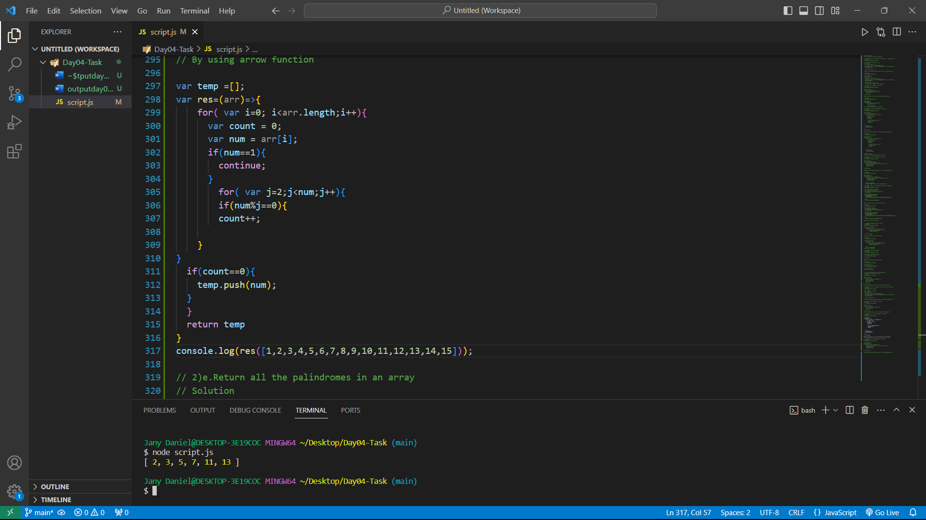

**2.e) Return all the palindromes in an array**

**Arrow function**

