Ex.No.5 Classifieds web application to buy and sell used products
Date:

Problem Statement :
Develop a classifieds web application to buy and sell used products.

Aim:

Procedure:
- Set up a project directory with index.html, app.js, and style.css files.
- Use a code editor or IDE to open your project folder.
- Open index.html in a web browser to view and interact with your app.
- Add your angular js controllers in app.js.
- Add styling in the style.css file.
- Ensure you have a working internet connection to fetch AngularJS from a CDN.
- Run the Application by double clicking on the index.html page as it is a simple HTML application.

Code:

//App.js
var app = angular.module("classifieds", []);

app.controller("ClassifiedsController", function ($scope) {
$scope.categories = [
"Education",
"Property",
"Recruitment",
"Services",
"Shopping",
"Vehicles",
];
$scope.category = $scope.categories[0];
$scope.postDate = new Date();
$scope.posts = [
{
category: "Services",
desc: "Full stack Application Development",
date: new Date(),
},
];

$scope.Post = function () {
if (!$scope.postContent || $scope.postContent.trim() === "") {
alert("Please enter a description for the post.");
return; // Exit the function if content is empty
}

// Create a new post object
var post = {
category: $scope.category,
desc: $scope.postContent,
date: $scope.postDate,
};

// Push the new post object to the posts array
$scope.posts.push(post);

// Clear the postContent field
$scope.postContent = "";
$scope.postDate = new Date();
$scope.category = $scope.categories[0];
};
});

//index.html
<!DOCTYPE html>
<html>
<head>
<title>Classifieds</title>
<script src="https://ajax.googleapis.com/ajax/libs/angularjs/1.8.2/angular.min.js"></script>
<link rel="stylesheet" type="text/css" href="style.css">
</head>
<body ng-app="classifieds">
<div ng-app="classifieds" ng-controller="ClassifiedsController">
<h1>Classifieds</h1>
<div id="classifieds-form">
<h2>Post a Classified advertisement</h2>
<form ng-submit="Post()">
<label for="category">Category</label>
<select ng-model="category" ng-options="type for type in categories"></select>
<label for="postContent">Give the description for the post:</label>
<textarea ng-model="postContent" type="required"></textarea>
<label for="postDate">Post Date:</label>
<input type="date" ng-model="postDate">
<button type="submit">Post</button>
</form>
</div>
<div id="classifieds-post">
<h2>Classifieds Posts</h2>
<ol type="1">
<li ng-repeat="post in posts">
<strong>Category:{{ post.category }}</strong><br>
<strong>Description:</strong> {{ post.desc }}<br>
<strong>Date:</strong> {{ post.date | date: 'dd/MM/yyyy' }}<br><br>
</li>
</ol>
</div>
</div>
<script src="app.js"></script>
</body>
</html>

//styles.css
body {
font-family: Arial, sans-serif;
margin: 0;
padding: 0;
background-color: #f2f2f2;
}
h1 {
background-color: black;
color: #fff;
text-align: center;
padding: 20px;
}
#classifieds-form, #classifieds-post {
margin-top: 20px;
border: 1px solid #ccc;
padding: 20px;
background-color: #fff;
box-shadow: 0 0 10px rgba(0, 0, 0, 0.1);
border-radius: 5px;
margin-left: auto;
margin-right: auto;
width: 70%;
}
form {
display: block;
margin: 20px auto;
max-width: 300px;
}
label {
display: block;
font-weight: bold;
margin-top: 10px;
}
input[type="date"]{
width: 300px;
padding: 10px;
margin-top: 5px;
margin-bottom: 20px;
border: 1px solid #ccc;
border-radius: 5px;
}
select {
width: 325px;
padding: 10px;
margin-top: 5px;
margin-bottom: 20px;
border: 1px solid #ccc;
border-radius: 5px;
}
textarea {
width: 300px;
padding: 10px;
margin-top: 5px;
margin-bottom: 10px;
border: 1px solid #ccc;
border-radius: 5px;
}
button[type="submit"] {
display: block;
width: 325px;
padding: 10px;
background-color: black;
color: #fff;
border: none;
border-radius: 5px;
cursor: pointer;
}
#classifieds-post h2 {
margin-top: 30px;
}
#classifieds-post p {
margin-top: 10px;
font-weight: bold;
}
p {
margin-bottom: 5px;
}

Output:

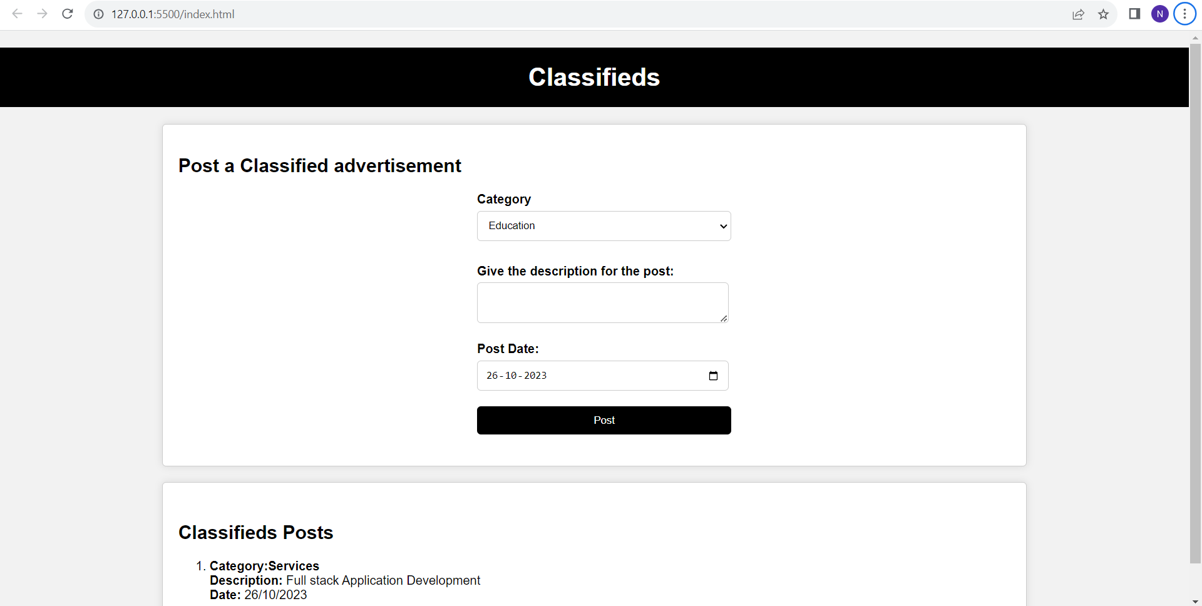

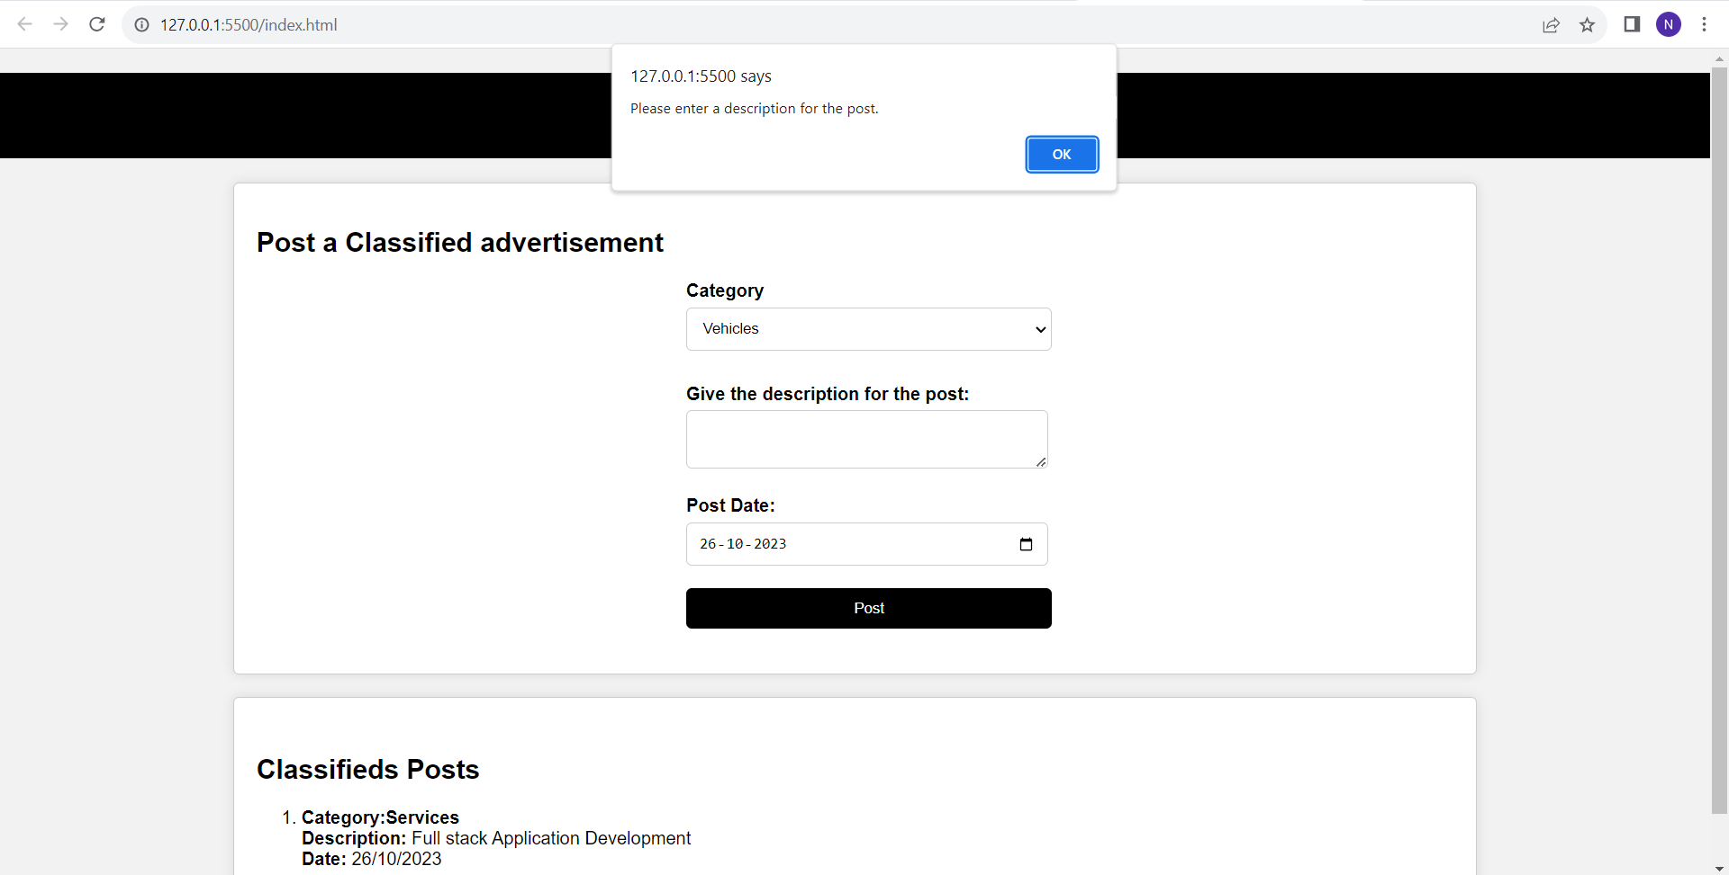

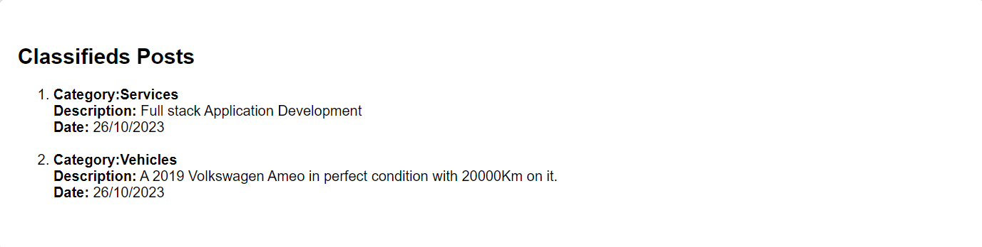

Result:

