Ex.No.6 Leave Management System
Date:

Problem Statement :
Develop a leave management system for an organization where users can apply different types of leaves such as casual leave and medical leave. They also can view the available number of days.

Aim:
To develop a leave management system using Angular JS.

Procedure:
- Set up a project directory with index.html, app.js, and style.css files.
- Use a code editor or IDE to open your project folder.
- Open index.html in a web browser to view and interact with your app.
- Add your angular js controllers in app.js.
- Add styling in the style.css file.
- Ensure you have a working internet connection to fetch AngularJS from a CDN.
- Run the Application by double clicking on the index.html page as it is a simple HTML application.

Code:

//App.js
var app = angular.module("leaveApp", []);

app.controller("LeaveController", function ($scope) {
// Initial leave balance values
$scope.casualLeaveBalance = 10;
$scope.medicalLeaveBalance = 15;

$scope.leaveTypes = ["Casual Leave", "Medical Leave"];
$scope.leaveType = $scope.leaveTypes[0];

$scope.applyLeave = function () {
// Calculate the number of days applied for
var startDate = new Date($scope.startDate);
var endDate = new Date($scope.endDate);
var daysApplied = (endDate - startDate) / (1000 * 60 * 60 * 24) + 1;

// Check if the leave balance becomes zero or negative
if ($scope.leaveType === "Casual Leave" && $scope.casualLeaveBalance - daysApplied < 0) {
alert("Insufficient Casual Leave balance. You cannot apply for more leave.");
} else if ($scope.leaveType === "Medical Leave" && $scope.medicalLeaveBalance - daysApplied < 0) {
alert("Insufficient Medical Leave balance. You cannot apply for more leave.");
} else {
// Update leave balances based on the leave type
if ($scope.leaveType === "Casual Leave") {
$scope.casualLeaveBalance -= daysApplied;
} else if ($scope.leaveType === "Medical Leave") {
$scope.medicalLeaveBalance -= daysApplied;
}

// Reset the form
$scope.startDate = null;
$scope.endDate = null;
}
};
});

//index.html
<!DOCTYPE html>
<html>
<head>
<title>Leave Management System</title>
<script src="https://ajax.googleapis.com/ajax/libs/angularjs/1.8.2/angular.min.js"></script>
<link rel="stylesheet" type="text/css" href="style.css">
</head>
<body ng-app="leaveApp">
<div ng-app="leaveApp" ng-controller="LeaveController">
<h1>Leave Management System</h1>
<div id="leave-application">
<!-- Leave application form -->
<h2>Apply for Leave</h2>
<form ng-submit="applyLeave()">
<label for="leaveType">Leave Type:</label>
<select ng-model="leaveType" ng-options="type for type in leaveTypes"></select>

<label for="startDate">Start Date:</label>
<input type="date" ng-model="startDate">

<label for="endDate">End Date:</label>
<input type="date" ng-model="endDate"><br><br>

<button type="submit">Apply</button>
</form>
</div>

<div id="leave-balance">
<!-- Display leave balances -->
<h2>Leave Balances</h2>
<p>Casual Leave: {{ casualLeaveBalance }} days</p>
<p>Medical Leave: {{ medicalLeaveBalance }} days</p>
</div>
</div>

<script src="app.js"></script>
</body>
</html>

//style.css
/* Apply some basic styles to the body and header */
body {
font-family: Arial, sans-serif;
margin: 0;
padding: 0;
background-color: #f2f2f2;
}

h1 {
background-color: rebeccapurple;
color: #fff;
text-align: center;
padding: 20px;
}

/* Style the application and balance containers */
#leave-application, #leave-balance {
margin-top: 20px;
border: 1px solid #ccc;
padding: 20px;
background-color: #fff;
box-shadow: 0 0 10px rgba(0, 0, 0, 0.1);
border-radius: 5px;
margin-left: auto;
margin-right: auto;
width: 70%;
}

/* Style the form */
form {
display: block;
margin: 20px auto;
max-width: 300px;
}

/* Style the labels and input fields */
label {
display: block;
font-weight: bold;
margin-top: 10px;
}

input[type="date"], select {
width: 100%;
padding: 10px;
margin-top: 5px;
border: 1px solid #ccc;
border-radius: 5px;
}

/* Style the button */
button[type="submit"] {
display: block;
width: 100%;
padding: 10px;
background-color: rebeccapurple;
color: #fff;
border: none;
border-radius: 5px;
cursor: pointer;
}

/* Style the leave balances */
#leave-balance h2 {
margin-top: 30px;
}

#leave-balance p {
margin-top: 10px;
font-weight: bold;
}

/* Add some space between elements */
p {
margin-bottom: 5px;
}

/* Additional styling can be added as needed */

Output:

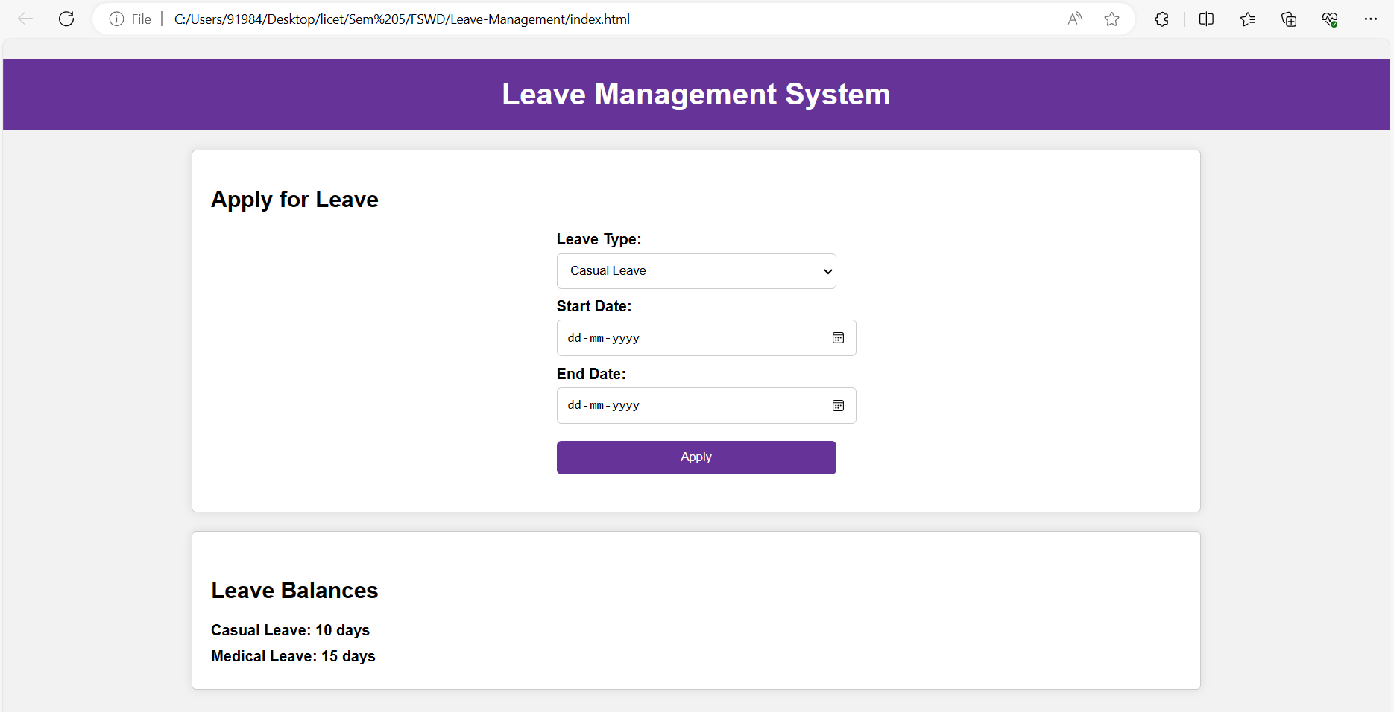
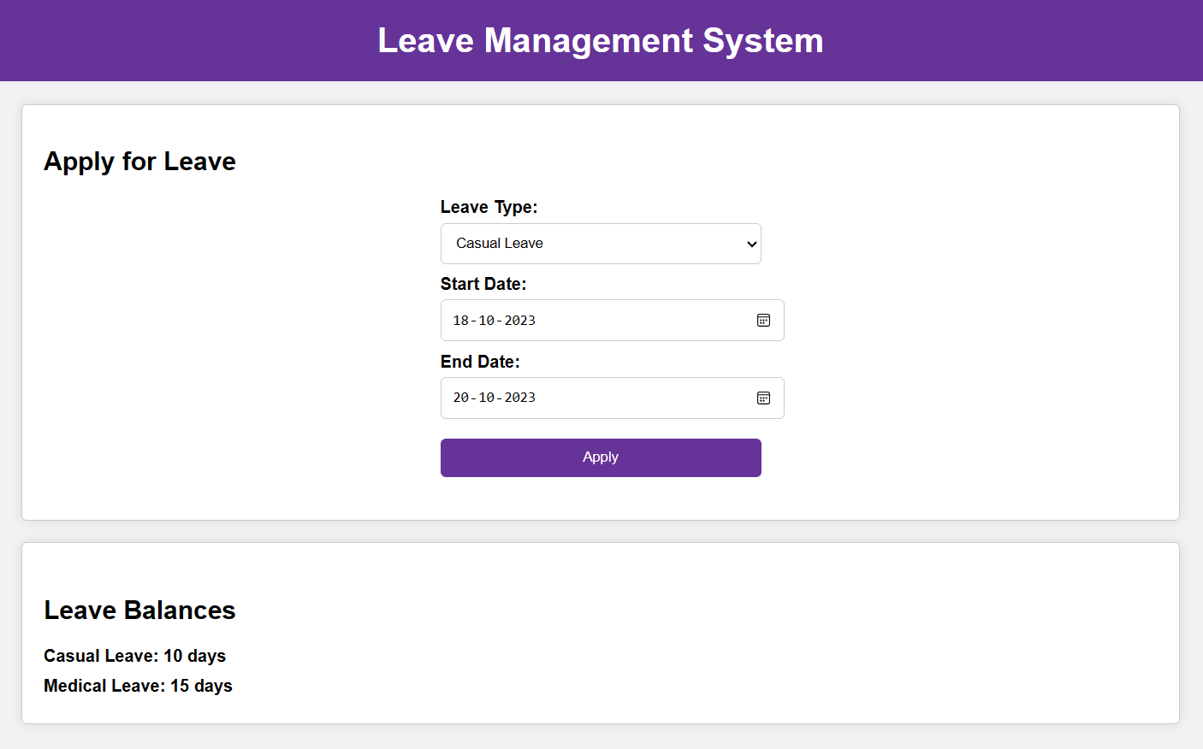
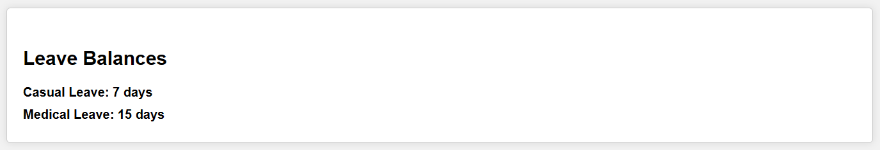
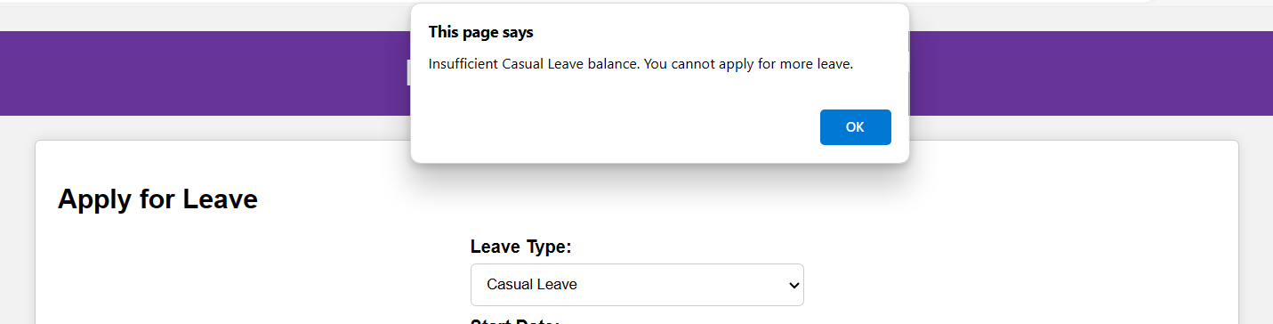

Result:
Thus the leave management system is developed successfully using AngularJS.

