AIM:

PROCEDURE:

Step 1 : Start Power BI Desktop
Step 2 : Connect to data.
Step 3 : Transform and clean data to create a data model.
Step 4 : Create visuals, such as charts or graphs that provide visual representations of the data.
Step 5: Create reports that are collections of visuals on one or more report pages.
Step 6 : Share reports with others by using the Power BI service.
Step 7 : Save the file in desired location
Step 8 : Close the Power BI Desktop application

EXPLORE THE FEATURES OF POWER BI DESKTOP:

WHAT IS POWER BI DESKTOP?

Power BI Desktop is a free application you install on your local computer that lets you connect to, transform, and visualize your data. With Power BI Desktop, you can connect to multiple different sources of data, and combine them (often called modeling) into a data model. This data model lets you build visuals, and collections of visuals you can share as reports, with other people inside your organization. Most users who work on business intelligence projects use Power BI Desktop to create reports, and then use the Power BI service to share their reports with others.
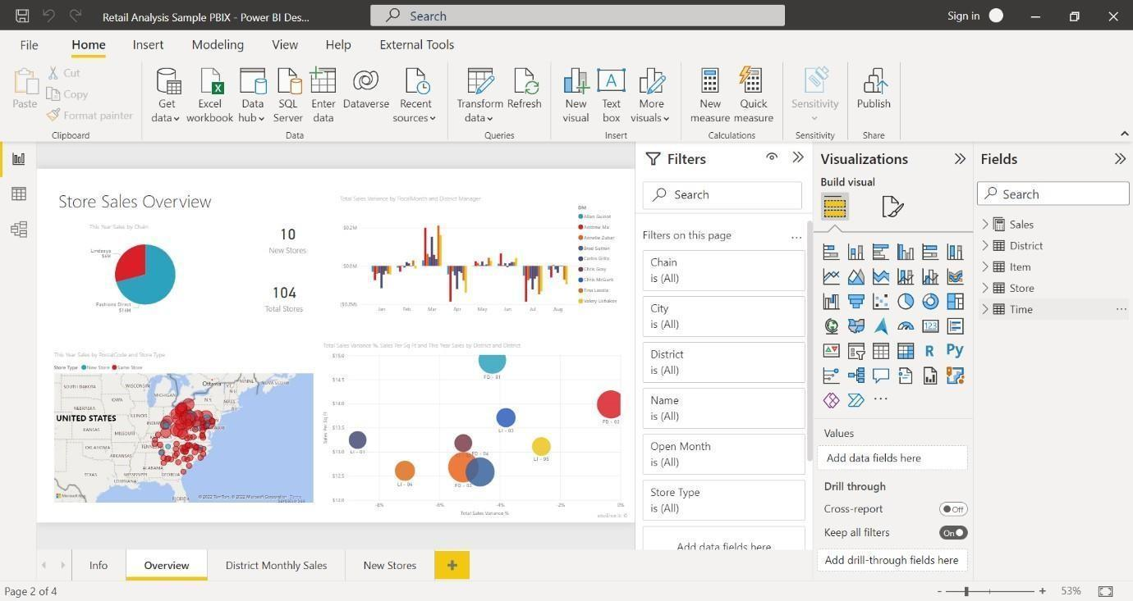

The most common uses for Power BI Desktop are as follows:
- Connect to data.
- Transform and clean data to create a data model.
- Create visuals, such as charts or graphs that provide visual representations of the data.
- Create reports that are collections of visuals on one or more report pages.
- Share reports with others by using the Power BI service.

People who are responsible for such tasks are often considered data analysts (sometimes referred to as analysts) or business intelligence professionals (often referred to as report creators). Many people who don't consider themselves an analyst or a report creator use Power BI Desktop to create compelling reports, or to pull data from various sources. They can build data models, and then share the reports with their coworkers and organizations.

Important
Power BI Desktop is updated and released on a monthly basis, incorporating customer feedback and new features. Only the most recent version of Power BI Desktop is supported; customers who contact support for Power BI Desktop will be asked to upgrade to the most recent version. You can get the most recent version of Power BI Desktop from the Windows store or as a single executable containing all supported languages that you download and install on your computer.

There are three views available in Power BI Desktop, which you select on the left side of the canvas. The views, shown in the order they appear, are as follows:

- Report: You create reports and visuals, where most of your creation time is spent.
- Data: You see the tables, measures, and other data used in the data model associated with your report, and transform the data for best use in the report's model.
- Model: You see and manage the relationships among tables in your data model.

The following image shows the three views, as displayed along the left side of the canvas:
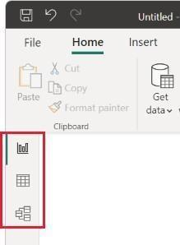

Connect to data

To get started with Power BI Desktop, the first step is to connect to data. There are many different data sources you can connect to from Power BI Desktop.

To connect to data:

- From the Home ribbon, select Get Data > More.
The Get Data window appears, showing the many categories to which Power BI Desktop can connect.
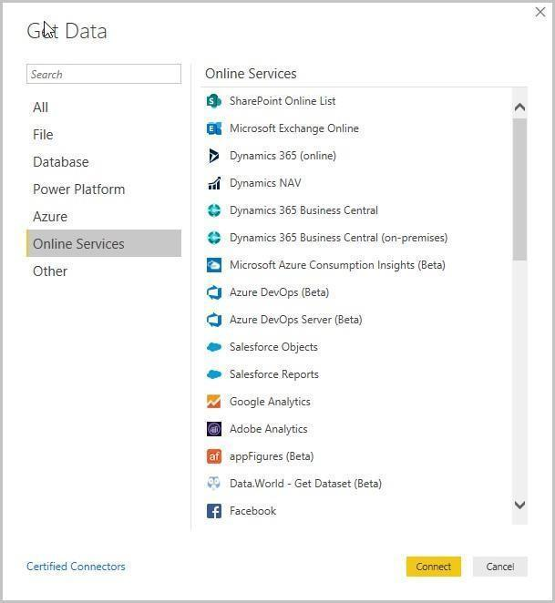

- When you select a data type, you're prompted for information, such as the URL and credentials, necessary for Power BI Desktop to connect to the data source on your behalf.
- After you connect to one or more data sources, you may want to transform the data so it's useful for you.

Transform , clean data and create a model

In Power BI Desktop, you can clean and transform data using the built-in Power Query Editor. With Power Query Editor, you make changes to your data, such as changing a data type, removing columns, or combining data from multiple sources. It's like sculpting: you start with a large block of clay (or data), then shave off pieces or add others as needed, until the shape of the data is how you want it.

To start Power Query Editor:

- On the Home ribbon, in the Queries section, select Transform data.
- The Power Query Editor window appears.

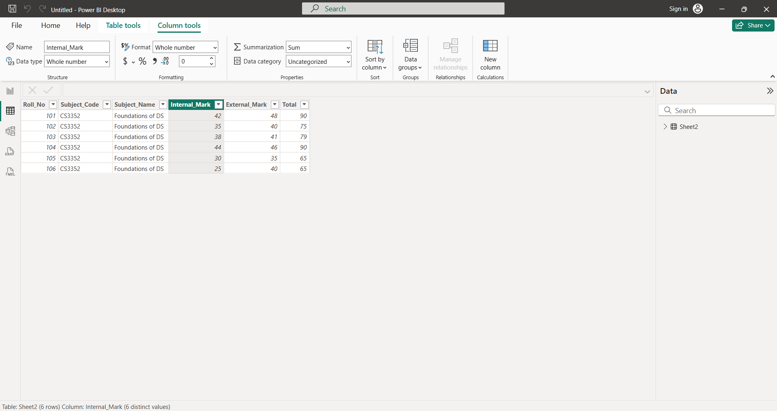

Create visuals

After you have a data model, you can drag fields onto the report canvas to create visuals. A visual is a graphic representation of the data in your model. There are many different types of visuals to choose from in Power BI Desktop. The following visual shows a simple column chart.



To create or change a visual:
- From the Visualizations pane, select the Build visual icon.
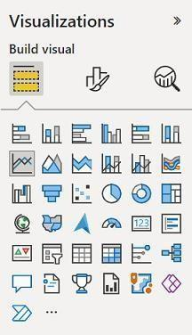
- If you already have a visual selected on the report canvas, the selected visual changes to the type you selected.
- If no visual is selected on the canvas, a new visual is created based on your selection.

Create reports

More often, you'll want to create a collection of visuals that show various aspects of the data you've used to create your model in Power BI Desktop. A collection of visuals, in one Power BI Desktop file, is called a report. A report can have one or more pages, just like an Excel file can have one or more worksheets.
With Power BI Desktop you can create complex and visually rich reports, using data from multiple sources, all in one report that you can share with others in your organization.

In the following image, you see the first page of a Power BI Desktop report, named Overview, as seen on the tab near the bottom of the image.

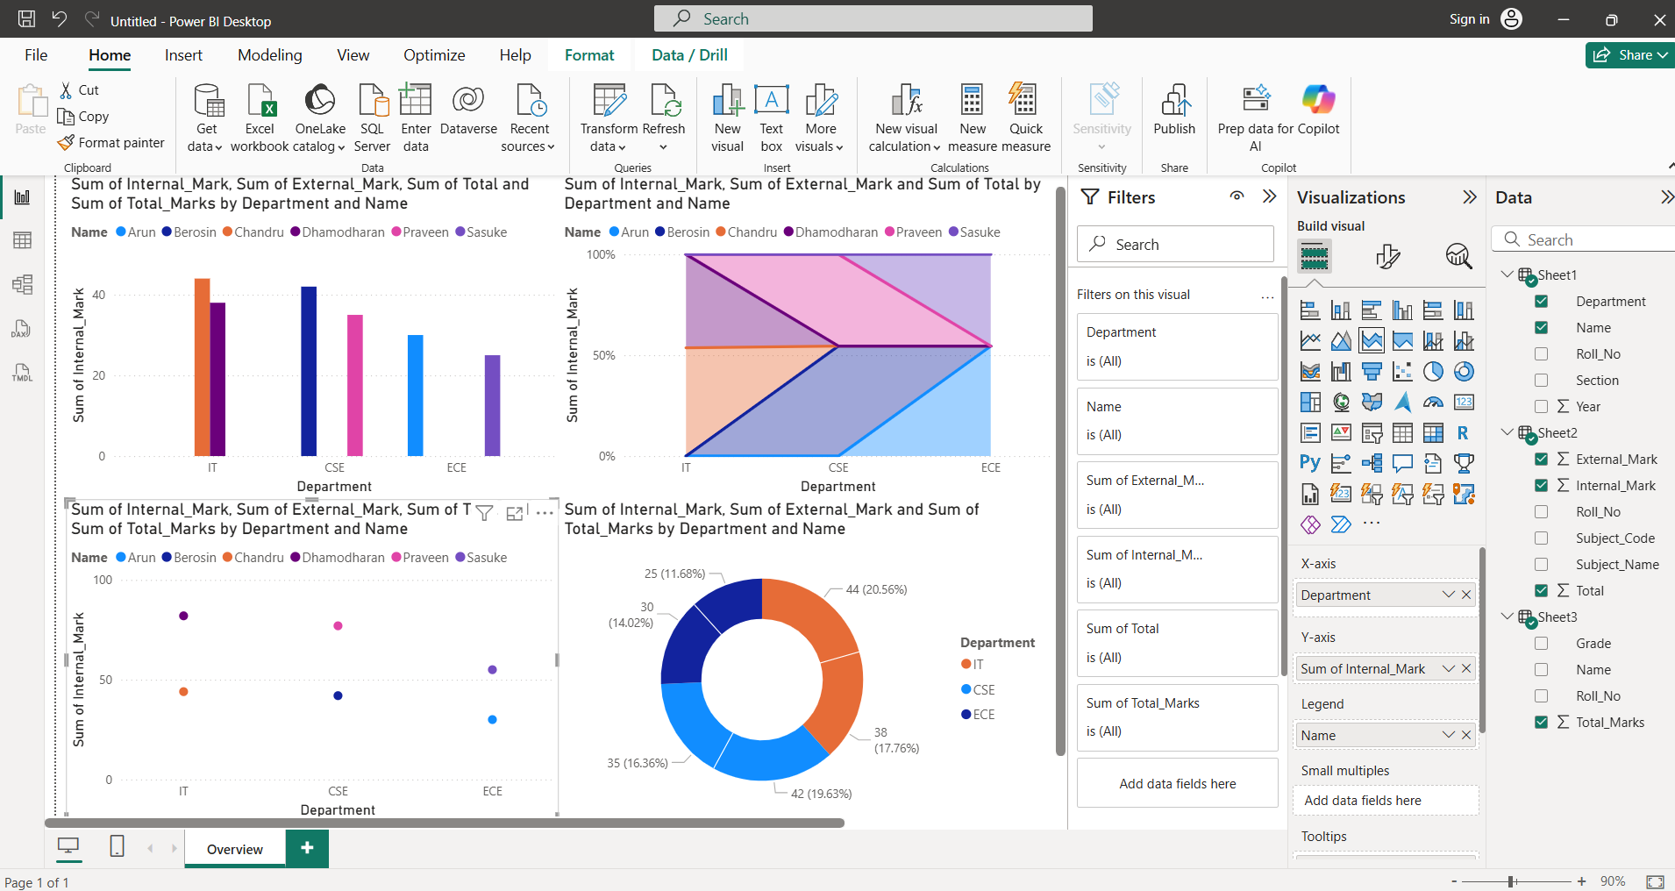

Share reports

After a report is ready to share with others, you can publish the report to the Power BI service, and make it available to anyone in your organization who has a Power BI license.

To publish a Power BI Desktop report:

- Select Publish from the Home ribbon.
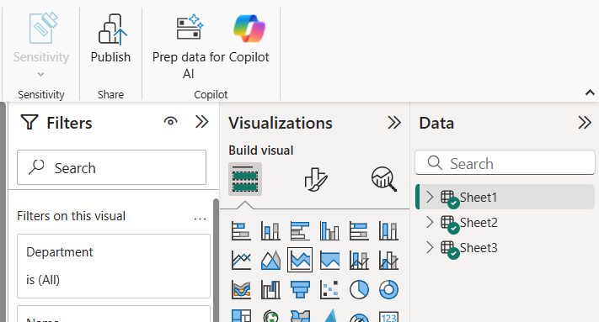
- Power BI Desktop connects you to the Power BI service with your Power BI account.
- You're prompted to select where in the Power BI service you'd like to share the report. For example, your workspace, a team workspace, or some other location in the Power BI service.

Following are some of the features of Power BI -
- Power BI Desktop
Power BI Desktop is free software that you can download and install, and it allows you to build reports by accessing data easily. For using Power BI desktop, you do not need advanced report designing, or query skills to build a report.

Stream Analytics
Power BI's primary advantage is its support stream analytics. From factory sensors to social media sources, Power BI assists in real-time analytics to make timely decisions.

Multiple Data Sources
Support for various data sources is one of the vital features of Power BI. You can access various sources of data such as Excel, CSV, SQL Server, Web files, etc. to create interactive visualizations.

Custom Visualization
While dealing with complex data, Power BI's default standard might not be enough in some cases. In that case, you can access the custom library of visualization that meets your needs.

RESULT:

AIM:

PROCEDURE:

Step 1 : Start Power BI Desktop
Step 2 : Goto to home menu , select get data and then choose excel worksheet
Step 3 : Select your file to load into Power Bi application and press load button
Step 4 : Now the file is loaded and now click data view in the left panel
Step 5: Now the file is loaded in the form of table format
Step 6 : Save the file in desired location
Step 7 : Close the Power BI Desktop application

OUTPUT:

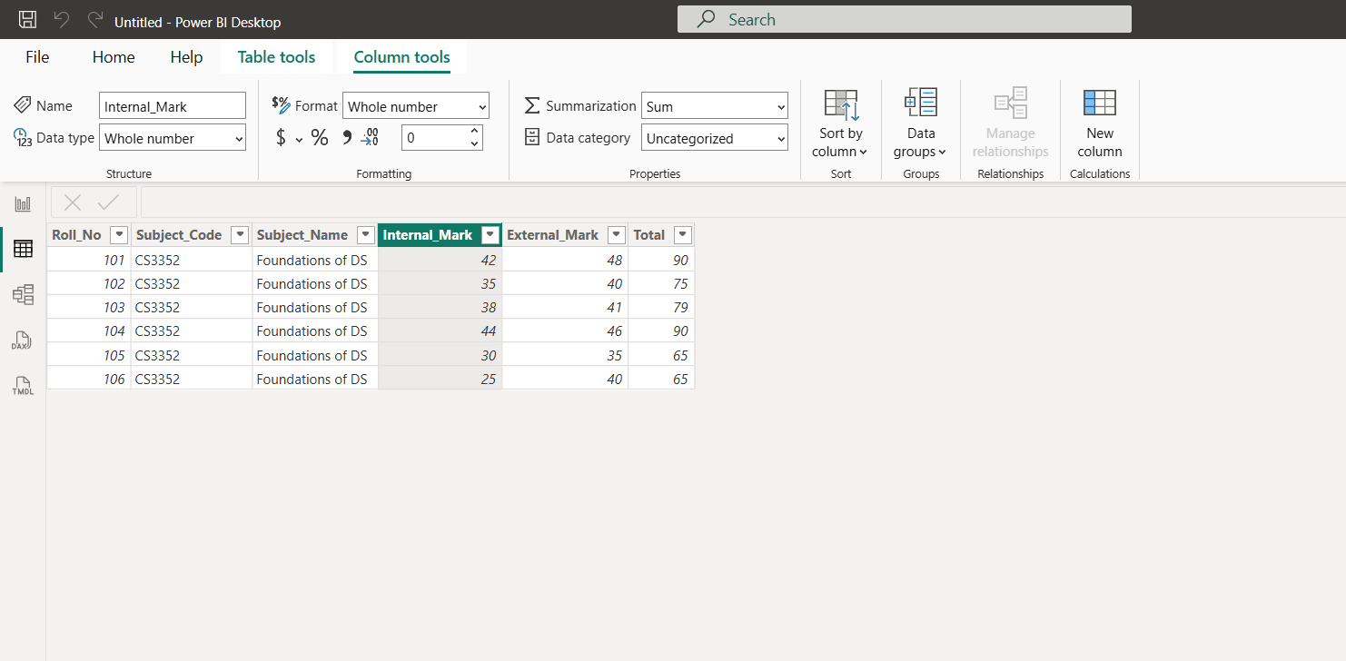

RESULT:

AIM:

PROCEDURE:

Step 1 : Start Power BI Desktop
Step 2 : Goto home menu , select get data and then choose excel worksheet
Step 3 : Select your file to load into Power Bi application and press load button
Step 4 : Now the file is loaded and now click model view in the left panel
Step 5 : Now data modeling of the given tables are displayed in output screen
Step 6 : Save the file in desired location
Step 7 : Close the Power BI Desktop application

OUTPUT:

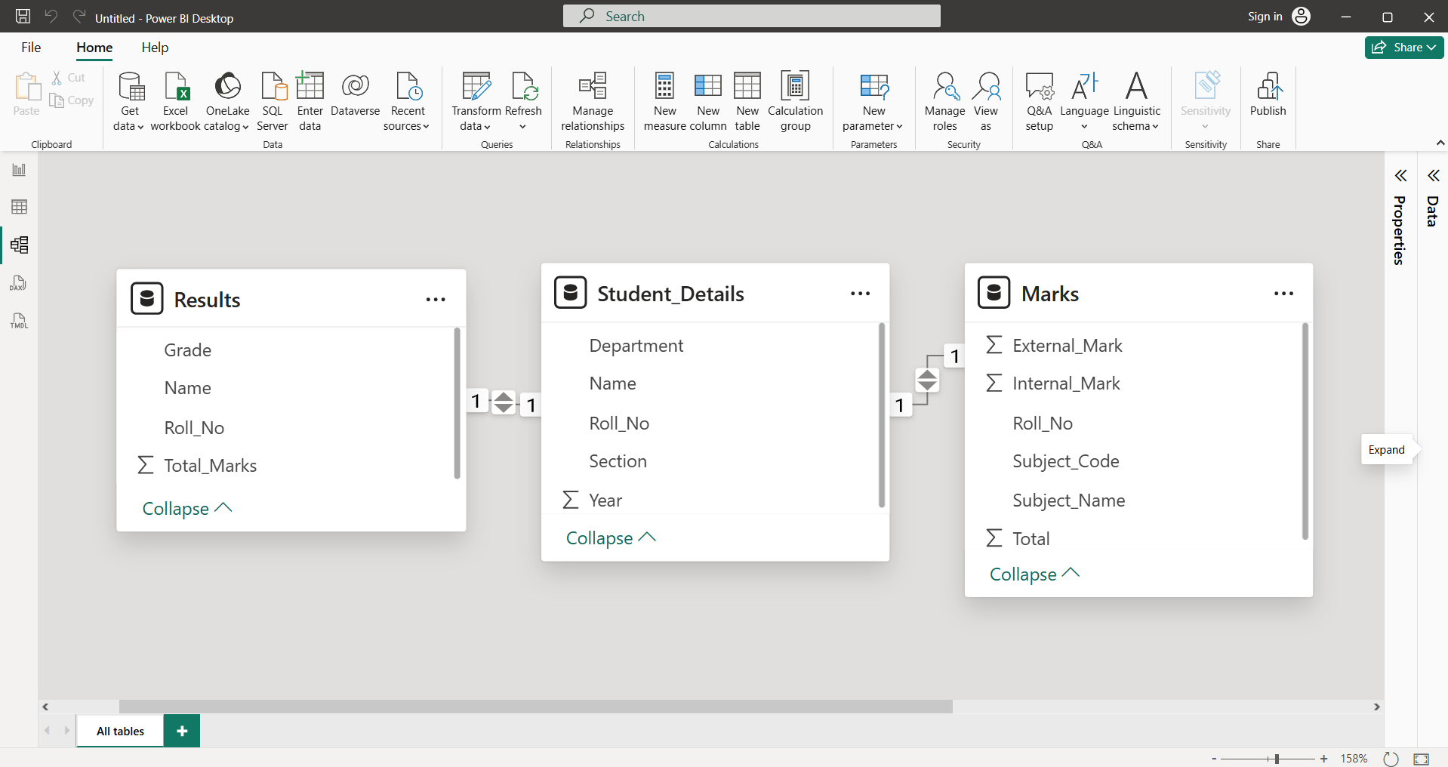

RESULT:

AIM:

PROCEDURE:

Step 1 : Start Power BI Desktop
Step 2 : Goto home menu , select get data and then choose excel worksheet
Step 3 : Select your file to load into Power Bi application and press load button
Step 4 : Now the file is loaded and now click report view in the left panel
Step 5 : Goto data panel and right click on data file and choose new measure
Step 6 : Type the formula for new measure and click the new measure “ was added
Step 7 : Drag the corresponding various types of visualization in workspace.
Step 8 : Save the file in desired location
Step 9 : Close the Power BI Desktop application

OUTPUT:

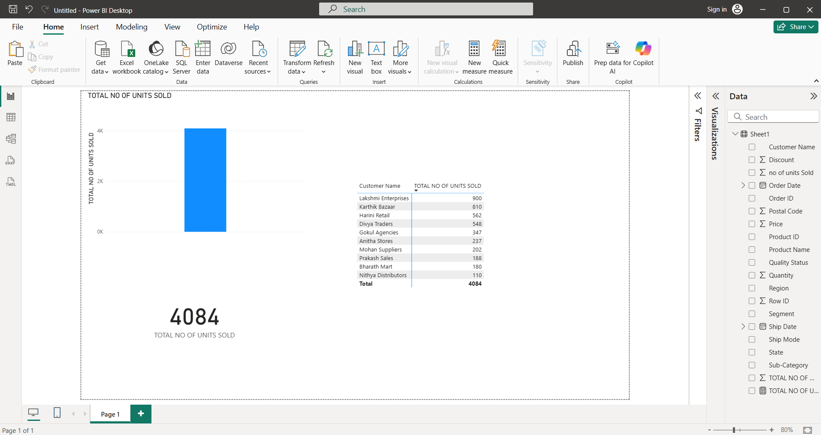

RESULT:

AIM:

PROCEDURE:

Step 1 : Start Power BI Desktop
Step 2 : Goto to home menu , select get data and then choose excel worksheet
Step 3 : Select your file to load into Power Bi application and press load button
Step 4 : Now the file is loaded and now click report view in the left panel
Step 5 : Goto data panel and right click on data file and choose new measure
Step 6 : Type the formula for new measure and click the new measure “ was added
Step 7 : Select clustered column chat and copy the visualization in workspace.
Step 8 : Change to decomposition tree visualization in workspace.
Step 9 : Explore the data in various forms for select filed .
Step 10 : Save the file in desired location
Step 11 : Close the Power BI Desktop application

OUTPUT:

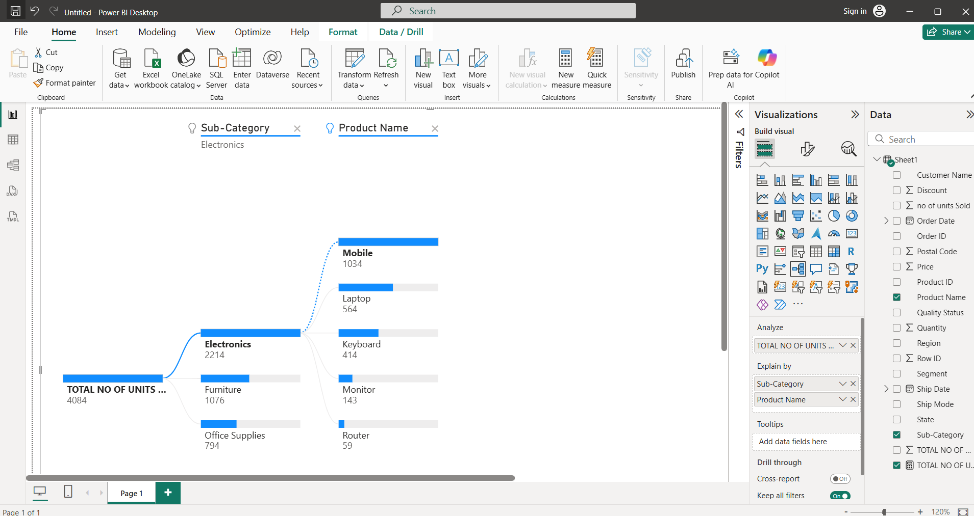

RESULT:

AIM:

PROCEDURE:
Step 1: Start Power BI Desktop
Step 2: Go to the home menu, select "Get Data," and then choose "Excel worksheet"
Step 3: Select your file to load into the Power BI application and press the "Load" button
Step 4: Once the file is loaded, click "Report View" in the left panel
Step 5: Go to the data panel, right-click on the data file, and choose the team field and slicer visualization
Step 6: Now, the teamwise slicer is displayed. Next, copy the visualization and change it to card visualization
Step 7: Copy the visualization and change it to gauge visualization
Step 8: Copy the visualization and change it to donut visualization, drag the gender field, and change the value field to count of gender
Step 9: Change and display the visualization as per teamwise
Step 10: Save the file in the desired location
Step 11: Close the Power BI Desktop application

OUTPUT:
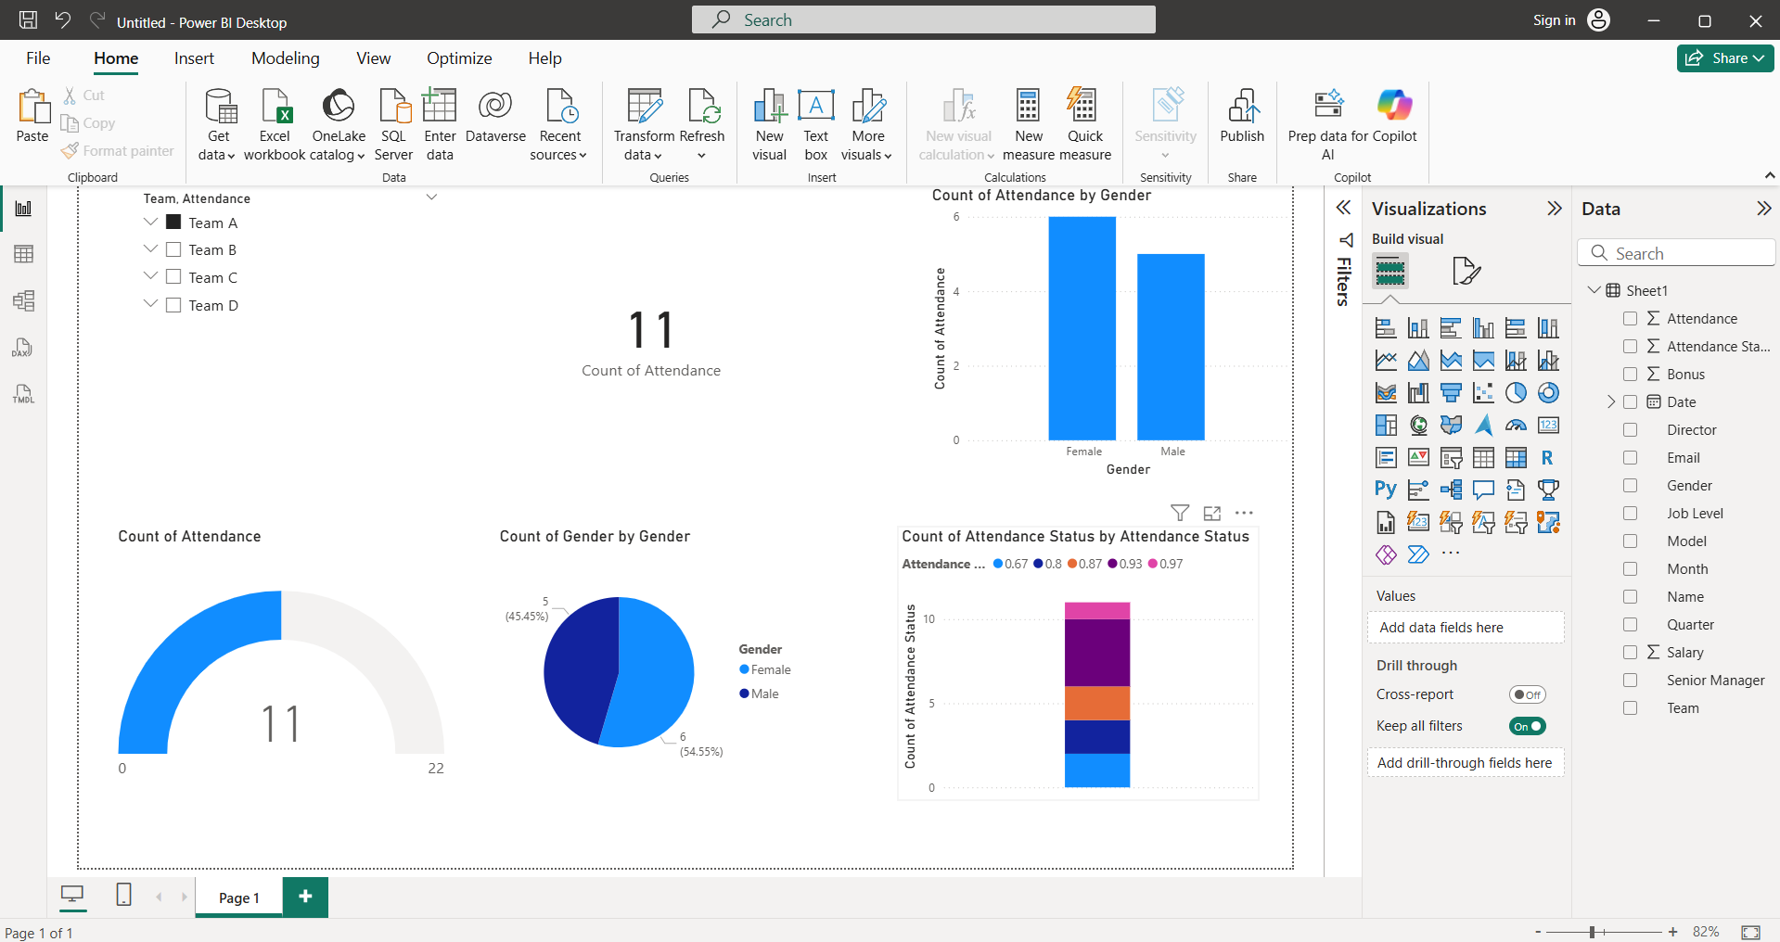

RESULT:

