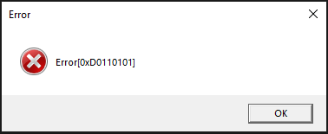

**[0xD0110101]**

**0 –** Main block

**D –** Sub block

**0110 –** Block No.

**101 –** Error No.