
C.K.PITHAWALLA COLLEGE OF COMMERCE-MANAGEMENT-COMPUTER APPLICATION, SURAT
VEER NARMAD SOUTH GUJARAT UNIVERSITY, SURAT
PROJECT REPORT
ON
“INTERNET BANKING MANAGEMENT”

AS A PARTIAL REQUIREMENT FOR THE DEGREE
OF
BACHELOR OF COMPUTER APPLICATION
(B.C.A)
2024-2025
SUBMITTED BY:
Jenil Dhola(7298)
Harsh Lakhani (7313)
Darshan Lakhani (7312)
Utsav Chheta (7294)

GUIDED BY:
Dr.Ami Desai
Mr. Juned Ansari

Acknowledgement
The reason of completing the project work successfully is not just our efforts but efforts of many people. The people, who trusted, guided and encouraged us with every means. Guide is a person who provides you the direction towards success, so we feel great pleasure to express our gratitude to all our guides, our faculty members as well as every person who helped me directly or indirectly with our project.

We would like to thank Dr. Marteen Patel (In-charge Principal at C.K.Pithawalla College) and Mr. Gaurang Joshi (BCA-HOD at C.K.Pithawalla College) for granting us an opportunity to work on this project. Their skills and experience was a guiding path in this learning process. She made constant efforts to shape up our skills as per the industry Standards. She provided us a very homely and friendly environment which made it the best place to work. Their guidance was really priceless and will always be a guiding light in Industry.

We are also indebted to our Faculty Dr.Ami Desai who provided constant encouragement, support & valuable guidance before and during our project. It was her effort who led us to this place for project work. Her guidance and suggestions were invaluable.

Jenil Dhola(7298)
Harsh Lakhani (7313)
Darshan Lakhani(7312)
Utsav Chheta (7294)

Thank you very much

Index
SrNo | Chapter |  | PageNo
1 | Introduction |  | 1
 | 1.1 | Project Profile | 2
 | 1.2 | Project Introduction | 3
2 | Environment Description |  | 4
 | 2.1 | Hardware Software Requirement | 5
 | 2.2 | Tools & Technology | 6
3 | Existing System & its Limitation |  | 11
 | 3.1 | Introduction | 12
 | 3.2 | Limitation | 13
4 | Proposed System |  | 14
 | 4.1 | Scope | 15
 | 4.2 | Aims & Objectives | 19
 | 4.3 | Excepted Advantage | 20
5 | System Model Architecture |  | 21
 | 5.1 | Use Case Diagram | 22
 | 5.2 | Activity Diagram | 24
6 | System Diagram |  | 45
 | 6.1 | Table Structure | 46
 | 6.2 | Screen Layout | 53
7 | System Limitations & Future Enhancements |  | 86
8 | References |  | 88
 | 8.1 | Bibliography | 89
 | 8.2 | Webography | 90

1
Chapter

Introduction
1.1 | Project Profile
1.2 | Project Introduction

1.1 Project Profile

Project Title | : | Internet Banking Management
Objective | : | To provide a secure and efficient platform for online banking services
Institute Name | : | C.K.Pithawalla College of Commerce-Management - Computer Application
Developed For | : | DigiBankX
Project Guide | : | Dr.Ami Desai
Front End | : | PHP
Back End | : | MySQL
Team Members | : | 4

1.2 Project Introduction

Introduction to DigibankX - Internet Banking Management System
- DigibankX is an advanced online banking system designed to simplify and manage various banking activities such as transactions, loans, and complaints.
- It features three key panels: Admin, Staff, and Client, ensuring organized control and efficient workflow.
- The Admin panel handles user management, financial reports, and complaint resolution.
- The Staff panel manages client profiles, transactions, and loan approvals.
- The Client panel allows users to manage accounts, apply for loans, and file complaints.
- The system is designed with strong data validation, ensuring accurate information entry and improved security.
- DigibankX currently supports only domestic transactions, requires manual loan approvals, and may face delays in complaint handling during busy periods.
- Future plans include introducing automated loan approvals, biometric authentication for improved security, and multilingual support for wider accessibility.
- Additional enhancements like a mobile app and improved financial reports with visual insights are planned to improve user convenience and system efficiency.
- The project is developed using HTML, CSS, JavaScript, and AJAX for the front-end, while PHP and MySQL power the back-end.
- Libraries like SweetAlert and jQuery are integrated for better alerts, form handling, and dynamic updates.
- DigibankX aims to provide a secure, reliable, and user-friendly platform for efficient online banking services.

2
Chapter

Environment Description
2.1 | Hardware and Software Requirement
 |  | 2.1.1 | Development Tools
 |  | 2.1.2 | Client Side Tools
 |  | 2.1.3 | Server Side Tools
2.2 | Tools and Technology
 |  | 2.2.1 | Core Technology
 |  | 2.2.2 | Extra Tools

2.1 Hardware and Software Requirement

  - Client Side :
Internet enabled devices with Web Browser
  - Server Side :-
Xampp Server (8.0.3)
Disk Space (1 GB)
  - Development Side :
Processor (Intel CORE i5 11th gen)
O.S (Windows 11 Pro)
Memory (16 GB)
Hard Disk (500 GB)
Web Browser : Developed in Google Chrome(Tested in Google Chrome)

2.2 Tools and Technology

Technology:
- Core Technology :

- HTML:
- First developed by Tim Berners-Lee in 1990, HTML is short for Hypertext Markup Language.
- HTML is used to create electronic documents (called pages) that are displayed on the World Wide Web.
- Each page contains a series of connections to other pages called hyperlinks.
- MySQL:
- MySQL, the most popular Open Source SQL database management system, is developed, distributed, and supported by Oracle Corporation.
- The MySQL website (http://www.mysql.com/) provides the latest information about MySQL software.
- A database is a structured collection of data.
- PHP:
- Hypertext Preprocessor (or simply PHP) is a general-purpose programming language was 32-bit x86 builds, requiring Windows 32-bit compatibility mode while using Internet Information Services (IIS) on a 64-bit Windows platform.

- Extra Technology:

- JQuery:
- JQuery is a JavaScript library designed to simplify HTML DOM tree traversal and manipulation, as well as event handling, CSS animation, and Ajax.
- JQuery also provides capabilities for developers to create plug-ins on top of the JavaScript library.
- AJAX:
- AJAX is a technique for creating fast and dynamic web pages.
- AJAX allows web pages to be updated asynchronously by exchanging small amounts of data with the server behind the scenes.
- This means that it is possible to update parts of a web page, without reloading the whole page.

- JavaScript:
- JavaScript is a dynamic computer programming language.
- It is lightweight and most commonly used as a part of web pages, whose implementations allow client-side script to interact with the user and make dynamic pages.
- It is an interpreted programming language with object-oriented capabilities.

Tools:
- Documentation Tools:
- MS Word:
- Microsoft Word or MS-WORD is a Graphical word processing program that users can type with.
- It is made by the computer company Microsoft. Its purpose is to allow users to type and save documents.
- MS Power Point:
- PowerPoint is a slideshow presentation program that's part of the Microsoft office suite of tools.
- PowerPoint makes it easy to create, collaborate, and present your ideas in dynamic, visually compelling ways.

- Development Tools:

Visual Studio Code
- Visual Studio Code (VS Code) is a powerful and versatile code editor used for developing the DigiBankX project.
- It offers a clean, functional, and fast environment ideal for writing PHP, HTML, CSS, and JavaScript code.
- VS Code provides excellent built-in features such as IntelliSense, Git Integration, and Debugging Tools, which streamline the development process.
- Additionally, its extensive support for extensions, snippets, and customizable settings enhances productivity and makes coding efficient.
- The lightweight yet feature-rich nature of VS Code played a crucial role in developing and maintaining the robust features of DigiBankX.

3
Chapter

3.1  3.2 | Introduction  Limitation
Existing System

3.1 Introduction

In traditional banking systems, clients often need to visit a physical bank branch to perform various financial tasks such as transactions, loan applications, and complaint submissions. This process can be time-consuming, inconvenient, and inefficient.

Challenges in the Existing System
•Limited Service Availability: Clients have restricted access to banking services outside regular banking hours, causing delays in essential financial.
•Lack of Real-Time Updates: Tracking transactions, loan statuses, or complaint resolutions often requires direct interaction with bank staff, leading.
•Manual Processes: Paper-based procedures and in-person verifications.
•Geographical Constraints: Clients in remote areas may struggle to access physical bank branches, limiting their ability to manage finances efficiently.
•Security Risks: Handling cash transactions at physical branches may expose clients to potential theft or fraud.
3.2 Limitation

- Limited Service Hours: Traditional banking systems operate within fixed working hours, restricting clients from performing transactions, applying for loans, or submitting complaints outside those hours.
- Limited Access to Services: Clients may face inconvenience if specific banking services are unavailable at their nearest branch, requiring them to visit multiple locations.
- Delayed Processes: Manual paperwork, long queues, and in-person visits often result in delays for essential banking tasks like loan approvals and account updates.

4
Chapter

4.1 Scope
4.2 Aim and Objective
4.3 Excepted Advantage

Proposed System

4.1 Scope

- The scope of the website “Wooden Street” is global.

SCOPE

ADMIN
STAFF
CLIENT
VISITOR

Admin
The key roles of the Admin in DigibankX are:
- User Management:
  - View, activate, or deactivate registered Staff and Clients.
  - Block or unblock Staff and Clients as needed.
- Loan Management:
  - View and manage loan applications submitted by Clients.
  - Approve or reject loan requests based on eligibility criteria.
- Transaction Management:
  - Monitor all client transactions for security and accuracy.
  - Manage disputed transactions and ensure proper resolution.
- Complaint Management:
  - View and respond to complaints raised by Clients or Staff.
  - Track the status of complaints and ensure timely resolution.
- Financial Reporting:
  - Generate and view detailed financial reports such as monthly transactions, revenue analysis, and loan approval statistics.
- Profile Management:
  - Update their own profile and change their password.
- Content Management:
  - Manage CMS pages like About Us, Contact Us, etc.
  - Update banner images displayed on the client side.
- Notification Management:
  - Send important announcements, alerts, and updates to Staff and Clients.

Staff
The key roles of Staff in DigibankX are:
- Client Management:
  - View, manage, and update client information.
  - Assist clients with account-related issues, profile updates, and password recovery.
- Loan Management:
  - Review and process loan applications submitted by clients.
  - Approve or reject loan requests based on provided documents and eligibility criteria.
- Transaction Management:
  - Monitor client transactions to ensure accuracy and security.
  - Assist in resolving disputed transactions and verifying payment status.
- Complaint Management:
  - View, respond to, and manage complaints raised by clients.
  - Track the status of complaints to ensure timely resolution.
- Financial Report Management:
  - View and analyze financial reports such as transaction summaries and loan status updates.
- Profile Management:
  - Update their own profile information and change their password.

Client
The key roles of Clients in DigibankX are:
- Account Management:
  - Register and create their account to access banking services.
  - Update their profile information and change their password when needed.
- Transaction Management:
  - Perform various transactions such as fund transfers, bill payments, and deposits.
  - View transaction history and download statements for record-keeping.
- Loan Management:
  - Apply for loans by submitting the required documents.
  - Track the status of their loan applications (e.g., Pending, Approved, or Rejected).
- Complaint Management:
  - Raise complaints regarding transaction issues, accounts concern, or service problems.
  - Track the status of their complaints until resolution.
- Offer and Notification Viewing:
  - View promotional offers, discounts, and important notifications shared by the Admin.
Visitor
The key roles of Visitors in DigibankX are:
- Information Access:
  - View general information about DigibankX services, including features, benefits, and security guidelines.
  - Access public pages like About Us, Contact Us, and FAQs for guidance.
- Registration Prompt:
  - Visitors must register as a Client to access personalized services such as transactions, loan applications, and complaint management.
4.2 Aims and Objectives

- Our aim is to provide a user-friendly and secure platform for clients to manage their banking needs efficiently.
- To enable clients to perform essential banking tasks such as fund transfers, loan applications, and complaint submissions from the comfort of their homes.
- To reduce manual paperwork by offering digital records, ensuring faster processing and improved accuracy.
- To provide clients with real-time updates on their transactions, loan statuses, and complaint resolutions.
- To enhance security by implementing robust measures such as data encryption, secure login systems, and two-factor authentication.
- To improve overall banking efficiency by streamlining processes for Admins, Staff, and Clients
CUSTOMER
VISITOR
4.3 Excepted Advantages

- The website allows the Admin to manage client accounts, oversee staff activities, and handle customer complaints effectively.
- The platform enables Visitors to access essential banking information, FAQs, and submit inquiries without the need for registration.
- Clients benefit from fast, secure, and user-friendly services, ensuring their banking needs are addressed efficiently.
- The system provides an interface for clients to raise inquiries about transactions, loans, or account issues, ensuring quick resolutions and improved customer satisfaction.
- The platform allows clients to provide feedback on banking services, helping the Admin and Staff improve service quality.
- Since DigibankX operates online, clients can access services 24/7 from anywhere, ensuring banking convenience without visiting a physical branch.
- DigiBankX offers a wide range of integrated services like fund transfers, loan management, transaction tracking, and complaint management — all in one place, improving efficiency and saving time.
- With features like real-time updates, secure transactions, and digital record-keeping, the platform ensures improved accuracy and transparency.

5
Chapter

System Model Architecture
5.1 | Use Case Diagram
5.2 | Activity Diagram

5.1 Use Case Diagram

- Super Admin’s Use Case Diagram:

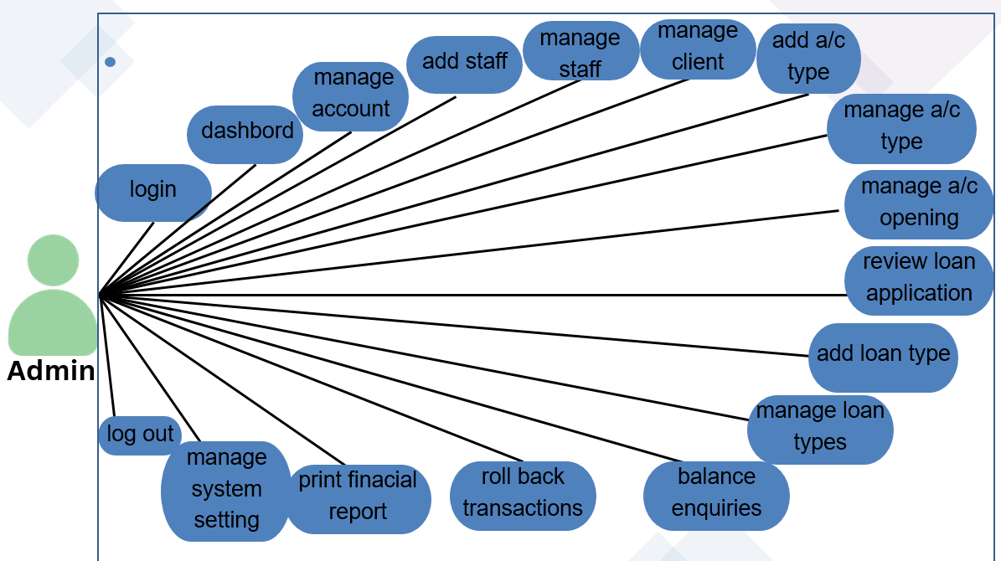
- Staff Use Case Diagram:
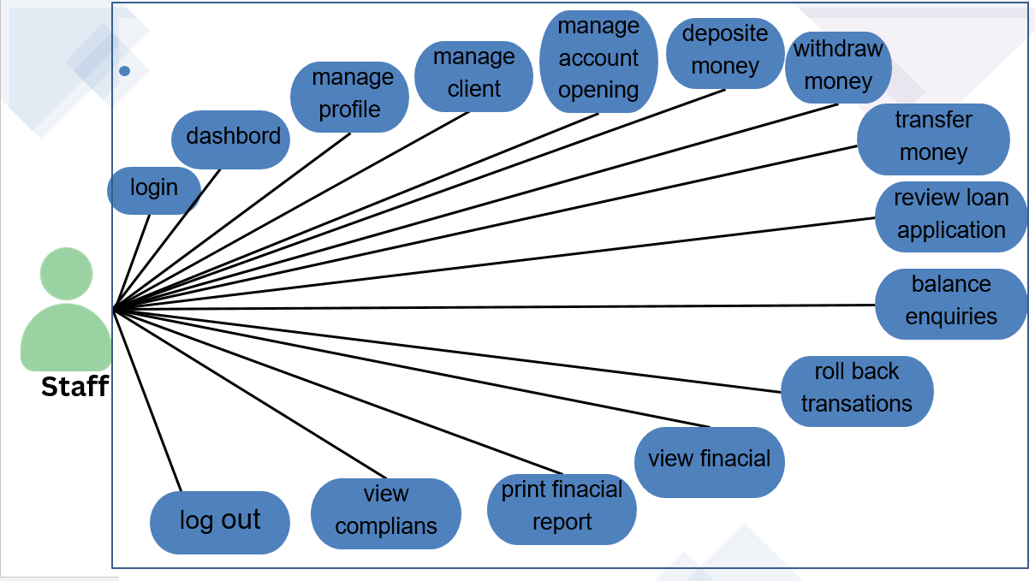
User Use Case Diagram:
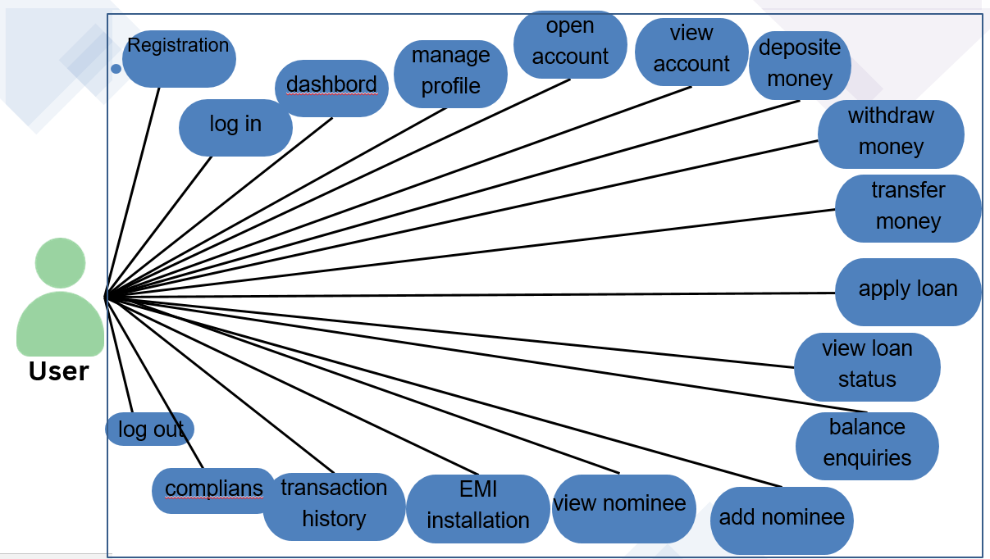

5.2 Activity Diagram

- Activity Diagram for Admin:
1
Admin
Login
Check EmailID & Password
Logged On
Forgot Password
Validate Data

Manage Staff

Manage Clients

Manage Account Type

Manage Loans

Change Password & Profile
Manage System Settings

Transaction History
Financial Reports
Deposit Interest
Balance Enquiries
Logout

1
5
4
3
2
6
7
8
9
Y
N
N
Y

- Activity Diagram for Admin – Staff Management
1
Manage Staff
Add New
Staff
View Staff
Enable/Disable
Staff
Edit Staff
Error
Error
Error
Valid
Data?
Valid
Data?
Valid
Data?
Staff Added
Staff Updated
Staff
Enabled/Disabled

End
No
N
N
Yes
Yes
Yes

- Activity Diagram for Admin – Client Management:
2
Manage Clients
View Clients
Enable/Disable
Client
Edit Clients
Error
Error
Valid
Data?
Valid
Data?
Client Updated
Clients
Enabled/Disabled

End
N
N
Yes
Yes

- Activity Diagram for Admin – Account Type Management:
3

Manage Account Type

Add New
Acc Type
View Accounts
Enable/Disable
Acc Type
Edit Acc Type
Error
Error
Error
Valid
Data?
Valid
Data?
Valid
Data?
Acc Type Added

Acc Type Updated
Acc Type
Enabled/Disabled

End
No
N
N
Yes
Yes
Yes

- Activity Diagram for Admin – Loan Management:

4

Manage Loan Type

Add New
Loan Type
View Application
Enable/Disable
Loan Type
Edit Loan Type
Error
Error
Error
Valid
Data?
Valid
Data?
Valid
Data?
Loan Type Added

Loan Type Updated
Loan Type
Enabled/Disabled

End
No
N
N
Yes
Yes
Yes

- Activity Diagram for Admin – Deposit Interest:
Deposit Interest
Deposit Interest
Error
Valid Data?
Deposit Successfully
End
No
Yes
5

- Activity Diagram for Admin – Balance Enquiries:

Balance Enquiries
Check Balance
Error
Valid Data?
View Balance
End
No
Yes
6

- Activity Diagram for Admin – Transactions History:

Transactions
Transactions History
View Transactions
Valid Data?
Rollback Transaction
End
No
Yes
7

- Activity Diagram for Admin – Financial Reports:

Financial Reports-Deposit
CSV Deposit

Copy Deposit
Print Deposit

Excel Deposit
Generate
CSV File
Generate
Excel File

Print Data

End
Copy Data

8

Financial Reports-Withdraw
CSV Withdraw

Copy Withdraw
Print Withdraw

Excel Withdraw
Generate
CSV File
Generate
Excel File

Print Data

End
Copy Data

8

Financial Reports-Transfer
CSV Transfer

Copy Transfer
Print Transfer

Excel Transfer
Generate
CSV File
Generate
Excel File

Print Data

End
Copy Data

8

- Activity Diagram for Admin – System Settings:

Manage System Settings
Edit System Settings
Error
Valid Data?

Edit Successfully

End
No
Yes
6

Activity Diagram for Staff:
1
Staff
Login
Check Email & Password
Logged On
Forgot Password
Validate Data

Manage Clients

Manage Account Opening

Manage Finances

Manage Loan Application

Change Password & Profile
Manage Complaints
Transaction History
Financial Reports
View Dashboard
Balance Enquiries
Logout

1
5
4
3
2
6
7
8
9
Y
N
N
Y

- Activity Diagram for Staff – Clients Management:
1
Manage Clients
View Clients
Enable/Disable
Client
Edit Clients
Error
Error
Valid
Data?
Valid
Data?
Client Updated
Clients
Enabled/Disabled

End
N
N
Yes
Yes

- Activity Diagram for Staff – Accounts Opening Management:
2

Manage Account Openings
View Accounts
Close Accounts

Edit Acc Type
Error
Error
Valid
Data?
Valid
Data?
Updated

Account Closed

End
N
N
Yes
Yes

- Activity Diagram for Staff – Loan Application Management:
3

Manage Loan Application

View Loan Status
Pay Installment

Apply for Loan
Error
Error
Valid
Data?
Valid
Data?

Applied Loan

Installment Paid

End
N
N
Yes
Yes

- Activity Diagram for Staff – Finance Management:
4

Manage Finance
Deposit Money
View Accounts

Money Transfer

Withdraw Money
Error
Error
Error
Valid
Data?
Valid
Data?
Valid
Data?
Money Deposited

Money Withdrawn

Money Transferred

End
No
N
N
Yes
Yes
Yes

- Activity Diagram for Staff – View Dashboard:
5

Dashboard
view

View Dashboard
End

- Activity Diagram for Staff – Balance Enquiries:

Balance Enquiries
Check Balance
Error
Valid Data?
View Balance
End
No
Yes
6

- Activity Diagram for Staff – Transaction History:-

Transactions
Transactions History
View Transactions
Valid Data?
Rollback Transaction
End
No
Yes

7

- Activity Diagram for Staff – Financial Reports:

Financial Reports-Deposit
CSV Deposit

Copy Deposit
Print Deposit

Excel Deposit
Generate
CSV File
Generate
Excel File

Print Data

End
Copy Data

8

Financial Reports-Withdraw
CSV Withdraw

Copy Withdraw
Print Withdraw

Excel Withdraw
Generate
CSV File
Generate
Excel File

Print Data

End
Copy Data

8

Financial Reports-Transfer
CSV Transfer

Copy Transfer
Print Transfer

Excel Transfer
Generate
CSV File
Generate
Excel File

Print Data

End
Copy Data

8

- Activity Diagram for Staff – Complaint Management:
Replay & View Complaints
View
Response Complaint
Error
Valid
Data?
Reply to Complaint
End
N
Yes
View Complaints
9

- Activity Diagram for Client:
3
Client
Login
Check Email & Password
Logged On
Forgot Password
Validate Data

Manage Accounts

Manage Finances

Manage Nominees

Manage Loan Application

Change Password & Profile
Manage Complaints
Transaction History
Financial Reports
View Dashboard
Balance Enquiries
Logout

1
5
4
3
2
6
7
8
9
Y
N
N
Y

- Activity Diagram for Clients– Account Management:
Manage Account Opening
Add Account
Error
Valid Data?
Account Added
End
No
Yes
View Account

Account Viewed

1

- Activity Diagram for Client – Finance Management:
2

Manage Finance
Deposit Money
View Accounts

Money Transfer

Withdraw Money
Error
Error
Error
Valid
Data?
Valid
Data?
Valid
Data?
Money Deposited

Money Withdrawn

Money Transferred

End
No
N
N
Yes
Yes
Yes

- Activity Diagram for Clients– Nominees Management:
Manage Nominees
Add Nominee
Error
Valid Data?

Nominee Added
End
No
Yes
View Nominee

Nominee Viewed

3

- Activity Diagram for clients– Loan Management:
4

Manage Loan Application

View Loan Status
Pay Installment

Apply for Loan
Error
Error
Valid
Data?
Valid
Data?

Applied Loan

Installment Paid

End
N
N
Yes
Yes

- Activity Diagram for clients– Dashboard:
5

Dashboard
view

View Dashboard
End

- Activity Diagram for clients– Balance Enquiries:

Balance Enquiries
Check Balance
Error
Valid Data?
View Balance
End
No
Yes
6

- Activity Diagram for clients– Transaction History:

Transactions
Transactions History
View Transactions
Valid Data?
Rollback Transaction
End
No
Yes

7

- Activity Diagram for Clients- Financial Reports:

Financial Reports-Deposit
CSV Deposit

Copy Deposit
Print Deposit

Excel Deposit
Generate
CSV File
Generate
Excel File

Print Data

End
Copy Data

8

Financial Reports-Withdraw
CSV Withdraw

Copy Withdraw
Print Withdraw

Excel Withdraw
Generate
CSV File
Generate
Excel File

Print Data

End
Copy Data

8

hh

Financial Reports-Transfer
CSV Transfer

Copy Transfer
Print Transfer

Excel Transfer
Generate
CSV File
Generate
Excel File

Print Data

End
Copy Data

8

- Activity Diagram for Clients- Complaint Management:
Replay & View Complaints
View
Response Complaint
Error
Valid
Data?
Reply to Complaint
End
N
Yes
View Complaints
9

6
Chapter

System Diagram
6.1 | Table Structure
6.2 | Screen Layout

6.1 Table Structure

Table Name: client_feedback
Use: It is used to store the information of client_feedback.
Field | Type | Constraints | Description
ID | int(10) | Primary Key (AutoIncrement) | Unique field.
client_id | Int(10) | foreign key | Unique field.
subject | varchar(255) | Not Null | Specify subject
feedback_message | text | Not Null | Specify feedback
Submission_date | Timestamp | Current Timestamp | Specify Contact Number.

Table Name : ib_acc_types
Use : It is used to store the information of a/c types.
Field | Type | Constraints | Description
acctype_id | int(10) | Primary Key (AutoIncrement) | Unique field.
Name | varchar(200) | Not Null | Specify Name.
discription | Longtext | Not null | Specify description
Rate | Varchar(200) | Not null | Specify rate
Is_active | Tinyint(1) | Not null | Specify active
Min_balance | Decimal(10,2) | Not null | Specify minimum balance

Table Name : ib_admin
Use : It is used to store the information of admin.
Field | Type | Constraints | Description
Admin_id | int(11) | Primary Key (AutoIncrement) | Unique field.
Name | varchar(200) | Not Null | Specify Name.
email | varchar(200) | Not null | Specify email
password | varchar(200) | Not null | Specify password
profile_pic | varchar(200) | Not null | Specify profile picture
Is_active | Tinyint(1) | Not null | Specify active
otp | Varchar(6) | allows null | Specify otp
Otp_expiry | Date_time | Allows null | Specify otp expiry

Table Name : ib_bankaccounts
Use : It is used to store the information of bankaccounts .
Field | Type | Constraints | Description
account_id | int(11) | Primary Key (AutoIncrement) | Unique field.
Acc_Name | varchar(200) | Not Null | Specify a/c Name.
account_number | varchar(200) | Not null | Specify a/c number
Acc_type_id | varchar(200) | foreign key (allows null) | Specify acc type
Acc_rate | varchar(200) | Not null | Specify acc rate
Acc_status | varchar(200) | Not null | Specify acc status
Acc_amount | varchar(200) | Not null | Specify a/c amount
client_id | int(10) | foreign key | Specify client id
Created-at | timestamp | not null | Specify created-at
Is_active | Tinyint(1) | Not null | Specify active

Table Name : ib_clients
Use : It is used to store the information of client .
Field | Type | Constraints | Description
client_id | int(11) | Primary Key (AutoIncrement) | Unique field.
Name | varchar(200) | Not Null | Specify Name.
phone | varchar(200) | Not null | Specify phone
Adress | varchar(200) | Not null | Specify adress
Email | varchar(200) | Not null | Specify email
Adhar_number | varchar(200) | Not null | Specify adhar_number
Pan_number | varchar(200) | Not null | Specify pan_number
password | varchar(200) | Not null | Specify password
Profile_pic | Varchar(200) | not null | Specify profile picture
Is_active | Tinyint(1) | Not null | Specify active
otp | Varchar(6) | allows null | Specify otp
Otp_expiry | Datetime | Allows null | Specify otp expiry

Table Name : ib_nominees
Use : It is used to store the information of nominees .
Field | Type | Constraints | Description
id | int(11) | Primary Key (AutoIncrement) | Unique field.
client_id | int(11) | Not null | Specify client id.
Nominee_Name | varchar(200) | Not Null | Specify nominee Name.
Relation | varchar(200) | Not null | Specify
Nominee_Email | varchar(200) | Not null | Specify nominee email
Nominee_phone | varchar(200) | Not null | Specify Nominee_phone
Nominee_Adress | varchar(200) | Not null | Specify Nominee_adress
Is_active | Tinyint(1) | Not null | Specify active
Adhar_number | varchar(12) | Not null | Specify adhar_number
Pan_number | varchar(10) | Not null | Specify pan_number

Table Name :ib_staff
Use : It is used to store the information of staff .
Field | Type | Constraints | Description
staff_id | int(11) | Primary Key (AutoIncrement) | Unique field.
Name | varchar(200) | Not Null | Specify Name.
phone | varchar(200) | Not null | Specify phone
Email | varchar(200) | Not null | Specify email
password | varchar(200) | Not null | Specify password
Sex | varchar(200) | Not null | Specify sex
Profile_pic | Varchar(200) | not null | Specify profile picture
otp | Varchar(6) | allows null | Specify otp
Otp_expiry | Datetime | Allows null | Specify otp expiry
Adhar_number | varchar(12) | Not null | Specify adhar_number
Pan | varchar(10) | Not null | Specify pan_number
Table Name :ib_systemsetting
Use : It is used to store the information of systemsettin
Field | Type |  | Constraints | Description
Id | int(11) |  | Primary Key (AutoIncrement) | Unique field.
Sys_Name | longtext |  | Not Null | Specify name.
Sys_lageline | longtext |  | Not null | Specify tageline
Sys_logo | Varchar(200) |  | Not null | Specify logo
Is_active |  | Tinyint(1) | Not null | Specify active

Table Name :ib_transaction
Use : It is used to store the information of transaction .
Field |  | Type |  | Constraints |  | Description
tr_id |  | int(11) |  | Primary Key (AutoIncrement) |  | Unique field.
code | Varchar(200) |  | Not null |  | Specify code
account_id |  | int(11) |  | foreign key |  | Specify account id
Tr_type |  | Varchar(200) |  | Not null |  | Specify type
Tr_status |  | Varchar(200) |  | Not null |  | Specify status
client_id |  | Int(10) |  | foreign key |  | Unique field.
transaction_amt |  | Varchar(200) |  | Not null |  | Specify transaction amt
receiving_acc_no |  | Varchar(200) |  | Not null |  | Specify receiving acc no
Created-at |  | timestamp |  | not null |  | Specify created-at
Is_active |  | Tinyint(1) |  | Not null |  | Specify active

Table Name :ib_loan_application
Use : It is used to store the information of application.
Field |  | Type |  | Constraints |  | Description
id |  | int(10) |  | Primary Key (AutoIncrement) |  | Unique field.
applicant_name | Varchar(255) |  | Not null |  | Specify code
loan_amount |  | decimal(10,2) |  | foreign key |  | Specify account id
Application_date |  | datetime |  | Not null |  | Specify type
status |  | enum |  | Not null |  | Specify status
Reviewed_by |  | Int(11) |  | foreign key |  | Unique field.
admin_review_id |  | Int(11) |  | foreign key |  | Specify transaction amt
Review_date |  | datetime |  | Not null |  | Specify receiving acc no
Staff_remark |  | text |  | not null |  | Specify created-at
admin_remark |  | text |  | Not null |  | Specify active
Client_id |  | Int(10) |  | foreign key |  | Specify cid
Loan_type_id |  | Int(11) |  | foreign key |  | Specify loan_type_id
is_approved_by_staff |  | Tinyint(1) |  | None |  | Specify staff
income_salary |  | Decimal(10,2) |  | None |  | Specify income
loan_duration_years |  | Int(11) |  | None |  | Specify loan
 |  | Int(11) |  | none |  | Specify duration
  loan_duration_months

Table Name : loan_payments
Use : It is used to store the information of loan_payments .
Field |  | Type |  | Constraints |  | Description
id |  | int(10) |  | Primary Key (AutoIncrement) |  | Unique field.
Client_id | int(10) |  | foreign key |  | Specify client id
loan_id |  | int(10) |  | foreign key |  | Specify loan id
emi_date |  | date |  | foreign key |  | Specify emi date
amount |  | Decimal(10.2 |  | Not null |  | Specify amount
status |  | enum |  | Not_null |  | Specify status.
Created_at |  | timestamp |  | Not null |  | Specify created at

Table Name : loan_types
Use : It is used to store the information of loan type .
Field |  | Type |  | Constraints |  | Description
id |  | int(10) |  | Primary Key (AutoIncrement) |  | Unique field.
type_name | Varchar(100) |  | Not null |  | Specify type_name
description |  | text |  | foreign keyclient |  | Specify description
interest_rate |  | Decimal(5,2) |  | Not null |  | Specify rate
Max_amount |  | Decimal(15,2) |  | Not null |  | Specify amount
Created_at |  | Timestamp |  | foreign key |  | Unique field.
Is_active |  | tinyInt(11) |  | Not null |  | Specify active

Table Name : password_reset
Use : It is used to store the information of loan types.
Field |  | Type |  | Constraints |  | Description
id |  | int(10) |  | Primary Key (AutoIncrement) |  | Unique field.
Admin_id | int(10) |  | foreign key |  | Specify admin_id
token |  | Varchar(64) |  | Not null |  | Specify token
expiry |  | datetime |  | Not null |  | Specify expiry

Table Name : lnterest_log
Use : It is used to store the information of interest log .
Field |  | Type |  | Constraints |  | Description
id |  | int(10) |  | Primary Key (AutoIncrement) |  | Unique field.
Month_year | Varchar(7) |  | foreign key |  | Specify month and year
Deposited_by |  | Int(11) |  | foreign keyclient |  | Specify deposited by
Created_at |  | datetime |  | Not null |  | Specify created at

6.2 Screen Layout

- Admin Side:
Login:-

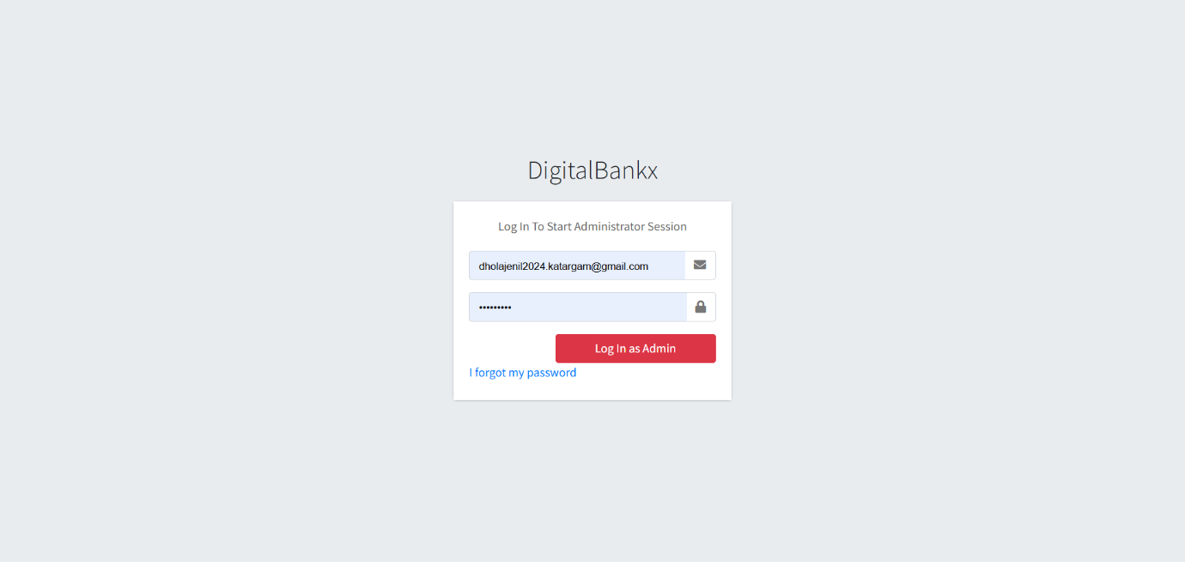
- In this page admin can login in to own website for authentication check.
- In any situation admin forgot the password they can get password on registered mail it will display on next page.

- Forget Password:-
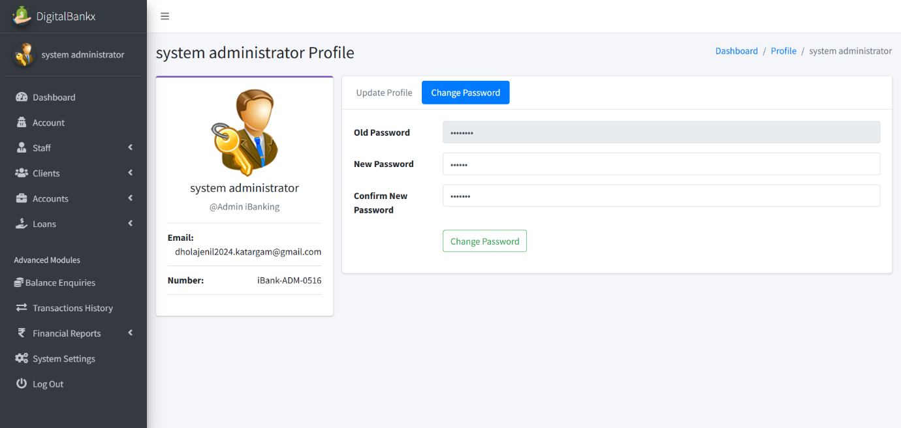
- Admin get their Forgot password through email and if they want to change it they can change password after logi
Dashboard:-
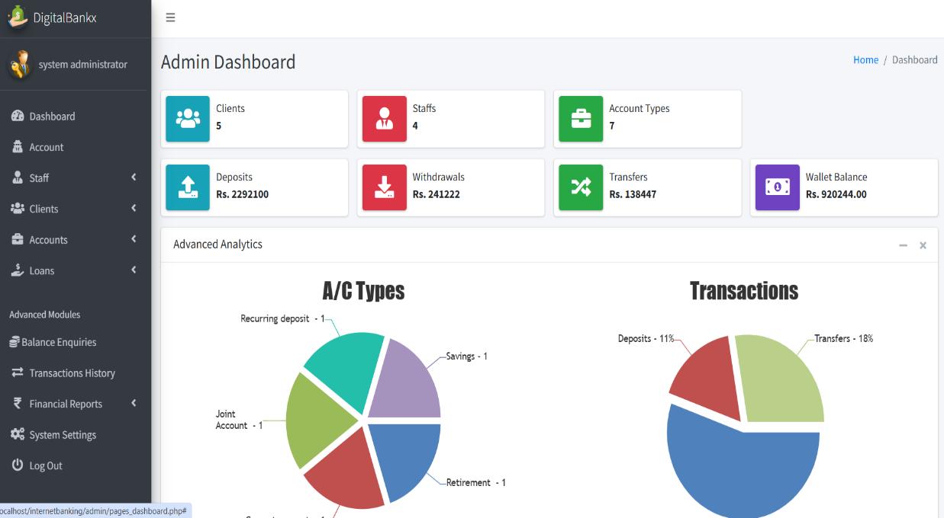

- In this Page admin can see the Dash Board, how many clients,staff, a/c types,deposits, withdrawlas ,transfer ,wallet balance
Admin update profile:

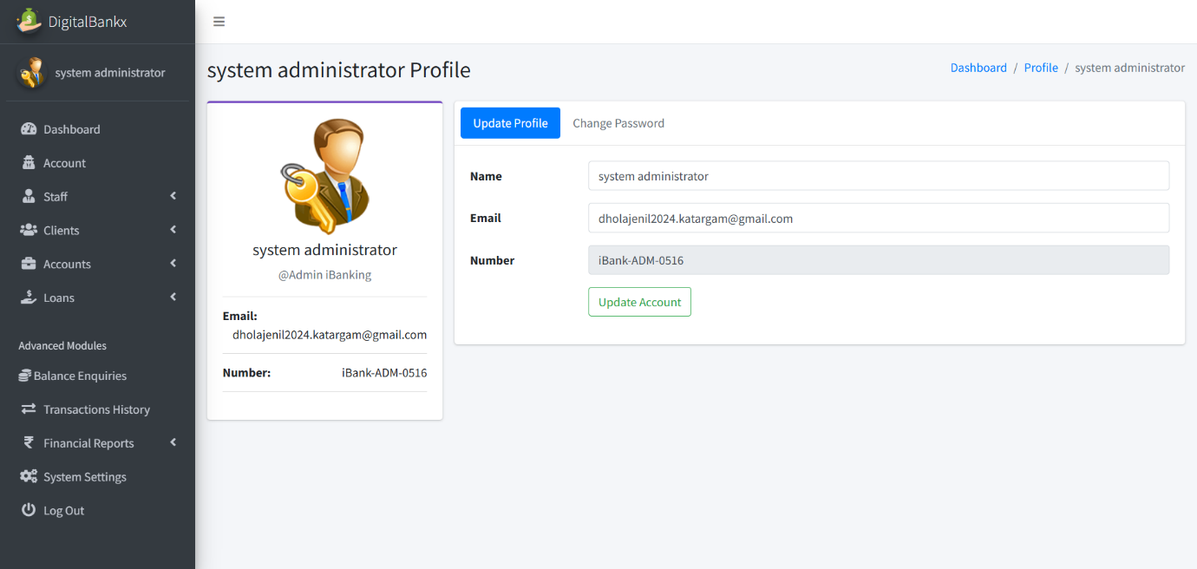

iin

- in this admin can update their profile. For update they have to enter name and email .
Admin change password :

- In this page Admin change the password. they have to enter old password and then they have to enter new password and confirm password.

Change password OTP
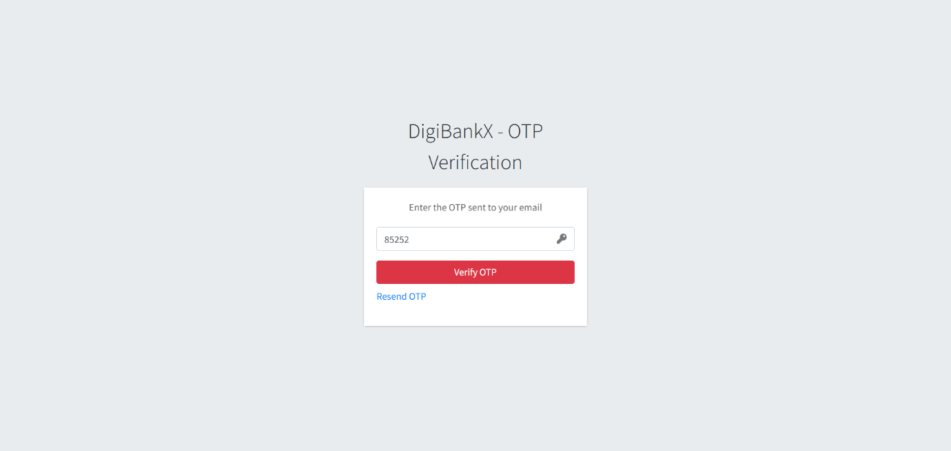
- If you forgot the password we have fasality of change password with OTP verification.
Create staff :

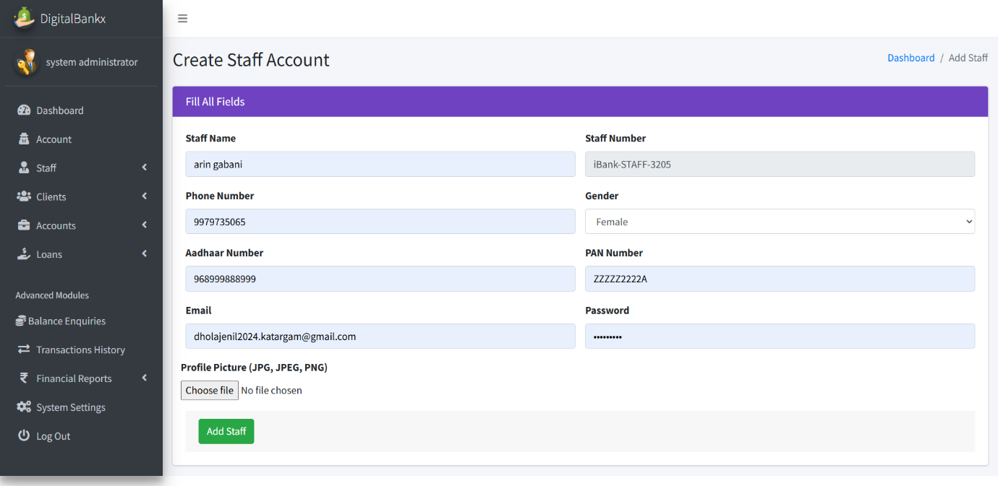
- In this page Admin can create a staff . it can ad staff after enter staff name,mo. Number ,gender , aadhar number , pann number etc.

- staff page:
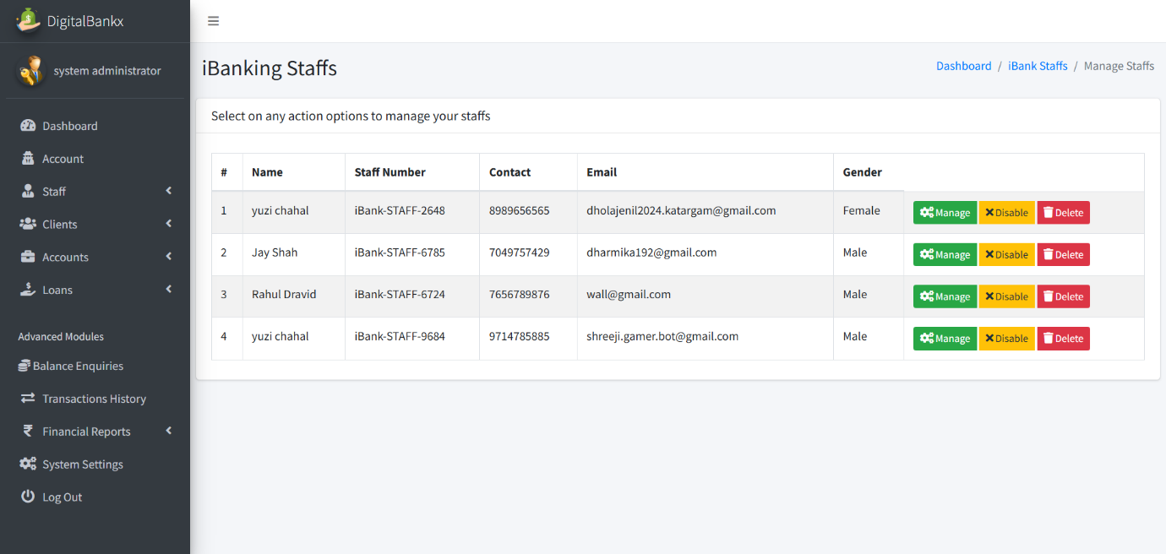

- In this page admin can see the list of staff and also it can disable and delete the staff.
- Admin can active or deactive them.
manage staff :
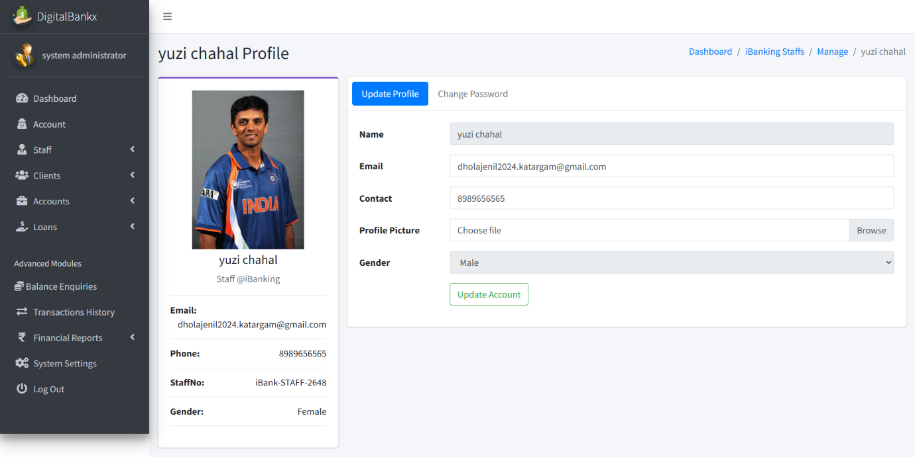

- In this page admin can change staff profile . they can change password also.
Client page :
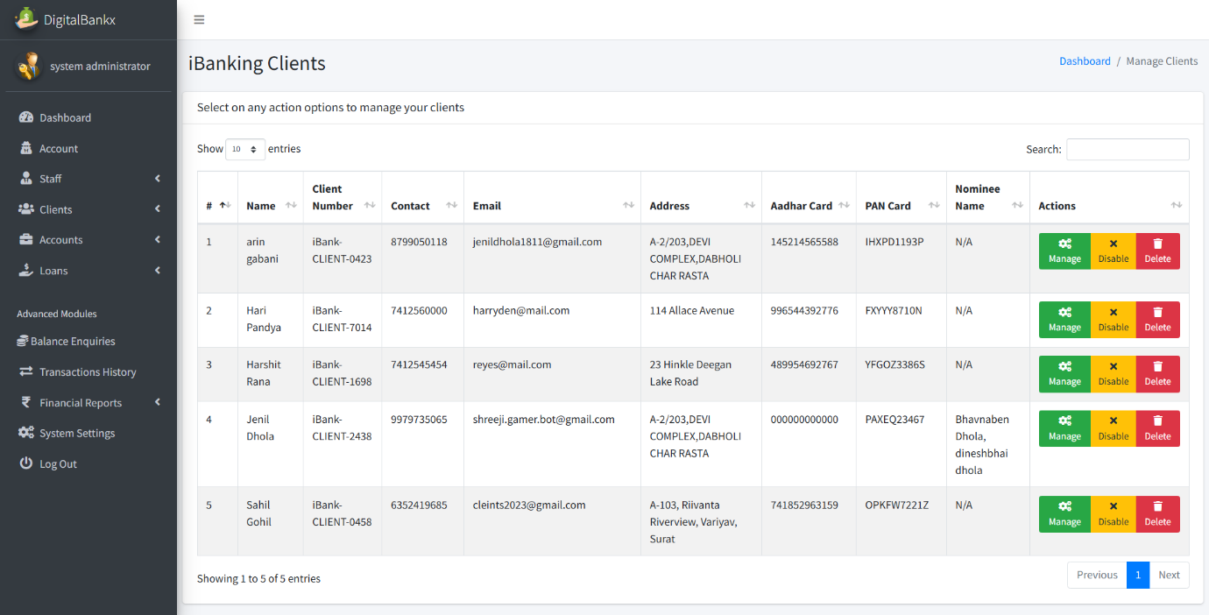

- In this Page admin can see list of clients. Admin can mange , disable and delete the staff.
- Admin can disable and enable the client.
Manage clients :
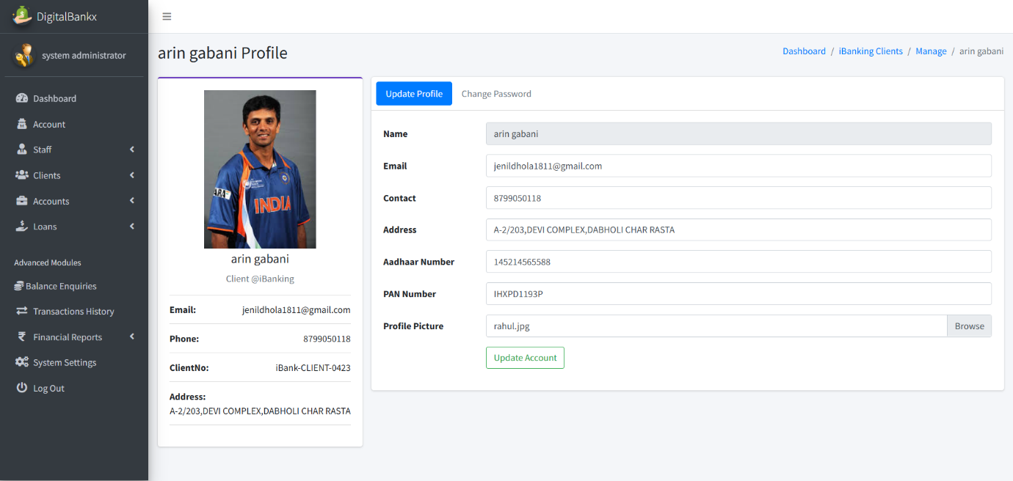

- In this page admin can update the profile of clients.
- Admin can change the pass word of clients.
Create account categories:
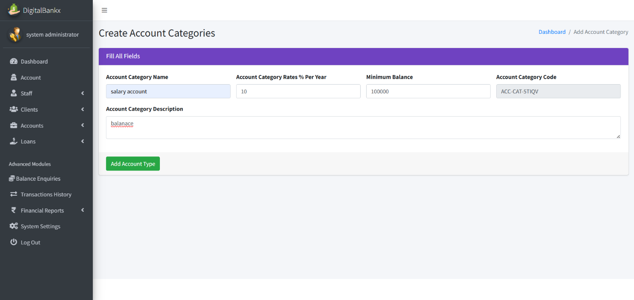

- In this page admin create the account categories by add name , rates , min balance of it .
Manage a/c type:
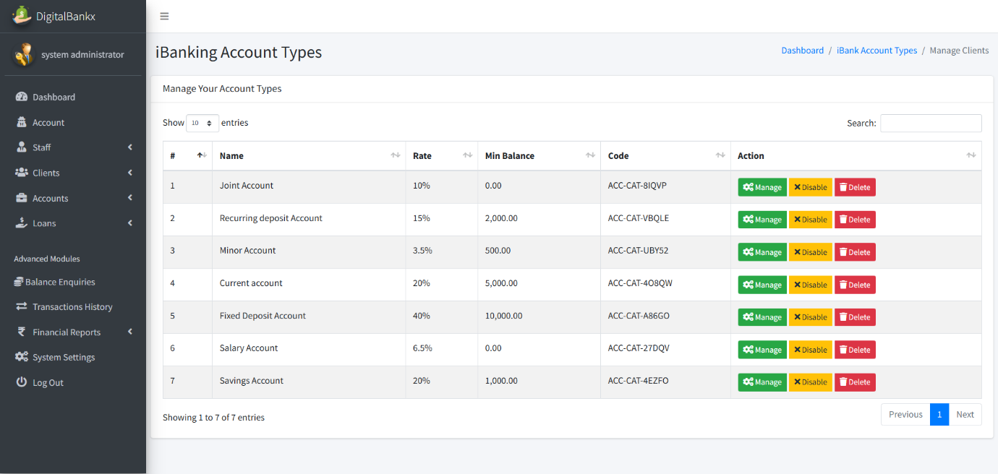
- In this Page admin can see list of account types .
- Admin can manage disable and delete the types.

Update category name :
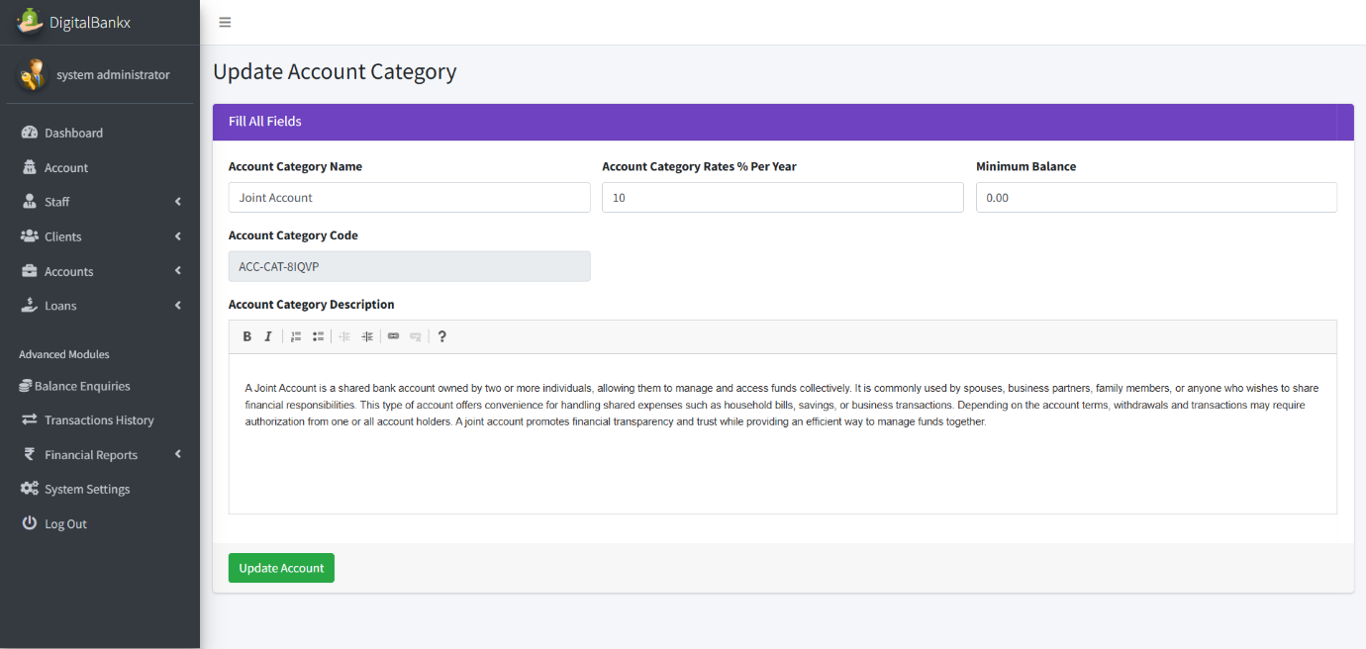
In this page admin can update account category.
Manage a/c :
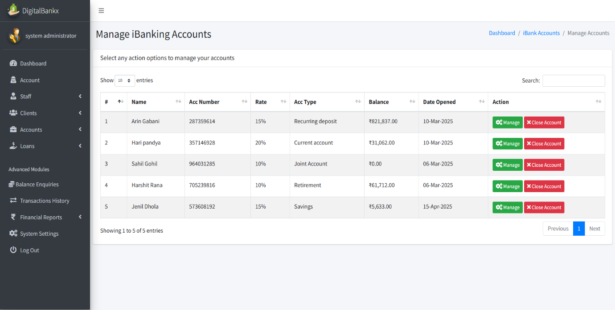
- In this page admin can see list of a accounts.
- Admin can manage and close account

update a/c type :
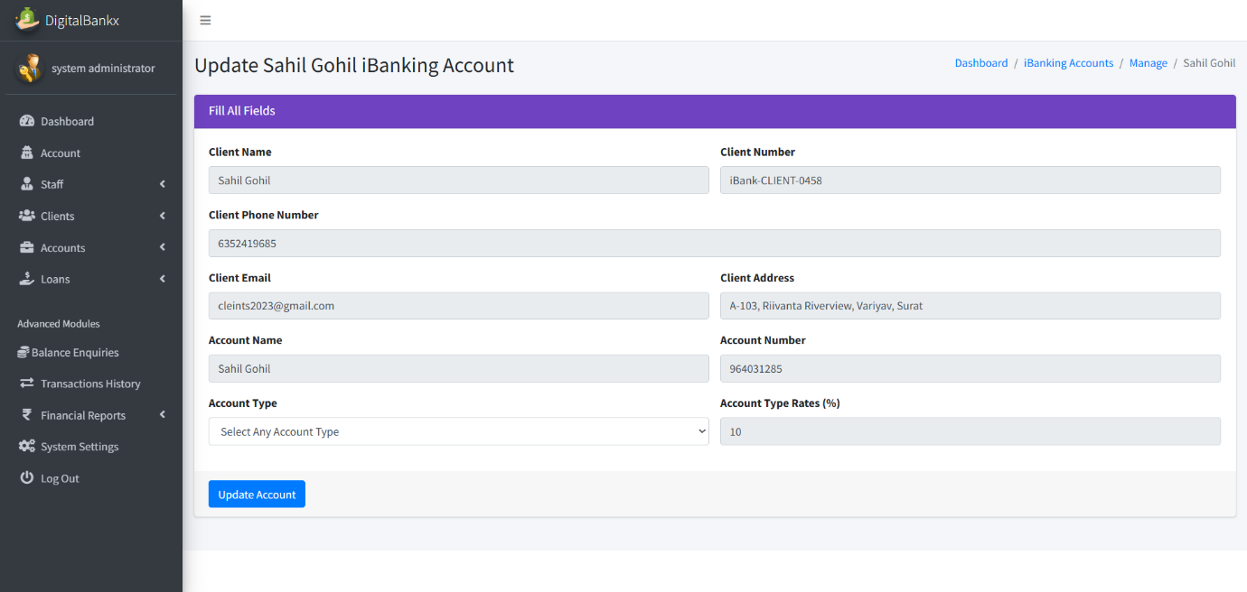
- In this page admin can update the clients account
- Admin can convert the account type .
Loan application:
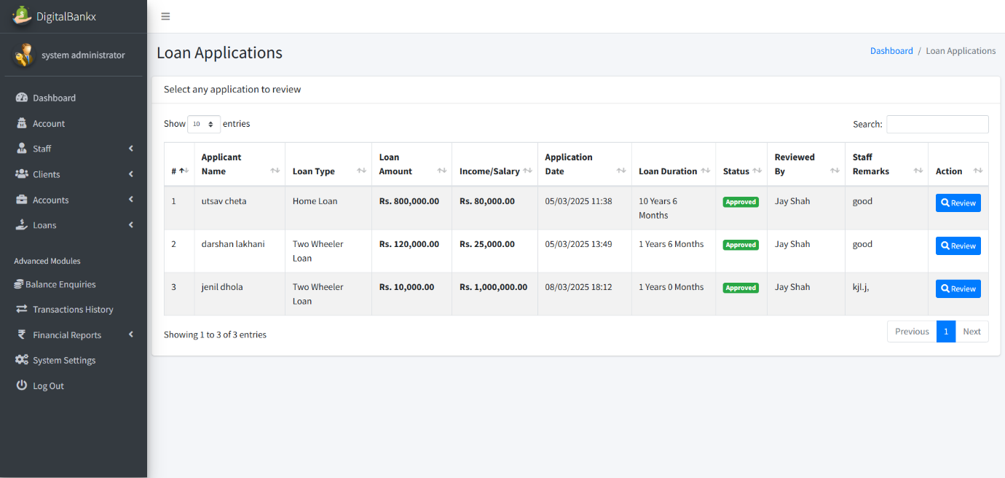
- In this page admin can see list of loan application and see its status also.

Review loan application:
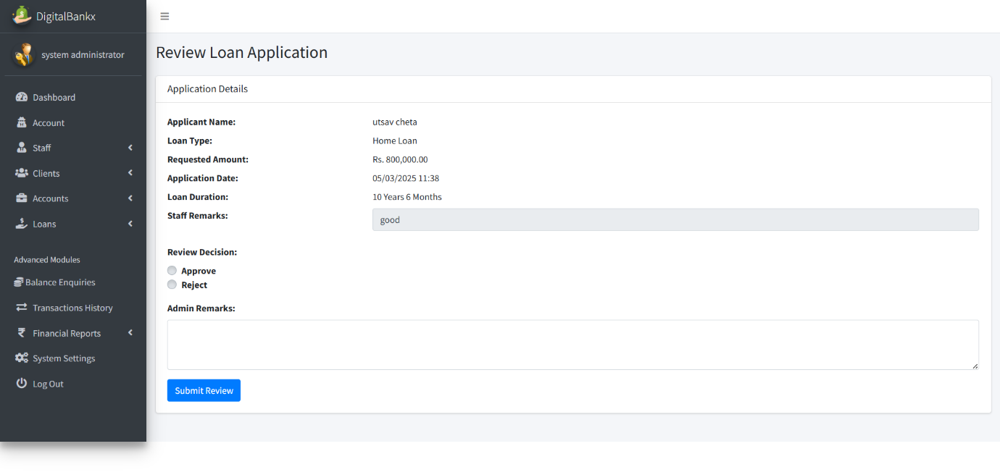
- In this page admin can review loan application.
- Admin also approve or reject the loan.

Add loan type :
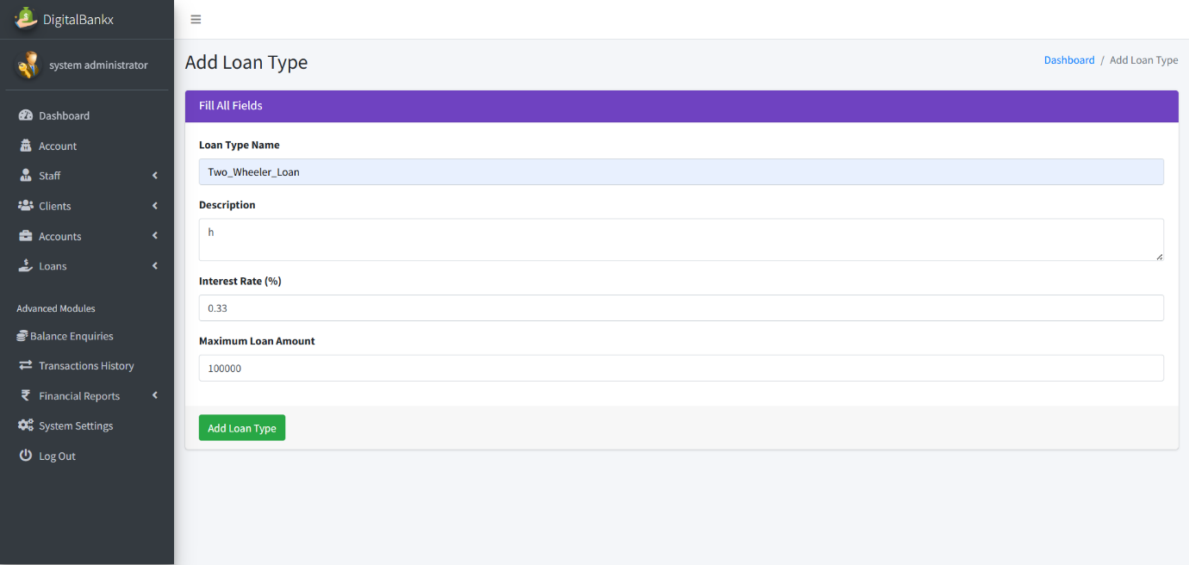
In this page admin can add loan type by add loan type name,description and max amount .

Edit loan type:
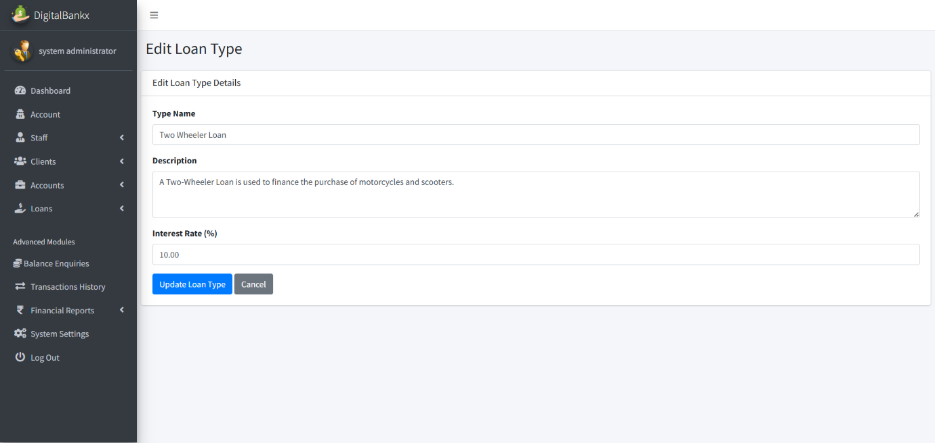
- In this page admin can edit the loan type .

Balance enquiries:
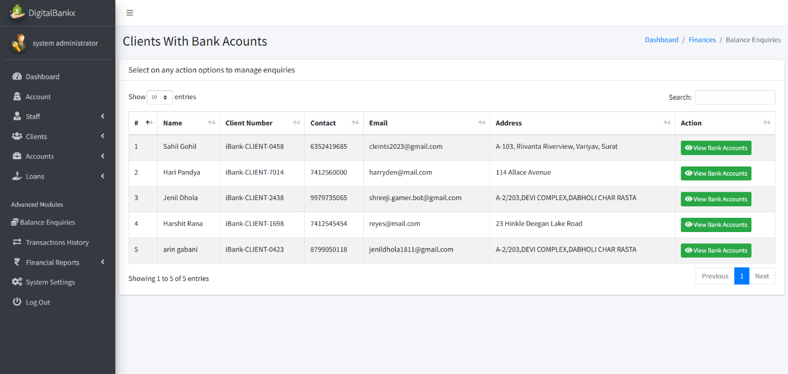
- In this page admin can see list of clients account .

Check balance:
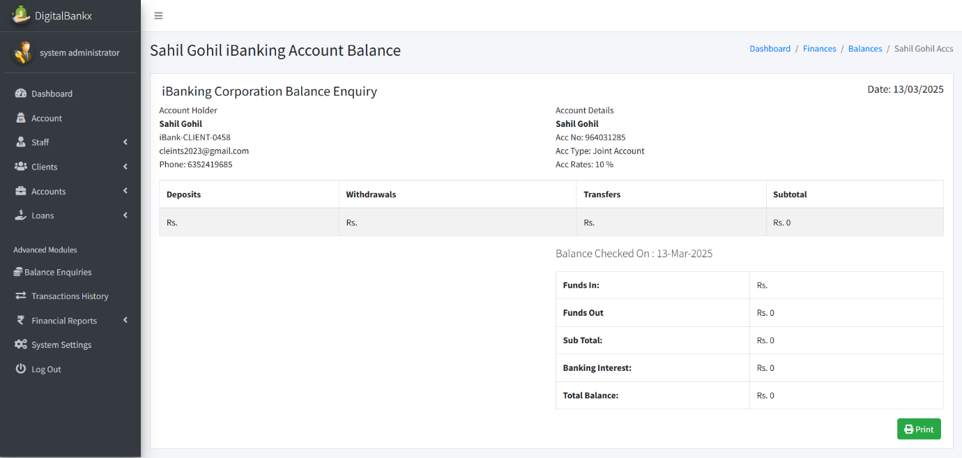
- In this page admin can see account balance .
- Admin can also see the total funds in and out.
Transaction history :
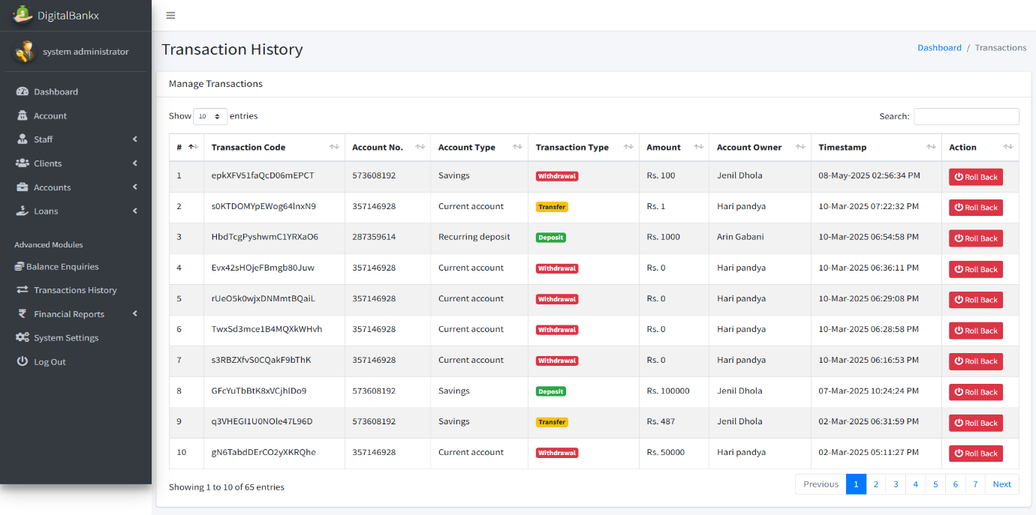
- In this page admin can see the whole transaction history.

Deposit report:
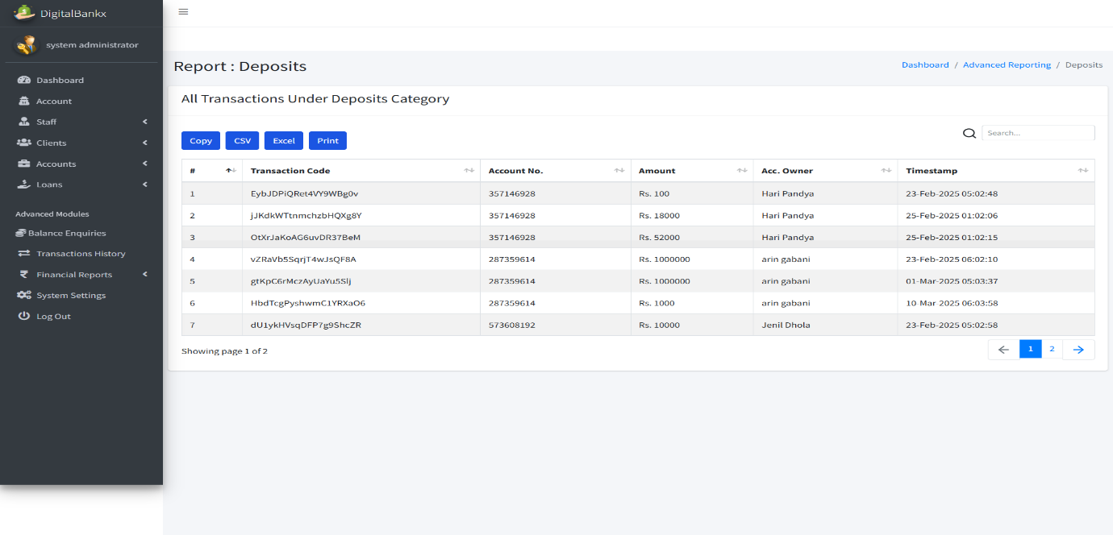
- In this page admin can see the whole history of deposite data.
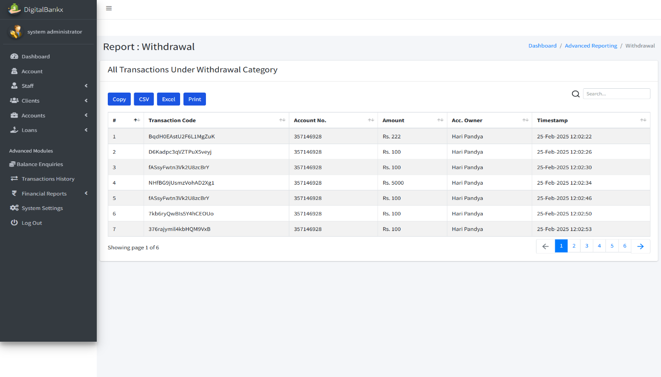
Withdrawal report:
- In this page admin can see whole withdrawal history .

Transfer report:
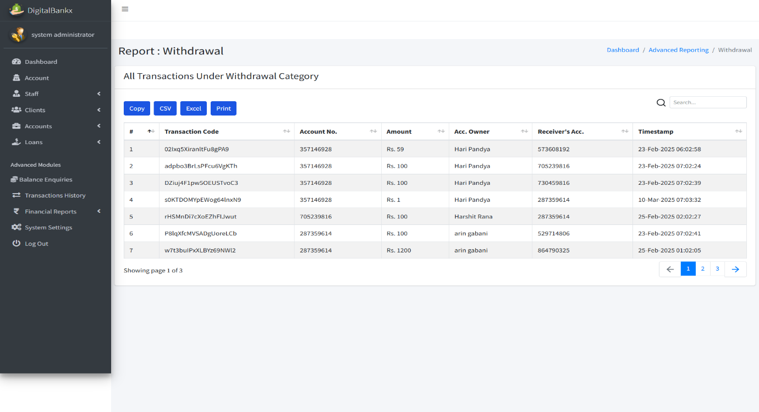
- In this page admin can see whole transfer history .

System setting :
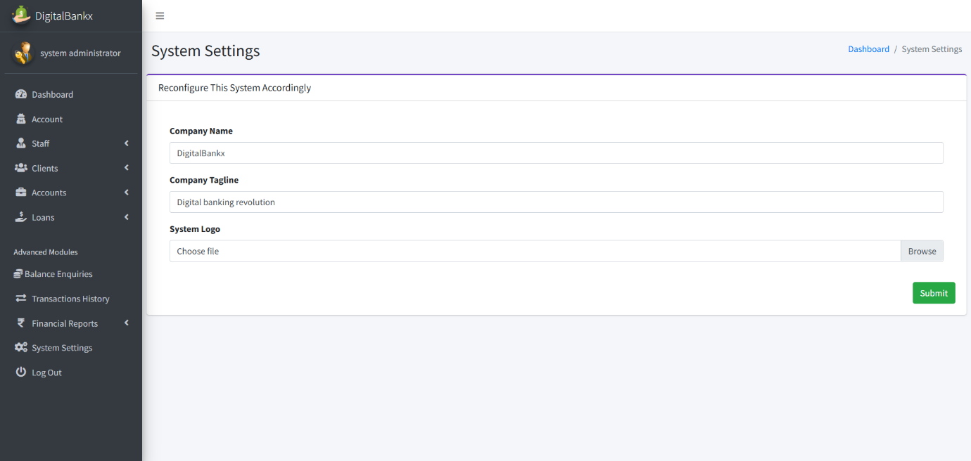
- In this page admin can update the system setting .
- Like company name , company tagline and system logo etc.

- Staff Side:
Staff login:

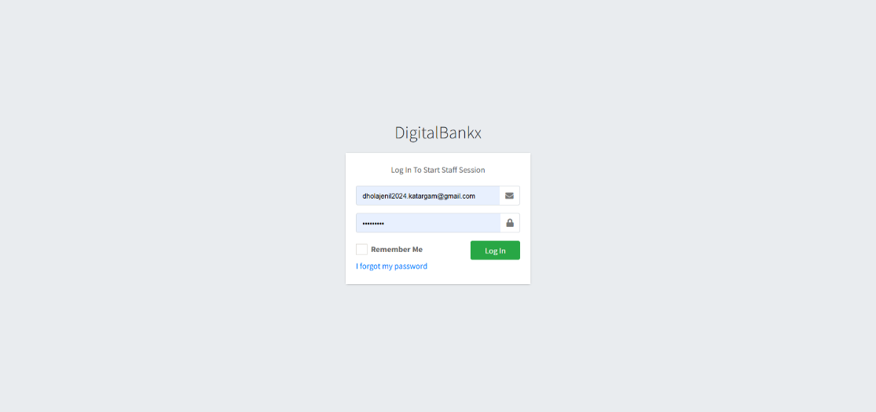
- In this page login to staff session and access the internal system..
Staff dashboard:

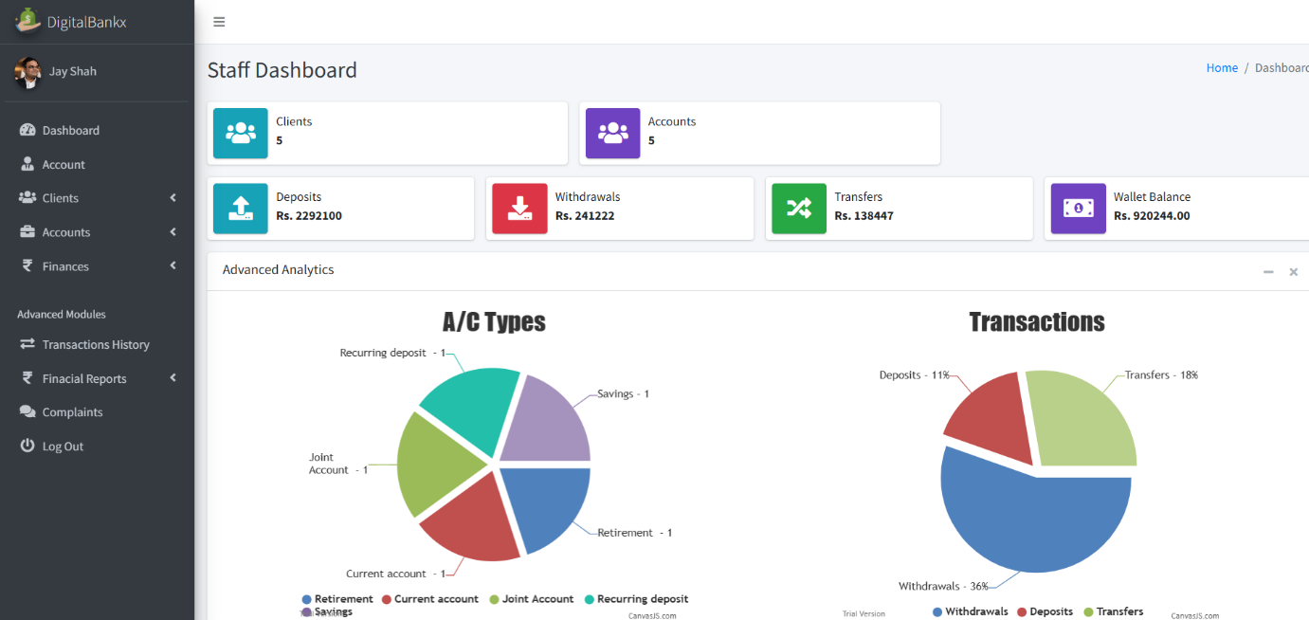

- in this page access transaction history, complaints, financial reports, and other modules.
- View reports and charts on account types and transaction trends.
Staff account :
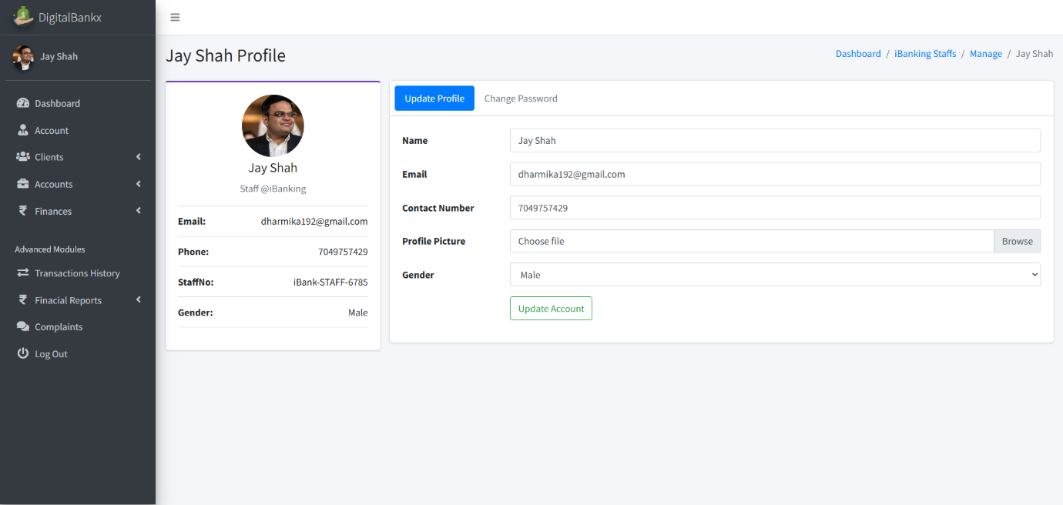
- In this page staff can update their name, email, contact number and profile picture.
- Staff account section is used to mange individual employee profiles within the banking system.
IB Clients:

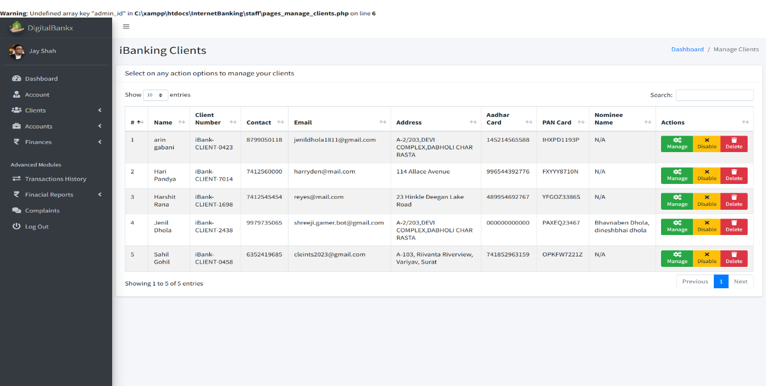
- In this page use to manage customers who have registered for internet banking.
- Account information maintain details like client name, contact, email, address, Aadhaar card, PAN card, etc.
Manage client :
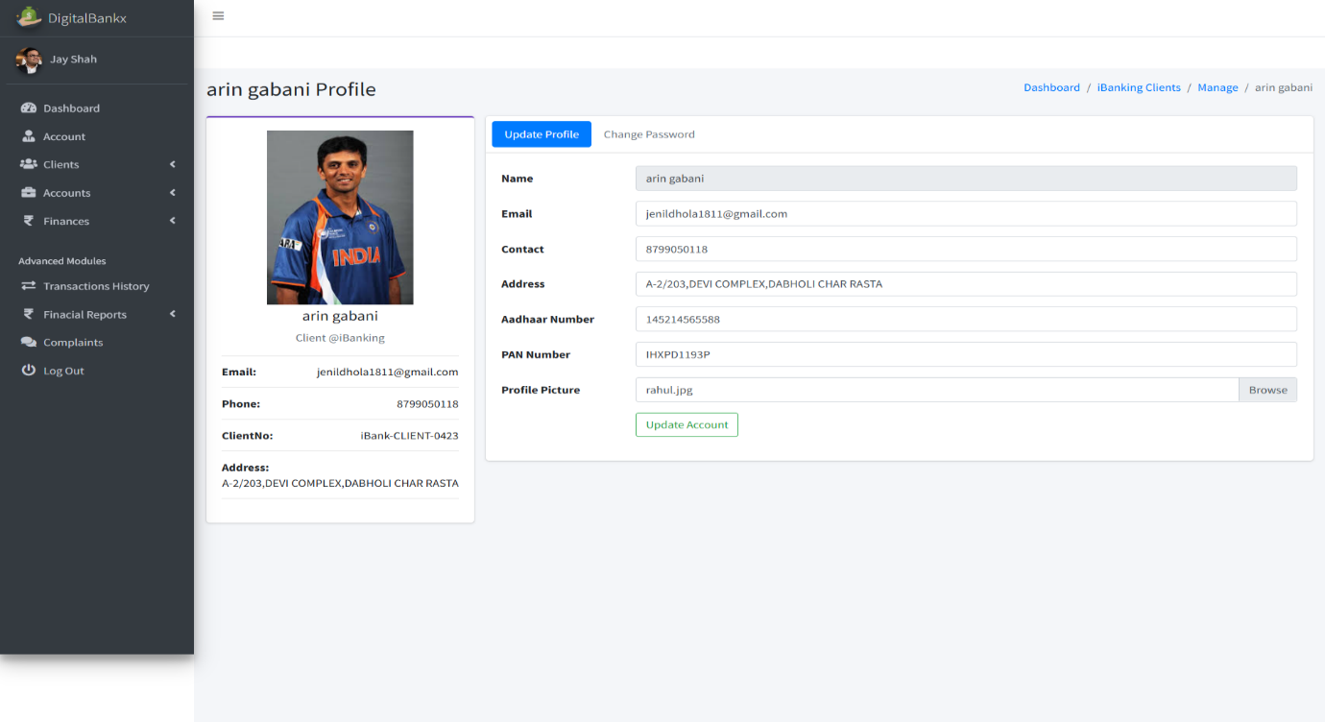
- In this page use for handing individual customer details.
- Change profile pictures and other personal details.
- Update details like name, email, phone number, address, Aadhaar number, PAN card, etc.
- IB account :
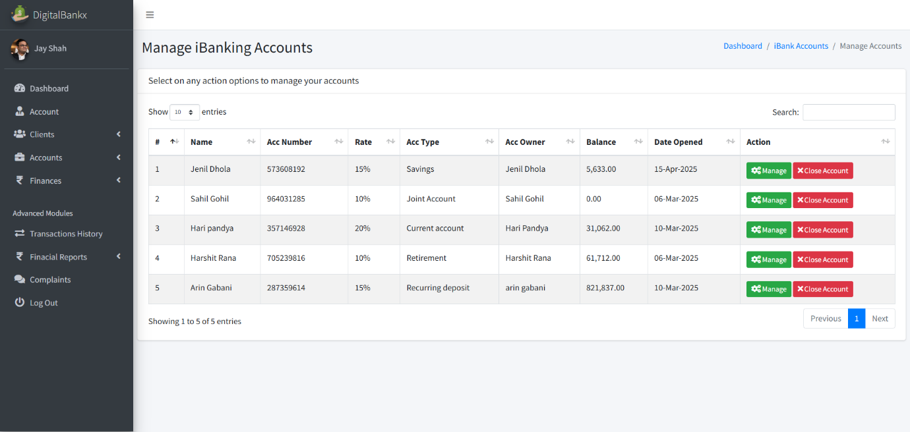

- In this page used to manage the internet banking accounts of clients.
- Handle different types of accounts like savings, current, joint, retirement, and recurring deposit accounts.
Manage account:

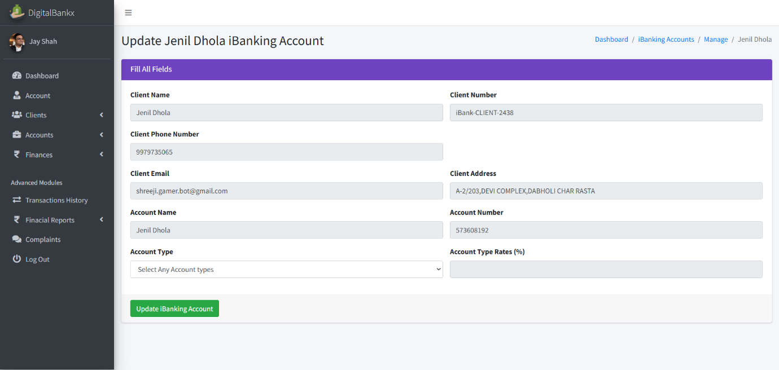
- In this page used for handling specific internet banking accounts of clients.
- Update Client Banking Details to Modify account-related information such as client name, account number, phone number, email, and address.
Deposits money:
- 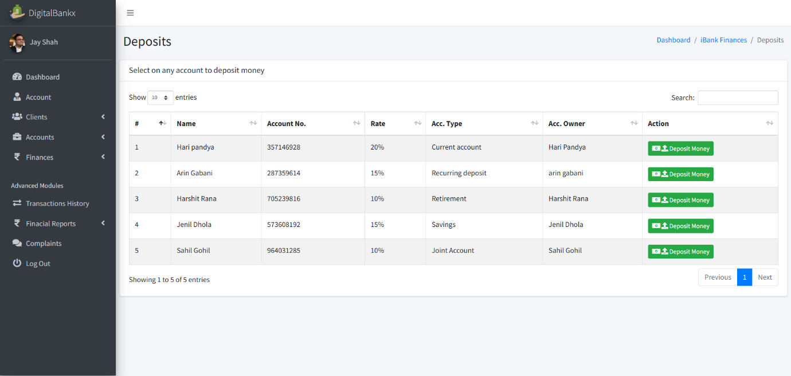 In this page use to current account and joint account for deposits money.
- Deposits money includes details of multiple accounts money can be deposited
Deposit money:
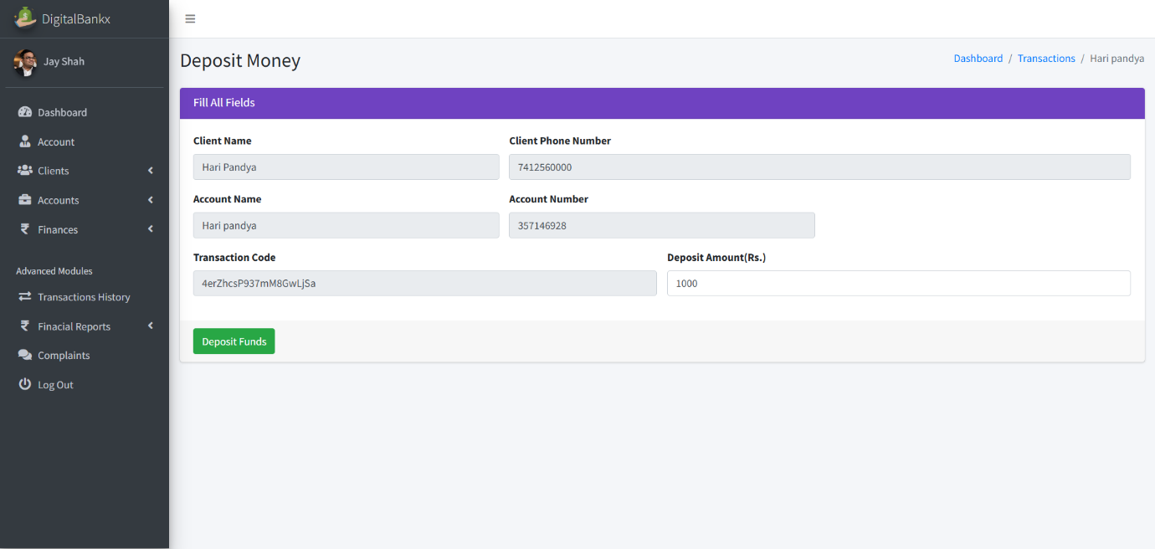
- In this page deposit is linked to a current account.
withdrawals:
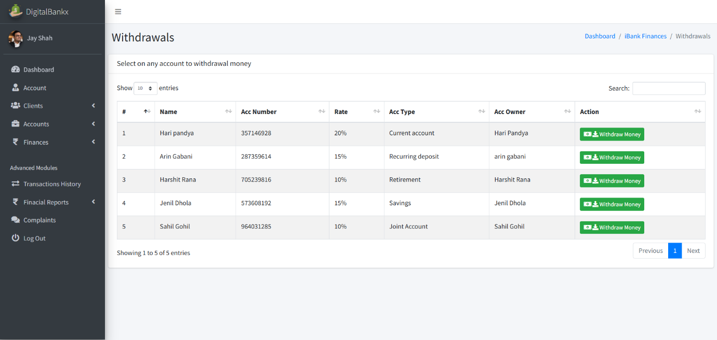
- In this page withdrawals section allows users to select an account and withdraw funds.
Withdraw money: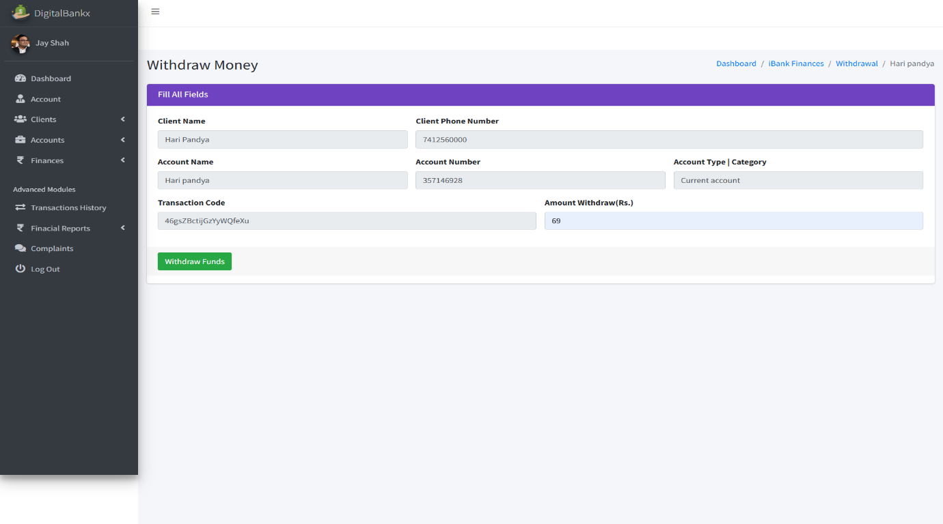

- In this page allows users to withdraw a specific amount from their account.
- transferring it elsewhere or making it available for cash withdrawal.
Transfers:
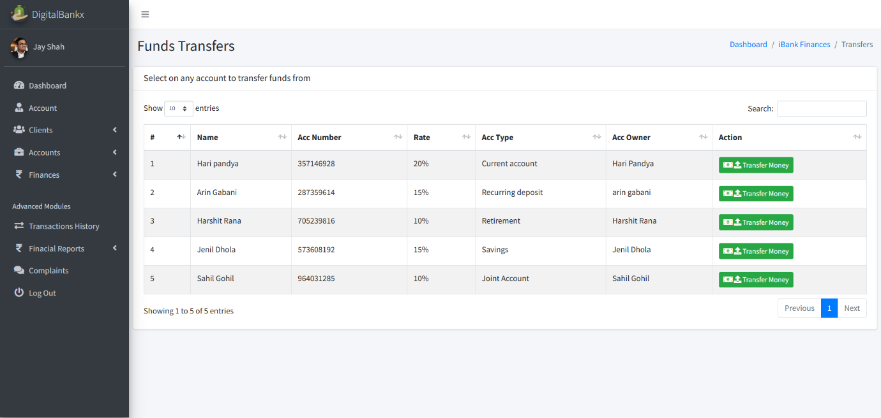
- in this page Transfer Money section allows users to select an account, enter the recipient’s details, and send funds securely.
- Transferring money is used to move funds from one account to another account.
Transfer money :
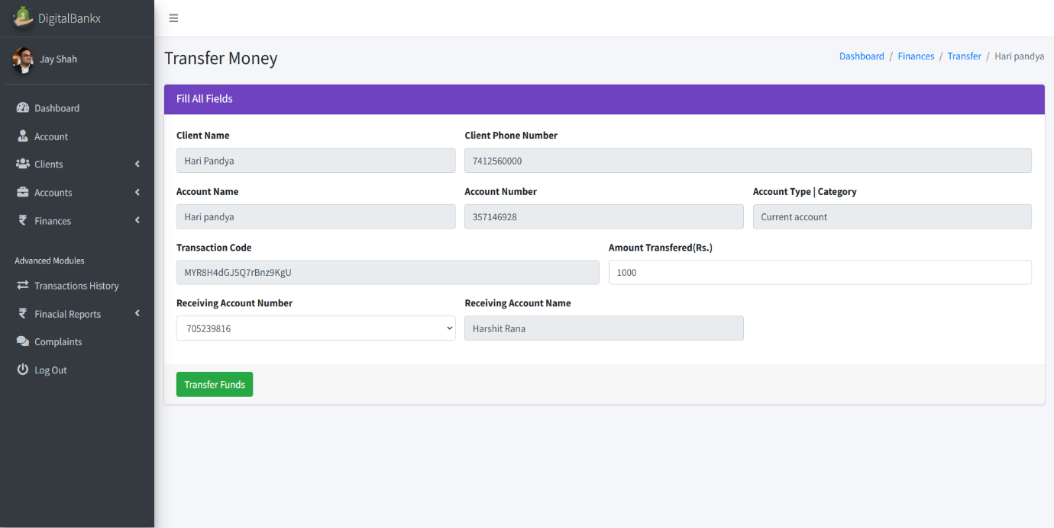
- In this page use to section is used to move funds from one account to another.
Loan application:
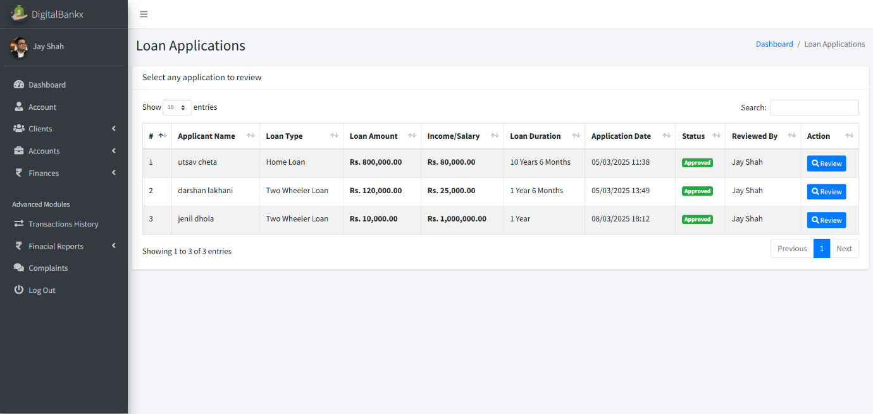

- In this page used Loan Applications section allows users to submit and review loan requests.
- Customers request a loan by providing details like loan type, amount, income, and repayment duration.

Review loan application:
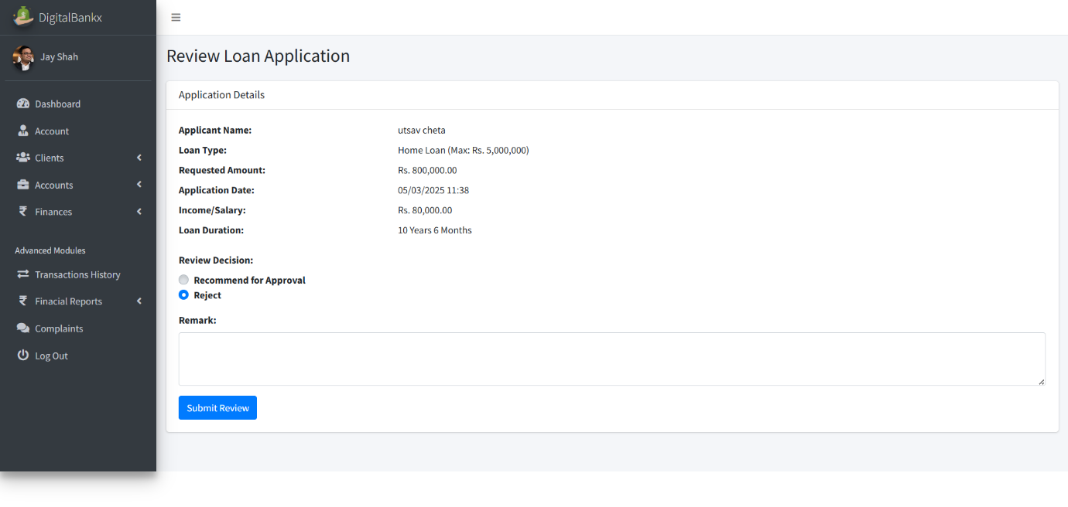
- In this page use to evaluate and process loan requests.
- this feature allows financial institutions or administrators.
Balance Inquiries:
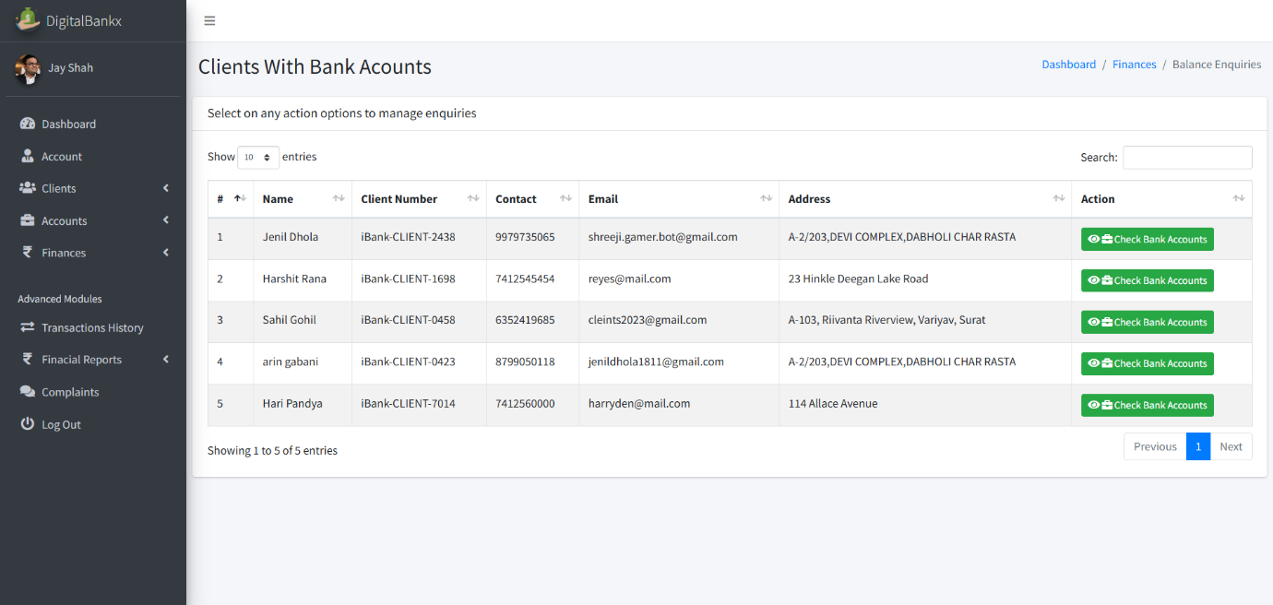

- in this page use to check and manage the account balances of clients.

Check balance :
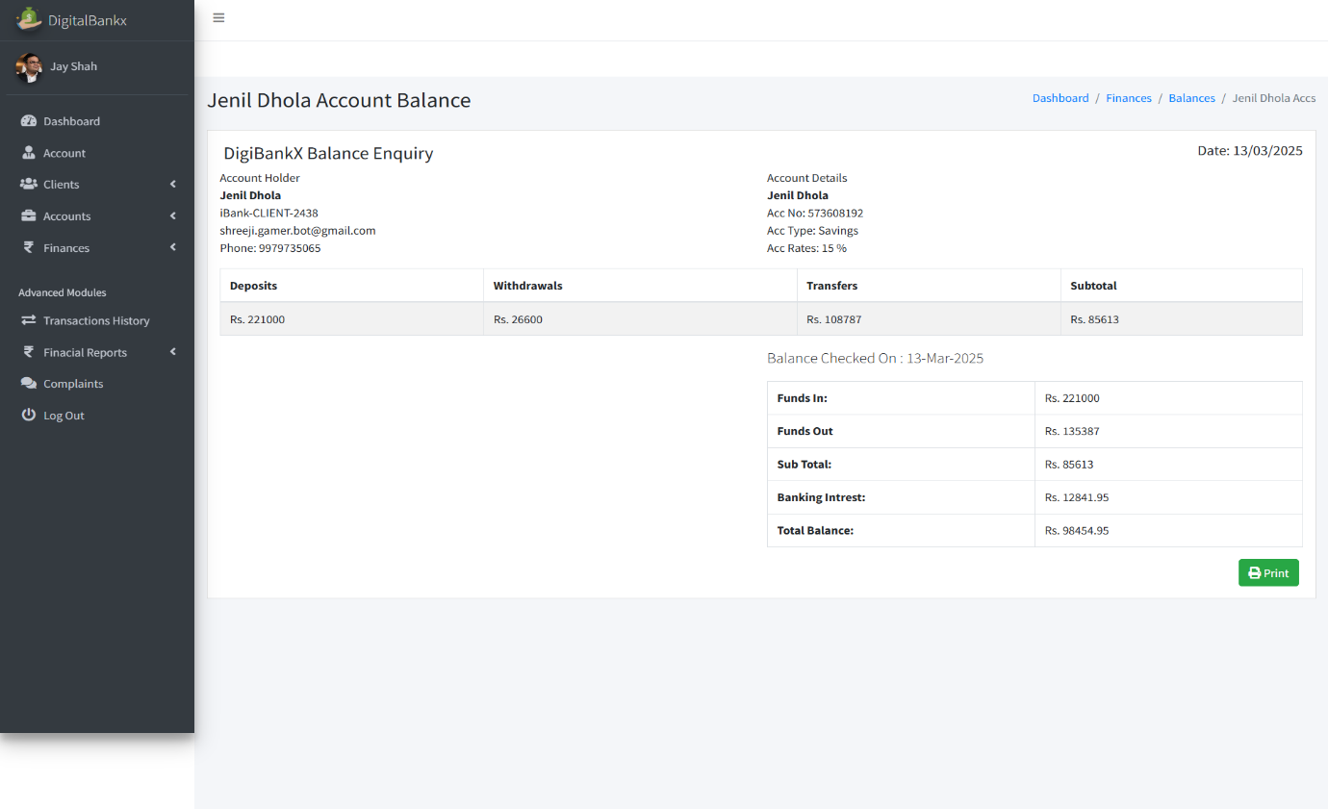
- Check Balance section is used to view the financial status of a bank account.
- Displays the total funds available in the account.
Transaction history :
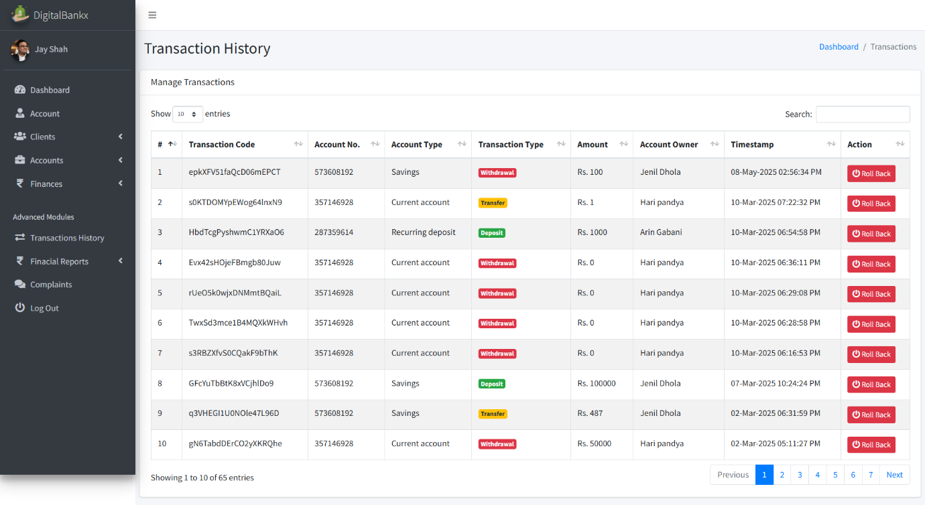
- In this page Displays deposits, withdrawals, and transfers in one place.

Withdraw history :
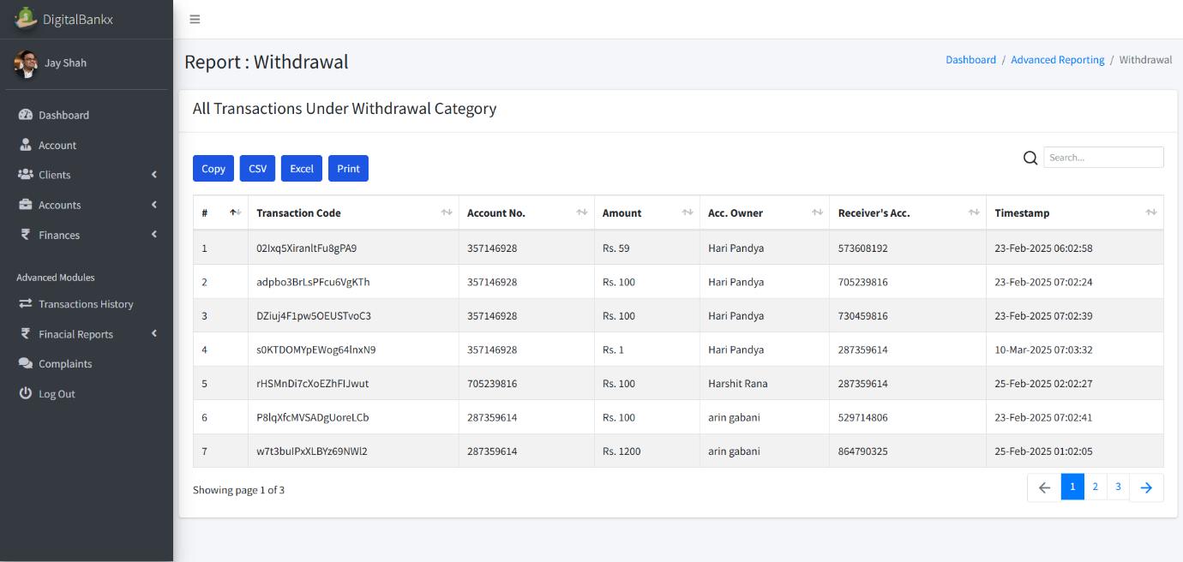

- In this page used to track and manage all withdrawal transactions made from an account.
- Displays all withdrawal transactions, including the amount, account number, and account owner.
Deposits history :
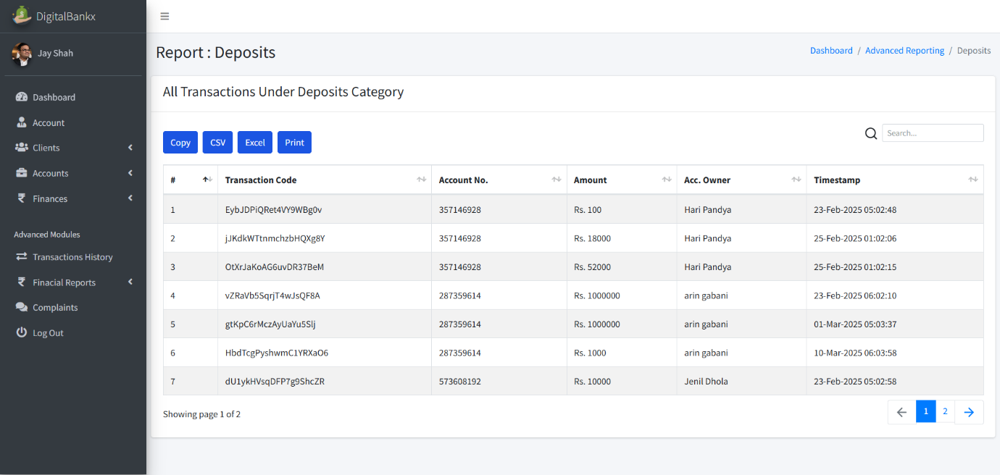
- In this page used for tracking all deposit transactions made into a bank account.
- Allows users to copy, export or print reports for documentation purposes.
Transfer history :

- In this page used to track all money transfer transactions within a banking system.
- Displays details such as transaction codes, account numbers, transferred amounts, and timestamps.
Complains:
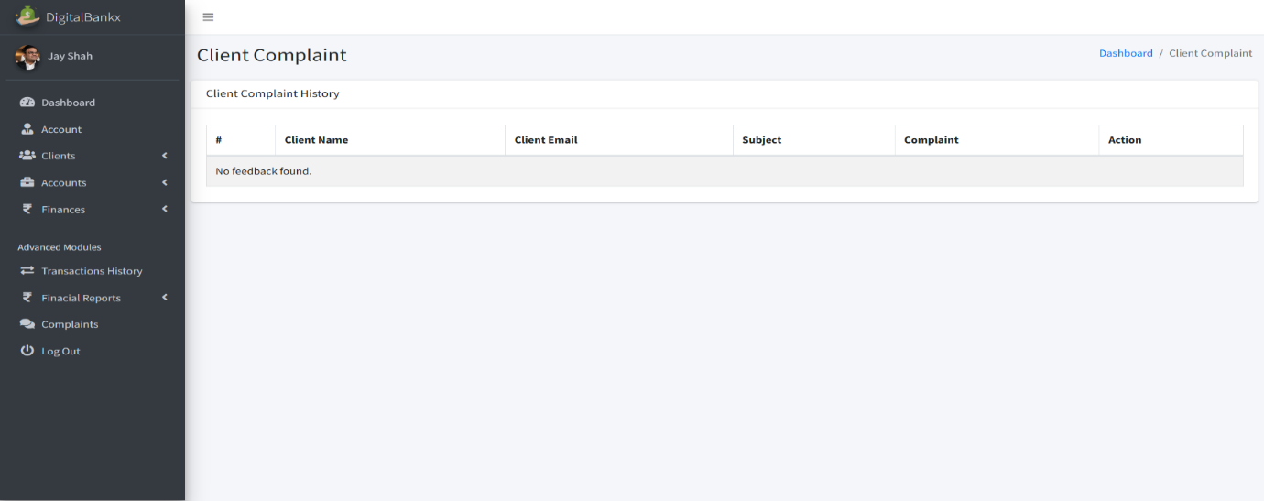

- Displays customer complaints along with their email, subject, and details of the issue.
- Client Side:
Visitor page :

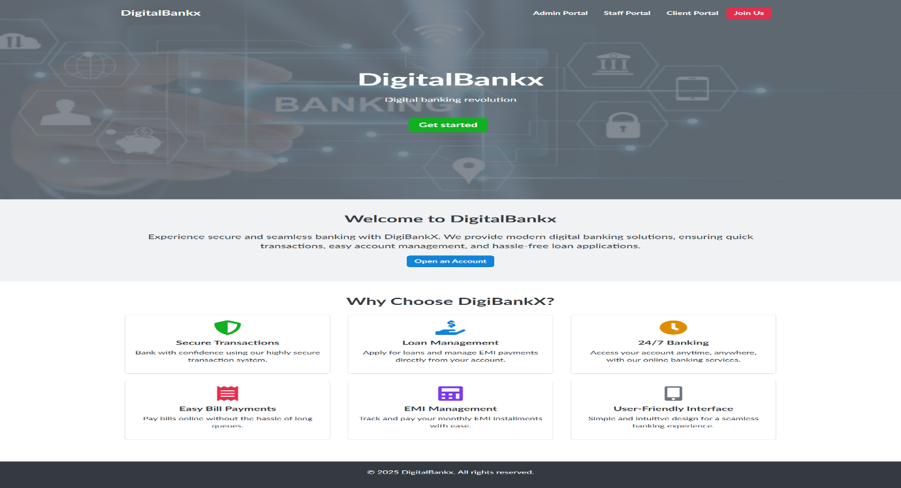

- Visitor Page in the DigitalBankx platform serves as the landing page for new and potential users.
- Includes buttons for Get Started or Open an Account
Sign up page:
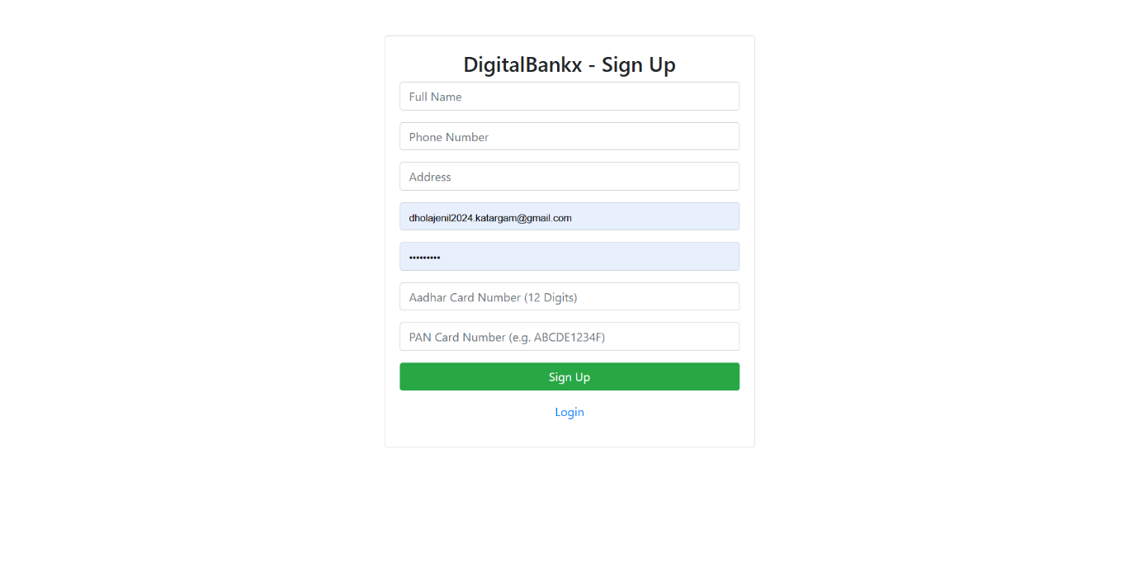
- In this page used for new user registration, allowing customers to create an account.
- Requires users to enter personal details Full Name, Phone Number, Address, Email ID, Aadhar Card Number (12 Digits), PAN Card Number,
Password.
Log in page
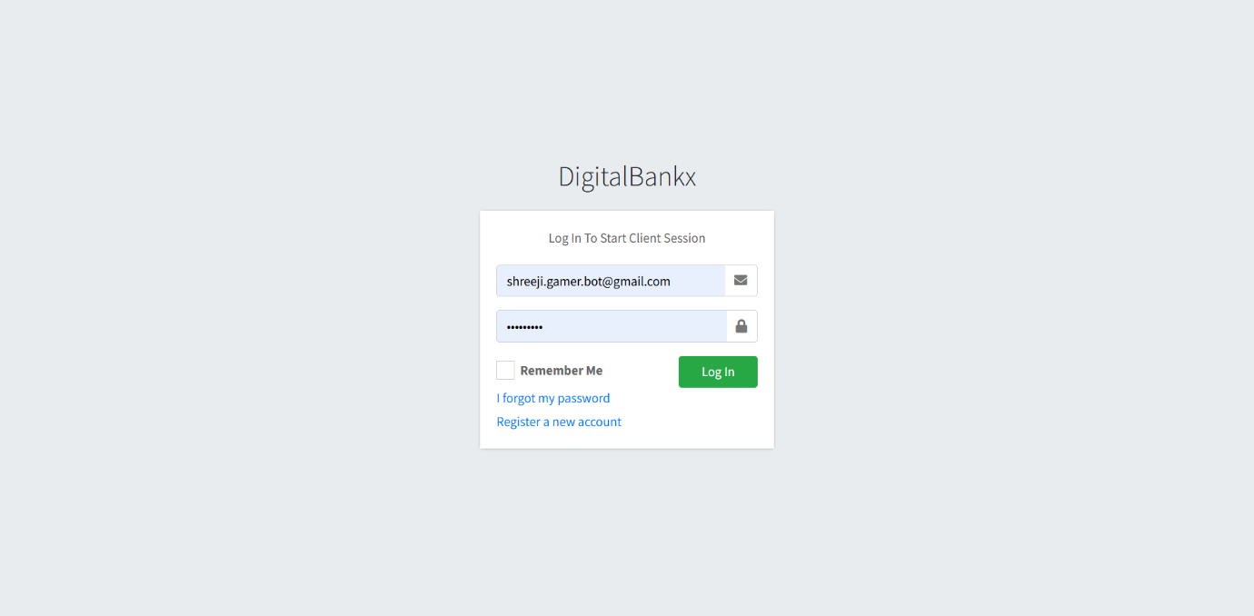

- In this page used for user authentication, allowing existing customers to securely access their accounts.
- Credential Input – Users must enter: Email ID or Username ,Password

User dashboard
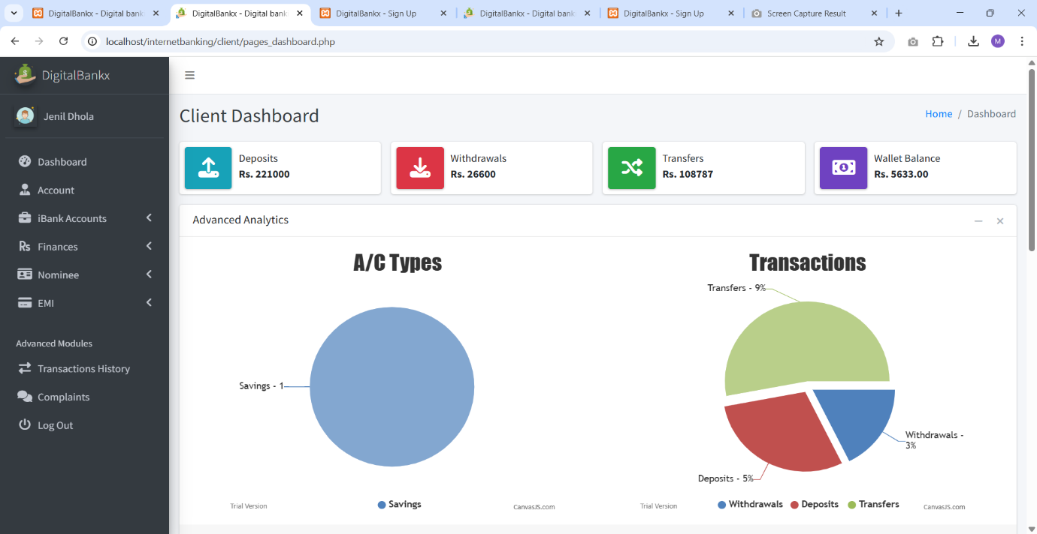

- In this page Displays deposits, withdrawals, transfers, and wallet balance.
- Allows access to features like accounts, finances, transaction history, and complaints.
Opening account page :
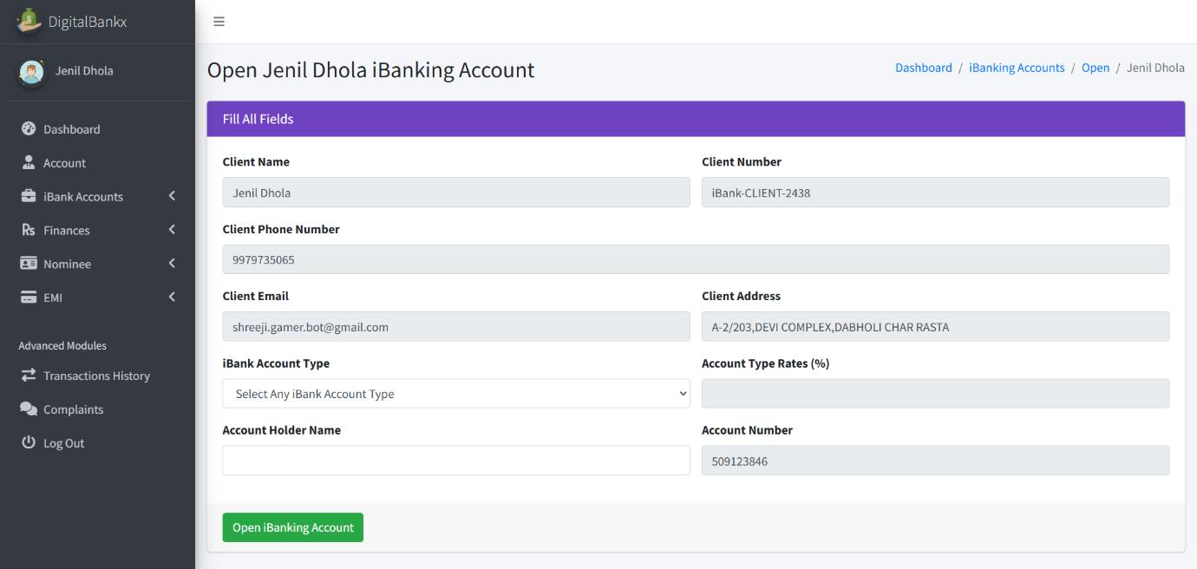
- In this page allows users to enter their personal details and select an account type.
- Display client details, account details, action button.
My account page :
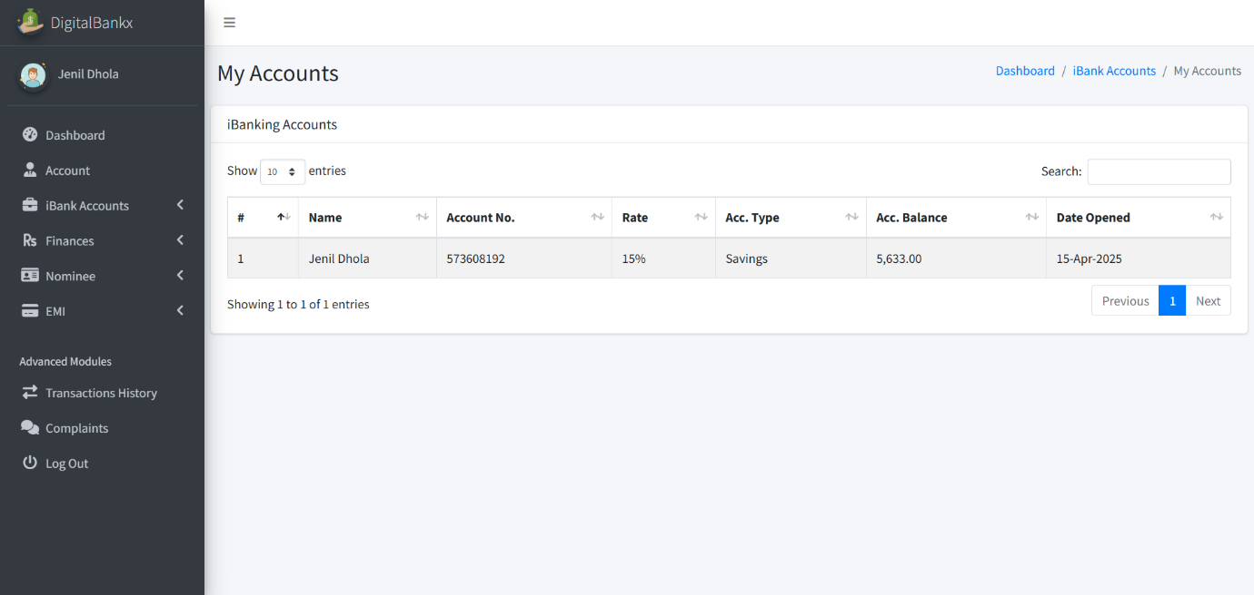

- This page provides an overview of account-related information.
- Display account list table, search and pagination.

Deposits:

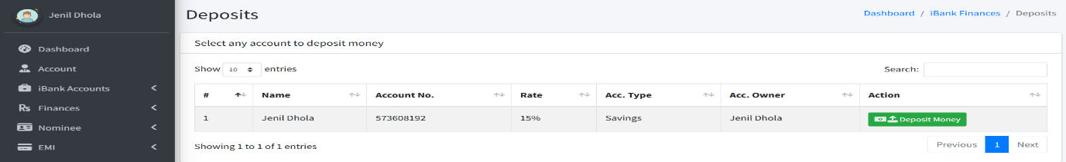
- Display deposit
Transfer deposits
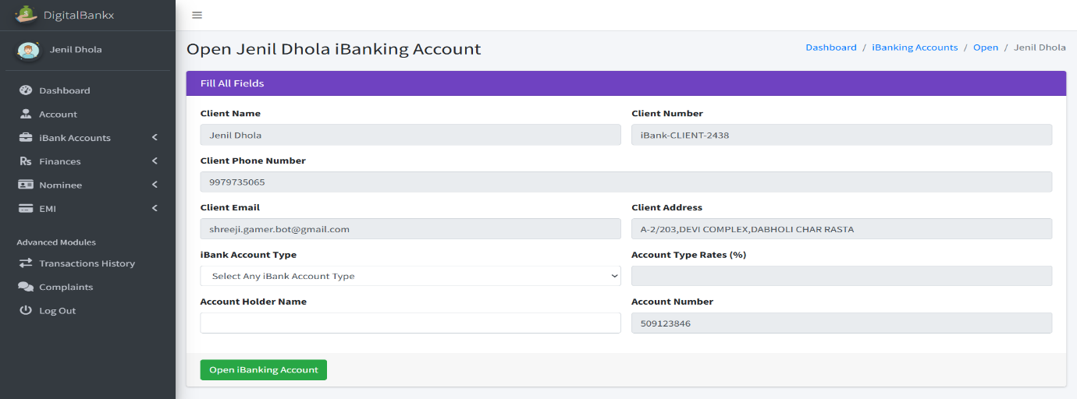

- In this page use feature that allows users to transfer money into their bank accounts.
- There is a green "Open internet Banking Account" button to confirm the deposit transfer.
Withdrawals
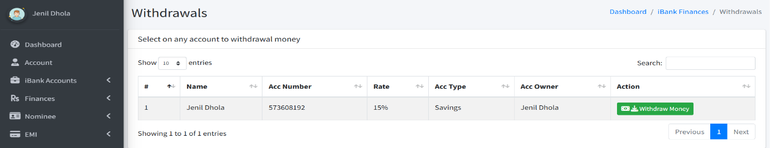

- Display withdrwals.

Withdraw Money
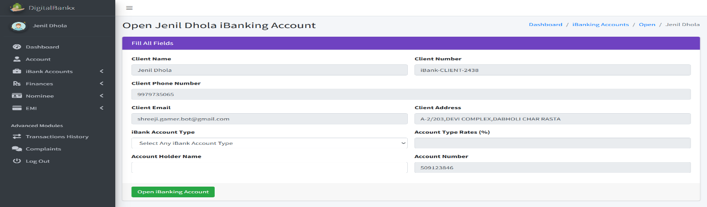

- In this page allows users to withdraw funds from their bank accounts.
- A green "Open internet Banking Account" button is available to confirm the withdrawal.
Transfer
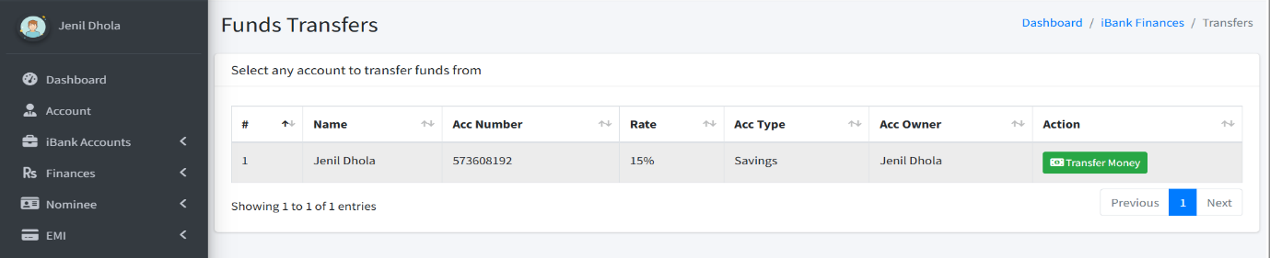
- In this page allows users to transfer funds between accounts.
- A green "Transfer Funds" button is available to finalize the transfer.
transfer Money
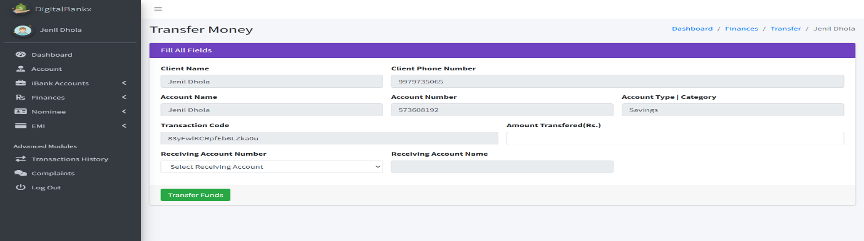
- Click the green "Transfer Funds" button to process the transactio
Apply for loan:
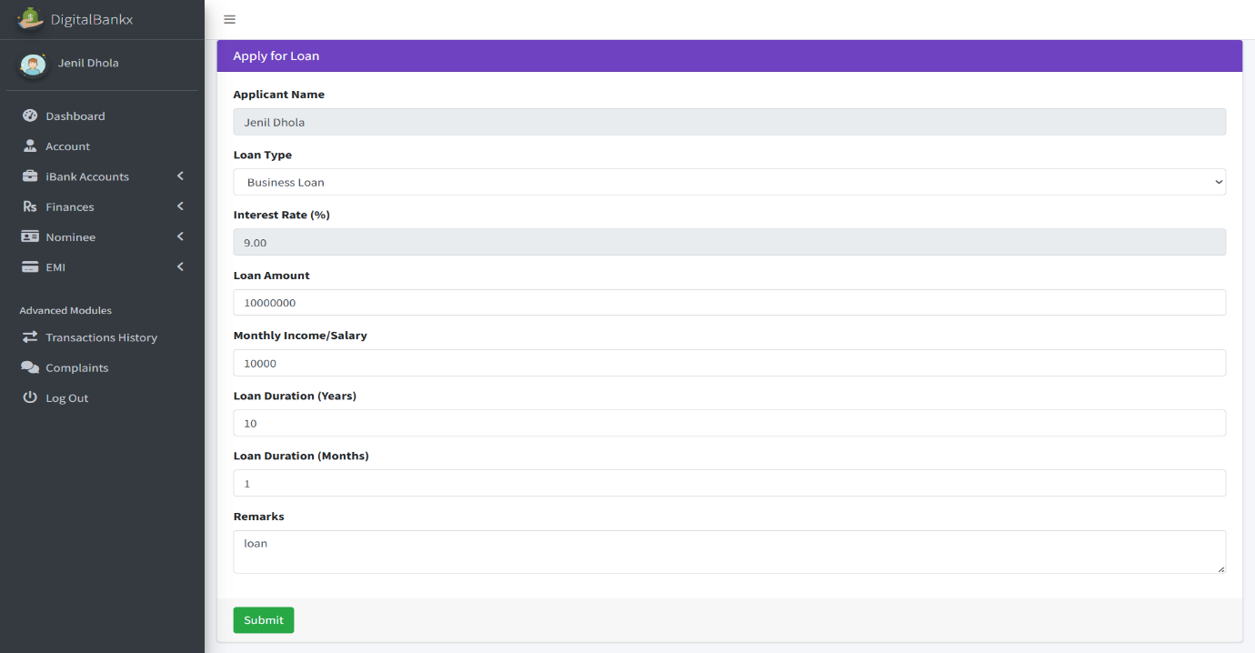

- The user fills in the required details and submits the loan application.
- It enables users to apply for different types of loans: Business Loan,
Home Loan, Two-Wheeler Loan, Other types depending on bank options.
My loan application
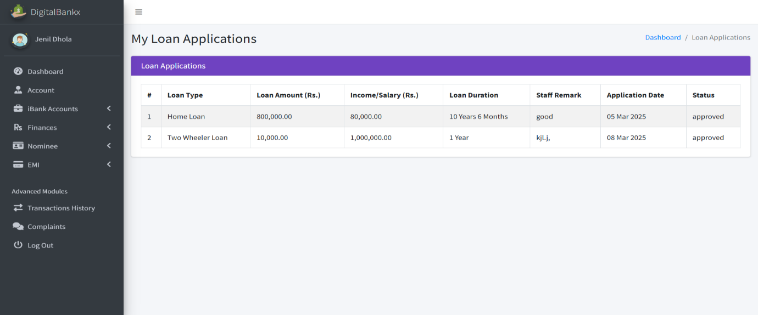

- Display home loan and two wheeler loan.
- Loan application display to loan type, loan amount, income, loan duration, staff remark, application date, status.
Balance enquiries :
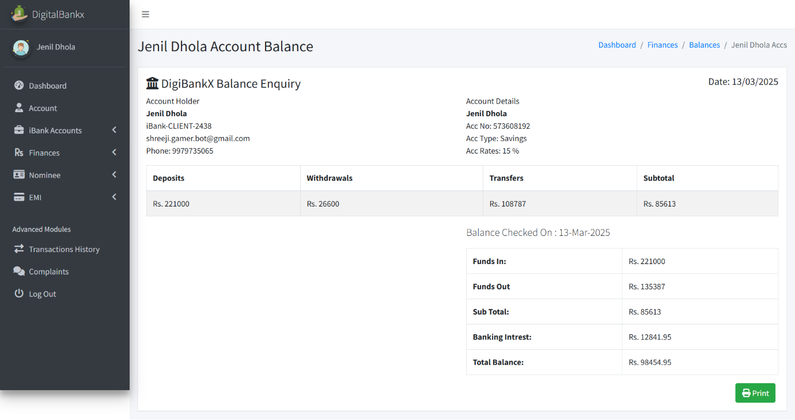

- In this page shows the account balance details for Jenil Dhola in the DigiBankX system.
- It includes: Deposit,Withdrawals,Transfers,Subtotal
Add nominee:
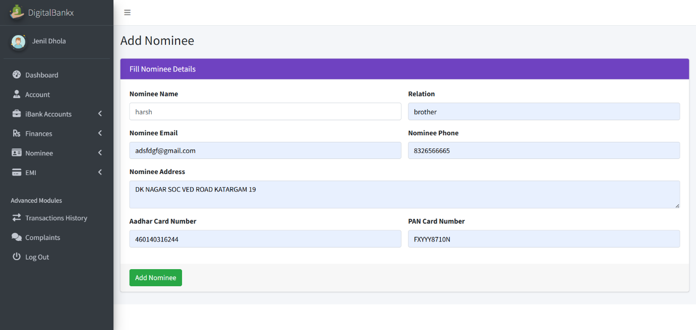

- In this page Add Nominee" section is used for adding a nominee to a user's bank account.
- entering these details, the "Add Nominee" button is clicked to save the information.
Transaction history:
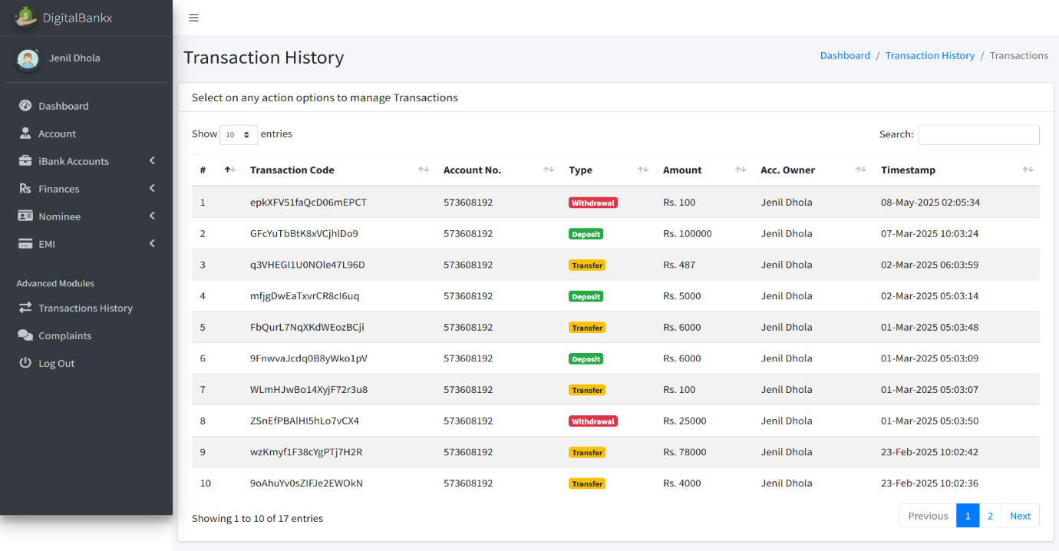

- in this page Track Financial Activities Users can view all deposits, withdrawals, and transfers in one place.
- The history includes color-coded labels for transaction types: Red (Withdrawal), Yellow (Transfer) , Green (Deposit)

Complain :
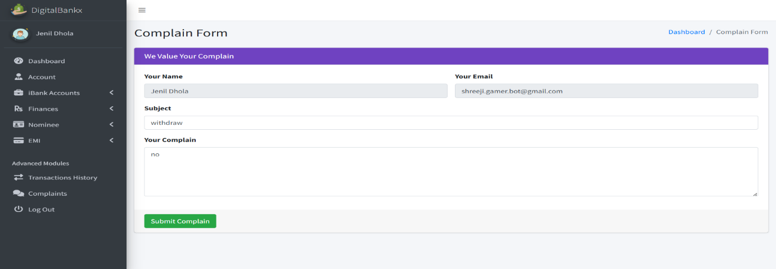

- feature allows users to report issues related to transactions, account services, or any other banking concerns.
- Details in the complaint form: your name, your email, subject, your complaint, submit complaint button.

7
Chapter

System Limitation and
Future Enhancemen
DigibankX is a comprehensive Internet Banking Management System designed to offer secure, efficient, and user-friendly banking services. It features three key panels: Admin, Staff, and Client, each tailored for specific banking operations to ensure smooth financial management.

Key Features
- Admin Panel: Facilitates user management, loan approvals, financial report generation, and complaint handling.
- Staff Panel: Manages client profiles, transaction processing, and loan applications.
- Client Panel: Provides account management, secure transactions, loan tracking, and complaint support.

Limitations
- The system currently supports domestic transactions only.
- Manual intervention is required for loan approvals, potentially causing delays during peak periods.
- The complaint resolution process may experience slower response times if multiple issues arise simultaneously.

Future Enhancements
- Implementing automated loan approvals for improved efficiency.
- Introducing biometric authentication for enhanced security.
- Adding multilingual support to cater to a broader audience.
- Developing a dedicated mobile app for improved accessibility and user convenience.
- Enhancing financial reporting with visual insights for better decision-making.

Technologies Used
- Front-end: HTML, CSS, JavaScript, AJAX
- Back-end: PHP, MySQL
- Libraries/Plugins: SweetAlert, jQuery

Conclusion
DigibankX offers a robust platform for secure and efficient online banking, combining strong data validation, AJAX-based updates, and intuitive user interfaces to improve customer experience and operational efficiency.

8
Chapter

References
8.1 | Bibliography
8.2 | Webography

8.1 Bibliography

All the needed information related to my project “DigiBankX as internet banking management” was being clumped from the following sources:
- Books:

- For PHP

- PHP Manual

- PHP 5 Fast & Easy Web Development, Julie C. Meloni, 2nd Ed, 2002.

8.2 Webography

- Sites URL:-

- For PHP

- www.php.net
- http://www.w3schools.com/php/

- For MySQL

- http://dev.mysql.com/doc

- For JQuery and CSS

- http://jquery.com/
- http://css-tricks.com/
- http://cssglobe.com/

FOR AI
www.chatgpt.com/

