LVToxinModel.R

josue

Wed Sep 9 17:24:26 2015

rm(list=ls())  
 library(deSolve)

##   
## Attaching package: 'deSolve'  
##   
## The following object is masked from 'package:graphics':  
##   
## matplot

library(ggplot2)  
 library(reshape)  
  
# parameters  
  
mu <- 0.1;   
gamma <- 0.3;  
c <- 0.3;  
sigma <- 0.5;  
beta <- 1;  
delta <- 1;  
T0 <- 1-mu  
T1 <- ((sigma*gamma*c + 2*beta*delta*sigma) - 2*sigma*sqrt(beta*delta*(beta*delta+c*delta*gamma)))/(c*c*gamma)  
  
  
# others  
TX <- 0.01;   
Delta <- ifelse(TX == T1, 0, ((sigma - TX*c)^2)*(gamma^2) - 4*gamma*TX*beta*delta*sigma)  
  
nullclines <- function() {  
 nullcline <- c()  
 axis <- c()  
 prey <- c()  
 predator <- c()  
 # x-null  
 x_x <- 0  
 x_y <- (max(0,1-TX) - mu)/beta  
   
 # y-null  
 y_x_1 <- 0  
 y_x_2 <- 0  
 if ( Delta > 0 ) {  
 y_x_1 <- ( (sigma - TX*c)*gamma - sqrt(Delta) )/(2*gamma*TX*beta)  
 y_x_2 <- ( (sigma - TX*c)*gamma + sqrt(Delta) )/(2*gamma*TX*beta)  
 }  
   
 if (Delta == 0) {  
 y_x_1 <- ( (sigma - TX*c))/(2*TX*beta)  
 }  
 y_y <- 0  
   
 xf <- max(x_x,y_x_1,y_x_2) + 0.2  
 yf <- max(x_y,y_y) + 0.2  
   
 nullcline <- c(nullcline, c("prey-null","prey-null"))  
 axis <- c(axis, c("x","x"))  
 prey <- c(prey, c(x_x,x_x))  
 predator <- c(predator, c(0,yf))  
 if ( x_y > 0) {  
 nullcline <- c(nullcline, c("prey-null","prey-null"))  
 axis <- c(axis, c("y","y"))  
 prey <- c(prey, c(0,xf))  
 predator <- c(predator, c(x_y,x_y))  
 }  
   
 if ( y_x_1 > 0) {  
 nullcline <- c(nullcline, c("predator-null","predator-null"))  
 axis <- c(axis, c("x_1","x_1"))  
 prey <- c(prey, c(y_x_1,y_x_1))  
 predator <- c(predator, c(0,yf))  
 }  
   
 if ( y_x_2 > 0) {  
 nullcline <- c(nullcline, c("predator-null","predator-null"))  
 axis <- c(axis, c("x_2","x_2"))  
 prey <- c(prey, c(y_x_2,y_x_2))  
 predator <- c(predator, c(0,yf))  
 }  
   
 nullcline <- c(nullcline, c("predator-null","predator-null"))  
 axis <- c(axis, c("y","y"))  
 prey <- c(prey, c(0,xf))  
 predator <- c(predator, c(y_y,y_y))  
 df <- data.frame(nullcline, axis, prey, predator)  
 df  
}  
  
g <- ggplot()+  
 geom_path(data = nullclines() ,  
 aes(x = prey, y = predator, colour = nullcline, linetype = axis))   
g

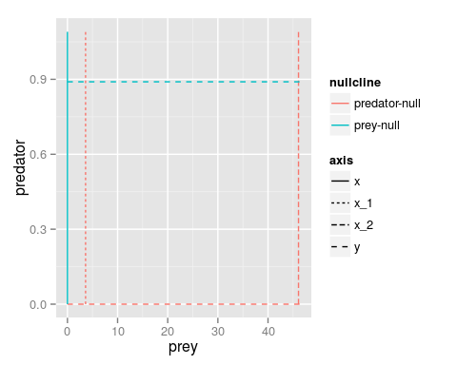

if ( (sigma/c -TX)>0 ) {  
 print("Se cumple la condición 1")  
 }else {  
 print("No se cumple la condición 1")   
 }

## [1] "Se cumple la condición 1"