**Fantasy Football Strategy: Why the Beginners Always Win**

**.**

Fantasy football has a larger degree of luck than most of us care to admit. If you’re like me, you spent many hours last summer reading articles about sleepers, rookie studs, and when to draft your quarterback. However, it turns out the best fantasy football strategy was to be lucky enough to get the third or fourth pick in the draft and end up with Christian McCaffrey. Last year, the difference between McCaffrey and the number two running back, Derrick Henry, was the same as the difference between the WR1 and the WR19.

It has been heavily studied and verified (hyperlink) that having the first pick in a fantasy draft gives you a huge advantage over all the other teams. Even in a snake draft, on average the 2nd pick gives you a better team than the 3rd, the 6th pick gives you a better team than the 7th, etc. However, on a year-to-year basis, some picks are better than others. Which picks were better last year?

**The difference between the picks**

We simulated 500 drafts using data from fantasyfootballcalculator.com (hyperlink) and computed the points scored by the starting lineup from each draft position. In the chart below we can actually *see* the amount of impact that draft position has on what your team looks like.

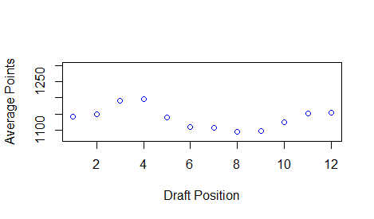

This chart screams one thing: the best pick depends a lot, year-to-year, on luck. In the 2019-2020 fantasy season, the third and fourth picks were best. Moreover, there is a huge difference between the picks. Having the wrong pick is a huge hurdle to overcome. But, as promised in our first fantasy article (hyperlink), we’ll present a way to give yourself an advantage.

We’re going to talk about a draft strategy today. The first benefit of this technique is that it is extremely simple. In fact, it is probably the technique used by the new guy in your league that doesn’t know anything about fantasy.

The second benefit: in the 2019 season it gave, on average, a 5 percent increase in fantasy points scored.

**The BPA Strategy**

That’s right. In this article I am advocating for the simplest strategy there is. Do no research, take the **best player available (BPA)**. That’s the strategy the new guy uses. We’ll show that strategy actually gives you a huge advantage.

Here’s the drawback with this strategy: it isn’t fun. You don’t get to do any work or get to gloat when you found the QB1 in the 10th round. You get what you get. But, this strategy can be incorporated in a milder sense: you can pick a few sleepers that you’ll reach for but when in doubt, go BPA.

**The Method**

Every year, players are *roughly* drafted at their **average draft position (ADP)**. However, teams reach for some players and other players fall in the draft so players aren’t always taken at their ADP. There is some randomness in what the draft boards actually look like.

So what do we do? For each player, we know their ADP and the standard deviation for where they were picked (the amount their draft pick differs from their ADP *on average*). Using these pieces of information, we can simulate hundreds and thousands of drafts, each time randomizing the order so that our mock drafts actually resemble **real** drafts.

After simulating each draft, we compute the best starting lineup for each team. Then, over the course of 500 or 1000 simulations, we average out the points achieved by the best starting lineup at each draft position. This lets us measure how many points your team is expected to score when you draft from each position.

Finally, to test our theory, we can take control over any one of our teams and force them to take BPA for each of their picks. So, we do exactly that. We will compare how well a team does on average by drafting ‘normally’ to how well the team does when they draft BPA at every pick.

**The Results**

Using the above technique, we simulated 500 mock drafts. In the plot below we put a blue dot above each draft spot corresponding to the average fantasy points scored by teams drafting from that position last year. Also on the plot is a red dot above each draft spot. The height of the red dot shows the average points of a team drafting from that spot that uses the BPA strategy.

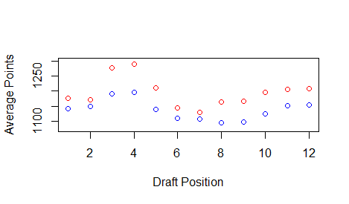

Not only is this strategy better, but it is vastly better. Using the BPA strategy, you can expect a **5%** increase in fantasy points on the season. Five percent is huge. Five percent is the difference between the best team in the league and the 7th team in the league.

Let me put this another way: there are six teams who, if they were the only team employing the BPA strategy, would be the best team in the league. That is a huge advantage that turns winning your league from a longshot into more of a coin flip.

**How to Use This Realistically**

Now, I am well aware that very few people that care enough to read fantasy football strategy articles will employ this technique because it seemingly takes all the skill out of the game. It turns being a fantasy savant into a being a robot with a spreadsheet. Sometimes, though, the best strategy is to do the smart thing rather than the fun thing.

However, you can incorporate this strategy into a grander fantasy football strategy overall. One way to do this is to simply pick one or two sleepers, reach for your guys a round or two early, then take BPA for the rest of the draft. You are likely to get most of the benefit of BPA drafting while still having room for research and fun.

This strategy may seem simplistic, but in the grand scheme of things it makes sense. If you could be reasonably certain a player will succeed, then it is probably that many other people will come to the same conclusion. It is probable that you being certain in a player’s success will be reflected in a higher ADP. Simply put, ADP is about as good of a predictor of fantasy performance as any other metric.