**Shooting Percentage Points Created: A New Metric to Rate the NBA’s Best Shooters**

There are a myriad of ways to measure or describe an NBA player’s impact on his team’s success. While assists, rebounds, steals, blocks, and many other statistics are important to winning a game, one of the most important attributes of a good player is good shooting.

Previously, the best measure of a player’s shooting ability was their *true shooting percentage* (TS%). A players TS% is a combination of their two point, three point, and free throw percentage all wrapped into one number that supposedly measures how good a player is at shooting. And it does *OK.* However, if you look at the 2018-2019 NBA data, the top 5 players in TS% are all centers. The TS% of centers is artificially inflated, though, because a large proportion of their shots are extremely high percentage.

I propose an alternative measure of shooting ability that measures shooting percentage relative to shot difficulty. This statistic, called Shooting Accuracy Points Create (SAPC), measures how well each player shoots relative to league average from a given distance. In this way, it is a natural generalization of TS% that attempts to answer the same question while better representing a shooter’s abilities.

**Distance Based Shooting Percentage**

The first step in computing SAPC is computing the league average shooting percentage from each distance (thanks to [this source](https://datavizardry.com/2020/01/28/nba-shot-charts-part-1/) for the data). What we did was go through each shot in the season, mark the distance it was taken from, and whether it was made or not. Then, we can compute the league average shooting percentage from each distance. Below, the red points are two point shots and blue are three pointers.

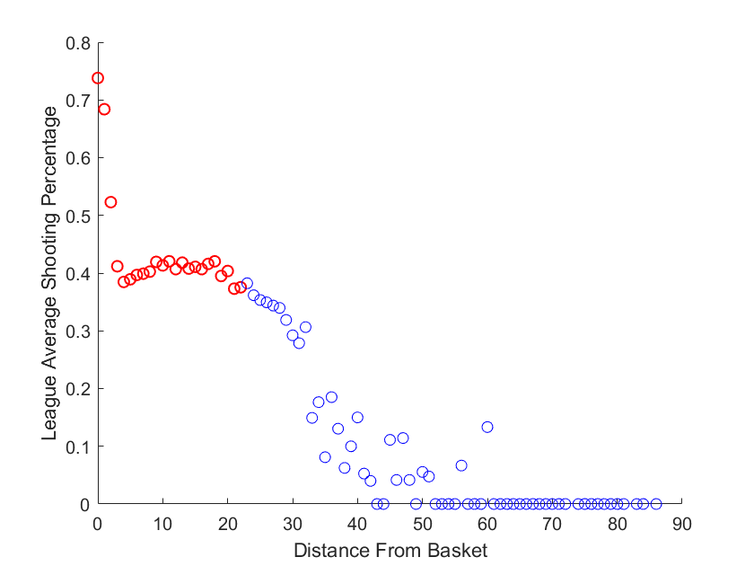

As a quick aside at this point, I would like to show a very simply graphic to explain why the frequency of three point shots has exploded in the last ten years. Multiplying the percentages on the y-axis for the red points by 2 and the blue points by 3 gives us ‘expected number of points scored based on the distance from the basket’.

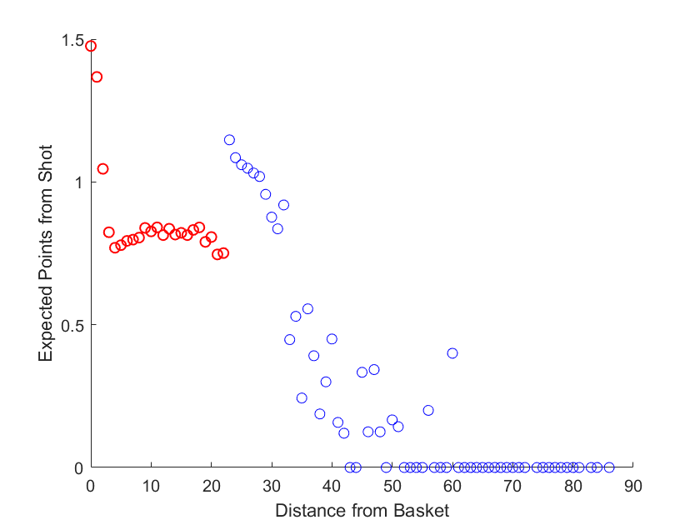

This graphic is precisely why for instance the Rockets take a large majority of their shots within 5 feet or behind the three point arc. Simply, those shots are the best bang for your buck.

Returning to the discussion of SAPC, we point out that shots at 0-3 feet go in at an extremely high rate. This explains why a center’s true shooting percentage is inflated as pointed at above!

If you have a center wo makes 55% of their shots at 2 feet from the rim, TS% would say they are a very good shooter because they make so many of their shots. However, that 55% number is below average from that distance. In fact, our hypothetical center hurts his team rather than helps. Obviously, TS% is deficient. Our proposed metric takes into account the relative difficulty of a player’s shot selection.

**Shooting Accuracy Points Created**

The whole idea of this statistic is quite simple and I admit I the inspiration comes from Baseball’s RE24. RE24 measures how many runs a baseball player creates through his at-bats relative to league average. SPPC will measure how many points an NBA player creates through his shooting prowess relative to league average. Note: this statistic isn’t meant to capture **all** the value an NBA player provides to his team but rather is meant to determine the value he provides with his shooting ability.

The best way to describe the calculation is with an example. League average from 25 feet is about 35.3%. Since these shots are all three pointers, the expected points scored on this play is 3 points times 35% or 1.05 expected points. If a player makes a three point shot from 25 feet, they have ‘added’ 1.95 points of value above expectation. If they miss the shot, they performed 1.05 points worse than expectation *on this shot*.

You can think of the numbers 1.95 or -1.05 above as an amount of value added by that specific player’s shot. Therefore, a player’s SAPC is computed by doing the same computation above for every hot that player takes over the season.

Here is one more way to think about SAPC. For a specific player look at how many shots they take from each distance. Then, using the league average shooting percentage from those distances, compute how many points an average shooter would score in a season if they took those exact same shots. Then, compare how many points your player actually scored to see how much they over/under performed expectation. The best shooters are the ones that get the most points out of the shots they take.

**2019 SAPC Leaders**

While I can’t display the entire list of SAPC for 2019 because there are a few hundred players, I’ve selected the top few to highlight how this technique works and show that it matches what we expect! Here are the top 10 players in SAPC for 2019.

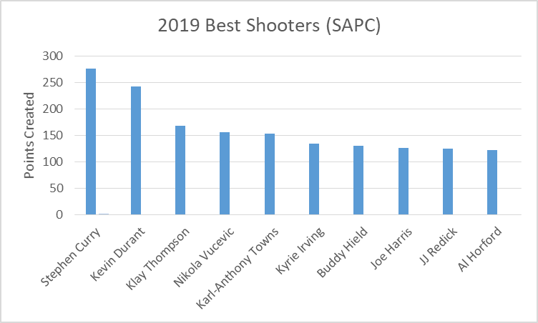

This chart matches much better what we expect in a ‘best shooters’ chart than the comparable results from using TS%. First of all, Steph Curry, Kevin Durant, and Klay Thompson are widely regarded as three of the best shooters in the league. Even better, the centers that show up are those who are actually good at shooting: Towns, Vucevic, and Al Horford.

Who performed the worst relative to expectation? The answer is exactly who you might expect: Russell Westbrook. Looking at all the shots taken by Westbrook, he scored a whopping 193 fewer points than would be expected by a league average shooter.

**Normalized SAPC**

SAPC is a ‘counting stat’. This means that you simply count the instances of something happen and the longer the season goes on and the more opportunities there are, the higher the numbers can get. Think of home runs or RBIs in baseball. The other type of stat is a ‘rate stat’ which, as abstractly as possible, counts events then divides by opportunities. Batting average is an example of a rate stat that is the counterpart to the counting stat ‘hits’. Rate stats are useful because they let us see who does the most with the opportunities they are given.

So, I compute a normalized version of SAPC which computes ‘points added relative to league average **per shot’.** All you do is take total SAPC and divide by shot attempts. This statistic should truly capture who the most dangerous shooters are. Note: we had to set a minimum qualifying level at 400 attempted shots on the season. Here are the top 10 normalized SAPC players from 2019.

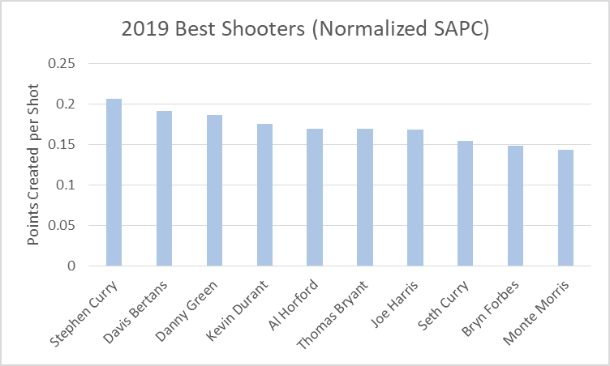

**A Note on the 2019 Toronto Raptors Championship**

A lot of folks seem to think the 2019 Toronto championship either came out of nowhere, was undeserved, or was surprising for whatever reason. Certainly the Warriors were the favorites and the outcome may have been different if not for all the injuries. However, the Raptors had insanely good shooting on their roster.

Almost every Raptor that played significant minutes in the finals was an above average shooter. Even better, three of the raptors heavy rotation players were in the top 25 when it comes to shooting accuracy using SAPC. Here are some of their heavy rotation players:

* Danny Green, 0.19 points added per shot, 3rd in the NBA
* Serge Ibaka, 0.12 points added per shot, 14th in the NBA
* Pascal Siakam, 0.11 points added per shot, 23rd in the NBA
* Kawhi Leonard, 0.9 points added per shot, 39th in the NBA
* Marc Gasol, 0.4 points added per shot, 84th in the NBA

And, while VanVleet and Lowry were roughly league average shooters during the regular season, in the playoffs the two of them actually led the team in three point shooting percentage. I think one of the reasons this Raptors team was so dangerous was that they had great shooting and it came from 6 or 7 different players. Having that many players who can score and be a threat is a huge advantage.

**Extensions and Considerations**

An interesting note here is that James Harden, arguably the best scorer in the NBA, does not appear on this list. Moreover, James Harden is generally considered to be a good shooter. However, his SAPC value for 2019 was only in the low 60s. That is, he only generated 60 points of offense above league average by virtue of shooting well.

However, if you truly wanted to capture James Harden’s impact on the game you could form a variant of SAPC that includes free throw shooting. League average is about 73% from the line. James Harden attempted 858 free throws in 2019 and a league average shooter would have made 634 of those. Harden, though, made 754. If you considered free throw shooting in a modified SAPC, Harden’s value would include an additional 121 points of ‘added offense’ just by virtue of making so many extra free throws.

There are conceivably many more extensions one could make to the SAPC statistic. In their current forms, though, I believe SAPC and its normalized counterpart are the best measures of who the best shooters in the NBA actually are.