**Appendix: Resources**

Evidence of Old System:

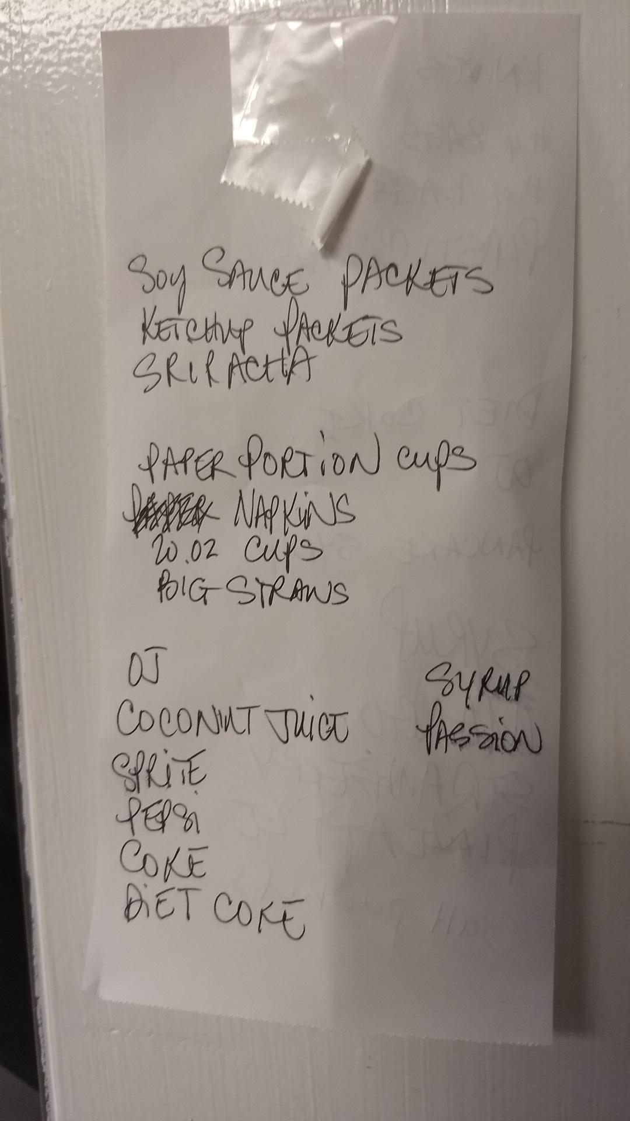

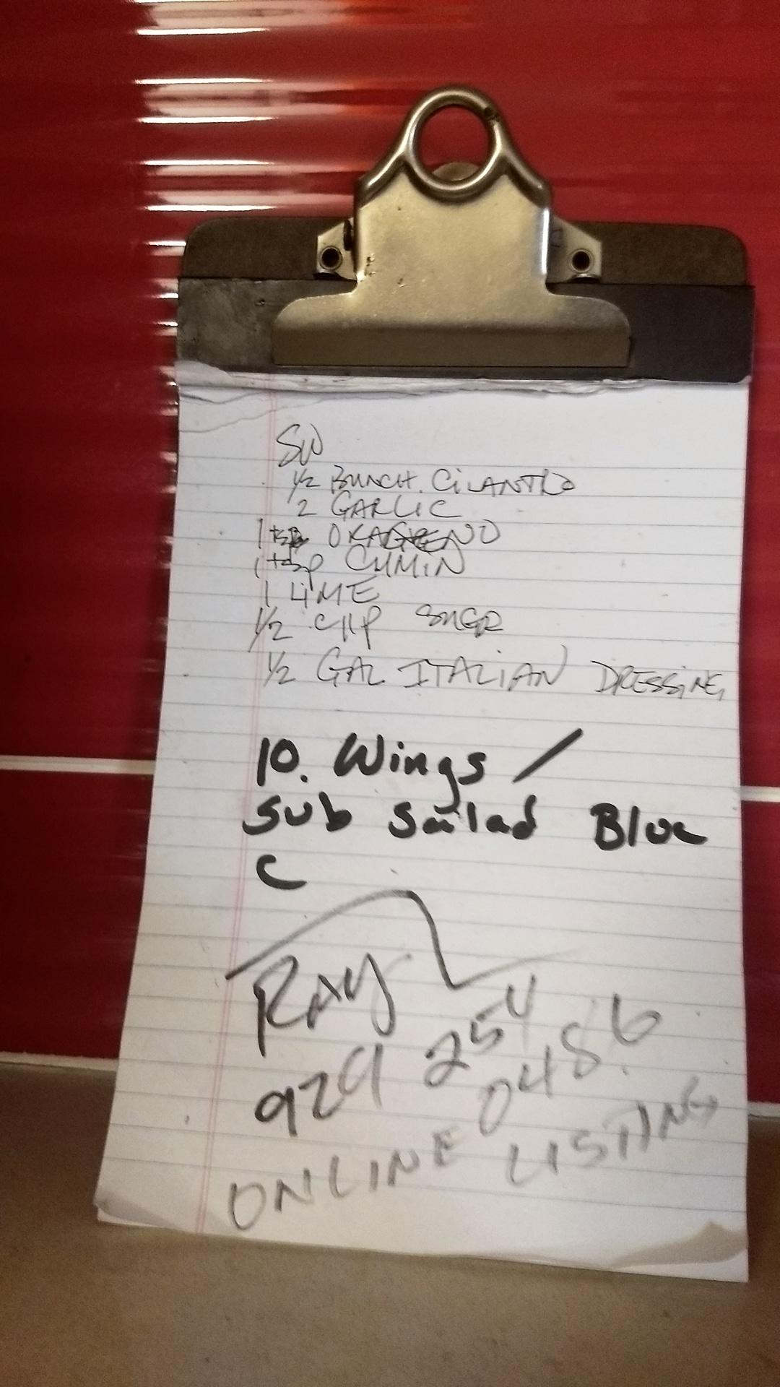

*The black box covers names and phone numbers that were also written at the end of the list.

1st Meeting:

In the first meeting on 9/7/18, we discussed the needs for a program to keep track of his stock. He showed me his current system of a list he has attached to a wall of items he is low on (See pictures above). We addressed the problem was how he only adds to the list whenever he sees an item is low and most of the time he only realizes he is low when he needs to use.

*Summary of conversation*

Me: Hello. I am going to ask you a few questions about the project now. Is it all right if I take notes on what you respond?

Client: Yes. Go ahead.

Me: We have talked about how you would like me to create a program that could fix your problem with your stock system. I would like to create a program that would keep track of the stock of your items and how much of each item you use weekly.

Client: Okay. Sounds good.

Me: So I can create a scrollable list of items that will display the names of each item. You can be able to add, delete, edit, search, and sort the items. It will be a simple database structure.

Client: Okay, I trust you will do well and look forward to the project. When do you think it will be completed?

Me: I would like to estimate roughly one to two months, dependent on both mine and your work schedules. I can set the deadline for sure once I get situated first at school.

Client: Sounds good. See you later.

2nd Meeting (Email):

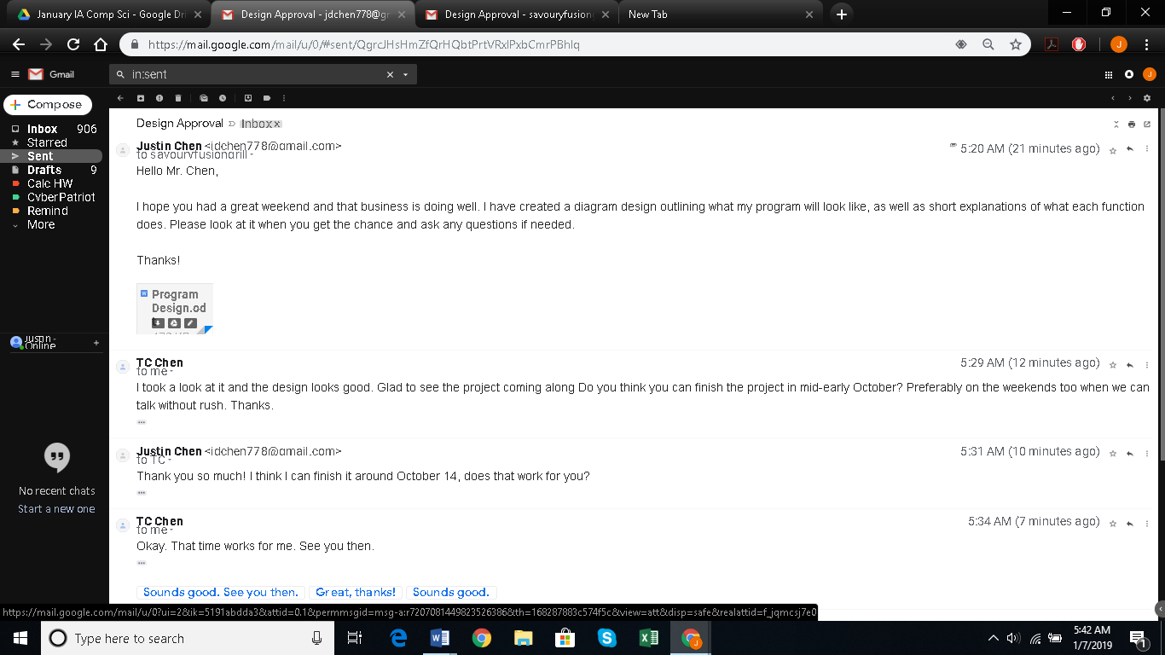I emailed the client before he left for work on 9/13/18 for the approval of a design concept I made (Criterion B) and explained briefly about the various buttons and the general interface.

*I am the first and third reply. My client is the second and fourth reply.

3rd Meeting:

In the third meeting on 10/14/18, I presented to him the finished program. I explained how it worked and taught him the basics of how to operate it, after installing it onto his work computer. He also gave me some feedback about adding on an additional function.

*Summary of conversation*

Me: I am glad to see that the program functions on your computer. Okay, so the program layout has varied a bit from the design I sent you. I also added in a few more functions.

Client: I am excited to see what you’ve done.

Me: This is the program, as you can see it now has a table layout or a JTable I call it. This makes it so that you can instantly see all the properties of each item at once instead of having to click each item individually.

Client: That’s pretty neat. I see you also moved the button below instead of on the side. What is that box for?

Me: That is the comboBox, or list, for the different sorts. You simply select how you would like the items in the table to be sorted based off of these 6 different sorts.

Client: Okay, that’s convenient. How about this “Specific Search” button, does it just search for item that I type into this textbox specifically?

Me: Kind of. It does an exact letter for letter search for whatever item that has the number or exact name that you enter. It is more specific than the generic search, so that way you can isolate out items you know you want to search for. Do you have any more questions or ideas that I can add on?

Client: Okay, I see. I don’t have any concerns at the moment, but I was thinking about how I could print out the list using a printer. Could I print out the text file?

Me: Yes, you could. But it would be the list for all the items.

Client: Is there any way that you could make it so that I could print out items that I want, like print out the items separated by those sorts?

Me: Sure I can manage that. I will work on that and send you another version of the program within the next few weeks.

Client: Sounds great. See you then.

4th Meeting (Email):

I emailed the client the program with changes he requested on 10/27/18 after waking up. I briefly went over the newest function of creating a text file from the different sorted JTables like he wanted.

5th Meeting:

In the fifth meeting on 11/10/18, I presented to him the finalized program. I asked him a few question regarding my performance, about all the success criterias, and some future improvements that could be made.

*Summary of conversation*

Me: I think that the program is complete for now. It has been fun working with you and thanks for the food too. I just have a few final questions to ask you.

Client: Sure go ahead.

Me: Was the program simple, identifiable, and easily navigable for you to understand?

Client: The program is easy to use and my other workers have also been able to learn how to use it.

Me: Did the program experience any problems with data? Were all your changes saved whenever you closed the program or shut off the computer?

Client: The data was saved, even after the program was closed or I shut down my computer.

Me: Did all the features work? Adding, deleting, and editing items with the appropriate parameters?

Client: The adding, removing, editing all works and there have been no problems with inputting new information.

Me: Did all the program sort the item entries based on the sorting option selected?

Client: The sorting options are nice and work appropriately.

Me: Was the program able to search for and find an item?

Client: Yes. The search function is nice and saves a lot of time instead of scrolling down the list.

Me: Did the program create new text files based off of the currently sorted list that you could print out?

Client: The printable text file option is very nice, just what I wanted. It’s been easy to print out only specified Items I wanted.

Me: Final question, on a scale of 1 – 10, how would you rate my overall program? Did it help resolve your problems?

Client: I would say a solid 10. It was interesting and easy to use.

Me: Are you sure? Nothing could be perfect, but thanks. Actually, that leads to my next question, are there any ways I could improve the program?

Client: I would like some more sorting options like decreasing stock and usage sorting options in addition to the increasing sorts for the two. I also was thinking of having another sort option of just items I can personally select.

Me: I see. Maybe I can add on those improvements in future updates. Anything else?

Client: Yeah, I would also like to have the number not just be whole but can be decimals or fractions. Sometimes I only use half of a serving or even a third. Also, I wanted to take stock of other things besides food like my drinks and containers, so more category choices would be nice.

Me: So much for a perfect 10. But thanks for the advice, I will take your feedback and see how I could improve my program. Maybe I will release a better version to you sometime in the future.

Client: Don’t worry. I was very satisfied with the program and thank you for your work. I look forward to any future versions or projects.

Me: Thank you. I will remain in touch with you and email me if you would like help with any other projects.