# **1.125 – Final Project: Deliverable 1**

**Project Proposal:**

Oftentimes it is necessary to search a large area to identify various objects. This can be during a search and rescue operation, where people need to be found quickly amongst dangerous debris or even a farmer looking for which fruits are at the perfect picking time. Using humans for such task can often lead to failures and inefficiencies due to fatigue, lack of focus, or physical capability. Machines on the other can be taught to detect various object in images and work without tiring around the clock. By combining micro controllers and a camera to a controllable vehicle and connecting the camera images to an image detection neural net API, a device can be controlled to search for a desired object.

For this project the Google Vision API and the Google Cloud Computing platform will form the scout’s ‘brain’. Its body will be comprised of a Tessel 2 board operated robot with wheels and a mounted webcam. The scout will use a number of Node.js packages, including Johnny5 to control the motion of the wheels as well as the images coming from the webcam. The scout will be controlled via Wi-Fi from a user’s terminal where the user can monitor what the scout sees as well as enter the names of various objects that the scout can look for.

**Technology Demonstrations:**

**Google Cloud Platform**

In order to make use of the Google APIs, a membership to the Google Cloud platform was made with a free membership available for 2 months. Below is the dashboard and a working API read out to demonstrate the usage of this platform.

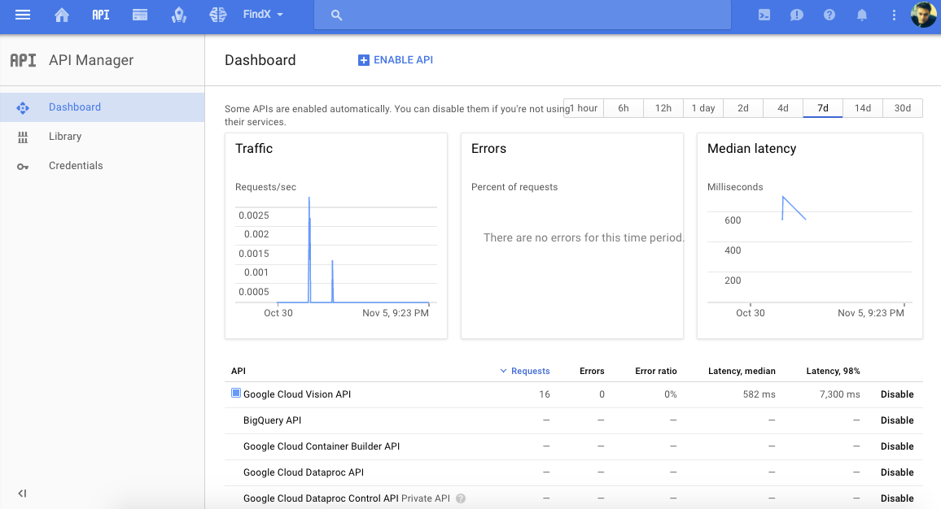

**Google Vision API**

The Google vision API can be used from the command line if the environment variables are set before use. Then the API links to the above cloud service and can be executed with local images. The screenshot below shows the API being used with a photo taken from a smartphone and linked to a dropbox folder.

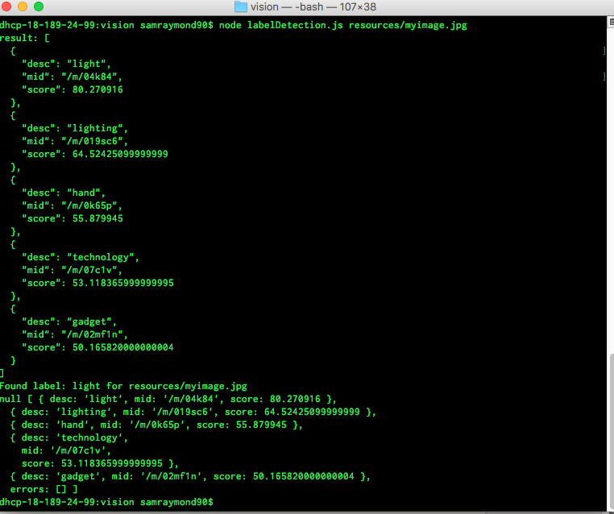

**Tessel Hardware**

The hardware used for this project involves a Tessel 2 board with a number of other components (motors, housing, wheels, etc. see photos below) that form the body of our drone: Scout. A webcam is used to capture images and send to the API for analysis before the main control code decides on how to actuate the scout.

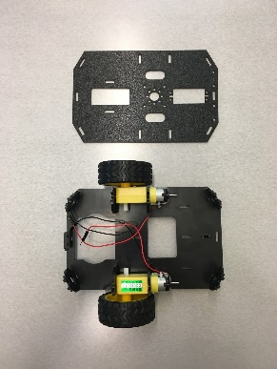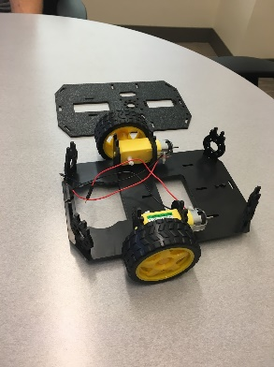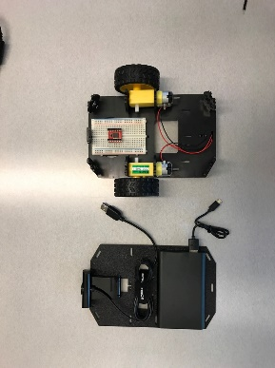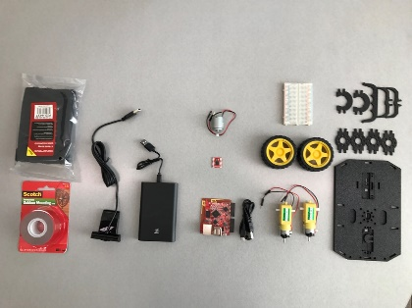

**Tessel Software**

To control the device this project will rely on Node.js and the tessel software API for robot control. This will include connecting to the machine via wifi on a command line interface (see below) as well as sending and receiving information regarding images and decision processes.

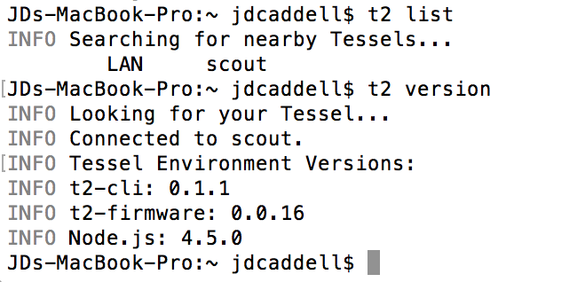

**Competitive Analysis**

While conducting the competitive analysis for this project, we discovered  a lot of really good work being done in the Machine Learning, Drove, and Search space. There are several projects that are very nicely compiled to serve different purposes. What we were surprised about was that each group has severely restricted itself in scope. A project may have good ML, excellent control, or highly capable imaging, but no project combined all of these and thought that there might be added benefit in linking several drones. Below is a brief set of bullets for each group we found that had interesting related projects. We still feel that our project focus is a currently unsolved or undressed situation. This examples get close, but miss important aspects.

1. Group of Researchers from the University of Genova are trying to create a similar project.
   1. No AI mentioned, No thermal. Focus on creating better search functions.
   2. <https://www.inverse.com/article/14368-drone-swarms-will-soon-be-used-for-search-and-rescue-operations>
2. Drone focused on searching trails - <https://news.developer.nvidia.com/autonomous-search-and-rescue-drones-outperform-humans-at-navigating-forest-trails/>
   1. Really nicely done deep learning for directing movement.
   2. Not much work done on linking drones together or finding people
3. Aerialtronics - <http://www.aerialtronics.com/search-rescue-sar/>
   1. Single drone system with FLIR camera capability
   2. No ML/AI
4. SAR Drones - <http://sardrones.org/>
   1. Volunteer network that uses people to take their drones to SAR operations, no use of google API or any image recognition software, entirely based on humans.

**Storyboard**

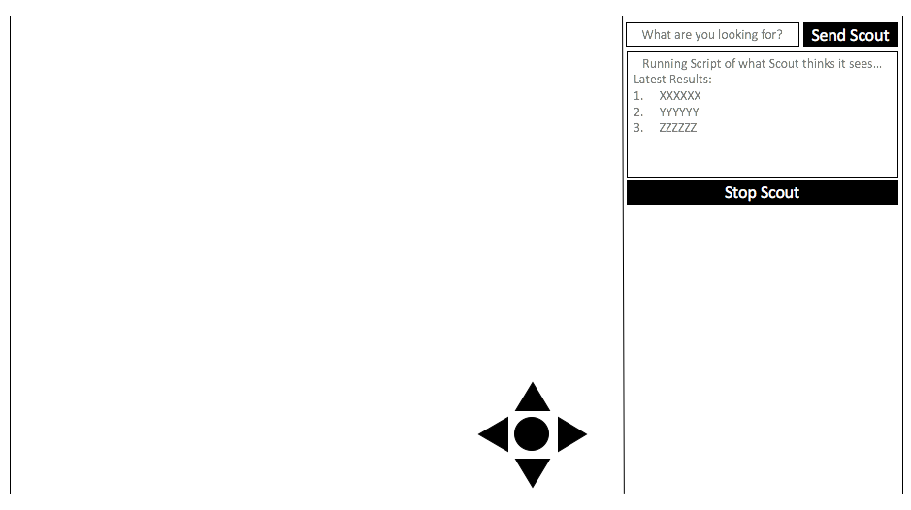

Left-hand side of the screen shows the video output of the device. Right-hand side has the entry point where the user can enter the search term. Two buttons, to start and stop the searching function will initialise the backend code to run the searching function and move the scout autonomously. The on screen joystick can be used to move the scout remotely.

**Code Artifacts**

**Hardware**:

Device is built mostly now and is able to move and project camera vision to a website.

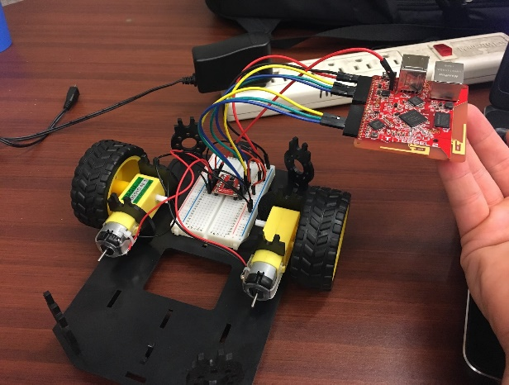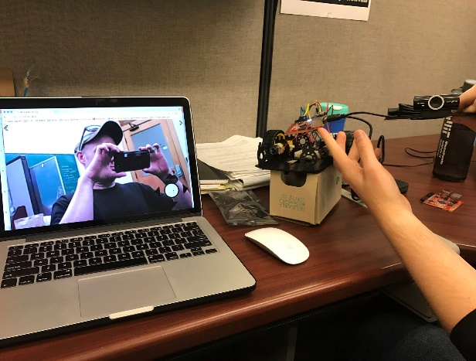

**Software**:

The control code for the scout drone will use several javascript modules already shown above in the following overall structure.

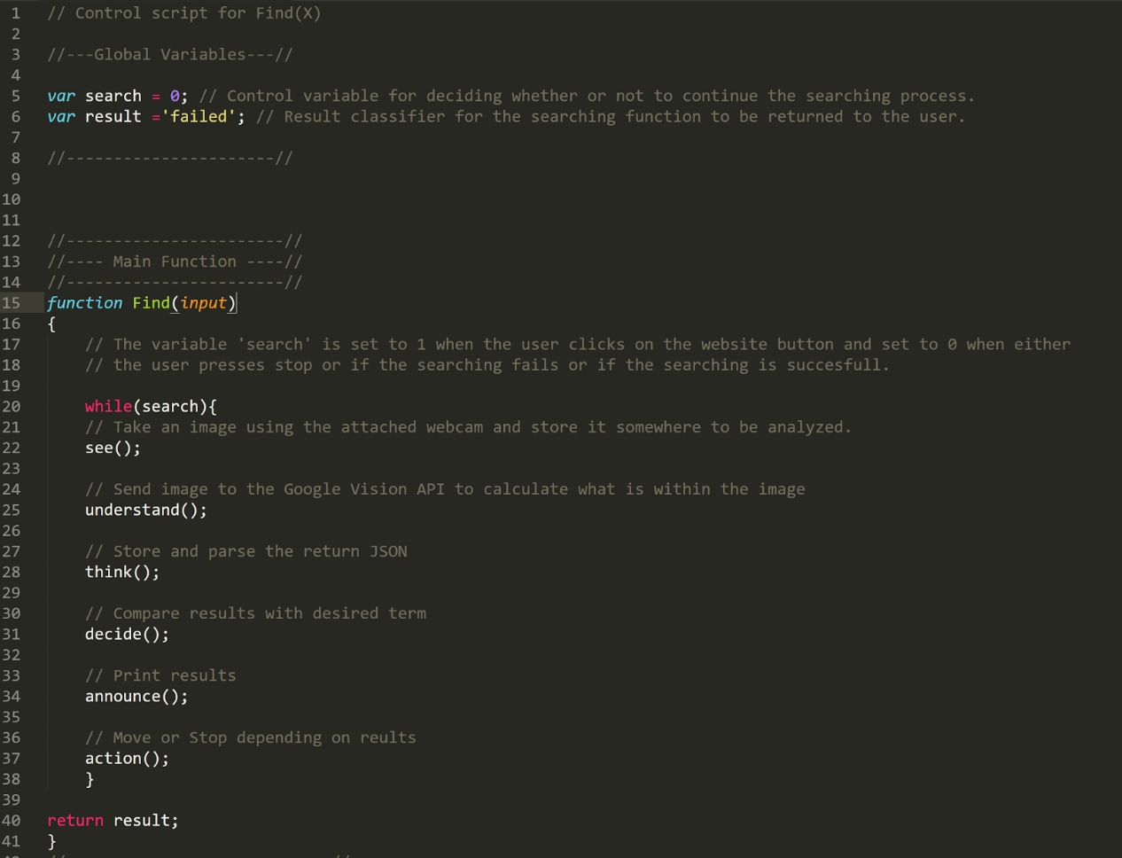

The modules mentioned will be developed in paralel and brought together for testing. These functions will likely run outside of the Tessel and utilize the computing power of the controlling computer and only send movement commands and camera commands to be done on the microcontroller.