Differences in Anxious and Depressive Symptomatology Between Transgender and Cisgender Populations: A Cross-Sectional Study

Methodology

Data and participants. Data were drawn from the Segunda Encuesta Nacional de Salud, Sexualidad y Género (ENSSEX-2022), a nationally representative survey conducted by Chile's Ministry of Health (MINSAL). The ENSSEX-2022 employed a stratified, multistage probabilistic area sampling design with four stages (municipality, city block, household, and individual), targeting the civilian non-institutionalized population aged 18 years and older residing in urban areas across all sixteen regions of Chile. The target sample size was 20,392 effective cases distributed proportionally across regions. Expansion factors were estimated at the municipality, city block, and household levels using the 2017 National Census (INE) as the reference population (13,439,667 persons aged 18 or older in urban areas). The analytic sample was restricted to participants with complete information on all study variables, yielding an unweighted sample of N=18,907, representing a weighted population of approximately 12,639,404 individuals. Of these, 191 participants (weighted N=125,877) self-identified as transgender or gender-diverse (TGD).

Variables and statistical analysis. Anxiety and depressive symptoms were assessed using the Patient Health Questionnaire-4 (PHQ-4), a validated ultra-brief screening instrument comprising two anxiety items drawn from the Generalized Anxiety Disorder-2 (GAD-2) and two depression items from the Patient Health Questionnaire-2 (PHQ-2). Each item was rated on a 4-point Likert scale (0=Never, 1=Some days, 2=More than half the days, 3=Almost every day), with subscale scores ranging from 0–6 and a total PHQ-4 score ranging from 0–12. Transgender or gender-diverse (TGD) identity was defined based on self-reported gender identity, contrasting TGD individuals against cisgender respondents. Covariates included age group (18–29, 30–44, 45–59, 60+), educational attainment, indigenous identity, migration status, health insurance type, and self-rated quality of life. Descriptive statistics (means, standard deviations, and prevalence of positive screening) were computed for both unweighted and weighted samples. Group comparisons were conducted using survey-weighted linear regression models (HC3 heteroskedasticity-robust standard errors) for continuous outcomes (GAD-2, PHQ-2, PHQ-4), and survey-weighted cumulative link models (proportional odds, CLM) for each individual PHQ-4 item treated as an ordered categorical variable. All models incorporated the complex survey design weights. Weighted logistic regression models for binary screening outcomes (GAD-2 ≥ 3, PHQ-2 ≥ 3, PHQ-4 ≥ 6) are presented in the supplementary material, together with unstandardized and standardized regression coefficients, item-level reliability statistics, and full ordinal model tables for both weighted and unweighted samples. All analyses were conducted in R (version 4.3) using the survey and ordinal packages, and supplementary material is provided alongside the main results.

Results

Descriptive comparisons. Transgender and gender-diverse (TGD) individuals consistently reported higher mean scores on all PHQ-4 dimensions compared to the full sample. In the weighted sample, the mean GAD-2 score among TGD individuals was 1.67 (SD=1.50), compared to 1.24 (SD=1.41) in the full sample. For the PHQ-2, TGD respondents reported a mean of 1.68 (SD=1.59) versus 1.40 (SD=1.43) in the full sample. For the overall PHQ-4, TGD individuals scored a mean of 3.35 (SD=2.79) compared to 2.64 (SD=2.57) in the full sample. Positive screening rates were substantially higher among TGD individuals: 25.76% met the anxiety screening threshold (GAD-2 ≥ 3) compared to 15.94% in the full weighted sample; 20.13% screened positive for depression (PHQ-2 ≥ 3) versus 16.19%; and 17.76% met the general distress criterion (PHQ-4 ≥ 6) compared to 12.99%.
Linear regression models. Survey-weighted linear regression models, adjusting for age, education, indigenous identity, migration status, health insurance, and quality of life, confirmed that TGD individuals reported significantly higher anxiety symptom scores compared to cisgender respondents (B=0.37, 95% CI [0.07, 0.66], p<.001 for GAD-2) and higher depression symptom scores (B=0.27, 95% CI [-0.12, 0.67], p=0.172 for PHQ-2) but not significative. The association with total PHQ-4 score was significant (B=0.66, 95% CI [0.02, 1.29], p<0.05). These effects remained robust after controlling for all covariates, indicating that TGD status independently and significantly predicts higher symptom burden beyond the contribution of sociodemographic factors.
Cumulative link models (item-level ordinal analysis). Cumulative link models (proportional odds) applied to each individual PHQ-4 item in the unweighted sample revealed that TGD identity was significantly associated with higher odds of endorsing more severe response categories on anxiety items: OR=1.43 (95% CI [1.09, 1.87], p<.001) for GAD item 1 and OR=1.56 (95% CI [1.19, 2.03], p<.001) for GAD item 2. For depression items in the unweighted sample, TGD status was associated with OR=1.20 (95% CI [0.92, 1.57], p=.171) for PHQ item 1 and OR=1.18 (95% CI [0.90, 1.55], p=.234) for PHQ item 2, though these item-level effects did not reach statistical significance. In the weighted sample, the pattern was consistent for anxiety items: OR=1.38 (95% CI [1.06, 1.81], p=.018) for GAD item 1 and OR=1.86 (95% CI [1.42, 2.43], p<.001) for GAD item 2. For depression items in the weighted sample, OR=1.41 (95% CI [1.08, 1.85], p=.012) for PHQ item 1 and OR=1.26 (95% CI [0.95, 1.66], p=.109) for PHQ item 2. Across all models, the predicted cumulative probability curves confirmed a consistent downward shift for TGD individuals at every response threshold, indicating systematically higher probability of endorsing more severe symptom categories (table S6).

Table 1. Descriptive characteristics of the full sample and transgender and gender-diverse.

 | Full Sample |  | Transgender and gender-diverse (TGD) individuals
 | Unweighted  N=18,907 | Weighted  N=12,6394,04 | Unweighted  N=191 | Weighted  N=125,877
Anxious and Depressive
GAD item 1: Feeling nervous, anxious, or on edge | 0.75 (SD=0.83)  [0.00 - 3.00] | 0.74 (SD=0.83) [0.00 - 3.00] | 0.98 (SD=0.95) [0.00 - 3.00] | 0.92 (SD=0.91) [0.00 - 3.00]
GAD item 2: Not being able to stop or control worrying | 0.55 (SD=0.82)  [0.00 - 3.00] | 0.50 (SD=0.79) [0.00 - 3.00] | 0.76 (SD=0.88) [0.00 - 3.00] | 0.74 (SD=0.84) [0.00 - 3.00]
GAD-2 | 1.31 (SD=1.44)  [0.00 - 6.00] | 1.24 (SD=1.41) [0.00 - 6.00] | 1.74 (SD=1.58) [0.00 - 5.00] | 1.67 (SD=1.50) [0.00 - 5.00]
PHQ item 1: Little interest or pleasure in doing things | 0.77 (SD=0.82) [0.00 - 3.00] | 0.75 (SD=0.82) [0.00 - 3.00] | 0.88 (SD=0.83) [0.00 - 3.00] | 0.92 (SD=0.89) [0.00 - 3.00]
PHQ item 2: Feeling down, depressed, or hopeless | 0.68 (SD=0.78) [0.00 - 3.00] | 0.65 (SD=0.78) [0.00 - 3.00] | 0.79 (SD=0.83) [0.00 - 3.00] | 0.76 (SD=0.88) [0.00 - 3.00]
PHQ-2 | 1.45 (SD=1.42) [0.00 - 6.00] | 1.40 (SD=1.43) [0.00 - 6.00] | 1.67 (SD=1.43) [0.00 - 6.00] | 1.68 (SD=1.59) [0.00 - 6.00]
Positive anxiety screening (GAD-2 >= 3) | 17.31% | 15.94% | 28.80% | 25.76%
Positive depression screening (PHQ-2 >= 3) | 16.81% | 16.19% | 24.08% | 20.13%
Positive general distress screening (PHQ-4 >= 6) | 13.68% | 12.99% | 19.90% | 17.76%
PHQ-4 | 2.76 (SD=2.59) [0.00 - 12.00] | 2.64 (SD=2.57) [0.00 - 12.00] | 3.41 (SD=2.68) [0.00 - 10.00] | 3.35 (SD=2.79) [0.00 - 10.00]
Age
18 to 29 | 24.26% | 22.09% | 36.13% | 39.16%
30 to 44 | 26.49% | 30.70% | 28.80% | 31.28%
45 to 59 | 23.98% | 24.51% | 16.75% | 11.56%
60 and older | 25.28% | 22.71% | 18.32% | 17.99%
Education
Primary complete/incomplete | 19.06% | 16.21% | 17.28% | 9.98%
Secondary incomplete | 14.22% | 9.88% | 10.47% | 5.14%
Secondary complete | 34.44% | 32.78% | 28.27% | 25.88%
Higher complete/incomplete | 32.28% | 41.13% | 43.98% | 59.00%
Indigenous | 11.06% | 9.48% | 13.61% | 9.57%
Nationality
Chilean | 95.89% | 95.69% | 95.29% | 92.90%
Other | 4.11% | 4.31% | 4.71% | 7.10%
Health insurance
Public (FONASA) | 88.09% | 84.37% | 82.20% | 78.59%
Private (ISAPRE) | 7.45% | 10.75% | 11.52% | 15.42%
Other systems | 4.46% | 4.88% | 6.28% | 5.99%
Quality of life
Very poor/Poor | 3.40% | 3.25% | 5.76% | 2.45%
Neither good nor poor | 23.62% | 22.37% | 26.18% | 22.99%
Very good/Good | 72.99% | 74.38% | 68.06% | 74.56%
Note: Means (standard deviations) and ranges reported for continuous variables; percentages for categorical variables. Weighted estimates incorporate complex survey design weights (stratification, clustering, and expansion factors). Full sample: unweighted N=18,907; weighted N=12,639,404. TGD individuals: unweighted N=191; weighted N=125,877. GAD-2: Generalized Anxiety Disorder 2-item subscale (range 0–6). PHQ-2: Patient Health Questionnaire 2-item subscale (range 0–6). PHQ-4: total scale score (range 0–12). Positive screening thresholds: GAD-2 ≥ 3, PHQ-2 ≥ 3, PHQ-4 ≥ 6.

Figure 1. Distribution of PHQ-4 total scores by group (cisgender vs. transgender and gender-diverse individuals).

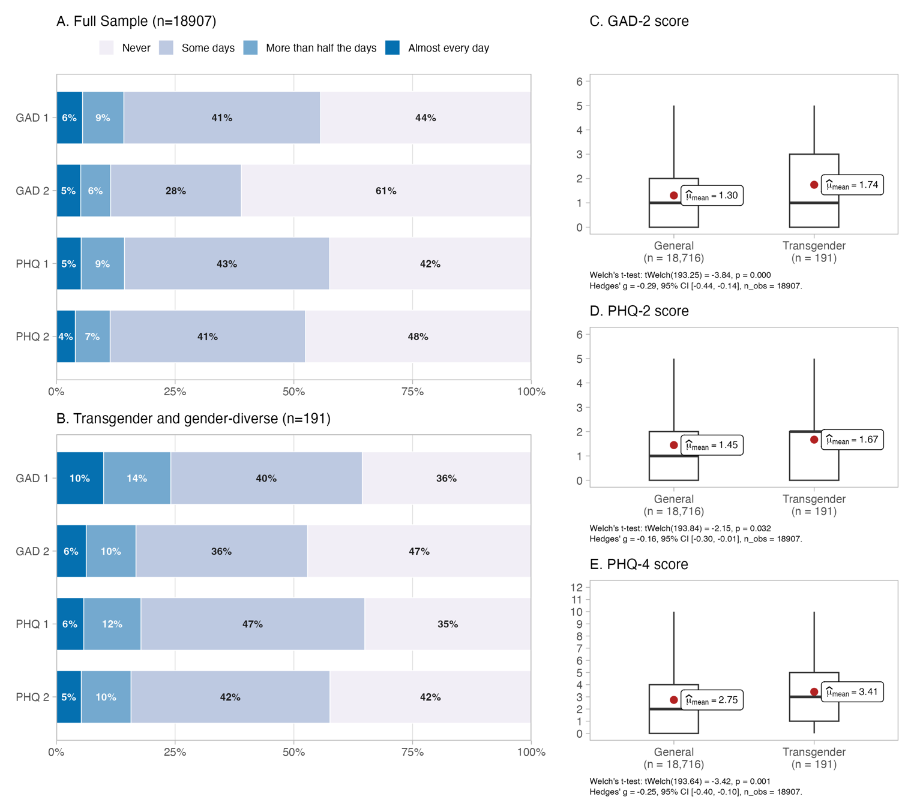
Note: Distribution of PHQ-4 total scores (range 0–12) for cisgender and transgender/gender-diverse (TGD) respondents. Scores are based on the unweighted analytic sample (N=18,907). The PHQ-4 combines the GAD-2 (anxiety) and PHQ-2 (depression) subscales. Higher scores indicate greater symptom burden. TGD individuals show a rightward shift in the distribution relative to cisgender respondents.

Table 2. Comparison of PHQ-4 scores and positive between the full sample and TGD (unweighted).

 | GAD 2 |  |  | PHQ 2 |  |  | PHQ 4
 | Mean  [CI 95%] | Stat. | p-val. | Mean  [CI 95%] | Stat. | p-val. | Mean  [CI 95%] | Stat. | p-val.
Gender group
Cisgender | 1.3 [1.3 - 1.3] | t=-3.84 | 0.00 | 1.4 [1.4 - 1.5] | t=-2.15 | 0.03 | 2.7 [2.7 - 2.8] | t=-3.42 | 0.00
Transgender | 1.7 [1.5 - 2.0] |  |  | 1.7 [1.5 - 1.9] |  |  | 3.4 [3.0 - 3.8]
Education
Primary complete/incomplete | 1.6 [1.5 - 1.6] | F=50.47 | 0.00 | 1.7 [1.7 - 1.8] | F=66.53 | 0.00 | 3.3 [3.2 - 3.4] | F=69.77 | 0.00
Secondary incomplete | 1.3 [1.3 - 1.4] |  |  | 1.5 [1.4 - 1.5] |  |  | 2.8 [2.7 - 2.9]
Secondary complete | 1.2 [1.1 - 1.2] |  |  | 1.3 [1.3 - 1.4] |  |  | 2.5 [2.4 - 2.6]
Higher education complete/incomplete | 1.3 [1.3 - 1.3] |  |  | 1.4 [1.4 - 1.4] |  |  | 2.7 [2.6 - 2.7]
Etnics
Non-indigenous | 1.3 [1.3 - 1.3] | t=-6.65 | 0.00 | 1.4 [1.4 - 1.4] | t=-6.05 | 0.00 | 2.7 [2.7 - 2.7] | t=-7.03 | 0.00
Indigenous | 1.5 [1.5 - 1.6] |  |  | 1.6 [1.6 - 1.7] |  |  | 3.1 [3.0 - 3.3]
Nationality
Chilean | 1.3 [1.3 - 1.3] | t=1.13 | 0.26 | 1.5 [1.4 - 1.5] | t=2.74 | 0.00 | 2.8 [2.7 - 2.8] | t=2.13 | 0.03
Migrant | 1.3 [1.2 - 1.4] |  |  | 1.3 [1.2 - 1.4] |  |  | 2.6 [2.4 - 2.7]
Health insurance
Public (FONASA) | 1.3 [1.3 - 1.3] | F=10.02 | 0.00 | 1.5 [1.4 - 1.5] | F=11.61 | 0.00 | 2.8 [2.7 - 2.8] | F=12.89 | 0.00
Private (ISAPRE) | 1.2 [1.1 - 1.2] |  |  | 1.3 [1.2 - 1.4] |  |  | 2.4 [2.3 - 2.6]
Other systems | 1.4 [1.2 - 1.5] |  |  | 1.4 [1.3 - 1.5] |  |  | 2.8 [2.6 - 2.9]
Quality of life
Very poor/Poor | 2.4 [2.3 - 2.6] | F=425.76 | 0.00 | 2.7 [2.5 - 2.8] | F=573.22 | 0.00 | 5.1 [4.9 - 5.4] | F=606.02 | 0.00
Neither good nor poor | 1.7 [1.7 - 1.8] |  |  | 2.0 [1.9 - 2.0] |  |  | 3.7 [3.6 - 3.8]
Very good/Good | 1.1 [1.1 - 1.1] |  |  | 1.2 [1.2 - 1.2] |  |  | 2.3 [2.3 - 2.4]
Note: Means [Confidence Interval 95%] reported for continuous outcomes. Full sample: unweighted N=18,907. TGD individuals: unweighted N=191. Means (SD) reported for continuous outcomes; percentages for binary screening outcomes. GAD-2: range 0–6. PHQ-2: range 0–6. PHQ-4: range 0–12. TGD: transgender and gender-diverse individuals.

Table 3. Linear regression models to PHQ-4 and subscale (unstandardized coefficients).

Unweighted Sample (N=18,907)
 | GAD-2 |  |  | PHQ-2 |  |  | PHQ-4
 | β | CI 95% | p-value | β | CI 95% | p-value | β | CI 95% | p-value
(Intercept) | 2.65 | [2.50, 2.80] | 0.000 | 2.87 | [2.71, 3.02] | 0.000 | 5.51 | [5.23, 5.79] | 0.000
Transgender | 0.35 | [0.13, 0.56] | 0.000 | 0.15 | [-0.05, 0.34] | 0.143 | 0.50 | [0.14, 0.86] | 0.000
Age
(Ref. 18 to 29)
30 to 44 | -0.12 | [-0.17, -0.06] | 0.000 | -0.09 | [-0.14, -0.04] | 0.000 | -0.21 | [-0.31, -0.11] | 0.000
45 to 59 | -0.17 | [-0.23, -0.11] | 0.000 | -0.10 | [-0.16, -0.04] | 0.000 | -0.27 | [-0.37, -0.16] | 0.000
60 and older | -0.19 | [-0.25, -0.12] | 0.000 | -0.16 | [-0.22, -0.10] | 0.000 | -0.34 | [-0.45, -0.23] | 0.000
Education
(Ref. Primary)
Secondary incomplete | -0.11 | [-0.18, -0.04] | 0.000 | -0.13 | [-0.21, -0.06] | 0.000 | -0.24 | [-0.37, -0.10] | 0.000
Secondary complete | -0.23 | [-0.29, -0.17] | 0.000 | -0.24 | [-0.30, -0.18] | 0.000 | -0.46 | [-0.58, -0.35] | 0.000
Higher education complete/incomplete | -0.07 | [-0.14, -0.01] | 0.035 | -0.10 | [-0.17, -0.03] | 0.000 | -0.17 | [-0.29, -0.05] | 0.000
Indigenous | 0.20 | [0.13, 0.26] | 0.000 | 0.17 | [0.10, 0.23] | 0.000 | 0.37 | [0.25, 0.48] | 0.000
Migrant | -0.10 | [-0.20, 0.00] | 0.061 | -0.15 | [-0.24, -0.06] | 0.000 | -0.24 | [-0.41, -0.07] | 0.000
Health insurance
(Ref. Public, FONASA)
Private (ISAPRE) | -0.06 | [-0.13, 0.02] | 0.132 | -0.05 | [-0.12, 0.02] | 0.183 | -0.11 | [-0.24, 0.02] | 0.087
Other systems | 0.08 | [-0.02, 0.19] | 0.125 | 0.00 | [-0.10, 0.10] | 0.948 | 0.09 | [-0.10, 0.27] | 0.362
Quality of life
(Ref. Very poor/Poor)
Neither good nor poor | -0.70 | [-0.85, -0.55] | 0.000 | -0.70 | [-0.85, -0.55] | 0.000 | -1.40 | [-1.67, -1.13] | 0.000
Very good/Good | -1.32 | [-1.46, -1.17] | 0.000 | -1.42 | [-1.57, -1.28] | 0.000 | -2.74 | [-3.01, -2.48] | 0.000
R² | 0.0627 |  |  | 0.0801 |  |  | 0.0627
Weighted Sample (N=12,6394,04)
 | GAD-2 |  |  | PHQ-2 |  |  | PHQ-4
 | β | CI 95% | p-value | β | CI 95% | p-value | β | CI 95% | p-value
(Intercept) | 2.70 | [2.48, 2.93] | 0.000 | 3.02 | [2.76, 3.28] | 0.000 | 5.71 | [5.29, 6.14] | 0.000
Transgender | 0.37 | [0.07, 0.66] | 0.014 | 0.27 | [-0.12, 0.67] | 0.172 | 0.66 | [0.02, 1.29] | 0.043
Age
(Ref. 18 to 29)
30 to 44 | -0.15 | [-0.23, -0.06] | 0.000 | -0.09 | [-0.18, -0.01] | 0.028 | -0.24 | [-0.39, -0.09] | 0.000
45 to 59 | -0.30 | [-0.39, -0.22] | 0.000 | -0.15 | [-0.24, -0.06] | 0.000 | -0.45 | [-0.61, -0.29] | 0.000
60 and older | -0.28 | [-0.37, -0.19] | 0.000 | -0.25 | [-0.35, -0.16] | 0.000 | -0.53 | [-0.70, -0.36] | 0.000
Education
(Ref. Primary)
Secondary incomplete | -0.19 | [-0.31, -0.07] | 0.000 | -0.15 | [-0.27, -0.03] | 0.012 | -0.33 | [-0.54, -0.11] | 0.000
Secondary complete | -0.31 | [-0.41, -0.21] | 0.000 | -0.29 | [-0.39, -0.19] | 0.000 | -0.59 | [-0.77, -0.40] | 0.000
Higher education complete/incomplete | -0.14 | [-0.24, -0.04] | 0.000 | -0.16 | [-0.27, -0.05] | 0.000 | -0.29 | [-0.48, -0.10] | 0.000
Indigenous | 0.18 | [0.07, 0.28] | 0.000 | 0.08 | [-0.02, 0.18] | 0.106 | 0.26 | [0.08, 0.45] | 0.000
Migrant | -0.13 | [-0.29, 0.02] | 0.092 | -0.24 | [-0.40, -0.08] | 0.000 | -0.37 | [-0.66, -0.09] | 0.000
Health insurance
(Ref. Public, FONASA)
Private (ISAPRE) | 0.00 | [-0.11, 0.10] | 0.945 | -0.08 | [-0.18, 0.03] | 0.144 | -0.09 | [-0.28, 0.10] | 0.367
Other systems | 0.07 | [-0.09, 0.22] | 0.392 | 0.02 | [-0.14, 0.18] | 0.831 | 0.08 | [-0.20, 0.36] | 0.554
Quality of life
(Ref. Very poor/Poor)
Neither good nor poor | -0.65 | [-0.88, -0.43] | 0.000 | -0.75 | [-1.00, -0.49] | 0.000 | -1.40 | [-1.83, -0.98] | 0.000
Very good/Good | -1.31 | [-1.53, -1.09] | 0.000 | -1.54 | [-1.78, -1.29] | 0.000 | -2.86 | [-3.27, -2.44] | 0.000
R² | 0.0706 |  |  | 0.0904 |  |  | 0.0965
Note: B = unstandardized regression coefficient. 95% confidence intervals estimated using heteroskedasticity-robust (HC3) standard errors, accounting for the complex sampling design. Reference categories: age 18–29, primary education, public health insurance (FONASA), very poor/poor quality of life, cisgender identity. N=18,907 (unweighted analytic sample).

Figure 2. Predicted cumulative probabilities by group for each PHQ-4 item (unweighted sample).
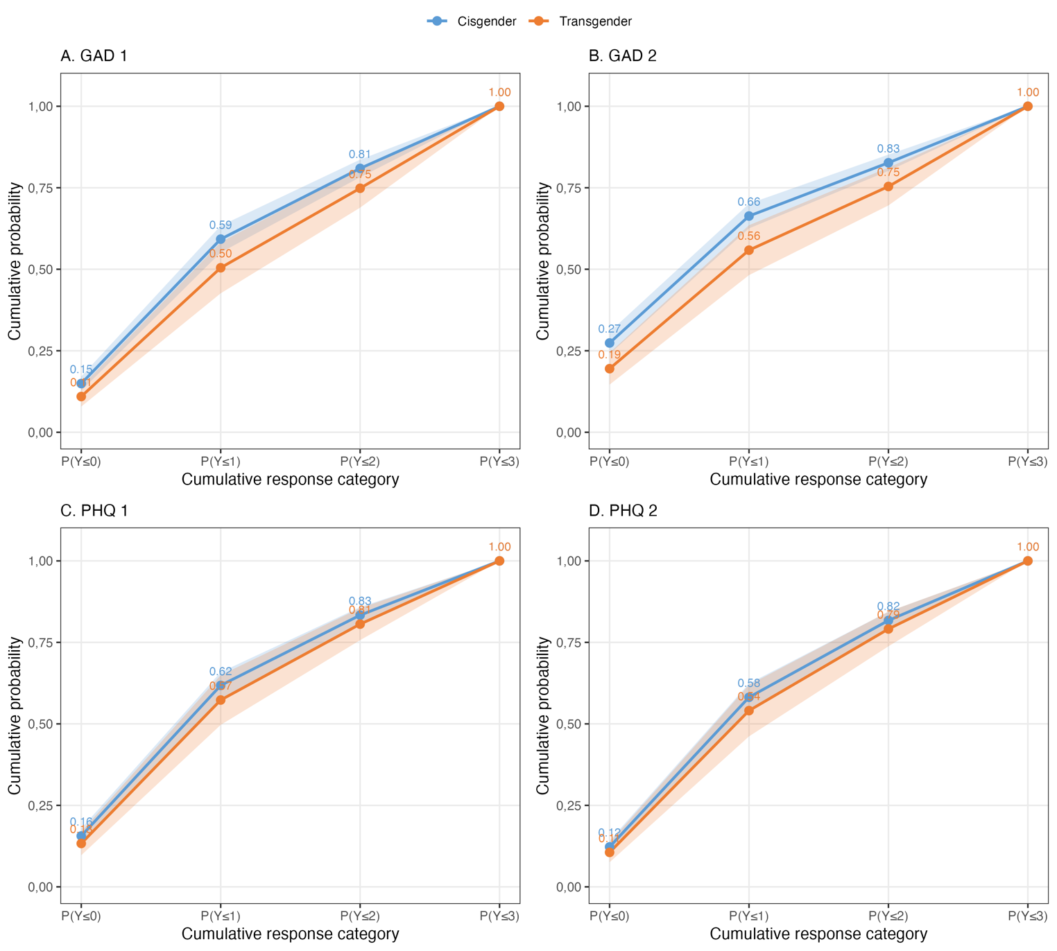
Note: Predicted cumulative probabilities P(Y ≤ k) from proportional odds cumulative link models fitted to each PHQ-4 item separately (unweighted sample, N=18,907). Models adjusted for age, education, indigenous identity, migration status, health insurance type, and quality of life. The downward shift of the transgender and gender-diverse (TGD) curve relative to the cisgender curve at each threshold indicates a higher probability of endorsing more severe response categories. Shaded bands represent 95% confidence intervals.

Material Supplementary

Data resources and codes are listed in the repository:
https://github.com/JDConejeros/Mental_Health_Transgenders
Reliability and inter-item correlations. The PHQ-4 demonstrated adequate internal consistency in the analytic sample (Cronbach's α=0.81, SE=0.002 for the 4-item total scale). The GAD-2 subscale yielded α=0.78 (SE=0.003), and the PHQ-2 subscale yielded a comparable coefficient. Spearman correlations between subscales were large and statistically significant: GAD-2 and PHQ-2 correlated at r=0.63 (p<.001), while each subscale correlated with the total PHQ-4 at r=0.90 (p<.001). Item-deletion analyses indicated that removing any single item did not substantially improve overall reliability (α range: 0.72–0.80 when items deleted), supporting retention of all four items as specified in the original PHQ-4 instrument.
Logistic regression models for binary screening outcomes. Survey-weighted logistic regression models predicting positive screening for anxiety (GAD-2 ≥ 3), depression (PHQ-2 ≥ 3), and general distress (PHQ-4 ≥ 6) consistently showed elevated odds for TGD individuals. After adjusting for all covariates, TGD respondents had approximately 1.5 to 2.0 times the odds of a positive screen compared to cisgender individuals, with effect sizes varying by outcome and sample weighting scheme. Better quality of life was the strongest protective factor across all models, with respondents rating their quality of life as very good/good showing odds reductions of approximately 75–85% relative to those with very poor/poor quality of life.
Item-level ordinal models — weighted sample. Weighted cumulative link models confirmed that TGD identity was significantly associated with higher odds of endorsing more severe anxiety symptom categories on both GAD items (GAD item 1: OR=1.38, 95% CI [1.06, 1.81], p=.018; GAD item 2: OR=1.86, 95% CI [1.42, 2.43], p<.001). For depression items, TGD identity was significantly associated with PHQ item 1 (OR=1.41, 95% CI [1.08, 1.85], p=.012) but not PHQ item 2 (OR=1.26, 95% CI [0.95, 1.66], p=.109). The predicted cumulative probability curves in Figure S1 visually illustrate the systematic downward shift for TGD individuals across all four items and all response thresholds in the weighted sample, reinforcing the pattern of greater symptom severity in this population.

Table S1. Comparison of PHQ-4 scores and positive between the full sample and TGD (weighted).

 | GAD 2 |  |  | PHQ 2 |  |  | PHQ 4
 | Mean  [CI 95%] | Stat. | p-val. | Mean  [CI 95%] | Stat. | p-val. | Mean  [CI 95%] | Stat. | p-val.
Gender group
Cisgender | 1.2 [1.2 - 1.3] | t=2.50 | 0.01 | 1.4 [1.4 - 1.4] | t=1.35 | 0.18 | 2.6 [2.6 - 2.7] | t=1.97 | 0.05
Transgender | 1.7 [1.3 - 2.0] |  |  | 1.7 [1.3 - 2.1] |  |  | 3.3 [2.6 - 4.1]
Education
Primary complete/incomplete | 1.5 [1.4 - 1.6] | F=23.46 | 0.00 | 1.7 [1.6 - 1.8] | F=24.19 | 0.00 | 3.3 [3.1 - 3.4] | F=27.57 | 0.00
Secondary incomplete | 1.3 [1.1 - 1.4] |  |  | 1.5 [1.4 - 1.6] |  |  | 2.7 [2.5 - 2.9]
Secondary complete | 1.1 [1.0 - 1.2] |  |  | 1.3 [1.2 - 1.4] |  |  | 2.4 [2.3 - 2.5]
Higher education complete/incomplete | 1.2 [1.2 - 1.3] |  |  | 1.3 [1.3 - 1.4] |  |  | 2.6 [2.5 - 2.7]
Etnics
Non-indigenous | 1.2 [1.2 - 1.3] | t=3.89 | 0.00 | 1.4 [1.3 - 1.4] | t=2.63 | 0.00 | 2.6 [2.5 - 2.7] | t=3.52 | 0.00
Indigenous | 1.5 [1.3 - 1.6] |  |  | 1.5 [1.4 - 1.6] |  |  | 3.0 [2.8 - 3.2]
Nationality
Chilean | 1.2 [1.2 - 1.3] | t=-1.59 | 0.11 | 1.4 [1.4 - 1.5] | t=-2.85 | 0.00 | 2.7 [2.6 - 2.7] | t=-2.43 | 0.02
Migrant | 1.1 [1.0 - 1.3] |  |  | 1.2 [1.0 - 1.3] |  |  | 2.3 [2.0 - 2.6]
Health insurance
Public (FONASA) | 1.3 [1.2 - 1.3] | F=1.74 | 0.18 | 1.4 [1.4 - 1.5] | F=7.44 | 0.00 | 2.7 [2.6 - 2.8] | F=4.88 | 0.00
Private (ISAPRE) | 1.1 [1.0 - 1.3] |  |  | 1.2 [1.1 - 1.3] |  |  | 2.4 [2.2 - 2.5]
Other systems | 1.3 [1.1 - 1.4] |  |  | 1.4 [1.2 - 1.5] |  |  | 2.7 [2.4 - 3.0]
Quality of life
Very poor/Poor | 2.3 [2.1 - 2.5] | F=182.51 | 0.00 | 2.7 [2.5 - 3.0] | F=284.69 | 0.00 | 5.1 [4.7 - 5.5] | F=282.51 | 0.00
Neither good nor poor | 1.7 [1.6 - 1.8] |  |  | 2.0 [1.9 - 2.0] |  |  | 3.7 [3.5 - 3.8]
Very good/Good | 1.1 [1.0 - 1.1] |  |  | 1.2 [1.1 - 1.2] |  |  | 2.2 [2.1 - 2.3]
Note: Means [Confidence Interval 95%] reported for continuous outcomes. Weighted estimates incorporate the ENSSEX-2022 complex survey design. Weighted sample n=12,639,404 (full sample); n=125,877 (TGD individuals). Expansion factors calibrated to the 2017 Chilean Census urban adult population. Means (SD) reported for continuous outcomes; percentages for binary screening outcomes. GAD-2: range 0–6. PHQ-2: range 0–6. PHQ-4: range 0–12. TGD: transgender and gender-diverse individuals.

Table S2. Spearman correlations among PHQ-4 subscales and total score.

Variable | GAD-2 | PHQ-2 | PHQ-4
GAD-2 | - | P=0.00 | P=0.00
PHQ-2 | 0.63 | - | P=0.00
PHQ-4 | 0.90 | 0.90 | -
Note: Spearman rank correlations. All reported correlations are statistically significant at p<.001. Cronbach's α=0.78 (SE=0.003) for the 2-item subscale structure; α=0.81 (SE=0.002) for the 4-item total PHQ-4. N=18,907 (unweighted analytic sample). GAD-2: 2-item anxiety subscale; PHQ-2: 2-item depression subscale; PHQ-4: 4-item total score.

Table S3. Internal consistency (Cronbach's α) of PHQ-4 subscales and total scale

PHQ-4 (2 Items) | α | SE | PHQ-4 (4 items) | SE | α
Global | 0.78 | 0.003 | Global | 0.81 | 0.002
If GAD-2 deleted | - | - | If GAD 1 deleted | 0.73 | 0.003
If PHQ-2 deleted | - | - | If GAD 2 deleted | 0.80 | 0.003
 |  |  | If PHQ 1 deleted | 0.78 | 0.003
 |  |  | If PHQ 2 deleted | 0.72 | 0.004
Note: Alpha-if-item-deleted statistics are shown for the 4-item PHQ-4 total scale. Dashes (-) in the 2-item subscale columns indicate that item-deletion statistics are not applicable for 2-item scales. N=18,907 (unweighted analytic sample). SE: standard error of Cronbach's alpha.

Table S4. Linear regression models to PHQ-4 and subscale (standardized coefficients).

Unweighted Sample (N=18,907)
 | GAD-2 |  |  | PHQ-2 |  |  | PHQ-4
 | β | CI 95% | p-value | β | CI 95% | p-value | β | CI 95% | p-value
(Intercept) | 0.93 | [0.82, 1.04] | 0.000 | 0.99 | [0.89, 1.10] | 0.000 | 1.06 | [0.96, 1.17] | 0.000
Transgender | 0.24 | [0.09, 0.39] | 0.000 | 0.10 | [-0.03, 0.24] | 0.143 | 0.19 | [0.06, 0.33] | 0.000
Age
(Ref. 18 to 29)
30 to 44 | -0.08 | [-0.12, -0.04] | 0.000 | -0.06 | [-0.10, -0.03] | 0.000 | -0.08 | [-0.12, -0.04] | 0.000
45 to 59 | -0.12 | [-0.16, -0.08] | 0.000 | -0.07 | [-0.11, -0.03] | 0.000 | -0.10 | [-0.14, -0.06] | 0.000
60 and older | -0.13 | [-0.17, -0.09] | 0.000 | -0.11 | [-0.15, -0.07] | 0.000 | -0.13 | [-0.18, -0.09] | 0.000
Education
(Ref. Primary)
Secondary incomplete | -0.08 | [-0.13, -0.03] | 0.000 | -0.09 | [-0.15, -0.04] | 0.000 | -0.09 | [-0.14, -0.04] | 0.000
Secondary complete | -0.16 | [-0.20, -0.11] | 0.000 | -0.17 | [-0.21, -0.12] | 0.000 | -0.18 | [-0.22, -0.13] | 0.000
Higher education complete/incomplete | -0.05 | [-0.10, 0.00] | 0.035 | -0.07 | [-0.12, -0.02] | 0.000 | -0.06 | [-0.11, -0.02] | 0.000
Indigenous | 0.14 | [0.09, 0.18] | 0.000 | 0.12 | [0.07, 0.16] | 0.000 | 0.14 | [0.10, 0.19] | 0.000
Migrant | -0.07 | [-0.14, 0.00] | 0.061 | -0.11 | [-0.17, -0.04] | 0.000 | -0.09 | [-0.16, -0.03] | 0.000
Health insurance
(Ref. Public, FONASA)
Private (ISAPRE) | -0.04 | [-0.09, 0.01] | 0.132 | -0.03 | [-0.09, 0.02] | 0.183 | -0.04 | [-0.09, 0.01] | 0.087
Other systems | 0.06 | [-0.02, 0.13] | 0.125 | 0.00 | [-0.07, 0.07] | 0.948 | 0.03 | [-0.04, 0.10] | 0.362
Quality of life
(Ref. Very poor/Poor)
Neither good nor poor | -0.48 | [-0.59, -0.38] | 0.000 | -0.49 | [-0.59, -0.39] | 0.000 | -0.54 | [-0.64, -0.43] | 0.000
Very good/Good | -0.91 | [-1.01, -0.81] | 0.000 | -1.00 | [-1.10, -0.90] | 0.000 | -1.06 | [-1.16, -0.96] | 0.000
R² | 0.0627 |  |  | 0.0801 |  |  | 0.0627
Weighted Sample (N=12,6394,04)
 | GAD-2 |  |  | PHQ-2 |  |  | PHQ-4
 | β | CI 95% | p-value | β | CI 95% | p-value | β | CI 95% | p-value
(Intercept) | 1.03 | [0.87, 1.19] | 0.000 | 1.13 | [0.95, 1.32] | 0.000 | 1.20 | [1.03, 1.36] | 0.000
Transgender | 0.26 | [0.05, 0.47] | 0.014 | 0.19 | [-0.08, 0.47] | 0.172 | 0.26 | [0.01, 0.50] | 0.043
Age
(Ref. 18 to 29)
30 to 44 | -0.10 | [-0.16, -0.04] | 0.000 | -0.07 | [-0.13, -0.01] | 0.028 | -0.09 | [-0.15, -0.03] | 0.000
45 to 59 | -0.21 | [-0.28, -0.15] | 0.000 | -0.11 | [-0.17, -0.04] | 0.000 | -0.17 | [-0.24, -0.11] | 0.000
60 and older | -0.20 | [-0.26, -0.13] | 0.000 | -0.18 | [-0.24, -0.11] | 0.000 | -0.21 | [-0.27, -0.14] | 0.000
Education
(Ref. Primary)
Secondary incomplete | -0.13 | [-0.22, -0.05] | 0.000 | -0.11 | [-0.19, -0.02] | 0.012 | -0.13 | [-0.21, -0.04] | 0.000
Secondary complete | -0.22 | [-0.29, -0.15] | 0.000 | -0.20 | [-0.28, -0.13] | 0.000 | -0.23 | [-0.30, -0.16] | 0.000
Higher education complete/incomplete | -0.10 | [-0.17, -0.03] | 0.000 | -0.11 | [-0.19, -0.04] | 0.000 | -0.11 | [-0.19, -0.04] | 0.000
Indigenous | 0.12 | [0.05, 0.20] | 0.000 | 0.06 | [-0.01, 0.12] | 0.106 | 0.10 | [0.03, 0.17] | 0.000
Migrant | -0.09 | [-0.20, 0.02] | 0.092 | -0.17 | [-0.28, -0.06] | 0.000 | -0.14 | [-0.26, -0.03] | 0.000
Health insurance
(Ref. Public, FONASA)
Private (ISAPRE) | 0.00 | [-0.08, 0.07] | 0.945 | -0.06 | [-0.13, 0.02] | 0.144 | -0.03 | [-0.11, 0.04] | 0.367
Other systems | 0.05 | [-0.06, 0.16] | 0.392 | 0.01 | [-0.10, 0.13] | 0.831 | 0.03 | [-0.08, 0.14] | 0.554
Quality of life
(Ref. Very poor/Poor)
Neither good nor poor | -0.46 | [-0.62, -0.30] | 0.000 | -0.52 | [-0.70, -0.35] | 0.000 | -0.55 | [-0.71, -0.38] | 0.000
Very good/Good | -0.93 | [-1.08, -0.77] | 0.000 | -1.08 | [-1.25, -0.90] | 0.000 | -1.11 | [-1.27, -0.95] | 0.000
R² | 0.0706 |  |  | 0.0904 |  |  | 0.0965
Note: β = standardized regression coefficient. 95% confidence intervals estimated using heteroskedasticity-robust (HC3) standard errors, accounting for the complex sampling design. Reference categories identical to Table 3. Standardized coefficients allow comparison of relative effect sizes across predictors within each model. N=18,907 (unweighted analytic sample).
Table S5. Logistic regression models to PHQ-4 screening outcomes.

Unweighted Sample (N=18,907)
 | GAD-2 >=3 |  |  | PHQ-2 >=3 |  |  | PHQ-4 >=6
 | OR | CI 95% | p-value | OR | CI 95% | p-value | OR | CI 95% | p-value
(Intercept) | 0.96 | [0.78, 1.17] | 0.666 | 1.02 | [0.84, 1.25] | 0.824 | 0.97 | [0.78, 1.19] | 0.739
Transgender | 1.75 | [1.26, 2.41] | 0.000 | 1.44 | [1.01, 2.01] | 0.041 | 1.40 | [0.95, 2.00] | 0.079
Age
(Ref. 18 to 29)
30 to 44 | 0.78 | [0.70, 0.87] | 0.000 | 0.78 | [0.70, 0.87] | 0.000 | 0.81 | [0.72, 0.92] | 0.000
45 to 59 | 0.69 | [0.61, 0.77] | 0.000 | 0.83 | [0.74, 0.93] | 0.000 | 0.76 | [0.67, 0.86] | 0.000
60 and older | 0.69 | [0.61, 0.78] | 0.000 | 0.71 | [0.63, 0.81] | 0.000 | 0.67 | [0.59, 0.77] | 0.000
Education
(Ref. Primary)
Secondary incomplete | 0.99 | [0.87, 1.13] | 0.853 | 0.94 | [0.82, 1.07] | 0.350 | 0.88 | [0.76, 1.02] | 0.082
Secondary complete | 0.80 | [0.71, 0.90] | 0.000 | 0.78 | [0.70, 0.88] | 0.000 | 0.78 | [0.68, 0.88] | 0.000
Higher education complete/incomplete | 0.94 | [0.83, 1.07] | 0.335 | 0.84 | [0.74, 0.96] | 0.000 | 0.85 | [0.74, 0.98] | 0.027
Indigenous | 1.30 | [1.16, 1.45] | 0.000 | 1.25 | [1.11, 1.41] | 0.000 | 1.30 | [1.14, 1.47] | 0.000
Migrant | 0.82 | [0.67, 1.00] | 0.053 | 0.78 | [0.63, 0.96] | 0.023 | 0.83 | [0.66, 1.04] | 0.111
Health insurance
(Ref. Public, FONASA)
Private (ISAPRE) | 0.84 | [0.71, 0.99] | 0.035 | 0.99 | [0.83, 1.16] | 0.859 | 0.92 | [0.76, 1.10] | 0.359
Other systems | 1.30 | [1.08, 1.54] | 0.000 | 1.12 | [0.92, 1.34] | 0.252 | 1.23 | [1.01, 1.50] | 0.038
Quality of life
(Ref. Very poor/Poor)
Neither good nor poor | 0.49 | [0.41, 0.58] | 0.000 | 0.50 | [0.42, 0.59] | 0.000 | 0.43 | [0.36, 0.51] | 0.000
Very good/Good | 0.22 | [0.19, 0.26] | 0.000 | 0.19 | [0.16, 0.22] | 0.000 | 0.15 | [0.13, 0.18] | 0.000
Deviance | 16,858.22 |  |  | 16,354.02 |  |  | 14,273.71
AIC | 16,886.22 |  |  | 16,382.02 |  |  | 14,301.71
BIC | 16,996.12 |  |  | 16,491.92 |  |  | 14,411.58
Weighted Sample (N=12,6394,04)
 | GAD-2 >=3 |  |  | PHQ-2 >=3 |  |  | PHQ-4 >=6
 | OR | CI 95% | p-value | OR | CI 95% | p-value | OR | CI 95% | p-value
(Intercept) | 1.09 | [0.80, 1.48] | 0.585 | 1.38 | [0.97, 1.96] | 0.074 | 1.28 | [0.89, 1.85] | 0.186
Transgender | 1.72 | [1.00, 2.97] | 0.050 | 1.32 | [0.70, 2.47] | 0.390 | 1.45 | [0.73, 2.87] | 0.283
Age
(Ref. 18 to 29)
30 to 44 | 0.78 | [0.66, 0.91] | 0.000 | 0.82 | [0.67, 1.00] | 0.054 | 0.88 | [0.72, 1.08] | 0.231
45 to 59 | 0.56 | [0.45, 0.68] | 0.000 | 0.78 | [0.65, 0.93] | 0.000 | 0.67 | [0.55, 0.81] | 0.000
60 and older | 0.57 | [0.47, 0.70] | 0.000 | 0.63 | [0.51, 0.77] | 0.000 | 0.57 | [0.46, 0.72] | 0.000
Education
(Ref. Primary)
Secondary incomplete | 0.89 | [0.69, 1.13] | 0.330 | 0.81 | [0.61, 1.08] | 0.153 | 0.79 | [0.59, 1.05] | 0.106
Secondary complete | 0.72 | [0.59, 0.86] | 0.000 | 0.68 | [0.54, 0.86] | 0.000 | 0.69 | [0.55, 0.87] | 0.000
Higher education complete/incomplete | 0.86 | [0.70, 1.06] | 0.155 | 0.72 | [0.56, 0.92] | 0.000 | 0.70 | [0.54, 0.90] | 0.000
Indigenous | 1.26 | [1.05, 1.50] | 0.011 | 1.07 | [0.89, 1.28] | 0.474 | 1.24 | [1.00, 1.52] | 0.045
Migrant | 0.75 | [0.52, 1.08] | 0.116 | 0.62 | [0.44, 0.88] | 0.000 | 0.67 | [0.46, 0.98] | 0.038
Health insurance
(Ref. Public, FONASA)
Private (ISAPRE) | 0.86 | [0.65, 1.14] | 0.303 | 0.82 | [0.63, 1.07] | 0.138 | 0.93 | [0.69, 1.24] | 0.612
Other systems | 1.32 | [1.01, 1.74] | 0.046 | 1.14 | [0.87, 1.48] | 0.338 | 1.07 | [0.78, 1.46] | 0.681
Quality of life
(Ref. Very poor/Poor)
Neither good nor poor | 0.51 | [0.39, 0.66] | 0.000 | 0.47 | [0.35, 0.64] | 0.000 | 0.40 | [0.30, 0.52] | 0.000
Very good/Good | 0.21 | [0.16, 0.28] | 0.000 | 0.16 | [0.12, 0.21] | 0.000 | 0.13 | [0.10, 0.17] | 0.000
Deviance | 15,953.22 |  |  | 15,779.31 |  |  | 13,634.41
AIC | 16,018.78 |  |  | 15,847.71 |  |  | 13,701.27
BIC | 16,091.12 |  |  | 15,917.20 |  |  | 13,772.27
Note: OR = odds ratio. 95% confidence intervals estimated using survey-weighted Wald method. Outcome variables: positive anxiety screening (GAD-2 ≥ 3), positive depression screening (PHQ-2 ≥ 3), and positive general distress screening (PHQ-4 ≥ 6). Log-likelihood and AIC/BIC are survey pseudo–log-likelihood and approximate fit indices. Reference categories identical to Table 3. N=18,907 (unweighted analytic sample).

Table S6. Cumulative link models (proportional odds) for individual anxiety ítems PHQ-4.
 | Anxious Items (Unweighted Sample, N=18,907)
 | GAD 1 |  |  | GAD 2
 | OR | CI 95% | p-value | OR | CI 95% | p-value
0 Never | 1 Some days | 0.18 | [0.15, 0.21] | 0.000 | 0.38 | [0.32, 0.45] | 0.000
1 Some days | 2 More than half the days | 1.45 | [1.23, 1.72] | 0.000 | 1.97 | [1.66, 2.33] | 0.000
2 More than half the day | 3 Almost every day | 4.25 | [3.57, 5.06] | 0.000 | 4.77 | [4.01, 5.68] | 0.000
Transgender | 1.43 | [1.09, 1.87] | 0.000 | 1.56 | [1.19, 2.03] | 0.000
Age
(Ref. 18 to 29)
30 to 44 | 0.85 | [0.79, 0.92] | 0.000 | 0.89 | [0.82, 0.97] | 0.000
45 to 59 | 0.81 | [0.75, 0.88] | 0.000 | 0.82 | [0.76, 0.90] | 0.000
60 and older | 0.78 | [0.71, 0.85] | 0.000 | 0.85 | [0.77, 0.93] | 0.000
Education
(Ref. Primary)
Secondary incomplete | 0.85 | [0.77, 0.94] | 0.000 | 0.85 | [0.77, 0.94] | 0.000
Secondary complete | 0.74 | [0.68, 0.80] | 0.000 | 0.74 | [0.67, 0.80] | 0.000
Higher education complete/incomplete | 1.03 | [0.94, 1.12] | 0.569 | 0.82 | [0.75, 0.90] | 0.000
Indigenous | 1.28 | [1.18, 1.40] | 0.000 | 1.29 | [1.18, 1.41] | 0.000
Migrant | 0.85 | [0.74, 0.98] | 0.024 | 0.97 | [0.84, 1.13] | 0.699
Health insurance
(Ref. Public, FONASA)
Private (ISAPRE) | 0.98 | [0.88, 1.09] | 0.719 | 0.95 | [0.84, 1.07] | 0.370
Other systems | 1.05 | [0.92, 1.20] | 0.455 | 1.05 | [0.91, 1.21] | 0.473
Quality of life
(Ref. Very poor/Poor)
Neither good nor poor | 0.51 | [0.44, 0.60] | 0.000 | 0.51 | [0.44, 0.59] | 0.000
Very good/Good | 0.23 | [0.19, 0.26] | 0.000 | 0.26 | [0.22, 0.30] | 0.000
AIC | 40,693.21 |  |  | 36,538.93
BIC | 40,818.84 |  |  | 36,664.54
 | Anxious Items (Weighted Sample, N=12,6394,04)
 | GAD 1 |  |  | GAD 2
 | OR | CI 95% | p-value | OR | CI 95% | p-value
0 Never | 1 Some days | 0.15 | [0.12, 0.18] | 0.000 | 0.35 | [0.30, 0.42] | 0.000
1 Some days | 2 More than half the days | 1.20 | [1.00, 1.42] | 0.045 | 1.91 | [1.60, 2.27] | 0.000
2 More than half the day | 3 Almost every day | 3.66 | [3.06, 4.38] | 0.000 | 4.77 | [3.98, 5.72] | 0.000
Transgender | 1.38 | [1.06, 1.81] | 0.018 | 1.86 | [1.42, 2.43] | 0.000
Age
(Ref. 18 to 29)
30 to 44 | 0.78 | [0.72, 0.84] | 0.000 | 0.89 | [0.82, 0.96] | 0.000
45 to 59 | 0.65 | [0.60, 0.70] | 0.000 | 0.70 | [0.64, 0.77] | 0.000
60 and older | 0.69 | [0.63, 0.76] | 0.000 | 0.76 | [0.69, 0.84] | 0.000
Education
(Ref. Primary)
Secondary incomplete | 0.80 | [0.71, 0.89] | 0.000 | 0.76 | [0.68, 0.86] | 0.000
Secondary complete | 0.67 | [0.61, 0.73] | 0.000 | 0.66 | [0.60, 0.73] | 0.000
Higher education complete/incomplete | 0.95 | [0.86, 1.04] | 0.230 | 0.78 | [0.70, 0.86] | 0.000
Indigenous | 1.24 | [1.13, 1.36] | 0.000 | 1.23 | [1.11, 1.36] | 0.000
Migrant | 0.75 | [0.66, 0.86] | 0.000 | 1.00 | [0.86, 1.16] | 0.983
Health insurance
(Ref. Public, FONASA)
Private (ISAPRE) | 1.02 | [0.93, 1.12] | 0.697 | 1.00 | [0.91, 1.11] | 0.945
Other systems | 1.07 | [0.94, 1.21] | 0.324 | 1.01 | [0.88, 1.16] | 0.916
Quality of life
(Ref. Very poor/Poor)
Neither good nor poor | 0.52 | [0.44, 0.61] | 0.000 | 0.53 | [0.45, 0.61] | 0.000
Very good/Good | 0.22 | [0.19, 0.26] | 0.000 | 0.24 | [0.20, 0.28] | 0.000
AIC | 40,428.67 |  |  | 34,543.57
BIC | 40,554.30 |  |  | 34,669.18
(continue…)
 | Depressive Items (Unweighted Sample, N=18,907)
 | PHQ 1 |  |  | PHQ 2
 | OR | CI 95% | p-value | OR | CI 95% | p-value
0 Never | 1 Some days | 0.18 | [0.16, 0.22] | 0.000 | 0.14 | [0.12, 0.17] | 0.000
1 Some days | 2 More than half the days | 1.62 | [1.36, 1.92] | 0.000 | 1.39 | [1.17, 1.65] | 0.000
2 More than half the day | 3 Almost every day | 5.00 | [4.19, 5.98] | 0.000 | 4.47 | [3.74, 5.36] | 0.000
Transgender | 1.20 | [0.92, 1.57] | 0.171 | 1.18 | [0.90, 1.55] | 0.234
Age
(Ref. 18 to 29)
30 to 44 | 0.90 | [0.83, 0.97] | 0.000 | 0.86 | [0.80, 0.93] | 0.000
45 to 59 | 0.84 | [0.78, 0.92] | 0.000 | 0.87 | [0.80, 0.95] | 0.000
60 and older | 0.75 | [0.69, 0.82] | 0.000 | 0.87 | [0.80, 0.95] | 0.000
Education
(Ref. Primary)
Secondary incomplete | 0.88 | [0.80, 0.97] | 0.000 | 0.81 | [0.74, 0.90] | 0.000
Secondary complete | 0.81 | [0.74, 0.88] | 0.000 | 0.67 | [0.62, 0.73] | 0.000
Higher education complete/incomplete | 1.02 | [0.93, 1.12] | 0.685 | 0.80 | [0.73, 0.87] | 0.000
Indigenous | 1.28 | [1.18, 1.40] | 0.000 | 1.20 | [1.10, 1.32] | 0.000
Migrant | 0.84 | [0.73, 0.96] | 0.011 | 0.84 | [0.73, 0.97] | 0.017
Health insurance
(Ref. Public, FONASA)
Private (ISAPRE) | 0.99 | [0.89, 1.10] | 0.841 | 0.88 | [0.79, 0.99] | 0.027
Other systems | 0.95 | [0.83, 1.09] | 0.487 | 0.98 | [0.85, 1.12] | 0.748
Quality of life
(Ref. Very poor/Poor)
Neither good nor poor | 0.55 | [0.47, 0.64] | 0.000 | 0.45 | [0.38, 0.53] | 0.000
Very good/Good | 0.25 | [0.21, 0.29] | 0.000 | 0.17 | [0.14, 0.19] | 0.000
AIC | 40,857.37 |  |  | 37,995.55
BIC | 40,982.98 |  |  | 38,121.18
 | Depressive Items (Weighted Sample, N=12,6394,04)
 | PHQ 1 |  |  | PHQ 2
 | OR | CI 95% | p-value | OR | CI 95% | p-value
0 Never | 1 Some days | 0.17 | [0.14, 0.20] | 0.000 | 0.11 | [0.09, 0.14] | 0.000
1 Some days | 2 More than half the days | 1.42 | [1.19, 1.70] | 0.000 | 1.08 | [0.91, 1.30] | 0.380
2 More than half the day | 3 Almost every day | 4.34 | [3.61, 5.21] | 0.000 | 3.45 | [2.87, 4.15] | 0.000
Transgender | 1.41 | [1.08, 1.85] | 0.012 | 1.26 | [0.95, 1.66] | 0.109
Age
(Ref. 18 to 29)
30 to 44 | 0.88 | [0.82, 0.95] | 0.000 | 0.84 | [0.78, 0.91] | 0.000
45 to 59 | 0.80 | [0.74, 0.87] | 0.000 | 0.79 | [0.72, 0.86] | 0.000
60 and older | 0.67 | [0.61, 0.73] | 0.000 | 0.76 | [0.70, 0.84] | 0.000
Education
(Ref. Primary)
Secondary incomplete | 0.90 | [0.80, 1.01] | 0.062 | 0.79 | [0.71, 0.89] | 0.000
Secondary complete | 0.78 | [0.72, 0.86] | 0.000 | 0.60 | [0.55, 0.66] | 0.000
Higher education complete/incomplete | 1.01 | [0.92, 1.11] | 0.780 | 0.70 | [0.63, 0.76] | 0.000
Indigenous | 1.16 | [1.06, 1.27] | 0.000 | 1.09 | [0.99, 1.19] | 0.085
Migrant | 0.72 | [0.63, 0.83] | 0.000 | 0.71 | [0.62, 0.82] | 0.000
Health insurance
(Ref. Public, FONASA)
Private (ISAPRE) | 0.97 | [0.88, 1.06] | 0.480 | 0.86 | [0.78, 0.95] | 0.000
Other systems | 0.98 | [0.86, 1.11] | 0.724 | 0.98 | [0.86, 1.12] | 0.814
Quality of life
(Ref. Very poor/Poor)
Neither good nor poor | 0.54 | [0.45, 0.63] | 0.000 | 0.42 | [0.36, 0.50] | 0.000
Very good/Good | 0.22 | [0.19, 0.26] | 0.000 | 0.15 | [0.12, 0.17] | 0.000
AIC | 40,556.80 |  |  | 37,293.30
BIC | 40,682.41 |  |  | 37,418.93
Note: OR = odds ratio from proportional odds cumulative link models. Models fitted separately for each item. Upper panel: unweighted sample (N=18,907). Lower panel: weighted sample (N=12,639,404). Thresholds represent cumulative log-odds cut-points between adjacent response categories (0|1, 1|2, 2|3). Covariates: age group, education, indigenous identity, migration status, health insurance type, and quality of life. Reference categories: age 18–29, primary education, public insurance (FONASA), very poor/poor quality of life, cisgender identity. AIC and BIC are survey-adjusted approximate fit indices.

Figure S1. Predicted cumulative probabilities by group for each PHQ-4 item (weighted sample).
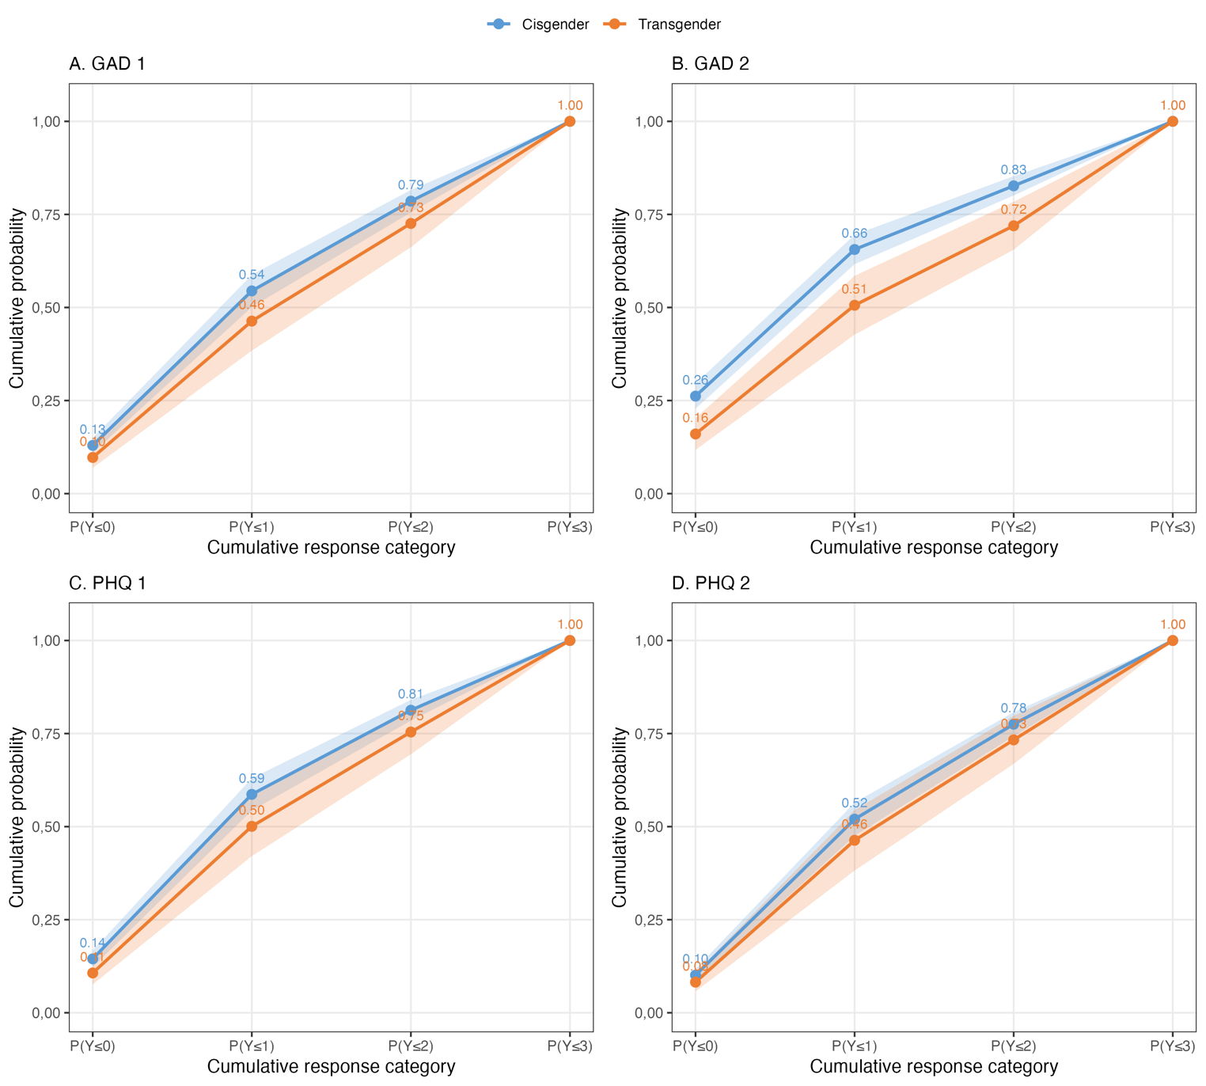
Note. Predicted cumulative probabilities P(Y ≤ k) from proportional odds cumulative link models for each PHQ-4 item, weighted sample (N=12,639,404). Models adjusted for age, education, indigenous identity, migration status, health insurance type, and quality of life. Blue line: cisgender individuals. Orange line: transgender and gender-diverse (TGD) individuals. The consistent downward shift of the TGD curve across all thresholds and all four items indicates a higher probability of endorsing more severe symptom categories. Shaded bands represent 95% confidence intervals. Weights renormalized to sum to n.

