Jeremy Ginter

Assignment 3.2

1/21/2024

<https://github.com/JDGinter/csd-340.git>

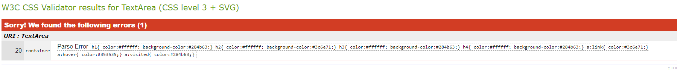

Note: I was unable to solve these two errors with my HTML and CSS files. Despite this they seem to be working correctly. If you could give many any advice on how to fix this so I can avoid these errors in the future I would appreciate it.

Github Landing Page Link:

<https://jdginter.github.io/csd-340/>