Lecture #10b - Standard Template Library (STL) - In addition to the standard C++ library, the STL contains templates for useful algorithms, containers, and iterators.

- The Standard Template Library (STL) uses templates, thus providing
compile-time polymorphism.
- Modern C++ compilers are tuned to minimize any abstraction penalty arising from
heavy use of the STL.

STL Containers - A container is a holder object that stores a collection of other objects.

- A container manages storage space for its elements and provides member
functions to access them, either directly or through iterators (reference objects with
similar properties to pointers).
Three types of Containers:
- Sequence containers - A sequence container organizes data sequentially like a sorted list.
- Associative containers - Unordered collections, like stacks, queues and
unordered lists.

- Container adaptors - Container adaptors are not full container classes.
  - They provide an interface but rely on an object of one of the container classes (such
as deque or list) to handle the elements.
There are 7 headers for container classes.

<vector> - vector is a sequential container class
<deque> - deque “ “ “
<list> - list “ “ “
<map> - map and multimap are associative container classes
<set> - set and multiset “ “ “
<stack> - stack is an adaptor container class (dependent on a container class)
<queue> - queue and priority_queue “ “ “
____________________________________________________________________________________________________________________________________
<iterator>
- Usually, when working with STL containers, the iterator header is not required. Each container
class provides its own iterators by including <iterator>.
    - By including <vector>, the <iterator> header is included.

<algorithm> - There are nearly seventy algorithms available from the <algorithm> header,
such as for searching and sorting.
#include <algorithm>

STL algorithms are independent of containers, which significantly reduces the
complexity of the library.
The following are examples of function templates found in the <algorithm> library:
  - swap() Ex: int num1 = 3;
int num2 = 5;
swap(num1, num2);
cout << num1; // output: 5
  - min() Ex: cout << "Lowest number: " << min(num1,num2);
  - max() Ex: cout << "Highest number: " << max(num1,num2);

Ex : The following program uses the swap function template, which is defined in
the <algorithm> header file.

vector STL class

#include <vector>

vector - A vector is a sequence container implemented as a dynamic array.*****See last page
- Just as regular arrays, vector elements are stored in contiguous storage locations.
  - Elements can be accessed using iterators, as well as, by using offsets on regular
pointers to elements.

Note: Unlike a regular array, storage in a vector is handled automatically, allowing it
to expand and contract as needed.

- Values can be added to or removed from the end or middle of a vector.

- Adding values to the back is very efficient O(1), but inefficient in the middle or front O(n).

- Insert and remove an element to/from back of the vector takes constant time 0(1).

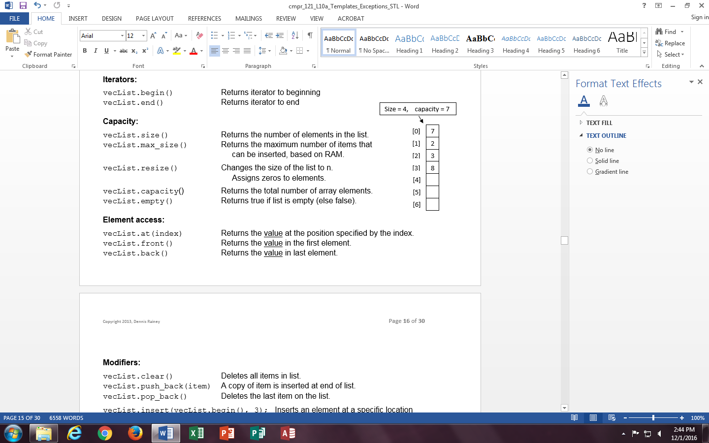
- Inserting and deleting at the front or in the middle is linear in time 0(n).

Advantage: Vectors provide almost the same performance as arrays,
plus they have the ability to be easily resized.

Vector size and capacity
size - Vectors have a size function, which represents the number
of items in a vector.
Note: size is the number of values in the array - not the array size.

capacity - Vectors also have a capacity function, which determines the
amount of allocated storage space, which can be either
equal or greater than the actual size.
- A vector does not have to reallocate storage with each insert operation.
- Only when capacity is exhausted (vector is full) and a new element is inserted.

- Reallocations may be a costly operation because the entire array used by the
vector is copied to a new array.

3 ways to declare a vector object:

Ex #1: vector<char>letters; // Creates an empty container

// Data type of values the container will hold must be specified.

.
Ex #2: vector<int>vecList(10); // Creates a container of size 10.
// All elements are initialized to 0.
Ex #3: vector<int>values = {2,4,6,8};

Assign values to vector containers, and output values using a for loop (same as
regular arrays).

Ex #4: for (int i = 0; i < 10; i++)
cout << vecList[i];

Ex #5: for (int i = 0; i < vecList.size(); i++)
cout << vecList[i];

Operations on vector objects - Pre-defined vector functions.

Function Name Effect

Iterators:

vecList.begin() Returns iterator to beginning
vecList.end() Returns iterator to end

Capacity:
vecList.size() Returns the number of elements in the list.
vecList.max_size() Returns the maximum number of items that
can be inserted, based on RAM.
vecList.resize(n) Changes the size of the list to n.
Assigns zeros to elements.
vecList.capacity() Returns the total number of array elements.
vecList.empty() Returns true if list is empty (else false).

Element access:
vecList.at(index) Returns the value at the position specified by the index.
Ex: cout << vecList.at(2); // cout << vecList[2];
vecList.front() Returns the value in the first element.
Ex: cout << vecList.front();

vecList.back() Returns the value in last element.

Modifiers:
vecList.clear() Deletes all items in list.
vecList.push_back(item) A copy of item is inserted at end of list.
vecList.pop_back() Deletes the last item on the list.

vecList.insert(vecList.begin(), 3); Inserts an element at a specific location
(at the beginning in this case (front))
Note: Use push_back() when possible (more efficient).
vecList.insert(vecList.begin() + 2, 3); Inserts 3 at index [2] )

vecList.erase(vecList.begin() + 4 ); // Delete the second element assuming int
vList_1.swap(vList_2) // Swaps items in two different vectors.

// swap vectors
#include <iostream>
using namespace std;
#include <vector>

int main ()
{
vector<int> vList_1 (3,100); // three ints with a value of 100
vector<int> vList_2 (5,200); // five ints with a value of 200

vList_1.swap(vList_2);

cout << "vList_1 contains:";
for (unsigned i = 0; i < vList_1.size(); i++)
/* OUTPUT
vList_1 contains: 200 200 200 200 200
vList_2 contains: 100 100 100
cout << ' ' << vList_1[i];

cout << "\n vList_2 contains:";
for (unsigned i = 0; i < vList_2.size(); i++)
cout << ' ' << vList_2[i];

Ex #6: vecList.push_back(33); // 33 is the first item inserted into the list.
vecList.push_back(17); // 17 is inserted at the end of the list.

Ex #7: cout << vecList.size( ) // Output: 2

Ex_9: vector (STL)

#include <iostream>
#include <vector>
using namespace std;
int main()
{
vector<int> values; // Define a vector object

// Use push_back() to push values into the back (end) of the vector.
cout << "Use (Push_back) to input 22, 18, 55, 841:\n";
// Store values in the vector
values.push_back(22);

values.push_back(18);
values.push_back(55);
values.push_back(841);

// The size function returns the number of vector elements.
cout << "The size of the values vector is: " << values.size();
cout << "\nThe front element is: " << values.front();
cout << "\nThe back element is: " << values.back();

// Remove a value from the vector
cout << "\n\n(pop_back) one value from the vector.";
values.pop_back();
cout << "\nSize of values vector is now: " << values.size();
/* Output:
Use (push_back) to input 22, 18, 55, 841:
The size of the values vector is: 4

The front element is: 22
The back element is: 841

(pop_back) one value from the vector.
Size of values vector is now: 3
The contents of the values vector is now:
22, 18, 55,
Now, empty the vector. . .
Size of values vector is now: 0

cout << "\n\nThe contents of the "
<< vector is now:\n";
for (int i = 0; i < values.size(); i++)
cout << values[i] << ", ";
cout << "\n\nNow, empty the vector. . .\n";
while (!values.empty())
values.pop_back();
cout << "Size of vector is now: "
<< values.size() <<"\n\n\n";
return 0;
}

Ex #9: Pass a vector of struct Box objects to a function (pass by reference

// ==== Box.h ====================================================

#include <iostream>
using namespace std;

struct Box
{
string name;
float height;
};
// ==============================================================

// ==== main.cpp=================================================

#include "Box.h"
#include <vector>

void insertBox(vector<Box> & boxes);

int main()
{
vector<Box> boxes;

insertBox(boxes);
---
--- (insertBox function on next page)
void insertBox(vector<Box> & boxes)
{
Box box;

cout << "Enter a name for a box: ";
getline(cin, box.name);

cout << "Enter the height of the box in inches: ";
cin >> box.height;

boxes.push_back(box);
---
---
STL Iterators - An iterator is used to move thru the elements of an STL container
in a similar way to using a pointer with an array.

1.) A pointer is an iterator and can be used with STL containers.
- A pointer can point to elements in an array, and can iterate through them using the
increment operator (++).

2.) The subscript operator is an iterator that works with some containers, including vectors.
- Passing over all the elements of a vector is simple, and is usually done using
subscripts instead of an iterator.

the way that array elements would be accessed.

Ex #10: Iterate over a vector using the subscript.

vector<int> vectList;
. . .
for (int i=0; i < vectList.size(); i++)
cout << vectList[i] << endl;

3.) Each container type has its own predefined iterator.

- Each container type (like vector) has a specific iterator type designed to iterate
through its elements in an efficient way.
- Iterators are similar to pointers. In fact, vector iterators are usually implemented as pointers.

- An advantage of iterators is that they can be used by many of the functions
in <algorithm>.
Ex #11: Iterate over a vector using an iterator.

vector<int> vectList;
vector<int>::iterator it;
for (it = vectList.begin(); it != vectList.end(); it++)
cout << *it << endl;
The * dereferences the iterator, just as
it does with pointers.

iterator - Iiterators are used to access data stored in STL containers such as vectors, maps and list.
- Iterators can be thought of as limited pointers, or in some cases, nearly equivalent to pointers.
- An iterator ‘points’ to an item in a container.
  - begin() - All containers have a begin() function that returns an iterator pointing to
the beginning of the container (the first element) and function.
  - end() - All containers have a end() function that returns an iterator corresponding to the
end of the container.
  - Dereference the iterator - An iterator can be dereferenced similar to how a pointer
is dereferenced, by including an asterisk: *it
  - Syntax to declare an iterator: class_name<template_parameters>::iterator name

Ex: Declare an interator for a vector: vector<int>::iterator it

Note: Because STL classes are defined in the std namespace, either prefix every container
class type with std::, as shown below, or include using namespace std;
vector<int>values; Declare a vector and iterator
vector<int>::iterator it;

int main()
{
// ---- No iterator --------------
vector<int>values;
// Put values in the vector
values.push_back(5);
values.push_back(6);
values.push_back(7);

for(int i = 0; i < values.size(); i++)
{
cout<<values[i] << " ";
}
// ---- Using an iterator --------------
vector<int> numbers;

// Add some elements to numbers vector
numbers.push_back(5);
numbers.push_back(6); // Declare the iterator in the for loop
numbers.push_back(7);

for (vector<int>::iterator it = numbers.begin();
it != numbers.end(); it++)
{
cout << *it << " ";
}
Note: STL algorithms defined in <algorithm> use iterators.

The statement "vector is a sequence container implemented as a dynamic array" means that a vector is a data structure that contains a sequence of elements, and its implementation is based on a dynamic array.
A dynamic array is an array whose size can be dynamically resized at runtime, unlike a static array whose size is fixed at compile time. A vector is implemented as a dynamic array, which means that it can resize itself automatically as elements are added or removed from it.
Internally, a vector typically allocates an array on the heap to store its elements, and it grows or shrinks the size of this array as necessary to accommodate the changing number of elements. This allows vectors to efficiently support random access to elements, as well as dynamic resizing without the need for manual memory management.
In summary, the statement "vector is a sequence container implemented as a dynamic array" is a concise way of describing the implementation details of the vector data structure.

If vectors are dynamic and are implemented in the heap, why don’t we use the new Operator?

You are correct that in most programming languages, a vector is allocated on the heap using the new operator or a similar mechanism.
For example, in C++, a vector is typically allocated on the heap using the new operator, like this:
std::vector<int>* myVector = new std::vector<int>();
However, many modern programming languages, including C++11 and later versions, provide a more convenient way to allocate and manage dynamically-sized arrays using standard library containers such as std::vector or std::array.
In these languages, you can create a vector object directly, without explicitly using the new operator, like this:
std::vector<int> myVector;
This creates a vector object on the stack, but the vector itself allocates its internal storage on the heap. This approach is more convenient and safer than using the new operator, because it avoids the need for manual memory management and reduces the risk of memory leaks and other memory-related issues.

Iterator

`iterator` is not a member function of `vector`. It is a nested class within the `vector` class in the C++ Standard Library. An iterator is an object that points to an element in a container, such as a `vector`. The `vector` class provides several iterator types, including `iterator`, `const_iterator`, `reverse_iterator`, and `const_reverse_iterator`. These iterator types allow you to traverse and modify the elements in a `vector`.

To use an iterator in a `vector`, you can declare an instance of the appropriate iterator type, and then use member functions such as `begin()`, `end()`, `rbegin()`, and `rend()` to obtain iterator objects that point to the beginning, end, reverse beginning, and reverse end of the `vector`. You can then use the iterator to access or modify the elements in the `vector`.

#include <iostream>
#include <vector>
#include <algorithm>
#include <iterator>

using namespace std;

int main()
{
vector<int> numbers = {1, 2, 3, 4, 5};

ostream_iterator<int> screen(cout, " ");

copy(numbers.begin(), numbers.end(), screen);

return 0;
}

