A.1)
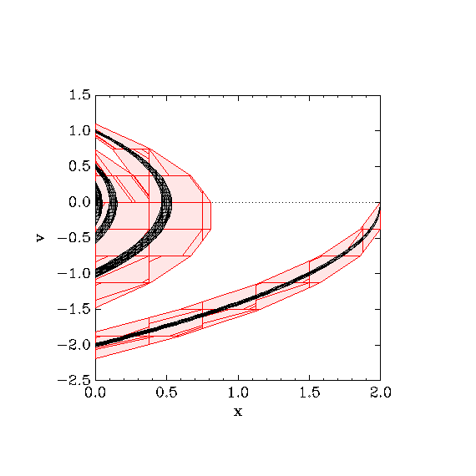
Based on the plot, when using pc=0.5, is x=0.55 and v=0.0 unreachable?
Based on the red color of the plot, when using pc=0.5, it is not unreachable.
Based on the plot, when using pc=0.05, is x=0.55 and v=0.0 unreachable?
Based on the black color of the plot, when using pc=0.05, it is unreachable.

A.2)
Partition Constraint PC | Condition reachable? | Num Locations reached | CPU Time (sec)
0.5 | yes | 33 | 0.03s
0.2 | yes | 71 | 0.077s
0.1 | yes | 152 | 0.171s
0.05 | no | 327 | 0.439s
0.01 | no | 2671 | 8.814s
0.005 | no | 5373 | 44.513s

A.3)
Based on the existing plot of reachable states, does it look like the ball can have a height of exactly 0.15 at the peak of the 1st, 2nd, 3rd, and 4th bounces?
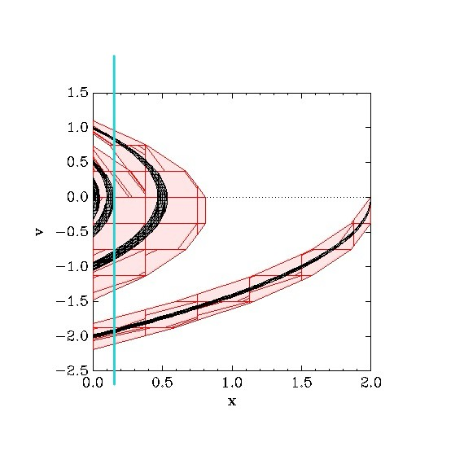
Based on the existing plot, it looks like it can have a height of exactly 0.15 at the peak of the 2nd bounces.
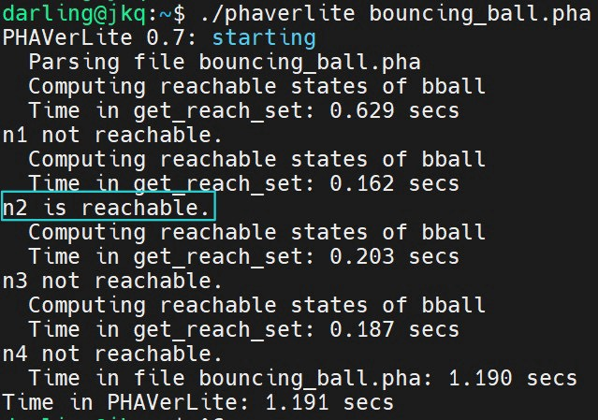
Based on the queries to the model, we can see that our output is the same as our plot.

B.1)
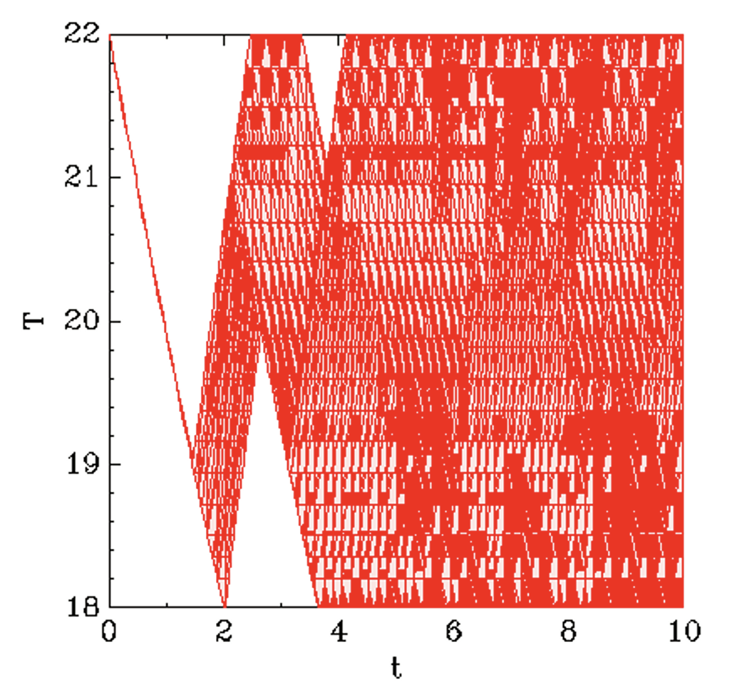

B.2)
bad = heatingsystem.{$ & t == 98/100 & x >20};
check = heatingsystem.is_reachable(bad);
I added these conditions under my code, when I was setting different pc number, I feel weird because It showed unreachable for all the pc value under 1. But when I set pc=1.3, it showed reachable. So the largest value can show it’s unreachable is 1.2.

C.3)
I sent u the code
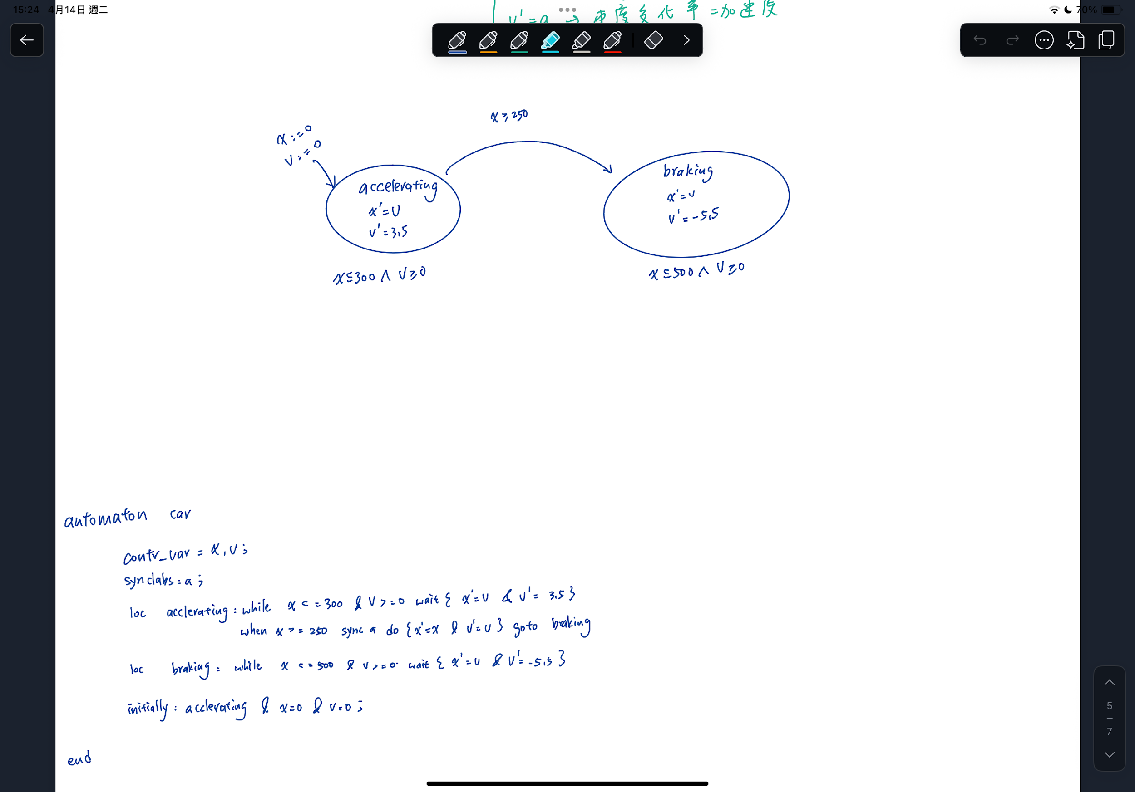

pc=3
Computing reachable states of car
Time in get_reach_set: 1.058 secs
property1 is reachable.
Computing reachable states of car
Time in get_reach_set: 0.239 secs
property2 is reachable.
Computing reachable states of car
Time in get_reach_set: 0.163 secs
property3 is reachable.
Time in file Shih_C3.pha: 3.880 secs
Time in PHAVerLite: 3.881 secs

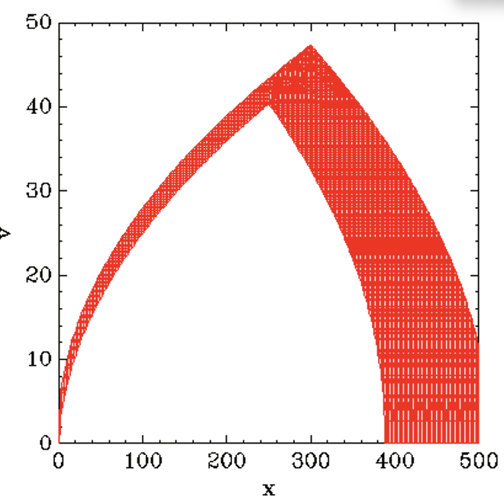

pc=1.2
Computing reachable states of car
Time in get_reach_set: 20.357 secs
property1 not reachable.
Computing reachable states of car
Time in get_reach_set: 20.450 secs
property2 not reachable.
Computing reachable states of car
Time in get_reach_set: 0.542 secs
property3 is reachable.
Time in file Shih_C3.pha: 97.038 secs
Time in PHAVerLite: 97.038 secs

