1. SELECT ORDER_NUM, ORDER_DATE, ORDERS.CUSTOMER_NUM, CUSTOMER_NAME

FROM ORDERS, CUSTOMER

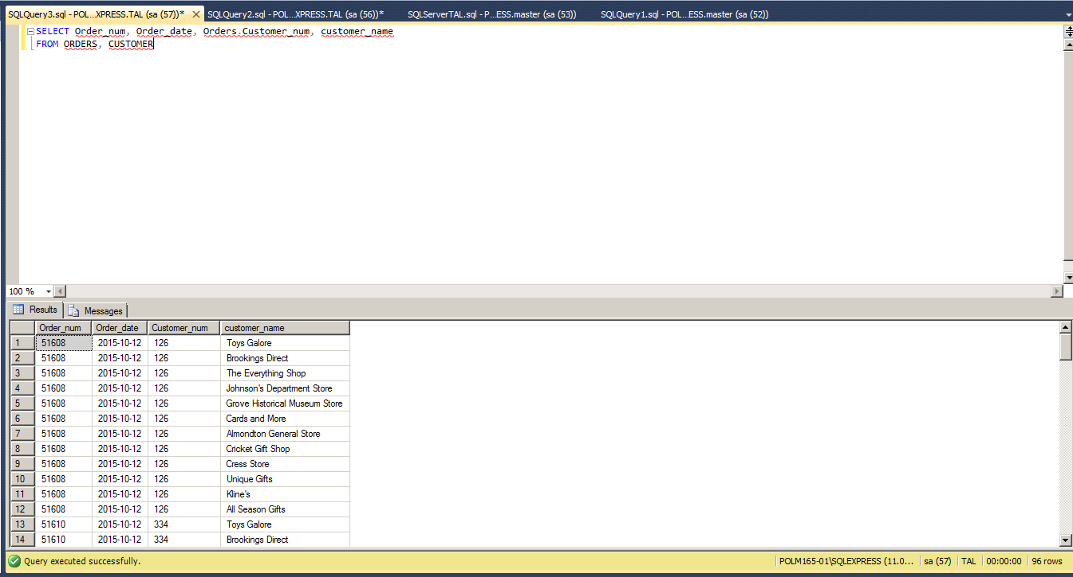

1. SELECT ORDER_NUM, ORDERS.CUSTOMER_NUM, CUSTOMER_NAME

FROM ORDERS, CUSTOMER

WHERE ORDER_DATE = '10/15/2015';

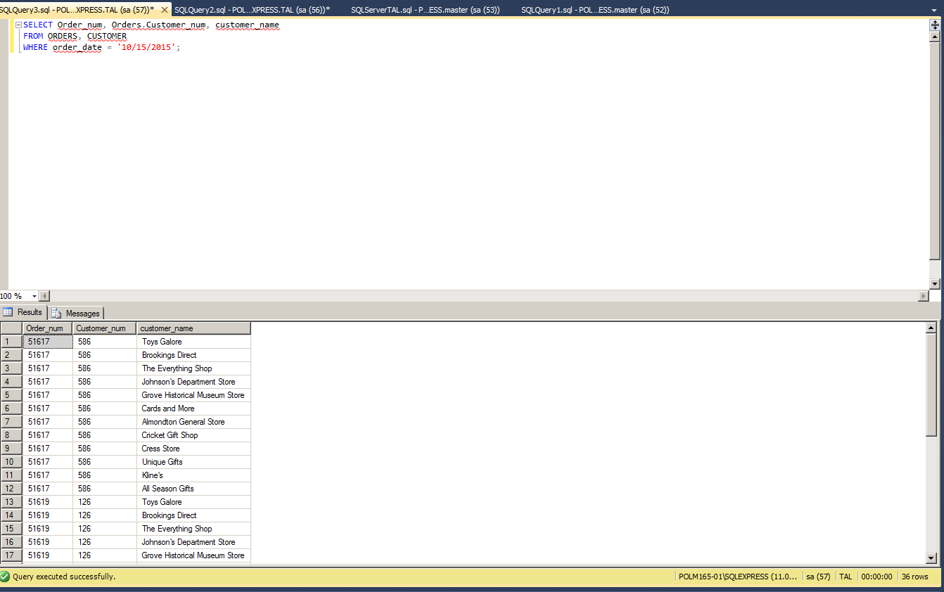

1. SELECT ORDERS.ORDER_NUM, ORDERS.ORDER_DATE, ORDER_LINE.ITEM_NUM, ORDER_LINE.NUM_ORDERED, ORDER_LINE.QUOTED_PRICE

FROM ORDERS INNER JOIN ORDER_LINE ON ORDERS.ORDER_NUM = ORDER_LINE.ORDER_NUM

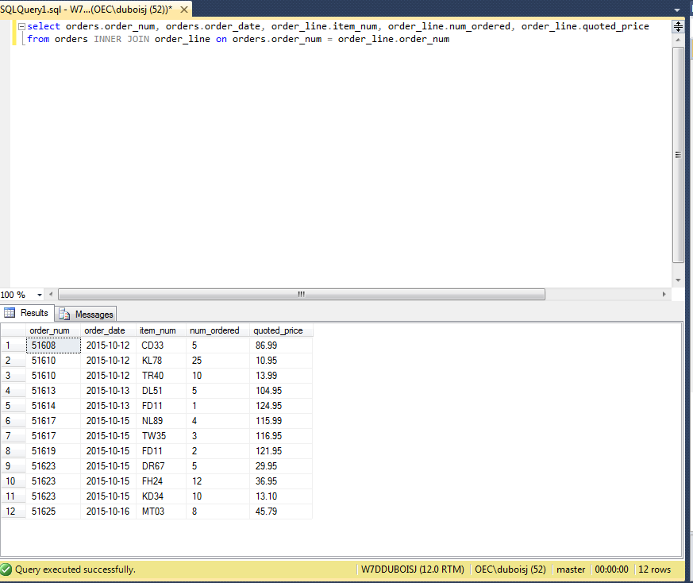

1. SELECT CUSTOMER_NUM,CUSTOMER_NAME

FROM CUSTOMER

WHERE CUSTOMER_NUM IN

(SELECT CUSTOMER_NUM FROM ORDERS WHERE ORDER_DATE = '10/15/2015');

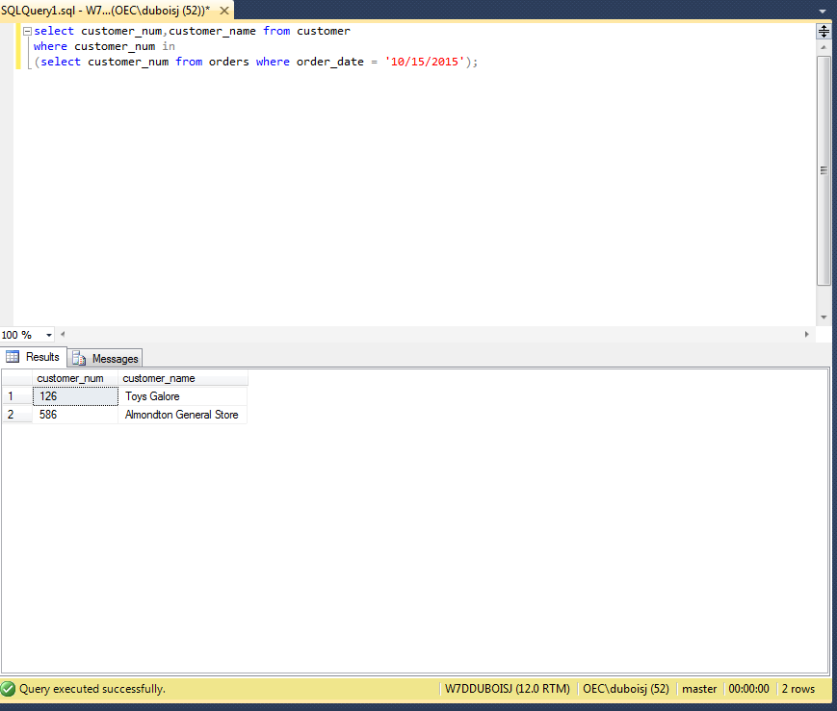

1. SELECT C.CUSTOMER_NUM,C.CUSTOMER_NAME FROM CUSTOMER C

WHERE EXISTS(SELECT CUSTOMER_NUM FROM ORDERS O WHERE ORDER_DATE = '10/15/2015' AND O.CUSTOMER_NUM=C.CUSTOMER_NUM);

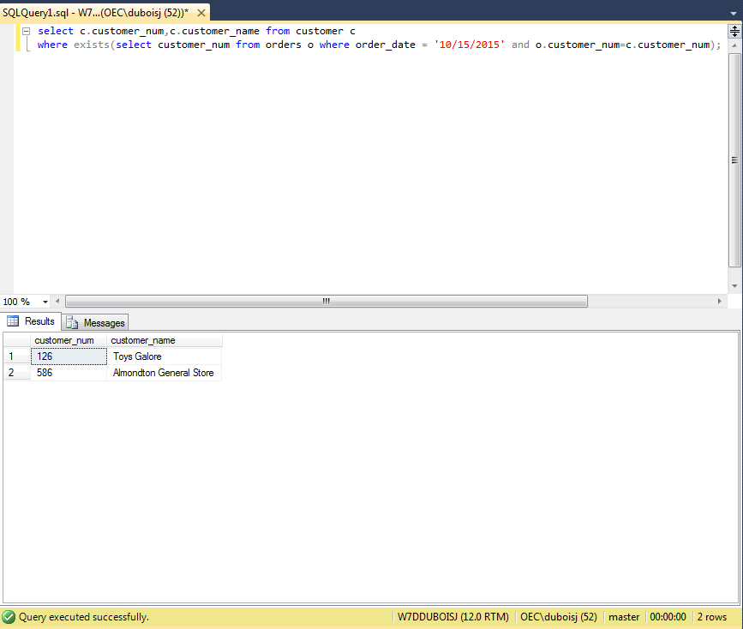

1. SELECT CUSTOMER_NUM,CUSTOMER_NAME FROM CUSTOMER WHERE CUSTOMER_NUM

NOT IN

(SELECT CUSTOMER_NUM FROM ORDERS WHERE ORDER_DATE = '10/15/2015');

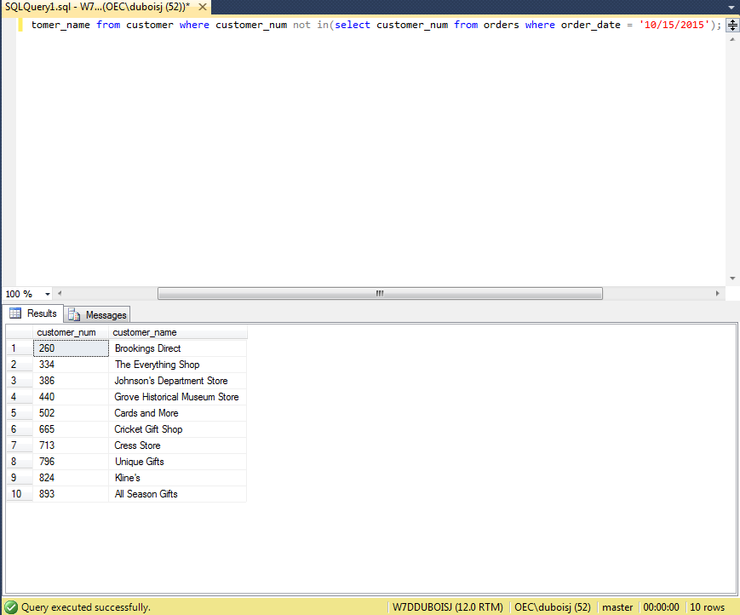

1. SELECT ORDER_NUM,ORDER_DATE, ITEM_NUM, DESCRIPTION, CATEGORY

FROM ORDERS,ITEM

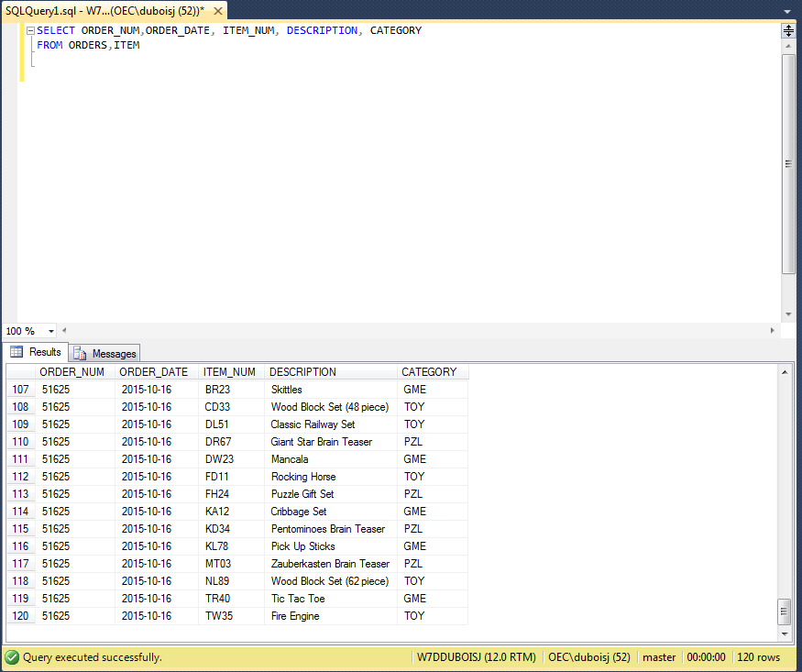

1. SELECT ORDER_NUM,ORDER_DATE, ITEM_NUM, DESCRIPTION, CATEGORY

FROM ORDERS,ITEM

ORDER BY CATEGORY, ORDER_NUM

