**1A.** CREATE VIEW MAJOR_CUSTOMER AS

SELECT CUSTOMER.CUSTOMER_NUM, CUSTOMER.CUSTOMER_NAME,CUSTOMER.BALANCE, Customer.CREDIT_LIMIT, CUSTOMER.REP_NUM

FROM CUSTOMER

WHERE CUSTOMER.CREDIT_LIMIT <= '10000'

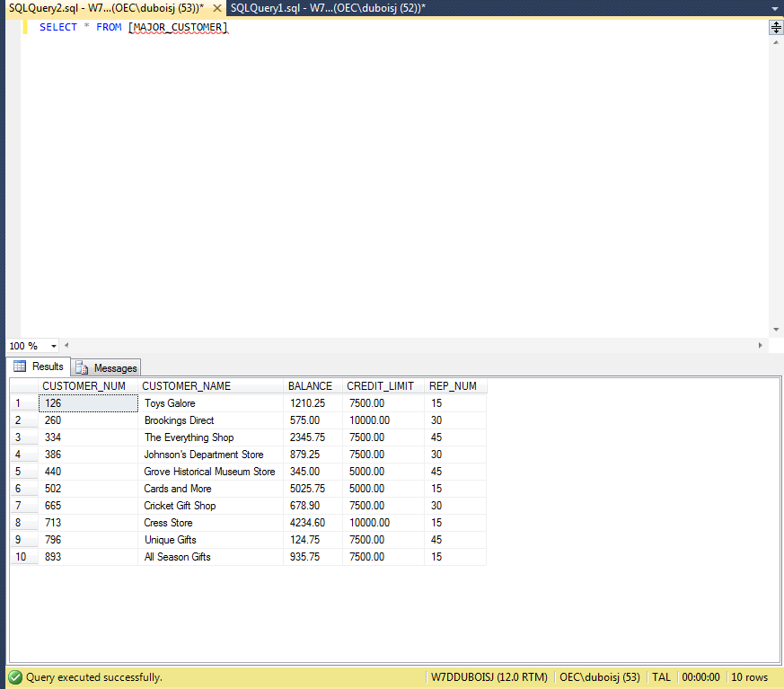

1b. SELECT CUSTOMER_NUM, CUSTOMER_NAME

FROM [MAJOR_CUSTOMER]

WHERE BALANCE > CREDIT_LIMIT

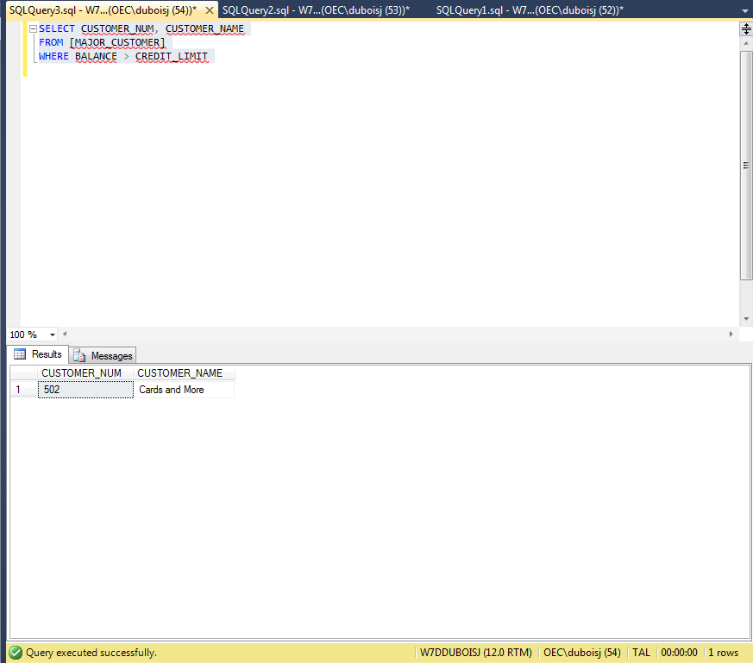

2a. CREATE VIEW ITEM_ORDER AS

SELECT ITEM.ITEM_NUM, ITEM.DESCRIPTION, ITEM.PRICE, ORDERS.ORDER_NUM, ORDERS.ORDER_DATE, ORDER_LINE.NUM_ORDERED, ORDER_LINE.QUOTED_PRICE

FROM ITEM, ORDERS, ORDER_LINE

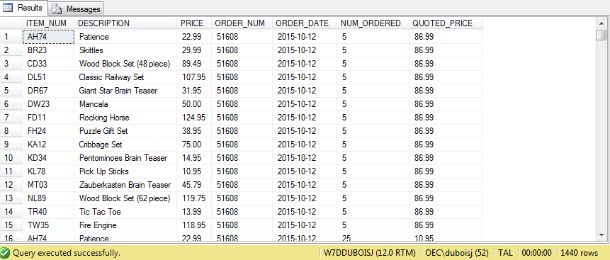

2b. SELECT ITEM_NUM, DESCRIPTION, ORDER_NUM, QUOTED_PRICE

FROM [ITEM_ORDER]

WHERE QUOTED_PRICE > '100'

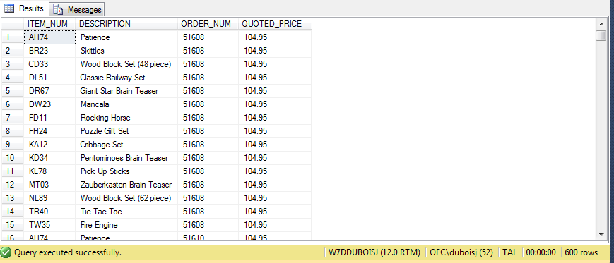

3a. CREATE VIEW [ORDER_TOTAL] AS

SELECT TOP 100 PERCENT ORDERS.ORDER_NUM, ORDER_LINE.NUM_ORDERED * ORDER_LINE.QUOTED_PRICE as TOTAL_AMOUNT

FROM ORDERS, ORDER_LINE

ORDER BY ORDER_NUM

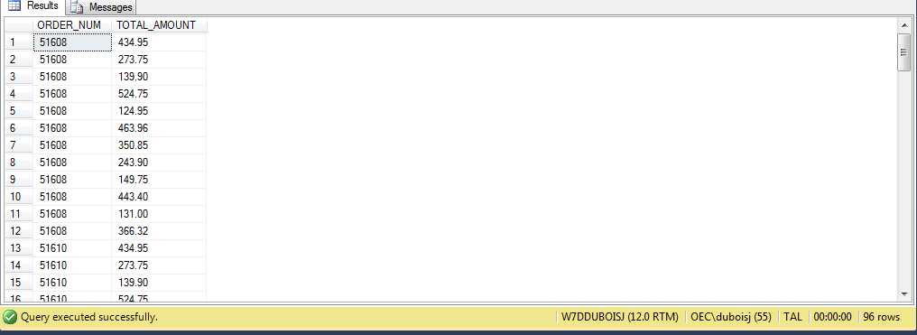

3b. SELECT ORDER_NUM, TOTAL_AMOUNT

FROM [ORDER_TOTAL]

WHERE TOTAL_AMOUNT > 500

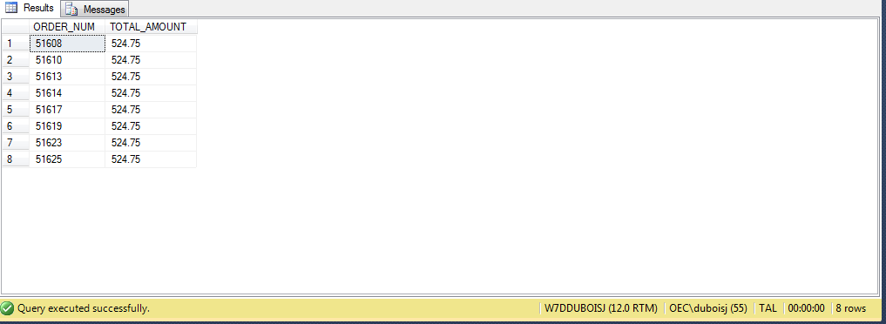

6a. CREATE INDEX ITEM_INDEX1

ON ORDER_LINE (ITEM_NUM)



6b. CREATE INDEX ITEM_INDEX2

ON ITEM (CATEGORY)

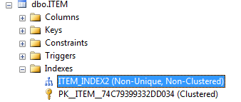

6c. CREATE INDEX ITEM_INDEX3

ON ITEM (CATEGORY,STOREHOUS

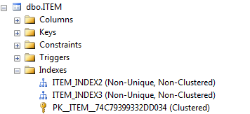

6d.

7.