Carbody Structure and Exterior

Introduction

Use

Purpose

Parts List

All figures are assigned to an individual page unless views are required to show a complete listing of equipment.
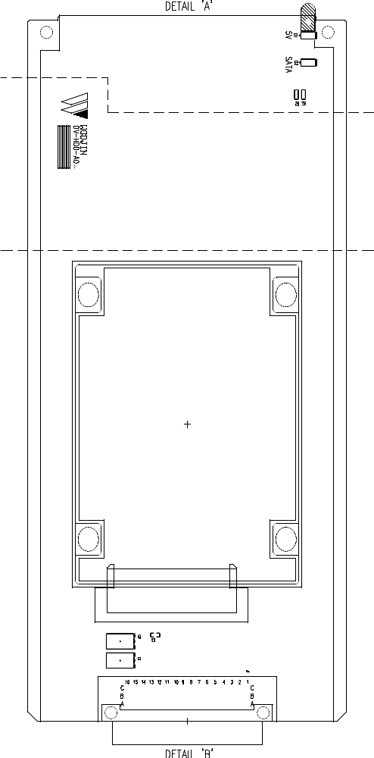

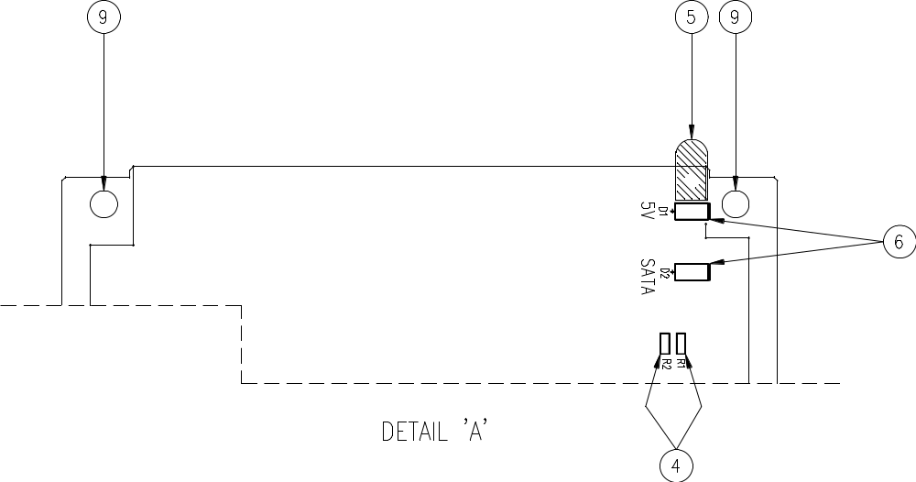

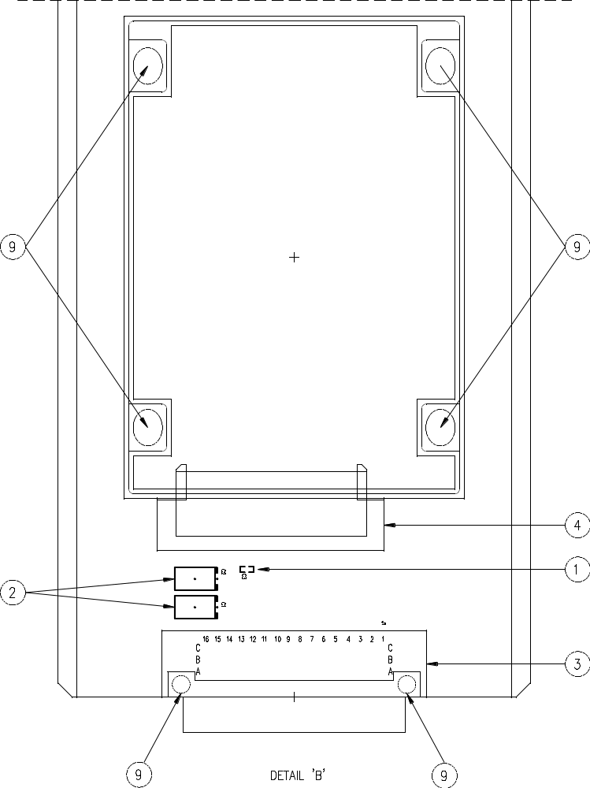

Figure 2.1. Electrical Locker – End No. 1
Table 1 - Figure 2.1. Electrical Locker
FIG No. | PART NUMBERS |  |  | ITEM DESCRIPTION | VENDOR CODE | QTY
 | HRC | VENDOR | DTP
1 |  | 0603N104F100CT  C0603C0G0J104JT |  | Capacitor | WALS  TDK | 1
2 |  | 293D476X5016A2WE3  T491A476K016AT |  | Capacitor | VISHA  KEMET | 2
3 |  | ERNI-254324  0923148919 |  | Connector | ERNI  HARTI | 1
4 |  | D-715F-02  10029364 |  | Connector | GANA  FCI | 1
5 |  | 7511A62 |  | Light pipes | VCC | 1
6 |  | SML-010MTT86  7016X5 |  | Diode | ROHM  CHIC | 2
7 |  |  |  | PCB BOLT HOLE | ANTS | 2
8 |  | ERJ3RBD4700V  DR-07470RL |  | Resistor | NAIS  YAGE | 2
9 |  |  |  | BOLT, ROUND, M2.6 X L12mm | ANTS | 8
9 |  |  |  | NUT, HEXA, M2.6 | ANTS | 8
9 |  |  |  | WASHER, FLAT, M2.6, D4.8mm | ANTS | 8
9 |  |  |  | WASHER, SPRING, M2.6, D4.8mm | ANTS | 8

