Carbody Structure and Exterior

Introduction

Use

Purpose

Parts List

All figures are assigned to an individual page unless views are required to show a complete listing of equipment.

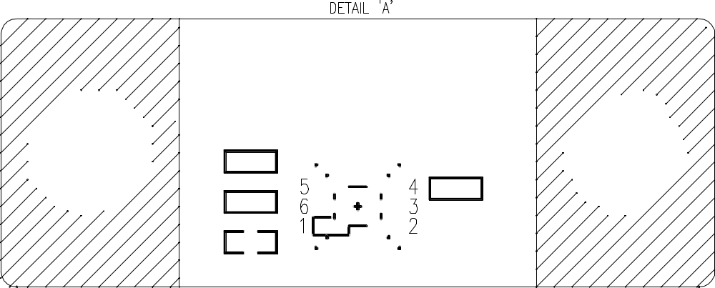

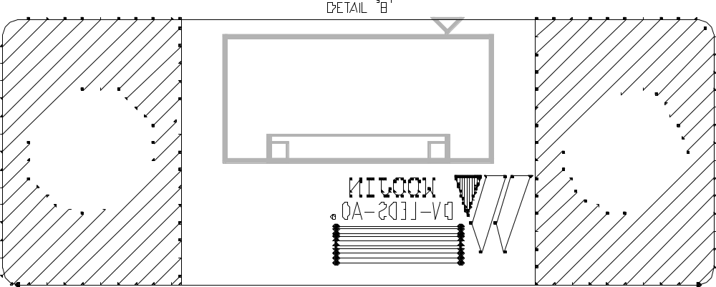

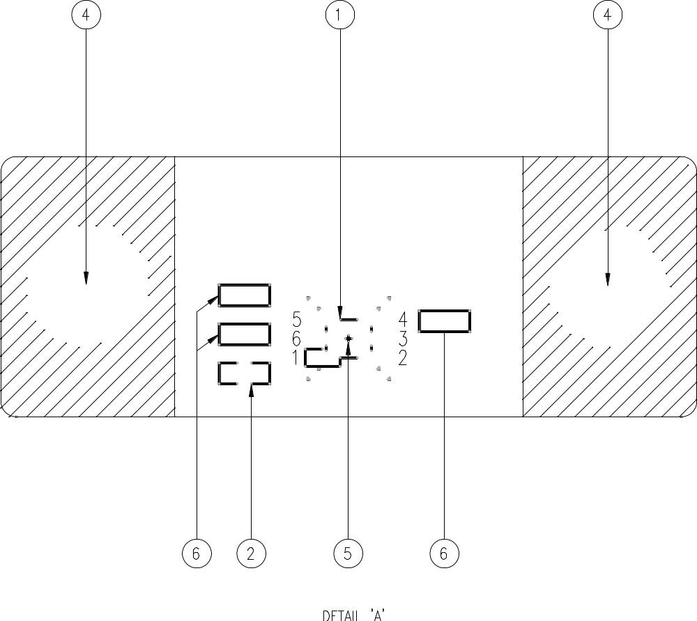

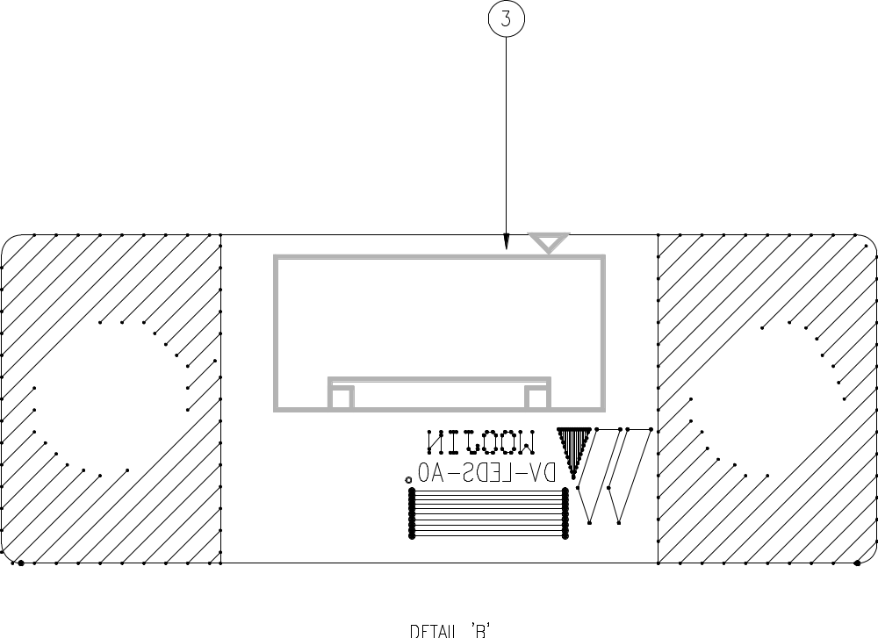

Figure 2.1. Electrical Locker – End No. 1
Table 1 - Figure 2.1. Electrical Locker
FIG No. | PART NUMBERS |  |  | ITEM DESCRIPTION | VENDOR CODE | QTY
 | HRC | VENDOR | DTP
1 |  | APDS-9300-020 |  | Diode | AVAGO | 1
2 |  | 0603N104F100CT  C0603C0G0J104JT |  | Capacitor | WALS  TDK | 1
3 |  | 0353120560  SMW250-05 |  | Connector | MOLEX  YEON | 1
4 |  |  |  | PCB BOLT HOLE | ANTS | 2
5 |  | VLP-300-R  LPA-C011301S-10 |  | Light pipes | BIVAR  LUME | 1
6 |  | ERJ3RBD4R73V  DR-074R9KL |  | Resistor | NAIS  YAGE | 1

