Carbody Structure and Exterior

Introduction

Use

Purpose

Parts List

All figures are assigned to an individual page unless views are required to show a complete listing of equipment.
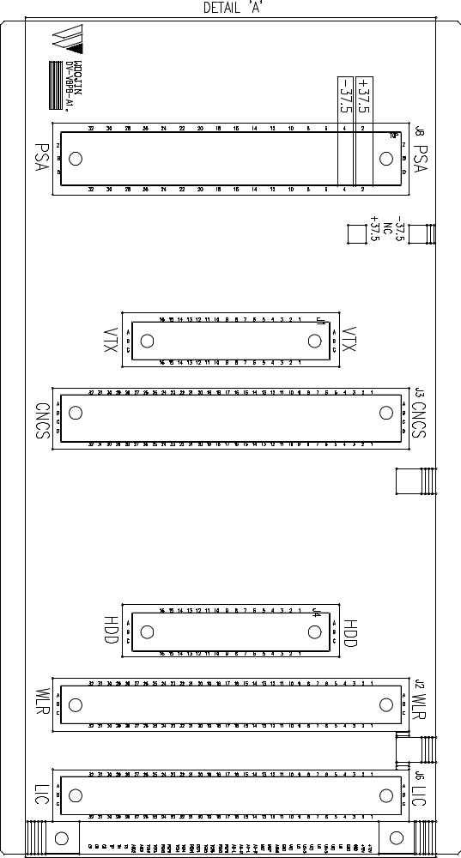

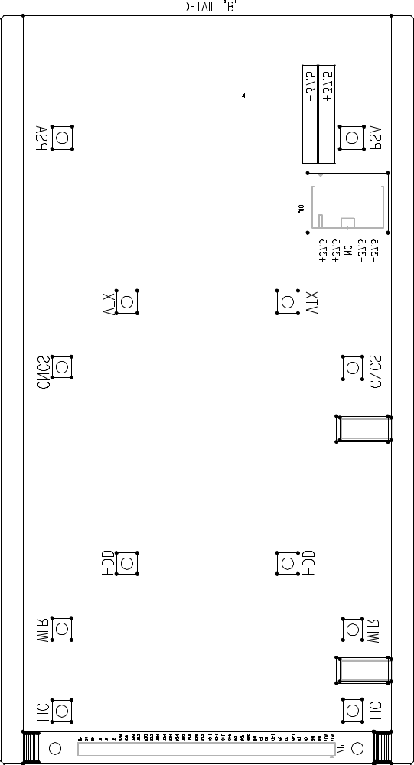

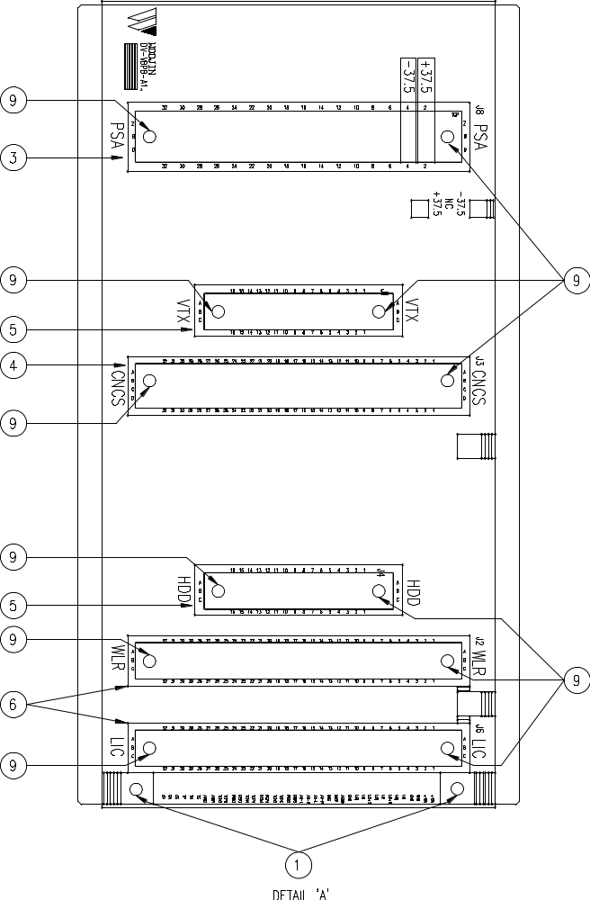

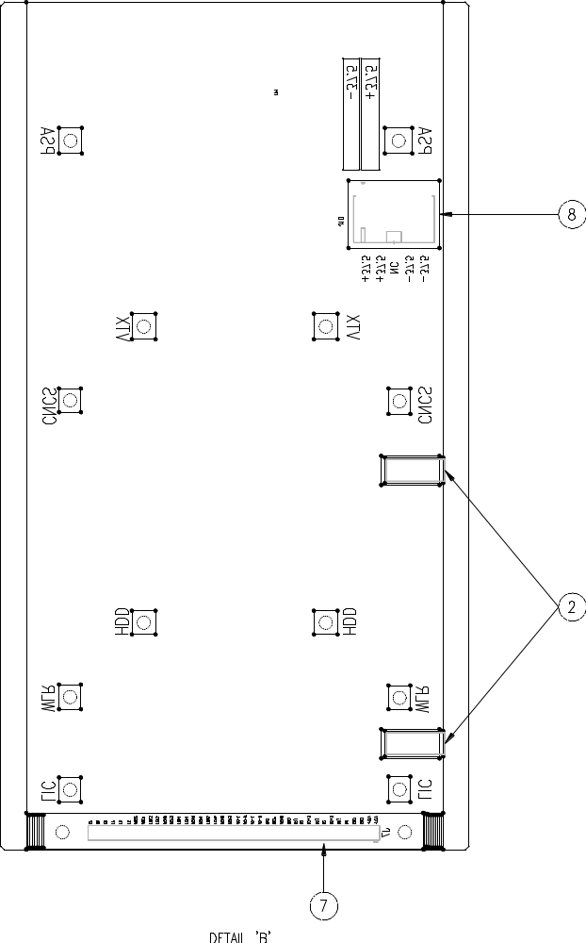

Figure 2.1. Electrical Locker – End No. 1
Table 1 - Figure 2.1. Electrical Locker
FIG No. | PART NUMBERS |  |  | ITEM DESCRIPTION | VENDOR CODE | QTY
 | HRC | VENDOR | DTP
1 |  | SSR-SM325  SSR315-AF |  | Thin Sheet Nut-Insert | PSC  PFC | 2
2 |  | DSLS 110  LWS-SE2 |  | Clamp | DONGA  RCC | 2
3 |  | ERNI-054755  09062482832 |  | Connector | ERNI  HARTI | 1
4 |  | ERNI-254977 |  | Connector | ERNI | 1
5 |  | ERNI-284174  09232482825 |  | Connector | ERNI  HARTI | 2
6 |  | ERNI-284308  09032642850 |  | Connector | ERNI  HARTI | 2
7 |  | HIF3H40PB-2.54DSA  XG8T-4041 |  | Connector | HRS  OMRON | 1
8 |  | 0039303057  LAD1140-05 |  | Connector | MOLEX  HANL | 1
9 |  |  |  | BOLT, ROUND, M2.6 X L12mm | ANTS | 14
9 |  |  |  | NUT, HEXA, M2.6 | ANTS | 14
9 |  |  |  | WASHER, FLAT, M2.6, D4.8mm | ANTS | 14
9 |  |  |  | WASHER, SPRING, M2.6, D4.8mm | ANTS | 14

