CHAPTER 2
OPERATING PROCEDURES

PREPARING A TRAIN FOR SERVICE.
Before being placed in service, inspect the train to ensure that the equipment functions correctly and safely. The following procedures prepare a train for operation. To couple or uncouple both married pairs and single cars, see Coupling/Uncoupling Operations (refer to Paragraph 2-6).
WARNING
BODILY INJURY. Make sure that no one is working under or near the train while preparing the train for service.
NOTE
Throughout this chapter, the car from which the train is to be operated is called the active cab car and the car at the opposite end of the train is called the trailing car (non active cab car).

Interior Preparation.
Board the last car of the train at the crew access door and perform the following steps:
NOTE
The crew switch on the carbody to the left and right of the dual stream door high level is used to open the crew access door if the car is at a platform. The crew switch mounted on the stepwell side to the left and right of the dual stream door low level is used to open the crew access doors from grade level.
- Use the Conductor’s key to open the crew access door (left leaf of dual stream door) and enter the car through the door.
- Use key to open Operator’s cab door, and enter cab.
- Open low voltage circuit breaker panel inspection cover of the electric locker (see Figure 1-33). Verify that all low voltage circuit breaker panel circuit breakers are placed in ON (up) position. Close low voltage circuit breaker panel door. And all cutout/bypass switches (rotary and locker type) are in the NORMAL position.
- Place Cab Control key in control key switch of Master Controller (1, Figure 1-35), and push in and turn fully counter-clockwise.
- Place control key switch (1, Figure 1-35) in NEUTRAL position. Cab should power up.
- Set SPEAKER switch (3, Figure 1-45), located on Driver Passenger Announcement (PA) Operation Box, to OUTSIDE, ALL, or INSIDE, as desired.
- On lead/trailing cars only, set HEADLIGHT switch (1, Figure 1-34), located on desk console control panel, to BRIGHT or DIM position.
- On lead/trailing cars only, place control key switch (1, Figure 1-35) in FORWARD position.
- On lead/trailing cars only, exit cab and open F-end door. Verify that both headlights are lit. Also, check that end gates and inter-car chains are properly attached. Close F-end door and re-enter cab.
- On lead/trailing cars only, place control Key switch in NEUTRAL position.
- Test CAB LIGHTS switch (1, Figure 1-37), located on left console control panel, for correct operation.
- On leading/trailing cars only, press the LAMP TEST button on overhead control panel for checking if all of the lamps are flashed
- On leading/trailing cars only, perform brake system test as follows:
- Verify that MAIN RES. pressure gage (1, Figure 1-39) indicates at least 130 psi ~ 145 psi.
- Allow three minutes for the equipment to charge. Move the Brake Control Handle Unit (BCHU) handle (3, Figure 1-36) to the full service position. Verify that the Brake Pipe (BP) pressure gage (2, Figure 1-39) should decrease from 110 psi to 84 psi in 3.0 to 4.0 seconds and verify that the Brake Cylinder (BC) Pressure gage (2, Figure 1-39) should increase from zero to 44 psi in 3.0 to 4.5 seconds.
- Move the BCHU handle to the release position (3, Figure 1-36). Verify that the BC gage indication should decrease form maximum to 5 psi in 3 to 4.5 seconds, and should continue to decrease to zero psi and verify BP gage indications increases to 110 psi.
- Rapidly move the BCHU handle to the emergency position. Verify that the BP gage indication decreases to zero psi in 1.0 second maximum and verify that the BC gage indication increases to 45 psi in less than two seconds.
- Verify the VX vent valves operate properly as indicated by the local venting of Brake Pipe pressure.
- The BCHU handle must remain in the Emergency position until the reset time of 30 seconds has elapsed.
- Move the BCHU handle to the Full service position for 2 seconds, and then move it to the release position. Verify the BP gage indicate 110 psi and verify the BC gage indication decreases to zero psi.
- Move the BCHU handle to the Emergency position and then to the handle-off position. Verify that emergency application occurs and then the ER and BP gage indications reduce to zero psi. Verify that the brake cylinder gage indicated the BCP is within the empty car emergency pressure range
- Move the BCHU handle to "Release" position. Verify the ER and BP gages indicate 110 psi and the BC gage indicates zero psi.
- Perform the alerter input - Penalty brake application test as follows:
- Verify that the BCHU handle is in the release position. And put the penalty brake cut-out cock in the cut-in position.
- Wait for the alerter to time out and command a penalty brake application and then verify that no emergency application occurs.
- Verify that the BP gage continues to drop at a service rate to less than 40 psi and BC gage indicates the BCP is within the empty car full service pressure range.
- Reset the penalty brake application and move the BCHU handle to the full service position until the reset time has elapsed.
- Move the BCHU handle to the release position and verify the BP gage indicates 110 psi and BC gage indicates zero psi.
- Put the Penalty brake cut-out cock in the cut-out position.
- Wait for the alerter to time out and command a penalty brake application.
- Verify that no emergency application occurs and the BP gage continues to drop at a service rate to less than 40 psi.
- Reset the penalty brake application. And move the BCHU handle to the full service position until the reset time has elapsed.
- Move the BCHU handle to the release position.
- Verify the BP gage indicates 110 psi and BC gage indicates zero psi.
- Put the penalty brake cut-out cock in the cut-out position.
- Place the externally available circuit breaker for the FBCU power in the OFF position.
- Verify that the BP gage indicates decreases to 0 psi at a service rate of reduction and BC gage indication increases to the empty car emergency pressure range.
- Place the externally available main circuit breaker for the FBCU power in the ON position.
- Move the BCHU handle to the Full service position, wait until the reset time of 8seconds has elapsed, then move the handle to the release position.
- Verify the BP gage indication increases to 110 psi and the BC gage indicates zero (0) psi.
- Press ENABLE DOORS switch for left doors (3, Figure 1-40), located on the upper left control panel and verify the DOORS ENABLED indicator is lit.
- Push HIGH LEVEL LEFT SIDE OPEN/CLOSE DOORS and LOW LEVEL LEFT SIDE OPEN/CLOSE DOORS located on the upper left control panel (1 and 2, Figure 1-40).
- Press ENABLE DOORS switch for right doors (3, Figure 1-54), located on the right door control panel and verify the DOORS ENABLED indicator is lit.
- During winter season, in the lead cab only, perform the following:
- Push WINDSHIELD HEATER switch (6, Figure 1-38), located on right console control panel, to test windshield heater function. The overhead control panel WINDSHIELD HEATER indicator (6, Figure 1-42) should light at the same time. Windshield temperature should rise. Push the windshield locker switch again to turn off windshield heater.
- Test CAB HEATER switch (4, Figure 1-43), located on middle console switch panel.
- Place control key switch of master controller (1, Figure 1-35) in OFF position.
- Remove key from control key switch (1, Figure 1-35), exit and lock cab, and proceed to interior of car.
- Inspect car interior for cleanliness, damaged seats, broken windows, and general condition.
- Verify the integrity of the fire extinguisher and emergency equipment lockers.
NOTE
The destination signs will display a serial number until a route has been established through the communications control unit.
- Verify that destination signs are lit.
- Proceed to next car of train. Check end gates and inter-car chains while moving from car to car. Repeat Interior Preparation Procedure starting at Paragraph 2-1.1, step b., until all interiors have been prepared. When the leading car of the train is completed, close all doors.

Exterior Train Preparation.
- Make an exterior inspection of the train, noting the following:
- All equipment covers are properly secured.
- During winter season, ensure covers on automatic couplers at each end of train are installed.
- There are no obvious fluid leaks and no debris fouling underside of the train.
- Examine door glass for damage.

Cab Signal and ATC System Departure Test.
Before departure, it is necessary to run and successfully complete the Cab Signal/ATC System Departure Test. Before initiating the Cab Signal/ATC System Departure Test it is necessary to verify that the following conditions are satisfied:
- Train is not in motion.
- Master Controller Handle is in the COAST position.
- Cab is active.
- Brake cylinder pressure is at suppression or higher.
- ATC OVERRIDE Switch is in the NORMAL position.
- Brake handle is in the SUPPRESS position.
- Portable Test Unit (PTU) Test mode is not active.
- No coded carrier cab signal is present in the rail.
- Brake pipe pressure is greater than 15 psi.
To Initiate the Cab Signal/ATC System Departure Test, turn the key in the Departure Test Key Switch to the ON position. The TEST indicator on the Aspect Display Unit (ADU) will illuminate and the Cab Signal/ATC System will proceed automatically through the test steps described in paragraph 2-1.3.1 through paragraph 2-1.3.21. Test status information will be displayed on the ADU’s 4-digit alphanumeric display during the test, starting with a display of "SLV" for 3 seconds. Operator actions are required during the Departure Test to enable it to be completed successfully. In paragraph 2-1.3.1 through paragraph 2-1.3.21, these actions are prefaced by "OPERATOR: " so as to clearly indicate the operator actions required.

ATC CPU Board Software Version Display.
The ADU's 4-digit alphanumeric display shows the ATC CPU Board software version for 3 seconds. The software version consists of a revision letter and an issue number (i.e. B3).

Lamp Test.
The aspect LEDs, TEST, SUPPRESS, FAULT, OVERSPEED, NON CAB SIGNAL TERRITORY, and ALERTER indicators and all of the segments on the 4-Digit Alphanumeric Display and 3-Digit Alphanumeric Displays will be illuminated for 5 seconds.

Alerter Test.
The ADU's 4-digit alphanumeric display shows "T03". The Alerter Alarm sounds and the ALERTER indicator flashes.
OPERATOR: Acknowledge the alert with the hand or foot acknowledge device within 10 seconds. If the alert is not acknowledged in time, the test fails and the ADU's 4-digit alphanumeric display shows "E03".

Low Cab Signal Level Test.
The ADU's 4-digit alphanumeric display shows "T04" and the restricted aspect remains illuminated. If the ATC detects a cab signal, the test fails and the ADU's 4-digit alphanumeric display shows "E04".

Non Cab Signal Territory Mode - Initiation Test.
The ADU's 4-digit alphanumeric display shows "T05", the Overspeed Alarm sounds and the restricted aspect is illuminated.
OPERATOR: Acknowledge this change with the hand or foot acknowledge device within 5 seconds. If the change is not acknowledged in time, the test fails, the EP vital output de-energizes, and the ADU's 4-digit alphanumeric display shows "E05".
Upon acknowledgement, the NON CAB SIGNAL TERRITORY indicator will illuminate and no aspect is illuminated.

Non Cab Signal Territory Mode - Underspeed / Overspeed Test.
The ADU's 4-digit alphanumeric display shows "T06". A speed of 79 mph is displayed. If underspeed is not detected, the test fails, and the ADU's 4-digit alphanumeric display shows "E06".
Upon detection of the underspeed train speed, the overspeed test runs. A speed of 84 mph is displayed. The Overspeed Alarm sounds and the OVERSPEED indicator illuminates.
OPERATOR: Acknowledge the alarm with the hand or foot acknowledge device within 5 seconds. If the alarm is not acknowledged in time, the test fails, the EP vital output de-energizes, and the ADU's 4-digit alphanumeric display shows "E06".

Transition to Cab Signal Territory Mode Test.
The ADU's 4-digit alphanumeric display shows "T07", the restricted aspect illuminates, the NON CAB SIGNAL TERRITORY indicator goes dark, and the Overspeed Alarm sounds.
OPERATOR: Acknowledge the alarm with the hand or foot acknowledge device within 5 seconds. If the alarm is not acknowledged in time, the test fails, the EP vital output de-energizes, and the ADU's 4-digit alphanumeric display shows "E07".

No Code - Underspeed / Overspeed Test.
The ADU's 4-digit alphanumeric display shows "T08" and the restricted aspect illuminates. A speed of 20 mph is displayed. If underspeed is not detected, the test fails, and the ADU's 4-digit alphanumeric display shows "E08".
Upon detection of the underspeed train speed, the overspeed test runs. A speed of 25 mph is displayed. The Overspeed Alarm sounds and the OVERSPEED indicator illuminates.
OPERATOR: Acknowledge the alarm with the hand or foot acknowledge device within 5 seconds. If the alarm is not acknowledged in time, the test fails, the EP vital output de-energizes, and the ADU's 4-digit alphanumeric display shows "E08".

100 Hz Carrier at 50 CPM - Detection Test.
The ADU's 4-digit alphanumeric display shows "T09" and the restricted aspect illuminates. A speed of 0 mph is displayed. If the test fails, the ADU's 4-digit alphanumeric display shows "E09".
No underspeed/overspeed test is performed for the restricted aspect. No overspeed alarm sounds nor does OVERSPEED indicator illuminate. No operator action required.

100 Hz Carrier at 225 CPM - Detection Test.
The ADU's 4-digit alphanumeric display shows "T10" and the restricted aspect illuminates. A speed of 0 mph is displayed. If the test fails, the ADU's 4-digit alphanumeric display shows "E10".
No underspeed/overspeed test is performed for the restricted aspect. No overspeed alarm sounds nor does OVERSPEED indicator illuminate. No operator action required.

100 Hz Carrier at 75 CPM - Underspeed / Overspeed Test.
The ADU's 4-digit alphanumeric display shows "T11" and the Approach aspect illuminates. A speed of 30 mph is displayed. If the underspeed is not detected, the test fails, and the ADU's 4-digit alphanumeric display shows "E11".
Upon detection of the underspeed train speed, the overspeed test runs. A speed of 35 mph is displayed. The Overspeed Alarm sounds and the OVERSPEED indicator illuminates.
OPERATOR: Acknowledge the alarm with the hand or foot acknowledge device within 5 seconds. If the alarm is not acknowledged in time, the test fails, the EP vital output de-energizes, and the ADU's 4-digit alphanumeric display shows "E11".

100 Hz and 250 Hz Interleaved Carriers at 75 CPM - Detection Test.
The ADU's 4-digit alphanumeric display shows "T12" and the Approach aspect illuminates. A speed of 0 mph is displayed. If the test fails, the ADU's 4-digit alphanumeric display shows "E12".
No underspeed/overspeed test is performed for the Approach aspect. No overspeed alarm sounds nor does OVERSPEED indicator illuminate. No operator action required.

100 Hz Carrier at 120 CPM - Underspeed / Overspeed Test.
The ADU's 4-digit alphanumeric display shows "T13" and the Approach Medium aspect illuminates. A speed of 45 mph is displayed. If underspeed is not detected, the test fails, and the ADU's 4-digit alphanumeric display shows "E13".
Upon detection of the underspeed train speed, the overspeed test runs. A speed of 50 mph is displayed. The Overspeed Alarm sounds and the OVERSPEED indicator illuminates.
OPERATOR: Acknowledge the alarm with the hand or foot acknowledge device within 5 seconds. If the alarm is not acknowledged in time, the test fails, the EP vital output de-energizes, and the ADU's 4-digit alphanumeric display shows "E13".

100 Hz Carrier at 270 CPM - Underspeed / Overspeed Test.
The ADU's 4-digit alphanumeric display shows "T14" and the Flashing Clear aspect illuminates. A speed of 60 mph is displayed. If underspeed is not detected, the test fails, and the ADU's 4-digit alphanumeric display shows "E14".
Upon detection of the underspeed train speed, the overspeed test runs. A speed of 65 mph is displayed. The Overspeed Alarm sounds and the OVERSPEED indicator illuminates.
OPERATOR: Acknowledge the alarm with the hand or foot acknowledge device within 5 seconds. If the alarm is not acknowledged in time, the test fails, the EP vital output de-energizes, and the ADU's 4-digit alphanumeric display shows "E14".

100 Hz and 250 Hz Interleaved Carriers at 120 CPM - Underspeed / Overspeed Test.
The ADU's 4-digit alphanumeric display shows "T15" and the Flashing Clear aspect illuminates. A speed of 80 mph is displayed. If underspeed is not detected, the test fails, and the ADU's 4-digit alphanumeric display shows "E15".
Upon detection of the underspeed train speed, the overspeed test runs. A speed of 85 mph is displayed. The Overspeed Alarm sounds and the OVERSPEED indicator illuminates.
OPERATOR: Acknowledge the alarm with the hand or foot acknowledge device within 5 seconds. If the alarm is not acknowledged in time, the test fails, the EP vital output de-energizes, and the ADU's 4-digit alphanumeric display shows "E15".

100 Hz Carrier at 180 CPM - Underspeed / Overspeed Test.
The ADU's 4-digit alphanumeric display shows "T16" and the Clear aspect illuminates. A speed of 100 mph is displayed. If underspeed is not detected, the test fails, and the ADU's 4-digit alphanumeric display shows "E16".
Upon detection of the underspeed train speed, the overspeed test runs. A speed of 105 mph is displayed. The Overspeed Alarm sounds and the OVERSPEED indicator illuminates.
OPERATOR: Acknowledge the alarm with the hand or foot acknowledge device within 5 seconds. If the alarm is not acknowledged in time, the test fails, the EP vital output de-energizes, and the ADU's 4-digit alphanumeric display shows "E16".

100 Hz and 250 Hz Interleaved Carriers at 180 CPM - Detection Test.
The ADU's 4-digit alphanumeric display shows "T17" and the Clear aspect illuminates. A speed of 0 mph is displayed. If the test fails, the ADU's 4-digit alphanumeric display shows "E17".
No underspeed/overspeed test is performed for the Clear aspect. No overspeed alarm sounds nor does OVERSPEED indicator illuminate. No operator action required.

100 Hz and 250 Hz Interleaved Carriers at 270 CPM - Detection Test.
The ADU's 4-digit alphanumeric display shows "T18" and the Clear aspect illuminates. A speed of 0 mph is displayed. If the test fails, the ADU's 4-digit alphanumeric display shows "E18".
No underspeed/overspeed test is performed for the Clear aspect. No overspeed alarm sounds nor does OVERSPEED indicator illuminate. No operator action required.

100 Hz Carrier at 270 CPM - Downward Aspect Test.
The ADU's 4-digit alphanumeric display shows "T19" and the Flashing Clear aspect illuminates. A speed of 0 mph is displayed. The Overspeed Alarm sounds and the OVERSPEED indicator illuminates.
OPERATOR: Acknowledge the alarm with the hand or foot acknowledge device within 5 seconds. If the alarm is not acknowledged in time, the test fails, the EP vital output de-energizes, and the ADU's 4-digit alphanumeric display shows "E19".

100 Hz Carrier at 120 CPM - Downward Aspect Test.
The ADU's 4-digit alphanumeric display shows "T20" and the Approach Medium aspect illuminates. A speed of 0 mph is displayed. The Overspeed Alarm sounds and the OVERSPEED indicator illuminates.
OPERATOR: Acknowledge the alarm with the hand or foot acknowledge device within 5 seconds. If the alarm is not acknowledged in time, the test fails, the EP vital output de-energizes, and the ADU's 4-digit alphanumeric display shows "E20".

Emergency Brake Test.
The ADU’s 4-digit alphanumeric display shows "T21" and a speed of 10 mph is displayed. The ADU display changes to a restricted aspect. The Overspeed Alarm sounds and the OVERSPEED indicator illuminates.
OPERATOR: Do NOT acknowledge the alarm so that after 5 seconds, the EP vital output de-energizes. If the EP vital output fails to de-energize, the test fails, and the ADU's 4-digit alphanumeric display shows "E21".

Departure Test Completion.
OPERATOR: After the ADU’s 4-digit alphanumeric display shows "PASS". Acknowledge the alarm from the last step with the hand or foot acknowledge device. Turn the key in the Departure Test Key Switch to the OFF position.
The TEST indicator goes dark. The ADU’s 4-digit alphanumeric display shows "RUN".

FAILURE TO RESPOND - PREPARING A TRAIN FOR SERVICE.

Common Problems.
Many problems which may be encountered in preparing a train for movement generally fall into two categories: Power interruption to an individual circuit, or a fault condition detected by the CDT system. Respond to these faults as described in the paragraphs that follow.

Power Interruption to an Individual Circuit.
- Verify that Control Key Switch (1, Figure 1-35) is in the correct position. Some controls only operate in specific modes and there are interlocks among master controller functions. Note the interlocks among the control key switch and master controller handle described in Table 2-1.
Table 2-1. Master Controller Mode Switch Interlocks.
Key Switch Position | Mode Switch Position | Controller Handle Position
OFF  FORWARD  REVERSE | LOCKED  Locked in RUN  Locked in RUN | LOCKED  Free  Free
ON | (FREE)  FORWARD  NEUTRAL  REVERSE | Coast  SW Position  P1 Position  P2 Position  P3 Position
- Verify that appropriate individual circuit breaker or switch is in correct position. Circuit breakers and switches on all cars should be as listed in Table 2-2. Circuit Breakers and Switch Positions.
- If all circuit breakers are in the correct position, press and release the FAULT RESET pushbutton switch, located in the Right console panel of the Cab desk, to reset the low voltage power supply.

Fault Condition Detected by the Fault Indication Panel (FDP).
- Follow instructions on FDP display panel (see Figure 1-50).
- Press FAULT RESET switch (see Figure 1-50), located on the left cab console lower panel, to acknowledge fault.
- Refer to Paragraph 3-5, Operator Diagnostics and Troubleshooting, for more information.
Table 2-2. Circuit Breakers and Switch Positions.

Panel (Location) | Circuit Breaker/Switch Position
Battery Control Box circuit breaker | All circuit breakers (BATB, TLB) in ON position.
Low voltage circuit breaker panel of Electrical Distribution Board (see Figure 1-25 through Figure 1-27). | All circuit breakers in ON position.
230 /120 Vac circuit breaker panel of Electrical Distribution Board (see Figure 1-28 through Figure 1-30). | All circuit breakers in ON position.

Uncommon Problems.
Other problems may occur which will prevent train operation. Some of these conditions are as follows (respond as indicated):

Emergency Pipe Does Not Recharge.
NOTE
If the brake handle is moved from the Full Service position prior to BP reaching 50 psi, then the BPCM will stop charging the brake pipe until the handle returns to the Full Service position.
- Check MAIN RES. pressure gauge (1, Figure 1-39) on left cab console. If gauge reads less than 130 psi but is rising (air compressor running), attempt recharge after pressure builds to normal (about 145 psi). If gauge reads less than 130 psi and is steady or falling (air compressor not running), contact Control Center or maintenance personnel, as necessary, for assistance.
- Ensure that Brake control handle (3, Figure 1-36) in lead cab is set to "RELEASE" position.
- Check that all cut-out cocks under the car are in the open position.
- Listen for any air leakage under the car from a stuck valve, broken pipe, etc.

PREPARING TO MOVE THE TRAIN.
Confirm that the interior of the train has been prepared according to Paragraph 2-1.1. If the interior has not been prepared, perform all steps in Paragraph 2-1.1 before proceeding.

Setting Destination Signs for Route.
Once the Communications System has been initialized, the Operator will be automatically prompted to initiate the inauguration process by entering the appropriate startup data into the Active Cab's Communication Control Panel (CCP) via the touch screen. The startup data required for activation of the Communication System is the "Route Number" which is entered into the system using the following screen of the Communication Control Panel Graphical User Interface.
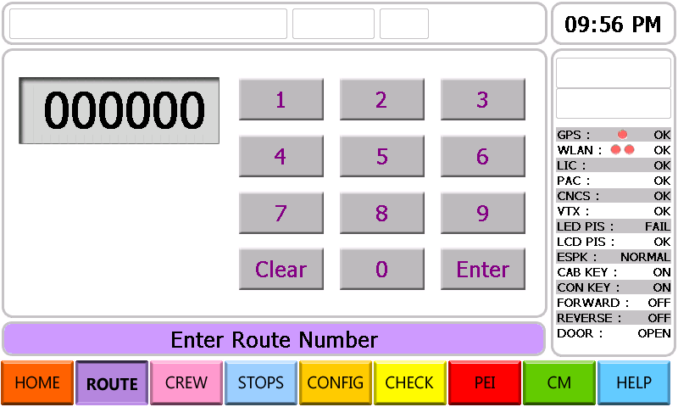
Figure 2-. CCP Graphic User Interface (GUI) to enter Route Number -1.
- Using the Communication Control Panel (CCP), set the route as follows:
- System Prompt: PLEASE ENTER ROUTE NUMBER.
- Press PLEASE ENTER ROUTE NUMBER key, the CCP will load the Route Number Entry Screen.
- Press NUMBER keys, Enter the two (2) digits Route Number using the touch screen key pad.
- Press ENTER key.
- System Prompt: The CCP will load the Stops screen.
- Communication System Ready.
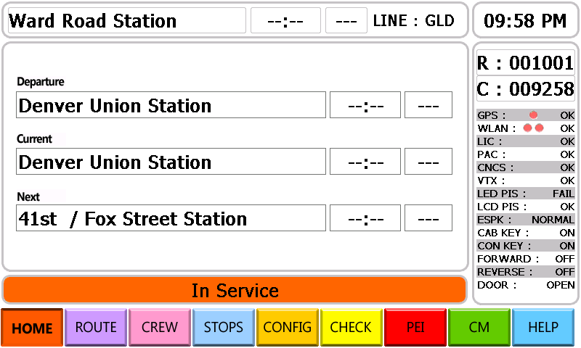
Figure 2-2. CCP GUI Route Number's entered.

LINE OPERATION.
NOTE
A complete description of cab controls and indicators is provided in Paragraph 1-4.
NOTE
The route must be set and start of trip message radioed to Control Center prior to beginning line operation. Refer to Paragraph 2-3.1.

Car Acceleration.
The master controller handle (2, Figure 1-35) may be positioned at one of four power settings (Switch through P3) to control car acceleration. See Table 2-3 for the acceleration response to the controller handle positions. The latter three are powering modes based on the acceleration up to the base speed (which is 25 mph).
The acceleration of P1 is 1.0 mphps, P2 is 2.0 mphps and P3 is the maximum, which offers 2.7 mphps. Switch position operates based on the speed of the vehicle and the acceleration and performance is dependant largely on the speed limit.
Table 2-3. Controller Handle Position vs. Acceleration.
Controller Handle Position | Acceleration Rate
P3 | 3.0 miles per hour per second (mphps)
P2 | 2.0 mphps
P1 | 1.0 mphps
SWITCH | Regulated speed 2 miles per hour (mph)

Service Braking.
Minimum Reduction position, full service brake position, release position (COAST), and an emergency brake position (EM) may be selected by setting the brake control handle (3, Figure 1-36) to the appropriate position. See Table 2-4 for the braking response to the controller handle positions.
Full service brake is normally provided dynamically (pneumatically & electrically) until the car reaches a low speed (approximately 7 mph). At this speed, pneumatically driven friction braking is gradually added to the braking effort.
Table 2-4. Controller Handle Position vs. Braking
Controller Handle Position | Deceleration Rate
RELEASE | Free running
Minimum Brake Reduction | -0.5 mphps
Suppression | -1.0 mphps
Full Service Brake | -1.5 mphps
When the train exceeds the maximum allowable speed indicated on the Aspect Display Unit (see Figure 1-51), the automatic train control portion of the CS/ATC responds by:
- lighting the OVERSPEED indicator on the ADU at cab,
- Sounding the audio alarm continuously, and
- Initiating an automatic Emergency Brake application.
If the overspeed condition is not acknowledged within two seconds by the Operator, placing the Brake control handle (3, Figure 1-36) in an EM position, the automatic brake application is irrecoverable until the train comes to a complete stop.
If the Operator acknowledges the overspeed condition within two seconds, and the train brake shall be applied by operator. When the train speed drops below the maximum allowable speed, the ATC responds by:
- Silencing the overspeed audio alarm,
- Making available train speed by Operator.

Emergency Braking.
Emergency braking can be initiated by the Operator or automatically by a train system due to a problem with the train.

Causes of Emergency Braking.
Emergency braking is applied whenever:
- Brake control handle (3, Figure 1-36) is moved to the EM position.
- Emergency pipe pressure (2, Figure 1-39) falls below 90 psi.
- The cars accidentally uncouple.
- A penalty brake magnetic valve is de-activated.
- Any reduction of emergency pipe pressure occurs at any point in the train.
Moving the brake control handle (3, Figure 1-36) to EM (cause a.) achieves the maximum braking rate (-6.0 mphps) with slide protection. The braking rate may be reduced in -0.5 mphps increments by moving the brake control handle to positions minimum reduction through Full service, down to -3.0 mphps when the Brake control handle is moved to the release position.

Recovering from Emergency Braking.
During emergency braking initiated from the master controller, moving the brake control handle (3, Figure 1-36) from EM to Full service brake position will lower the deceleration rate by 0.2 mphps.
After an emergency brake condition, brake pipe recharge is initiated when the handle is moved into the Full Service position with a no motion signal and after a 30 second timeout from the emergency condition indication (BPCM reads BP less than 25 psi). Once brake pipe pressure has increased greater than 50 psi, the handle can then be moved to Release position to fully charge the brake pipe. If the handle is moved from the Full Service position prior to BP reaching 50 psig, then the BPCM will stop charging the brake pipe until the handle returns to the Full Service position.

Deadman Braking.
Releasing the master controller handle (2, Figure 1-35) or foot pedal switch when the brake handle is outside of positions suppression through full service causes deadman brake application after 1 seconds. To release the brake application, the Master controller handle must be depressed or foot the pedal switch and moved to a suppression or greater brake position. Then normal operation may be resumed.

Spin/Slide Protection.
The Friction Brake Control Unit (FBCU) along with the Brake Cylinder Control Units, and speed sensors (signal will be provided by the propulsion system) are used to provide the friction braking wheel slide control on each truck independently. For electric blended braking, wheel slide control on both systems is allowed as described in this paragraph. Each system’s detection, response and control are adjustable on the car during initial dynamic testing with respect to sensitivity and potential interference between the systems.
The wheel slide control of the service and emergency friction braking is performed by the FBCU microprocessor Application software using the ERV A & R magnet valve sets on the Brake Cylinder Control Units.
The following paragraphs are divided up into Detection, Correction, Prioritization, and Interfaces. The FBCU uses a number of logic sensors programmed into the software to perform the wheel slide control function. The slide control’s software is designed to be executed in a 20 ms program loop. Specifically, inputs and outputs from the logic are updated every 20 ms.
- Wheel slide detection and control is active for all service braking and emergency braking except when disabled by the emergency brake wheel slide enable TL signal*. The default state is WSP is disabled during emergency.
- The FBCU will indicate through a relay contact to a sander circuit when wheel slides are detected.

Air Supply/Air Brake.

Friction Brake Interlock Bypass.
When brakes have been applied and the upper right control panel BRAKE APPLIED indicator is on, the FRICTION BRAKE CUTOUT switch, located on the backwall control panels, can be used to bypass the friction brake interlock in the event an interlock component or circuit fails and inhibits propulsion. When the friction brake interlock has been bypassed, the upper control panel BYPASS IN USE indicator illuminates and the BRAKE APPLIED indicator is illuminated.

Friction Brake Cut-Out Cocks.
To cut off air supply to the brake cylinders on a specific truck, place the appropriate friction brake cut-out cock (see Figure 1-6 and Figure 1-17) in the cut-out position. The BRAKE APPLIED indicator (3, Figure 1-41) on the upper right control panel will turn off. Observe the overhead control panel BYPASS IN USE indicator (7, Figure 1-42) when brakes are applied. Observe the fault display panel (FDP) for a fault indication.
When the friction brake cut-out cock is placed in the cut-out position, the truck control unit relay valve will vent the brake cylinders through a dump valve and those brakes will release.

ATC Line Operation.
The operator may operate the train in Cab Signal Territory with the Cab Signal/ATC System active, in Non Cab Signal Territory with the Cab Signal/ATC System automatically cutout, or in Non Cab Signal Territory with the Cab Signal/ATC System manually cutout. The Cab Signal/ATC System may also be manually overridden in the event of an ATC failure. While the Cab Signal/ATC System is active, the operator must acknowledge alerter and overspeed alarms activated by the Cab Signal/ATC System.

Reoccurring Acknowledgement Alerter System.
Within 30 seconds of a Restricting aspect being displayed, a transition to a Non Cab Signal Territory, an ATC override, or a Departure Test being required, it is expected that the operator take some action which results in a change in the state of the brake cylinder pressure switch, the hand acknowledge switch, the foot acknowledge switch, the master controller position, or a brake related trainline. If no such change in state occurs, the Reoccurring Acknowledgement Alerter System will initiate an operator alert. When an operator alert is activated, first the Alerter indicator on the ADU illuminates. After 4 seconds, if the visual alert has not yet been acknowledged, the Alerter Alarm sounds in addition to the continuation of the visual alert. If the operator fails to take appropriate action in response to the visual and audio alert within the total 10 second period, the Reoccurring Acknowledgement Alerter System initiates an emergency brake application.

Overspeed Acknowledgement.
The OVERSPEED indicator on the ADU illuminates and the Overspeed Alarm sounds in the event of an overspeed condition resulting either from acceleration or in the event of a change to a more restrictive aspect. The operator must acknowledge the alarm within 5 seconds using either the hand or foot acknowledge device in order to prevent an emergency brake application. An Overspeed Alarm takes precedence over an Alerter Alarm.

Automatic Switch to Non Cab Signal Territory.
The Cab Signal/ATC System allows a moving train to automatically switch from CAB SIGNAL TERRITORY mode to NON CAB SIGNAL TERRITORY mode. For the Automatic Cutout mode to take effect the train speed must be 20 mph or less and the Cab Signal/ATC System must receive a 420 CPM code rate. Upon detection of the cutout code rate, the Overspeed Alarm sounds and the Restricted aspect is shown. The operator must acknowledge the alarm with the hand or foot acknowledge device within 5 seconds. If the alarm is not acknowledged in time, an emergency brake application will occur. The Cab Signal/ATC System will cut back in automatically when it receives a valid code rate.

Manual Switch to Non Cab Signal Territory.
The operator may manually switch from cab signal territory mode to non cab signal territory mode, given the train speed is 20 mph or less and no valid code rate is present in the rail. To change to non cab signal territory mode, the operator must press and hold a console mounted manual cab signal bypass momentary pushbutton switch. The Overspeed Alarm sounds as long as the switch is held. The operator must activate the hand or foot acknowledge switch while the alarm is active. Upon receipt of the acknowledgement, the Cab Signal/ATC System changes over to non cab signal territory mode, the NON CAB SIGNAL TERRITORY indicator on the ADU is illuminated, and the exterior white speed control active lights extinguish. If the operator fails to acknowledge the alarm within 5 seconds, the equipment remains in the cab signal territory mode and the alarm is silenced. If the non cab signal territory mode switch is activated for more than 15 seconds, the Cab Signal/ATC System indicates a fault condition and initiates an emergency brake.

Manual Cutout.
A sealed ATC OVERRIDE switch is located in every cab which may be used in the event of a Cab Signal/ATC System failure. When the ATC OVERRIDE switch is placed in the OVERRIDE (cutout) position, the system deactivates the reoccurring acknowledgement system, blanks the cab signal aspects on the ADU and relinquishes all control of the car's brake system. The system will not respond to any valid code rates, keeps alarms silent, and extinguishes the exterior white speed control active lights. The actual train speed display on the ADU operates under all cutout or override conditions unless the ATC speed measuring subsystem has failed. The ATC OVERRIDE indicator on the ADU is illuminated. All other indicators remain dark. If the ATC OVERRIDE switch is operated when the train is above zero speed, the Cab Signal/ATC System initiates an emergency brake application but the emergency brakes will not be applied because the carborne system brake control is overridden.

Normal Operation of Passenger Doors.
The train is at standstill, zero speed signal is activated.
The door operations are activated as using cab door control panel or each side door control panel. When operating the doors at each side control panel inserting the conductor key, cab door control is inhibited.
Once one control panel is activated (by action of the master key switch by means of the SEPTA crew key), the door control relay panel (DCRP) authorizes dual stream door control panel (DSDCP) or single stream door control panel (SSDCP) to send orders from the active control panel.
When a control panel is activated, the operator can send opening and closing train lines rearward or forward the panel position.
When the control panel is de-activated, the door stays free, waiting for the next order from an active control panel.

Opening Passenger Doors on Right Side of Train in the cab.
- When the cars are visually check platform on right side of train.
- Momentarily press ENABLE DOORS switch for both right side HIGH LEVEL and LOW LEVEL doors (3, Figure 1-54), located Right Door control panel, to enable cab right door controls. DOORS ENABLED indicator for right side doors will go on.
- Momentarily press OPEN DOORS switch for both right side HIGH LEVEL and LOW LEVEL doors (1 and 2, Figure 1-54), located on Right Door control panel, to OPEN position.
- The upper right control panel DOORS CLOSED indicator (2, Figure 1-41) will go off and DOORS OPEN indicator (1, Figure 1-41) will go on.
- All right side passenger doors will open.

Closing Passenger Doors on Right Side of Train in the cab.
- Visually check platform on right side of train.
- Momentarily press CLOSE DOORS switch for both right side HIGH LEVEL and LOW LEVEL doors (3, Figure 1-54), located on Right Door control panel, to CLOSED position.
- All right side passenger doors will close.
- After the doors have fully closed, the upper right control panel DOORS OPEN indicator (1, Figure 1-41) will go off, and DOORS CLOSED indicator (2, Figure 1-14) will go on.
- When the cars are moved, door enable indicator will go off automatically.

Opening Passenger Doors on Left of Train in the cab.
- Visually check platform on left side of train.
- Momentarily press ENABLE DOORS switch for both left side HIGH LEVEL and LOW LEVEL doors (3, Figure 1-40), located upper left control panel, to enable cab left door controls. Left DOORS ENABLED indicator will go on.
- Momentarily press OPEN DOORS switch for both left side HIGH LEVEL and LOW LEVEL doors (1 and 2, Figure 1-40), located on upper left control panel, to OPEN position.
- The upper right control panel DOORS CLOSED indicator (2, Figure 1-41) will go off and DOORS OPEN indicator (1, Figure 1-41) will go on.
- All left side passenger doors will open.

Closing Passenger Doors on Left Side of Train in the cab.
- Visually check platform on left side of train.
- Momentarily press CLOSE DOORS switch for both left side HIGH LEVEL and LOW LEVEL doors (3, Figure 1-40), located on upper left control panel, to CLOSED position.
- All left side passenger doors will close.
- After the doors have fully closed, the upper right control panel DOORS OPEN indicator (1, Figure 1-41) will go off, and DOORS CLOSED indicator (2, Figure 1-41) will go on.
- When the cars are moved, door enable indicator will go off automatically.

Opening Passenger Doors on Right Side of Train in the side control panel.
- Visually check whether platform on right side of train is high level or low level through windows by operator in passenger cabin.
- If needed, convert the door level according to the platform level by trap door up/down latching device.
- Insert SEPTA conductor’s key to master key switch (13, Figure 1-64 and Figure 1-65) and turn it to activate DSDCP or SSDCP on right side of train.
- In high level platform, press OPEN HIGH forward (↑) (2, Figure 1-64 and Figure 1-65) or OPEN HIGH rearward (↓) (1, Figure 1-64 and Figure 1-65) or OPEN LOCAL DOOR (5, Figure 1-64 and Figure 1-65) or OPEN ADJ DOOR (6, Figure 1-64).
- In low level platform, press OPEN LOW forward (↑) (16, Figure 1-64 and Figure 1-65) or OPEN LOW rearward (↓) (15, Figure 1-64 and Figure 1-65). or OPEN LOCAL DOOR (19, Figure 1-64 and Figure 1-65) or OPEN ADJ DOOR (6, Figure 1-64).
- Right side passenger doors will be opened according to pressed button.

Closing Passenger Doors on Right Side of Train in the side control panel.
- Visually check platform on right side of train through opened passenger door by a operator.
- In high level platform, press CLOSE HGH forward (↑) (4, Figure 1-64 and Figure 1-65) or CLOSE HIGH rearward (↓) (3, Figure 1-64 and Figure 1-65) or CLOSE LOCAL DOOR/ADJ DOOR (7, Figure 1-64 and Figure 1-65).
- In low level platform, press CLOSE LOW forward (↑) (18, Figure 1-64 and Figure 1-65) or CLOSE LOW rearward (↓) (17, Figure 1-64 and Figure 1-65) or CLOSE LOCAL DOOR (20, Figure 1-64 and Figure 1-65).
- Right side passenger doors will close.
- Check green lamp "All DOORS CLOSED AND LOCKED forward (↑) (10, Figure 1-64 and Figure 1-65) and rearward (↓) (9, Figure 1-64 and Figure 1-65)" are turn on.
- Take off SEPTA conductor’s key from master key switch (13, Figure 1-64 and Figure 1-65) to deactivate DSDCP or SSDCP.

Opening Passenger Doors on Left of Train in the side control panel.
- Visually check whether platform on Left side of train is high level or Low level through windows by a operator in passenger cabin.
- If needed, convert the door level according to the platform level through trap door up/down latching device.
- Insert SEPTA conductor’s key to master key switch (13, Figure 1-64 and Figure 1-65) and turn it to activate DSDCP or SSDCP on Left side of train.
- In high level platform, press OPEN HIGH forward (↑) (2, Figure 1-64 and Figure 1-65) or OPEN HIGH rearward (↓) (1, Figure 1-64 and Figure 1-65) or OPEN LOCAL DOOR (5, Figure 1-64 and Figure 1-65) or OPEN ADJ DOOR (6, Figure 1-64).
- In low level platform, press OPEN LOW forward (↑) (16, Figure 1-64 and Figure 1-65) or OPEN LOW rearward (↓) (15, Figure 1-64 and Figure 1-65). or OPEN LOCAL DOOR (19, Figure 1-64 and Figure 1-65) or OPEN ADJ DOOR (6, Figure 1-64).
- Left side passenger doors forward or rearward will be opened according to pressed button.

Closing Passenger Doors on Left Side of Train in the side control panel.
- Visually check platform on left side of train through opened passenger door by a operator.
- In high level platform, press CLOSE HGH forward (↑) (4, Figure 1-64 and Figure 1-65) or CLOSE HIGH rearward (↓) (3, Figure 1-64 and Figure 1-65) or CLOSE LOCAL DOOR/ADJ DOOR (7, Figure 1-64 and Figure 1-65).
- In low level platform, press CLOSE LOW forward (↑) (18, Figure 1-64 and Figure 1-65) or CLOSE LOW rearward (↓) (17, Figure 1-64 and Figure 1-65) or CLOSE LOCAL DOOR (20, Figure 1-64 and Figure 1-65).
- Left side passenger doors will close.
- Check green lamp All DOORS CLOSED AND LOCKED forward (↑) (10, Figure 1-64 and Figure 1-65) and rearward (↓) (9, Figure 1-64 and Figure 1-65)" are turn on.
- Take off SEPTA conductor’s key from Master key switch (13, Figure 1-64 and Figure 1-65) to deactivate DSDCP or SSDCP.

Communication.
NOTE
When the raido is in any Select mode, it continues to receive messages on the last selected RX channel.

Train Radio Sub-System.
The Train Radio Sub-System consists of components related to analog radio functionality, and/or integration with existing SEPTA analog radio infrastructure, necessary to facilitate specific types of communication between the Regional Rail Division Control Center (RRDCC) and the individual train cars. The primary functionality facilitated by this sub-system will include the following:
- Radio Communication between the RRDCC and Train Cab.
- Provide for Emergency PA audio announcements to the passengers from a Passenger Information Specialist located at the RRDCC.
- Provide a mechanism to deliver "Form D - Cab Text Messages" from a dispatcher directly to a printer located within each Cab.

Changing Channels (Common Select Mode)
In general, to enter a Select mode, the pertinent Select mode key is pressed. The corresponding display(s) change to dashes, with the data entry location being indicated by a flashing underscore. The numeric keypad is now configured to enter numbers. Any Select mode is automatically terminated after one of the following conditions occurs:
NOTE
When the radio is in any Select mode, it continues to receive messages on the last selected RX channel.
- Completion of a valid Select mode entry .The corresponding displays are updated and a configuration-good-alert tone is heard at the speaker.
- After ten seconds of no keypad activity. The display reverts to the last selected display and an invalid-key-alert tone is heard at the speaker.
- If after initiating a Select mode, the same Select mode key is pressed again before complete entry of the number information, then the display reverts to the last selected display.
- If after initiating a Select mode, another Select mode key is pressed, then the display changes to the new Select mode display.

Selecting TX and RX Channels.
To select a new TX and RX channel pair, execute the following:
- Momentarily press the CHAN button to initiate the Channel Select state. The TX and RX displays become dashes, with a flashing underscore appearing in the leftmost (TX hundreds) position. The numeric keypad is now configured for number entry.
- Enter the first digit using the numeric keypad, including a leading zero if required (The operator has 10 seconds after a key is pressed to press the next key before Select mode time-out occurs). The keypad number entry replaces the flashing underscore which moves right to the next position.
- Enter the remaining five digits using the numeric keypad. When 4 digit channel entry is enabled in the ASTRO Clean Cab CPS, if the user enters 4 digits and pauses the radio will assume a leading zero before each digit pair. Thus an entry of 1212 will be interpreted as 012 012.
For a valid keypad sequence, the TX and RX displays are updated to indicate the keypad entries. A configuration-good-alert tone sounds when the sixth digit has been entered successfully or when the 4 digit channel is auto entered after a few seconds. The Channel Select mode is terminated and the radio now transmits and receives on the new channel assignments.
If either the TX or RX channel is invalid (not a valid preprogrammed conventional channel or a trunking mode) an invalid-key-alert tone sounds when the sixth digit has been entered or when the 4 digit channel is auto entered after a few seconds. The TX and RX displays become dashes as before. If either the TX or RX channel is a trunking talk group, the display will also show "ERROR TRUNK" before returning to display dashes. The operator may enter new digits or exit the Channel Select mode in one the ways described under Common Select Mode Conditions above.

Selecting TX and RX Channels.
Before starting transmission, monitor the traffic on the selected channel to ensure that it is not in use. To transmit voice messages, execute the following:
- Press and hold the RADIO button on the Driver PA Operation Box. The radio keyed and the TX indicator lights.
NOTE
The radio has a Time-Out Timer (TOT) to limit the duration of a transmission to 60 seconds (typically), or as set via the ASTRO Mobile CPS. A low-frequency, alert tone signals the operator that the transmitter will be disabled in four seconds. Once the TOT expires, the radio stops transmitting and a continuous low frequency tone is generated until the Push To Talk (PTT) key is released.
- Speak clearly into the Drivers Lapel Microphone, if the Lapel Microphone is plugged into the system. If the Lapel Microphone is not plugged into the system the Operator must us the Internal Condenser Microphone within the Driver PA Operation Box using the same RADIO button located on the DPO. Voice message is transmitted.
- After finishing your message, release the PTT key and wait for a reply. Radio is de-keyed and TX indicator goes out.

Transmit Voice Messages
Before starting transmission, monitor the traffic on the selected channel to ensure that it is not in use. To transmit voice messages, execute the following
- Press and hold the PTT key.
The radio is keyed and the TX indicator lights.
NOTE
The radio has a Time-Out Timer (TOT) to limit the duration of a transmission to 60 seconds (typically), or as set via the ASTRO Mobile CPS. A low-frequency, alert tone signals the operator that the transmitter will be disabled in four seconds. Once the TOT expires, the radio stops transmitting and a continuous low frequency tone is generated until the PTT key is released.
- Speak clearly in the direction of the front grill of the radio set with mouth 8 to 12" away.
Voice message is transmitted.
- After finishing your message, release the PTT key and wait for a reply.
Radio is de-keyed and TX indicator goes out.

Passenger Information Display Sub-System.
The Passenger Information Display Sub-System is comprised of components related to the physical, transmission, management, presentation, and automation of both static and rich media content. This includes a range of display devices, transmission technology, cabling, monitoring devices, as well as system management and maintenance software.

Using the CCP to Change Destination Sign Displays based on the Route.
- Press STOPS key, for detailed route information and adjustments. The CCP will load the following screen.
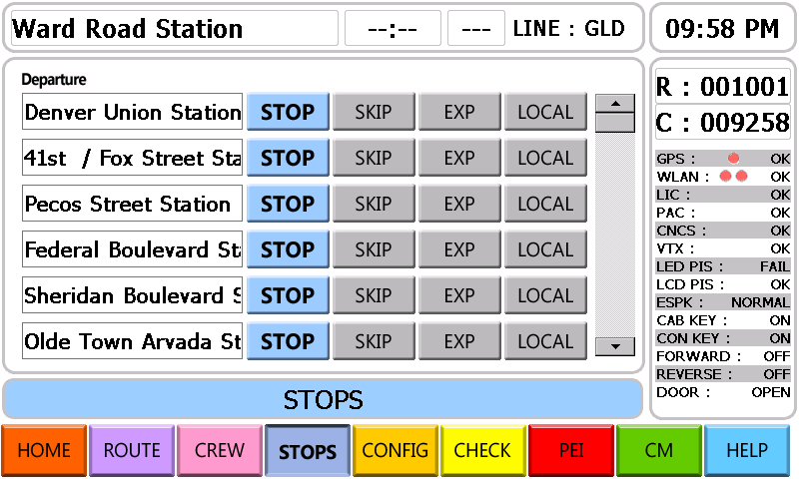
Figure 2-. CCP GUI screen for detailed stops information.
- Use the Scroll Bar to view entire Stops determined by the entry of the ROUTE NUMBER. This screen allows the operator to adjust the information displayed by the destination signs by the use of (4) characteristic buttons.
- STOP – The train will now Stop at a station previously not scheduled for a stop.
- SKIP – The train will now Skip a station previously scheduled for a stop.
- EXP – The train will be changed into an Express to the specified station.
- LOCAL – The train will be changed to a local to the specified station..

Procedures for CONFIG, CHECK, HELP and PEI Buttons:
- The following "CONFIG" screens allow the Operator to configure different aspects of the Communication System including "Speaker Volume", "LCD Dimmer", "System Reset", “Simulation Time”, “C/I Setting” and “Password”.
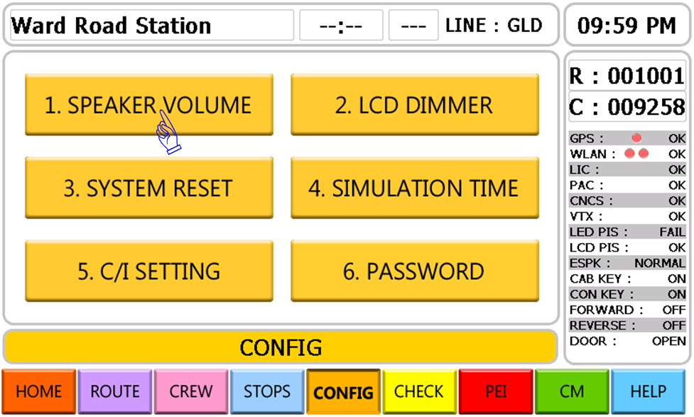
Figure 2-. CCP GUI screen for Speaker Setting -1.
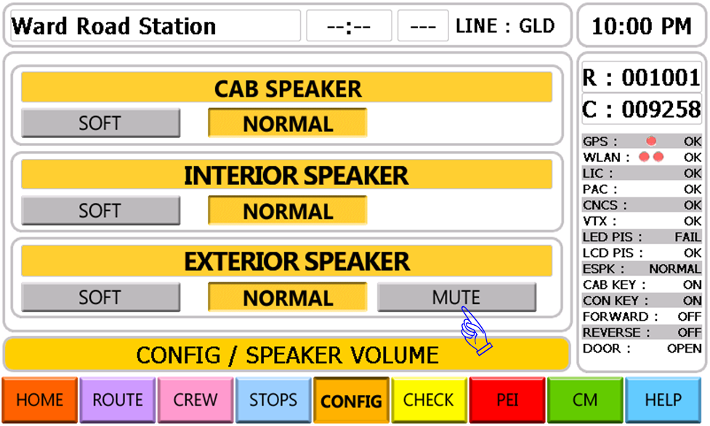
Figure 2-. CCP GUI screen for Speaker Setting -2.
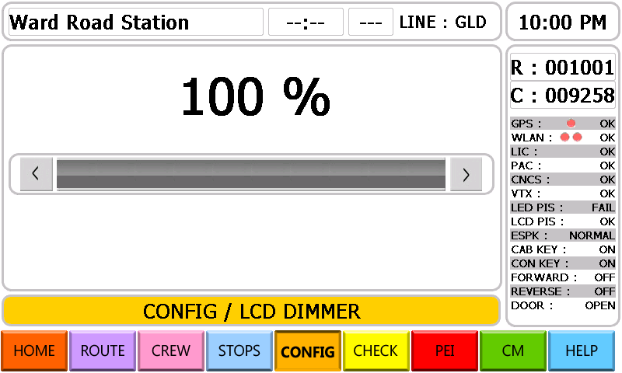
Figure 2-. CCP GUI screen for LCD dimmer Setting.
- The following two "Check" screens allow the Operator to check the status of each car in a given train Consist as well as visually inspect the physical devices of the Communication System to confirm that each is functioning properly. In the event that a critical component is in a state of failure, the fault will be displayed on the CCP for the driver to review. It is anticipated that a normal Consist will include up to six Cars, but the system must be capable of supporting up to a 8 Car Consist.
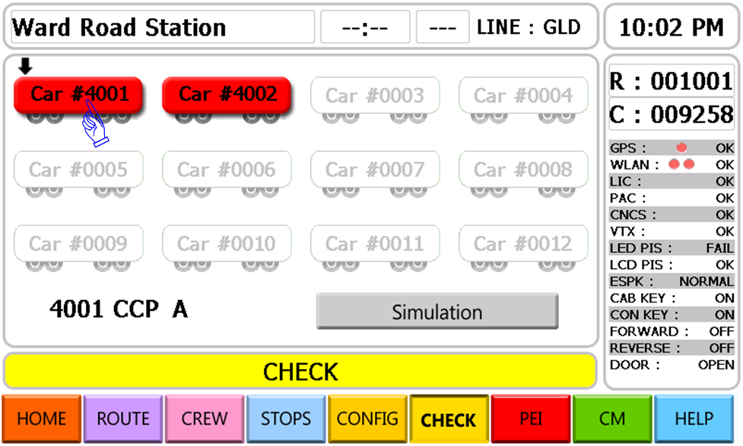
Figure 2-. CCP GUI screen for System Check -1.
- The following "Check" screen provides the detailed device information once a specific Car has been selected in the previous screen.
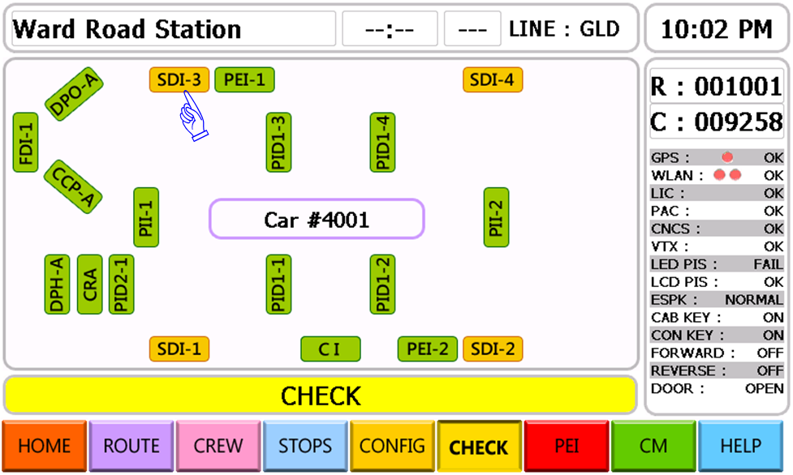
Figure 2-. CCP GUI screen for System Check -2.
- A scroll bar will allow the operator to move through a list of up to 50 pre-entered custom text messages.
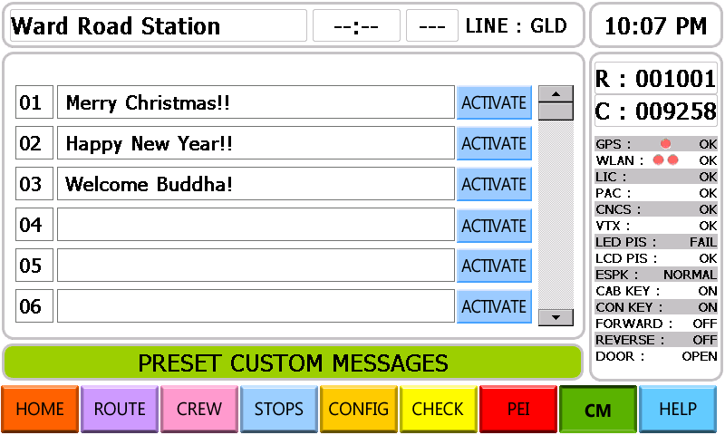
Figure 2-. CCP GUI screen for Custom Text Message Lists.
- The "Help" screens provide for an onboard quick reference guide to help give the Operator a better understanding of the structure of the CCP GUI Interface and how to use it.
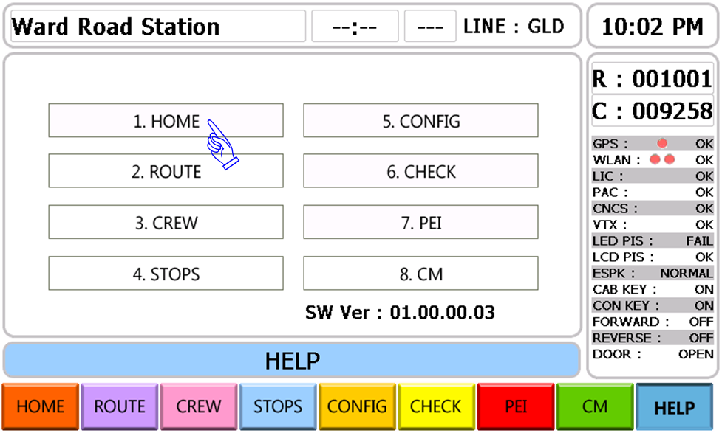
Figure 2-. CCP GUI Screen for Help.
- During normal operating conditions the CCP screen will default to display current Route information with a message indicating that the Train is IN SERVICE.
Figure 2-. Default CCP GUI Screen.
- When a PEI Call is initiated by a passenger the CCP in the Active Cab will display the message, "Passenger Emergency Intercom Call" providing the Operator with notification of the PEI Call. The "PEI" screen which displays where in the Consist the PEI Call was initiated can then be accessed by pressing the PEI Button at the bottom right of the screen.
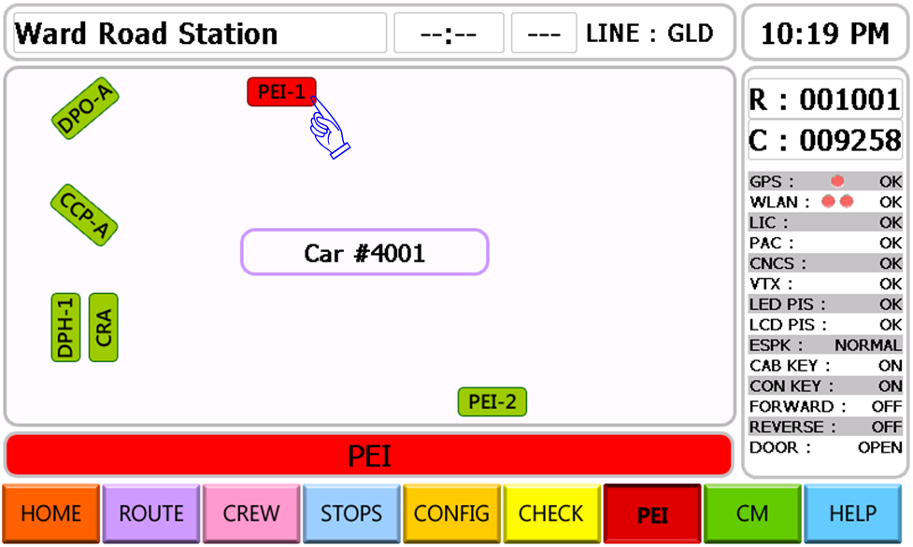
Figure 2-. CCP GUI Screen for Incoming PEI Call.
The CCP provides the driver with Operational Control of the on-board communications system via a touch screen GUI interface. To accommodate the required integration with other CS devices, and to provide for the required GUI functionality, the CCP will be equipped with an integrated Microprocessor running Windows CE. When power is applied to the CCP, it will automatically initialize and performs a complete POST process. At the conclusion of the POST process the CCP will load the operating software and the main CCP application. The CCP has several external interfaces by which it communicates with the other on-board CS devices, accepts input from train devices, and provides for an interface with the Driver.

Public Address & Intercom Sub-Systems.
Public Address Sub-System is comprised of components related to the acquisition, amplification, transmission, output, and management of both automated and manual audio messaging. There are four primary categories of audio messages which are incorporated into the system functionality.
- Manual PA Announcements: These are announcements that are intended to be made to the passengers by either a crew member or Regional Rail Division Control Center agent.
- Intercom communication: This includes private and/or party line conversations between individual members of the crew and/or with individual passengers.
- Automated route related announcements based upon an Automatic Vehicle Location (AVL) system delivering pre-recorded audio content which is initiated by pre-defined trigger points along the route. This system will be synchronized with the LED destination indicators to provide for audio based stop announcements.
The system design incorporates the use of a number of audio enhancements technologies to insure a consistent audio quality. This includes such things as audio line level balancing, audio feedback prevention techniques, and auto muting when not in use. The PA Sub-System is also equipped with automatic noise sensing (ANS) microphones to sense the ambient noise level within the vehicle and adjust the output level accordingly to maintain an apparently consistent audio intelligibility level.

Driver PA Operation Box and PA Handset
- PA Announcement (Operator/Crew to Passenger).
- Crew Key (Cab Key / Conductor Key) Turn On.
- Press "INT" or "EXT" or "BOTH" push button switch located on both the DPO and DPH boxes.
- Speak into the Microphone.
- When the PTT button switch is released the PA Announcement ends.
- Intercom Communication from Operator/Crew to Operator/Crew.
- Crew Key (Cab Key / Conductor Key) Turn ON.
- Push "IC" Button Switch located on DPO box to initiate an IC Call.
- The Crew can answer an intercom call by pressing the IC Button on the Active DPO in the other cab of the consist.
- Press a "CANCEL" Push button switch located on the Active DPO box to cancel a Intercom Communication.
- Passenger Emergency Intercom
- The passenger who needs assistance pushes the "RED" PEI Push button located on the PEI box.
- Crew Key(Cab Key & Conductor Key) Turn ON
- An Operator or a Crew pushes "PEI" Button located on the DPO to answer the PEI Call.
- When a "CANCEL" Push button switch is pressed on any active DPO within the train consist the PEI Call will be canceled returning the system to it default state.

Communication Control Sub-System.
Communication Control Sub-system consists of those components which perform, manage, and/or monitor the overall functionality of the system. Although there are some components that are mutually exclusive to this Sub-system, such as the Contents and Control Server (CNCS) and the CCP, it must also be viewed as a functional entity as it interfaces with all other devices and Sub-systems.
- To Operate the Communication Control Sub-System
- For normal operations the Communication Control Sub-System is a fully automated system that runs based on the Route Number that is input during system initiation.
- Setup and Maintenance functions are controlled via the Portable Test Unit.

On Board Wireless LAN & GPS Sub-System.
WLAN & GPS Sub-system consists of components related to functionality requiring on-board device connectivity to the Wayside Network, GPS Satellite Data, and other vehicle propulsion telemetry. In addition to the hardware components this Sub-system also includes Commercial Off The Shelves (COTS) software components, device drivers and an IVT/CMK developed automated vehicle location reckoning custom software application.
- To Operate the On Board Wireless LAN & GPS Sub-System System
- For normal operations the On-Board Wireless LAN & GPS Sub-System is a fully automated system that runs based on the Train Number that is input during system initiation.
- Setup and Maintenance functions are controlled via the Portable Test Unit.

High Voltage Power Systems.

Auxiliary Power Unit Status.
Auxiliary Power Unit Status indicates whether the auxiliary power unit is active or has failed. The Fault Display panel (see Figure 1-50) illuminates

230 Vac Circuit Breaker Supervision.
When the overhead catenary voltage input to the Main Transformer and car status is normally prepared, Auxiliary Power Unit Static is running and 230V AC output voltage is available. Only 230V AC output is monitored at inside indicating lamp of APU.
- HVAC blowers
- Air Compressor motor
- Cab heater
- Main Traction Motor Blower & Oil pump motor
- Converter/Inverter (C/I) Blower motor
The C/I Blower motor circuit breaker second contact signal input to the C/I for monitoring only. When a circuit breaker trips, Operator ensure that the circuit breaker is tripped at EDB.

Heating, Ventilation, and Air Conditioning.
The Heating, Ventilation, and Air Conditioning (HVAC) system maintains comfortable interior air temperature and ventilates the car. Operation of this unit is automatic due to the temperature sensor and is regulated by the HVAC module. The HVAC system is turned on whenever the control Key switch of master controller is inserted.

SHUTDOWN PROCEDURES.
When a train is to be taken out of service, it must be shut down to reduce wear. The type of shutdown procedure to be followed depends on how long the train is to be out of service.

Changing Cab operation at a Terminal.
To change the operating end of a train:
NOTE
END OF TRIP key must be pressed from active cab to reset communication system to accept input from another cab.
- Place brake control hand unit in CUT-OUT.
- Place control key switch of master controller (1, Figure 1-35) in "OFF" position.
- Remove key from control key switch.
- Exit cab, and close and lock cab door.
- Go to other end of train and prepare cab for operation.
NOTE
When the cab control switch is placed in "OFF" position, the train remains in a standby condition for approximately 15 minutes, after which all cars in the train will shut down. This will permit the interior lights to remain on while changing ends.

Layover Mode.
If a train is at the end of a run and will be used within 15 minutes and Operator wishes to leave the train or cab briefly:
- Place control key switch (2, Figure 1-35) in "OFF" position.
- Remove key from control key switch.
- Pantograph should be remained as being raised and vacuum circuit breaker (VCB) closed without the pantograph control operation.
- Train will be shut down after 15 minutes automatically, if needed, operating the shut down push button located on backwall switch panel.
- During the train layover mode status, needed loads will be alive continuously.
- 600 Vac floor heater.
- 317 Vac threshold heater.
- HVAC 37.5 Vdc control power.
- Dual stream low level door left and right side for crew operation.

COUPLING AND UNCOUPLING CARS.
To allow operation of a train consisting of up to 12 married pairs and single cars, each end of a married pair (the F-end of each car) and each end of single car (F-end and A-end) is equipped with an automatic coupler system. A mechanical coupler is located at each end of the car except each A-end of married pair car, and incorporates automatic connection of the emergency pipe between married pairs and single cars. The mechanical coupler includes a manual uncoupling handle. Located below the mechanical coupler is an electrical coupler which also connects during coupling, allowing trainlines to be established between married pairs and single cars. An electrical coupler door protecting lid over the electrical contacts opens automatically when units are coupled.
Each car has coupler-related pneumatic cut-out cocks to:
- Cut out the air supply normally used to uncouple cars (shared with whistle).
- Cut out the emergency pipe connection between cars.
Coupling cars normally involves automatically coupling the cars three ways:
- Mechanically (via the mechanical coupler)
- Pneumatically (via the pneumatic coupler)
- Electrically (via the electrical coupler)
After physical coupling (mechanical, pneumatic, and electrical), end-of-train control circuits must be configured using the COUPLER switch in the Operator’s cab to ensure proper train operation.
The procedure for coupling cars differs, depending on whether coupling will be performed on straight or curved track. During coupling, one car is at rest and the second car moves to couple to the first car. In the procedures that follow, the car at rest is referred to as the standing car, and the car moving is referred to as the active car.

Coupling on Straight Track.
Automatic coupling is accomplished by gently buffing cars together using the following instructions.
- The operator approaches the stationary car(s) and stops 2 to 3 feet (0.6 to 1.0 m) from the stationary car coupler to visually confirm that the couplers are within the proper gathering range for coupling and that both electric coupler shutters are closed. The operator then applies lowest power to initiate movement and then coasts into the stationary car’s coupler.
- The following events occur during mechanical coupling. The spears enter the opposing coupler funnels to provide alignment. The tip of the spears pushes the latches outward compressing their return springs. The tappet valve plungers contact each other at this point to open and provide pneumatic coupling of main reservoir and brake pipe trainlines. At this point, the coupler faces contact each other, the latches engage the spear notches and the tappet valve gaskets mate.
- The following events occur during electrical coupling. The electric coupler shutter wedges contact the sloped surface of the opposing coupler shutter. The shutters pivot downward and "cam" open operating the "end of train" switch. As coupler separation decreases, the shutters fully open and exposing the contacts. The contacts and gaskets touch. As the coupler faces touch, the contacts are slightly compressed to provide positive contact and the gaskets compress to form a moisture resistant barrier.
- Coupling is complete and cars are ready to operate as a train.
WARNING
When coupling a Silverliner IV car equipped with an FL electric coupler to a car equipped with new button-style electric coupler, both shutter doors must be propped open and both contact carriages must be retracted. Doing so will preclude the use of a stand-off adapter. Failure to do so will result in electric coupler damage.

Coupling On Curved Track.
If the couplers are misaligned by more than ±4 inches (such as on a curve), they will fail to couple properly. To couple cars on a curve:
- The operator approaches the stationary car(s) and stops 2 to 3 feet (0.6 - 1.0 m) from the stationary car coupler to visually confirm that the couplers are within the proper gathering range for coupling and that both electric coupler shutters are closed. The operator then applies lowest power to initiate movement and then coasts into the stationary car’s coupler.
- The following events occur during mechanical coupling. The spears enter the opposing coupler funnels to provide alignment. The tip of the spears pushes the latches outward compressing their return springs. The tappet valve plungers contact each other at this point to open and provide pneumatic coupling of main reservoir and brake pipe trainlines. At this point, the coupler faces contact each other, the latches engage the spear notches and the tappet valve gaskets mate.
- The following events occur during electrical coupling. The electric coupler shutter wedges contact the sloped surface of the opposing coupler shutter. The shutters pivot downward and "cam" open operating the "end of train" switch. As coupler separation decreases, the shutters fully open and exposing the contacts. The contacts and gaskets touch. As the coupler faces touch, the contacts are slightly compressed to provide positive contact and the gaskets compress to form a moisture resistant barrier.
- Coupling is complete and cars are ready to operate as a train.
WARNING
When coupling a Silverliner IV car equipped with an FL electric coupler to a car equipped with new button-style electric coupler, both shutter doors must be propped open and both contact carriages must be retracted. Doing so will preclude the use of a stand-off adapter. Failure to do so will result in electric coupler damage.
To check that coupling is secure, do the following:
- In mated-side cab of the active car, place control key switch of master controller in the REVERSE position.
- Briefly place master controller handle (2, Figure 1-35) in P1 position to operate cars in reverse.
- If the couplers hold, the pairs are physically coupled.
WARNING
BODILY INJURY. The UNCOUPLER switch must not be operated anytime personnel are near the coupler. Pressing the switch may cause the coupler to move. Personal injury or death may result.

Failure to Couple.
If coupling between cars is not initially successful, follow the procedures below before notifying the Control Center or maintenance personnel.
- Coupler heads fail to latch, cannot recharge emergency pipe due to leak at pilot valve on coupler face.
- Close F-end BRAKE PIPE CUTOUT COCK on active car.
- Recharge emergency pipe and back away active car.
- Open F-end BRAKE PIPE CUTOUT COCK on active car. Recharge emergency pipe if necessary.
- Re-attempt coupling, moving cars together more firmly. If coupling is still not successful, contact Control Center or maintenance personnel, as appropriate.
- Coupler heads fail to latch, can recharge brake pipe.
- Back away active car.
- Check that coupler latch mechanism is free to move, using manual actuator on non- cab side of coupler head. Check on both standing and active pair. If latch mechanism is jammed, contact Control Center or maintenance personnel, as appropriate.
- Re-attempt coupling, moving pairs together more firmly. If coupling is still not successful, contact Control Center or maintenance personnel, as appropriate.

Automatic Uncoupling.
Automatic uncoupling normally requires battery power and compressed air from the main reservoir. It can be accomplished regardless of the operational status of the car being removed from the train.
Automatic uncoupling is accomplished using the following instructions.
The operator sets the brakes and takes control of the cab where uncoupling is desired to occur.
The uncoupling control is activated to energize the uncouple solenoid valve. The solenoid valve directs main reservoir air pressure into the control car’s tappet valve to virtually close the brake pipe trainline and bias the opposing brake pipe tappet valve fully open. Both couplers uncoupling cylinders are pressurized to knock the latches from the spear notches. The operator then accelerates away from the stationary portion of the train at a rate of at least 1.0 to 2.0 mphps. The controlling car’s tappet valve should rapidly close thus retaining pressure and brake release while the stationary car’s biased open tappet valve causes a brief rapid reduction of brake pipe air which should initiate an emergency brake application. The main reservoir tappet valves of both couplers close under spring and pressure force.
Electrical uncoupling occurs simultaneously as follows. The electric coupler contacts and gaskets separate breaking the trainline circuits. As the couplers separate further, the shutters pivot upward under torsion spring force until they close.
Uncoupling is complete. It is recommended to apply a hand brake on the stationary set of cars.

Failure to Uncouple.
- On both cars, check that the COUPLER CONTROL circuit breaker (COCB), located on the low voltage circuit breaker panel (see Figure 1-25 through Figure 1-27), is in ON position.
- Check that the brake pipe cut-out cock (6, Figure 1-6 and 4, Figure 1-17) on both cars are open.
- The cars can be manually uncoupled if two Operators are present. Perform the following steps with caution:
Manual uncoupling can be accomplished by manually activating the uncouple solenoid valve from trackside or by wrenching open both latches of the mechanical coupler. If latches are wrenched open, they must be wrenched closed to provide automatic coupling.
WARNING
Personnel should never position themselves between the coupler heads while two cars are in close proximity to each other. Failure to heed this warning can result in serious injury or death.

