CHAPTER 3
EMERGENCY OPERATION PROCEDURES

EMERGENCY EQUIPMENT.
Emergency procedures described in the Silverliner V Book of Operating and Safety Rules should always be followed.
Each side passenger access door in the Silverliner V car has an interior emergency door releases (see Figure 1-62) that allows the door to be opened manually. Also, an exterior emergency door releases (see Figure 1-61) is mounted next to each door on both side of the carbody. Other emergency equipment includes a fire extinguisher and a pry-bar, located inside of the end wall of front end of each car (see Figure 1-66), and a first aid box, located into the underseat equipment box (4, Figure 1-7 and Figure 1-18).

FIRE.
A smoke detector is located in the delivery air stream of the heating, ventilation, and air conditioning (HVAC) system. When a fire occurs in the interior of the car, smoke is drawn into the return air stream and then picked up by the ionization chamber of the smoke detector. The smoke detector sends a signal to the automatic radio alarm system, and illuminates the red FIRE DETECTED light in the cab.
When smoke is detected, the system will respond as follows:
- The FIRE DETECTED indicator (9, Figure 1-41) in the overhead control panel illuminates in the active cab of the train.
- An automatic alarm is sent to the Control Center.
- The HVAC unit automatically shuts down.
To reset the fire alarm, the train must come to a complete stop and the control key switch of master controller (1, Figure 1-34) must be placed in the OFF position. The alarm will be reset when the key switch is placed in the OFF position, if the cause of the alarm no longer exists.

EMERGENCY OPERATING MODES.

Operation with a Disables Lead Cab.
When an equipment failure has made it impossible to operate from the lead cab, train operation. Operation under these circumstances is described below.
- To operated the car. cab selection should be changed to the tailing cab. In the tailing the cab, operation the Master Bypass Switch and ATC Cutout Switch must be used. This will allow a maximum speed of 30 mph. master controller should be placed to the reverse position.
- An additional member of the train crew, or a transportation supervisor, will need to be stationed in the lead cab to observe the track ahead during operation.
- The radio in the lead cab can be activated by the push button operation. It will allow the observer to communicate with the operator by radio.
- The headlights will be turned on in the lead car by means of the HEADLIGHTS switch, located on the middle console panel.
- The horn and windshield wiper will be activated in the lead cab by use of the each switch.
- The propulsion/ door interlock circuit will continue to function correctly, protecting against open doors both to the front and to the rear of the Operator if some doors are not closed.

Operation Coupled to a Dead Train, Dead Cars Trailing.
An operating train may be used to tow a train that has lost 11.5/25 kVac power on the cars themselves. Battery power and trainline capabilities are assumed to be available on all cars without Auxiliary Power Unit (APU) out put voltage.
- Couple a second train to the disabled train. During towing, the number of operational cars should equal the number of disabled cars, up to a maximum train length of 12 cars.
- Cutout the Converter/Inverter (CI) on the cars to be towed by placing the CI cut out switches.
Operational limitations are as follows:
- The maximum acceleration rate is approximately 50 percent of that of a fully operational train.
- Since the disabled cars are limited to a 1.5 mphps (mile per hour per second) friction only service brake rate, the maximum service braking rate of the entire train will be approximately 75 percent of that of a fully operational train.
- Motoring and electric braking performance will be reduced on the operational cars when the measured inverter heat sink temperatures reach a certain limit. The resulting loss in electric braking effort is replaced by additional friction braking effort on the operational cars.
- LVPS of the APU on the trailing pairs closed to the operational cars will be supported not only by the local battery but also by power available through the battery trainlines. This effect is negligible beyond the second trailing pair. However, if the panto on one side of the disabled train is intact, primary power, and thus battery charging, will be available on the trailing units approximately half of the time.
- Since the lead pair has an operational low voltage power system, control trainlines originating in the lead car will be supplied with full voltage (+37.5 Vdc). Voltage drops on all trainlines must still be considered, however, to ensure proper operation with a 12 car train.

Operation Coupled to a Dead Train, Dead Cars Leading.
Operational considerations in this case are similar to those described in Paragraph 3-3.2, with the exception that the lead car has an inoperative low voltage power system. Trainline voltage drop considerations are thus more important in this case.

Operation Coupled to Completely Inoperative Cars (Dead Hauling).
Trainline circuits in the operational cars can be isolated from the inoperative cars by means of the trainline tendum switch. And battery trainline power circuit breakers should be cut off.
For Dead Haul mode, the graduated release MC-30A valve is replaced with the direct release MC-30B valve and the BPCU Variable Load Valve is replaced with one set to a lower freight brake rate of -1.2 mphps:
The setting for the special Variable Load Valve is:
- Emergency BCP @ AW0: 23 psi for brake rate of -1.2 mphps

TOWING A DEAD CAR.
The air from the Brake pipe line during dead car towing is used to charge the Main Reservoir line through this 3/8" Vented Cutout Cock with a locking handle.
- This cutout cock is used for dead tow hauling purposes with the C-1-3-8 Strainer and check valve device.
- There is one cutout cock provided per car.
NOTE
The handle position is required to be perpendicular to the pipe when the cock is in the open position, parallel to the pipe when closed. Handle color: white.

OPERATOR DIAGNOSTICS AND TROUBLESHOOTING.
Operator responses to fault conditions may occur in two areas: responding to fault indications from the Fault Display Panel (FDP) on the operator console or messages displayed by the Central Diagnostic Terminal (CDT); and troubleshooting as detailed in Table 3-5.2.1 through Table 3-5.2.7. Equipment failure symptoms that are not corrected or covered by the fault display panel or the troubleshooting tables must be reported immediately to the SEPTA Control Center.

Fault Display Panel and Central Diagnostic Terminal.
Faults within the CDT itself are first announced by the General Fault indicator on the FDP. Note that faults in certain other car equipment are also reported through the General Fault indicator.
Fault conditions within the CDT may be diagnosed through the CDT display screen. Fault data items may be viewed on the CDT’s Real-Time Data screen, as described in paragraph 3-5.1.5. Refer to paragraph 3-5.1.6 for details of configuring a filter to focus attention on only CDT faults.
To access a detailed description of the fault condition, select the particular fault data item on the Real-Time Data screen; the item will be highlighted in cyan when selected. Then press the Help button. A window will appear providing detailed diagnostics, including possible corrective actions.

Central Diagnostic Terminal (CDT) Usage Overview.
This paragraph describes how to operate the diagnostic equipment after a fault has been indicated and the Operator has taken any necessary initial reactions.
When the Fault Display Panel (FDP) indicates that a fault exists, it is generally necessary to localize the fault to a particular car. The Central Diagnostic Terminal (CDT) in each car has a fault indicator display identical to that of the FDP, except that the CDT indicators relate only to faults within the local car. To localize a fault to a particular car, the train crew must "walk the train", i.e. inspect each CDT in turn looking for the particular CDT that has the fault indication(s) first reported at the FDP.
Note that one fault indicator on the FDP might be the result of the same fault in multiple cars, or of multiple faults for the same car system. The General Fault indicator might also represent concurrent faults in multiple car systems, e.g. both Doors and Communications.
The Central Diagnostic Terminal provides diagnostic data processing for its local car. Figure 3- shows the CDT front panel.
The CDT has a suite of screens that provide its various operator functions. These screens are organized into a hierarchy as shown in Figure 3-.
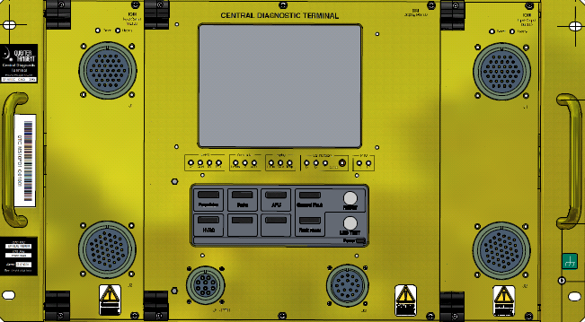
Figure 3-. CDT Front Panel.
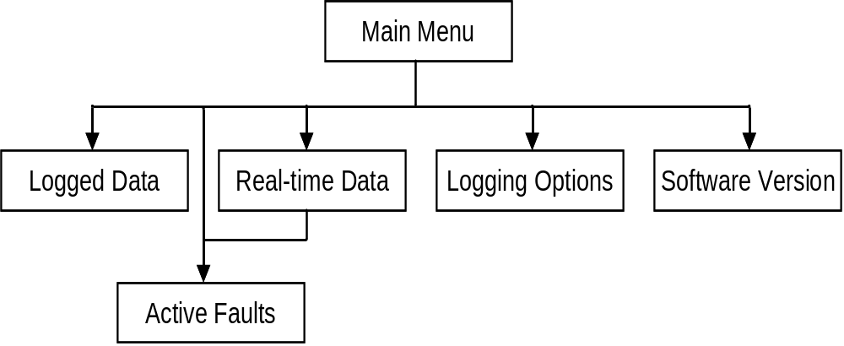
Figure 3-. CDT Screen Hierarchy.
Lower-level screens have a "Main Menu" button in the top-left corner of the screen. Touching this button will navigate up the screen hierarchy towards the Main Menu screen.
The CDT also uses temporary windows that overlay the center paragraph of the basic screen. The temporary windows provide features such as setting the filter for viewing logged data. Sometimes multiple levels of nested temporary windows are required. On any temporary window, press the OK or Cancel button to return to the parent screen.

CDT Touch Screen Operation.
Areas of screens representing buttons and some item lists are sensitive to touch. The CDT uses visual highlighting to show when a button has been pressed or a data item has been selected.
Use a fingertip or a blunt object to operate the screen; avoid touching the screen with anything sharp that may scratch the surface. Only light pressure is required to operate the touch screen; pressing harder will have no effect. Sometimes there is a short time delay between the press and the action.
Calibration of the touch screen is enabled through the Portable Test Unit (PTU) laptop computer. Please refer to the Running Maintenance Manual for details.

General CDT User Interface Features.

Display Screen Control.
The display screen automatically goes into a power saving mode when not in use. It turns itself off after a 15 minute time delay with no operation of the touch screen. Within the next 15 minutes, touching the screen will reactivate the display in the previous state. After the screen is in power saving mode for at least 15 minutes, it will wake up at the Main Menu screen.
The display screen operates only when its temperature lies within the range +14 °F (–10 °C) to +158 °F (+70 °C). The CDT front panel has a "Temp" LED that is green when the display is operational and turns yellow to indicate that the display is disabled.

Scrolling Lists.
Various screens contain scrolling lists. See Figure 3- for an example. At the bottom of these screens are Up, Down and Scroll Mode buttons used to scroll through the displayed list:
- Scroll Mode: Changes up/down buttons between three different modes: Line Up/Line Down, Page Up/ Page Down and Top/Bottom.
- Line Up / Line Down: Scroll data one line at a time.
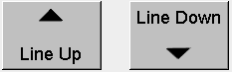
- Page Up / Page Down: Scroll data one page at a time.
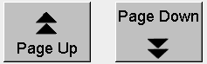
- Top / Bottom: Scroll data to top and bottom of list.
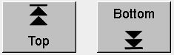

CDT Main Menu Screen.
The Main Menu screen is the first shown when the CDT is powered on. It is also shown when the display is turned on after being in power saving mode for more than 15 minutes.
This screen mainly provides access to lower-level screens. It has the following buttons:
- Real-Time Data: Current state of faults and operating status. Updated immediately the state changes. See paragraph 3-5.1.5 for further details.
- Active Faults: Provides quick access to real-time data focusing on faults that are currently active. See paragraph 3-5.1.5 for further details.
- Logged Data: Historical record of car faults and operating status. See paragraph 3-5.1.7 for further details.
- Logging Options: Provides access to a screen that is only of use to maintenance personnel, and is described in the Running Maintenance Manual.
- Software Versions: Provides access to a screen that is only of use to maintenance personnel, and is described in the Running Maintenance Manual.
- Dim Display: Makes the display a little dimmer. Press repeatedly to continue dimming the screen.
- Brighten Display: Makes the display a little brighter. Press repeatedly to continue brightening the screen.
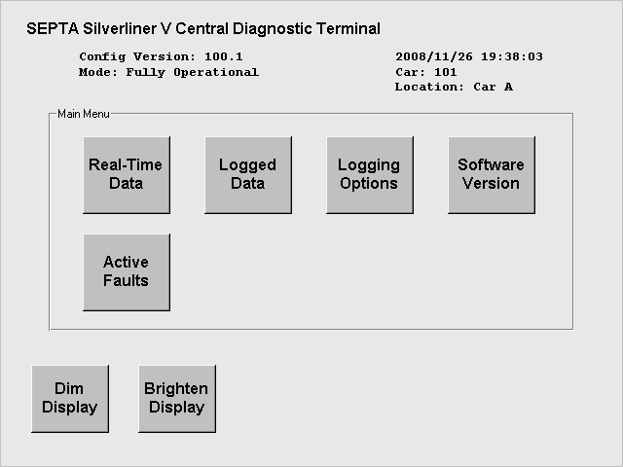
Figure 3-. CDT Main Menu Screen.

CDT Real-Time Data Screen.
To access this screen, press "Real-Time Data" on the Main Menu screen. It can also be accessed to view active faults by pressing "Active Faults" on the Main Menu screen.
This screen displays the real-time state of fault and operating status data available to the CDT. Most data items are "Boolean" meaning that they are in one of two possible states, i.e. On/True/Set or Off/False/Clear. Remaining data items are numeric values.
A fault data item (with a fault number) appears in red. An operating status appears in yellow. Stale data appears in grey. When an item is Set, it appears with a colored background. When an item is Clr, its background is black and the text is colored. A single item can be selected by touching within the scrolling list; this item will then turn to cyan.
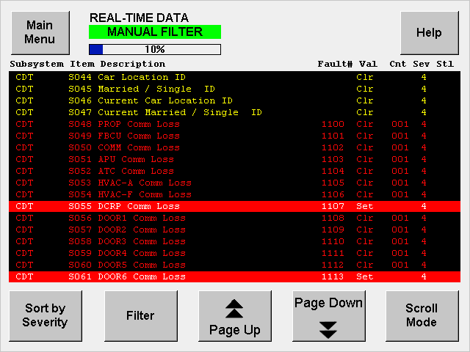
Figure 3-. CDT Real-Time Data Screen.
This screen has the following buttons:
- Main Menu: Return to the top-level screen.
- Help: When a data item in the scrolling list is highlighted, show a detailed description in a temporary window. When no data item is selected a description of all the fields is displayed.
- Sort by Severity: Re-orders the displayed data to place the most severe faults at the top of the list.
- Filter: Displays a temporary window used to select which data items appear in the scrolling list. See paragraph 3-5.1.6 for further details.
- Page Up / Page Down / Scroll Mode: Used to scan up and down the list of data items. See paragraph 3-5.1.3 for further details.
The scrolling list has the following columns:
- Subsystem: The car subsystem corresponding to the data item.
- Item: Data item identifier useful to maintenance personnel.
- Description: A short identification of the data item.
- Fault#: A unique number corresponding to certain fault data items.
- Val: Current value of the data item. For Boolean data items, the value is either "Set" (On, True, active) or Clr (short for Clear, Off, False, inactive).
- Cnt: Counter of Set conditions for intermittent, repetitive faults.
- Sev: Severity code:
1 – High 2 – Medium 3 – Low 4 – Operating Status
- Stl: Staleness flag. "Y" in this column indicates that the CDT has not received any update of this data item for an extended interval.

Filter Selection.
To access this screen, press "Filter" on the Real-Time Data screen or the Logged Data screen.
This is a temporary window used to select which data items appear in the Real-Time Data or Logged Data screen, depending on how it was accessed.
The text in the upper left indicates the current filter mode: No Filter, Manual, Active Faults or Custom. The button representing the current filter mode is also indicated by color. The Text in the "Manual Filter Criteria" box indicates the current manual filter settings for each of three filter attributes: Subsystem, Fault# and Severity.
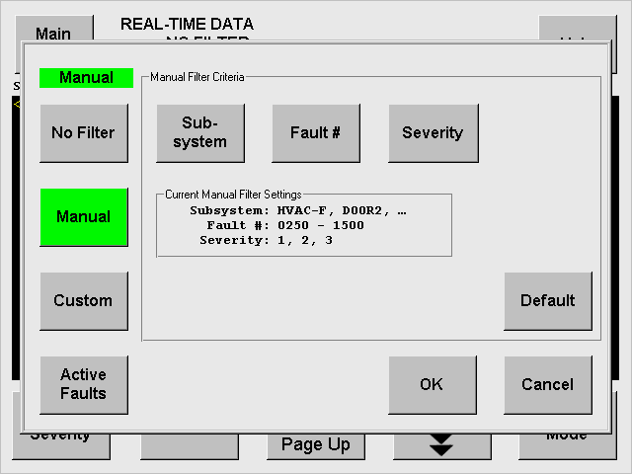
Figure 3-. CDT Main Filter Screen.
This screen has the following buttons:
- No Filter: Turns off filtering. All data is displayed.
- Manual: Turns on manual filtering. The Manual Filter Criteria buttons become active.
- Active Faults: Displays only status and equation items that are set and have a fault number assigned. This button is only available for real-time data filtering.
- Custom: Displays a preset selection of data items. The mechanism for choosing which data items will appear is described in the Running Maintenance Manual.
- Subsystem: Opens the subsystem filter window, which allows selection of one or more subsystems.
- Fault #: Opens the fault number filter window, which allows selection of a range of fault numbers.
- Severity: Opens the severity filter window, which allows selection of individual severity values.
- Default: Resets the current manual filter to include all filter settings.
- OK: Accept the filter settings and close the Filter window.
- CANCEL: Reject the filter settings and close the Filter window.

CDT Logged Data Screen.
To access this screen, press "Logged Data" on the Main Menu screen.
This screen shows a historical record of the data items viewable through the Real-Time Data screen. Boolean data items (those with On/Off states) are logged whenever they change state. Numeric values are logged according to pre-determined criteria (see the Running Maintenance Manual for details).
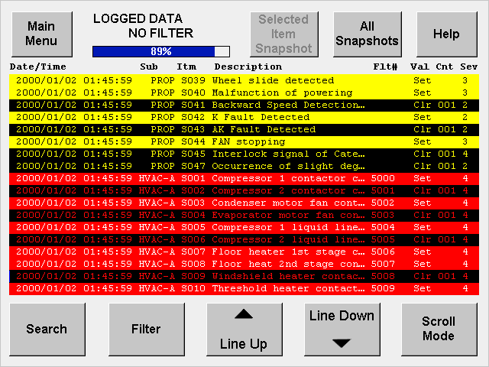
Figure 3-. CDT Logged Data Screen.
The historical record appears in date/time order, with the oldest data at the top of the screen.
Particular data items are setup to trigger the recording of "vehicle snapshot" data when they are logged. The snapshot is a pre-determined set of data items that provide a general picture of the vehicle’s operational state. Snapshot data is normally hidden and can be viewed on demand.
A fault data item (with a fault number) appears in red. An operating status appears in yellow. Stale data appears in grey. When an item is Set, it appears with a colored background. When an item is Clr, its background is black and the text is colored. A single item can be selected by touching it; this item will then turn to cyan.
This screen has the following buttons:
- Main Menu: Return to the top-level screen.
- Selected Item Snapshot: Accessible only when a data item is selected that has associated vehicle snapshot data. Reveals/hides vehicle snapshot data, if present.
- All Snapshots: Reveals/hides vehicle snapshot data for all data items.
- Help: When a data item in the scrolling list is highlighted, show a detailed description in a temporary window.
- Search: Displays a temporary window used to select a date and time to place at the top of the window.
- Filter: Displays a temporary window used to select which data items appear in the scrolling list. See paragraph 3-5.1.3 for further details.
- Page Up / Page Down / Scroll Mode: Used to scan up and down the list of data items. See paragraph 3-5.1.3 for further details.
The scrolling list has the following columns:
- Date/Time: When the data item was logged.
- Sub: The car subsystem corresponding to the data item.
- Itm: Data item identifier useful to maintenance personnel.
- Description: A short identification of the data item.
- Flt#: A unique number corresponding to certain fault data items.
- Val: Value of the data item when it was logged. For Boolean data items, the value is either "Set" (On, True, active) or Clr (short for Clear, Off, False, inactive).
- Cnt: Counter of Set conditions for intermittent, repetitive faults.
- Sev: Severity code:
1 – High 2 – Medium 3 – Low 4 – Operating Status

General Fault Reset.
After locating the source of a General Fault indication and investigating the root cause, it might be determined that the train crew cannot take further action to rectify the fault. In this situation, the Operator can press the RESET button on any Fault Display Panel (FDP) to acknowledge the existing fault. This will override the fault indication on all of the FDPs in the train. The FDP fault indicator will light up to tell the Operator if a new fault arises later.

Troubleshooting.
Problems that may be corrected by the train Operator which are not covered by the Fault Display Panel (FDP) and Central Diagnostic Terminal (CDT) are contained in Troubleshooting Tables. Table contains a listing of the troubleshooting tables.
Table 3-1. Troubleshooting Listing.

Table | Name
Table 3-2 | Cab Controls and Equipment Troubleshooting
Table 3-3 | Coupler Troubleshooting
Table 3-4 | Vehicle Operation Troubleshooting
Table 3-1. Troubleshooting Listing (Cont.).
Table | Name
Table 3-5 | Brake System Troubleshooting
Table 3-6 | Cab Signal and Automatic Train Control System Troubleshooting
Error: Reference source not found | Communication System Troubleshooting
Table 3-7 | Door System Troubleshooting
Table 3-8 | HVAC System Troubleshooting
Table 3-9 | Lighting System Troubleshooting

Cab Controls and Equipment Troubleshooting.
Table 3-2. Cab Controls and Equipment Troubleshooting.
Symptom | Probable Cause | Remedy
1. FDP LEDs will not turn on when the LED TEST button is pressed. | a. No power to the CDT. | a. Reset FDP Power Supply circuit breaker (FDTB).
 | b. Faulty button. | b. Cannot be corrected on the road. FDP must be removed for maintenance.
2. CDT display screen will not turn on when touched. | a. No power to the CDT. | a. Reset CDT circuit breaker (CDTB).
2. CDT display screen will not turn on when touched. | b. Display screen, backlight or touch screen is defective. | b. Power-cycle the CDT.
Table 3-2. Cab Controls and Equipment Troubleshooting (Cont.).
Symptom | Probable Cause | Remedy
2. CDT display screen will not turn on when touched (cont.). | c. Display screen is disabled because of extreme temperature. | c. Check state of CDT screen temperature interlock.
3. Annunciator indicators do not illuminate when LAMP TEST switch is pressed. | a. Circuit breaker for overhead console panel in active cab is tripped. | a. Reset Cab Dimming Control circuit breaker (CDICB).
 | b. Master controller handle switch in. | b. Set master controller handle switch to NEUTRAL or FORWARD.
Table 3-2. Cab Controls and Equipment Troubleshooting (Cont.).
Symptom | Probable Cause | Remedy
4. Loss of door monitoring loop. | a. No electrical power to door operation controller. | a. Reset Door Power and Command circuit breakers: DCICB, DOEB, DPMPB, and DPRCB.
4. Loss of door monitoring loop. | b. No power to door power supply. | b. Reset the door control relay panel.
Table 3-2. Cab Controls and Equipment Troubleshooting (Cont.).
Symptom | Probable Cause | Remedy
5. Cab heater not working. | a. Cab heater is overheated. | a. Allow element to cool.
5. Cab heater not working. | b. No power to cab heater. | b. Reset Cab Heater circuit breaker (CHB).
6. Windshield does not defrost. | a. No power to heater, or HVAC module malfunctioning. | a. Reset Windshield Heater circuit breaker (WIHEB).
Table 3-2. Cab Controls and Equipment Troubleshooting (Cont.).
Symptom | Probable Cause | Remedy
7. No windshield wiper movement. | a. Delay control engaged. | a. Adjust delay.
7. No windshield wiper movement. | b. No power to wiper motor. | b. Reset Windshield Wiper Power Supply circuit breaker (WWCB).
8. Train horn not working. | a. Lack of air pressure. | a. Reset Compressor Motor Power Supply circuit breaker (CMPCB). Open isolating cut-out cock.

Coupler Troubleshooting
Table 3-3. Coupler Troubleshooting.
Symptom | Probable Cause | Remedy
1. Coupling does not work. | a. Out of Gathering range. | a. Check gathering range
1. Coupling does not work. | b. Electric coupler shutters are closed. | b. Check spring return prop.
2. Uncoupling Magnet Valve does not work. | a. No power to coupling equipment. | a. Reset Coupler Control circuit breaker (COCB).
2. Uncoupling Magnet Valve does not work. | b. Electrical heads not properly mated. | b. Uncouple and repeat coupling procedure.
Table 3-3. Coupler Troubleshooting (Cont.).
Symptom | Probable Cause | Remedy
3. Centered position does not work. | a. The extension spring come loose. | a. Check spring tension.
4. Adapter does not work. | a. No interface to AAR knuckle coupler. | a. Check interface with AAR knuckle coupler.
4. Adapter does not work. | b. N-2-A mechanical coupler is not connected. | b. Check spear of adapter and funnel of mechanical coupler.
5. Uncoupling does not work in Cab. | a. Wiring is isolated to the uncouple push button. | a. Check the wiring to the uncouple push button.
Table 3-3. Coupler Troubleshooting (Cont.).
Symptom | Probable Cause | Remedy
5. Uncoupling does not work in Cab (cont.). | b. No power to the uncoupling Magnet Valve. | b. Check the power to the valve.

Vehicle Operation Troubleshooting
Table 3-4. Vehicle Operation Troubleshooting.
Symptom | Probable Cause | Remedy
1. No trainline control. Master controller can be moved but no train response. | a. Trainline is isolated. | a. Set Trainline Tendum switch in the trainline junction box to NORMAL.
 | b. No power to trainline. | b. Reset Propulsion Command Trainline Signal circuit breaker (CITLCB).
Table 3-4. Vehicle Operation Troubleshooting (Cont.).
Symptom | Probable Cause | Remedy
2. Train is inoperable in RUN mode. | a. No power to control cab. | a. Reset Cab Control circuit breaker (CTLCB).
2. Train is inoperable in RUN mode. | b. Failed ATC processor. | b. Set ATC Override switch to OVERRIDE position..
3. Speed increases beyond overspeed limit. | a. Equipment failure or train running downhill. | a. Slow car to valid speed using brakes. Reduce power levels and apply brake to manually maintain speed.
Table 3-4. Vehicle Operation Troubleshooting (Cont.)
Symptom | Probable Cause | Remedy
4. Train does not slow to below valid speed code. | a. ATC logic malfunction. | a. Set ATC Override switch to OVERRIDE position..
5. Overspeed occurs at below ATC speed. | a. ATC logic malfunction. | a. Slow car to valid speed using brakes.
5. Overspeed occurs at below ATC speed. |  | b. Set ATC Override switch to OVERRIDE position..
Table 3-4. Vehicle Operation Troubleshooting (Cont.)
Symptom | Probable Cause | Remedy
6. Train will not move after STOP/PROCEED switch is pressed. | a. Train is not at zero speed. | a. Stop train completely.
6. Train will not move after STOP/PROCEED switch is pressed. | b. No power to Propulsion system. | b. Reset Propulsion fault.
7. Propulsion remains inhibited when using DOOR INTERLOCK Bypass switch. | a. No power to bypass circuit or equipment failure. | a. Activate MASTER BYPASS Switch. Speed limited to 20 mph.
Table 3-4. Vehicle Operation Troubleshooting (Cont.)
Symptom | Probable Cause | Remedy
8. Flat wheel sound heard while train is moving. | a. Faulty wheel. | a. Notify SEPTA Control Center of wheel problem.
9. Interior fire alarm sounds with no fire present. | a. Smoking by passengers. | a. Stop train and check for fire. Notify Control Center of situation.  Allow smoke to dissipate and reset Smoke Detector Controller circuit breaker (SDTB).

Brake System Troubleshooting
Table 3-5. Brake System Troubleshooting.
Symptom | Probable Cause | Remedy
1. Emergency Brake (EB) is not released. | a. Abnormal Brake Pipe (BP) pressure. | a. Charge BP pressure to 100 psi.
1. Emergency Brake (EB) is not released. | b. Low Main Reservoir (MR) pressure. | b. MR pressure should be 130 – 145 psi.
1. Emergency Brake (EB) is not released. | c. Malfunction of Brake Control Handle Unit (BCHU). | c. BCHU handle is not EM position.
Table 3-5. Brake System Troubleshooting (Cont.).
Symptom | Probable Cause | Remedy
1. Emergency Brake (EB) is not released (cont.). | d. Penalty Magnet Valve (PMV) is working. | d. PMV is energized.
1. Emergency Brake (EB) is not released (cont.). | e. B-3-B handle position is not returned. | e. Return the B-3-B handle.
1. Emergency Brake (EB) is not released (cont.). | f. EMPS contact is open. | f. EMPS contact closed.
1. Emergency Brake (EB) is not released (cont.). | g. Emergency trainline is not working. | g. Check the emergency trainline.
Table 3-5. Brake System Troubleshooting (Cont.).
Symptom | Probable Cause | Remedy
2. MR pressure is not charging. | a. No operation of air compressor. | a. Check the air compressor.
3. BP pressure is not charging. | a. No power to the Friction Brake Control Unit (FBCU). | a. Check the FBCU power.
3. BP pressure is not charging. | b. No power to the BP charge magnet valve. | b. Check the BP charge magnet valve.
3. BP pressure is not charging. | c. Malfunction of BCHU. | c. Check BCHU is normal operating.
Table 3-5. Brake System Troubleshooting (Cont.).
Symptom | Probable Cause | Remedy
4. BC pressure is not applied properly. | a. BCHU is not working. | a. Check the BCHU notches in MIN RED, SUPP, FSB, EB.
4. BC pressure is not applied properly. | b. FBCU is not working. | b. Check the FBCU power and do self test.
4. BC pressure is not applied properly. | c. BPCU/BCCU is not working. | c. Check the BC output via test fitting on BPCU/BCCU.
4. BC pressure is not applied properly. | d. Brake Cylinder (BC) pipe is damaged. | d. Check the BC pipe.
Table 3-5. Brake System Troubleshooting (Cont.).
Symptom | Probable Cause | Remedy
5. No EB application by B-3-B valve operation. | a. Pipe is blocked to the valve. | a. Check the pipe to the valve.
5. No EB application by B-3-B valve operation. | b. Operation of the valve does not work. | b. Operation check of the B-3-B and E-3 valves.
5. No EB application by B-3-B valve operation. | c. Handle of the valve is stuck. | c. Operation check of the valve handle.
Table 3-5. Brake System Troubleshooting (Cont.).
Symptom | Probable Cause | Remedy
6. Handbrake does not work. | a. Loose chain to the handbrake lever. | a. Tighten the chain by handbrake lever.
6. Handbrake does not work. | b. Loose cable to the TBU. | b. Check the cable connection to the TBU.
6. Handbrake does not work. | c. Loose spindle and clevis. | c. Tighten the screws installed the spindle and clevis.

Cab Signal and Automatic Train Control System Troubleshooting
Table 3-6. Cab Signal and Automatic Train Control System Troubleshooting.
Aspect Display Unit Fault Code | Probable Cause | Remedy
1. "ADUT" | a. Train Speed Under Secondary Control. | a. No action required.
2. "AIR" | a. Departure Test initialization failed. Brake Pipe pressure below 15 psi. | a. Build up brake pipe pressure to greater than 15 psi.
3. "BRC" | a. Departure Test initialization failed. Brake cylinder pressure below suppression level. | a. Build up brake cylinder pressure to greater than suppression level.
Table 3-6. Cab Signal and Automatic Train Control System Troubleshooting (Cont.).
Aspect Display Unit Fault Code | Probable Cause | Remedy
4. "COAS" | a. Departure Test initialization failed. Master Controller is not in COAST position. | a. Place the Master Controller in the COAST position.
5. "COD" | a. Departure Test initialization failed. Code rate is present on rails. | a. Move train to a location that does not have cab signals in the rails.
Table 3-6. Cab Signal and Automatic Train Control System Troubleshooting (Cont.).
Aspect Display Unit Fault Code | Probable Cause | Remedy
6. "COM" | a. ATC Lost Communication with ADU. | a. Place the ATC Override Switch to the OVERRIDE position or take the train out of revenue service.
7. "COMF" | a. ATC Lost Communication With Other end's ADU.  NOTE: This may occur in a single car configuration only. | a. Place the ATC Override Switch to the OVERRIDE position or take the train out of revenue service.
Table 3-6. Cab Signal and Automatic Train Control System Troubleshooting (Cont.).
Aspect Display Unit Fault Code | Probable Cause | Remedy
8. "DEP" | a. Departure Test Required mode. | a. Perform Departure Test or operate the train at a maximum of 10 mph until a Departure Test has been completed successfully.
9. "ERMM" | a. Event Recorder Memory Module fault. | a. Report problem because train may only be operated for up to 1 calendar day of revenue service.
Table 3-6. Cab Signal and Automatic Train Control System Troubleshooting (Cont.).
Aspect Display Unit Fault Code | Probable Cause | Remedy
10. "EXX" | a. Departure Test is in progress and an error has occurred (XX is a number representing the test paragraph in which the error has occurred). | a. Re-start Departure Test. If error persists, take train out of revenue service.
11. "LN" | a. ATC Revision Level which appears during Departure Test only (L = Letter Revision 'A' to 'Z', N = Number Revision ‘0’ to '9'). | a. No action required.
Table 3-6. Cab Signal and Automatic Train Control System Troubleshooting (Cont.).
Aspect Display Unit Fault Code | Probable Cause | Remedy
12. "PASS" | a. Departure Test has successfully completed. | a. No action required.
13. "PTU" | a. Departure Test initialization failed. PTU Test mode is in force. | a. Take out of PTU Test mode.
14. "RUN" | a. Departure Test passed. This message is displayed after "PASS". | a. No action required.
Table 3-6. Cab Signal and Automatic Train Control System Troubleshooting (Cont.).
Aspect Display Unit Fault Code | Probable Cause | Remedy
15. "SLV" | a. Departure Test is starting. | a. No action required.
16. " SPD" | a. Departure Test initialization failed. Train is not at zero speed. | a. Bring the train to zero speed.
17. "SUPP" | a. Departure Test initialization failed. Brake Control Handle Unit is not in SUPPRESS position. | a. Place the Brake Control Handle Unit in the SUPPRESS position.
Table 3-6. Cab Signal and Automatic Train Control System Troubleshooting (Cont.).
Aspect Display Unit Fault Code | Probable Cause | Remedy
18. "TXX" | a. Departure Test is in progress (XX is a number representing the test paragraph currently in progress). | a. No action required.

Communications System Troubleshooting

Table 3-6. Communications System Troubleshooting (Cont.).
Symptom | Probable Cause | Remedy
1. No Output to PA Speakers. | a. Stop Announcement System in Use. | a. Wait Until Doors Open or Close.
1. No Output to PA Speakers. | b. No Power to Communications System. | b. Reset Communication circuit breaker (COMCB).
Table 3-6. Communications System Troubleshooting (Cont.).
Symptom | Probable Cause | Remedy
2. Unable to Communicate: Cab to Cab. | a. No Power to Communications System. | a. Reset Communication circuit breaker (COMCB).
3. Passenger Noise Heard in Driver PA Operation Box. | a. Passenger Emergency Intercom is Active | a. Press CANCEL Button.
Table 3-6. Communications System Troubleshooting (Cont.).
Symptom | Probable Cause | Remedy
4. No Automatic Stop Announcement. | a. No Power to Communications System. | a. Reset Communication circuit breaker (COMCB).
4. No Automatic Stop Announcement. | b. PA Equipment Failure. | b. Reset Communication circuit breaker (COMCB).
4. No Automatic Stop Announcement. | c. AVL System Failure. | c. Check that Correct ROUTE Number is Entered.
Table 3-6. Communications System Troubleshooting (Cont.).
Symptom | Probable Cause | Remedy
5. Incorrect Automatic Stop Announcement. | a. Route is Unsynchronized. | a. Re-enter Route Number using Communication Control Panel (CCP).
5. Incorrect Automatic Stop Announcement. | b. AVL System Failure. | b. Select Default Route.
6. No Door Open/Close Announcement. | a. No Power to Communications System. | a. Reset Communication circuit breaker (COMCB).
Table 3-6. Communications System Troubleshooting (Cont.).
Symptom | Probable Cause | Remedy
7. Loss of Destination Sign Display. | a. No Power to Communications System. | a. Reset Communication circuit breaker (COMCB).
7. Loss of Destination Sign Display. | b. No Power to Destination Sign. | b. Reset Passenger Information System circuit breaker (DSIDB, PICB).
8. Destination Sign Display Out of Sync. | a. Route is Unsynchronized. | a. Re-enter Route Number using Communication Control Panel (CCP).
8. Destination Sign Display Out of Sync. | b. AVL System Failure. | b. Select Default Route.

Door System Troubleshooting
Table 3-7. Door System Troubleshooting.
Symptom | Probable Cause | Remedy
1. Doors inoperable (do not open or close). | a. No power to door controls. | a. Reset Door Isolation Power circuit breaker (DISPB).
1. Doors inoperable (do not open or close). | b. Door Control key switch active in another cab. | b. Use cab intercom to alert second person in two-person operation.
1. Doors inoperable (do not open or close). | c. No power to door motors. | c. Reset Door Preparation Power circuit breaker (DPRPB) and Door Permanent Power Supply circuit breaker (DPMPB).
Table 3-7. Door System Troubleshooting (Cont.).
Symptom | Probable Cause | Remedy
1. Doors inoperable (do not open or close) (cont.). | d. Equipment failure. | d. Try crew access switch.
1. Doors inoperable (do not open or close) (cont.). | e. Equipment failure. | e. Try manual operation.
1. Doors inoperable (do not open or close) (cont.). | f. Zero speed sensing failure. | f. Bypass zero speed function.
Table 3-7. Door System Troubleshooting (Cont.).
Symptom | Probable Cause | Remedy
2. Door does not open or close using crew access switch. | a. No power to door motor. | a. Reset Door Preparation Power circuit breaker (DPRPB) and Door Permanent Power Supply circuit breaker (DPMPB).
2. Door does not open or close using crew access switch. | b. Equipment failure. | b. Manually open or close door.
Table 3-7. Door System Troubleshooting (Cont.).
Symptom | Probable Cause | Remedy
3. Doors fail to close. | a. No power to door motors. | a. Reset Door Preparation Power circuit breaker (DPRPB) and Door Permanent Power Supply circuit breaker (DPMPB).
3. Doors fail to close. | b. Equipment failure. | b. Try crew access switch.
3. Doors fail to close. | c. Equipment failure. | c. Place active cab in OFF position. Exit cab. Manually close failed door. Place Door Cutout switch of Lock-out device in CUT OUT position.
Table 3-7. Door System Troubleshooting (Cont.).
Symptom | Probable Cause | Remedy
4. No door open/close announcement. | a. No electrical power to communications control unit. | a. Reset Communication circuit breaker (CPCB and/or CPCBA).
5. Door emergency exists with no emergency indication. | a. Equipment failure. | a. Place active cab in OFF position. Exit cab. Manually close failed door. Place Door Cutout switch of Lock-out device in CUT OUT position.
6. Door emergency release does not unlock door. | a. Equipment failure. | a. Try another door.

HVAC System Troubleshooting
Table 3-8. HVAC System Troubleshooting.
Symptom | Probable Cause | Remedy
1. No air flow or temperature regulation. | a. No power to heating, ventilation and air conditioning controls. | a. Reset HVAC circuit breakers (HVCB1 and HVCB2).
1. No air flow or temperature regulation. | b. Car "Layover" mode engaged.  - Master controller handle position. | b. Place the Cab Control Key Switch to the OFF position. Push the shut down button under the status of PANTO-UP.
Table 3-8. HVAC System Troubleshooting (Cont.).
Symptom | Probable Cause | Remedy
2. No layover heat. | a. Internal car temperature too high. | a. No problem. Heat will turn on when temperature drops below 38 °F.
2. No layover heat. | b. Car not in correct mode of operation. | b. Set Cab Control Key Switch to OFF position.
2. No layover heat. | c. No power to heating, ventilation, and air conditioning controls. | c. Reset HVAC circuit breakers (HVCB1 and HVCB2).

Lighting System Troubleshooting
Table 3-9. Lighting System Troubleshooting.
Symptom | Probable Cause | Remedy
1. Interior lighting failure. | a. No power to interior lights. | a. Reset Interior Lights 1, 2 (INTLB1, INTLB2) or Emergency Light circuit breakers (EMLCB).
2. Interior emergency lights do not illuminate. | a. No power to interior emergency lights. | a. Reset Interior Lights 1, 2 (INTLB1, INTLB2) or Emergency Light circuit breakers (EMLCB).
Table 3-9. Lighting System Troubleshooting (Cont.).
Symptom | Probable Cause | Remedy
3. Cab/gauge lights do not illuminate. | a. No power to cab/gauge lights. | a. Reset Cab Dimming Control circuit breaker (CDICB).
3. Cab/gauge lights do not illuminate. | b. Cab Control Key Switch in OFF or NEUTRAL position. | b. Set Cab Control Key Switch to NEUTRAL or OFF position.
Table 3-9. Lighting System Troubleshooting (Cont.).
Symptom | Probable Cause | Remedy
4. No headlights at the active cab end. | a. No power to headlights. | a. Reset Headlight Controller Power Supply circuit breaker (ELCB and/or ELCBA ).
4. No headlights at the active cab end. | b. Head Control Relay or Headlight Switch Failed. | b. Compulsorily energized Head control relay or reset Headlight Controller Power Supply circuit breaker (ELCB and/or ELCBA ).
5. Low beam headlights do not work. | a. Equipment failure. | a. Use high beam headlights.
Table 3-9. Lighting System Troubleshooting (Cont.).
Symptom | Probable Cause | Remedy
6. High beam headlights do not work. | a. Equipment failure. | a. Use low beam lights.
7. No marker lights at the non-active end of train. | a. No power to marker lights. | a. Reset Marker Light Control circuit breaker (MKLCB).

