CHAPTER 1
CAR DESCRIPTION

EQUIPMENT LOCATIONS.

EQUIPMENT DATA.

Car Physical Characteristics.

Truck Physical Characteristics.

System Descriptions.

Carbody Shell and Exterior Items.

Cab and Carbody Interior Items.

Couplers and Draft Gear.

Door Control.

Auxiliary Power System.

Heating, Ventilation and Air Conditioning System.

Lighting System.

Communications.
The communication system must be addressed relative to the four major transit passenger information system (TPIS) subsystems. Although the majority of each subsystem's components are independent, they are often dependent upon the input, output, or functionality of one or more of the other subsystems. Sub-components of the individual subsystems may also be housed within the same enclosures. As such, each of the subsystems defined below represent both a physical as well as a functionally specific entity.
- Passenger information display sub-system: This system is specific to those components related to delivering digital signals from the content and control server to the visual output devices, as well as including the actual visual display devices.
- Public address (PA) sub-system: This system is made up of components related to audio messaging including amplifiers, speakers, distribution technology, and audio controls.
- Communication control sub-system: This system stores, manages, controls, schedules, and monitors all data and messaging activity within the integrated TPIS system.
- Interface with VoIP through WiMAX & GPS: To be described.
The on-board communication system provides the following functions:
(Functions are listed by their relationship to each device for better understanding of the system operation.)
- Front destination indicators (FDIs) are LED-based exterior passenger information displays typically mounted above the train cab's front windshields. The purpose of this type of display indicator provides destination information to passengers on station platforms as the train arrives at any given station.
- Side destination indicators (SDIs) are LED-based exterior passenger information displays typically mounted near or above the train's passenger boarding doors. The purpose of this type of display indicator is to provide destination information to passengers on station platforms as the train arrives and when the train is stopped at the station.
- Passenger information indicators (PIIs) are LED-based interior passenger information displays typically mounted within the train car passenger seating area. The purpose of this type of display indicator is to provide dynamic stop information to passengers within each car.
- Driver's PA operation box (DPO) is the main intercom control unit that is installed in each cab and provides the engineer with audio communication capability to multiple devices. These devices include driver's PA operation boxes, passenger emergency intercoms (PEI), and the ability to deliver public announcements via either or both the internal and external speakers.
- PEI is installed within the train passenger seating area and provides a mechanism for any passenger to contact a crew member in the event of an emergency situation.
- Passenger information displays (PIDs) are LCD-based interior passenger information displays mounted within the train passenger seating area. The purpose of this type of display indicator is to provide public announcements, train operational data, way finding, news and third party advertising content to passengers throughout the train. Content types such as video clips, text scrolls and still images are all able to be displayed on the PIDs.
- Communication control panel (CCP) is installed in each cab to provide the engineer an interface for controlling functionality and monitoring of the entire communications system within a given train consist. A built-in LCD touch screen monitor allows the engineer to view a summary of all specified train diagnostic, vehicle location, schedule adherence, communications, passenger emergency, and all other pertinent information.

Closed Circuit Video System
The CCTV system is largely composed of 7 system units: Interior Camera , Cab Camera, Outside camera, Front Facing Camera, PoE Hub collecting and transmitting images and supplies power to each cameras, DVR recording and playing images and LCD touch screen displaying images and enables user to operate program. Backbone Ethernet is running through the complete train set where video image signals move back and forth. IP cameras transmit compressed video images through the Ethernet and digital video recorders receive them to decompress and display on LCD touch screen display installed on the driving cab. The digital video recorders also enables driver to search and playback of the stored video streams through touch screen operation, if it is necessary.
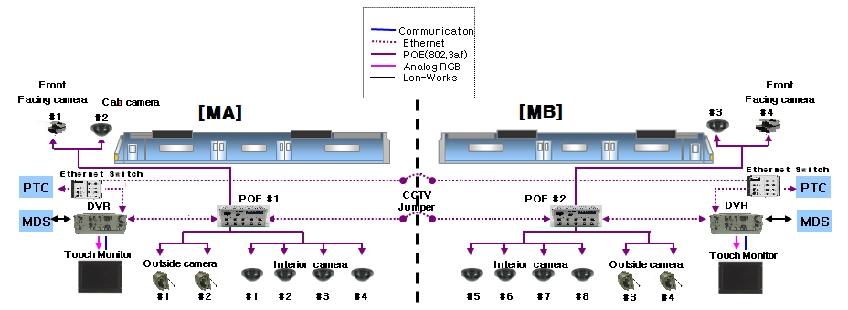
.

Pantograph and High Voltage Apparatus.

Propulsion System.

Friction Brake and Pneumatic System.

Event Recorder System
The Event Recorder System (hereafter “ERS”) obtains the majority of its signals from individual inputs and transducers dedicated for use by the ERS. The ERS receives its data from analog transducers, frequency input counters, digital inputs. Data is then transmitted on a frame-basis to external data storage equipment. The following diagram illustrates the relationship between these two systems and the various signal sources collected by the ERS’s functional blocks.
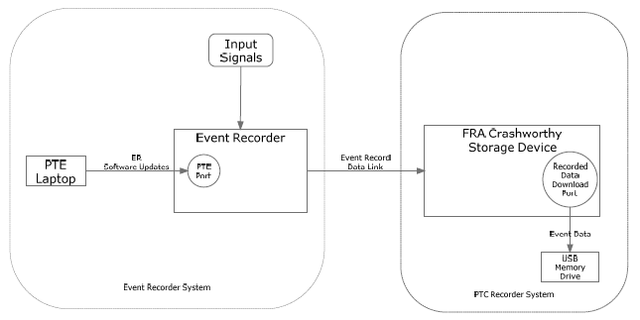

Trucks.

Cab Signal and Automatic Train Control (CS/ATC).

Diagnostic Test Equipment.

Car Keys.

CIRCUIT BREAKER PANELS.

CAB CONTROLS AND INDICATORS.

Desk Console Control Panel.

HEADLIGHT Switch.

CAB SIGNAL ACKNOWLEDGE Switch.

HORN Lever Switch.

Master Controller.

CAB CONTROL KEY Switch.

Master Controller Handle.

Deadman.

Brake Control Handle Unit.

Left Console Control Panel.

Right Console Control Panel.

Duplex Air Gauge.

Upper Left Control Panel.

Upper Right Control Panel.

Overhead Control Panel.

Right Windshield Control Panel.

Communication System Controls.

Driver PA Operation Box.
The Driver PA Operation Box (DPO) (see Figure 1-1) is the main intercom control unit that is installed in each cab and provides the engineer with audio communication capability to multiple devices. These devices include the driver's PA Operation boxes (CPO), PEIs, and the ability to deliver public announcements via either or both the internal and external speakers. By depressing any one of the 5 intercom "Push to Talk" buttons, the output signal of the cab microphone is routed to the specified output device(s) via the appropriate PA audio car wiring and the trainlines. All Intercom "Push to Talk" buttons are backlit during passive operation and are brightened when activated. The brightness of the buttons is controlled via PWM circuitry which manages all device lights in the Cab with a single control.
The features of the DPO also includes a speaker volume control knob which provides a level range adjustment from 10% to 100% of the amplifier output, a communication BUZZER pushbutton, and a CANCEL button for deactivating passenger emergency intercom calls. The DPO also includes an internal microphone which automatically becomes engaged in the event that the external Engineer's Microphone, Gooseneck, or Lapel microphone is unplugged or damaged.

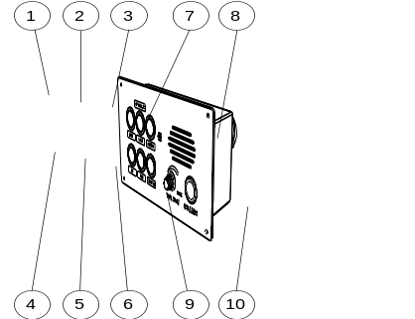
1
2
3
4
5
10
9
8
7
6
Figure 1-1. Driver PA Operation Box
Driver PA Operation Box – Controls
1 | Interior Speaker PTT (INT) Button | Initiates manual PA announcements to the interior (passenger seating area) speakers of the train
2 | Exterior Speaker (EXT) PTT Button | Initiates manual PA announcements to the exterior speakers of the train.
3 | BOTH (INT/EXT) Speaker PTT Button | Initiates manual PA announcements to both the interior (passenger seating area) and exterior speakers of the train.
4 | Microphone | Internal condenser microphone
5 | Intercom Speaker | This speaker is used for all intercom communications.
6 | BUZZER Pushbutton | Cancels all communications on the IC and PEI trainlines.

Driver PA Operation Box – Controls
7 | VOLUME Control Knob | Used to adjust the volume of the intercom speaker.
8 | CANCEL Button | Sounds the communication buzzer throughout the train consist.
9 | PEI Button | Answers PAI calls initiated by the PEI.
10 | IC Button | Initiates and answers intercom communication calls. Calls can be answered by any other active CPO or DPO throughout the train.

Communication Control Panel.
The CCP (see Figure 1-2) is installed in each cab to provide the engineer an interface for controlling functionality and monitoring of the entire communications system within the train. A built-in LCD touch screen allows the engineer to view a summary of all specified train diagnostic, vehicle location, schedule adherence, communications, passenger emergency, and other pertinent information.

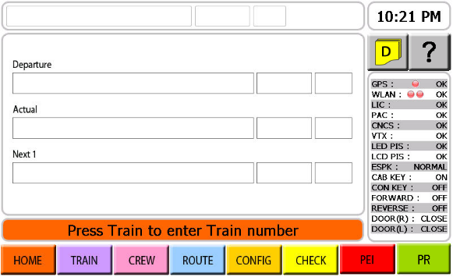
9
10
1
7
6
8
4
3
5
2
11
12
14
13
Figure 1-2. Example of CCP GUI Screen
Communication Control Panel – Controls
1 | HOME | Navigates the CCP graphic user interface (GUI) to the home diagnostic screen. This screen provides for train operational status such as train number, time, route (departure, actual & next station), device status and incoming form "D" messages.
2 | TRAIN | Navigates the CCP GUI to the train number entry screen. This screen allows the user to enter the TRAIN NUMBER.
3 | CREW | Navigates the CCP GUI to the crew ID entry screen. This screen allows the user to enter a CREW ID#.
4 | ROUTE | Navigates the CCP GUI to the detailed route editing screen. This screen allows the user to change the attributes for each station in the current route by the use of 4 buttons including: STOP, SKIP, EXPRESS, and LOCAL.
Communication Control Panel – Controls
5 | CONFIG | Navigates the CCP GUI to the system configuration sub- menu screen. This screen allows the user to configure attributes of the communication system including: SPEAKER VOLUME, LCD DIMMER, and SYSTEM RESET.
6 | CHECK | Navigates the CCP GUI to the detailed system status screen which allows the user to check the status of all RS-485 devices throughout the train.
7 | PEI | Navigates the CCP GUI to the active PEI call screen. This allows the user to see where in the train, an active PEI call was initiated from. Both Car# and PEI box ID are provided.
8 | PR | Navigates the CCP GUI to the Public Relations message screen. This screen provides the listing of selectable public relations messages pre-programmed to the system.

Communication Control Panel – Controls
9 | ? (HELP) | Navigates the CCP GUI to the navigation buttons sub-menu help screen. This sub-menu describes what each of the navigation buttons allows the user to do.
9 | Form "D" Message | Navigates the CCP GUI to the detailed form "D" print list. This screen provides for detail form "D" message information such as time/date stamp and print status. This screen also allows the user to reprint or clear a form "D" message from the active list.
10 | Operational Info | Provides communication system device status and operating parameters display information.

Communication Control Panel – Controls
11 | Operational Info | Destination & train number display line
12 | Operational Info | Time display line
13 | Operational Info | Schedule adherence display line
14 | Operational Info | System alerts & message display line

Passenger Emergency Intercom (PEI).

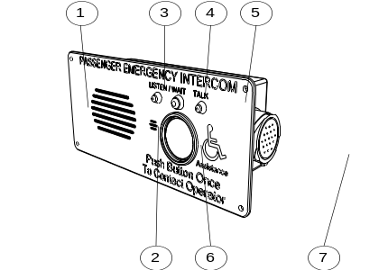
1
2
3
4
7
6
5
Figure 1-3. Passenger Emergency Intercom
Passenger Emergency Intercom – Controls & Indicators
1 | Intercom Speaker | This speaker is used for all intercom communications.
2 | Microphone | Internal condenser microphone.
3 | LISTEN / WAIT  LED Indicator | When the LISTEN/WAIT indicator is illuminated when the passenger should be either waiting for the PEI Call to be answered or when the PEI is receiving voice communication from the crew via the intercom speaker.
4 | POWER LED Indicator | When the POWER indicator is illuminated the PEI is receiving power.
5 | TALK LED Indicator | When the TALK indicator is illuminated, the passenger is able to talk to the crew via the microphone.
Passenger Emergency Intercom – Controls & Indicators
6 | PEI Call Button | When passenger requests help by pressing PEI call button, a signal is transmitted to communication Rack. The activated signal triggers Automated announce unit in communication Rack to broadcast a voice file combined with pre-recorded announcement and car number sound.
7 | Wiring Connector | Interior wiring connection that is not accessible to passengers.

Aspect Display Unit.

Right Door Control Panel.

Backwall Control Panel.

Door Zoning Control.

ENGINEER'S SEAT.

OTHER DOOR CONTROL SWITCHES.

FIRE EXTINGUISHER AND PRY-BAR.

PANTOGRAPH PUMP.

PANTOGRAPH POLE.

