THE DRAWING(S) AND THE INFORMATION CONTAINED HEREIN ARE THE PROPERTY OF WOOJIN INDUSTRIAL SYSTEMS CO., LTD. THEY SHALL NOT BE DISCLOSED, REPRODUCED OR USED, IN ANY MANNER WITHOUT THE PRIOR WRITTEN CONSENT OF WOOJIN INDUSTRIAL SYSTEMS CO., LTD. |  | DENVER RTD EAGLE P3  Communication System  Software Project Management Plan  (SPMP)
DISTRIBUTION |  | R  E  V  I  S  I  O  N
 |  | R  E  V  I  S  I  O  N | No. | ISSUED  DATE |  | REVISION NOTE |  |  | DESIGNED | CHECKED | APPROVED | REVIEWED
 |  |  |  |  |  |  |  |  | ENGINEERING |  |  | PM
 |  | PM |  |  | REVIEWED |  | E.K. LEE |  | CUSTOMER :
 |  | ENGINEERING |  |  | APPROVED |  | B.J. JONE |  | HYUNDAI ROTEM COMPANY
 |  |  |  |  | CHECKED |  | D.S. JANG
 |  |  |  |  | DESIGNED |  | J.Y. LEE |  | PROJECT :
 |  | ISSUED DATE |  |  | July 27, 2011 |  |  |  | COMMUNICATION SYSTEM FOR DENVER RTD EAGLE P3 PROJECT
 |  | ISSUED BY |  |  | R & D CENTER
 |  | PROJECT NO. |  |  | P2011-020
 |  | ORDER NO. |  |  | P110701149 |  |  |  | 
 |  | DOCUMENT NO. |  |  |  |  |  | REVISION
 |  | WJ-RTD-COMM-SPMP-V1.0 |  |  |  |  |  | 0
TOTAL |  |  |  |  |  |  |  | 0
Revision History
Revision  History | Page | History |  | Revision  Date
Revision  History | Page | From | To | Revision  Date
0 | All | First Issued |  | 07. 27, 2011

Table of Contents

1 Introduction 5
1.1 Project Overview 5
1.2 Project Deliverables 6
1.3 Document Overview 7
1.4 Acronyms and Definitions 8
1.5 Schedule and Evolution of SPMP 9
１.5.1 Schedule 9
１.5.2 Evolution of SPMP 9
2 Reference 10
3 Project Organization 11
3.1 Organizational roles and Responsibilities 11
3.2 Internal Structure 11
3.3 Process Model 12
3.4 Organizational Structure 12
3.5 Project Responsibilities 13
4 Managerial Process 14
4.1 Management Objectives and Priorities 14
4.2 Risk Management 14
4.3 Monitoring and Controlling Mechanism 15
4.4 Staffing Plan 16
5 Technical Process 17
5.1 Tools, Techniques and Methods 17
5.2 Software Documentation 17
5.3 Project Support Functions 17
5.3.1 Configuration Management Plan 17
5.3.2 Quality Assurance Plan 17
5.3.3 Documentation Plan 18
5.3.4 Deployment Plan 18
5.3.5 Review Plan 18
5.3.6 Verification and Validation Plan 18
5.3.7 Subcontractor Management Plan 18
5.3.8 Problem Resolution Plan 18
5.3.9 Process Improvement Plan 18
6 Additional Plans 19

Introduction

Project Overview
This is the Software Project Management Plan(SPMP) for the Denver RTD project. The SPMP is used by the Project Manager(PM) to guide the project and to come to an agreement with the customer about planning. The PM uses the SPMP to organize the project in different phase, i.e. to arrange the team and their task and to set deadlines. This document is related to [SQAP], which describes all phase of the project.

The Denver RTD PM assumes responsibility for this document and updates it as required to meet of the project. Updates to this document are performed in accordance with the configuration management process defined within this document, reviewed and concurred by applicable team members listed in the signature page of this document.

The objectives of the project are as follows:
- Complete the project by the project due date
- Provide all deliverables identified in section 1.2 by the project due date.

Project Deliverables
All of the items listed in this subsection are the deliverables requested by project manager that are to be provided prior to completion of the project.

The deliverables of the project are as follows:
- Software Project Management Plan. (SPMP)
Outlines the project and people involved and details the processes and guidelines to be followed throughout the duration of the project.
- Software Requirements Specifications. (SRS)
Details what is required of the system by the Client. Will contain both functional and non-functional requirements, ranked as core or optional.
- Software Design Document. (SDD)
Contains an in-depth design of the software, including use-case, collaboration, sequence and class diagrams.
- Software Test Plan (STP)
Details the types of tests to be carried out on the system to ensure the system meets requirements and maintains integrity.
- User Manual
Details how the system runs and instructs the user in how to install and use the product.

Deliverable | Description | Deadline
SPMP | Software Project Management Plan | June 30th , 2011
SRS | Software Requirement Specification | July 31st, 2011
*Revised SRTM
SDD | Software Design Description | August 31st, 2011
*Revised SRTM
STP  *Revised SRTM | Software Test Plan | December 30th, 2011

- Major Milestone
- 2011.05.01: Project Beginning
- 2011.07.31: Requirements Complete
- 2011.08.31: Design Complete
- 2011.12.31: Product Complete
- 2012.02.28: Test Complete
- 2012.03.01: Maintenance Beginning

Document Overview
This plan is organized as follows:

- Section 1: Introduction
This section provides an overview of the scope and objectives of the project, project's assumptions and constraints, deliverables, schedule and evolution of the plan.

- Section 2: References
This section provides a list of documents, standards, policies, templates, processes, and other material referenced within this plan.

- Section 3: Project Organization
This section identifies interfaces to organizational entities external to the project, describes the project's internal organization structure, and defines roles and responsibilities for the project.

- Section 4: Management Process
This section specifies the project management processes for the project; i.e., planning, measurement, tracking, reporting, risk control mechanisms, and project initiation and closeout procedures.

- Section 5: Technical Process
This section specifies the development process model, the technical methods, tools, and techniques to be used to develop the various work products, plans for establishing and maintaining the project infrastructure, and the product acceptance.

- Section 6: Addition Plans
This section contains additional plans required to satisfy product requirements, safety requirements, privacy and security requirements, as well as any other plans.

Acronyms and Definitions

The abbreviations, acronyms and terminologies used throughout this document are listed below:

Term | Definition
ICD | Interface Control Document
IEEE | Electrical and Electronics Engineers
Milestone | A scheduled event used to measure progress. Examples of major milestones for software projects may include an acquirer or managerial sign-off, base lining of a specification, completion of system integration and product delivery.
MS | Microsoft
PM | Project Manager
QA | Quality Assurance
QAM | Quality Assurance Manager
SDD | Software Design Description
SPMP | Software Project Management Plan
SRS | Software Requirements Specification
STP | Software Test Plan
STPr | Software Test Plan Procedure
STR | Software Test Report
SRTM | Software Requirement Traceability management
SVVR | Software Verification and Validation Plan
SQAP | Software Quality Assurance Plan
SCMP | Software Configuration Management Plan
SVVP | Software Verification and Validation Plan
SVD | Software Version Description Document
TBD | To be determined

Schedule and Evolution of SPMP

Schedule

The schedule is prepared according to three criteria. First one is the deadlines of deliverables which is given by the senior project committee. The other one is the weekly course schedule of the team members. The last criteria is the weekly meeting time with the supervisor. We will follow this schedule as long as there are no unexpected things. The team members will work on project according to this schedule and the system, the projects will be ready on time. Maybe there will be postpones in the deadlines of the reports also this will be a chance from the aspects of the team members.

Evolution of SPMP

During the application of the steps of the project, there may be some changes. According to the supervisor and the team members and may be from the external persons aspect, extra information can be added and the SPMP versions can be updated. Therefore, SPMP is also may change according to probable changes.

The Software Project Management Plan (SPMP) describes the planning of the project in
detail. It is an evolutionary document that is updated in each work package of the project The updated SPMP is a milestone of every work package.

Reference
The standards and documents listed below are referenced in this document:

- IEEE Std 1058-1998, IEEE Standard for Software Project Management Plans
- SCMP: Software Configuration Management Plan
- SVVP: Software Verification and Validation Plan
- SQAP: Software Quality Assurance Plan
- General Technical Description

Project Organization

Organizational roles and Responsibilities

The organizational structure is depicted in Figure 1.

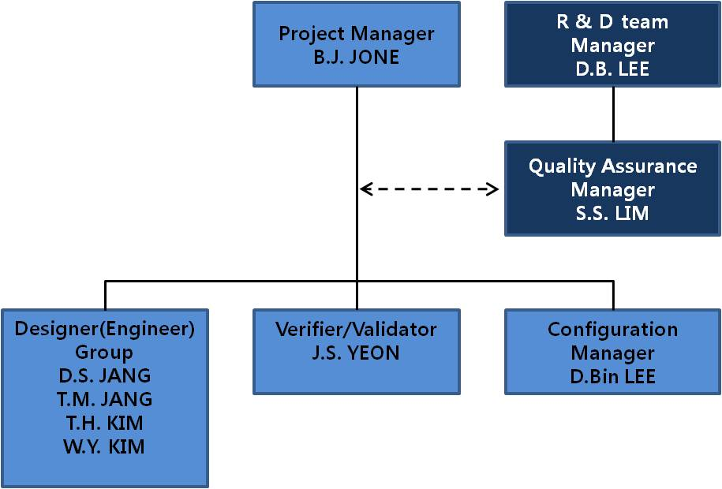
Figure 1. Organization

Internal Structure
Internal structure is the structure that explains the internal factors of the project. It also uses to show that what are the organizational interfaces between the project and organizational entities. In our project, we grouped internal structures as Project Manager, Quality Assurance Manager, Designer group( SW Developer, SW Designer and DB Manager), Configuration Manager and Risk Manager.

Team members are responsible for each step of their project. Every member of the team has different roles during the project work plan. Project group leader is both responsible for team members and communication with supervisor. Group members must be open for new ideas about the project. When the members of the project team faced with difficult situation, they should make critical decisions about the project.
The group will meet weekly after class on Mondays. Email will be used for all communication outside of class. Additional meetings and work sessions will be scheduled during the Monday meetings or through email as necessary.

Process Model
The process model used for the RTD project is the waterfall model. We use the so-called V-model:
The purpose of the initial development is to produce the following the following software artifacts:

- A complete project plans ( → SPMP & STP).
- Requirements specification for the overall system framework → SRS).
- Overall system architectural and high-level component designs ( → SDD).
- Test cases, procedures, and results for the framework ( → STPr & STR).

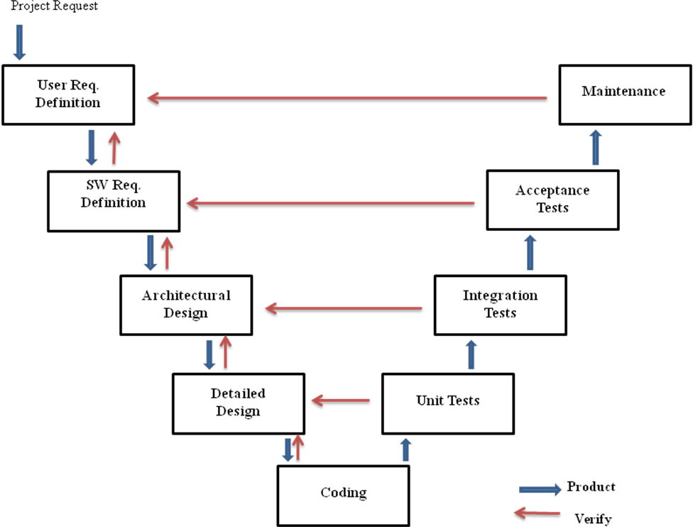

Organizational Structure
In the following table, the roles which are distinguished and the person(s) assigned to each role are given. Roles within the group are described in section 3.5.

Project Responsibilities

Role | Description
Project  Manager | Produce and maintain a project management plan and lead the project according to this plan thus ensuring that the product is delivered on time. The PM’s management task includes but is not limited to:  - Motivating team members;  - Forming teams and assigning tasks;  - Checking progress;  - Control Risk Management  - Defining work packages and goals;
Team Leader | Perform all necessary activities to ensure that a task assigned to a team is performed well and on time. This includes but is not limited to:  - Providing feedback about team progress to the PM;  - Chairing reviews of the items made by his team.  - Track status of committed assignments  - Check on change and issue tracking activity  - Check that team members have submitted the required project data
Quality Assurance Manager | Guarantee that the product will be delivered as agreed and that it is of good quality. This includes but is not limited to:  - Writing the SQAP and the SVVP;  - Verifying that procedures and standards which are defined in the SQAP and SVVP are adhered to;  - Checking that all project documents are consistent;  - Monitoring and reviewing all testing activities.
Engineer Group  Team Members | Perform all necessary activities to ensure that a task assigned to a team is performed well and on time. This includes but is not limited to:  - Assisting the Team Leader or Project Manager by signaling problems in an early stage;  - Executing plans made by the Team Leader and by the Project Manager;  - Keeping track of time spent on various tasks;  - Following procedures and plans.
Verifier/Validator | - Verification and Validation activities of the project work products  - Author and maintain test plan and test report  - Control test records and track defects
Configuration  Manager | Perform version management for documents and code. This includes but is not limited to:  - Writing the SCMP;  - Creating a repository for all documents and code;  - Checking that the repository is used appropriate by all team members;  - Maintaining the repository according to the SCMP.

Managerial Process

Management Objectives and Priorities

The management objective is to deliver the product in time and of high quality. The PM and QAM work together to achieve this by respectively checking that progress is made as planned and monitoring the quality of the product at various stages.

Risk Management

Risks will be managed through a list or spreadsheet to be developed by the Project Manager. The top few risks will be reviewed at each team meeting. This list will be maintained and updated by the PM on as necessary. When we started to establishing this project, we took in to consideration about the disadvantages and risks of establishing this project. Therefore, we will give a brief description and brief information about these risks and the probability of risks.

- Miscommunication
Sometimes the team members cannot connect with each other. For example, their schedules can be different from each other. Because of this reason their available hours could not correspond with each other. Also, the mobiles phones can run out of batteries and prepaid. Therefore, these issues will ruin the connection of the team. The mitigations are discussed below.

To avoid the losing connection, we collected schedules from each team member. After that, we decided available times according to these schedules. In addition, all team members have e-mail addresses, so we can leave messages when they were not at computer. On the other hand, we are forcing everyone to have an active mobile phone and, they should keep these phones on at any cost. Also, we are organizing meetings at the end of each week and, we were sharing news.

- Absence of Members
Absence of members is a huge risk for any project which is developing. Because , it decreases the work rate of the team members. The other team members have to split the missing one’s parts because of his absence. Therefore, this situation ruins the improvement of project. In addition, this risk may appear because of health problems.

To avoid this situation, team members should support each other and, they should work as a team. Every people should remember, they have responsibility for others and this project. On the other hand, when an unexpected situation occurs like health problems, remaining team members will share the missing parts of the project in order to complete at due time.

- Deadline Expiration
Deadline Expiration risk states the case of not catching up with the deadlines which are stated before.

To avoid this situation, team members should perform meetings constantly. With those weekly constant meetings, team members can find out how far they are away from the deadlines. Therefore, team can perform some overtime work if necessary.

- Design Errors
The design should be reviewed very critically. The advisor should be consulted frequency on his opinion about the feasibility and the correctness of certain design decisions.

To avoid this situation, when errors in the design are noticed the advisor should be consulted to help correct the design errors as soon as possible. Also all the work, that depends on the faulty design, should be until error is corrected.

Monitoring and Controlling Mechanism
The monitoring of progress is done by the PM using the following means:

- Weekly Project Group Meetings
The project group meetings take place in the project room. Project group meetings usually take place on Monday 9:00 am, although this time may be subject to change, e-mails will be send about the time if it changes. These meetings are meant to inform each other of the progress made on various tasks. New tasks are assigned by the PM on these meetings. Before the meeting, all members read minutes of previous meeting. The PM takes care of the agenda and presides the meeting.

- Team leader meetings
Whenever the PM or QAM finds it necessary he can arrange a team leader meeting. Team leader meetings are rather informal and infrequent and the tasks required for one depend on the purpose of the meeting.

Staffing Plan
The following table contains contact information about the members of the RTD project group:

Name | Email | Function
B.J.JONE | bjjone@wjis.co.kr | PM
D.B.LEE | delee@wjis.co.kr | QAM (supervisor)
S.S.LIM | sslim@wjis.co.kr | QAM
J.S.YEON | jsyeone@wjis.co.kr | VERIFIER/VALIDATOR
D.Bin.LEE | fedor@wjis.co.kr | CM
D.S.JANG | dsjang@wjis.co.kr | TEAM MEMBERs
T.H.KIM | thkim@wjis.co.kr
W.Y.KIM | wykim@wjis.co.kr

Technical Process

Tools, Techniques and Methods
The methods, tools and techniques used during the course of the project are listed in the [SCMP].

This subsection should also describe any tools (compilers, CASE tools, project management tools), any techniques (reviews, walk-through, inspections, prototyping) and the methods (Object-oriented design, rapid prototyping) to be used during the project.

Software Documentation
During the project, documents should conform to a number of aspects:

Documents must be of good quality.
The standards all documents are required to meet are documented in the [SCMP] with respect to style and in [SQAP] with respect to content.
Documents must be reviewed.
The manner in which document reviews are performed is described in the [SVVP].

Project Support Functions
Besides Project Management, three other management functions are present. Below a short description of each of them is given.

Configuration Management Plan
In software project, needs and requirements of customer or supervisor is changed. This is inevitable, so that the new version of the documentation will be arranged as follows:
- The first version of the document defined as:
Document Name V1.0, such as SPMP V1.0
- If the minor revision done, the document defined as:
Document Name V1.1 such as SPMP V1.1
- If the major revision is done, the document defined as:
Document Name V2.0, such as SPMPV2.0
The purpose of software configuration management is to plan, organize, control and coordinate the identification, storage and change of software through development and transfer. The CM writes the SCMP in which plans are outlined for performing these tasks.

Quality Assurance Plan
In order to create high quality product, the team members will join all meeting about the project. Meeting will held on a weekly. Documentation will be composed according to IEEE Standards.
The QAM outlines plans and procedures needed for performing this task in the SQAP.

Documentation Plan
In this project, documentation will be composed according to the IEEE Standards. Each deliverables will be reviewed by quality group and the customer.

Deployment Plan
If the project will be resulted that is hoped, after completing the product, it will be presented to related companies. Moreover, the product will be planed to participate in the competition. So, the product will be presented to more related people and companies.

Review Plan
There shall be 3 reviews scheduled at which points certain phases (SPMP, SRS and SDD) must be completed. At each phase, two types of review shall be accomplished.
After the completion of the derivable of each phase, the Developer Team conducts first review internally.

Our team will check for the completeness of all requirements that includes documents and products requirements as second review under control of the supervisor. For checking the requirements match up with the product requirements, traceability is also used, so the risk factor of an incomplete product will decrease.

Verification and Validation Plan
A Verification and Validation Plan as a part of the Software Quality Assurance and Verification & Validation Plan will be developed following recommended departmental standards.

All modules will be tested individually during and again after they are coded using boundary value testing to insure correct results are returned.
Software Verification and Validation activities check the software against its specifications. The QA team writes the SVVP. In this document the verification and validation activities are described.

Subcontractor Management Plan
None

Problem Resolution Plan
None, problems would be resolved informally between the developer, the advisor.

Process Improvement Plan
None

Additional Plans
There are no other addition plans.

