THE DRAWING(S) AND THE INFORMATION CONTAINED HEREIN ARE THE PROPERTY OF WOOJIN INDUSTRIAL SYSTEMS CO., LTD. THEY SHALL NOT BE DISCLOSED, REPRODUCED OR USED, IN ANY MANNER WITHOUT THE PRIOR WRITTEN CONSENT OF WOOJIN INDUSTRIAL SYSTEMS CO., LTD. |  | DENVER RTD EAGLE P3  Communication System  Software Quality Assurance Plan  (SQAP)
DISTRIBUTION |  | R  E  V  I  S  I  O  N
 |  | R  E  V  I  S  I  O  N | No. | ISSUED  DATE |  | REVISION NOTE |  |  | DESIGNED | CHECKED | APPROVED | REVIEWED
 |  |  |  |  |  |  |  |  | ENGINEERING |  |  | PM
 |  | PM |  |  | REVIEWED |  | E.K. LEE |  | CUSTOMER :
 |  | ENGINEERING |  |  | APPROVED |  | B.J. JONE |  | HYUNDAI ROTEM COMPANY
 |  |  |  |  | CHECKED |  | D.S. JANG
 |  |  |  |  | DESIGNED |  | D.B. LEE |  | PROJECT :
 |  | ISSUED DATE |  |  | June 14, 2011 |  |  |  | COMMUNICATION SYSTEM FOR DENVER RTD EAGLE P3 PROJECT
 |  | ISSUED BY |  |  | R & D CENTER
 |  | PROJECT NO. |  |  | P2011-020
 |  | ORDER NO. |  |  | P110701149 |  |  |  | 
 |  | DOCUMENT NO. |  |  |  |  |  | REVISION
 |  | WJ-RTD-COMM-SQAP-V1.0 |  |  |  |  |  | 0
TOTAL |  |  |  |  |  |  |  | 0
Revision History
Revision  History | Page | History |  | Revision  Date
Revision  History | Page | From | To | Revision  Date
0 | All | First Issued |  | 06. 14, 2011

Table of Contents

1 Purpose 4
2 Reference 4
3 Management 5
3.1 Organization 5
3.2 Organization Tasks 6
3.3 Reporting Relationship 6
3.4 Software Development Lifecycle Phases, Tasks and Deliverables 7
3.5 Master Schedule 11
3.6 Quality Assurance Activities 11
3.7 Documents Control and Revisions 12
4 Standard and Procedure 13
4.1 Documentation Standard 13
4.2 Coding Standard 13
4.3 Software Design Standard 13
5 Software Review 14
5.1 Technical Review 14
5.2 Software Project and Process Audits 14
6 Problem Reporting and Corrective Action 14
6.1 Problem Reporting 14
6.2 Corrective Action 14
7 Tools 15
8 Configuration Item 15
9 Media Control 16
10 Supplier Control 16
11 Quality Records 16
12 Training 17
13 Risk Management 18
13.1 Risk Identification Criteria 18
13.2 Risk Assessment 18
13.3 Risk Mitigation 18
13.4 Risk Management Procedure Document 18
14 Glossary 19

Purpose
This Software Quality Assurance Plan (here-in-after called as “SQAP”) collects and presents the results of the Software Quality Assurance (SQA) planning activities for the Woojin Industrial Systems Communication System installed in the EMUs supplied to the Denver RTD (Regional Transportation District) by Hyundai-Rotem.

In organizational aspect, this SQAP shall be applied to Quality Assurance Manager, Configuration Manager, SW Project Manager, SW Designer, Verifier and Validator. Refer to 3.1 and 3.2 for the organizational and reporting structure.

This SQAP shall be applied to software development team and the QA team of PA.
This SQAP shall be applied to overall software development lifecycle phases.

Reference
- IEEE 730 IEEE Standard for Software Quality Assurance Plans for SW Planning
- Project Planning Process (PP-PD-001-V1.0)
- Project Monitoring and Control Process (PMC-PD-00-V1.0)
- Quality Assurance Process

Management

Organization
The project-specific SQA organizational chart includes members of the software group at each level, as shown in Figure 1.

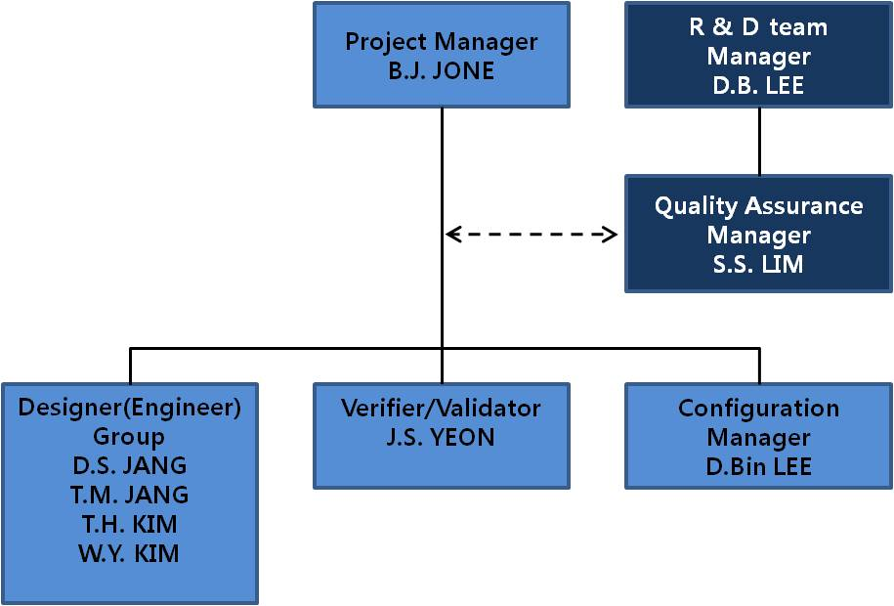
Figure 1. Organization

Organization Tasks
Role | Description
Project  Manager | - Responsible for the overall control of project (progress, risks and issues)  - Planning and maintenance of project plan  - Review and approve project QA plan, and Configuration Management Plan  - Reports project status to the senior manager
R&D Development Manager | - Designated QAM for project.  - Review and approve propriety of SQA Plan.  - Approved SW QA audit and report result.  - Reports QA audit report to the executive.
Quality Assurance Manager | - SW QA planning and maintenance  - Support preparation of SW process definition and review  - SW QA audit and report results  - Verify corrective action of SW QA audit findings  - Collect, analyze and report SW quality objective related data  - Monitoring review and test activities
Engineer Group | - Cannot be verifier/validator  - Analyze requirements specification, design and develop SW  - Development activity according to the SQA plan
Verifier/Validator | - Verification and Validation activities of the project work products  - Author and maintain test plan and test report  - Control test records and track defects
Configuration  Manager | - Establish and maintain SW CM Plan and support SW builds  - Perform SW configuration management activity and keep records  - Perform SW configuration audit and manage corrective actions  - Evaluates the change impact of the requirements changes

Reporting Relationship
Engineer Group, Verifier, Validator and Configuration Manager report the project related issues and problems to the SW Project Manager.
SW Project Manager and Quality Assurance Manager report that issues to the senior Manager.

Software Development Lifecycle Phases, Tasks and Deliverables
Phase | Task | INPUT | OUPUT | Deliverable  (Rotem Submit)
Planning | - Understand environment and structure which system is going to be arranged  - Plan understanding and aim of task problem  - Review System Requirements and Safety Requirements  - Analyze TS and SRS, Plan Software development considering business requirement | - Procurement Technical Specification for Denver RTD EMU Communication System | - SQAP  - SCMP  - SVVP  - SPMP  - SVVR | - SQAP  - SCMP  - SPMP  - SVVP  - SVVR
Requirements  Analysis | - Define SRS based on System requirement and safety requirement, System architecture  - Understand software function which meets system requirement(safety/unsafe function)  - Define connection with boundary and other system  - Review limitation of SW and HW | - Procurement Technical Specification for Denver RTD EMU Communication System | - SRS  - SRTM  - SVVR Revision  - Interface Control Document  - SFD | - SRS  - SRTM  - SVVR Revision  - Interface Control Document  - SFD
Design | - Design Software architecture based on system and software requirement and safety requirement  - Software architecture in detail suitable for software safety integration level considering function of Software requirement  - Higher level software design will be realized by data flow diagram and mini specification and program leaded from these.  - Lower level software design includes Module specification on software module algorism, I/O parameter, high/low module interface | - Procurement Technical Specification for Denver RTD EMU Communication System  - SRS | - SDD  - SRTM Revision  - SVVR Revision | - SDD  - SRTM Revision  - SVVR Revision
Implementation | - Realize software based on SRS  - Application of Coding Standard | - SRS  - SDD | - SW Source Code and Program  - SRTM Revision | - SW Source Program  - SRTM Revision
System Integration Test | - Implement system integration test based on SRS  - Implement equal division, boundary value test and interface test to assure compatibility of module | - SRS  - SDD  - SW Source Code and Program | - System Test Plan  - System Integration Procedure/ Report  - SRTM Revision | - System Test Plan  - System Integration Procedure/ Report  - SRTM Revision
Type Test | - Implement type test with the software module which has finished system integration test  - Implement regression test when integration problem occurs by I/O between modules (Not an algorism in module) | - SRS  - SDD  - SW Source Code and Program | - Type Test Procedure/ Report  - SVVR Revision  - SRTM Revision | - Type test Procedure/ Report  - SVVR Revision  - SRTM Revision
Complete Car Test | - Implement complete car test after type test  - Implement regression test when integration problem occurs by I/O between SW and HW | - SRS  - SDD  - SW Source Code and Program | - Complete Car Test Procedure/ Report  - SVVR Revision  - SRTM Revision | - Complete Car Test Procedure/ Report  - SVVR Revision  - SRTM Revision
Main Line Test | - Validate HW and SW integrated system in view of software  - Review validity with design and SRS through detailed demonstration  - Review validity of Software product function | - SRS  - SDD  - SW Source Code and Program | - Main Line Test Procedure/ Report  - SVVR Revision  - SRTM Revision | - Main Line Test Procedure/ Report  - SVVR Revision  - SRTM Revision
Maintenance | - Release package preparation review and release  - Determine release package name by requirement | - SW Program  - TS and Problem Report  - Change Assessment Request Form (SCI) | - Maintenance Manual  - User Manual  - Release Package  - Changed SW  (When requested)  - SW Version Description Document | - Maintenance Manual  - User Manual  - SW Version Description Document

Master Schedule
Phase | Beginning | Complete | 2011 |  |  |  |  |  |  |  | 2012
Phase | Beginning | Complete | 5 | 6 | 7 | 8 | 9 | 10 | 11 | 12 | 1 | 2 | 3
Plan | 11/05/01 | 11/06/15
Requirements | 11/06/16 | 11/07/31
Design | 11/08/01 | 11/08/31
Implementation | 11/09/01 | 11/12/31
Test | 12/01/01 | 12/02/28
Maintenance | 12/03/01
- Major Milestone
- 2011.05.01: Project Beginning
- 2011.07.31: Requirements Complete
- 2011.08.31: Design Complete
- 2011.12.31: Product Complete
- 2012.02.28: Test Complete
- 2012.03.01: Maintenance Beginning

Quality Assurance Activities
Quality Assurance Audit implements Quality Assurance Activity in the end of major Design phase by separate and independent person in development group.

Phase | Check items | Responsibility
Planning | - Check compliance to the organizational policy and standard process  - Check compliance to the customer requirements  - Check adequacy of project plan, procedure and standards,  - Check work products from Planning phase | -Project Manager  -Quality Assurance Manager
Requirements | - identify nonconformities and confirm corrective actions  - Check the implementation of contracted items  - Check the work products at the each end of the phase | -Quality Assurance Manager  -Verifier and Validator
Design |  | -Quality Assurance Manager  -Verifier
Implementation | - identify nonconformities and confirm corrective actions  - Check implementation of contracted items  - Check readiness of future operation  - Check work products at the ends of the phase | -Quality Assurance Manager  -Verifier and Validator
Test |  | -Quality Assurance Manager  -Verifier and Validator
Maintenance | - Check relevant work products  - Check project quality control activities  - identify various project risks | -Project Manager  -Quality Assurance Manager

Documents Control and Revisions
All documents belong to configuration items shall be maintained in configuration management server. The configuration management server shall retain the master document and configuration manager has sole access for changes
- The initial draft of documents shall be submitted to the affected departments for comments. All comments received shall be incorporated into the document or discussed until a resolution is reached.
- The final draft shall be submitted to the Executive Office for review, revisions, and final signature.
- The final signed document shall be dated and placed on the server for distribution. The Configuration Management process shall be utilized for document revisions.
- Documents shall be reviewed periodically for updates as conditions changed. The Configuration Management process shall be utilized for document revisions.

Standard and Procedure
SQAP applies to quality related general work including design change, procurement, manufacture, installation, operation, test and inspection etc. related to equipment design, manufacture, repair work and complies with documentation standard and coding standard referring to ANSI/IEEE 730.

Documentation Standard
Document of each phase complies with the related standard and documentation, review, approval, revision, issue, distribution, management procedure complies with Quality Assurance Plan Procedure document.

Coding Standard
Software source code will be prepared like the followings complied with the software version management guideline (Coding standard criteria).
- File name convention
- Uses of global variables
- Uses of Macro and Constant
- Comments and Indention style

Software Design Standard
Design standard will be prepared complied with the Woojin Industrial Systems Co., Ltd. Structure Chart Guide Line and Data Flow Diagram Guide Line.

Software Review

Technical Review
Refer to SVVP. (WJ_RTD_COMM_SVVP-R1.0)

Software Project and Process Audits
The purpose of the Software Project and Process Audit is to assure whether these comply with certain project plans. (i.e. SQAP, SVVP, and SCMP etc.) Audit also may be implemented to verify Quality system procedure related to Software engineering of Woojin. Audit shall be implemented at least once during the design process. Auditor will verify actual implementation on the quality assurance system procedure and plan documents.

Problem Reporting and Corrective Action
Quality Assurance Manager measures status of Quality Assessment Activity periodically and prepares result report on Quality Assessment Activity. Quality Assurance Manager also informs to the Project Manager to understand performance result of Quality Assessment Activity for a certain period of time and to take appropriate improvement action.

Problem Reporting
When Problems occur, during project execution that shall be reported to the Development Department Manager for resolution.

Corrective Action
- Project Manager shall issue corrective action for each nonconformity found. When the nonconformity is not expected to be resolved within the project team, the project manager reports this to the Development Department Manager for problem resolution.
- When corrective action completed, the Project Manager request Quality Assurance Manager to verify the corrected status. If the nonconformity is corrected, Quality Assurance Manager shall approve the result.
- When the nonconformity is not corrected, Quality Assurance Manager shall request again the Project Manager to monitor the corrective action continuously to verify the result.

Tools
Items |  | Description | Note
 | MS Office 2003/2007 | Documentation Tool
Source  Coding | AMC Emulator v1.5 | Software Source Coding Tool
Source  Coding | AVR Studio V4 | Software Source Coding Tool
Source  Coding | Visual Studio 2008 | Software Source Coding Tool
Source  Coding | EWARM 4.42 | Software Source Coding Tool

Configuration Item
Prepared each software configuration item in component unit in detail as the following table
Item |  | Development Degree |  |  | Note
 |  | Re-use | Modify | New | Note
Software  Type | Firmware |  | O
Software  Type | Application Software |  |  | O
Software  Type | COTS (Windows) | O
Software  Type | User Interface |  |  | O

Media Control
Backup copies shall be classified as follows. They shall be managed according to the configuration management procedure.
- Newly developed SW
- Upgraded SW
- SW for maintenance
Documents and SW in development shall be backed up periodically to project server in SW development department.

Supplier Control
Not Applicable

Quality Records
Quality records shall be established and maintained to provide evidence of conformity to requirements and of the effective operation of the quality management system. Quality records shall include, but are not limited to:
- Development Related Records
- Configuration Management Records
- Test Related Records

Training
Tools and techniques which is identified to be appropriate for certain function of QA should come along with training and education and processed training in team should be performed by manual document.
Classification | Training Content | Schedule | Participation
Project Team Training | CMMI Process Training  Configuration Management  Software Quality Assurance Activity  Verification and Validation  Coding Standard Training | In 1 week after Contract | Development team
Project Team Training | Each Specifications Presentation | For 1 day after Specifications Confirmation | Development team
Project Team Training | Project Management Plan Presentation | For 1 day after Project Management Plan Approval | Development team
Project Team Training | Master Schedule Presentation | For 1 day after WBS Confirmation | Development team
Project Team Training | Deliverables Documentation Training | Frequently if necessary | Development team

Risk Management

Risk Identification Criteria
Risk shall be identified from the view point of
- Project Lifecycle Phases
- Type of SW
The degree of risk shall be determined according to the table below.
Degree | Description
H(High) | Risk that require special effort and continuous observation
M(Middle) | Risk that require development effort and observation
L(Low) | Risk that can be successfully managed later with only Minimum development effort

Risk Assessment
Identified risks shall be endowed with priorities and risk mitigation procedure shall be applied to the risks according to the sequence of priorities.

Risk Mitigation
Risk mitigation strategy shall be established to reduce or avoid the identified risks and the status of each risk shall be traced continuously. Risk status shall be classified as follows.
- Risk Identification: Risk is identified and reported
- Risk Mitigation: Risk mitigation plan is applied
- Naturally expired: Risk is naturally expired
- Risk Closed: Risk is closed by mitigation effort

Risk Management Procedure Document
Refer to the following documents for planning strategy effectively for potential danger element and hazard thing that might be occur during project management or daily work.
- RSKM-PD-001: Risk Management Process
- RSKM-FM-001: Risk Register Log

Glossary
Acronym | Description
SQAP | Software Quality Assurance Plan
SW | Software
HW | Hardware
QA | Quality Assurance
PM | Project Manager
CM | Configuration Management
SRS | Software Requirement Specification
SFD | Software Functional Description
SDD | Software Design Description
SRTM | Software Requirement Traceability Matrix
SVVP | Software Verification and Validation Plan
SCMP | Software Configuration Management Plan
SVVR | Software Verification and Validation Report
SPMP | Software Project Management Plan
SPMP | Software Project Management Plan

