THE DRAWING(S) AND THE INFORMATION CONTAINED HEREIN ARE THE PROPERTY OF WOOJIN INDUSTRIAL SYSTEMS CO., LTD. THEY SHALL NOT BE DISCLOSED, REPRODUCED OR USED, IN ANY MANNER WITHOUT THE PRIOR WRITTEN CONSENT OF WOOJIN INDUSTRIAL SYSTEMS CO., LTD. |  | DEVER RTD EAGLE P3  Communication System  Software Verification & Validation Plan  (SVVP)
DISTRIBUTION |  | R  E  V  I  S  I  O  N
 |  | R  E  V  I  S  I  O  N | No. | ISSUED  DATE |  | REVISION NOTE |  |  | DESIGNED | CHECKED | APPROVED | REVIEWED
 |  |  |  |  |  |  |  |  | ENGINEERING |  |  | PM
 |  | PM |  |  | REVIEWED |  | E.K. LEE |  | CUSTOMER :
 |  | ENGINEERING |  |  | APPROVED |  | B.J. JONE |  | HYUNDAI-ROTEM COMPANY
 |  |  |  |  | CHECKED |  | D.S. JANG
 |  |  |  |  | DESIGNED |  | D.B. LEE |  | PROJECT :
 |  | ISSUED DATE |  |  | June 14, 2011 |  |  |  | COMMUNICATION SYSTEM FOR DENVER RTD EAGLE P3 PROJECT
 |  | ISSUED BY |  |  | R & D CENTER
 |  | PROJECT NO. |  |  | P2011-020
 |  | ORDER NO. |  |  | P110701149 |  |  |  | 
 |  | DOCUMENT NO. |  |  |  |  |  | REVISION
 |  | WJ-RTD-COMM-SVVP-V1.0 |  |  |  |  |  | 0
TOTAL |  |  |  |  |  |  |  | 0
REVISION RECORD
Rev. No. | PAGE | Details |  | Date
Rev. No. | PAGE | FROM | TO | Date
0 | All | Issued |  | June 14, 2011
Table of Contents

1. Purpose 4
2. Reference Documents 4
3. Terms, Definition and Acronym 5
3.1 Terms and Definition 5
3.2 Acronym 6
4. V & V Summary 7
4.1 Organization 7
4.2 Roles and Responsibility 8
4.3 Schedule 9
4.4 Master Schedule 10
4.5 Resource Summary 11
4.6 Tools, Techniques and Methods 11
5. Software Integrity Level 11
6. V&V Processes 12
6.1 Planning 12
6.2 Requirement Aalysis 12
6.3 Design 13
6.4 Implementation 13
6.5 System Intergration Test 14
6.6 Type Test 14
6.7 Complete Car Test 15
6.8 Main Line Test 15
6.9 Release and Maintance 16
7. V&V Report, and Documentation Requirement 17
8. V&V Administrative Requirements 17
8.1 Anomaly Resolution and Reporting 17
8.2 Control Procedures 17
8.3 Standard, Practices and Conventions 17

Purpose
This software(called “SW” here after) verification and validation plan provides a specific method and procedure for the verification process to ensure that work products or products or product components from the engineering activities from the start to completion of project are in compliance with requirements, and validation process to ensure that needed function performs properly in the intended environment.

This Verification and Validation Plan applies to software requirements, software design, and software implementation phases of software development life cycle.

The audience for this document consists of the following groups and individuals:
- WOOJIN’s software engineering group, project management and software quality assurance
- Rotem and RTD representatives

Reference Documents
This document shall be used in conjunction with the following documents and publications. If the reference documents or publications are superseded by an approved revision, the most recent revision shall apply.

- IEEE STD 1012 for SW Verification and Validation
- IEEE 829 Standard for Software Test Documentation

Terms, Definition and Acronym

Terms and Definition
The definition of terms is described as follows:

Terms | Definition
Verification | Activity to ensure that work products, product or product components comply with requirements and customer is not involved generally.  Verification is an incremental process covering the whole project life cycle starting from the requirement verification, verifying the intermediate work products at the end of each phase and completing with the verification of the product completed.  “You built it right”
Validation | Activity to demonstrate that work products, products or product components are functioning in the intended environment and normally customer is involved. Validation activity uses a similar method used in verification and is sometimes done at the same time with verification using a part of same environment.  “You built the right thing”
Peer | Generally refer to the person who is not the manager of the work product author. When necessary, the manager of the author may become the peer of the work product author for the review of the work product.
Peer Review | Review activity performed by the peer of the work product author to detect defects of the work product through the whole phase of the product lifecycle. Cover informal review for which customer is not involved, and Formal Review for which customer jointly participates.
V&V personnel | Person who has responsibility and authority to establish V&V plan and to perform V&V activity.
Inspection | A kind of peer review led by the peer review leader where review meeting is held according to the pre-defined role to identify defects or work products which has been distributed in advance.  Benefit: maximize the identification of defects  Weakness: Separate amount of efforts for review planning and pre-review.
Walkthrough | A kind of peer review led by the author of the work product and review meeting is held without pre-review of work products.  Benefit: minimize the time for review.  Weakness: work product author may be biased.
Desk Check | A kind of peer review done with the least effort and this method is used for relatively non-critical products or environmental restriction is inevitable; Desk check may not be recorded.
Joint Review | A formal meeting to have approval or to invite opinion of the final user, customer and stakeholders, and formally check that H/W, S/W from the phase is equipped with the required quality.
Defect | Incompleteness or various abnormal performance related items of work products or product which prevents system or component perform the required functions.
Engineering  Manager | The manager of the Engineering department at Woojin.
Project Manager | The manager of the project as designated by management at Woojin.
QA Group | One or more representatives of the Quality department at Woojin as designated by the Quality Manager.
Software Configuration Item | An aggregation of software that is designated for configuration management and treated as a single entity in the configuration management process. The Software Configuration Item is distributed, installed, and version tracked as one item.

Acronym
Acronym used in the SW VV plan is as follows:
Acronym | contents
SW | Software
COTS | Commercial-Off-The-Shelf
SDD | Software Design Description
SRS | Software Requirements Specification
SVVP | Software Verification and Validation Plan
SVVR | Software Verification and Validation Report
V&V | Verification and Validation

V & V Summary

Organization
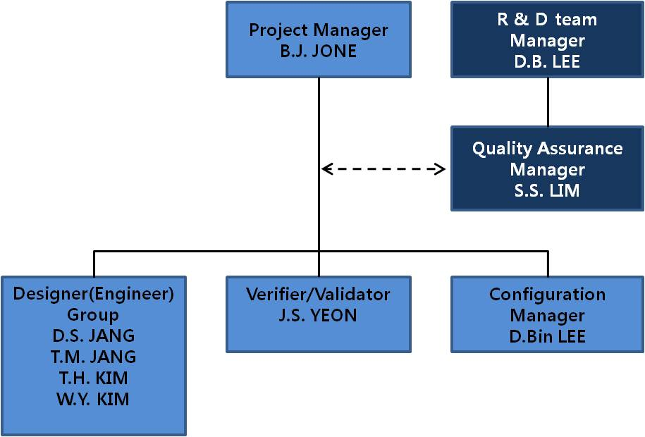

Roles and Responsibility
Role | Responsibility | Work products
Customer | - Review V&V plan  - Check V&V plan  Reported on the V&V activity results and corrective action results | Approval
Project Manager | - Establish and document V&V plan.  - Confirm the V&V activity result and report to the customer.  - Confirm the quality of V&V activities. | SVVP and SVVR, Approval
QA Manager | - Review V&V plan  - Approves V&V plan.  - Review V&V results independently from project view  - Participate in the training support and activity for the performing V&V process as needed | Approval
Verifier/Validator | - Verification and Validation activities of the project work products  - Author and maintain test plan and test report  - Control test records and track defects | SVVR
Software Engineering  Group | - Develop the configuration items by staged and request the changes of configuration items if necessary.  - Establish the changes for the configuration item.  - Perform the corrective action of nonconformance caused configuration audit results.  - Participate in the V&V activities.  - Provide work products needed for V&V activities. | SVVR

Schedule
The project software life cycle follows Woojin’s Engineering Process. Verification milestones correspond with the project milestones at the end of each development phase.

Phase | V&V Activity | Result | Schedule/ Participant
Planning | SW Planning V&V activity | Software Planning Verification and Validation Report | 2011. 6. 15  / B.J. JONE, J.S. YEON
Requirement Analysis | SW Requirement V&V activity | Software Requirements Verification and validation Report (Updated) | 2011. 7. 31  / B.J. JONE, J.S. YEON
Design | SW Design V&V activity | Software Design Verification and validation Report (Updated) | 2011. 8. 31  / B.J. JONE, J.S. YEON
Implementation | SW Implementation  V&V activity | Software Implementation Verification and Validation Report (Updated) | 2011. 12. 31  / B.J. JONE, J.S. YEON
Test | SW Test V&V activity | Software Test Verification and Validation Report (Updated) | 2012. 2. 28  / B.J. JONE, J.S. YEON
Maintenance  Release | N/A | N/A | N/A
Refer to section 6.0 for more detail information.

Master Schedule
Phase | Beginning | Complete | 2011 |  |  |  |  |  |  |  | 2012
Phase | Beginning | Complete | 5 | 6 | 7 | 8 | 9 | 10 | 11 | 12 | 1 | 2 | 3 | 4
Plan | 11/05/01 | 11/06/15
Requirements | 11/06/16 | 11/07/31
Design | 11/08/01 | 11/08/31
Implementation | 11/09/01 | 11/12/31
Test | 12/01/01 | 12/02/28
Maintenance | 12/03/01

- Major Milestone
- 2011.05.01: Project Beginning
- 2011.07.31: Requirements Complete
- 2011.08.31: Design Complete
- 2011.12.31: Product Complete
- 2012.02.28: Test Complete
- 2012.03.01: Maintenance Beginning

Resource Summary
Human resources for software verification tasks consist of members of Woojin’s Engineering Department, Management and QA Group, and Verifier/Validator
Documentation tool is Microsoft Word 2003/2007.

Software V&V Check List is based on ANS/IEEE 1012 and use for V&V activity.

Type | Contents | Comment
Efforts | Refer to 4.1 organization, 4.4 Schedule
Tool used | Process checklist, Work product Check list, Test Tool

Tools, Techniques and Methods
Tools and technique used for this project is as follows.

Type | item
Documentation tool | MS Office 2003/2007
Analysis | Case Studio 2
V&V | Checklist
Human efforts shall be used for documents reviews and Software test.

Document Review
Document review verifies accuracy and completeness of the information contained in the document. The objects of documents review shall be Software Requirements Specification and Software Design Specification.

Testing
Testing shall be performed from the viewpoint of software requirements.

Software Integrity Level
The safety Integrity Level (SIL) of the PA/PIS system is 0 (Non safety-related) for all PA/PIS hardware and software as described in the DENVER RTD Communication system SSIL (Software Safety Integrity Level) Justification document.

V&V Processes
V&V Process supports Planning V&V, Concept V&V, Requirement V&V, Design V&V, Implementation V&V, Test V&V, Installation and Checkout V&V and maintenance V&V
For more details about V&V activities, WOOJIN will follow the table 1 of IEEE-STD-1012.

Planning
Phase | INPUT | Task | OUTPUT | Deliverable
Planning | - SCMP  - SQAP  - SVVP  - SPMP  - SW V&V Check List | Technique/Management activity should be reviewed for software to check, identify, monitor to assure software required quality aim. | - SW V&V Check Result  - SVVR | SVVR
Planning | - SCMP  - SQAP  - SVVP  - SPMP  - SW V&V Check List | Method | - SW V&V Check Result  - SVVR | SVVR
Planning | - SCMP  - SQAP  - SVVP  - SPMP  - SW V&V Check List | - Document Review | - SW V&V Check Result  - SVVR | SVVR

Requirement Analysis
Phase | INPUT | Task | OUTPUT | Deliverable
Requirement Analysis | - SRS  - SFD  - SW V&V Check List | SRS should be reviewed to meet the requirements of Technical Specifications and Procurement Technical Specification. | - SW V&V Check Result  - SVVR revision  - SRTM Revision  (when required) | - SVVR revision  - SRTM Revision  (when required)
Requirement Analysis | - SRS  - SFD  - SW V&V Check List | Method |  | - SVVR revision  - SRTM Revision  (when required)
Requirement Analysis | - SRS  - SFD  - SW V&V Check List | - Document Review |  | - SVVR revision  - SRTM Revision  (when required)

Design
Phase | INPUT | Task | OUTPUT | Deliverable
Design | - SDD  - SW V&V Check List | Software Design Specification should be reviewed to meet the requirement of structured analysis/design. | - SW V&V Check Result  - SVVR revision  - SRTM Revision  (when required) | - SVVR revision  - SRTM Revision  (when required)
Design | - SDD  - SW V&V Check List | Method |  | - SVVR revision  - SRTM Revision  (when required)
Design | - SDD  - SW V&V Check List | - Data Flow Diagram Review  - Structure Chart Review  - Detailed Design Review |  | - SVVR revision  - SRTM Revision  (when required)

Implementation
Phase | INPUT | Task | OUTPUT | Deliverable
Implementation | - SW Source Code  - SW V&V Check List  - SW Source Code check List | Software Source Code should be reviewed to be implemented on the basis of Software design. | - SW V&V Check Result  - SVVR revision  - SRTM Revision  (when required) | - SVVR revision  - SRTM Revision  (when required)
Implementation |  | Method |  | - SVVR revision  - SRTM Revision  (when required)
Implementation |  | - Source Code Peer Review |  | - SVVR revision  - SRTM Revision  (when required)

System Integration Test
Phase | INPUT | Task | OUTPUT | Deliverable
System Integration Test | - Test Plan  - System Integration /Procedure/ Report  - SW V&V Check List | System Integration test procedure/report should be reviewed to verify whether operated correctly that SRS was intended. | - SW V&V Check Result  - SVVR revision  - SRTM Revision  (when required) | - SVVR revision  - SRTM Revision  (when required)
System Integration Test |  | Method |  | - SVVR revision  - SRTM Revision  (when required)
System Integration Test |  | - CCP Test |  | - SVVR revision  - SRTM Revision  (when required)

Type Test
Phase | INPUT | Task | OUTPUT | Deliverable
Type Test | - Type Test Procedure/ Report  - SW V&V Check List | Process each type of performance test by certain format of the competent authorities, loading software which has completed the system integration test on the hardware. | - SW V&V Check Result  - SVVR revision  - SRTM Revision  (when required) | - SVVR revision  - SRTM Revision  (when required)
Type Test | - Type Test Procedure/ Report  - SW V&V Check List | Method |  | - SVVR revision  - SRTM Revision  (when required)
Type Test | - Type Test Procedure/ Report  - SW V&V Check List | - Factory Test |  | - SVVR revision  - SRTM Revision  (when required)

Complete Car Test
Phase | INPUT | Task | OUTPUT | Deliverable
Complete Car Test | - Complete Car Test Procedure/ Report  - SW V&V Check List | Verify whether the hardware design which has completed the type test operates properly as intended on the rail vehicle. | - SW V&V Check Result  - SVVR revision  - SRTM Revision  (when required) | - SVVR revision  - SRTM Revision  (when required)
Complete Car Test | - Complete Car Test Procedure/ Report  - SW V&V Check List | Method |  | - SVVR revision  - SRTM Revision  (when required)
Complete Car Test | - Complete Car Test Procedure/ Report  - SW V&V Check List | - Field Test |  | - SVVR revision  - SRTM Revision  (when required)

Main Line Test
Phase | INPUT | Task | OUTPUT | Deliverable
Main Line Test | - Main Line Test Procedure/Report  - SW V&V  - Check List | Implement test on the high speed line by temporarily operation command to verify the accurate performance and function of vehicle system. | - SW V&V Check Result  - SVVR revision  - SRTM Revision  (when required) | - SVVR revision  - SRTM Revision  (when required)
Main Line Test | - Main Line Test Procedure/Report  - SW V&V  - Check List | Method |  | - SVVR revision  - SRTM Revision  (when required)
Main Line Test | - Main Line Test Procedure/Report  - SW V&V  - Check List | - Field Test |  | - SVVR revision  - SRTM Revision  (when required)

Release and Maintenance
Phase | INPUT | Task | OUTPUT | Deliverable
Release and Maintenance | - N/A | Receive the requirements and problems during the software operation from the contractor. Compose a release package including the changed documents and re-release it when the related problem has been solved. | N/A | - N/A
Release and Maintenance | - N/A | Method | N/A | - N/A
Release and Maintenance | - N/A | - N/A | N/A | - N/A

V&V Report, and Documentation Requirement

The Verification and Validation Reports contain various software verification and validation task results for the project, plus a summary of the anomalies and a description of how the anomalies were resolved.
The Verification and Validation Report for software requirements specification, software design, Software Source Codes and Software Test shall be created.

V&V Administrative Requirements

Anomaly Resolution and Reporting
Anomalies that affect a software configuration item in a released product shall be recorded in the Software Verification and Validation Report.

The Project Engineer is responsible for ensuring that appropriate actions for resolution are initiated, involving one or more of the following activities:
• Modification of the software design
• Modification of a test procedure
• Modification of the software
• Generation of a suitable report detailing why the anomaly is acceptable

Control Procedures
All inputs and outputs to verification and validation tasks are subject to configuration management standards as defined in the Software Configuration Management Plan.
All verification and validation tasks are subject to QA review and audit at any time throughout the life of the project.

Standard, Practices and Conventions
Standards applied to the verification and validation activities, refer to section 2 of this document.

