THE DRAWING(S) AND THE INFORMATION CONTAINED HEREIN ARE THE PROPERTY OF WOOJIN INDUSTRIAL SYSTEMS CO., LTD. THEY SHALL NOT BE DISCLOSED, REPRODUCED OR USED, IN ANY MANNER WITHOUT THE PRIOR WRITTEN CONSENT OF WOOJIN INDUSTRIAL SYSTEMS CO., LTD. |  | SEPTA Scheduler Software  Requirements Specification
DISTRIBUTION |  | R  E  V  I  S  I  O  N
 |  | R  E  V  I  S  I  O  N | No. | ISSUED  DATE |  | REVISION NOTE |  |  | DESIGNED | CHECKED | APPROVED | REVIEWED
 |  |  |  |  |  |  |  |  | ENGINEERING |  |  | PM
 |  | PM |  |  | REVIEWED |  | E.K.LEE |  | CUSTOMER :
 |  | ENGINEERING |  |  | APPROVED |  | B.J.JONE |  | HYUNDAI-ROTEM COMPANY
 |  |  |  |  | CHECKED |  | Y.J. KWON
 |  |  |  |  | DESIGNED |  | J.W.AHN |  | PROJECT :
 |  | ISSUED DATE |  |  | April 05, 2011 |  |  |  | SEPTA SILVERLINER V  COMMUNICATION SYSTEM
 |  | ISSUED BY |  |  | R & D CENTER
 |  | PROJECT NO. |  |  | P2009-024
 |  | ORDER NO. |  |  | P091201400 |  |  |  | 
 |  | DOCUMENT NO. |  |  |  |  |  | REVISION
 |  | WJ-SCH-SRS-001 |  |  |  |  |  | 0
TOTAL |  |  |  |  |  |  |  | 0

Table of Contents

1. INTRODUCTION 3
1.1. Purpose 3
1.2. Scope 3
1.3. Acronyms and Abbreviations 3
1.4. Overview 4
2. Overall Description 4
2.1. Product 4
2.2. Product Functions 6
2.3. User Characteristics 7
2.4. Constraints 7
2.5. Assumptions and Dependencies 7
2.6. Apportioning of Requirements 7
3. Specific Requirements 8
3.1. External Interfaces 8
3.2. Functional Requirements 12
3.3. Performance Requirements 16
3.4. Logical Database Requirements 16
3.5. Design Constraints 16
3.6. SW System Attributes 16

Revision Records
Revision | Description | Date
0 | First Issued | 2011.04.05

- INTRODUCTION

  - Purpose

This Software Requirements Specification describes the requirements of software function and non-function on the SEPTA Scheduler. This document will be used by the project team members, who will realize and verify the proper function of the system, and if there is no further mention, all requirements defined by this document have the priority.

  - Scope

SEPTA Scheduler is the software to create downloadable update file on the train after editing announcement data relevant to the schedule by entering or loading the schedule operated on SEPTA EMU vehicle. (Service schedule, Operation Routes, LED display data, LCD display data and Editing announcement data)

  - Acronyms and Abbreviations

Acronyms & Abbreviations | Description
PP | Primary Player
SP | Secondary Player
PII | Passenger Information Indicator
FDI | Front Destination Indicator
SDI | Side Destination Indicator
Raw Data | It is the Mp3 or the video file data that the Operator created.

  - Overview

The remainder of this SRS is divided into two main sections.

- Section 1: Overall Description
This section describes the hardware and software context of this SEPTA Scheduler system, as well as its intended operations, functions and constraints. This section does not specify the requirements for this SEPTA Scheduler system, but provides the background information necessary to interpret the requirements.

- Section 2: Specific Description
This section lists all of the specific requirements for this particular SEPTA Scheduler system.

- Overall Description

  - Product

    - System Interface
      - SEPTA Scheduler System Interface

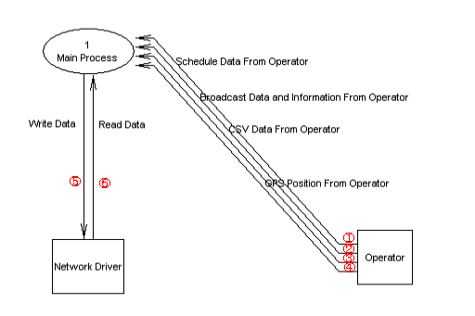
Figure 2. PA Data Flow Diagram Level 0 with External Entities

- Schedule Data Interface
- Schedule administrator enters the service schedule manually.
② Announcement data and Announcement Information Interface
- Enter the sound source, Text, Video Data and Information that will be announced.
③ CSV Data Interface
- It registers the service schedule, service routes and Whole train information on the SEPTA Scheduler using the CSV file not manually.
④ GPS Position Interface
- Entering the Trigger Point Information relevant to the station
⑤ Network Write Interface
- Record all data which have been used in SEPTA Scheduler, as Network Driver.
⑥ Network Read Interface
- Network Driver reads all data used in SEPTA Scheduler.

    - User Interface

      - SEPTA Scheduler User Interface
External Entity | Description
Operator | - User can enter or set up the service schedule.  - Location coordinate between stations can be entered or set up.  - Video can be entered or set up consecutively.  - GPS coordinate can be entered and set up.  - LED FDI, SDI, PII text can be entered or set up.  - Announcement sound source file can be designated or set up.

    - Hardware Interface
- None

    - Software Interface
- None

    - Communication Interface

External Entity | Description
Network Driver | - All data used in the SEPTA scheduler are able to read and write in Network Driver.  - But, if there are sharing folder and account using Windows Active Directory Server, it is able to use.

    - Memory Constraints
- None

    - Site Adaptation Requirement
- None

  - Product Functions

Classification | Description
Editing the Service Information | Setting up vehicle number should be able on operating information.
Editing the Service Information | Vehicle type (Local, Express, Limited, SEPTA) should be selectable on operating information.
Editing the Service Information | Day should be selectable on operating information.  (WEEKDAY,FRIDAY,SATURDAY,SUNDAY)
Editing the Service Information | Arrival time should be selectable on operating information.
Editing the Service Information | Departure time should be selectable on operating information.
Editing the Service Information | Final destination should be selectable on operating information.
Editing the Service Information | Adding and setting up the detailed route shall be available on the service information.
Editing the Routes Information | Service route arrival time should be able to set up.
Editing the Routes Information | Service route departure time should be able to set up.
Editing the Routes Information | Station information of service route should be able to set up.  (CONNECT, DISCHARGE, FLAGSTOP)
Editing the Routes Information | Bypass information of service route should be able to set up.  (Whether SKIP is available or not)
Editing the Station Information | Shall be able to set up the station type information.
Editing the Station Information | Shall be able to set up the station name information.
Editing the Station Information | Shall be able to set up the second station name.
Editing the Station Information | Shall be able to set up the Trigger direction that is to be announced.
Relevant station Trigger Point Set-up | Shall be able to set up the longitude relevant to the station.
Relevant station Trigger Point Set-up | Shall be able to set up the latitude relevant to the station.
Setting up the Whole Train Announcement | It shall be able to select the sound source that is to be announced before arriving at the Center City.
Setting up the Whole Train Announcement | It shall be able to select the sound source that is to be announced after arriving at the Center City.
Editing the FDI, SDI Text | Setting up the FDI shall be available.
Editing the FDI, SDI Text | Setting up the SDI shall be available.
Editing the FDI, SDI Text | If there are two station, setting up the station name which alternates FDI should be available.
Editing the FDI, SDI Text | If there are two station names, setting up the station name which alternates SDI should be available.
Editing the LCD, PAC, PII Text | Setting up announcement sound source shall be available.
Editing the LCD, PAC, PII Text | Setting up the text that will be displayed on LCD shall be available.
Editing the LCD, PAC, PII Text | Setting up the text that will be displayed on PII shall be available.
Editing the Holiday Information | Setting up Holiday information shall be available.
Editing the Holiday Information | It shall be able to set up to operate as a different day schedule on a set up holiday.
Editing the Video Information | Adding and deleting video shall be available.

  - User Characteristics
The user should be familiar with GUI based computer application programs.

  - Constraints
- Transmitting/Receiving update, DB Data and Raw Data should be available using Window Network Driver.

  - Assumptions and Dependencies

  - Apportioning of Requirements
- None

- Specific Requirements

  - External Interfaces

    - Graphical User Interfaces

- Train Information
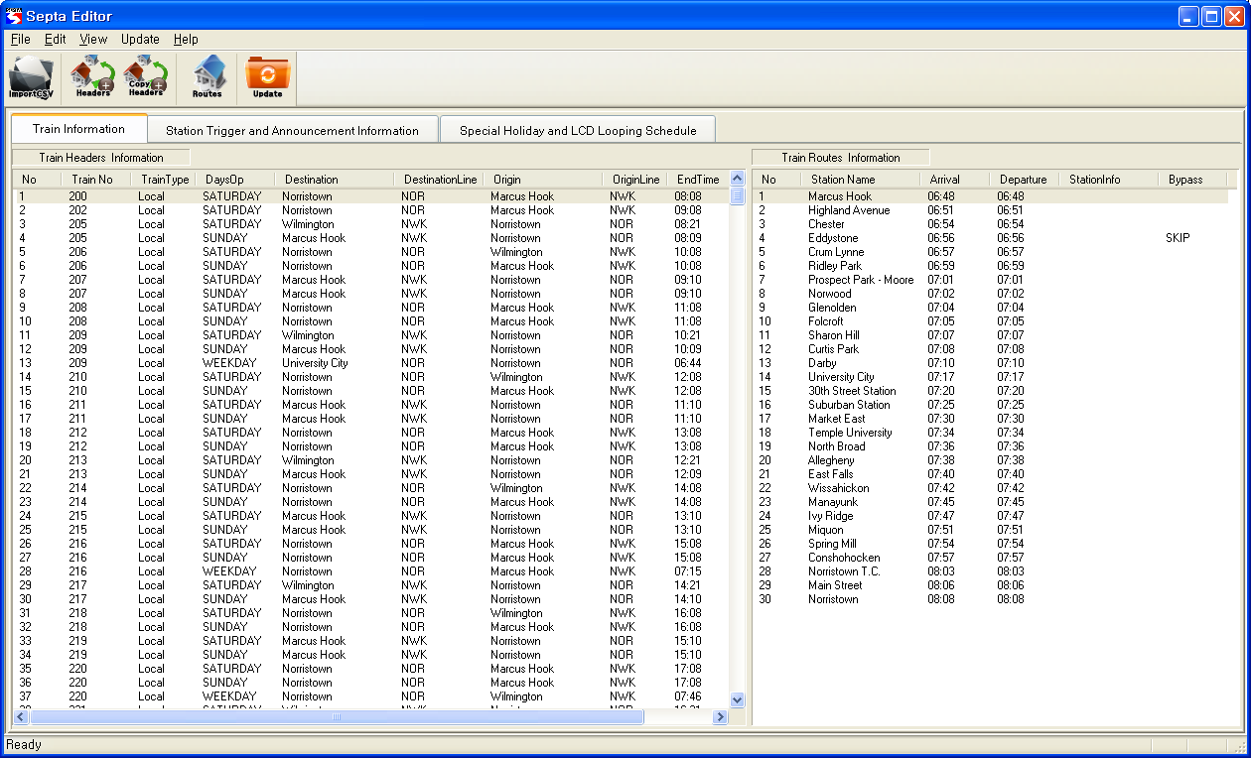
- Train Headers Information : Displays the schedule that the train serves.
- Train Routes Information : Displays the Routes Information relevant to the train service.

- Station Trigger point and Announcement Information

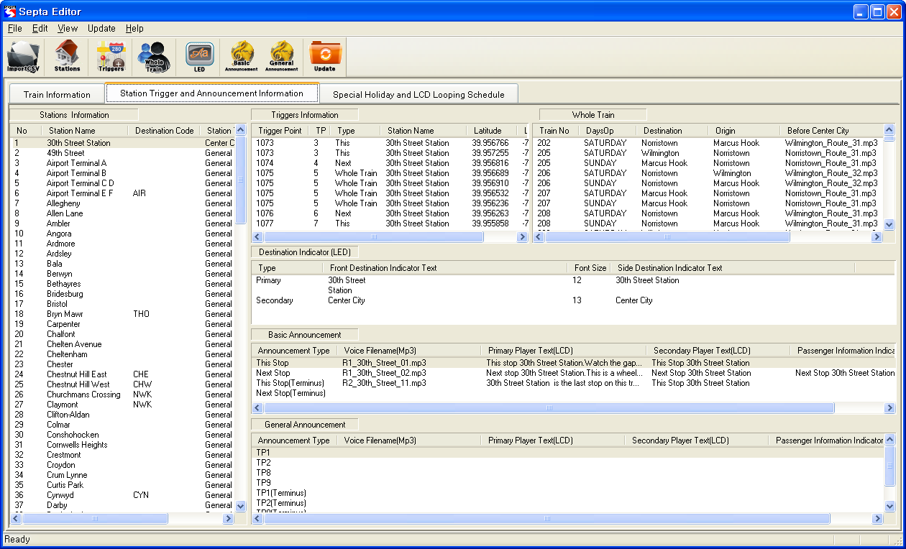

- Stations Information : Displays all Station names that are to be served.
- Triggers Information : Displays the Trigger Point relevant to the station.
- Whole Train : Displays the Whole Train announcement data when stopping at a station.
- Destination Indicator (LED) : Displays the text that will be displayed on the LED.
- Basic Announcement : Displays This/Next/Destination announcement that will be announced before or after stopping at a station.
- General Announcement : Displays announcement other than the station announcement.
- Special Holiday and LCD Looping Schedule

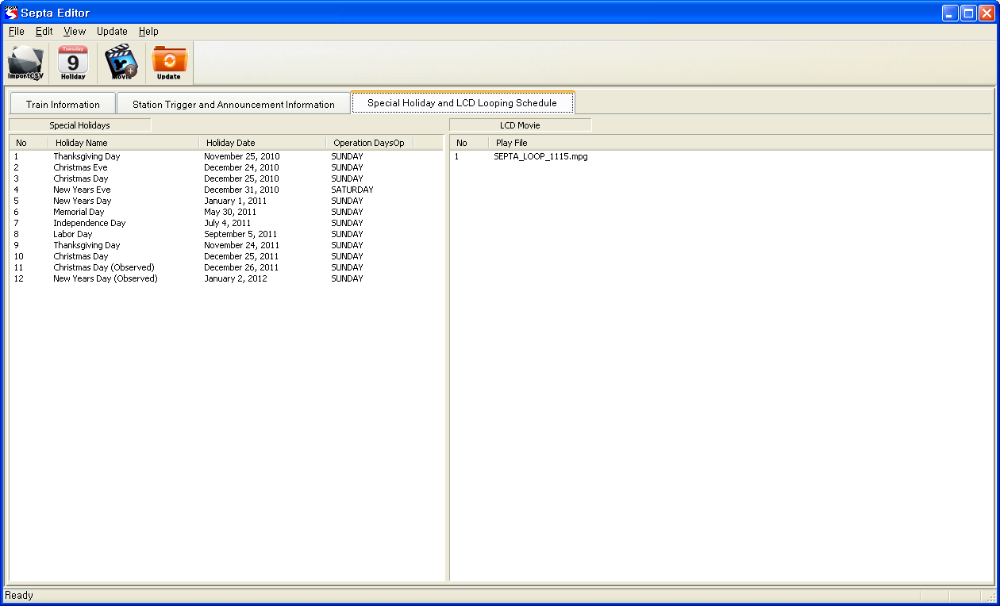

- Special Holidays : Displays the Holiday information that will be designated.
- LCD Movie : Displays the video file list that will be played on the Primary Player.

- Import CSV interface
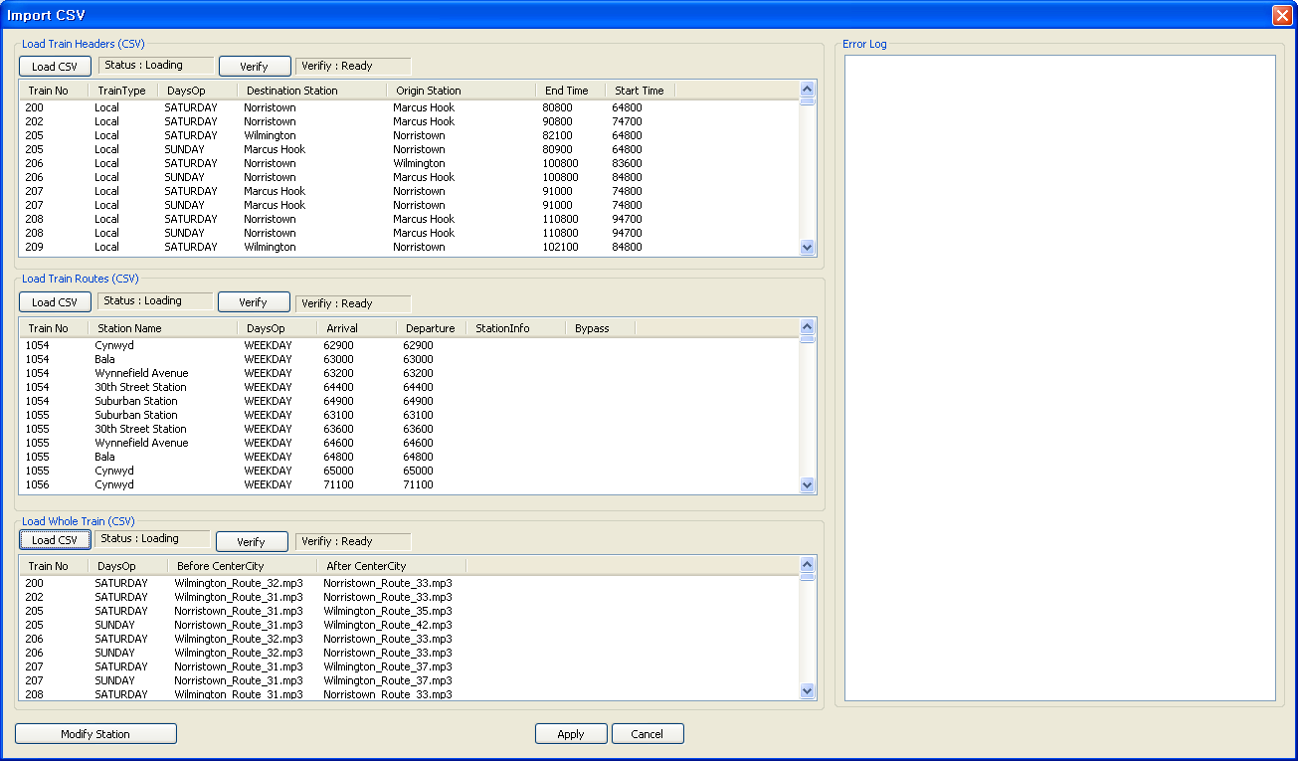

- Load Train Headers : Displays the contents of loaded Train Header CSV.
- Load Train Routes : Displays the contents of loaded Train Routes CSV.
- Load Whole Train : Displays the contents of loaded Train Whole Train CSV.
- Error Log : Displays the contents of error when verify error occurs.

- Create Update interface
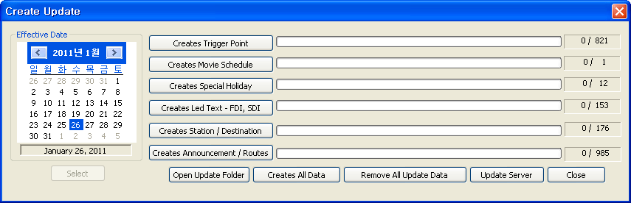

- Effective Date : It shall be able to select the actual date that will be updated.
- Creating the Update file is available.

  - Functional Requirements

    - Adding operator information

Req.ID : SEPTASCH-1
- Select the Add Headers Information Button.
- Train Number: Input train number to add.
- Train Type: Setting up into 4 types of Local, Express, Limit and SEPTA are available.
- Day: Select day information of WEEKDAY, FRIDAY, SATURDAY, SUNDAY.
- Start Time: Sets up starting time of train operation.
- End Time: Sets up ending time of train operation.
- Select (Change) last stop of train service. (Display terminus and Center City)
- Selecting origin station is available. (Display terminus and Center City)
- Displays all station that is able to add route.
- Arrival: Set up arrival time of station.
- Departure: Set up departure time from origin station
- Select the ‘Apply’ button.

    - Editing operator information

Req.ID : SEPTASCH-2
- Double click the Train Number that will be modified.
- Modify the Train Number.
- Train Type: Setting up into 4 types of Local, Express, Limit and SEPTA are available.
- Day: Select day information of WEEKDAY, FRIDAY, SATURDAY, SUNDAY.
- Start Time: Sets up starting time of train operation.
- End Time: Sets up ending time of train operation.
- Select (Change) last stop of train service. (Display terminus and Center City)
- Selecting origin station is available. (Display terminus and Center City)
- Displays all station that is able to modify route.
- Arrival: Set up arrival time of station.
- Departure: Set up departure time from origin station
- Select the ‘Apply’ button.

    - Operator information delete

Req.ID : SEPTASCH-3
- Select delete station name.
- Select ‘Delete’ button

    - Adding route procedure

Req.ID : SEPTASCH-4
- Select the Header which you want to add.
- Double click the Train Number that will be modified.
- Select the station name you want to add among the left side station name list of the Path Connector.
- Set up departure time and arrival time
- Select if there is station information (Connect, Discharge, Flag Stop)
- Select if there is By Pass (Skip).
- Selects Add button.
- Selected station name, time, and information will be inputted
- It can change added station of order.
- ‘Set Header Time’ button is automatically set start departure and arrival time up in determined Path.
- Select the ‘Apply’ button.

    - Route information modification procedure

Req.ID : SEPTASCH-5
- Select the Header which you want to modify.
- Select the station name you want to modify among the right side station name list of the Path Connector.
- Set up departure time and arrival time
- Select change button after modified station info (CONNECT, DISCHARGE, FLAG STOP) and By Pass (SKIP)
- Set Header Time: button is automatically set start departure and arrival time up in determined Path.
- Select the ‘Apply’ button.

    - Route information delete

Req.ID : SEPTASCH-6
- Select the Header which includes the routes you want to delete.
- Select delete station name.
- Select ‘Delete’ button
- Select the ‘Apply’ button.

    - Adding trigger point information

Req.ID : SEPTASCH-7
- Select the station name which includes the trigger point you want to add.
- Select the Add Triggers Information Button.
- Enter the latitude.
- Enter the longitude.
- Select the ‘Apply’ button.

    - Editing trigger point information

Req.ID : SEPTASCH-8
- Select the station name which includes the trigger point you want to modify.
- Select the Trigger that will be modified.
- Modify the latitude or the longitude.
- Select the ‘Apply’ button.

    - Deleting trigger point information

Req.ID : SEPTASCH-9
- Select the station name which includes the trigger point you want to delete.
- Select the Delete Button.

    - Editing Whole Train information

Req.ID : SEPTASCH-10
- Select the station name that will be modified.
- Select the Modify Whole Train Button.
- Select the sound source that will be announced before Center City after selecting Load button of Before Center City.
- Select the sound source that will be announced after Center City after selecting Load button of After Center City.
- Select the ‘Apply’ button.

    - Editing LED information

Req.ID : SEPTASCH-11
- Select the station name of LED data that will be modified.
- Select the Modify Destination Indicator button.
- Enter the FDI text inside the Front Destination Indicator.
- Enter the FDI size inside the Front Destination Indicator.
- Enter the SDI text inside the Side Destination Indicator.
- Enter the SDI size inside the Front Destination Indicator.
- Select the ‘Apply’ button.

    - Edit Station info. Announcement
Req.ID : SEPTASCH-12
- Select the station name which has an announcement to be added.
- Select the type you want to modify at Basic Announcement and select Basic Announcement.
- Voice Information: Displays selected audio file of trigger point.
- Enter the Time when PP will be displayed on Display Time.
- Enter the time that will display the clock on Clock Display Time.
- Modify the Text in Edit Text Column of Primary Player.
- Modify the Border Text of Primary Player.
- Select the Font color of Primary Player.
- Enter the Font Size of Primary Player.
- Modify the text that will be displayed at SP of LED on Secondary Player Text.
- Modify the Text that will be displayed on PII in Passenger Information Indicator column.
- Select the ‘Apply’ button.

    - Holiday information addition

Req.ID : SEPTASCH-13
- Select the Manage Holiday Button.
- Select New.
- Holiday Name: Input holiday name.
- Select date of holiday to be set up.
- Select desire to change day of train service.
- Select Add.
- Select the ‘Apply’ button.

  - Performance Requirements
- None
  - Logical Database Requirements
- None
  - Design Constraints
- None
  - SW System Attributes
none

    - Reliability
- Unregistered station name will not be added.
- It is able to check whether video is registered or not by playing.
- It is able to listen to the registered announcement by playing.
    - Availability
- Verify whether the CSV File Import Train Header is valid or not by using Train Type, Day, Destination and origin of station.
- Verify whether the CSV File Import Train Route is valid or not through station name, day, station information bypass.
- Verify whether the CSV File Import Whole Train file is valid or not using the day.
    - Security
- When using the Network Driver for Window Active Directory Server in a shared folder permissions only on the account can be modified.
    - Maintainability
- Software structural analysis and design techniques as appropriate to increase the modularity and maintainability.

    - Portability
- None

