THE DRAWING(S) AND THE INFORMATION CONTAINED HEREIN ARE THE PROPERTY OF WOOJIN INDUSTRIAL SYSTEMS CO., LTD. THEY SHALL NOT BE DISCLOSED, REPRODUCED OR USED, IN ANY MANNER WITHOUT THE PRIOR WRITTEN CONSENT OF WOOJIN INDUSTRIAL SYSTEMS CO., LTD. |  | SEPTA Silverliner V  Communication System  SEPTA DB Scheduler
DISTRIBUTION |  | R  E  V  I  S  I  O  N | 3 | June 7,2011 |  | Revised |  |  | J.Y.LEE | Y.J.KWON | B.J.JONE | E.K.LEE
 |  |  | 2 | April 15,2011 |  | Revised |  |  | J.W.AHN | Y.J.KWON | B.J.JONE | E.K.LEE
 |  |  | 1 | Feb 7, 2011 |  | Revised |  |  | J.W.AHN | Y.J.KWON | B.J.JONE | E.K.LEE
 |  |  | 0 | Dec 6, 2010 |  | Issued |  |  | J.W.AHN | Y.JKWON | B.JJONE | E.K.LEE
 |  |  | No. | ISSUED  DATE |  | REVISION NOTE |  |  | DESIGNED | CHECKED | APPROVED | REVIEWED
 |  |  |  |  |  |  |  |  | ENGINEERING |  |  | PM
 |  | PM |  |  | REVIEWED |  | E.K.LEE |  | CUSTOMER :
 |  | ENGINEERING |  |  | APPROVED |  | B.J.JONE |  | HYUNDAI-ROTEM COMPANY
 |  |  |  |  | CHECKED |  | Y.J. KWON
 |  |  |  |  | DESIGNED |  | J.W.AHN |  | PROJECT :
 |  | ISSUED DATE |  |  | June 7,2011 |  |  |  | SEPTA SILVERLINER V  COMMUNICATION SYSTEM
 |  | ISSUED BY |  |  | R & D CENTER
 |  | PROJECT NO. |  |  | P2009-024
 |  | ORDER NO. |  |  | P091201400 |  |  |  | 
 |  | DOCUMENT NO. |  |  |  |  |  | REVISION
 |  | WJ-SDB-001 |  |  |  |  |  | 3
TOTAL
REVISION RECORD
Rev. No. | PAGE | Details |  | Date
 |  | FROM | TO
0 |  | Issued |  | December 06, 2010
1 | 8~9 | Section 2.1 | Setup_SeptaEditor 1.0.exe → Setup_SeptaEditor_Ver_1.0.0.2.exe | January 20, 2011
1 | 16 | Section 2.3 | Network Drive installation info. added | January 20, 2011
1 | 18 | Section 3.1 | Log in account is added due to request of SEPTA. | January 20, 2011
1 | 22 | Section 3.2.2. | Picture updated  ‘Adding operation info.’ function added due to SEPTA request. | January 20, 2011
1 | 24 | Section 3.2.3 | Picture updated | January 20, 2011
1 | 28 | Section 3.3.6 | Picture updated | January 20, 2011
1 | 38 | Section 3.3.2 | TP Order updated | January 20, 2011
1 | 47 | Section 3.3.7.3 | Font size modified | January 20, 2011
1 | 49~69 | Section 3.3.8 ~ 3.5.6 | Picture updated | January 20, 2011
1 | 56 | Section 3.4.5 | Preview function added due to SEPTA request | January 20, 2011
1 | 69 | Section 3.5.4 | Revised meaning of “Partial update’ | January 20, 2011
1 | 70 | Section 4.1.1~4.1.3 | Contents updated | January 20, 2011
1 | 72 | Sec. 4.1.5 | SEPTA_DB info. added | January 20, 2011
2 | 5 | Section 2.1 | Setup_SeptaEditor_Ver_1.0.0.2.exe →  Setup_SEPTAScheduler_Ver_1.0.0.3.exe | April 15, 2011
2 | 13 | Section 2.4 | Select program path added | April 15, 2011
2 | 14 | Section 3.1 | Contes removerd due to network drive setting method changed. | April 15, 2011
2 | 49 | Section 3.3.1 | 4) LCD movie Picture modified.  Related play list change content updated. | April 15, 2011
2 | 63 | Section 3.4.3 | Updated related content revised. | April 15, 2011
2 | 66 | Section 4 | Contents revised as SEPTA comments. | April 15, 2011
3 | 4 | Section 1.21 | Add resolution information. | June 7, 2011
3 | 8 | Section 1.21 | Typo was revised. | June 7, 2011
3 | 5~6 | Section 2 | Software Installation information revised. | June 7, 2011
3 | 7 | Section 2.2 | Raw data information updated. | June 7, 2011
3 | 8 | Section 2.3 | Select Program Path contents updated. | June 7, 2011
3 | 9~10 | Section 2.4 | Deleted unnecessary section. | June 7, 2011
3 | 18 | Section 3.1.4 | Typo was revised | June 7, 2011
3 | 28 | Section 3.2.1 | (8) General Broadcast-1, 2, 8,9Trigger Point information updated. | June 7, 2011
3 | 33 | Section 3.2.3 | Typo was revised. | June 7, 2011
3 | 35 | Section 3.2.5 | Typo was revised. | June 7, 2011
3 | 46 | Section 3.3.1 | Contents updated. | June 7, 2011
3 | 49 | Section 3.3.3 | Contents updated. TP order deleted. | June 7, 2011
3 | 50 | Section 3.3.5 | Contents updated. | June 7, 2011
3 | 52 | Section 3.4.1 | Typo was revised. | June 7, 2011
3 | 57 | Section 3.4.2.1 | Contents revised. | June 7, 2011
3 | 59 | Section 3.4.2.2 | Contents revised. | June 7, 2011
3 | 60 | Section 3.4.2.3 | Contents revised. | June 7, 2011
3 | 62 | Section 3.4.3 | Typo was revised.  Contents revised(Described Network Drive Z to X drive) | June 7, 2011
3 | 64 | Section 3.4.5, 3.4.6 | Contents revised. | June 7, 2011
3 | 65 | Section 4.1 | Contents updated. | June 7, 2011
3 | 5~66 | All | Add figure number | June 7, 2011
Table of Contents

1. Specification 5
1.1. Septa Editor Definition 5
1.2. Hardware and Software Specification (Data Capacity) 5
2. Software Installation 6
2.1. Septa Editor Software installation 6
2.2. Raw Data 8
3. User Manual 10
3.1. Train service schedule management 10
3.2. Management of Station name, TP, announcement information 24
3.3. Holiday and Video Schedule Management 47
3.4. CSV File Loading, Update file creation 54
4. Data Composition 66
4.1. Folder Composition 66

Specification

Septa Editor Definition
Septa Editor software to create downloadable update file on vehicle after editing announcement data on relevant schedule by inputting or loading the train schedule operated by SEPTA.

Hardware and Software Specification (Data Capacity)

Hardware Specification
Device | Specification
CPU | Core Duo (1.66 Ghz) more
raphics | Resolution 1280 * 1024 or more
RAM | 1024MB or more
HDD | 80GB or more
OS | WinXP or more

Data capacity
It is minimum capacity on current 984 train operation basis.
Device |  | Capacity
LCD | PP | 6MB
 | SP | 12MB
 | Video | Changeable by capacity
PAC |  | 250MB
LED | FDI | 180KB
 | SDI
 | PII
Total capacity |  | Minimum 271MB

Software Installation

Septa Editor Software installation
Setup_SEPTAScheduler_Ver_1.0.06.exe is SPETA Data Base Editor Software installation file. (1.0.0.1 Initial release version)
*** Attention: Before install new version of SEPTA Scheduler program, remove previous program.

[Figure 2.1-A Insatallation porcess]

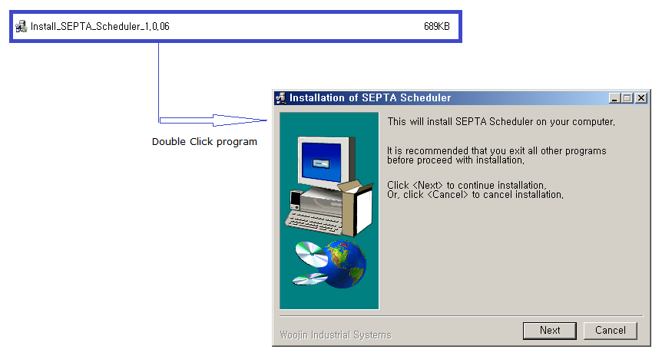
Select Next button.
[Figure 2.1-B Insatallation porcess]
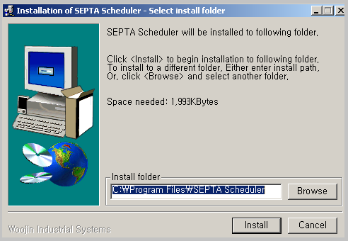
Select install folder. C drives or X drive.

[Figure 2.1-C Insatallation porcess]
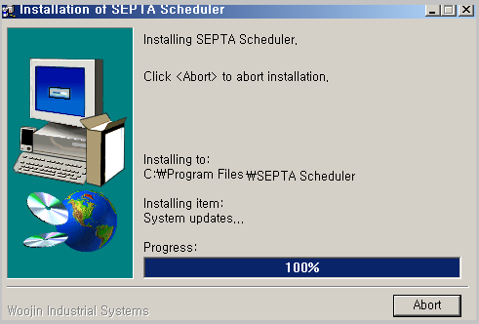
It will process SeptaEditor installation.
[Figure 2.1-D Insatallation porcess]
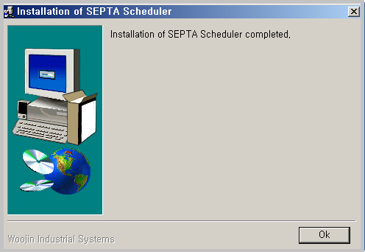
Select OK button. It completed Septa Editor installation.

Raw Data
SEPTA Scheduler database as raw data must be stored selected drive (C drive or Xdrive) after you install installation program. SEPTA Scheduler can load all data related operation schedule, audio MP3 files and text files from data.

Raw data is composed of SEPTA_DB and SEPTA_ANNOUNCEMENT folders. SEPTA_DB is SEPTA.mdb database file and include all operation information. This raw data should be installed for management schedule. This is actual database for management. If it didn’t installed drive, you may not hear any audio files or movie files.

SEPTA_ANNOUNCEMENT folder is PEI_DATA, PEI_TEXTDATA, MOVIE_DATA and VOICE_DATA. It includes ad file, PEI call, LED, text file and MP3 files. (Reference 4.1.1 Raw Data Folder)

*** If database (raw data) is already populated, Installation of raw data is optional.
Select program path
[Figure 2.3-A Select Path]
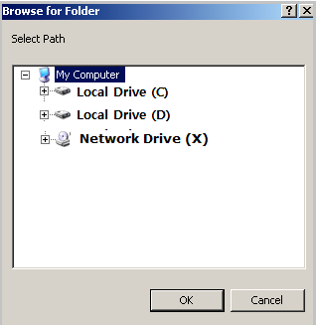

Run the Scheduler program after you installed the program, and select path.
*** SEPTA_DB \ \ SEPTA_DB.mdb file must be in selected drive.

For example, when you select the path to a network drive X, mdb file should be in X drive. (X: \ SEPTA_DB \ SEPTA_DB.mdb)
When you select the path to a local drive C, mdb file should be in C drive. (C:\SEPTA_DB\SEPTA_DB.mdb)

If you select cancel without setting the path the program is terminated. If there isn’t path specified in the mdb file to the folder, it shows selection window dialog box until select valid path designated.

User Manual

Train service schedule management

Train Information composition
** “Double-click the new desktop icon  to start the program; you should see this screen as the default.

[Figure 3.1.1-A Default Screen]
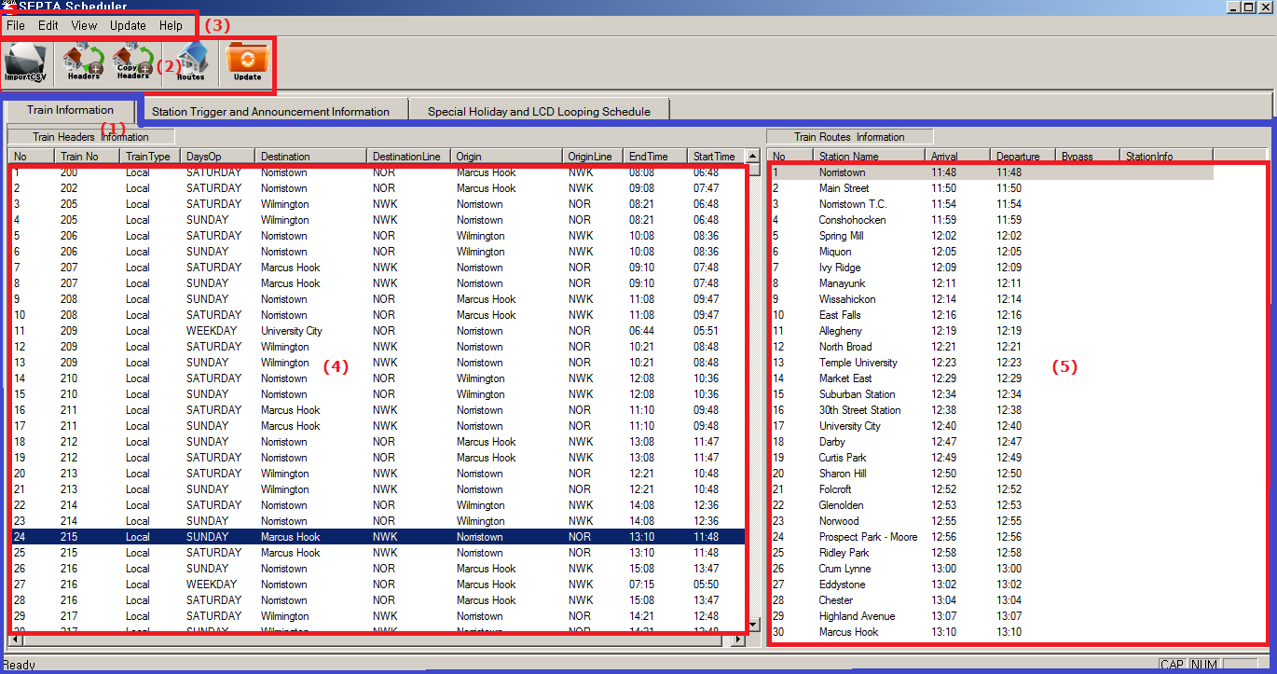
This section manages schedule for SEPTA train. It can edit operation schedule and route.

- Train Information
- It can manage operation schedule and route of train.
- Menu Icon Function
[Table 3.1.1-A menu Icon]
Icon | Icon Name | Contents
 | Import CSV | Import CSV (Figure 3.4 )
 | Add Header | Add Operation info.
 | Copy Header | Copy Operation info
 | Routes | Edit Route info
 | Update | Create Update Data (Figure 3.4.3 )

- Menu Description
[Table 3.1.1-B Menu function]
Menu | Contents
File | Import CSV
Edit | Management of operation schedule.
View | Selection of Toolbar and Status bar
Update | Create Update Data
Help | Display version of SEPTA scheduler. (Figure 3.1.1-A)

[Figure 3.1.1-A. Select Help Version Information]
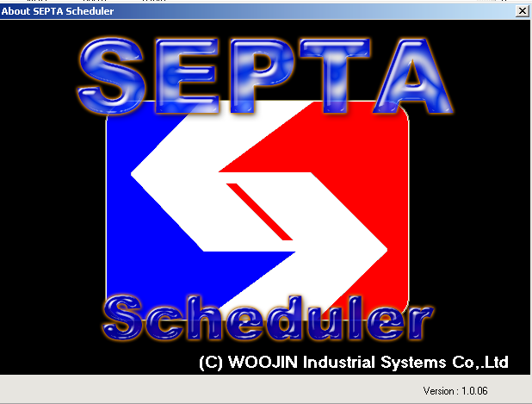
- Train Headers Information
- Displays SEPTA train operation schedule.
[Figure 3.1.1-B Train Heafers Information]
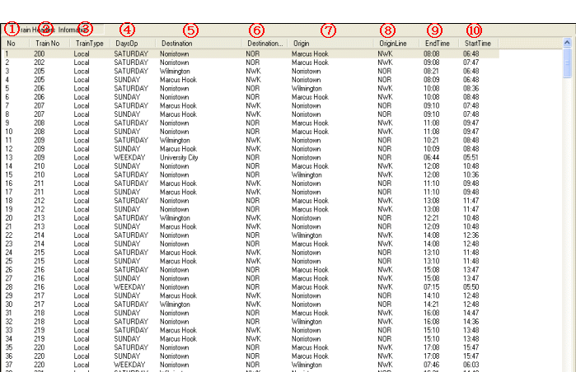
- No (Numerical order)
- Train No: Displays train number of 1 to 9999.
- Train Type: There are 4 type of train as Local, Express, Limit and SEPTA
- DayOP (Day information)
WEEKDAY: Operate Monday through Friday.
FRIDAY: Operate Friday only.
SATURDAY: Operate Saturday only.
SUNDAY: Operate Sunday only.
- Destination (Final destination): Displays final destination.
- Destination Code (Final destination code): Display final destination.
- Origin: Displays Origin station.
- Origin Code: Displays origin station perceptible line name.
- End Time: Display train arrival time in final destination.
- Start Time: Display departure time from origin station.

- Train Routes Information
- Displays route information relevant to train operation.
[Figure 3.1.1-C Train Routes Information]
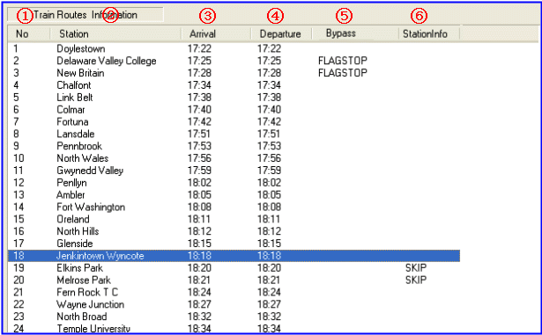
- No (Numerical order)
- Station: Displays station name relevant to selected operation schedule.
- Arrival: Display train arrival time in station.
- Departure: Displays train departing time from station.
- ByPass: Displays whether to skip the station or not.
- Station Info: Displays information relevant to station.
(CONNECT, DISCHARGE, FLAG STOP)

Edit operation information
Double click after selecting train number to be modified at Train Headers Information.
[Figure 3.1.2-A. Train Headers Information]
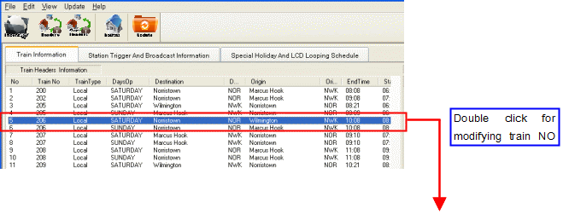
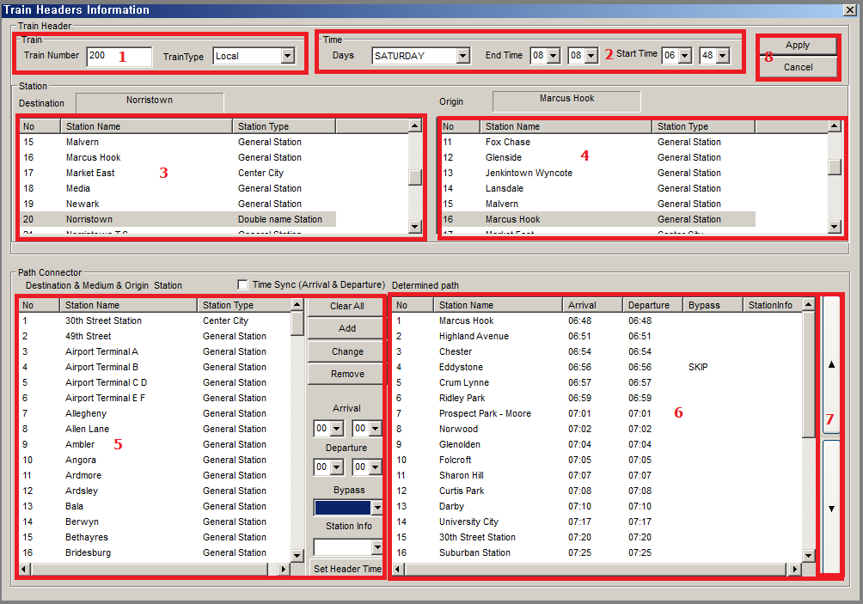
- Train Number: Input train number to edit.
- Train Type: Setting up into 4 types of Local, Express, Limit and SEPTA are available.
- Day: Select day information of WEEKDAY, FRIDAY, SATURDAY, and SUNDAY.
- Start Time: Sets up starting time of train operation.
- End Time: Sets up ending time of train operation.
- Select (Change) last stop of train service. (Display terminus and Center City)
- Selecting origin station is available. (Display terminus and Center City)
- Displays all station that is able to add route.
- Arrival: Set up arrival time of station.
- Departure: Set up departure time from origin station
※ When check Time Sync section, arrival time abd departure time will be synchronize.
- Station Info: CONNECT, DISCHARGE, FLAG STOP
- ByPass: Displays whether to skip the station or not.
- : Delete all data designated on ⑥.
- : Add selected station on ⑤ to route of ⑥.
- : Modify selected station information on ⑤.
- : Delete station route information selected on ⑥.
- : Setting start time and end time of ② by using origin and final station time on
- Display current designated route information.
- UP and DN scroll: It can change Station list sequence.
- By selecting Register button, it will be registered current information of Header.

Adding Operation Information
Click on icon or select Edit →Add Train Headers Information.

[Figure 3.1.1-A. Adding information]
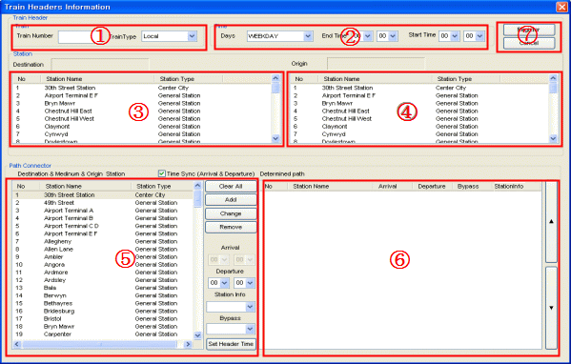
- Train Number: Input train number to add.
- Train Type: Setting up into 4 types of Local, Express, Limit and SEPTA are available.
- Day: Select day information of WEEKDAY, FRIDAY, SATURDAY, and SUNDAY.
- Start Time: Sets up starting time of train operation.
- End Time: Sets up ending time of train operation.
- Select (Change) last stop of train service. (Display terminus and Center City)
- Selecting origin station is available. (Display terminus and Center City)
- Displays all station that is able to add route.
- Arrival: Set up arrival time of station.
- Departure: Set up departure time from origin station
※ When check Time Sync section, arrival time abd departure time will be synchronize.
- Station Info: CONNECT, DISCHARGE, FLAG STOP
- ByPass: Displays whether to skip the station or not.
- : Delete all data designated on ⑥.
- : Add selected station on ⑤ to route of ⑥.
- : Modify selected station information on ⑤.
- : Delete station route information selected on ⑥.
- : Setting start time and end time of ② by using origin and final station time on
- Display current designated route information.
- By selecting Register button, it will be registered current information of Header.

Copy Header
Desired train number right-click and copy header information.
[Figure 3.1.4-A. Copy Header]
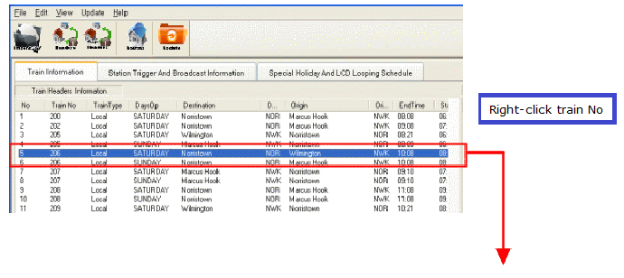
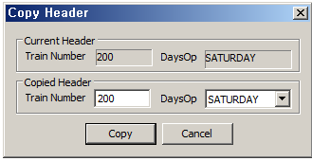
Eidt train number and DaysOp.
If same train number you apply, you can see this message.
[Figure 3.1.4-B. Copy Header pop up window]

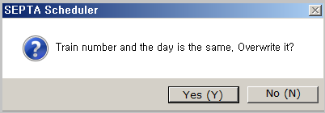

Delete Operation information
Select “DELETE” key after selecting train number to be deleted on Train Headers Information.

[Figure 3.1.5-A Delete screen]
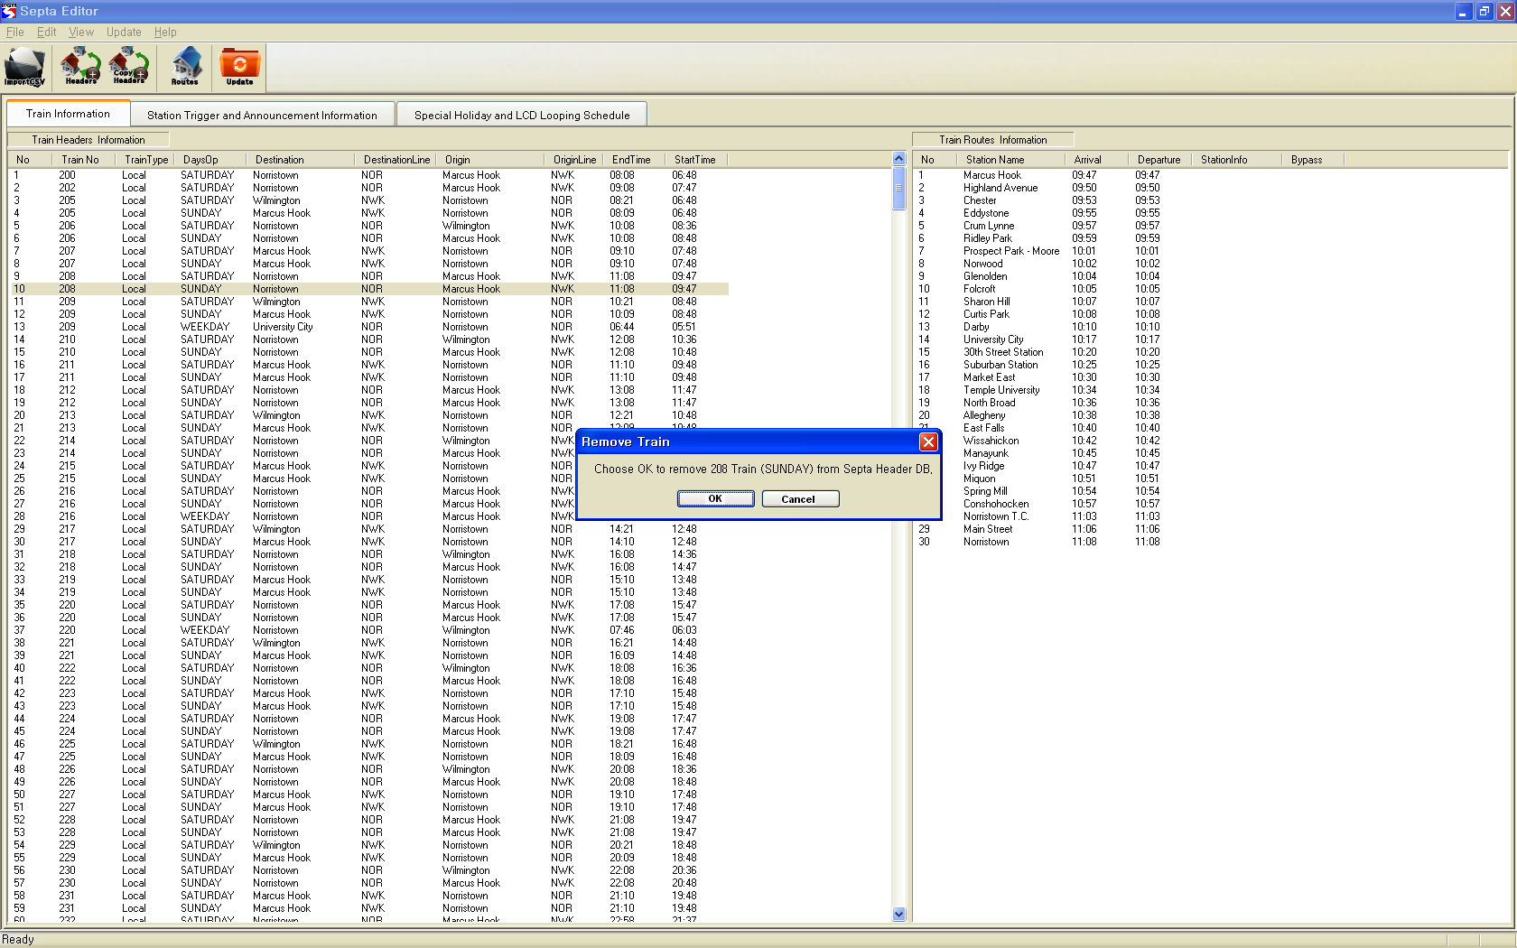
All data relevant to train number will be deleted when selected OK.

Management of Train Service Route
[Figure 3.1.6-A Train Service Route]
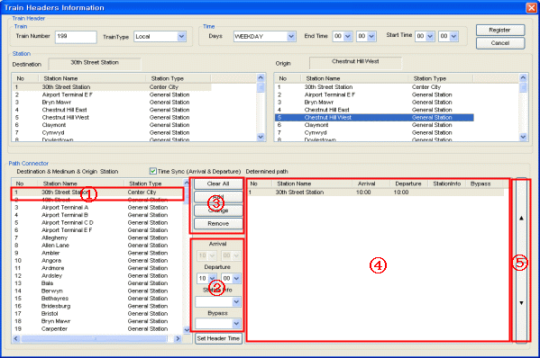
When check Time Sync section, arrival time abd departure time will be synchronized.

Adding route procedure
- Select station name on 1.
- Set up departure time and arrival time on 2.
- Select if there is station information (Connect, Discharge, Flag Stop) at 2.
- Select if there is By Pass (Skip).
- Selects Add button.
- Selected station name, time, and information will be inputted as 4.
- It can change added station of order.
- button is automatically set start departure and arrival time up in determined Path.
[Figure 3.1.6-B Edit Screen]
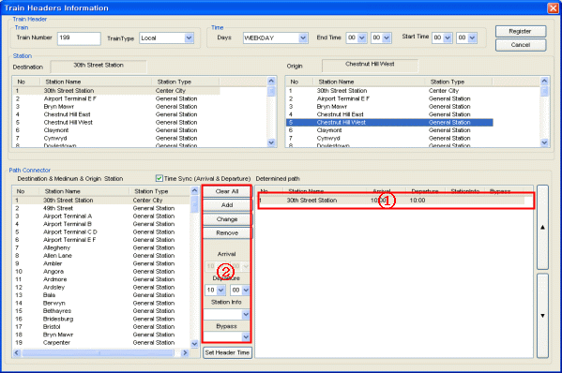

Route information modification procedure
- Select station name to modify on 1.
- Set up departure time and arrival time on 2.
- Select change button after modified station info (CONNECT, DISCHARGE, FLAG STOP) and By Pass (SKIP) on 2.
- Set Header Time: button is automatically set start departure and arrival time up in determined Path.

Route information delete
- Select delete station name in section ①.
- Select [Remove] button in section ②.

Edit Route
[Figure 3.1.6-C Eidt Route]
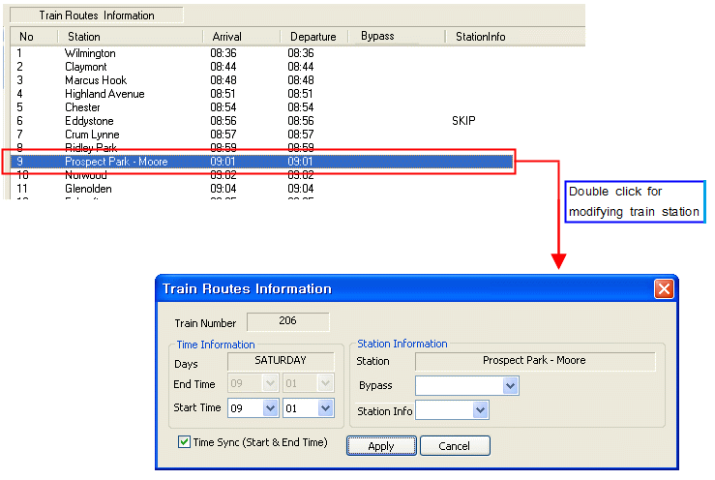
Performance method: Select desired to modify station name in Train Route section.
Select station name to be modified at Train route window and click on icon or select Edit Modify Train Routes Information.
- Time Sync: Make sure to modify start time and end time equally.
- Station Info
Set- up station information of CONNECTS, DISCHARGE, FLAG STOP are available.
- Bypass: Setting up whether current station is SKIP type, is available.

Management of Station name, TP, announcement information

Station Trigger and Announcement Information composition
Currently, SEPTA manage LED, LCD, Trigger Point, and station information.
** Click on the Station Trigger and Announcement Information tab to see this.

[Figure 3.2.1-A Station Trigger and Announcement Information]
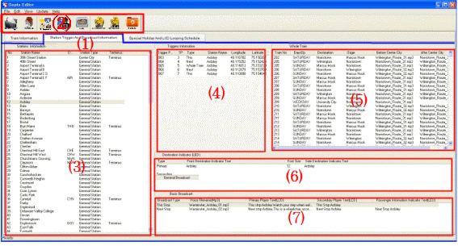
- Station Trigger And Broadcast Information Function
◆ Editing station information is available.
◆ Editing trigger point information is available.
◆ Editing whole train announcement information is available.
◆ Edit LED (Front Destination Indicator, Side Destination Indicator)
◆ Editing broadcast information is available.
◆ Primary Player (LCD Indicator)
◆ Secondary Player (LCD Indicator)
◆ Editing station announcement and public relations announcement information are available.
- Menu Icon

[Table 3.2.1-A Menu Icon]
Icon | Icon Name | Contents
 | Import CSV | Import CSV (Figure 3.4 )
 | Stations | Station Information
 | Routes | Edit Route info
 | Trigger | Trigger information modification
 | Whole Train | Whole Train Information
 | Basic Announcement | Station announcement information modification (This / Next)
 | General Announcement | Set general annmouncement (Except Basic announcement)
 | Update | Create Update Data (Figure 3.4 )

- Station Information
- Display train station information.

[Figure 3.2.1-B Station Information]
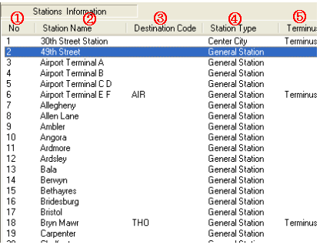
- No (Numerical order)
- Station Name: Displays station name registered on station information.
- Destination Code: Display last stop of Station.
- Station Type: General Staion and Centercity
- Terminus: Display last stop of station.
- Trigger Information
- Display GPS point information. GPS is written according to the standard notation. (Degree)

[Figure 3.2.1-C. Trigger Point]
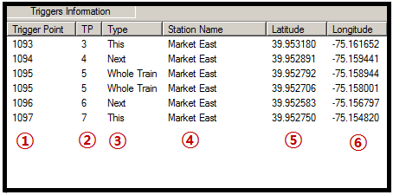

- Trigger Point: Displays trigger point relevant to station.
- TP: Display trigger point location.
- Type: Display trigger point function.
- Station Name: Displays station that includes current coordi3.2.1 nate.
- Longitude: Displays longitude at GPS Position.
- Latitude: Displays latitude at GPS Position.
- Whole Train
Displays whole train route announcement information. Displays information announced when door opens.

[Figure 3.2.1-D whole Train]
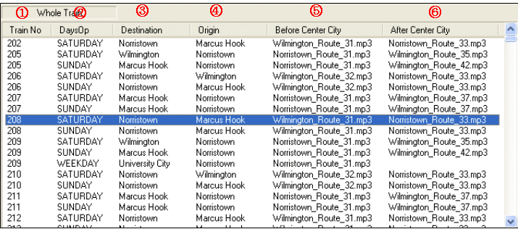
- Train No: Displays whole train designated train number.
- DaysOP: Displays whole train designated day. (WEEK, FRIDAY, SATURDAY, SUNDAY)
- Destination: Displays whole train designated destination.
- Origin: Displays whole train designated origin station.
- Before Center City: The audio file is announced before Center City.
- After Center City: The sound source to be announced after Center City.

- Destination Indicator (LED)
- Displays station information that will be displayed on LED.
[Figure 3.2.1-E Destination Indicator]
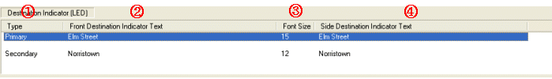
- Type Primary - Displays the first station name
Secondary - Displays the double name station.
- Front Destination Indicator Text: Displays destination name that will be displayed on FDI.
- Font Size: Displays character size of destination name that will be displayed on FDI.
- Side Destination Indicator Text: Displays destination name that will be displayed on SDI.

- Basic Announcement
- Select audio file for this and next stop and final station announcement.
- Trigger Point uses as TP 3, 4 6, 7 (It will not operate without TP information)

[Figure 3.2.1-F Basic Announcement]
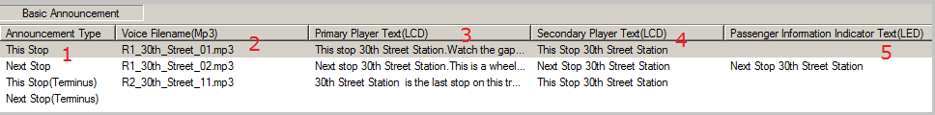
- Announcement Type
· Display current announcement.
· This Stop: Display announcement of arrival station.
· Next Stop: Display announcement of next stop.
· This Stop (Terminus): Display announcement when station arrived selected station and it is final stop.
· Next Stop (Terminus): Display announcement when station is next stop and final stop of station.
- Voice File name (MP3)
· Displays audio file that will be announced.
- Primary Player Text (LCD)
· Displays Primary Player that will be displayed at the upper part of LCD.
- Secondary Player Text (LCD)
· Displays Secondary Player that will be displayed at the lower part of LCD.
- Passenger Information Indicator Text (LED)
· Displays text that will be displayed on LED PII.

- General Announcement – 1, 2, 8, 9Trigger Point
- Select general announcement except basic announcement.
- Trigger Point uses as TP 1, 2, 8, and 9 (It will not operate without TP information)
- This can public service announcements and commercial advertisement by using trigger points.

[Figure 3.2.1-G Add information of trigger points for 1, 2, 8, 9]
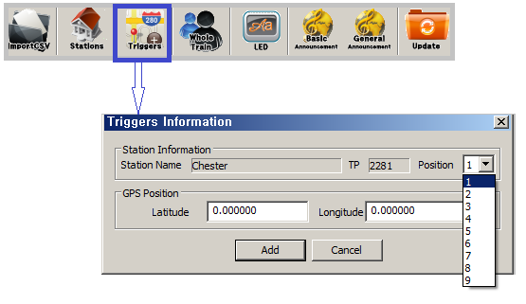
[Figure 3.2.1-H Add information ofPrimary Player Text for 1, 2, 8, and 9]
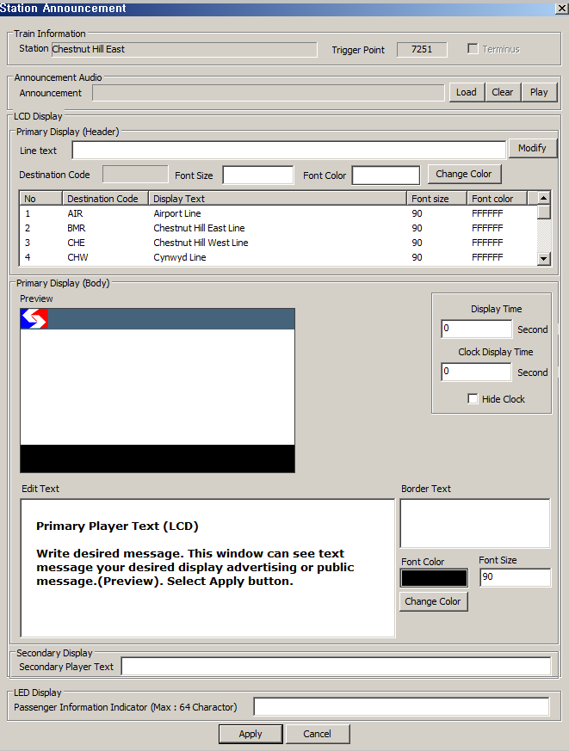
[Figure 3.2.1-I Preview of 1,2,8,9 displayed information]
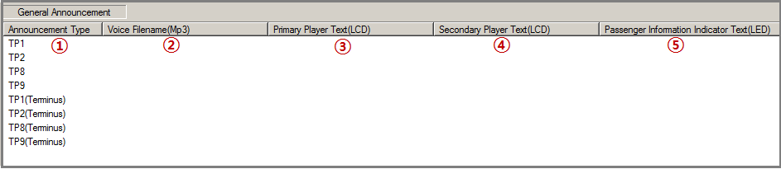
- Announcement Type
· Display current announcement.
- Voice File name (MP3)
· Displays audio file that will be announced.
- Primary Player Text (LCD)
· Displays Primary Player that will be displayed at the upper part of LCD.
Write desired message. This window can see text message your desired display advertising or public message (Preview). Select Apply button.
- Secondary Player Text (LCD)
· Displays Secondary Player that will be displayed at the lower part of LCD. Same as Primary PlayerText edit method.
- Passenger Information IndicatoPr Text (LED)
· Displays text that will be displayed on LED PII.

※ Trigger Point Reference
TP1 |  | TP2 |  | TP3 |  | TP4 |  | TP5 |  | TP6 |  | TP7 |  | TP8 |  | TP9
General  broadcast |  | General  broadcast |  | This broadcast |  | Next broadcast |  | Station |  | Next broadcast |  | This broadcast |  | General  broadcast |  | General  broadcast
 |  |  |  | Basic broadcast |  | Basic broadcast |  | Whole Train  broadcast |  | Basic broadcast |  | Basic broadcast

Edit Station information
Click on icon or select Edit Manage Station Information or select any station at Station Information and double click.
[Figure 3.2.2-A Edit Station Infomation]
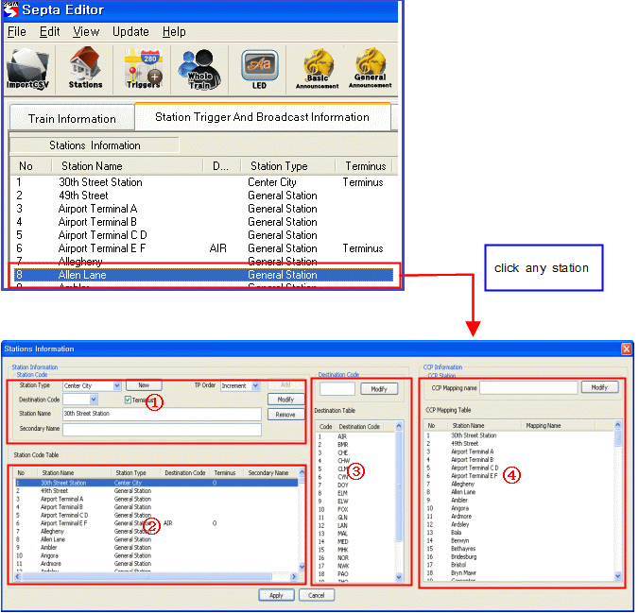

- Station Information
- Station Type
· General Station: Single station
Ex) 49th Street, Airport Terminal A and E
· Center City: Stations that all route crosses.
Ex) Market East, Suburban Station, 30th Street Station
· Double name Station: Multiple stations
Ex) Norristown / Elm Street
- Terminus
· Check when current station is terminus.
Ex) 30th Street Station, Airport Terminal E F, Chestnut Hill EAST
- Destination Code
· Terminus Line
Ex) Airport Terminal E F Code: AIR, Wilmington Code: NWK
- Displays destination code name that will be displayed on CCP.
- Sets up the station name that will be displayed on CCP. Use default station name for the default value.

Add Trigger Point information
Performance Method: Click icon or select Edit Add Triggers Information.
[Figure 3.2.3-A Add Trigger Point]
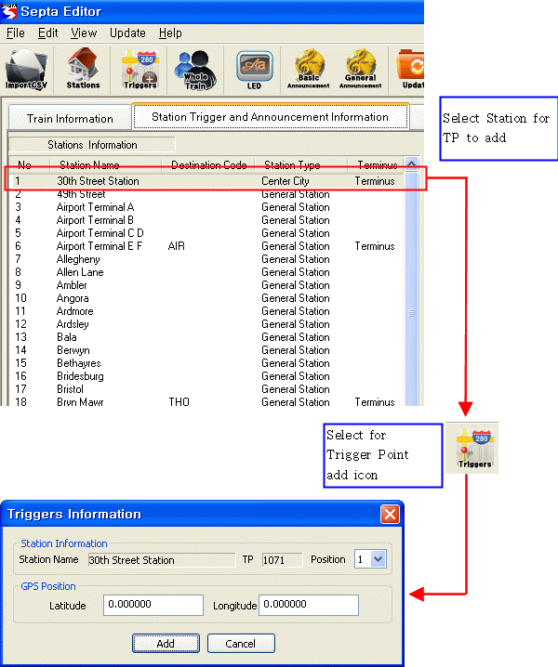
Select additional Trigger Position. Select button, new trigger point information will be created.

※ Trigger Point Reference
TP1 |  | TP2 |  | TP3 |  | TP4 |  | TP5 |  | TP6 |  | TP7 |  | TP8 |  | TP9
General  broadcast |  | General  broadcast |  | This broadcast |  | Next broadcast |  | Station |  | Next broadcast |  | This broadcast |  | General  broadcast |  | General  broadcast
 |  |  |  | Basic broadcast |  | Basic  broadcast |  | Whole Train  broadcast |  | Basic  broadcast |  | Basic  broadcast

Edit Trigger Point information
Performance Method: Double click desired to modify Trigger Point, then it will be displayed information of Trigger Point.
[Figure 3.2.4-A. Edit Trigger Point ]
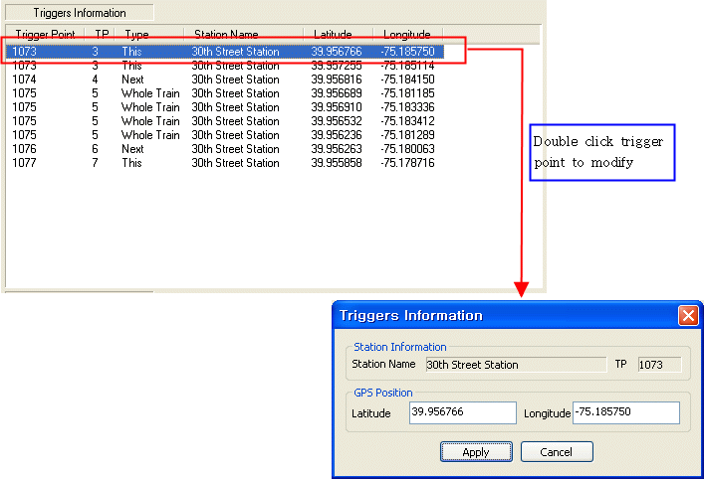

Latitude: Input latitude on GPS coordinates.
Longitude: Input longitudes on GPS coordinate.
Inputted longitude and latitude will be applied when selected apply button.

Deleting Trigger Point information
Performance method: Select desired to delete trigger point in Triggers Information section, select “DELETE” Key.
[Figure 3.2.5-A. Delete Trigger Point]
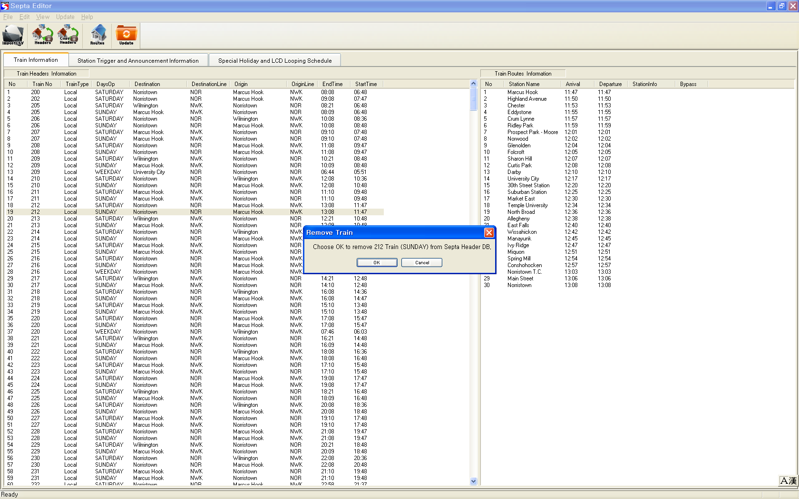
When select OK button designated trigger is deleted.

Edit Whole Train information
Editing information of whole train is available.
Performance Method: Click on icon after selecting whole train information to be modified or select Edit->Modify Whole Train Information or double click at Whole Train.
[Figure 3.2.6-A Eidt Whole Train information]
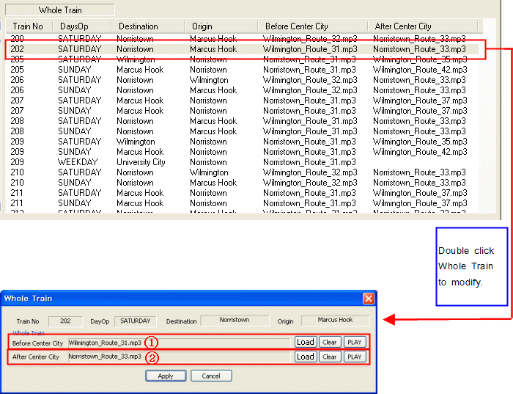
① Displays the announcements from the origin station to Center City.
② Displays the announcements from Center City to Destination station.
Selecting Whole Train sound source is available when selected .
[Figure 3.2.6-B Eidt Whole Train information]
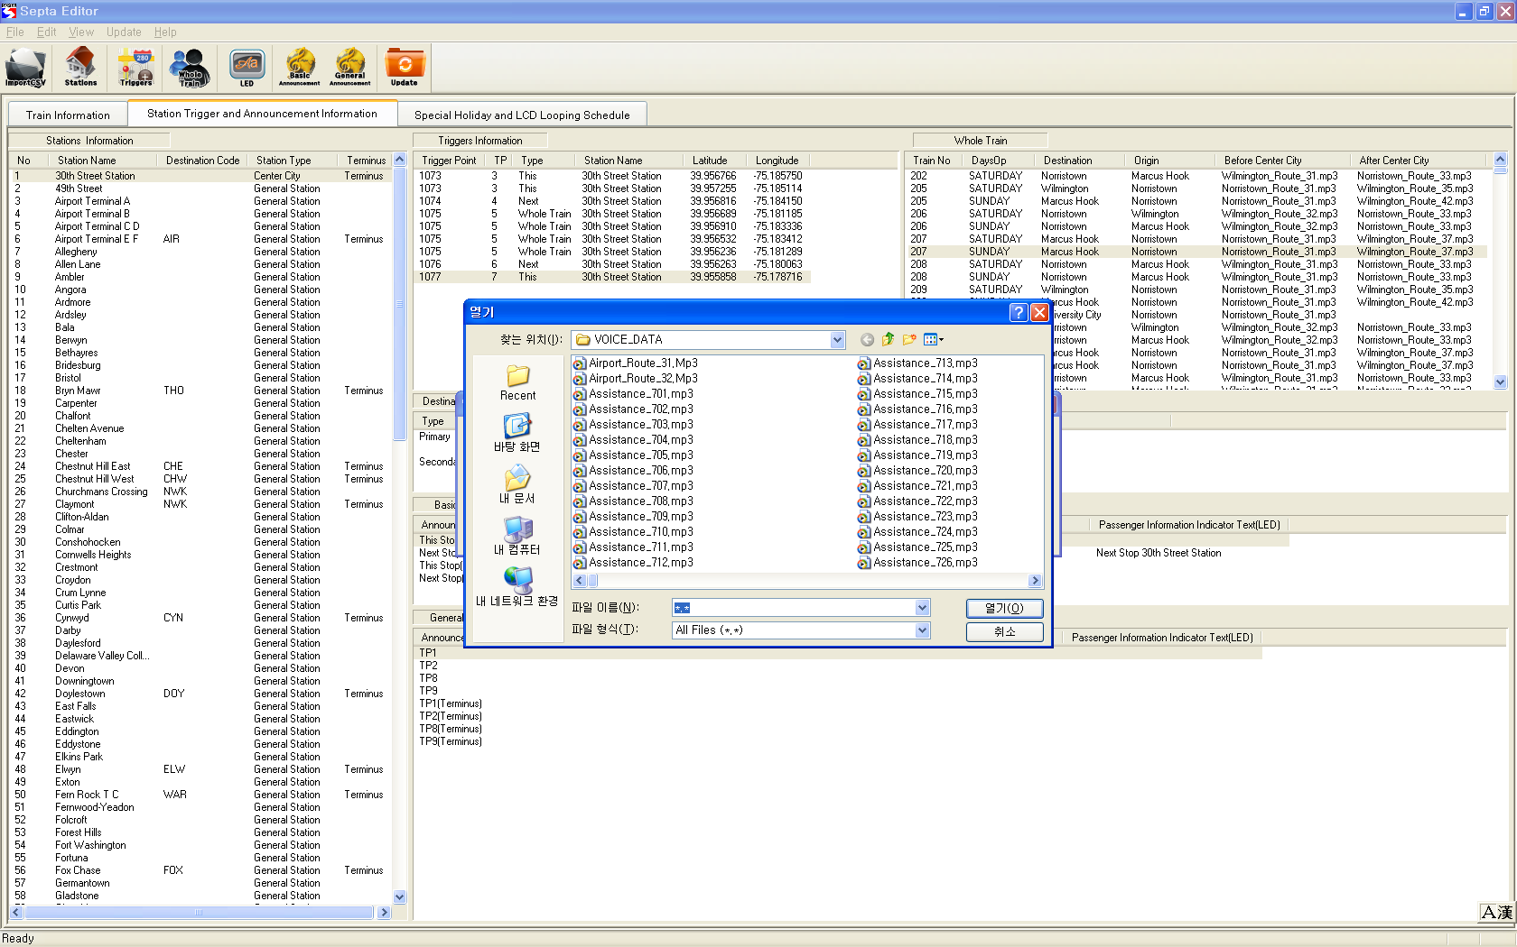
Clears designated whole train sound source when selected.

[Figure 3.2.6-C. Eidt Whole Train information]
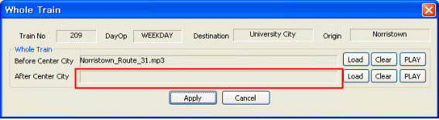
Plays designated whole train sound source when selected.

Editing LED (FDI, SDI) information
Click on 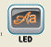 icon or select Edit Modify Destination. Double click at destination indicator.

[Figure 3.2.7-A Edit Destination Indicator]
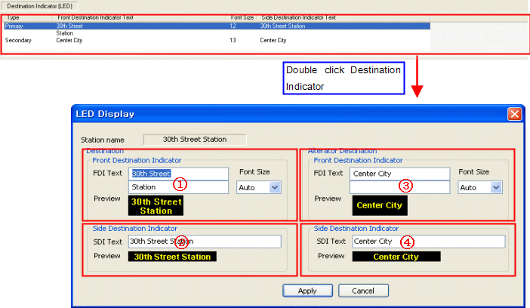

In case of Destination name used as a single station
① Front Destination Indicator (FDI)
- Inputs destination station text that will be displayed on FDI.
② Side Destination Indicator (SDI)
- Inputs destination station text that will be displayed on SDI.

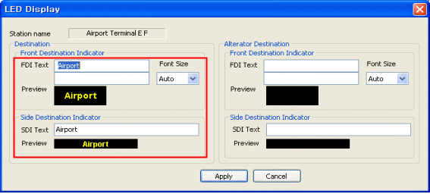[Figure 3.2.7-B. Destination Indicator- single station]

In case of destination name used as multiple station
① Front Destination Indicator (FDI)
- Inputs destination station text that will be displayed on FDI.
② Side Destination Indicator (SDI)
- Inputs destination station text that will be displayed on SDI.
③ Front Destination Indicator (FDI)
- Inputs final station text.
④ Side Destination Indicator (SDI)
- Inputs destination station text that will be displayed on SDI.

[Figure 3.2.7-C. Destination Indicator-Multiple stations]
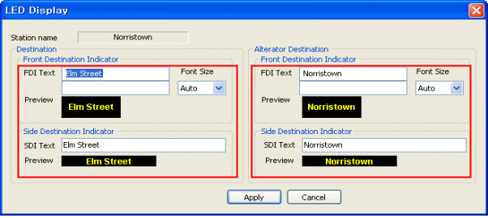

3.2.7.3 Modifying font size of (final) destination name
- Font Size
· Set-up desired font size when entry final station in single line.
[Figure 3.2.7-D. Modify font size]
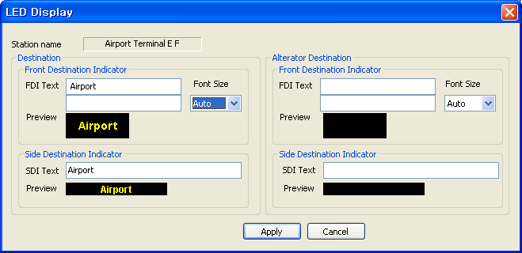
· When set font size as 23.

[Figure 3.2.7-E. Modify font size]
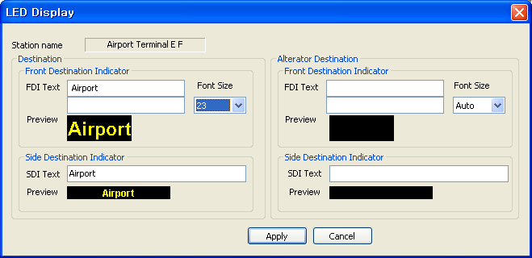
*** If letter font size is invalid value, it will not display on LED display due to invalid value.

[Figure 3.2.7-F. Modify font size]
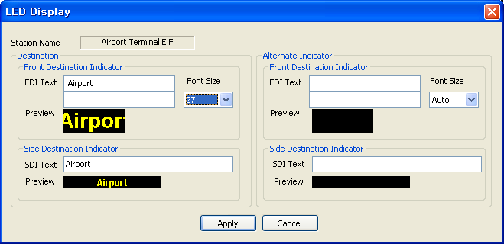

※ Edit font size only sing line of FDI. (Not available alternate destination)

Edit Station info. Announcement (This Stop/Next Stop)
Click on icon after announcement location to be modified or select Edit Modify Basic Broadcast or double click at station broadcast.
[Figure 3.2.8-A Station Announcement]
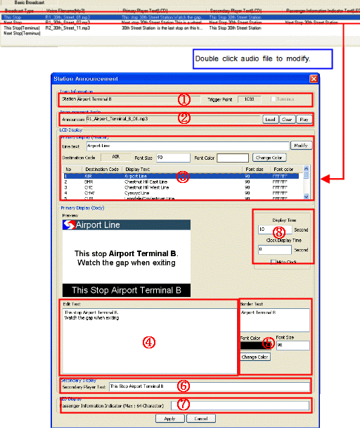
- Train Information :
Displays station name that will be modified and trigger point.
- Voice Information: Displays selected audio file of trigger point.
- Select button to select from any directory an MP3 file announcement to be associated with this trigger.
- Select button to remove the announcement currently loaded.
- Select button to listen to the designated audio file.
- Primary Player (Header)
- Modifying line name that will be displayed on the upper part of Primary Player is available.
-Line Text: Select Destination Code and modify Text color.
-Font Size: Modify Font size.
- Primary Player (Body)
Input text that will be displayed on Primary Player at Edit Text.
- Bolder Text
Font Color: Modifying color by selecting button is available.
- Secondary Player
Input text that will be displayed on Secondary Player.
- LED Display
Input text that will be displayed on Passenger Indicator Text. The characters are limited to 64. It will be changed to modified text and sound source when selected button.

Holiday and Video Schedule Management

Special Holiday and LCD Looping Schedule

[Figure 3.3.1-A Special Holiday and LCD Looping Schedule]
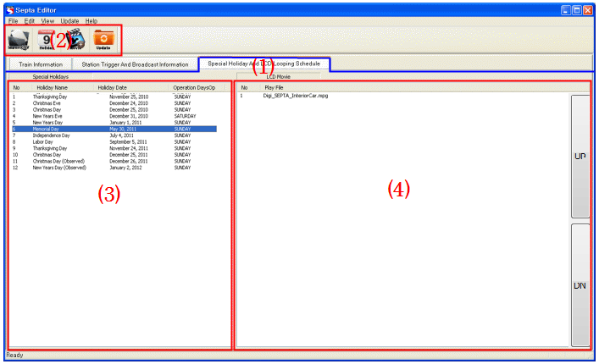
- Special Holiday and LCD Looping Schedule Function
- Editing holiday information is available.
- Editing LCD video information is available.
- Menu Icon
Icon | Icon Name | Contents
 | Import CSV | Import CSV (Figure 3.4 )
 | Holiday | Edit Holiday information
 | Movie | Edit Video information
 | Update | Create Update Data (Figure 3.4 )

- Special Holidays
Displays registered information of Special Holiday to change into different schedule.

[Figure 3.3.1-B]
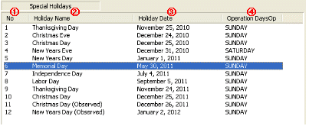

- No (Numerical order)
- Holiday Name: Displays designated holiday name.
- Holiday Date: Displays designated date of holiday.
- Operation DaysOp: Displays the day to be modified on designated holiday.

- LCD Movie
Show updated (listed) video information in LCD. Up and down scroll can change play list sequence of movie file.

[Figure 3.3.1-A LCD movie]
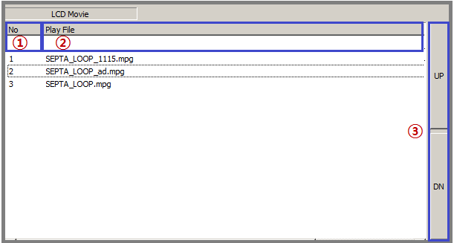
- No (Numerical order)
- Play File: Displays video information that will be played on LCD Display.
- UP and DN scroll: It can change play list sequence.

Holiday information addition
Click on icon or select Edit Define Holiday or double click at Special Holidays.
[Figure 3.3.2-A Edit Holiday Information]
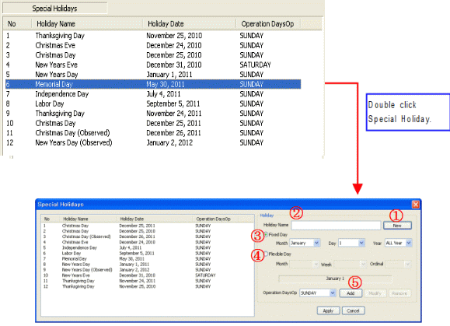
- Select New.
- Holiday Name: Input holiday name.
- Select date of holiday to be set up.
Fixed Day: Use for fixed holiday.
Ex) July 4th or December 25th
Flexible Day: Use specific weeks or months.
Ex) Forth Thursday of November
- Select desire to change day of train service.
- Select Add button.

Video file addition
Click on icon or select Edit Add Movie.
- Setting up and editing holiday management and video schedule file are available.
[Figure 3.3.3-A Add Video file]
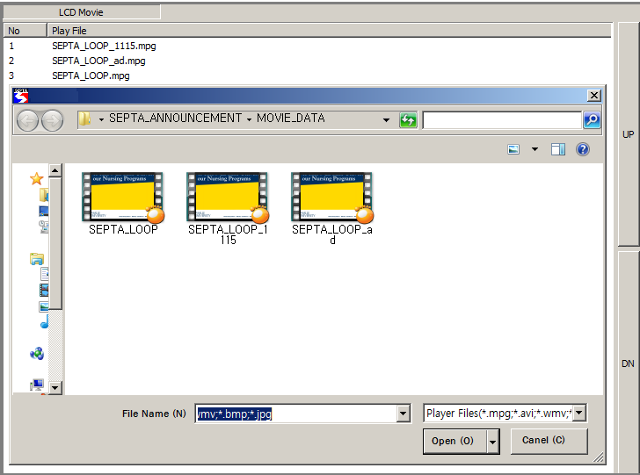

Delete video file
Performance Method: Select “DELETE” Key after selecting video data to be deleted at LCD Movie.
[Figure 3.3.4-A Delete Video file]
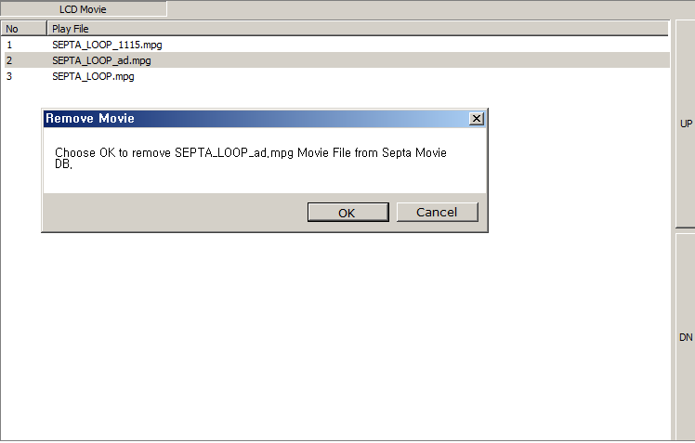
Selected video will be deleted when selected OK button.

Play video file (Preview)
To preview updated (Listed) video file, select the video file and right click. Note that this will use Windows Media Player; ensure you have the necessary codecs loaded on your PC.

[Figure 3.3.5-A. Video file Preview]
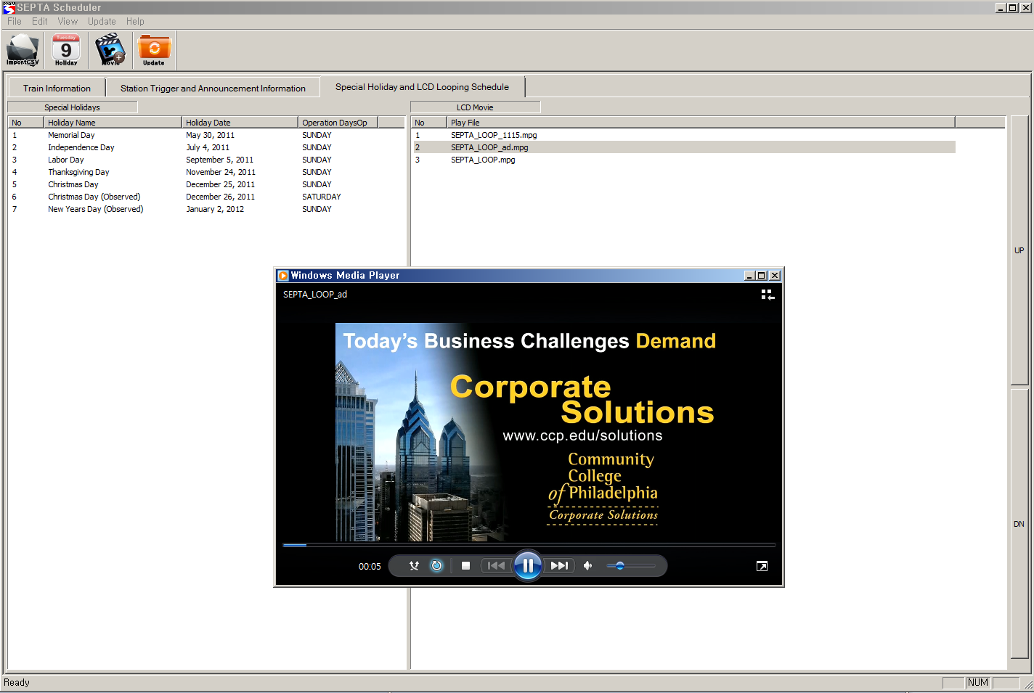

CSV File Loading, Update file creation
[Figure 3.4-A CSV Loading]
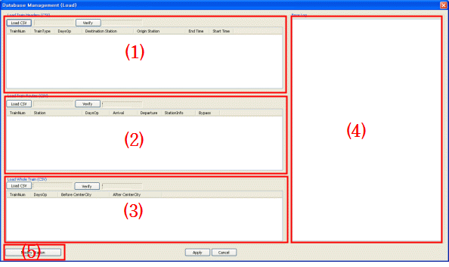

Import CSV
Loading CSV file of Train Header, Train Routes, and Whole Train information and re-create data in current editor.
Performance method: click or, select File Import CSV.
- Load Train Headers:
[Figure 3.4.1-A Inport CSV]
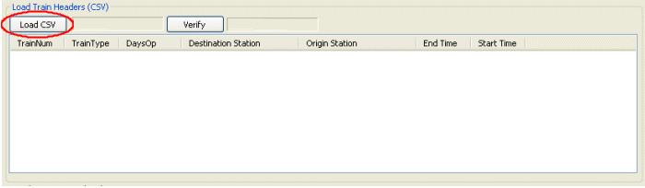
- Loading Train Headers information.
[Figure 3.4.1-B. Train Headers Information]
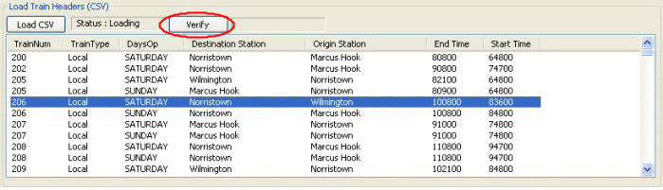
- After Load CSV button, selcet Headers.CSV file to read.

[Figure 3.4.1-C. Train Headers Information]
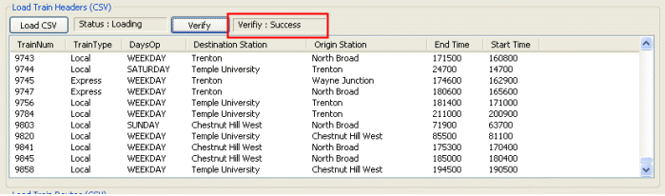
    - Selecting the Verify button will confirm that selected data is valid. (Note that if validity fails, it will be necessary to edit the source CSV file)
※ CSV detailed information, verification method: (Refer: 3.4.2 CSV file format)
(2) Load Train Routes
[Figure 3.4.1-D. Train Routes]
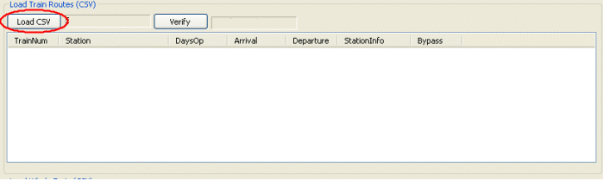
- Load train routes information as CSV file.

[Figure 3.4.1-E Verify Train Routes data]
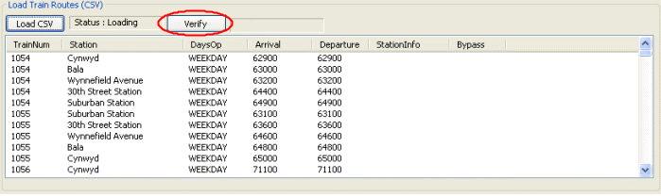
    - After Load CSV button, selcet Routes.CSV file to read.
[Figure 3.4.1-F. Verify Train Routes data]
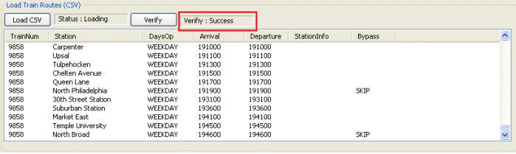
    - Selecting the Verify button will confirm that selected data is valid. (Note that if validity fails, it will be necessary to edit the source CSV file)
※ Detailed CSV information, verification method: (Refer: 3.4.2 CSV file format)

(3) Load Whole Train
[Figure 3.4.1-G Wole Train data]
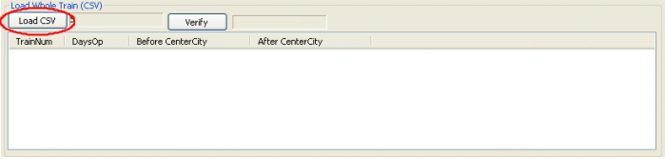
- Loads whole train information as CSV file.
[Figure 3.4.1-H. Verify Whole Train data]
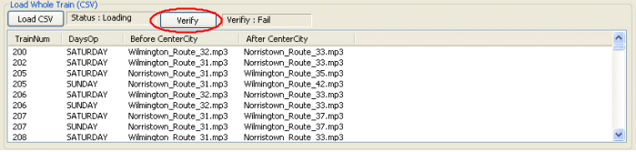
- After Load CSV button, select WholeTrain.CSV to load. (Loading Whole Train Information)
- [Figure 3.4.1-I. Verify Whole Train data]
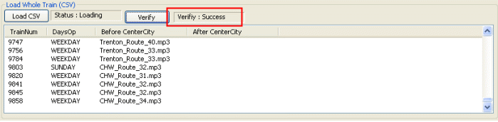
② Selecting the Verify button will confirm that selected data is valid. (Note that if validity fails, it will be necessary to edit the source CSV file)
※ Detailed CSV information, verification method: (Refer: 3.4.2 CSV file format)
(4) Error Log: When CSV file is not match with DB format, indicate log file. (Loading CSV)
[Figure 3.4.1-J. Error Log]
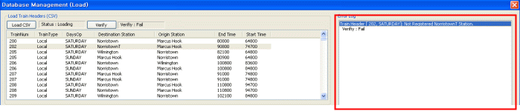

(5) If current station doesn't register in DB, then register station name by using Modify Station section. (Refer 3.2: station name. trigger, announcement infomation)

[Figure 3.4.1-K. Modify-Station Information]
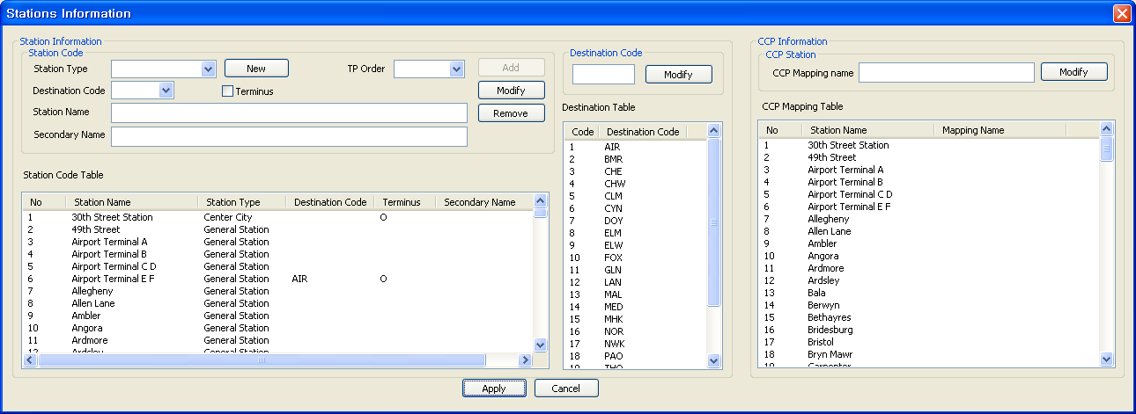
※ Detailed CSV information, verification method: (Refer: 3.4.2 CSV file format)

CSV File Format

3.4.2.1 Headers CSV File Format (Headers.CSV)
Operation schedule format is following table, actual use is blue and red section.

[Figure 3.4.2-A. Hearders CSV file format]
Active  Train | Train  Num | Train  Ver | Train  Type | DaysOp | Destination | Dest  Line  Code | Origin | Origin  Line  Code | Path | EndTime | StartTime
A | 200 | 6 | Local | SATURDAY | Norristown | NOR | Marcus Hook | WIL | R2/6N | 80800 | 64800
A | 202 | 6 | Local | SATURDAY | Norristown | NOR | Marcus Hook | WIL | R2/6N | 90800 | 74700
A | 205 | 6 | Local | SATURDAY | Wilmington | WIL | Norristown | NOR | R6/2S | 82100 | 64800
A | 205 | 7 | Local | SUNDAY | Marcus Hook | WIL | Norristown | NOR | R6/2S | 80900 | 64800
A | 206 | 6 | Local | SATURDAY | Norristown | NOR | Wilmington | WIL | R2/6N | 100800 | 83600
A | 206 | 7 | Local | SUNDAY | Norristown | NOR | Marcus Hook | WIL | R2/6N | 100800 | 84800
A | 207 | 6 | Local | SATURDAY | Marcus Hook | WIL | Norristown | NOR | R6/2S | 91000 | 74800
A | 207 | 7 | Local | SUNDAY | Marcus Hook | WIL | Norristown | NOR | R6/2S | 91000 | 74800
A | 208 | 6 | Local | SATURDAY | Norristown | NOR | Marcus Hook | WIL | R2/6N | 110800 | 94700
A | 208 | 7 | Local | SUNDAY | Norristown | NOR | Marcus Hook | WIL | R2/6N | 110800 | 94700

- Essential data (Blue and Red section)
Train number, train type, day, terminus, origin, Arrival time, departure time
- Verify condition (Red section)
- Confirm train Type consists of Local, Express, Limit, SEPTA.
- Confirm DaysOp consists of WEEK, FRIDAY, SATURDAY, and SUNDAY.
- Confirm final station is registered in DB.
- Confirm Origin station is registered in DB.
3.4.2.2 Routes CSV File Format (Routes.CSV)

[Figure 3.4.2-B. Routes CSV file format]
Active  Station | Train  Num | Train  Ver | Path | Station | DaysOp | Arrival | Departure | StationInfo | Bypass
A | 1295 | 5 | R2SPC | Suburban Station | WEEKDAY | 52600 | 52600
A | 1295 | 5 | R2SPC | 30th Street Station | WEEKDAY | 53100 | 53100
A | 1295 | 5 | R2SPC | University City | WEEKDAY | 53300 | 53300
A | 1295 | 5 | R2SPC | Darby | WEEKDAY | 53900 | 53900 |  | SKIP
A | 1295 | 5 | R2SPC | Curtis Park | WEEKDAY | 54000 | 54000 |  | SKIP
…
A | 1295 | 5 | R2SPC | Newark | WEEKDAY | 62600 | 62600
A | 1456 | 5 | R1N-V | Airport Terminal E F | WEEKDAY | 190900 | 190900
A | 1456 | 5 | R1N-V | Airport Terminal C D | WEEKDAY | 191100 | 191100
A | 1456 | 5 | R1N-V | Airport Terminal B | WEEKDAY | 191200 | 191200
A | 1456 | 5 | R1N-V | Airport Terminal A | WEEKDAY | 191300 | 191300
A | 1456 | 5 | R1N-V | Eastwick | WEEKDAY | 191700 | 191700
A | 1456 | 5 | R1N-V | University City | WEEKDAY | 192700 | 192700 | DISCHARGES
A | 1456 | 5 | R1N-V | 30th Street Station | WEEKDAY | 193000 | 193000 | DISCHARGES

- Essential data (Blue and Red section)
Train number, day, Before Center City announcement, After Center City announcement
- Verify condition (Red section)
- Confirm station is registered in DB.
- Confirm DaysOp consists of WEEK, FRIDAY, SATURDAY, and SUNDAY.
- Confirm Station Info matchS with CONNECT, DISCHARGE, FLAG STOP.

3.4.2.3 WholeTrain CSV File Format (WholeTrain.CSV)

[Figure 3.4.2-C. Whole Train CSV file format]
TrainNum | DaysOp | Before Center City | After Center City
200 | SATURDAY | Wilmington_Route_32.mp3 | Norristown_Route_33.mp3
202 | SATURDAY | Wilmington_Route_31.mp3 | Norristown_Route_33.mp3
205 | SATURDAY | Norristown_Route_31.mp3 | Wilmington_Route_35.mp3
205 | SUNDAY | Norristown_Route_31.mp3 | Wilmington_Route_42.mp3
206 | SATURDAY | Wilmington_Route_32.mp3 | Norristown_Route_33.mp3
206 | SUNDAY | Wilmington_Route_32.mp3 | Norristown_Route_33.mp3
207 | SATURDAY | Norristown_Route_31.mp3 | Wilmington_Route_37.mp3
207 | SUNDAY | Norristown_Route_31.mp3 | Wilmington_Route_37.mp3
208 | SATURDAY | Wilmington_Route_31.mp3 | Norristown_Route_33.mp3
208 | SUNDAY | Wilmington_Route_31.mp3 | Norristown_Route_33.mp3
209 | SATURDAY | Norristown_Route_31.mp3 | Wilmington_Route_35.mp3
209 | SUNDAY | Norristown_Route_31.mp3 | Wilmington_Route_42.mp3
209 | WEEKDAY | Norristown_Route_31.mp3
210 | SATURDAY | Wilmington_Route_32.mp3 | Norristown_Route_33.mp3
210 | SUNDAY | Wilmington_Route_32.mp3 | Norristown_Route_33.mp3
211 | SATURDAY | Norristown_Route_31.mp3 | Wilmington_Route_37.mp3
211 | SUNDAY | Norristown_Route_31.mp3 | Wilmington_Route_37.mp3
212 | SATURDAY | Wilmington_Route_31.mp3 | Norristown_Route_33.mp3

- Essential data (Blue and Red section)
Train number, day, Before Center City announcement, After Center City announcement
- Verify Condition (Red section)
- Confirm station is registered in DB.
- Confirm DaysOp consists of WEEK, FRIDAY, SATURDAY, and SUNDAY.
- Confirm Station Info matchS with CONNECT, DISCHARGE, FLAG STOP.

Update: Creates downloadable file on train.
Performance Method: Click on  icon or select Update Create Update.
[Figure 3.4.3-A. Update data]
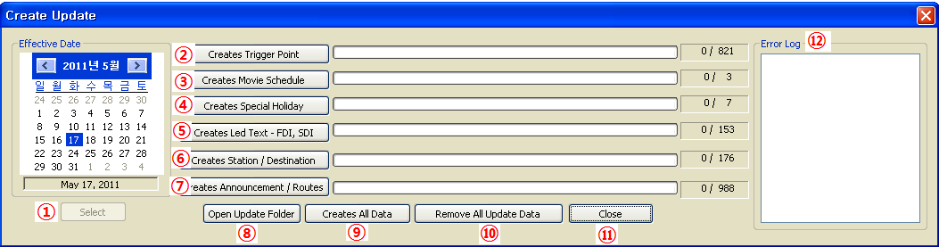
- Effective Date
Select effective data and press select button. Update process will be activated as selected date.
- Creates Trigger Point
Creates trigger point that will be updated on CCP.
- Creates Movie Schedule
Creates video and list information those will be updated on LCD.
- Creates Special Holiday
Create holiday information. It will be updated on CCP.
- Creates Led Text
· Front Destination Indicator or Side
· Creates destination image on Destination indicator
- Creates Station / Destination
· Creates station information that will be updated on CCP.
- Creates Announcement / Routes (It takes long time of creation data)
· Creates sound source that will be update on PAC.
· Creates text message that will be updated on PII.
· Creates route that will be updated on CCP.
- Open Update Folder: Opens created update folder.

[Figure 3.4.3-B. Process Update data]
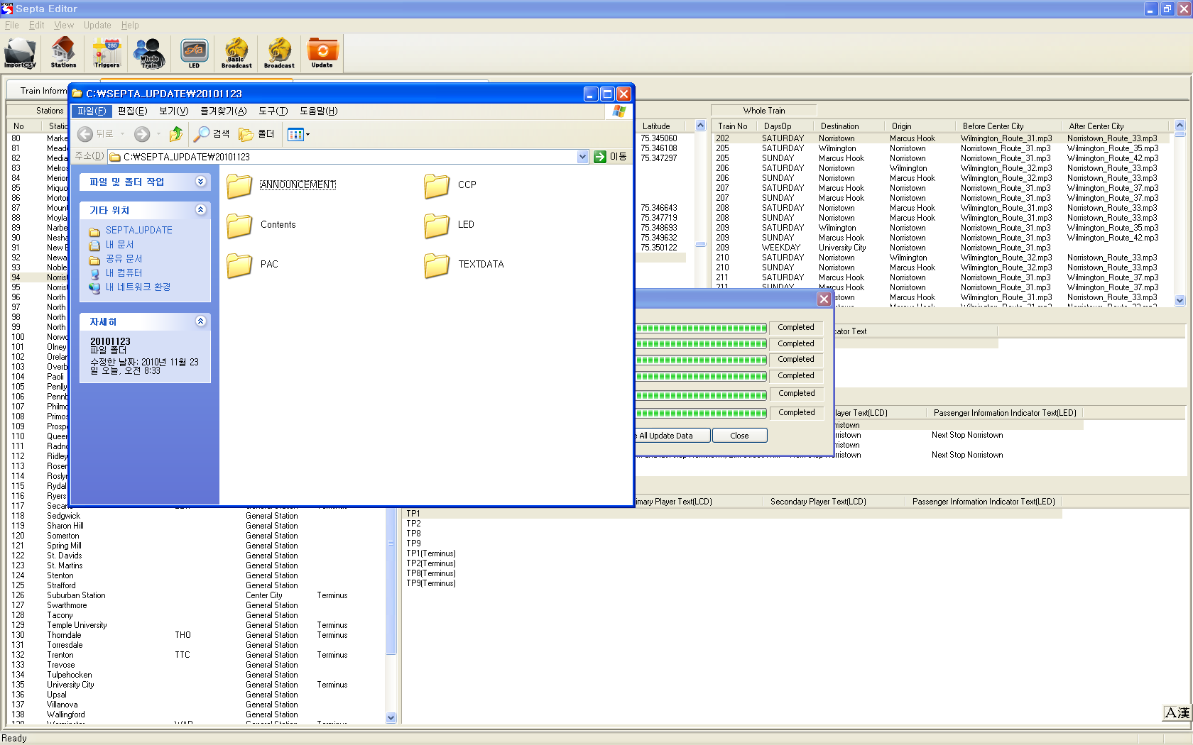

· Local Drive: Update file opens created folder. (C:\SEPTA_UPDATE\YYYYMMDD)
· Network Drive: Update file opens created folder. (X:\SEPTA_UPDATE\YYYYMMDD)
- Creates All Data
· Create all data through ① to ⑦ process.
- Remove All Update Data
· Deleted previous updated data. (Today date)
· Local Drive: Update file deletes created folder. (C:\SEPTA_UPDATE\YYYYMMDD)
· Network Drive: Update file deletes created folder. (X:\SEPTA_UPDATE\YYYYMMDD)
- Close
· Close update window.
- Error Log
·. Error log section displays a message when wrong file type or error occurs.

Group update: Independent unit update by device
- In case of modifying only GPS coordinate
· Creates Trigger point
- In case of editing only holiday (Add, delete)
· Creates Special Holiday
- In case of modifying only video data (uploading)
· Creates Movie Schedule
- In case of modifying only destination text
· Creates Led Text
· Creates Station and Destination (SEPTA DB register only)

Required whole update
- Modified audio file include whole train announcement.
- Adding train service route

Data Composition

Folder Composition

Raw Data Folder
There are two types of raw data in DB Scheduler. (SEPTA_ANNOUNCEMENT, SEPTA_DB)

- SEPTA_ANNOUNCEMENT

[Diagram 4.1.1-A SEPTA_ANNOUNCEMENT composition]

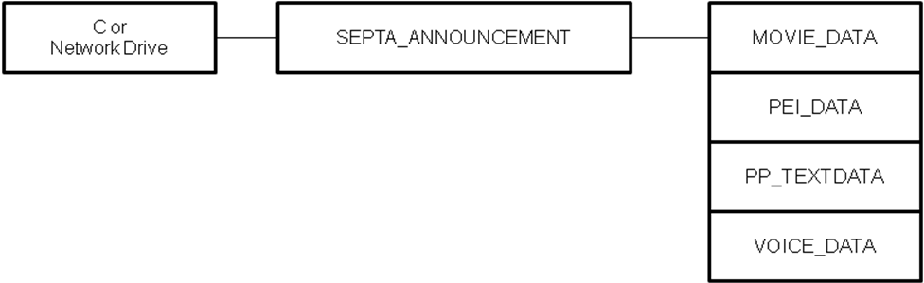

- MDB file: SEPTA.mdb is database file and include all operation information.

[Diagram 4.1.1-B DB files composition]

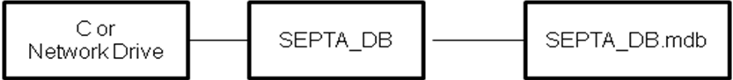

Raw Data Information
[Diagram 4.1.2-A. DB files composition]

Folder Name | Contents
MOVIE_DATA | Video Data
PEI_DATA | PEI Call MP3 data
PP_TEXTDATA | Primary Display Text Data
VOICE_DATA | Station Announcement MP3 data

PEI_DATA: Followings are the form of PEI call file.
- Create PEI Call for train number as 00 + 4 digit train NO.mp3.
Ex) Train 901 -> 000901.mp3
- Local Drive: Copy created data to C:\SEPTA_ANNOUNCEMENT\PEI_DATA.
Network Drive: Copy created data to X:\SEPTA_ANNOUNCEMENT\PEI_DATA.
- Local Drive: Final path should be C:\SEPTA_ ANNOUNCEMENT\PEI_DATA\000901.mp3.
Network Drive: Copy created data to X:\SEPTA_ANNOUNCEMENT\PEI_DATA\000901.mp3.
(It should create manually.)
MOVIE_DATA: Video to be played on LCD will be stored. (Mpeg, AVI, Wmv, Bmp, JPG)
(Creates automatically at editor)
- Local Drive: Created data to C:\SEPTA_ANNOUNCEMENT\MOVIE_DATA.
- Network Drive: Created data to X:\SEPTA_ANNOUNCEMENT\MOVIE_DATA.
PP_TEXTDATA: In case of Primary Display Text, it will be created automatically when it edits in DB scheduler.
(Creates automatically at editor)
- Local Drive: Created data to C:\SEPTA_ANNOUNCEMENT\PP_TEXTDATA.
- Network Drive: Created data to X:\SEPTA_ANNOUNCEMENT\PP_TEXTDATA.
VOICE_DATA: Stores all announcement sound audio file except for the whole train announcement and PEI Call.
- Local Drive: Created data to C:\SEPTA_ANNOUNCEMENT\VOICE_DATA.
- Network Drive: Created data to X:\SEPTA_ANNOUNCEMENT\VOICE_DATA.

- MP3 file format
- This Stop: Destination Name(Code)_Station Name_01.MP3
Ex) CHE_Sedgwick_01.MP3
- This Stop Terminus: Destination Name(Code)_Station Name_11.MP3
Ex) Norristown_University_City_11.MP3
- Next Stop: Destination Name_Station Name(Code)_02.MP3
Ex) Lansdale_Fort_Washington_02.MP3
- Next Stop Terminus: Destination Name_Station Name(Code)_12.MP3
Ex) W_Trenton_West Trenton_12.MP3

Update Folder Composition
[Diagram 4.1.3-A Update Folder composition]

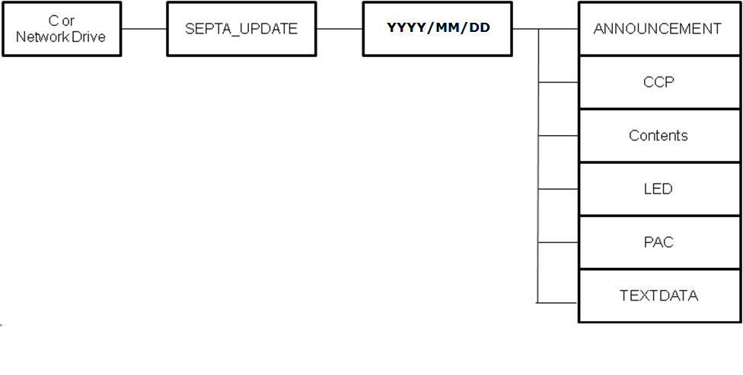
*** Update folder composition applies same path to [SEPTA Scheduler SEPTA office Yard DB Copy CNCS].

DB Folder Information
ANNOUNCEMENT | Primary Player display text data
CCP | Information of station, Trigger Point, Route, Terminus, Holiday  CCP_config.nod, CCP_holiday.nod, CCP_schedule.nod, CCP_station.nod, CCP_trainline.nod, CCP_trigger.nod
Contents | Video Play file data
LED | FDI, SDI, PII Display Data
PAC | Whole Train and station announcement MP3 data
TEXTDATA | Secondary Player display text data

