THE DRAWING(S) AND THE INFORMATION CONTAINED HEREIN ARE THE PROPERTY OF WOOJIN INDUSTRIAL SYSTEMS CO., LTD. THEY SHALL NOT BE DISCLOSED, REPRODUCED OR USED, IN ANY MANNER WITHOUT THE PRIOR WRITTEN CONSENT OF WOOJIN INDUSTRIAL SYSTEMS CO., LTD. |  | DESIGN QUALIFICATION  TEST PROCEDURE  FOR  COMMUNICATION SYSTEM
DISTRIBUTION |  | R  E  V  I  S  I  O  N
 |  | R  E  V  I  S  I  O  N | 1 | Nov. 30, 2011 |  | Document revised |  |  | D.B. LEE | D.S. JANG | B.J. JONE | E.K. LEE
 |  | R  E  V  I  S  I  O  N | 0 | Oct. 14, 2011 |  | First Issued |  |  | D.B. LEE | D.S. JANG | B.J. JONE | E.K. LEE
 |  | R  E  V  I  S  I  O  N | No. | ISSUED  DATE |  | REVISION NOTE |  |  | DESIGNED | CHECKED | APPROVED | REVIEWED
 |  |  |  |  |  |  |  |  | ENGINEERING |  |  | PM
 |  | PM |  |  | REVIEWED |  | E.K. LEE |  | CUSTOMER :
 |  | ENGINEERING |  |  | APPROVED |  | B.J. JONE |  | HYUNDAI-ROTEM COMPANY
 |  |  |  |  | CHECKED |  | D.S. JANG
 |  |  |  |  | DESIGNED |  | D.B. LEE |  | PROJECT :
 |  | ISSUED DATE |  |  | October 14, 2011 |  |  |  | DENVER RTD EAGLE P3  COMMUNICATION SYSTEM
 |  | ISSUED BY |  |  | R & D CENTER
 |  | PROJECT NO. |  |  | P2011-020
 |  | ORDER NO. |  |  | P110701149 |  |  |  | 
 |  | DOCUMENT NO. |  |  |  |  |  | REVISION
 |  | 423-316 |  |  |  |  |  | 1
TOTAL |  |  |  |  |  |  |  | 1
REVISION RECORD
Rev.  No. | PAGE | Details |  |  | Date
Rev.  No. | PAGE | FROM |  | TO | Date
0 |  | First Issued |  |  | October 14, 2011
1 | 8 | IEC 62236-3-2 Tab 7 |  | IEC 60571 | November 30, 2011
1 | 9 | IEC 62236-3-2 Tab 9 |  | IEC 61373 | November 30, 2011
1 | 10 | IEC 62236-3-2 Tab 7, 8 |  | IEC 60529 | November 30, 2011
1 | 37 | 6 kV, 8 kV |  | ±6 kV, ±8 kV | November 30, 2011
1 | 39 | 800MHz – 960MHz  1400MHz – 2000MHz  1kHz, 80% AM |  | 20V 800 – 1000MHz  10V 1400 – 2100MHz  5V 2100 – 2500MHz | November 30, 2011
1 | 41 | 2 kV |  | ±2 kV, deleted remarks and notes | November 30, 2011
1 | 44 | 5.4.7.1 |  | Deleted IEC 62236-3-2 Tab 7 | November 30, 2011
1 | 45 | 5.4.8.1: IEC 60571 |  | IEC 61000-4-5 Deleted Figure 5.8.2-2 | November 30, 2011
1 | 46 | 5.4.8.2: 1.8 kV waveform 5/50 µs Source impedance 100Ω |  | 1.2/50 µs  ±2 kV L-G  ±1 kV L-L | November 30, 2011
Table of Contents

1. Overview 5
2. Test Equipment 5
2.1 Test equipments and special tools. 5
2.2 System Components 5
2.2.1 Test Components 5
3. Test Procedures 6
3.1 Schedule of Tests (Application) 6
3.1.1 Visual Inspection 7
3.1.2 Dimension Inspection 7
3.1.3 Weight Inspection 7
3.1.4 Insulation Resistance Test 7
3.1.5 Dielectric Test 7
3.1.6 Performance Test 8
3.1.7 Speech Intelligibility Test 8
3.1.8 EMC Test 9
3.1.9 Temperature Test 9
3.1.10 Shock & Vibration Test 10
3.1.11 Dust / Waterproof Test 10
3.2 Functional Test Procedure Checklist 12
3.3 Power variation Test Checklist 18
3.4 Speech Intelligibility Test 20
4. APPENDIX 1. 21
4.1 Definitions and abbreviations 21
4.1.1 Definitions 21
4.1.2 Abbreviations 22
4.2 Test Items 22
4.3 EUT of CS (Communication System) 23
4.3.1 CCS (Communication Control System) 23
4.3.2 PAS (Passenger Announcement System) 23
4.3.3 LED PIS (LED Passenger Information System) 24
4.3.4 LCD PIS(LCD Passenger Information System) 24
4.4 Electromagnetic compatibility test 25
4.4.1 Conducted emissions 25
4.4.2 Radiated emissions 26
4.4.3 Electrostatic discharge immunity test – Enclosure ports 26
4.4.4 Radiated radio frequency electromagnetic field immunity test 29
4.4.5 Electrical Fast Transient/Burst immunity test 30
4.4.6 Conducted radio frequency electromagnetic field immunity test 31
4.4.7 Power Variation and Interruption test 34
4.4.8 Surge test 34

- Overview
This examination is carried out to verify that all Woojin’s Electronic deliverables fulfill technical and functional specifications detailed in the DENVER RTD TS (Conformed Version, March 2010) Part C Rolling Stock Requirements and all approved Specification Changes.

- Test Equipment
  - Test equipments and special tools.
Following measuring instruments and special tools will be used for the test:
- Insulation resistnace tester
- Withstand voltage tester
- Digital calipers
- Multi-meter
- Digital weight scale
- AC power supply
- DC power supply
- Sound level meter
- Tone generator
- Audio analyzer
- Power resistance array (10W, 8Ω)
- Speech intelligibility test equipment
- Tape measure
- OCC simulator
- Cab LED indicator dimming control box

  - System Components
    - Test Components

Component Name | Woojin  Part # | Test Train Consist |  | Total Q’ty
Component Name | Woojin  Part # | Married A  4  2  4  4  4  2  4  2  2  2  2  2  2  2  2  2  2  2  2  2  2 | Married B  2  4  4  4  4  4  6  16  8  8  2  8  8  4  4  4  8  4  8  4  - | Total Q’ty
Communication Control Panel (CCP) | R1D1473-25842 | 1 | 1 | 2
Communication Rack A (CRA) | R1D1473-25838 | 1 | 1 | 2
Driver PA Operation Box (DPO) | R1D1473-25854 | 1 | 1 | 2
Driver PA Handset(DPH) | R1D1473-26838 | 1 | 1 | 2
Passenger Emergency Intercom1 (PEI1) | R1D1473-25856 | 2 | 2 | 4
Passenger Emergency Intercom2 (PEI2) | R1D1473-25855 | 2 | 2 | 4
Exterior Microphone Box(EMB) | R1D1473-25870 | 2 | 2 | 4
Cab Speaker (CSP) | R1D1473-25859 | 1 | 1 | 2
Interior Speakers (ISP) | R1D1473-25857 | 8 | 8 | 16
Exterior Speakers (ESP) | R1D1473-25858 | 4 | 4 | 8
Transformer (TRF) | R1D1473-25866 | 4 | 4 | 8
ANS Microphone (ANSM) | R1D1473-25864 | 2 | 2 | 4
Front Destination Indicator (FDI) | R1D1473-25849 | 1 | 1 | 2
Side Destination Indicator (SDI) | R1D1473-25850 | 4 | 4 | 8
Passenger Information Indicator (PII) | R1D1473-25853 | 2 | 2 | 4
Passenger Information Display 1 (PID-1) | R1D1473-25851 | 4 | 4 | 8
Passenger Information Display 2 (PID-2) | R1D1473-25852 | 1 | 1 | 2
Gooseneck Microphone(GNM) | R1D1473-25863 | 1 | 1 | 2
Jumper Coupler Plug(JCP) | R1D1473-25868 | 1 |  | 1
Jumper Coupler Receptacle(JCR) | R1D1473-25869 | 1 | 1 | 2

- Test Procedures

  - Schedule of Tests (Application)
The following chart provides a list of the test types that will be performed throughout the various stages of the design, manufacturing, and delivery processes.

No | Test Name |  | Pre-Production  (Type Test) | FAI | Routine  Production
1 | Visual Inspection |  | O | O | O
2 | Dimension Inspection |  | O | O | O
3 | Weight Inspection |  | O | O | -
4 | Insulation Resistance Test |  | - | O | O
5 | Dielectric Test |  | - | O | O
6 | Performance  Test | Functional Test(s) | - | O | O
6 | Performance  Test | Power Variation Test | - | O | -
7 | Speech Intelligibility Test |  | - | O | -
8 | EMC Test |  | O
9 | Environment Temperature Test |  | O | - | -
10 | Shock & Vibration test |  | O | - | -
11 | Dust/Waterproof Test |  | O | - | -
12 | Burn-in Test |  | O | - | O

- GM, JCP and JCR only take test #1, 2, 3.
    - Visual Inspection
The Visual Inspection is performed to ensure that the quality of materials, the coating condition, the plug in condition of connector, and the installation of all components has been done according to the approved Mechanical Drawings. (Doc. No.: 423-323)

    - Dimension Inspection
The Dimension Inspection is performed to ensure that all of the dimensions of each specified device are manufactured to the specifications in the corresponding approved Mechanical Drawings. All areas to be inspected will be specified within each Test Form including a device diagram with dimensions. (Doc. No.:423-323)

    - Weight Inspection
The Weight Inspection is performed to ensure that all of the weights of each specified device are manufactured to the specifications in the corresponding approved Mechanical Drawings. The weight of each individual component or device will be specified within each Test Form. (Doc. No.:423-323)

    - Insulation Resistance Test
The measurement of direct current or voltage drop across an electrical insulating material to determine its resistance by the application of Ohm’s law. Insulation resistance testing is performed either on samples of the insulation material or on the electrical equipment which uses the insulation. (Doc. No.: 423-323 )

The criteria of the test is as follows:

Rated voltage Test voltage Minimum result
230V 1000V 25MΩ
37.5V 500V 5MΩ

    - Dielectric Test
A test involving application of a voltage higher than the rated value for a specified time, to determine the margin of safety against later failure of insulating materials. (Doc. No.: 423-323)

The criteria of the test is as follows:

Rated voltage Test voltage Endurance time
230V 1460V 60 sec.
37.5V 1075V 60 sec.

    - Performance Test
Performance test will be done based on one Married Pair system composition.
      - Functional Test
The specific test configuration and the individual procedure for each functional element are defined in the referenced “3.2 Functional Test Procedure Checklist”.
      - Power Variation Test
The following devices will be tested to ensure their correct performance throughout the voltage range specified for each device. The actual voltage and range parameters are listed within the Inspection & Test Record sheet defined for each device.

 | Voltage Spec. | Operating Range | Products
DC Power | DC 37.5V | DC 24~48V | CCP, CRA, DPO, DPH,  PEI1, PEI2, PII
AC Power | AC 230V | AC 180~260V | FDI, SDI, PID1, PID2

    - Speech Intelligibility Test
Speech Intelligibility test will be performed during the combination & commissioning phase, in accordance with the ‘STIPA’ method specified in IEC 60268-16.
<Test Preparation>
* There sould be no noise around the test place as the noise interrupts the measurement.

(1) Input the voice source for speech intelligibility test to the microphone voice input part of the DPO.
- Adjust the level of the input signal to be equal to that of the gooseneck microphone.
(2) Output the voice for STI-PA to the interior speaker by handling ‘INT’ button of the DPO.
(3) Measure the articulation using the articulation equipment in front of the interior speaker in 1 m.
- Measure total of 3 times and identify if the average value exeeds ‘0.60 STI’.

    - EMC Test
All EMC type testing of system components will be executed at an official certificate authority. Refer to the APPENDIX 2.
No | Test  Items | Specific Standard | Communication Systems
No | Test  Items | Specific Standard | CCS | PA | LED PIS | LCD PIS
1 | CE | IEC 62236-3-2 Tab 3,4,5 | O | O | O | O
2 | RE | IEC 62236-3-2 Tab 6 | O | O | O | O
3 | ESD | IEC 62236-3-2 Tab 9, Performance Criteria B | O | O | O | O
4 | R/S | IEC 62236-3-2 Tab 9, Performance Criteria A | O | O | O | O
5 | EFT | IEC 62236-3-2 Tab 7, 8, Performance Criteria A | O | O | O | O
6 | C/S | IEC 62236-3-2 Tab 7, 8, Performance Criteria A | O | O | O | O
7 | PVI | IEC 60571, Performance Criteria A | O | O | O | O
8 | Surges | IEC 62236-3-2 Tab 7, Performance Criteria B | O | O | O | O
- Scheduled Test
× Unscheduled Test
TABLE 1: Test Matrix EMC Type Tests

    - Temperature Test
This matrix identifies the various Temperature tests that are to be performed and which test procedure specification is to be used for testing each system component. All Temperature type testing will be executed at an official certificate authority and will be based on the standards listed below.
.
No | Test Items | Specific Standard | Communication Systems
No | Test Items | Specific Standard | CCS | PA | LED PIS | LCD PIS
1 | Damp Heat  Test | IEC 60068-2-30 | O | O | O | O
2 | Cold Test | IEC 60068-2-1 | O | O | O | O
3 | Dry Heat Test | IEC 60068-2-2, | O | O | O | O
O Scheduled Test
X Unscheduled Test

TABLE 1: Test Matrix Environmental Type Tests

    - Shock & Vibration Test
This matrix identifies the various Shock & Vibration tests that are to be performed and which test procedure specification is to be used for testing each system component. All Shock & Vibration testing will be executed at an official certificate authority. and will be based on the standards listed below.

No | Test Items | Specific Standard | Communication Systems
No | Test Items | Specific Standard | CCS | PA | PIS | JCR
1 | Shock & Vibration Test | IEC 61373, Performance  Criteria A | O | O | O | O
O Scheduled Test
X Unscheduled Test

TABLE 1: Test Matrix Environmental Type Tests

    - Dust / Waterproof Test
This matrix identifies the various Dust/Waterproof tests that are to be performed and which test procedure specification is to be used for testing each system component. All Dust/Waterproof test will be executed at an official certificate authority. and will be based on the standards listed below.

No | Test Items | Specific Standard | Communication Systems
No | Test Items | Specific Standard | CCS | PA (ESP) | PIS | JCR
1 | Dust/Waterpro of Test | IEC 60529, Performance Criteria A | X | O | X | O
O Scheduled Test
X Unscheduled Test

TABLE 1: Test Matrix Environmental Type Tests

The Dust/Waterproof Testing is performed to ensure that the introduction of neither dust nor water at specified levels causes any degradation or failure of the equipment being tested. For SLV related purposes, these tests will be performed in accordance with IEC 60529 – IP66.

Item | Code | Remark
No. 1 | 6 | Talcum powder 2 kg/m³ Powder density, 2 kpa(20 mbar) Depression, 8h Duration
No. 2 | 6 | Water jet hose nozzle(12.5 mm in diameter), 100 ℓ/min ± 5 %, 1min/ , 2.5 to 3.0 m  Distance , at least 3min Duration

  - Functional Test Procedure Checklist.

- Functional Test of CCP  It identifies if function which composes display of the CCP operates normally. | PASS / FAILED Comment(s)
Identify if it displays correctly with the operation status of relevant switch by operating switch of test equipment for vehicle signal inut.
Identify if there remains afterimage or any other problems by operating Navigation Button.
(Home, Train, Crew, Route,Config,Check,PEI)
Enter the vehicle number and identify if the home screen displays the enetered vehicle number.
Enter the Crew and identify if the home screen displays the Crew number.
Identify if each button’s function operates normally on the Config Screen.
- LCD Dimming
- Speaker Volume(Check at th Simulation test)
- System Reset
Identify if the current status is the same with other device’s operation status on the Check Screen.
- Disconnect the connector of Any Equipment that include the controller, then identify if the product disconnected from the CCP displays in red color.
Identify if each button’s function is correctly described on the Help Screen.
Identify if the PEI operation staus displays the same with the current status, on the PEI Screen.
- Push the button on PEI, then identify if the button pressed PEI displays in red color.

2. Software Component Update Test  This test is being performed to test the LAUNCHER.EXE process for physically installing software components which have been previously uploaded from the wayside to the onboard CS. This test assumes that new versions of one or more of the software components have, (automatically or manually), been placed onto the appropriate directory of the CNCS HDD, and that the current operating version information has been recorded for each component. | PASS / FAILED Comment(s)
Identify if the Software Component has been updated.

3. Software Component Update Interrupt Test  This test is being perfomed to test if the software component has been updated after the interruption.  To make the interruption, power of the CRA should be turned off during the Software Component Update test. | PASS / FAILED Comment(s)
Identify if the Software Component has been updated even after the interruption.

4. FTP Data Update Test  This test is to identify if the received status information file from the MDS updates properly to the server. Perform the test supposing the computer for test as the server. Uploading to the server will be performed after turning off the CRA power and then turned on. | PASS / FAILED Comment(s)
Identify if the sample file for test has been transmitted to the computer.

5. FTP Data Upload Interruption Test  This test is being perfomed to test if the FTP Data has been uploaded after the interruption.  To make the interruption, power of the CRA should be turned off during the Software Component Update test. | PASS / FAILED Comment(s)
Identify if the FTP Data has been uploaded even after the interruption.

6. Content Data Download Test  This test is being performed to test if the CRA downloads the newest Contents data from the server. | PASS / FAILED Comment(s)
Identify if the CRA downloads the newest Contents data properly from the server.

7. Content Data Download Interruption Test  This test is being performed to test if the CRA downloads the newest Contents data from the server after the interruption | PASS / FAILED Comment(s)
Identify if the CRA downloads the newest Contents data properly from the server after the interruption.

8. Content Update Test  The test procedures for this function require multiple components and processes. Each of these is defined in the individual section relating to the actual device on which Content is being updated. The following components each require Content updating:  1) CCP – Master Schedule File  2) CCP – Route Coordinate definitions  3) CCP – Trigger Point definitions  4) PAC (PA control board in CRA) – MP3 Audio player content library  5) FDI, SDI, and PII – Image based message Content  6) PII – Text based message content  7) CNCS – PID Content Elements  Content Update Test Procedure:  - As part of the individual component test procedures, each of these Content data elements must be loaded onto the CNCS in the appropriate directory and with the appropriate file naming conventions.  - Restart the CNCS to initiate the Content Update program.  - Allow sufficient time for the update process to be carried out  - Physically review and/or observe the individual components to confirm that the updated content has been stored in the correct manner to the device and that the device can access the data and utilize it correctly. | PASS / FAILED Comment(s)
Identify if the Contents update has been correctly done.

9. Content Update Interruption Test (Incorrect, Invalid, or Interrupted Updates)  This test is being performed to test if the CRA downloads the newest Contents data from the server after the interruption | PASS / FAILED Comment(s)
Identify if the CRA downloads the newest Contents data properly from the server after the interruption.

10. Automatic Brightness Adjustment Test(FDI, SDI) | PASS / FAILED Comment(s)
Identify if the brightness of LED becomes darker when covered the illumination sensor of the FDI with opaque object.
Identify if the brightness of LED becomes brighter when removed the covered opaque object from the illumination sensor of the FDI.
Identify if the brightness of LED becomes darker when covered the illumination sensor of the SDI with opaque object.
Identify if the brightness of LED becomes brighter when removed the covered opaque object from the illumination sensor of the SDI.

11. Manual Broadcasting Test | PASS / FAILED Comment(s)
Identify if the voice outputs through the interior speaker when inputted voice to the handset microphone or the gooseneck microphone, in the situation of the INT button of DPO has been pressed.
Identify if the voice outputs through the exterior speaker when inputted voice to the handset microphone or the gooseneck microphone, in the situation of the EXT button of DPO has been pressed.
Identify if the voice outputs through the interior and the exterior speaker when inputted voice to the handset microphone or the gooseneck microphone, in the situation of the BOTH button of DPO has been pressed.
Identify if the voice outputs through the interior speaker when inputted voice to the handset microphone, in the situation of INT button of DPH has been pressed.
Identify if the voice outputs through the exterior speaker when inputted voice to the handset microphone, in the situation of EXT button of DPH has been pressed.
Identify if the voice outputs through the interior speaker and the exterior speaker when inputted voice to the handset microphone, in the situation of BOTH button of DPH has been pressed.

12. Communication Test of Between DPO to DPO | PASS / FAILED Comment(s)
Identify if the IC Button lamp of another DPO has been lighted and the communication between 2 DPOs is available when IC Button of the DPO has been pressed.
Identify if the Speaker Volume changes by adjusting the volume during the communication between the DPOs.

13. PEI Operational Test  This is the test which identifies the communication function between passenger and the driver through PEI and DPO. It identifies if the communication start and communication completion operates normally. Refer to the following for the test procedure. | PASS / FAILED Comment(s)
- Identify if the Button lamp of the PEI turns on when the Button of the PEI has been pressed.
- Identify if the passenger emergency call announcement has been outputted to the Cab speaker and the PEI button’s lamp of the DPO starts to flash.
- Identify if the PEI button lamp has been turned on when the PEI button of the DPO has been pressed.
- Identify if the Listen LED of the PEI has turned on and the voice has outputted through the speaker by inputting voice via gooseneck microphone pressing the PEI button of the DPO.
- Identify if the Talk LED of the PEI has been turned on when returning to the status which the PEI button of the DPO is not pressed, and identify if the voice has outputted through the speaker of the DPO when inputting voice to the microphone of the PEI.
- Identify if the Listen LED of the PEI has been turned on pressing the Handset microphone button of the DPO and identify if the voice has outputted through the speaker.
- Identify if the Talk LED of the PEI has been turned on when returning to the status which the Handset microphone button of the DPO is not pressed, and identify if the voice has outputted through the speaker of the DPO when inputting voice to the microphone of the PEI.
- Identify if the speaker volume changes by adjusting the volume of the DPO when entering the voice from the PEI.
- Identify if the PEI of the DPO changes to waiting status when pressing the Cancel button of the DPO.

14. EMB Operational Test | PASS / FAILED Comment(s)
Identify if the voice has outputted through Cab speaker when inputting the voice connecting the microphone to the EMB, and identify if the outputted volume changes by adjusting volume of the Cab speaker.

15. Route Information Automatic Announcement and Display Test  It is the test which identifies operation status of communication system with the recorded schedule. Recorded schedule file has been applied to the SEPTA Silverliner V.  It performs the Simulation operation suitable to the entered vehicle number when pressing the simulation Button on the Check function after entering the train number and the crew number to the CCP.  Identify if the Home screen’s Route information of the CCP is the same with the display information of announcement/Passenger Information Display. | PASS / FAILED Comment(s)
Identify if the Home screen’s Route information of the CCP is the same with the display information of announcement/Passenger Information Display.

Identify if the set up value applies to the announcement output by changing the Speaker Volume Setup value from the Config. Of the CCP.

16. Master Rack Switching Function Test  It is the test which identifies if the CRA which was Slave changes to the CRA in Master when Master CRA operation is out of control and if there is any problem in Manual announcement, route information automatic announcement and display. Test will be performed by only shutting the CRA power out in the status which power has been permitted to all equipment. | PASS / FAILED Comment(s)
Identify if thereis any problem by performing route information automatic announcement and display test.
Identify if there is any problem by performing the manual announcement test

17. Main Amplifier Audio Quality Test  It is the test which identifies the quality by measuring distortion ratio of voice signal that is outputted from the Main Amplifier by separating the Main Amplifier from the assembled CRA and connecting with the Audio Analyzer. Test frequency is 100Hz~8 kHz. | PASS / FAILED Comment(s)
Identify if the distortion ratio is within 1%.

18. Pre-Amplifier Audio Quality Test(DPO, DPH, PEI)  It is the test which identifies the quality by measuring distortion ratio of voice signal that is outputted from the Pre-Amplifier by connecting the Pre-Amplifier with the Audio Analyzer. Test frequency is 300Hz~8 kHz. | PASS / FAILED Comment(s)
Identify if the distortion ratio of the DPO is within 3%.
Identify if the distortion ratio of the DPH is within 3%.
Identify if the distortion ratio of the PEI is within 3%.

19. OCC to Passenger PA Test  Test the announcement transmission from the OCC to the passengers. Perform the test by operating OCC test equipment. | PASS / FAILED Comment(s)
Identify if the voice outputs through the Cab speaker and the interior speaker by inputting voice via OCC test equipment.

20. Record Test  It is the function which records every announcement including the manual announcement, emergency communication, communication between DPOs, OCC announcement etc.  except for the automatic announcement. Basic function is to transmit to the PC  which is installed in the CRA, in case of voice recording for 72 hours. However, identify  by randomly downloaded data via test equipment, as the voice recording for 72 hours is  not possible. | PASS / FAILED Comment(s)
Identify if the recorded contents can be recognized when played the downloaded voice file.

  - Power variation Test Checklist

1. Control Power 37.5VDC Equipment (CCP, CRA, DPO, DPH, PEI1, PEI2, PII)  There sould be no problem when performed the test in 24VDC/ 48VDC. | PASS / FAILED Comment(s)
Identify if the CCP operates normally when changed the power to 24VDC.
Identify if the CCP operates normally when changed the power to 48VDC.
Identify if the CRA operates normally when changed the power to 24VDC.
Identify if the CRA operates normally when changed the power to 48VDC.
Identify if the DPO operates normally when changed the power to 24VDC.
Identify if the DPO operates normally when changed the power to 48VDC.
Identify if the DPH operates normally when changed the power to 24VDC.
Identify if the DPH operates normally when changed the power to 48VDC.
Identify if the PEI1 operates normally when changed the power to 24VDC.
Identify if the PEI1 operates normally when changed the power to 48VDC.
Identify if the PEI2 operates normally when changed the power to 24VDC.
Identify if the PEI2 operates normally when changed the power to 48VDC.
Identify if the PII operates normally when changed the power to 24VDC.
Identify if the PII operates normally when changed the power to 48VDC.

2. Control Power 230VAC Equipment (FDI, SDI, PID1, PID2)  There sould be no problem when performed the test in 180VAC/ 260VAC. | PASS / FAILED Comment(s)
Identify if the FDI operates normally when changed the power to 180VAC.
Identify if the FDI operates normally when changed the power to 260VAC.
Identify if the SDI operates normally when changed the power to 180VAC.
Identify if the SDI operates normally when changed the power to 260VAC.
Identify if the PID1 operates normally when changed the power to 180VAC.
Identify if the PID1 operates normally when changed the power to 260VAC.
Identify if the PID2 operates normally when changed the power to 180VAC.
Identify if the PID2 operates normally when changed the power to 260VAC.

  - Speech Intelligibility Test.

Calculate the average by measuring articulation 3 times as defined in 3.1.7. | PASS / FAILED Comment(s)
Indetify if the average of the articulation is more than 0.60STI.

- APPENDIX 1.
  - FUNTION TEST DATA SHEET.
    - Functional Test of CCP.
Project |  | Date of Test
Equipment |  | Authorized  Supervisor
Manufacture |  | I  N  S  P  E  C  T  O  R | Rotem  Company
Equipment SN # |  | I  N  S  P  E  C  T  O  R | Rotem  Company
Equipment SN # |  | I  N  S  P  E  C  T  O  R | Woojin
Test Result  (PASS/ FAIL) |  | I  N  S  P  E  C  T  O  R | Woojin
TEST
Comments

    - Software Component Update Test.
Project |  | Date of Test
Equipment |  | Authorized  Supervisor
Manufacture |  | I  N  S  P  E  C  T  O  R | Rotem  Company
Equipment SN # |  | I  N  S  P  E  C  T  O  R | Rotem  Company
Equipment SN # |  | I  N  S  P  E  C  T  O  R | Woojin
Test Result  (PASS/ FAIL) |  | I  N  S  P  E  C  T  O  R | Woojin
TEST
Comments
    - Software Component Update Interrupt Test.
Project |  | Date of Test
Equipment |  | Authorized  Supervisor
Manufacture |  | I  N  S  P  E  C  T  O  R | Rotem  Company
Equipment SN # |  | I  N  S  P  E  C  T  O  R | Rotem  Company
Equipment SN # |  | I  N  S  P  E  C  T  O  R | Woojin
Test Result  (PASS/ FAIL) |  | I  N  S  P  E  C  T  O  R | Woojin
TEST
Comments

    - FTP Data Update Test.
Project |  | Date of Test
Equipment |  | Authorized  Supervisor
Manufacture |  | I  N  S  P  E  C  T  O  R | Rotem  Company
Equipment SN # |  | I  N  S  P  E  C  T  O  R | Rotem  Company
Equipment SN # |  | I  N  S  P  E  C  T  O  R | Woojin
Test Result  (PASS/ FAIL) |  | I  N  S  P  E  C  T  O  R | Woojin
TEST
Comments

    - FTP Data Upload Interruption Test
Project |  | Date of Test
Equipment |  | Authorized  Supervisor
Manufacture |  | I  N  S  P  E  C  T  O  R | Rotem  Company
Equipment SN # |  | I  N  S  P  E  C  T  O  R | Rotem  Company
Equipment SN # |  | I  N  S  P  E  C  T  O  R | Woojin
Test Result  (PASS/ FAIL) |  | I  N  S  P  E  C  T  O  R | Woojin
TEST
Comments

    - Content Data Download Test.
Project |  | Date of Test
Equipment |  | Authorized  Supervisor
Manufacture |  | I  N  S  P  E  C  T  O  R | Rotem  Company
Equipment SN # |  | I  N  S  P  E  C  T  O  R | Rotem  Company
Equipment SN # |  | I  N  S  P  E  C  T  O  R | Woojin
Test Result  (PASS/ FAIL) |  | I  N  S  P  E  C  T  O  R | Woojin
TEST
Comments

    - Content Data Download Interruption Test.
Project |  | Date of Test
Equipment |  | Authorized  Supervisor
Manufacture |  | I  N  S  P  E  C  T  O  R | Rotem  Company
Equipment SN # |  | I  N  S  P  E  C  T  O  R | Rotem  Company
Equipment SN # |  | I  N  S  P  E  C  T  O  R | Woojin
Test Result  (PASS/ FAIL) |  | I  N  S  P  E  C  T  O  R | Woojin
TEST
Comments

    - Content Update Test.
Project |  | Date of Test
Equipment |  | Authorized  Supervisor
Manufacture |  | I  N  S  P  E  C  T  O  R | Rotem  Company
Equipment SN # |  | I  N  S  P  E  C  T  O  R | Rotem  Company
Equipment SN # |  | I  N  S  P  E  C  T  O  R | Woojin
Test Result  (PASS/ FAIL) |  | I  N  S  P  E  C  T  O  R | Woojin
TEST
Comments

    - Content Update Interruption Test (Incorrect, Invalid, or Interrupted Updates).
Project |  | Date of Test
Equipment |  | Authorized  Supervisor
Manufacture |  | I  N  S  P  E  C  T  O  R | Rotem  Company
Equipment SN # |  | I  N  S  P  E  C  T  O  R | Rotem  Company
Equipment SN # |  | I  N  S  P  E  C  T  O  R | Woojin
Test Result  (PASS/ FAIL) |  | I  N  S  P  E  C  T  O  R | Woojin
TEST
Comments

    - Automatic Brightness Adjustment Test(FDI, SDI)..
Project |  | Date of Test
Equipment |  | Authorized  Supervisor
Manufacture |  | I  N  S  P  E  C  T  O  R | Rotem  Company
Equipment SN # |  | I  N  S  P  E  C  T  O  R | Rotem  Company
Equipment SN # |  | I  N  S  P  E  C  T  O  R | Woojin
Test Result  (PASS/ FAIL) |  | I  N  S  P  E  C  T  O  R | Woojin
TEST
Comments

    - Manual Broadcasting Test.
Project |  | Date of Test
Equipment |  | Authorized  Supervisor
Manufacture |  | I  N  S  P  E  C  T  O  R | Rotem  Company
Equipment SN # |  | I  N  S  P  E  C  T  O  R | Rotem  Company
Equipment SN # |  | I  N  S  P  E  C  T  O  R | Woojin
Test Result  (PASS/ FAIL) |  | I  N  S  P  E  C  T  O  R | Woojin
TEST
Comments

    - Communication Test of Between DPO to DPO.
Project |  | Date of Test
Equipment |  | Authorized  Supervisor
Manufacture |  | I  N  S  P  E  C  T  O  R | Rotem  Company
Equipment SN # |  | I  N  S  P  E  C  T  O  R | Rotem  Company
Equipment SN # |  | I  N  S  P  E  C  T  O  R | Woojin
Test Result  (PASS/ FAIL) |  | I  N  S  P  E  C  T  O  R | Woojin
TEST
Comments

    - PEI Operational Test.
Project |  | Date of Test
Equipment |  | Authorized  Supervisor
Manufacture |  | I  N  S  P  E  C  T  O  R | Rotem  Company
Equipment SN # |  | I  N  S  P  E  C  T  O  R | Rotem  Company
Equipment SN # |  | I  N  S  P  E  C  T  O  R | Woojin
Test Result  (PASS/ FAIL) |  | I  N  S  P  E  C  T  O  R | Woojin
TEST
Comments

    - EMB Operational Test.
Project |  | Date of Test
Equipment |  | Authorized  Supervisor
Manufacture |  | I  N  S  P  E  C  T  O  R | Rotem  Company
Equipment SN # |  | I  N  S  P  E  C  T  O  R | Rotem  Company
Equipment SN # |  | I  N  S  P  E  C  T  O  R | Woojin
Test Result  (PASS/ FAIL) |  | I  N  S  P  E  C  T  O  R | Woojin
TEST
Comments

    - Route Information Automatic Announcement and Display Test.
Project |  | Date of Test
Equipment |  | Authorized  Supervisor
Manufacture |  | I  N  S  P  E  C  T  O  R | Rotem  Company
Equipment SN # |  | I  N  S  P  E  C  T  O  R | Rotem  Company
Equipment SN # |  | I  N  S  P  E  C  T  O  R | Woojin
Test Result  (PASS/ FAIL) |  | I  N  S  P  E  C  T  O  R | Woojin
TEST
Comments

    - Master Rack Switching Function Test.
Project |  | Date of Test
Equipment |  | Authorized  Supervisor
Manufacture |  | I  N  S  P  E  C  T  O  R | Rotem  Company
Equipment SN # |  | I  N  S  P  E  C  T  O  R | Rotem  Company
Equipment SN # |  | I  N  S  P  E  C  T  O  R | Woojin
Test Result  (PASS/ FAIL) |  | I  N  S  P  E  C  T  O  R | Woojin
TEST
Comments

    - Main Amplifier Audio Quality Test.
Project |  | Date of Test
Equipment |  | Authorized  Supervisor
Manufacture |  | I  N  S  P  E  C  T  O  R | Rotem  Company
Equipment SN # |  | I  N  S  P  E  C  T  O  R | Rotem  Company
Equipment SN # |  | I  N  S  P  E  C  T  O  R | Woojin
Test Result  (PASS/ FAIL) |  | I  N  S  P  E  C  T  O  R | Woojin
TEST
Comments

    - . Pre-Amplifier Audio Quality Test(DPO, DPH, PEI).
Project |  | Date of Test
Equipment |  | Authorized  Supervisor
Manufacture |  | I  N  S  P  E  C  T  O  R | Rotem  Company
Equipment SN # |  | I  N  S  P  E  C  T  O  R | Rotem  Company
Equipment SN # |  | I  N  S  P  E  C  T  O  R | Woojin
Test Result  (PASS/ FAIL) |  | I  N  S  P  E  C  T  O  R | Woojin
TEST
Comments

    - OCC to Passenger PA Test.
Project |  | Date of Test
Equipment |  | Authorized  Supervisor
Manufacture |  | I  N  S  P  E  C  T  O  R | Rotem  Company
Equipment SN # |  | I  N  S  P  E  C  T  O  R | Rotem  Company
Equipment SN # |  | I  N  S  P  E  C  T  O  R | Woojin
Test Result  (PASS/ FAIL) |  | I  N  S  P  E  C  T  O  R | Woojin
TEST
Comments

    - Record Test.
Project |  | Date of Test
Equipment |  | Authorized  Supervisor
Manufacture |  | I  N  S  P  E  C  T  O  R | Rotem  Company
Equipment SN # |  | I  N  S  P  E  C  T  O  R | Rotem  Company
Equipment SN # |  | I  N  S  P  E  C  T  O  R | Woojin
Test Result  (PASS/ FAIL) |  | I  N  S  P  E  C  T  O  R | Woojin
TEST
Comments

- APPENDIX 2.
:DENVER RTD Eagle P3 Communication System EMC Test Procedure.
  - Definitions and abbreviations
    - Definitions
For the purpose of this Test procedure of Communication System, the following definitions apply:

Port:
The particular interface of the specified apparatus with the external environment, for example a.c. power port, DC power port, I/O (input/output) port

Enclosure port:
The physical boundary of the apparatus through which electromagnetic fields may radiate or impinge

Performance criteria:
For the tests, the results are evaluated against performance criteria relating to the operating conditions and functional specifications of the EUT, and defined as follows:

- Performance criterion A: the EUT shall continue to operate as intended during and after the test. No degradation of performance or loss of function is allowed, as defined in the relevant equipment standard and in the technical specification published by the manufacturer

- Performance criterion B: the EUT shall continue to operate as intended after the test. No degradation of performance or loss of function is allowed, as defined in the relevant equipment standard and in the technical specification published by the manufacturer. During the test, degradation or loss of function or performance which is self- recoverable is however, allowed, but no change of actual operating state or stored data is allowed

- Performance criterion C: temporary degradation or loss of function or performance is allowed during the test, provided the function is self-recoverable, or can be restored at the end of the test by the operation of the controls, as defined in the relevant equipment standard and in the technical specification published by the manufacturer.

Performance check:
A short functional test carried out during or after an EMC test to confirm that the equipment complies with the required immunity performance criteria.

    - Abbreviations
Abbreviation | Meaning
EMC | Electro Magnetic Compatibility
EUT | Equipment Under Test
CE | Conducted Emissions
RE | Radiated Emissions
ESD | Electrostatic Discharge immunity test
EFT | Electrical Fast Transient/Burst immunity test
C/S | Conducted radio frequency electromagnetic field immunity test
R/S | Radiated radio frequency electromagnetic field immunity test
PVI | Power Variation and Interruption test
CCS | Communication Control System
PA | Passenger Announcement
LED PIS | LED Passenger Information System
LCD PIS | LCD Passenger Information System

  - Test Items
The following Test Items are proposed to test for the Communication System.
Table 3.1 List of tests

No | Test  Items | Specific Standard | Test LAB | Communication System
 |  |  |  |  | CCS | PA | LED PIS | LCD PIS
1 | CE | IEC 62236-3-2 Tab 3,4,5 | SK Tech |  | O | O | O | O
2 | RE | IEC 62236-3-2 Tab 6 | SK Tech |  | O | O | O | O
3 | ESD | IEC 62236-3-2 Tab 9, Performance Criteria B | SK Tech |  | O | O | O | O
4 | R/S | IEC 62236-3-2 Tab 9, Performance Criteria A | SK Tech |  | O | O | O | O
5 | EFT | IEC 62236-3-2 Tab 7, 8, Performance Criteria A | SK Tech |  | O | O | O | O
6 | C/S | IEC 62236-3-2 Tab 7, 8, Performance Criteria A | SK Tech |  | O | O | O | O
7 | PVI | IEC 62236-3-2 Tab 7, Performance Criteria A | SK Tech |  | O | O | O | O
8 | Surges | IEC 62236-3-2 Tab 7, Performance Criteria B | SK Tech |  | O | O | O | O

  - EUT of CS (Communication System)
    - CCS (Communication Control System)
      - Component parts of CCS
Table 4.2.1 EMC Test of CCS

Part | CE | RE | ESD | R/S | EFT | C/S | PVI | Surges
CCP | O | O | O | O | O | O | O | O
CRA | O | O | O | O | O | O | O | O

CCP: Communication Control Panel
CRA: Communication Rack A

      - Performance check of CCS

Table 4.2.2 Check List of CCS
Part | Performance Check
CCP | To provide control function for driver
CRA | To provide communication function

    - PAS (Passenger Announcement System)
      - Component parts of PAS
Table 4.3.1 EMC Test of PAS

Part | CE | RE | ESD | R/S | EFT | C/S | PVI | Surges
TRF | O | O | X | O | O | O | O | O
ANSM | O | O | X | O | O | O | O | O

TRF: Transformer
ANSM: ANS Microphone

      - Performance check of PA
Table 4.3.2 Check list of PA

Part | Performance Check
TRF | To transform voice signal for control output of SPK
ANSM | To check the noise in the car and deliver the status to PAC to control power of output

    - LED PIS (LED Passenger Information System)
      - Component parts of LED PIS
Table 4.4.1 EMC Test of LED PIS

Part | CE | RE | ESD | R/S | EFT | C/S | PVI | Surges
FDI | O | O | X | O | O | O | O | O
SDI | O | O | X | O | O | O | O | O
PII | O | O | O | O | O | O | O | O

FDI: Front Destination Indicator

SDI: Side Destination Indicator

PII: LED Passenger Information Indicator

      - Performance check of LED PIS
Table 4.4.2 Check list of LED PIS

Part | Performance Check
FDI | To provide destination information to passenger
SDI | To provide destination information to passenger
PII | To provide information to passenger

    - LCD PIS(LCD Passenger Information System)
      - Component pars og LCD PIS
Table 4.5.1 EMC Test of LCD PIS

Part | CE | RE | ESD | R/S | EFT | C/S | PVI | Surges
PID1 | O | O | O | O | O | O | O | O
PID2 | O | O | O | O | O | O | O | O

PID1: LCD Passenger Information Display 1

PID2: LCD Passenger Information Display 2

      - Performance check of LCD PIS

Table 4.5.2 Check list of LCD PIS

Part | Performance Check
PID1 | To provide information to passenger
PID2 | To provide information to passenger

  - Electromagnetic compatibility test
    - Conducted emissions
This test measures any signals generated by equipment which appear on its power supply port and which can, therefore, be conducted into the power supply, and potentially disturb other equipment.

      - Standards
- Specific Standard: IEC 62236-3-2 Tab 3, 4, 5
- Basic Standard: CISPR 11

      - Test conditions
During the test the equipment under test is operated of its rated operational voltage.

Ports | Frequency range | Limits
Auxiliary AC or DC power – ports Battery referenced ports | 150 kHz – 500 kHz | 99 dBμV/m quasi-peak
Auxiliary AC or DC power – ports Battery referenced ports | 500 kHz – 30 MHz | 93 dBμV/m quasi-peak

      - Test result
The radio-frequency voltage at the power supply terminals of the EUT shall not exceed the limits shown upper test condition limits.
    - Radiated emissions
This test measures any signals radiated by equipment which can potentially disturb other equipment.

      - Standards
- Specific Standard: IEC 62236-3-2 Tab 6
- Basic Standard: CISPR 11

      - Test conditions
During the test the equipment under test is operated of its rated operational voltage.

Ports | Frequency range | Limits
Enclosure | 30 MHz – 230 MHz | 40 dBμV/m quasi-peak @ 10m
 | 230 MHz – 1 GHz | 47 dBμV/m quasi-peak @ 10m
NOTE 1 A measurement distance of 3 m may be used with the limit increased by 10 dB.

      - Test result
The radiation limit from the enclosure port shall not exceed the limits shown upper limits

    - Electrostatic discharge immunity test – Enclosure ports
This test serves to demonstrate that under the influence of electrostatic discharges no damage is caused to the equipment under test and no permanent malfunctions occur.

      - Standards
- Specific Standard: IEC 62236-3-2 Tab 9
- Basic Standard: IEC 61000-4-2

      - Test conditions
During the test, the equipment under test is operated at its rated operational voltage.

Ports | Discharge type | Test voltage | Performance criteria
Enclosure | contact | ±6 kV | B
Enclosure | air | ±8 kV | B
NOTE 1 Specific set-up for the EUT are shown in EUT test configurations section of this report (where applicable).

      - General instructions for test performance
The tests are performed in accordance with the IEC publication. Electrostatic discharge will be performed at all hose points and surfaces of the equipment under test which can be touched by persons during operation.

The following methods are used:

– Contact discharge on conductive surfaces and coupling planes
– Air discharge on insulating surface

      - General test set-up
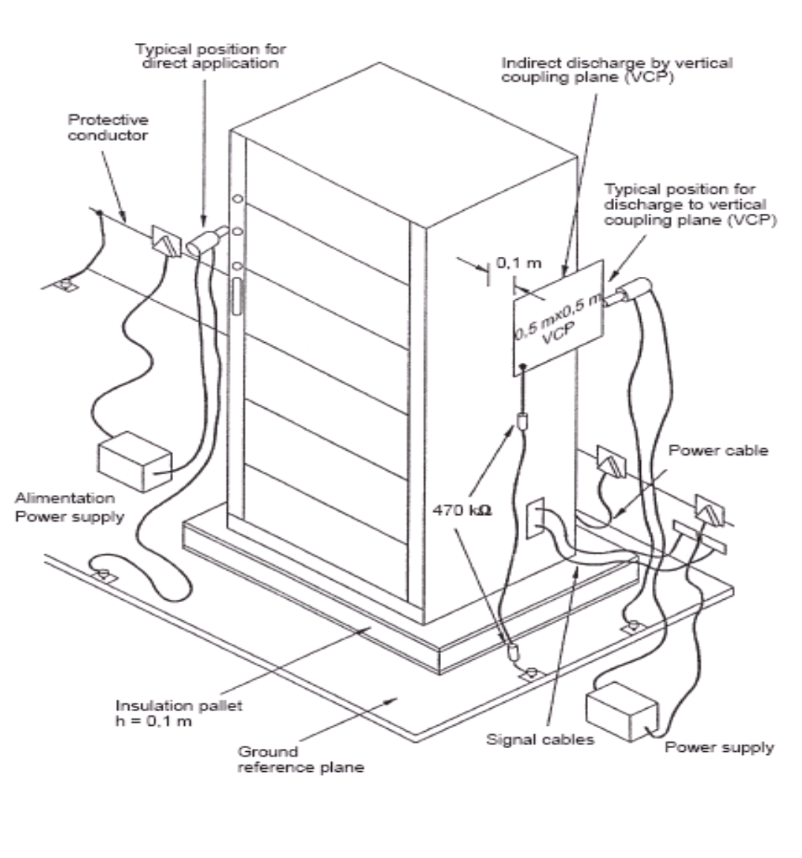
Figure 5.3 General test set-up for immunity to ESD
    - Radiated radio frequency electromagnetic field immunity test
This test serves to demonstrate that under the influence of electromagnetic fields no damage is caused to the equipment under test and no permanent or temporary malfunctions occur.

      - Standards
- Specific Standard: IEC 62236-3-2 Tab 9
- Basic Standard: IEC 61000-4-3

      - Test conditions
During the test, the equipment under test is operated at its rated operational voltage.

Ports | Environmental phenomena | Severity | Performance criteria
Enclosure | Radiated electromagnetic field | 10 V/m (r.m.s. carrier voltage)  80 MHz – 1 GHz  1 kHz, 80 % AM | A
Enclosure | Radiated electromagnetic field from digital radio telephones | 20 V/m (r.m.s. carrier voltage)  20V 800 – 1000MHz  10V 1400 – 2100MHz  5V 2100 – 2500MHz | A
NOTE 1 The frequency range shall be swept at a rate in the order of 1.5 X 10-3 decades/s, and shall be slow enough to allow the detection of any malfunction of the EUT.

      - General instructions for test performance
The tests are performed in accordance with the IEC publication. During the test functional tests shall be performed on the equipment under test.
      - General test set-up for immunity to RS

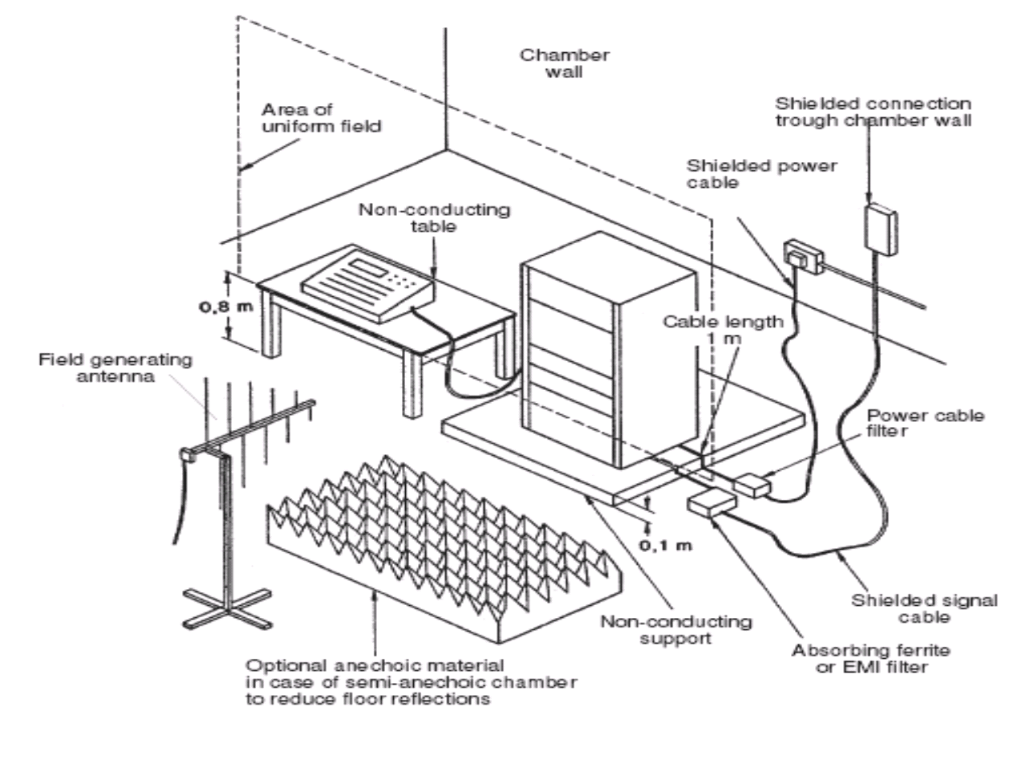
Figure 5.4 General Test Set-up for immunity to RS

    - Electrical Fast Transient/Burst immunity test
This test serves to demonstrate that under the influence of interference on power and signal connections which may occur at switching contacts as a result of arcs, no damage is caused to the equipment under test and no permanent or temporary malfunctions occur.

      - Standards
- Specific Standard: IEC 62236-3-2 Tab 7,8
- Basic Standard: IEC 61000-4-4

      - Test conditions
During the test the equipment under test is operated of its rated operational voltage.

Ports | Severity | Performance criteria | Remarks
Auxiliary AC or DC power - ports  Battery referenced ports | ±2 kV 5/50 μs  5 kHz rep. frequency burst-duration 15 ms burst-period 300 ms | A
Signal and communication, process measurement and control ports |  | A

      - General instructions for test performance
The tests are performed in accordance with the IEC publication. During the test functional tests shall be performed on the equipment under test. The test is performed at the feed lines and on external control, data and communications lines.

If a galvanic coupling on the connections of the equipment under test is not possible a capacitive coupling clamp shall be used.

    - Conducted radio frequency electromagnetic field immunity test
This test serves to demonstrate that under the influence of interference which may occur on power and signaling lines as a result of signal radiation, no damage is caused to the equipment under test and no permanent or temporary malfunction occur.

      - Standards
- Specific Standard: IEC 62236-3-2 Tab 7,8
- Basic Standard: IEC 61000-4-6

      - Test conditions
During the test the equipment under test is operated of its rated operational voltage.

Input Voltage: 37V DC

Ports | Severity | Performance criteria
Auxiliary AC or DC power - ports  Battery referenced ports | 10V_{rms} (carrier voltage)  150kHz – 80MHz  1kHz, 80% AM  Source impedance 150Ω  3V_{rms} – Max 2W  1kHz – 25kHz | A
Signal and communication, process measurement and control ports |  | A
NOTE 2: The frequency range shall be swept at a rate in the order of 1.5 X 10⁻³ decades/s, and shall be slow enough to allow the detection of any malfunction of the EUT.
NOTE 3: Two kinds of severity are used under testing.

      - General instructions for test performance
The tests are performed in accordance with the IEC publication.
The power supply lines shall be treated directly while signal and data lines shall be treated via a coupling clamp. During application of interferences functional tests shall be performed on the equipment under test.

      - General test set-up for immunity to CS
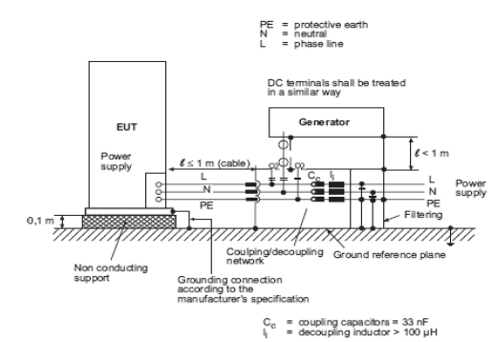
Figure 5.6.4-1 General test set-up for direct coupling of the
test voltage to AC/DC power supply ports/terminals

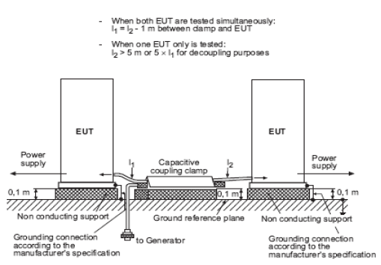
Figure 5.6.4-2 General test set-up for application of the test voltage by the capacitive coupling clamp

    - Power Variation and Interruption test
This test serves to demonstrate that in the event of power supply variations no damage is caused to the equipment under test and no permanent or temporary malfunctions occur.

      - Standards
- Basic Standard: IEC 60571

      - Test conditions
During the test the equipment under test is operated of its rated operational voltage.

※Variation

Ports | Severity | Performance criteria
Auxiliary AC or DC power-ports  Battery referenced ports | Not exceeding 1s at 0.7V_{n} – 1.25V_{n}  Not exceeding 0.1s at 0.6V_{n} – 1.4V_{n} | A

※Interruption

Ports | Severity | Performance criteria
Auxiliary AC or DC power-ports  Battery referenced ports | 100ms at 0.6 V_{n}  30ms at interruption of electric power | A

      - General instructions for test performance
The tests are performed in accordance with the IEC publication.

    - Surge test
This test serves to demonstrate that under the influence of interference which may occur on power lines (AC and DC) as a result of high-energy interference.

(Switching over voltages caused by inductive loads), no damage is caused to the equipment under test and no permanent or temporary malfunctions occur.
      - Standards
- Specific Standard: IEC 62236-3-2 Tab 7
- Basic Standard: IEC 61000-4-5

      - Test conditions
(1) The basic test circuit and test waveform is as following figure.

(2) Test waveform should have same polarity like system power supply.

(3) Voltage magnitude and duration time of test voltage is measured with no connecting to EUT.

(4) Cable length between EUT and waveform generator is less than 3 meter.

(5) Applying of waveform is maximum 5. The interval time is not over 1 minute on applying consequently.

During the test the equipment under test is operated of its rated operational voltage.

Item | Input Voltage | Permission Time | Period | Number of times | Performance Judgement Criteria
Line-Earth | ±2kV | 1.2/50µs | 1 minute | 5 times each | B
Line-Line | ±1kV

      - General instructions for test performance
The tests are performed in accordance with the IEC publication.

During application of interferences functional tests shall be performed on the equipment under test. Equipment under test using the same lines for power supply and signal transmission are to be tested according to under figure. This applies also to data, control and communication connections of the equipment under test, which may get direct connection to power lines by external wiring required by applications.

