THE DRAWING(S) AND THE INFORMATION CONTAINED HEREIN ARE THE PROPERTY OF WOOJIN INDUSTRIAL SYSTEMS CO., LTD. THEY SHALL NOT BE DISCLOSED, REPRODUCED OR USED, IN ANY MANNER WITHOUT THE PRIOR WRITTEN CONSENT OF WOOJIN INDUSTRIAL SYSTEMS CO., LTD. |  | DENVER RTD EAGLE P3  COMMUNICATION SYSTEM  EMC TEST PROCEDURE
DISTRIBUTION |  | R  E  V  I  S  I  O  N
 |  | R  E  V  I  S  I  O  N | 0 | Oct. 20, 2011 |  | First Issued |  |  | D.B. LEE | D.S. JANG | B.J. JONE | E.K. LEE
 |  | R  E  V  I  S  I  O  N | No. | ISSUED  DATE |  | REVISION NOTE |  |  | DESIGNED | CHECKED | APPROVED | REVIEWED
 |  |  |  |  |  |  |  |  | ENGINEERING |  |  | PM
 |  | PM |  |  | REVIEWED |  | E.K.LEE |  | CUSTOMER :
 |  | ENGINEERING |  |  | APPROVED |  | B.J.JONE |  | HYUNDAI-ROTEM COMPANY
 |  |  |  |  | CHECKED |  | D.S. JANG
 |  |  |  |  | DESIGNED |  | D.B. LEE |  | PROJECT :
 |  | ISSUED DATE |  |  | October 20, 2011 |  |  |  | DENVER RTD EAGLE P3  COMMUNICATION SYSTEM
 |  | ISSUED BY |  |  | R & D CENTER
 |  | PROJECT NO. |  |  | P2011-020
 |  | ORDER NO. |  |  | P110701149 |  |  |  | 
 |  | DOCUMENT NO. |  |  |  |  |  | REVISION
 |  | 423-322 |  |  |  |  |  | 0
TOTAL |  |  |  |  |  |  |  | 0
REVISION RECORD
Rev.  No. | PAGE | Details |  | Date
Rev.  No. | PAGE | FROM | TO | Date
0 |  | First Issued |  | October 20, 2011
Table of Contents

1. Introduction 4
2. Definitions and abbreviations 4
2.1 Definitions 4
2.2 Abbreviations 5
3. Test Items 5
4. EUT of CS (Communication System) 6
4.1 CCS (Communication Control System) 6
4.2 PAS (Passenger Announcement System) 6
4.3 LED PIS (LED Passenger Information System) 7
4.4 LCD PIS(LCD Passenger Information System) 7
5. Electromagnetic compatibility test 8
5.1 Conducted emissions 8
5.2 Radiated emissions 9
5.3 Electrostatic discharge immunity test – Enclosure ports 9
5.4 Radiated radio frequency electromagnetic field immunity test 11
5.5 Electrical Fast Transient/Burst immunity test 12
5.6 Conducted radio frequency electromagnetic field immunity test 13
5.7 Power Variation and Interruption test 16
5.8 Surge test 16

- Introduction
This document describes the EMC (Electromagnetic compatibility) test specification of “Communication System” to be supplied for DENVER RTD Project. The test will be performed according to IEC 62236-3-2(2003).

- Definitions and abbreviations
  - Definitions
For the purpose of this Test procedure of Communication System, the following definitions apply:

Port:
The particular interface of the specified apparatus with the external environment, for example a.c. power port, DC power port, I/O (input/output) port

Enclosure port:
The physical boundary of the apparatus through which electromagnetic fields may radiate or impinge

Performance criteria:
For the tests, the results are evaluated against performance criteria relating to the operating conditions and functional specifications of the EUT, and defined as follows:

- Performance criterion A: the EUT shall continue to operate as intended during and after the test. No degradation of performance or loss of function is allowed, as defined in the relevant equipment standard and in the technical specification published by the manufacturer

- Performance criterion B: the EUT shall continue to operate as intended after the test. No degradation of performance or loss of function is allowed, as defined in the relevant equipment standard and in the technical specification published by the manufacturer. During the test, degradation or loss of function or performance which is self- recoverable is however, allowed, but no change of actual operating state or stored data is allowed

- Performance criterion C: temporary degradation or loss of function or performance is allowed during the test, provided the function is self-recoverable, or can be restored at the end of the test by the operation of the controls, as defined in the relevant equipment standard and in the technical specification published by the manufacturer.

Performance check:
A short functional test carried out during or after an EMC test to confirm that the equipment complies with the required immunity performance criteria.

  - Abbreviations
Abbreviation | Meaning
EMC | Electro Magnetic Compatibility
EUT | Equipment Under Test
CE | Conducted Emissions
RE | Radiated Emissions
ESD | Electrostatic Discharge immunity test
EFT | Electrical Fast Transient/Burst immunity test
C/S | Conducted radio frequency electromagnetic field immunity test
R/S | Radiated radio frequency electromagnetic field immunity test
PVI | Power Variation and Interruption test
CCS | Communication Control System
PA | Passenger Announcement
LED PIS | LED Passenger Information System
LCD PIS | LCD Passenger Information System

- Test Items
The following Test Items are proposed to test for the Communication System.
Table 3.1 List of tests

No | Test  Items | Specific Standard | Test LAB | Communication System
 |  |  |  |  | CCS | PA | LED PIS | LCD PIS
1 | CE | IEC 62236-3-2 Tab 3,4,5 | SK Tech |  | O | O | O | O
2 | RE | IEC 62236-3-2 Tab 6 | SK Tech |  | O | O | O | O
3 | ESD | IEC 62236-3-2 Tab 9, Performance Criteria B | SK Tech |  | O | O | O | O
4 | R/S | IEC 62236-3-2 Tab 9, Performance Criteria A | SK Tech |  | O | O | O | O
5 | EFT | IEC 62236-3-2 Tab 7, 8, Performance Criteria A | SK Tech |  | O | O | O | O
6 | C/S | IEC 62236-3-2 Tab 7, 8, Performance Criteria A | SK Tech |  | O | O | O | O
7 | PVI | IEC 62236-3-2 Tab 7, Performance Criteria A | SK Tech |  | O | O | O | O
8 | Surges | IEC 62236-3-2 Tab 7, Performance Criteria B | SK Tech |  | O | O | O | O

- EUT of CS (Communication System)
  - CCS (Communication Control System)
    - Component parts of CCS
Table 4.2.1 EMC Test of CCS

Part | CE | RE | ESD | R/S | EFT | C/S | PVI | Surges
CCP | O | O | O | O | O | O | O | O
CRA | O | O | O | O | O | O | O | O

CCP: Communication Control Panel
CRA: Communication Rack A

    - Performance check of CCS

Table 4.2.2 Check List of CCS
Part | Performance Check
CCP | To provide control function for driver
CRA | To provide communication function

  - PAS (Passenger Announcement System)
    - Component parts of PAS
Table 4.3.1 EMC Test of PAS

Part | CE | RE | ESD | R/S | EFT | C/S | PVI | Surges
TRF | O | O | X | O | O | O | O | O
ANSM | O | O | X | O | O | O | O | O

TRF: Transformer
ANSM: ANS Microphone

    - Performance check of PA
Table 4.3.2 Check list of PA

Part | Performance Check
TRF | To transform voice signal for control output of SPK
ANSM | To check the noise in the car and deliver the status to PAC to control power of output

  - LED PIS (LED Passenger Information System)
    - Component parts of LED PIS
Table 4.4.1 EMC Test of LED PIS

Part | CE | RE | ESD | R/S | EFT | C/S | PVI | Surges
FDI | O | O | X | O | O | O | O | O
SDI | O | O | X | O | O | O | O | O
PII | O | O | O | O | O | O | O | O

FDI: Front Destination Indicator

SDI: Side Destination Indicator

PII: LED Passenger Information Indicator

    - Performance check of LED PIS
Table 4.4.2 Check list of LED PIS

Part | Performance Check
FDI | To provide destination information to passenger
SDI | To provide destination information to passenger
PII | To provide information to passenger

  - LCD PIS(LCD Passenger Information System)
    - Component pars og LCD PIS
Table 4.5.1 EMC Test of LCD PIS

Part | CE | RE | ESD | R/S | EFT | C/S | PVI | Surges
PID1 | O | O | O | O | O | O | O | O
PID2 | O | O | O | O | O | O | O | O

PID1: LCD Passenger Information Display 1

PID2: LCD Passenger Information Display 2

    - Performance check of LCD PIS

Table 4.5.2 Check list of LCD PIS

Part | Performance Check
PID1 | To provide information to passenger
PID2 | To provide information to passenger

- Electromagnetic compatibility test
  - Conducted emissions
This test measures any signals generated by equipment which appear on its power supply port and which can, therefore, be conducted into the power supply, and potentially disturb other equipment.

    - Standards
- Specific Standard: IEC 62236-3-2 Tab 3, 4, 5
- Basic Standard: CISPR 11

    - Test conditions
During the test the equipment under test is operated of its rated operational voltage.

Ports | Frequency range | Limits
Auxiliary AC or DC power – ports Battery referenced ports | 150 kHz – 500 kHz | 99 dBμV/m quasi-peak
Auxiliary AC or DC power – ports Battery referenced ports | 500 kHz – 30 MHz | 93 dBμV/m quasi-peak

    - Test result
The radio-frequency voltage at the power supply terminals of the EUT shall not exceed the limits shown upper test condition limits.
  - Radiated emissions
This test measures any signals radiated by equipment which can potentially disturb other equipment.

    - Standards
- Specific Standard: IEC 62236-3-2 Tab 6
- Basic Standard: CISPR 11

    - Test conditions
During the test the equipment under test is operated of its rated operational voltage.

Ports | Frequency range | Limits
Enclosure | 30 MHz – 230 MHz | 40 dBμV/m quasi-peak @ 10m
 | 230 MHz – 1 GHz | 47 dBμV/m quasi-peak @ 10m
NOTE 1 A measurement distance of 3 m may be used with the limit increased by 10 dB.

    - Test result
The radiation limit from the enclosure port shall not exceed the limits shown upper limits

  - Electrostatic discharge immunity test – Enclosure ports
This test serves to demonstrate that under the influence of electrostatic discharges no damage is caused to the equipment under test and no permanent malfunctions occur.

    - Standards
- Specific Standard: IEC 62236-3-2 Tab 9
- Basic Standard: IEC 61000-4-2

    - Test conditions
During the test, the equipment under test is operated at its rated operational voltage.

Ports | Discharge type | Test voltage | Performance criteria
Enclosure | contact | 6 kV | B
Enclosure | air | 8 kV | B
NOTE 1 Specific set-up for the EUT are shown in EUT test configurations section of this report (where applicable).

    - General instructions for test performance
The tests are performed in accordance with the IEC publication. Electrostatic discharge will be performed at all hose points and surfaces of the equipment under test which can be touched by persons during operation.

The following methods are used:

– Contact discharge on conductive surfaces and coupling planes
– Air discharge on insulating surface

    - General test set-up
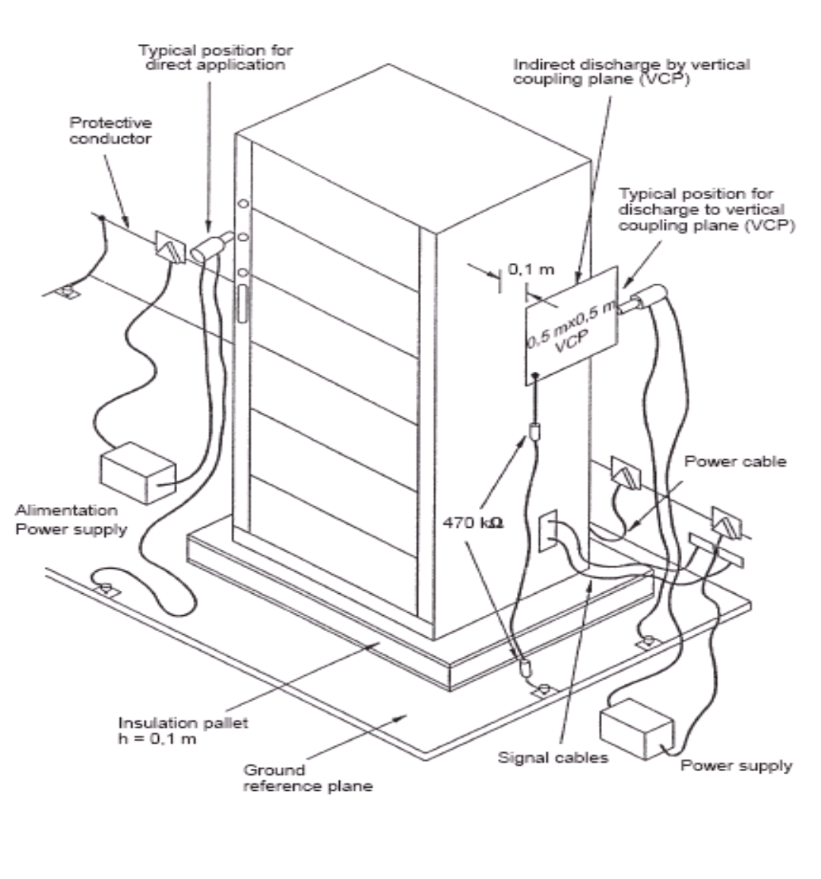
Figure 5.3 General test set-up for immunity to ESD
  - Radiated radio frequency electromagnetic field immunity test
This test serves to demonstrate that under the influence of electromagnetic fields no damage is caused to the equipment under test and no permanent or temporary malfunctions occur.

    - Standards
- Specific Standard: IEC 62236-3-2 Tab 9
- Basic Standard: IEC 61000-4-3

    - Test conditions
During the test, the equipment under test is operated at its rated operational voltage.

Ports | Environmental phenomena | Severity | Performance criteria
Enclosure | Radiated electromagnetic field | 10 V/m (r.m.s. carrier voltage)  80 MHz – 1 GHz  1 kHz, 80 % AM | A
Enclosure | Radiated electromagnetic field from digital radio telephones | 20 V/m (r.m.s. carrier voltage)  800 MHz – 960 MHz  1400 MHz – 2000 MHz  1 kHz, 80 % AM | A
NOTE 1 The frequency range shall be swept at a rate in the order of 1.5 X 10-3 decades/s, and shall be slow enough to allow the detection of any malfunction of the EUT.

    - General instructions for test performance
The tests are performed in accordance with the IEC publication. During the test functional tests shall be performed on the equipment under test.

    - General test set-up for immunity to RS

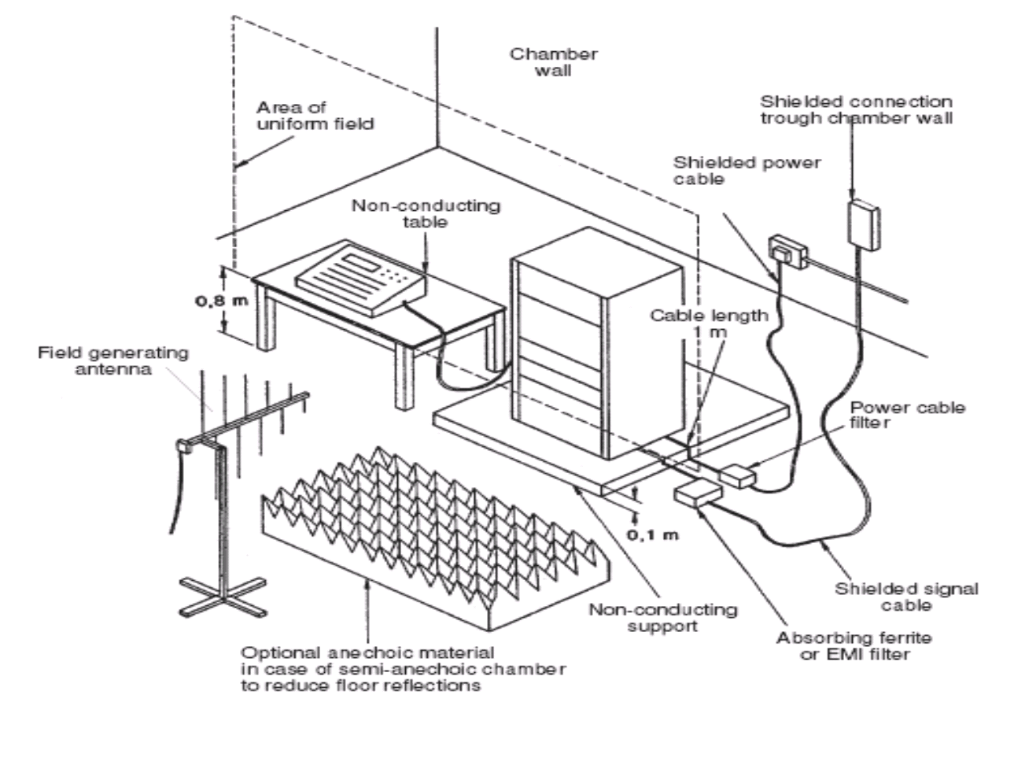
Figure 5.4 General Test Set-up for immunity to RS

  - Electrical Fast Transient/Burst immunity test
This test serves to demonstrate that under the influence of interference on power and signal connections which may occur at switching contacts as a result of arcs, no damage is caused to the equipment under test and no permanent or temporary malfunctions occur.

    - Standards
- Specific Standard: IEC 62236-3-2 Tab 7,8
- Basic Standard: IEC 61000-4-4

    - Test conditions
During the test the equipment under test is operated of its rated operational voltage.

Ports | Severity | Performance criteria | Remarks
Auxiliary AC or DC power - ports  Battery referenced ports | 2 kV 5/50 μs /  5 kHz rep. frequency burst-duration 15 ms burst-period 300 ms | A | See note 1 or 3
Signal and communication, process measurement and control ports |  | A | See note 2 or 3
NOTE 1 Direct coupling, positive and negative polarity
NOTE 2 Capacitive coupling, positive and negative polarity
NOTE 3 Test duration per polarity and test point: 5 minute

    - General instructions for test performance
The tests are performed in accordance with the IEC publication. During the test functional tests shall be performed on the equipment under test. The test is performed at the feed lines and on external control, data and communications lines.

If a galvanic coupling on the connections of the equipment under test is not possible a capacitive coupling clamp shall be used.

  - Conducted radio frequency electromagnetic field immunity test
This test serves to demonstrate that under the influence of interference which may occur on power and signaling lines as a result of signal radiation, no damage is caused to the equipment under test and no permanent or temporary malfunction occur.

    - Standards
- Specific Standard: IEC 62236-3-2 Tab 7,8
- Basic Standard: IEC 61000-4-6

    - Test conditions
During the test the equipment under test is operated of its rated operational voltage.

Input Voltage: 37V DC

Ports | Severity | Performance criteria
Auxiliary AC or DC power - ports  Battery referenced ports | 10V_{rms} (carrier voltage)  150kHz – 80MHz  1kHz, 80% AM  Source impedance 150Ω  3V_{rms} – Max 2W  1kHz – 25kHz | A
Signal and communication, process measurement and control ports |  | A
NOTE 2: The frequency range shall be swept at a rate in the order of 1.5 X 10⁻³ decades/s, and shall be slow enough to allow the detection of any malfunction of the EUT.
NOTE 3: Two kinds of severity are used under testing.

    - General instructions for test performance
The tests are performed in accordance with the IEC publication.
The power supply lines shall be treated directly while signal and data lines shall be treated via a coupling clamp. During application of interferences functional tests shall be performed on the equipment under test.

    - General test set-up for immunity to CS
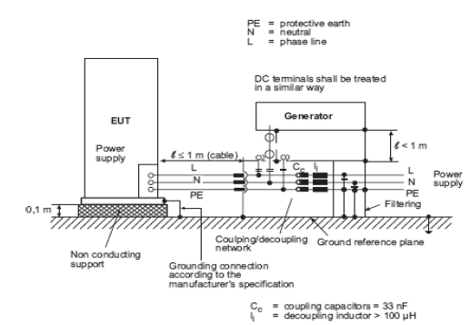
Figure 5.6.4-1 General test set-up for direct coupling of the
test voltage to AC/DC power supply ports/terminals

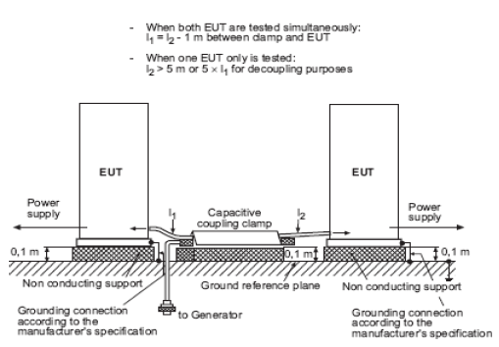
Figure 5.6.4-2 General test set-up for application of the test voltage by the capacitive coupling clamp

  - Power Variation and Interruption test
This test serves to demonstrate that in the event of power supply variations no damage is caused to the equipment under test and no permanent or temporary malfunctions occur.

    - Standards
- Specific Standard: IEC 62236-3-2 Tab 7
- Basic Standard: IEC 60571

    - Test conditions
During the test the equipment under test is operated of its rated operational voltage.

※Variation

Ports | Severity | Performance criteria
Auxiliary AC or DC power-ports  Battery referenced ports | Not exceeding 1s at 0.7V_{n} – 1.25V_{n}  Not exceeding 0.1s at 0.6V_{n} – 1.4V_{n} | A

※Interruption

Ports | Severity | Performance criteria
Auxiliary AC or DC power-ports  Battery referenced ports | 100ms at 0.6 V_{n}  30ms at interruption of electric power | A

    - General instructions for test performance
The tests are performed in accordance with the IEC publication.

  - Surge test
This test serves to demonstrate that under the influence of interference which may occur on power lines (AC and DC) as a result of high-energy interference.

(Switching over voltages caused by inductive loads), no damage is caused to the equipment under test and no permanent or temporary malfunctions occur.
    - Standards
- Specific Standard: IEC 62236-3-2 Tab 7
- Basic Standard: IEC 60571

    - Test conditions
(1) The basic test circuit and test waveform is as following figure.

(2) Test waveform should have same polarity like system power supply.

(3) Voltage magnitude and duration time of test voltage is measured with no connecting to EUT.

(4) Cable length between EUT and waveform generator is less than 3 meter.

(5) Applying of waveform is maximum 5. The interval time is not over 1 minute on applying consequently.
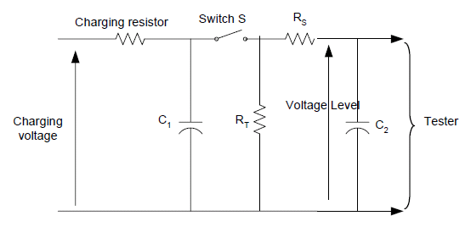
Figure 5.8.2-1 Simplified circuit diagram

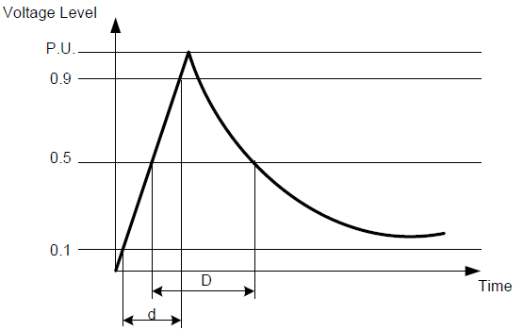
Figure 5.8.2-2 Waveform of open-circuit voltage

During the test the equipment under test is operated of its rated operational voltage.

Ports | Severity | Performance criteria
Auxiliary AC or DC power - ports  Battery referenced ports | 1,8 kV waveform 5/50 μs  Source impedance 100Ω | B

    - General instructions for test performance
The tests are performed in accordance with the IEC publication.

During application of interferences functional tests shall be performed on the equipment under test. Equipment under test using the same lines for power supply and signal transmission are to be tested according to under figure. This applies also to data, control and communication connections of the equipment under test, which may get direct connection to power lines by external wiring required by applications.

