Project | Eagle P3
CTO / WD
CDRL



XORAIL
Communications & Systems Integration
Woojin Wayside Interface Test Plan & Procedure

This document describes a preliminary integration and test plan to integrate the onboard Woojin sub-systems with their paired OCC based sub-systems.

Author
Rakesh Malhotra
Version
0.6
Date
August 1, 2012
File Name
woojin_wayside_interface_test_plan_0-6_20120801.docx

APPROVALS
 |  | Name | Signed
 | Author: | Rakesh Malhotra, Xorail
 | Reviewed by: | Kevin Hassett, RSC
 | Reviewed by: | Bobby Chandler, Penta
 | Reviewed by: | Roland Muse, Nomad
 | Reviewed by: | TBD, Woojin
 | Approved by: | Todd Ostendorf, DTP

VERSION CONTROL
Version Number | Version Date | Change history
0.1 | 7/15/2012 | Initial version
0.4 | 7/23/2012 | Changes as a result of input from subs, discussion with DTP.
0.5 | 7/24/2012 | Minor changes to add in computer need for PA/VMS test.
0.6 | 7/26/2012 | Changes due to review with Woojin, others on 7/25/2012.

TABLE of CONTENTS
1. INTRODUCTION 1
1.1. PURPOSE 1
1.2. LIMITATIONS 1
1.3. overview 1
1.4. DEFINITIONS AND ACRONYMS 1
2. Test items 2
3. features to be tested 2
4. features not to be tested 2
5. approach 2
6. item pass/fail requirements 5
7. suspension criteria and resumption requirements 5
8. test deliverables 6
8.1. test documentation 6
8.2. test data 6
9. environmental needs 6
10. responsibilities 7
11. staffing and training needs 7
12. schedule 7
13. risks and contingencies 8
14. approvals 8
15. Test procedure 8
15.1. special requirements 8
15.2. system configuration 8
15.3. procedure steps 8
15.3.1. log 8
15.3.2. setup 9
15.3.3. start 9
15.3.4. proceed 9
15.3.5. Measure 11
15.3.6. shutdown 11
15.3.7. restart 11
15.3.8. stop 11
15.3.9. wrap up 12
15.3.10. contingencies 12
15.4. summary of test results 12
Appendix A 13
DOCUMENT STRUCTURE: 14

INTRODUCTION

PURPOSE
The purpose of this document is to describe a proposed preliminary wayside integration test to be performed by Woojin. This test shall be supported by Xorail and its subcontractors.
: VPN 연동 시험은 현차에서 발생 할 수 있는 장치간 Interface 문제점에 대하여 우진과 Xorail이 서로 점검 하는데 목적이 있다.
VPN 연동 시험은 현차 조건과 일치 하지 않기 때문에 우선 순위가 높은 기능에 대하여 우선적으로 실시 하며, VPN 연동 시험 후 현차에서 연동 시험을 다시 실시 한다.

LIMITATIONS
This document is limited to describing the interfaces and integration aspects of this test. The document does not contain a description of any functional requirements, specifications of the various products used in this test or any other information that is not directly related to the integration aspects.

overview
Woojin have developed an on-board system that includes the following sub-systems:
- Passenger Information Display sub-system.
- Public Address sub-system.
- Communication Control sub-system.
- On-board Wireless LAN sub-system.(Inter-M)
- Wayside Network sub-system.
- Passenger Emergency Intercomm.
These various onboard sub-systems have already been integrated and tested from an onboard perspective. Many of these sub-systems provide input to or are interfaced to their respective sub-systems in the OCC (head-end). Woojin would now like to perform an integration test that transcends the on-board side by having the various onboard sub-systems send and receive information from the wayside head end system. This requires the temporary installation of these head-end subsystems in a lab environment.

DEFINITIONS AND ACRONYMS
-

Test items
Woojin to provide a list of onboard subsystems that are under test here.
CRA / DPO/ PEI

features to be tested
Woojin to provide a list of those features that are under test here e.g. communication interfaces from Woojin

features not to be tested
Woojin to describe any features that are not to be tested. Since this test is very specific to just onboard-wayside interfaces we can just state that everything else is out of scope.

approach
The overall approach for this preliminary integration test plan is to re-create a test environment in the lab that is as close as possible to the actual components being used for the Eagle-P3 project.
Testing will be divided into 2 phases: Internet-based test and Denver-based test. The Internet-based test will be conducted using a VPN established over the Internet with each organization continuing to host their own equipment at their location. The Denver-based test will be conducted in Denver, CO at the Xorail office.
Denver-based Test
Referring to the context diagram below, the intent is to use the actual Woojin components for the PA, PEI sub-systems connected to the HR onboard Ethernet switch. The Nomad CCU will also be connected to this Ethernet switch.
A CCU normally allows for multiple air-interfaces to be provided and manages data transmission from/to these multiple interfaces for train to off-shore communication. For Eagle P3 the intent is to provide cellular (LTE) and WiMax interfaces onboard the locomotive. However, for this preliminary integration plan a LAN connection will be used to simulate a train to offshore bearer. At this time it is not intended to use the RuggedComm Radio for either on-board nor base. The CCU shall be connected to the Home Agent directly.
The OCC end-point of the Nomad CCU system is a Home Agent (HA). This HA will be a demo HA setup hosted by Nomad. Note that the HA will not be co-located with the simulated OCC for this test. So the expected end-to-end RTT’s could be relatively high. Ping tests between the CCU, HA and OCC will help in quantifying the delays associated with the remote location of the HA.
Each CCU in each locomotive establishes a connection with the Home Agent. Together these two components are responsible for maintaining the same IP address for the connection as the train traverses the rail network and goes from cell to cell.
For this integration effort the Home Agent shall be connected to a switch. The other components at the simulated OCC are the Penta PA/VMS Simulator and an Avaya switch and phone.
Once the system has been connected and configured correctly it shall be possible for announcements generated from the OCC to be heard on the onboard system. It shall also be possible for messages to be sent from the Penta OCC Simulator for display onboard. Similarly PEI calls made from the onboard system shall be heard in the OCC.
For purposes of interfacing the Penta PA/VMS Simulator to the onboard system it is expected that a train is treated the same as a station i.e. the Penta PA/VMS system will use the same protocol to interface to a train that it uses to interface to the stations.
In order to ensure the correct priority of network traffic between the onboard/wayside Woojin shall provide priority information for the various onboard data streams. This allows the QoS to be setup correctly on the CCU.
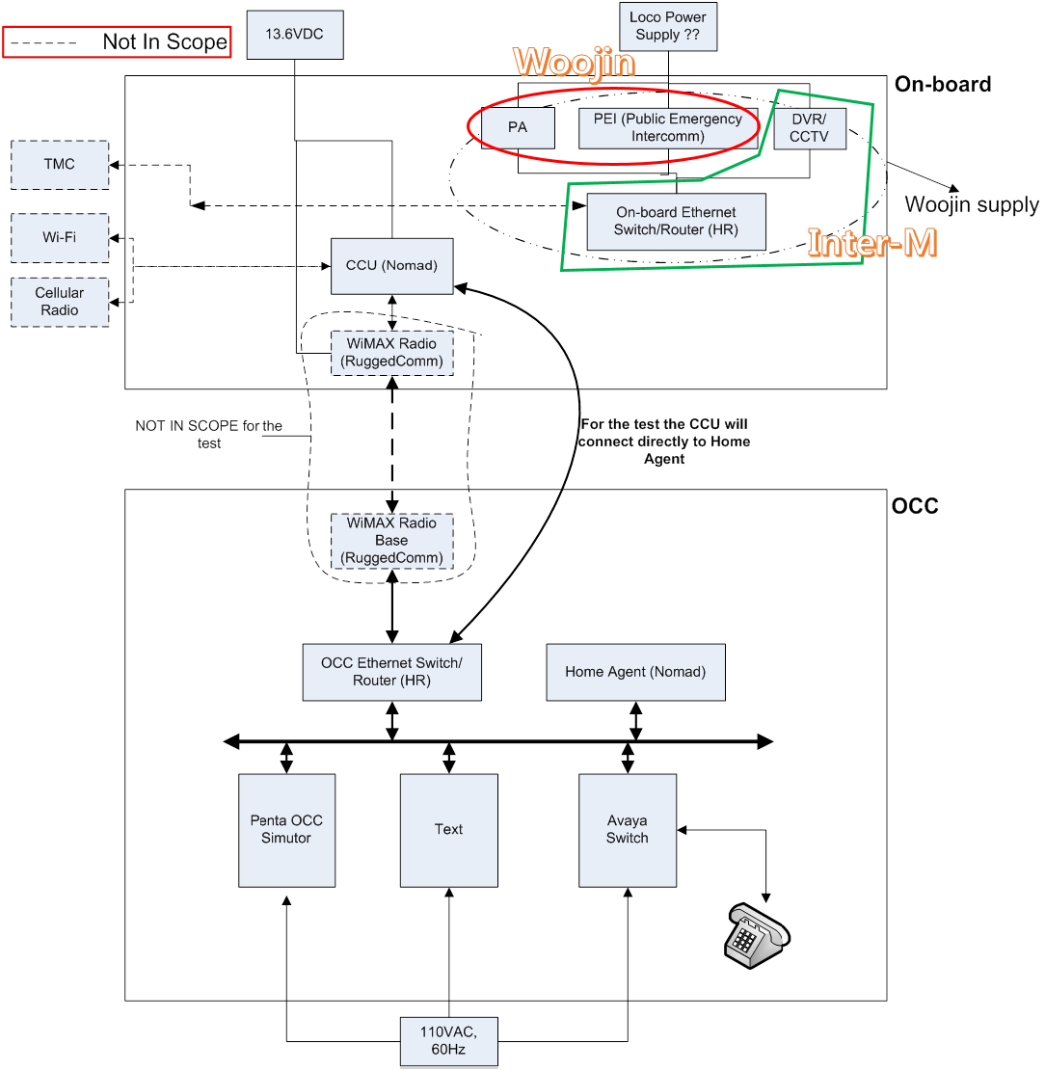
Figure 5-1 Context Diagram(그림 수정)
Internet-based Test
In order to maximize the possibility of success when performing the Denver-based integration test it is suggested that prior to conducting this test, integration be conducted via a VPN connection over the internet. To accomplish this one approach is for Woojin to set up a VPN connection that will allow RSC, Penta and Nomad to connect their devices to the VPN connection. This will create a network as described in the context diagram but it will be geographically dispersed.
This approach allows the various sub-systems to be integrated and key interface issues to be debugged. Any major issues found can be researched and fixed and the test repeated. Once most of the system is integrated and tested then the Denver-based Test can be performed to resolve the remaining configuration oriented issues.
In summary, once the internet based test is complete, testing can also be performed in-person at a lab in the US.
One item that will need to be ensured is that all communication between the onboard and OCC sub-systems is only through the Nomad CCU – HA interface. There must not be any other path that messages can travel through i.e. no loops.
The Internet-based test shall be performed in 2 steps:
Step1: In this step the Nomad devices will not be connected. Instead the Avaya phone sub-system and PA/VMS sub-system will be connected directly to the VPN. Integration shall be performed and any issues found shall be debugged.
Step 2: In this step the 2 Nomad devices shall be add to the VPN network. Data traffic shall flow only between the CCU and Home Agent. The integration tests conducted in Step 1 shall be re-performed. Any issues found shall be debugged. It is expected that any issues found in this step should directly relate to the Nomad devices only.
The figure below shows a VPN established by the VPN Router. The Avaya, Home Agent and PA/VMS Simulator will all be connected to this VPN. Naturally, a local VPN client will be needed, that is co-located at the Avaya, HA and PA/VMS Simulator sites. This local VPN client will be set up to establish the VPN tunnel to the VPN Router in Korea.
TheAvaya, Home Agent and PA/VMS Simulator devices will need to be on one side of the network. The CCU along with the Onboard Ethernet Switch/Router will also be connected to the VPN Router but they will need to be on the other side of the network. The VPN Router will need to keep the 2 networks separate.
The green lines show the network on the OCC side. The Red lines represent the Onboard network. As stated previously the CCU is part of the Onboard network (even though, physically, it will reside in the US).
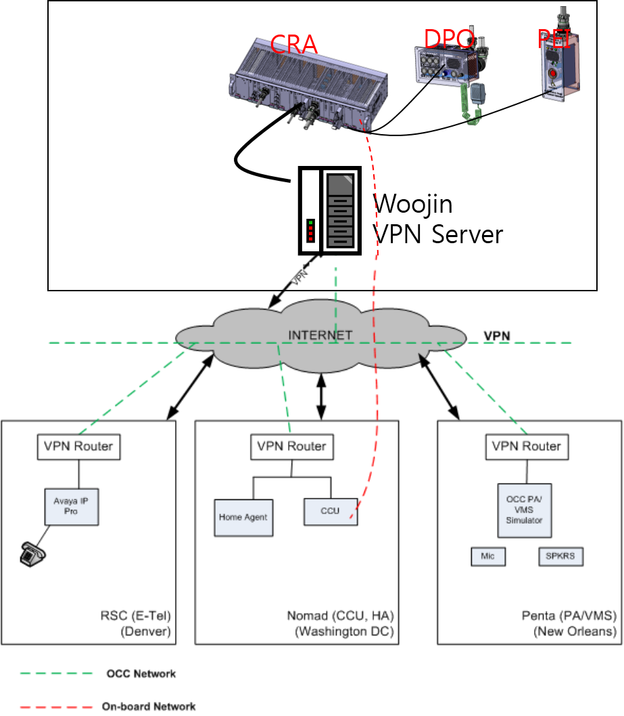
Figure 5-2 Internet-based VPN test(그림 수정)
우진이 VPN Server 를 설치 하기 위해서는 RSC/Nomad/Penta 에서 사용할 IP를 우진으로 알려 주어야 한다. 우진은 해당 IP에 대하여 ISP 포트를 OPEN 할 것 이다.

item pass/fail requirements
N/A.

suspension criteria and resumption requirements
N/A.

test deliverables

test documentation
This Test Plan with integrated Test Procedure.

test data
This test procedure shall be filled out with test results and submitted to DTP.

environmental needs
The in-person integration test described in this plan shall require reasonable lab space (at least 2 tables of 6’ each with sufficient space around the tables for engineers) to setup all the equipment on benches or tables. It is expected that this test shall be performed in Denver, CO.
Mains power (110VAC, 60Hz) shall be provided.
Each of the participating organizations is responsible for providing their own connecting cables, lab tools, lab equipment, equipment under test, simulators etc.
Bill of Materials
 | Item Quantity Lead Time
RSC | Avaya IP Pro switch 1 Immediate  IP Telephone 1 Immediate  Cables, test equipment, lab equipment, tools Assorted, to be provided by RSC Immediate
Penta | OCC PA/VMS Simulator software 1 Depends on compliance to Penta ICD.  Computer/Laptop for PA/VMS Simulator software 1 Woojin to supply. 우진은 어떠한 프로그램도 제공 하지 않는다.  Cables, test equipment, lab equipment, tools Assorted, to be provided by Penta Immediate
Nomad | CCU – R3200, Rev C 1 AC version – Immediate DC version – 4weeks  HA Server (including software installs) 1 Nomad to respond  FM - Server 1 Nomad to respond  CCU Firmware, V4.17 1 Immediate  Fleet Manager, V1106 1 Nomad to respond  Cables, test equipment, lab equipment, tools Assorted, to be provided by Nomad Immediate
Woojin | Train Switch 1 TBD  PA/VMS simulator computer/laptop (see Penta above) 1 Woojin to supply  TBD TBD TBD

responsibilities
Woojin is responsible for providing all the onboard sub-systems that are in their scope. They are also responsible for wiring, configuring all the onboard equipment as well as conducting the overall test. This test is being performed in support of Woojin requirement to conduct a preliminary end-to-end integration test.
Xorail shall be responsible for supporting the in-person test by providing adequate lab space, power and tables/racks to allow all test specific equipment to be wired up. Xorail shall also provide all IP information prior to the test for configuration of the test equipment.
Nomad shall be responsible for providing their equipment, configuring it and supporting the test.
RSC shall provide an AVAYA switch (IP Pro) configured for the onboard IP. Also, an IP phone will be provided and the system will be configured to forward all calls from the onboard to this phone. They are also responsible for configuring the equipment and supporting the test.
Penta shall provide the OCC PA/VMS Simulator and are also responsible for configuring the equipment and supporting the test.

staffing and training needs
No special staffing needs have been identified for this test other than the obvious responsibility for each company to provide staff in preparation for this test and during the execution of the test.
No special training needs have been identified at this time.

schedule
This schedule below is ONLY a place holder. It is highly unlikely that this schedule will be followed. It will be updated after discussions with all involved parties.
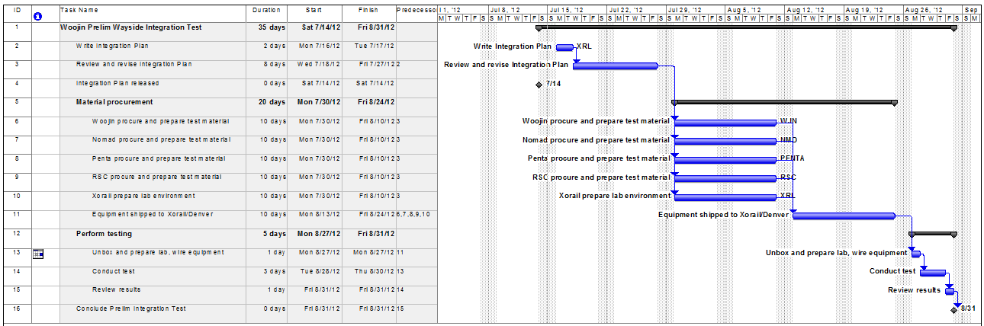

risks and contingencies
N/A.

approvals
Approvals are as listed at the beginning of this document.

Test procedure

special requirements
List any special tools, software etc required for this test.
RSC has no special requirements at this time.

system configuration
What is the configuration and version of all hardware and software ?
    - All devices shall be configured per the IP addresses provided by Xorail.
    - Onboard: The Woojin system shall be connected to the CCU network. The CCU shall be configured to route all PEI ‘calls’ via SIP to extension 1001.
    - Network: The Nomad (simulated) environment shall be configured. The Woojin provided data stream priority for onboard data shall be configured into the CCU (QoS).
    - OCC: The routing switch from the Nomad network shall be connected to the Avaya IP Pro switch and to the IP phone.
      - The IP onboard shall be configured in the Avaya switch as follows
        - Switch will accept calls from onboard.
        - Car ID is programmed into Avaya switch associated with this extension.
      - The OCC phone shall be configured as extension ‘1001’.

procedure steps

log
Record the results of the tests in the boxes provided on this form.

setup
Enter the names of the persons performing the test:
Name | Date of Test | Signature
Describe other setup that has to be performed before the test can start e.g. any configuration parameters that have to be loaded into various equipment, any calibration that has to be done before testing can start etc.

start
Short list of items to be done before this test procedure can be executed.
Nomad: CCU loaded with firmware and configuration file along with correct IP configuration. Pings between the CCU and subsystems should be functional. A laptop connected to the CCU should be able to communicate with the HA. Basic ping/connectivity between laptop and OCC should work. Verify that the above connections work for all the bearers which are being used for the test: WiMax/LAN/LTE. Verify that the CCU is reporting to the FM server.

proceed
: 우진 산전은 VPN을 이용한 예비 시험으로 OCC – DPO-PEI 삼자 통화 기능만을 실시 하길 원한다.
Wayside Interface 에 있어 가장 중요한 VoIP Signaling Protocols / Audio Codec 처리 부분 확인을 통해 음성 통화 지연 시간 확인 및 통화 품질을 점검 할 수 있을 거라 생각 한다. 나머지 시험에 대하여 현차 시험시 실시 한다.
Step | Test Description | Expected Results | Results
 | PEI TEST
1 | PEI initiates call to driver | Rings in cab
2 | Driver does NOT answer within 30 seconds. Call to OCC extension 1001 is initiated | Extension 1001 rings and shows Car ID
3 | OCC phone is answered by tester.
4 | Onboard PEI shall talk | Listening at OCC, rate the voice quality as acceptable
5 | OCC tester should talk | Listening at PEI, rate the voice quality as acceptable
6 | Driver should attempt to answer original call
7 | OCC should hang up  OCC – Driver – PEI 삼자 통화를 한다. | OCC – Driver – PEI 듣고, 말할 수 있다. 음량이나 비율 품질에 대해 수용 가능한지 판단.
8 | Repeat test steps 1 – 3, and have PEI hang up??? | ?????
 | 아래 시험은 우진과 관계 없다.
 | PA/VMS TEST (assumes Train is treated the same as a station)
3.00 | HEARTBEAT MESSAGE From Penta Server  - Verify that the Penta Server/Simulator sends ‘heartbeat’ message to Train VLU.  - Verify Train VLU responds to Penta server ‘heartbeat’ message. | - Penta active server/simulator sends appropriate heartbet message at designated interval to each active Train VLU.  - Each asctive train VLU responds appropriately top Penta server/simulator ‘heartbeat’ message.
3.01 | AD HOC MESSAGE FROM CONSOLE  - From the console/Simulator, connect to Test Train PA and make an ad hoc announcement.  - From the console, select a group from the map or PA dialog and make an ad hoc message. The group must contain the Test Train PA.  - Remove Train PA from the group and make an ad hoc announcement. | - The message can be heard at the selected Train PA system.  - The message can be heard at the selected Train PA.  - The message is not heard at the Train PA.
3.02 | IMMEDIATE MESSAGE  - Record a new prerecorded audio file named “Test Message.” Preview the message using the “Preview” function.  - Add “This is a Test” for the text and save the message. Schedule the message for the Test Train PA for 1 minute.  - Edit the message and change the text to “FAT Test.” Schedule the message for the Test Train PA for 1 minute. | - The audio message is clear and complete.  - The audio is heard and the text message is displayed at the Test Train PA for 1+/-0.25 minutes.  - The audio is heard and the new text message is displayed at the Test Train PA for 1+/- 0.25 minutes.
3.03 | SCHEDULED MESSAGE  - Schedule the prerecorded message “Test Message Priority 2” for priority = 2 and play forever.  - Schedule the prerecorded message “Test Message Priority 3” for priority = 3 and play for 1 minute to begin at 5 minutes in the future. | - The message “Test Message Priority 2” is displayed on the Test Train PA LED display.  - At the appropriate time +/- 0.25 minutes, “Test Message Priority 3” plays for 1+/-0.25 minutes and then “Test Message Priority 2” is displayed.

Measure
Describe any special measurements that have to be taken during the test, other than those described in the Proceed section.

shutdown
Describe any special shutdown requirements i.e. does anything special have to be done after the test is complete before the system can be shutdown or the next test started.

restart
Describe any special requirements that have to be met before the test can be restarted.

stop
Describe any special requirements that have to be met before the test can be stopped.

wrap up
Are there any special requirements that have to be met before the test can be wrapped-up

contingencies
Any special contingencies during or after testing.

summary of test results
Provide a short description.
Pass | Fail

Appendix A

DOCUMENT STRUCTURE:
File Description: | Woojin Wayside Interface Test Plan & Procedure
Parent document(s): | None
Integral documents: | None
Offspring documents: | None
References: | None

Template Version 1.5

