THE DRAWING(S) AND THE INFORMATION CONTAINED HEREIN ARE THE PROPERTY OF WOOJIN INDUSTRIAL SYSTEMS CO., LTD. THEY SHALL NOT BE DISCLOSED, REPRODUCED OR USED, IN ANY MANNER WITHOUT THE PRIOR WRITTEN CONSENT OF WOOJIN INDUSTRIAL SYSTEMS CO., LTD. |  | DENVER RTD EMU (50)  INTEGRATION TEST PROCEDURE FOR  COMMUNICATIONS SYSTEM  (PTC LAB)
DISTRIBUTION |  | REVISION
 |  | REVISION | 0 | May 21, 2013 |  | Issued |  |  | D. B. LEE |  | D. S. JANG | B. J. JONE
 |  | REVISION | NO. | DATE |  | NOTE |  |  | DESIGNED |  | REVIEWED | APPROVED
 |  | ENGINEERING |  |  | APPROVED |  | B.J.JONE |  |  | CUSTOMER:
 |  |  |  |  | CHECKED |  | D.S. JANG |  |  | HYUNDAI ROTEM COMPANY
 |  |  |  |  | DESIGNED |  | D.B. LEE
 |  | ISSUED DATE |  |  | May 21, 2013 |  |  |  |  | PROJECT:
 |  | ISSUED BY |  |  | R & D CENTER |  |  |  |  | COMMUNICATION SYSTEM FOR  DENVER RTD EAGLE P3
 |  | PROJECT NO. |  |  | P2011-020
 |  | ORDER NO. |  |  | P110701149
 |  | DOCUMENT NO. |  |  |  |  |  | REVISION |  | 
 |  | 42-2013-0041 |  |  |  |  |  | 0
Record of Revisions
Rev. | Date | Description | Entered By
0 | May 21, 2013 | First Issued

Table of Contents
Abbreviation 4
1. Introduction 4
2. Test Components 4
2.1 System Components 4
2.2 Test Equipment 5
3. Interface Check Issue before the Functional Test 5
3.1 Check Issue before the OCC to Passenger PA Test 5
3.2 Check Issue before the DPO/PEI – OCC Test 6
4. Static Test Procedure 7
4.1 Software Component Update Test 7
4.2 Software Component Update Interrupt Test 7
4.3 FTP Data Update Test 8
4.4 FTP Data Update Interruption Test 8
4.5 Content Data Download Test 8
4.6 Content Data Download Interruption Test 8
4.7 Content Update Test 8
4.8 Content Update Interruption Test (Incorrect, Invalid, or Interrupted Updates) 9
5. OCC to Passenger PA Test 10
5.1 Functionality prioritization Test 10
5.2 PEI call auto routing and PEI-OCC Communication Test 11
5.3 Party line functional test 12
5.4 GPS interface test 13
5.5 OCC-PII/PID interface test 13

Abbreviation
Abbreviation | Description
CCP | Communication Control Panel
CNCS | Content & Control Server
CRA | Communication Rack A
CS | Communications System
CSP | Cab Speaker
DPO | Driver PA Operation Box
FDI | Front Destination Indicator
FTP | File Transfer Protocol
GPS | Global Positioning System
MDS | Monitoring and Diagnostic System
OCC | Operation Control Center
PEI | Passenger Emergency Intercom
PID1 | Passenger Information Display 1
PID2 | Passenger Information Display 2
PII | Passenger Information Indicator
SDI | Side Destination Indicator
USB | Universal Serial Bus

Introduction
This document describes the PTC Lab Integration Test in order to check the function verification for communication system on the Denver RTD Eagle P3 car.

Test Components

2.1 System Components
Component Name | Quantity
Communication Control Panel (CCP) | 1ea
Communication Rack A (CRA) | 1ea
Driver PA Operation Box (DPO) | 1ea
Cab Speaker (CSP) | 1ea
Passenger Emergency Intercom (PEI) | 1ea
Passenger Information Indicator (PII) | 1ea
Passenger Information Display 1 (PID-1) | 1ea

2.2 Test Equipment
The preparation for the test follows as below:
- Equipment which Woojin has to prepare
- Laptop Computer
- Cable (Equipment)
- USB Mouse and Keyboard

● Equipment which Xorail has to prepare
- DC Power Supply (37.5V/5A)
- Avaya Switch
- FTP Server
- Program which can monitor MDS fault data
- OCC Software

Interface Check Issue before the Functional Test
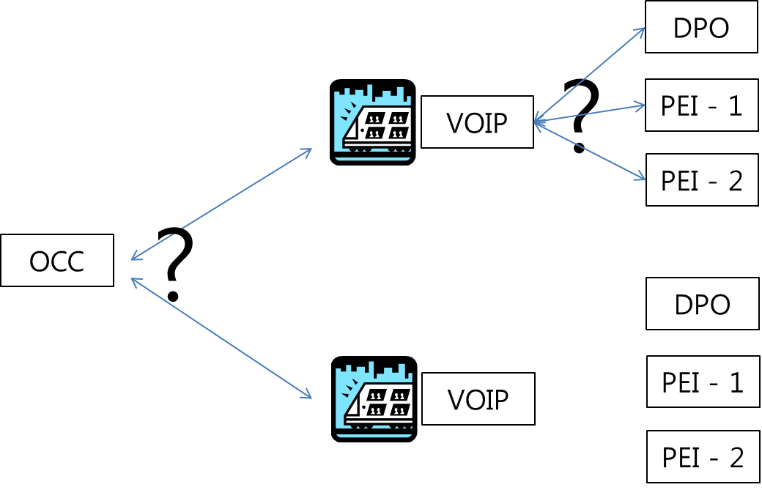

Check Issue before the OCC to Passenger PA Test
- Woojin requires the sample of the UDP packet when beginning and ending the OCC to Passenger PA test.

- We need to know the entire length of packet, accurate location of the commander, accurate commander etc.

- There is only the header file format in the document we have received. We cannot notify which commander and which location to receive from to perform the beginning and ending the PA announcement.

- Accurate test is available if there is a simulation program which can execute the beginning and ending of the PA.

- The command should be transmitted to the Main VOIPC of the cab vehicle, in order to make the OCC to passenger PA.

- Main VOIPC can be either the CRA-RA or CRA-RB by the failure condition of the boards even in the cab vehicle.

Check Issue before the DPO/PEI – OCC Test
- To receive voice of specific PEI, it is not able to receive the voice of specific PEI only with the VOIP phone from the OCC. Data communication between the OCC and the VOIPC is required.
- OCC should request to the VOIPC which has the specific PEI to receive the voice of specific PEI.
- OCC should notify the above purpose and the specific PEI location when requesting communication to the VOIPC in order to receive voice of specific PEI. (This is the reason that data communication is required.)
- Woojin should know which method will be used between the TCP method and the UDP method, in order to receive the data communication of specific PEI. There should be a protocol and a simulation program. Please let Woojin know the development method of the OCC, and then Woojin can follow the method.
- There are 2 causes in the case of OCC calling the VOIPC. One is calling the DPO and the other is receiving voice of specific PEI.
- Accurate function performing is available by transmitting the above information when OCC calls the VOIPC. (This is the reason that data communication is required.)
- There are 2 causes in the case of VOIPC calling the OCC. One is DPO requesting the call with the OCC and the other is when the PEI call transfers to the OCC in case of DPO not answering the call in 13 seconds.
- The scenario is required when an emergency situation has occurred for example, various PEI of various train number request call to the OCC. It is able to handle the priority and exception of the program logic by this scenario.
- It could be a lot of help to Woojin if there is a brief hardware composition diagram for the OCC to passenger PA, PEI communication, and specific PEI voice reception. We would like to get the diagram it is possible.

Static Test Procedure
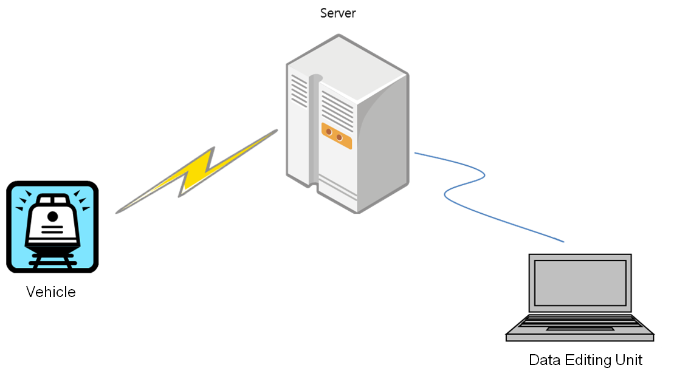
:

Software Component Update Test
This test will be performed to test the LAUNCHER.EXE process for physically installing software components which have been previously uploaded from the wayside to the onboard CS. This test assumes that new versions of one or more of the software components have (automatically or manually) been placed onto the appropriate directory of the CNCS HDD, and that the current operating version information has been recorded for each component. Contents and software files and data will be received from the wayside server so it is difficult to demonstrate.
Description | Pass/Fail | Tested by
- Identify if the Software Component has been updated.

Software Component Update Interrupt Test
This test is being performed to test if the software component has been updated after the interruption.
To make the interruption, power of the CRA should be turned off during the Software Component Update test. Contents and software files and data will be received from the wayside server so it is difficult to demonstrate.
Description | Pass/Fail | Tested by
- Identify if the Software Component has been updated even after the interruption.

FTP Data Update Test
This test is being performed to test if the FTP Data (including MDS fault Data) has been uploaded after the interruption.
To make the interruption, power of the CRA should be turned off during the Software Component Update test.
Description | Pass/Fail | Tested by
- Identify if the sample file for test has been transmitted to the computer.

FTP Data Update Interruption Test
This test is being perfomed to test if the FTP Data (including MDS fault Data) has been uploaded after the interruption.
To make the interruption, power of the CRA should be turned off during the Software Component Update test.
Description | Pass/Fail | Tested by
- Identify if the FTP Data has been uploaded even after the interruption.

Content Data Download Test
This test is being performed to test if the CRA downloads the newest Contents data from the server.
Description | Pass/Fail | Tested by
- Identify if the CRA downloads the newest Contents data properly from the server.

Content Data Download Interruption Test
This test is being performed to test if the CRA downloads the newest Contents data from the server after the interruption.
Description | Pass/Fail | Tested by
- Identify if the CRA downloads the newest Contents data properly from the server after the interruption.

Content Update Test
The test procedures for this function require multiple components and processes. Each of these is defined in the individual section relating to the actual device on which Content is being updated. The following components each require Content updating:
1) CCP – Master Schedule File
2) CCP – Route Coordinate definitions
3) CCP – Trigger Point definitions
4) PAC (PA control board in CRA) – MP3 Audio player content library
5) FDI, SDI, and PII – Image based message Content
6) PII – Text based message content
7) CNCS – PID Content Elements
Content Update Test Procedure:
- As part of the individual component test procedures, each of these Content data elements must be loaded onto the CNCS in the appropriate directory and with the appropriate file naming conventions.
- Restart the CNCS to initiate the Content Update program.
- Allow sufficient time for the update process to be carried out
- Physically review and/or observe the individual components to confirm that the updated content has been stored in the correct manner to the device and that the device can access the data and utilize it correctly. Contents and software files and data will be received from the wayside server so it is difficult to demonstrate.
Description | Pass/Fail | Tested by
- Identify if the Contents update has been correctly done.

Content Update Interruption Test (Incorrect, Invalid, or Interrupted Updates)
This test is being performed to test if the CRA downloads the newest Contents data from the server after the interruption. Contents and software files and data will be received from the wayside server so it is difficult to demonstrate.
Description | Pass/Fail | Tested by
- Identify if the CRA downloads the newest Contents data properly from the server after the interruption.

OCC to Passenger PA Test
Test the announcement transmission from the OCC to the passengers. Perform the test by operating OCC test equipment.
Description | Pass/Fail | Tested by
- Identify if the voice outputs through the Cab speaker and the interior speaker by inputting voice via OCC test equipment.

Functionality prioritization Test
It is the test to identify the priority among the automatic announcement, manual announcement and the OCC-Passenger announcement. The priority is as the following.
1) OCC – Passenger Announcement
2) Manual Announcement by the Driver or Crews
3) Automatic Announcement
Description | Pass/Fail | Tested by

Between the Automatic announcement and the manual announcement
- Identify if the automatic announcement stops and the manual announcement outputs when operating the manual announcement with the DPO during the automatic announcement outputs.
- Identify if the automatic announcement stops and the manual announcement outputs when operating the manual announcement with the DPH during the automatic announcement outputs.

Between the manual announcement -OCC Passenger announcement
- Identify if the manual announcement voice is stopped and the OCC-passenger announcement outputs to the interior speaker in case of the OCC requests passenger announcement during the DPO manual announcement.
- Identify if the manual announcement voice is stopped and the OCC-passenger announcement outputs to the interior speaker in case of the OCC requests passenger announcement during the DPH manual announcement.
* There is no content about voice reception of specific PEI. Please verify.
The program should be executed after confirming the method of data communication and the protocol to make the 5.1 test.

PEI call auto routing and PEI-OCC Communication Test
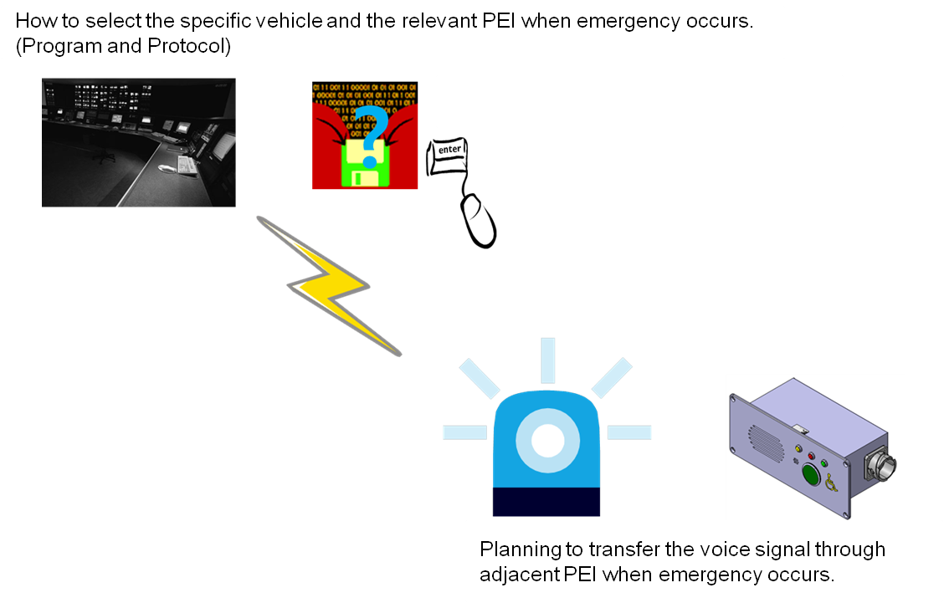
Description | Pass/Fail | Tested by
- Try to make the emergency call request by activating the PEI.
- Identify whether the call requests to the OCC, in case of the DPO not responding the call for 13 seconds.
- Identify if the communication between the PEI and the OCC operates normally, in case of the OCC responds the call.

Party line functional test
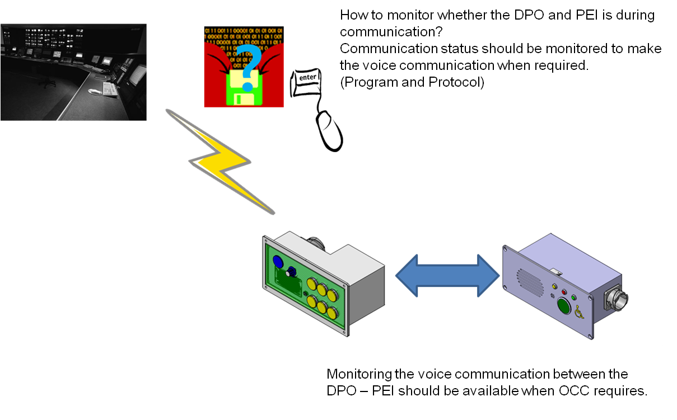
Description | Pass/Fail | Tested by
- OCC interference test during the DPO-PEI communication
Identify if the 3-way communication among DPO-PEI-OCC operates normally in case of the emergency call request inputs from the OCC during the communication between the DPO-PEI is in progress.
- DPO interference test during the OCC-PEI communication
Identify if the 3-way communication among PEI-OCC-DPO operates normally when pressing the PEI button of the DPO during the communication between PEI-OCC.
- PEI interference test during the DPO-PEI communication
Identify whether the 3-way communication is available when PEI interferes during the communication between the DPO and the other PEI.
- DPO interference test during the DPO-PEI communication
Identify whether the 3-way communication is available when another DPO interferes during the communication between the DPO and the PEI.

GPS interface test
This test is performed to verify that the CRA properly receives GPS data from the ‘GPS receiver’. If the CRA receives the GPS data, the GPS status lamp on the CCP will turn green and the time on the CCP will be displayed. This test should be performed on both the MA car and MB car.
Description | Pass/Fail | Tested by
- Ensure that the GPS receiver is receiving appropriate GPS signal from satellite.
- Check the CCP screen and verify that the GPS indicator is colored in green.
- Check the CCP clock and verify that it is displaying the correct time.

OCC-PII/PID interface test
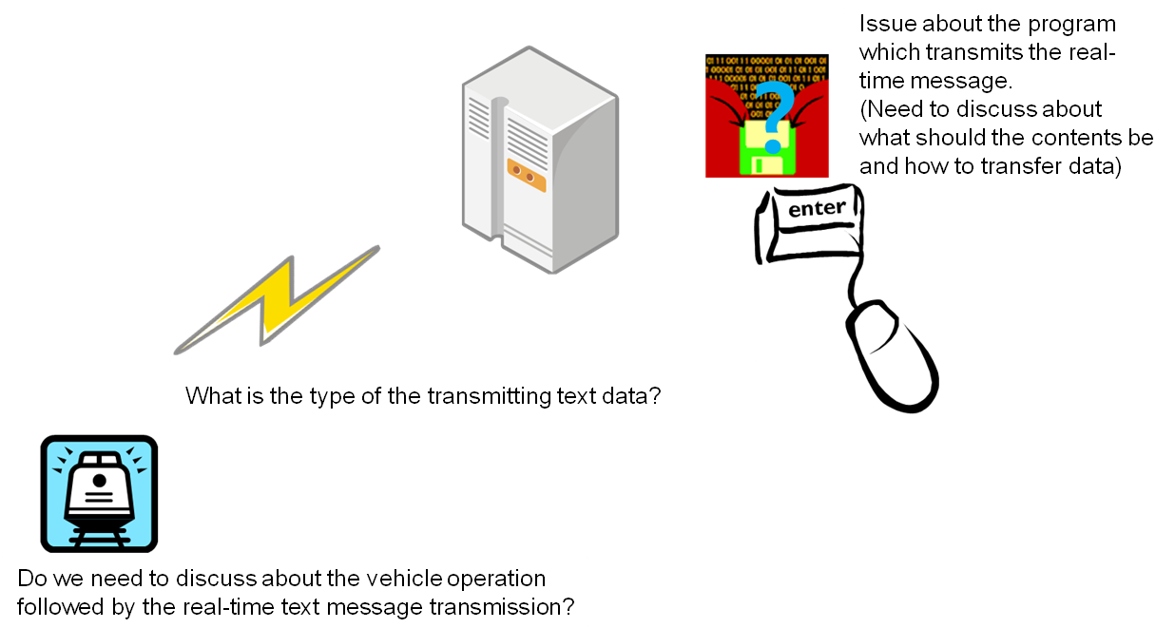
Description | Pass/Fail | Tested by
- Verify that the PIIs and PIDs display text messages received from the OCC test equipment.

CAR # : MA car ( ) & MB car ( )
TESTED ON: | TESTED BY:  (DTS)  (Hyundai-Rotem) | SIGNATURE  (DTS)  (Hyundai-Rotem)

