THE DRAWING(S) AND THE INFORMATION CONTAINED HEREIN ARE THE PROPERTY OF WOOJIN INDUSTRIAL SYSTEMS CO., LTD. THEY SHALL NOT BE DISCLOSED, REPRODUCED OR USED, IN ANY MANNER WITHOUT THE PRIOR WRITTEN CONSENT OF WOOJIN INDUSTRIAL SYSTEMS CO., LTD. |  | DESCRIPTION  OF  CCP USER INTERFACES
DISTRIBUTION |  | R  E  V  I  S  I  O  N
 |  | R  E  V  I  S  I  O  N | 0 | Mar. 21, 2012 |  | First Issued |  |  | M.H. JIN | D.B. LEE | D.S. JANG | B.J. JONE
 |  | R  E  V  I  S  I  O  N | No. | ISSUED  DATE |  | REVISION NOTE |  |  | DESIGNED | CHECKED | APPROVED | REVIEWED
 |  |  |  |  |  |  |  |  | ENGINEERING |  |  | PM
 |  | PM |  |  | REVIEWED |  | B.J. JONE |  | CUSTOMER :
 |  | ENGINEERING |  |  | APPROVED |  | D.S. JANG |  | HYUNDAI ROTEM COMPANY
 |  |  |  |  | CHECKED |  | D.B. LEE
 |  |  |  |  | DESIGNED |  | M.H. JIN |  | PROJECT :
 |  | ISSUED DATE |  |  | March 21st, 2012 |  |  |  | DENVER RTD EAGLE P3  COMMUNICATION SYSTEM
 |  | ISSUED BY |  |  | R & D CENTER
 |  | PROJECT NO. |  |  | P2011-020
 |  | ORDER NO. |  |  | P110701149 |  |  |  | 
 |  | DOCUMENT NO. |  |  |  |  |  | REVISION
 |  | 42A-2012-0055 |  |  |  |  |  | 0
TOTAL |  |  |  |  |  |  |  | 0
REVISION RECORD
Rev. No. | PAGE | Details |  | Date
Rev. No. | PAGE | FROM | TO | Date
0 |  | First Issued |  | March 21, 2012
Table of Contents

1. CCP Initial Screen 3
2. Train Number Input 4
3. Crew ID Input 4
4. Initial screen after setting a Train Number / Crew ID 5
5. Destination information, Destination arrival time, Delay time, and Departure station, This stop, and Next stop Information Display 5
6. Configuration Initial Screen 6
7. Interior / Exterior Speaker Volume Setting 7
8. LCD brightness control 7
9. System initialization : pre-set Train Number / Crew ID initialization 8
10. Simulation Interval Setting 8
11. C/I number setting 9
12. Vehicle failure information display 9
12.1 Married A vehicle failure information display 10
12.2 Married B vehicle failure information display 10
13. HELP Initial Menu Display 11
13.1 HELP on the HOME screen 11
13.2 HELP on the TRAIN screen 12
13.3 HELP on the CREW screen 12
13.4 HELP on the ROUTE screen 13
13.5 HELP on the CONFIG. screen 13
13.6 HELP on the CHECK screen 14
13.7 HELP on the PEI screen 14
14. PEI initial screen 15
14.1 PEI CALL display of Married A 15
14.2 PEI CALL display of Married B 16
15. PR information display 16

1. CCP Initial Screen
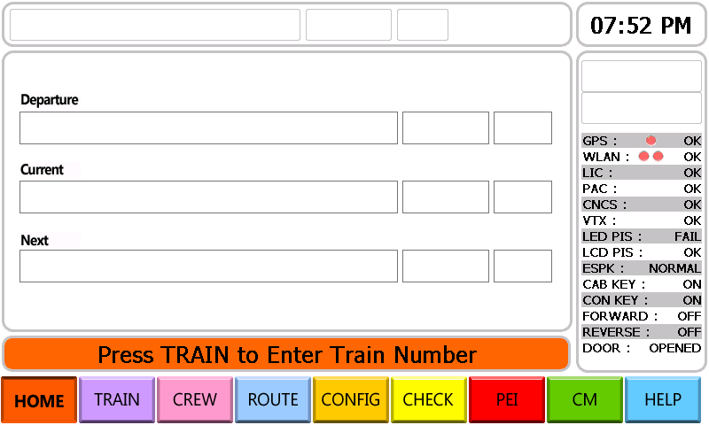

2. Train Number Input
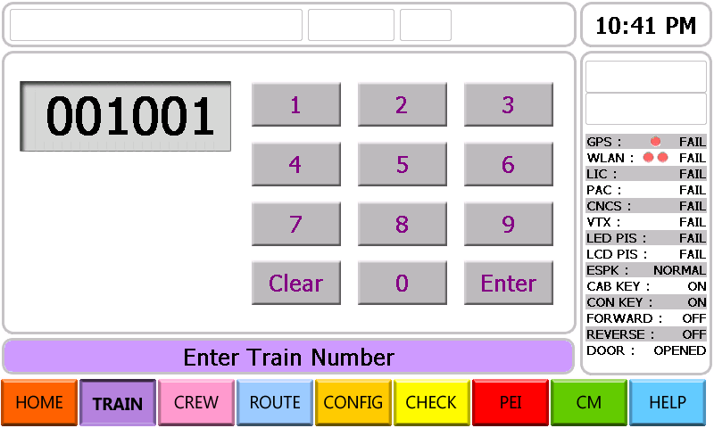
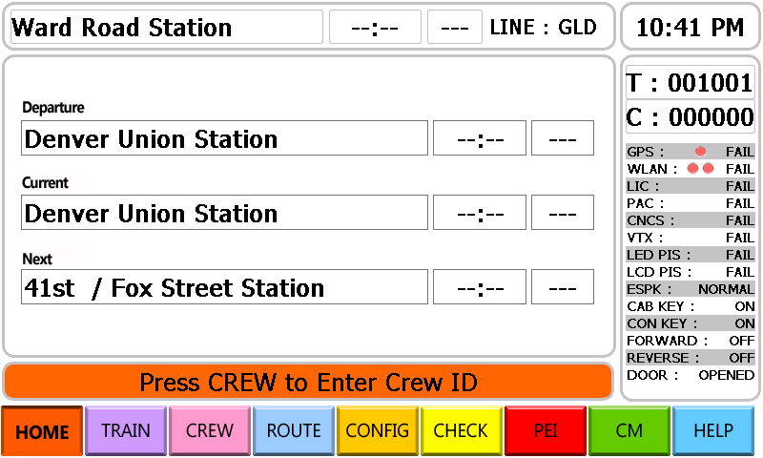

3. Crew ID Input
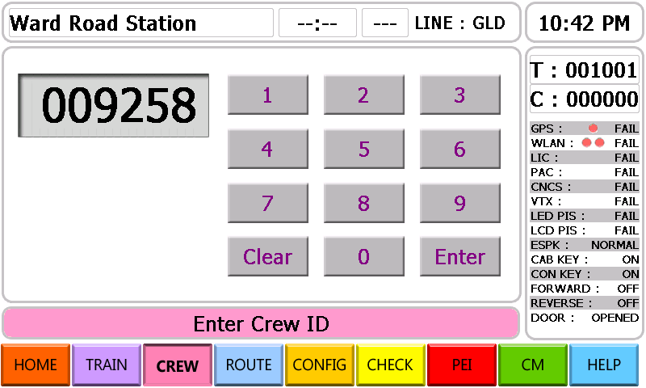

4. Initial screen after setting a Train Number / Crew ID
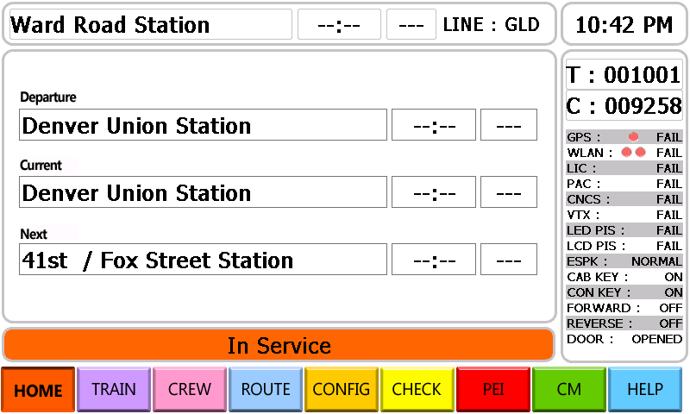

5. Destination information, Destination arrival time, Delay time, and Departure station, This stop, and Next stop Information Display
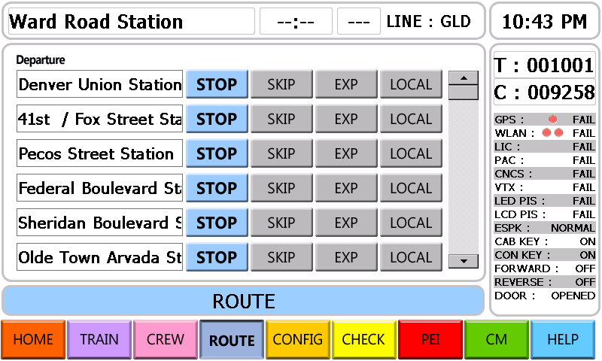
- Route setting
STOP :It transmits an automatic announcement.
SKIP : It does not transmit the automatic announcement.
EXP : It is considered as “SKIP” from the terminal to the selected station.
LOCAL : It is considered as “STOP” from the terminal to the selected station.

6. Configuration Initial Screen
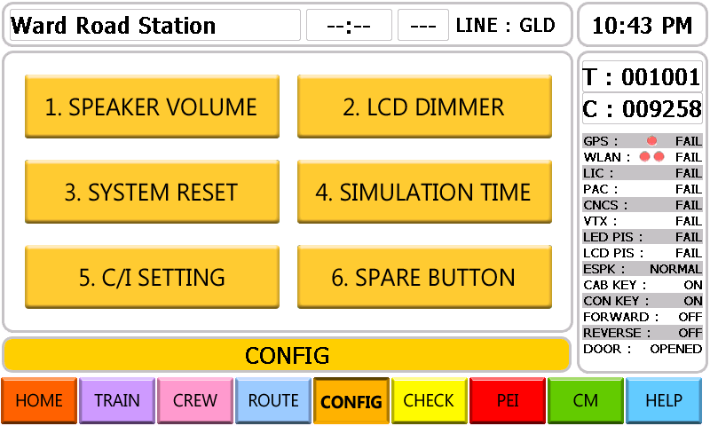

7. Interior / Exterior Speaker Volume Setting
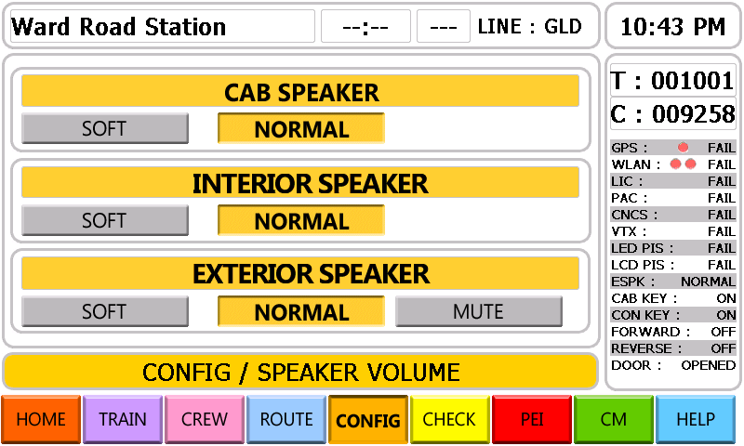

8. LCD brightness control
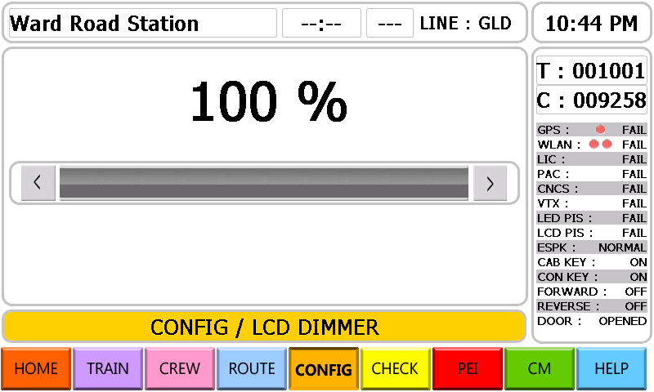

9. System initialization : pre-set Train Number / Crew ID initialization
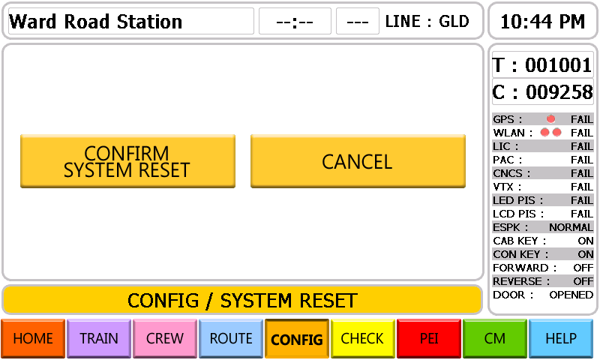

10. Simulation Interval Setting
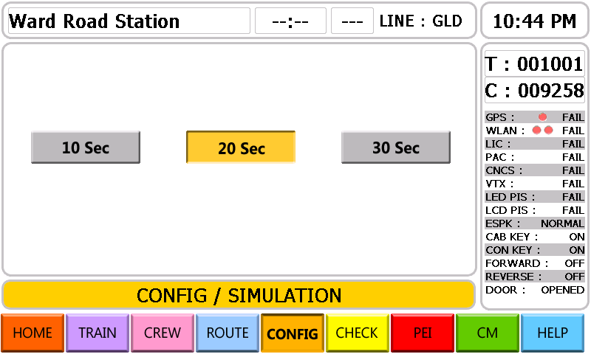

11. C/I number setting
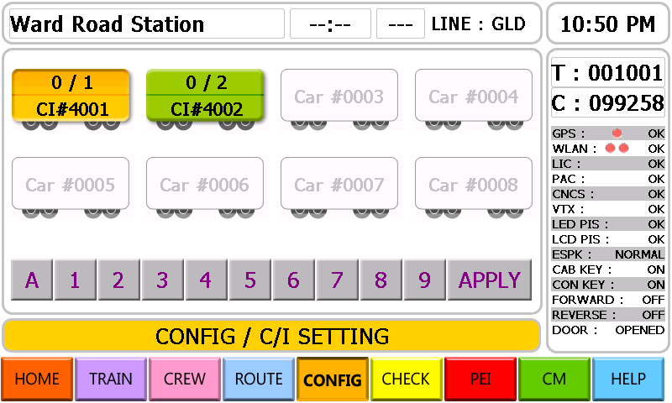

12. Vehicle failure information display
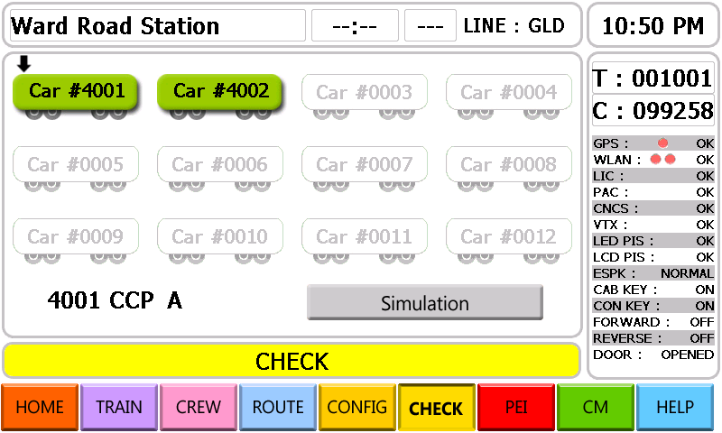
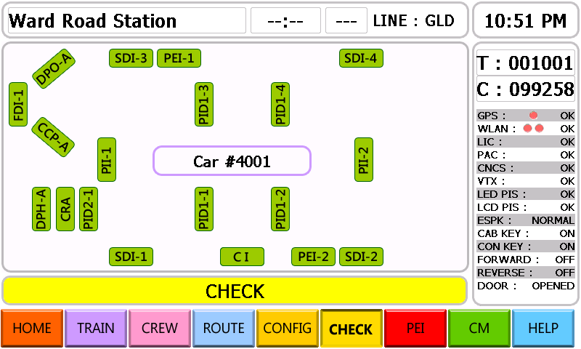

A vehicle without any failure information will be displayed with green color, but a vehicle including failure information will be displayed in red.

12.1 Married A vehicle failure information display
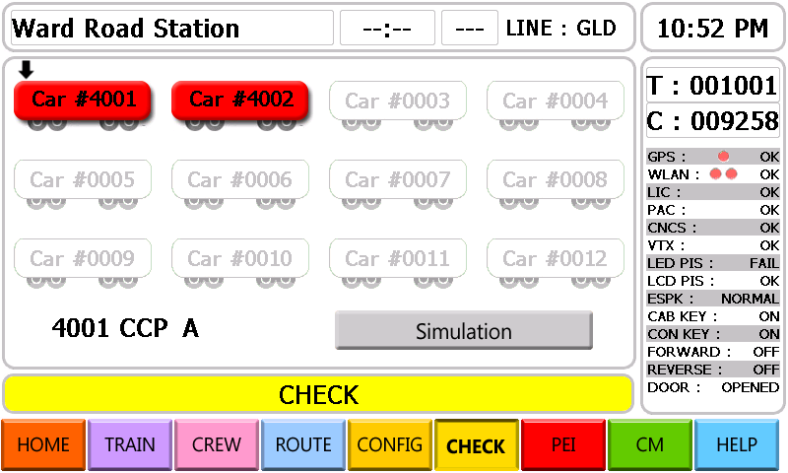
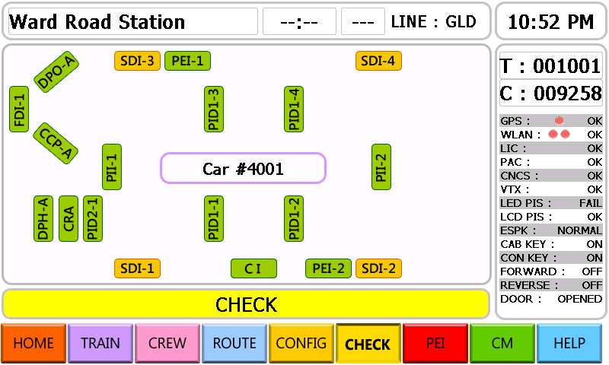
- Equipment which has failure will be displayed in yellow color.

12.2 Married B vehicle failure information display
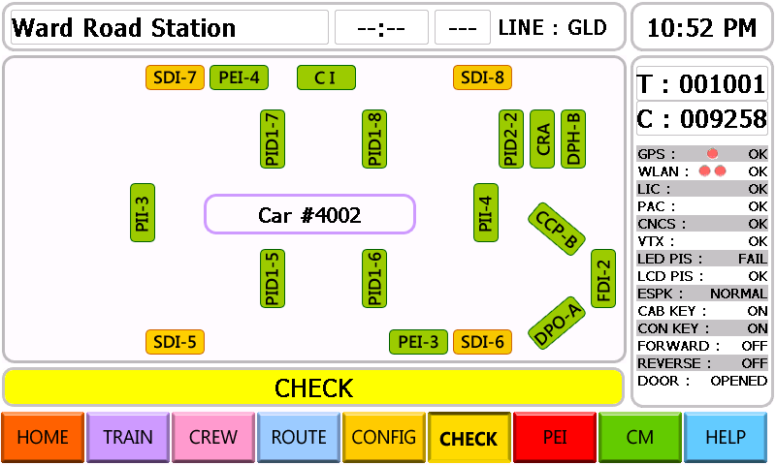

13. HELP Initial Menu Display
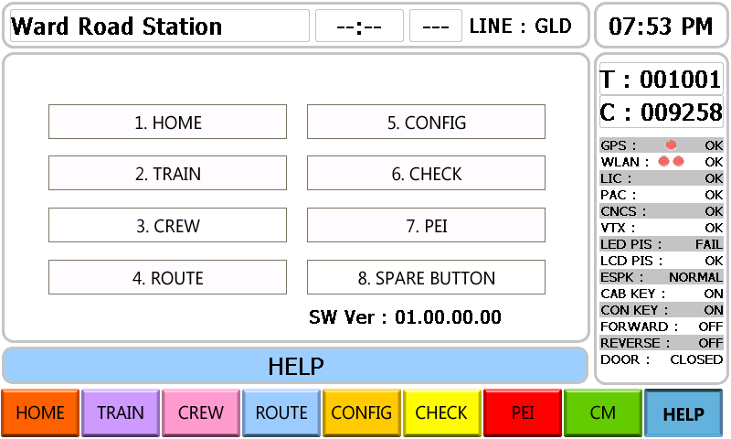

13.1 HELP on the HOME screen
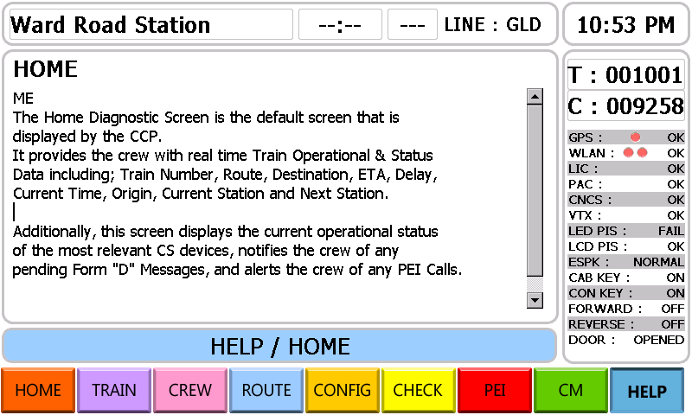

13.2 HELP on the TRAIN screen
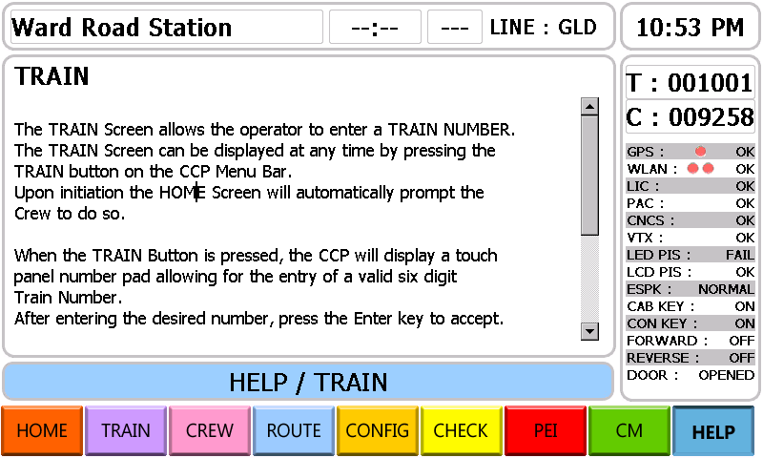

13.3 HELP on the CREW screen
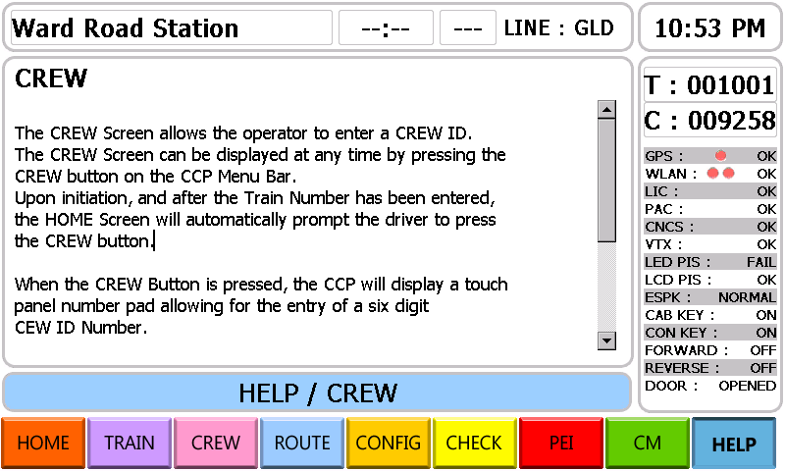

13.4 HELP on the ROUTE screen
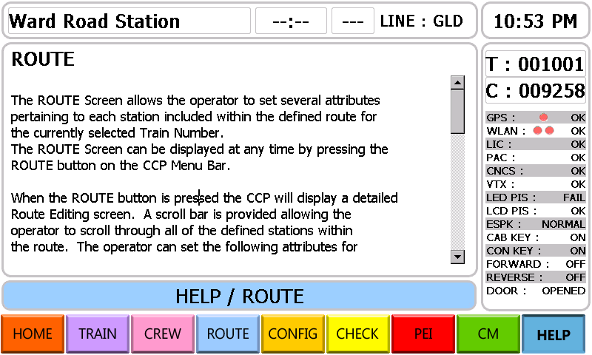

13.5 HELP on the CONFIG. screen
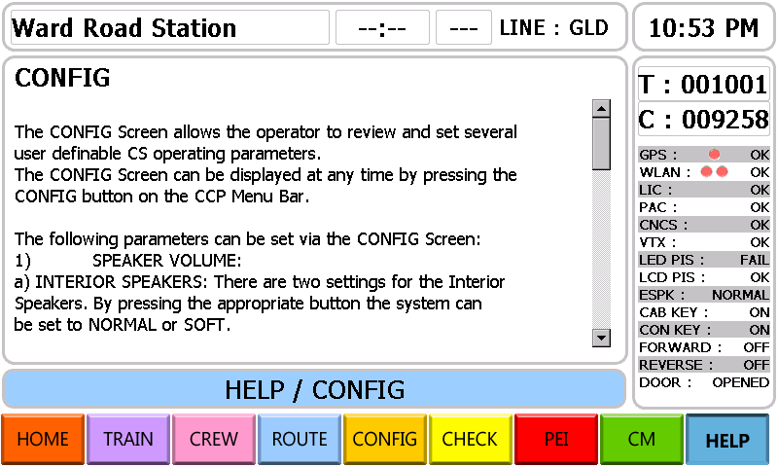

13.6 HELP on the CHECK screen
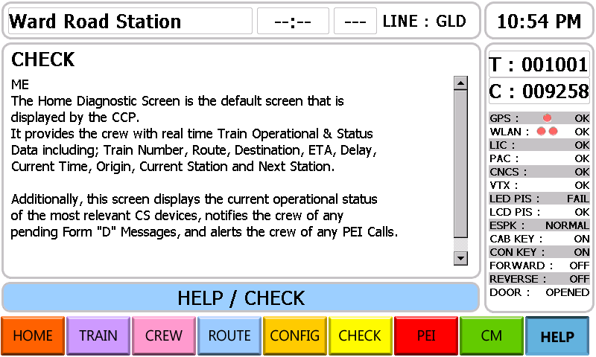

13.7 HELP on the PEI screen
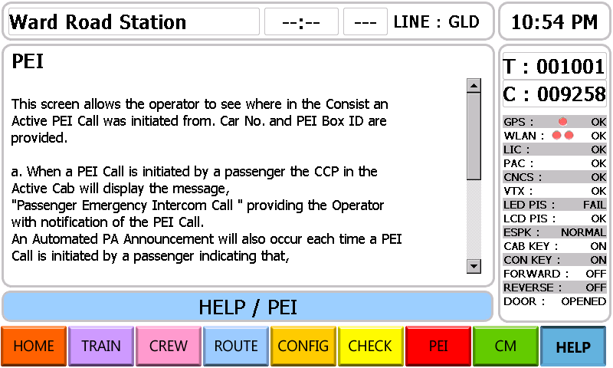

14. PEI initial screen
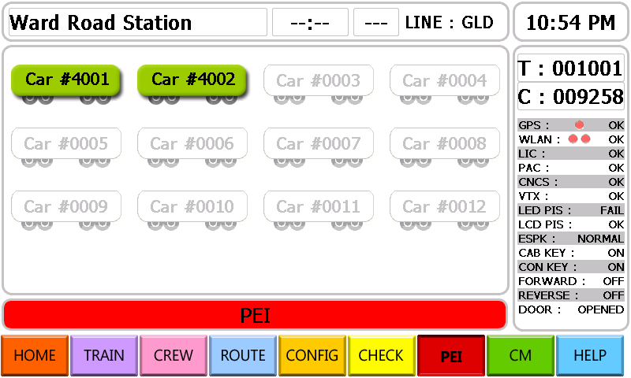
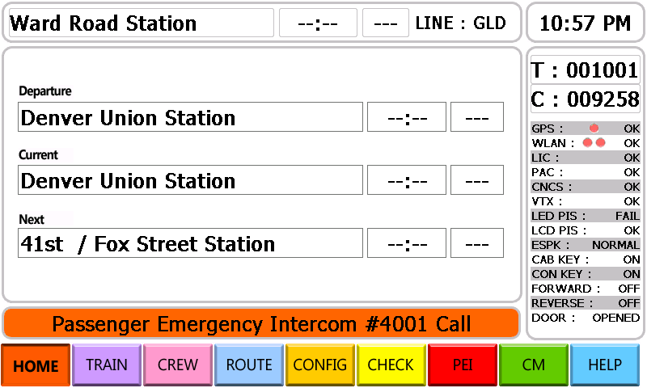
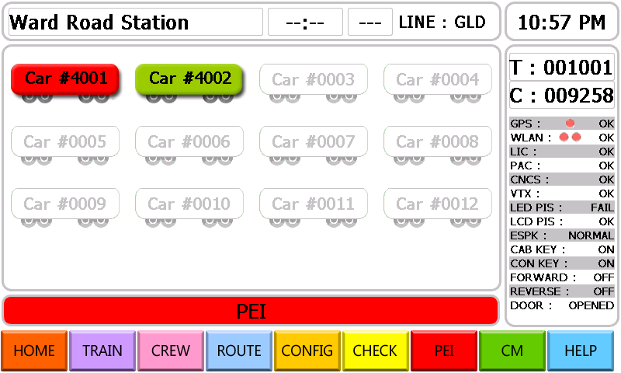
It is displayed a vehicle without PEI CALL in green and a vehicle with PEI CALL in red.

14.1 PEI CALL display of Married A
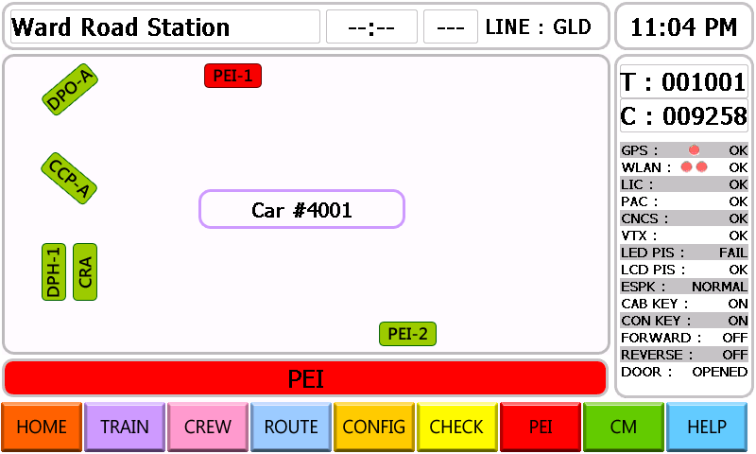
- PEI unit which has been pressed or called will be displayed in red color.

14.2 PEI CALL display of Married B
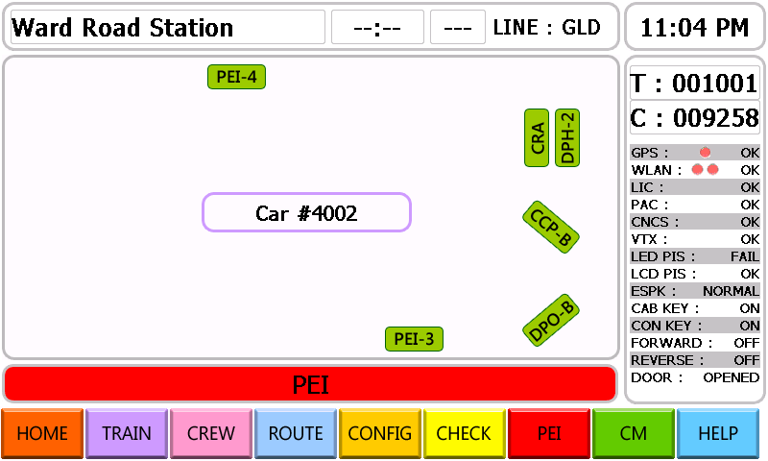

15. PR information display
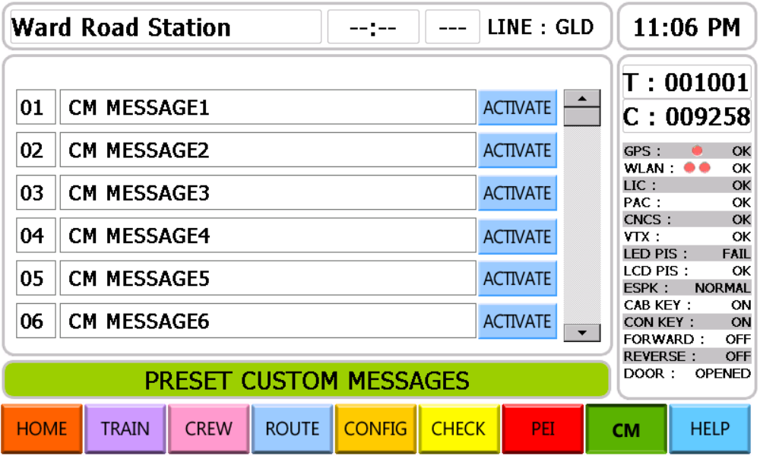
- A user-selected one of listed messages will be displayed on the indicator.
