Data Sheet for LIC
- TMS320VC33-150
  - Features 1페이지
High-Performance Floating-Point Digital Signal Processor (DSP):
− 13-ns Instruction Cycle Time
− 150 Million Floating-Point Operations
− 34K × 32-Bit (1.1-Mbit) On-Chip Words of Dual-Access Static Random-Access Memory (SRAM) Configured in 2 × 16K Plus 2 × 1K Blocks to Improve Internal Performance
− Very Low Power: < 200 mW @ 150 MFLOPS
32-Bit High-Performance CPU
  - Electrical characteristics 26페이지
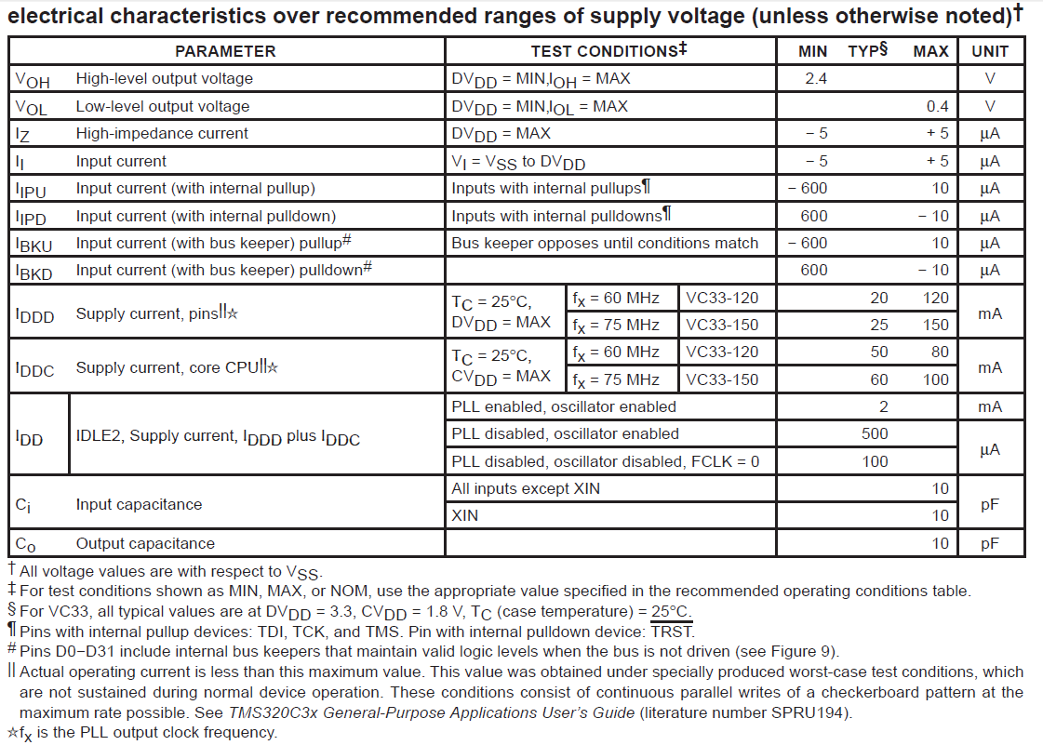

- XC95288XLTQG144
2.1 Features 1페이지
• 6 ns pin-to-pin logic delays
• System frequency up to 208 MHz
• 288 macrocells with 6,400 usable gates
• Available in small footprint packages
- 144-pin TQFP (117 user I/O pins)
• Optimized for high-performance 3.3V systems
- Low power operation
- 5V tolerant I/O pins accept 5V, 3.3V, and 2.5V signals
- 3.3V or 2.5V output capability
- Advanced 0.35 micron feature size CMOS
FastFLASH™ technology
• Advanced system features
- In-system programmable
- Superior pin-locking and routability with FastCONNECT II™ switch matrix
- Extra wide 54-input Function Blocks
- Up to 90 product-terms per macrocell with individual product-term allocation
- Local clock inversion with three global and one product-term clocks
- Individual output enable per output pin with local inversion
- Input hysteresis on all user and boundary-scan pin inputs
- Bus-hold circuitry on all user pin inputs
- Full IEEE Standard 1149.1 boundary-scan (JTAG)
• Fast concurrent programming
• Slew rate control on individual outputs
• Enhanced data security features
• Excellent quality and reliability
- Endurance exceeding 10,000 program/erase cycles
- 20 year data retention
- ESD protection exceeding 2,000V

2.2 Electrical characteristics 3페이지
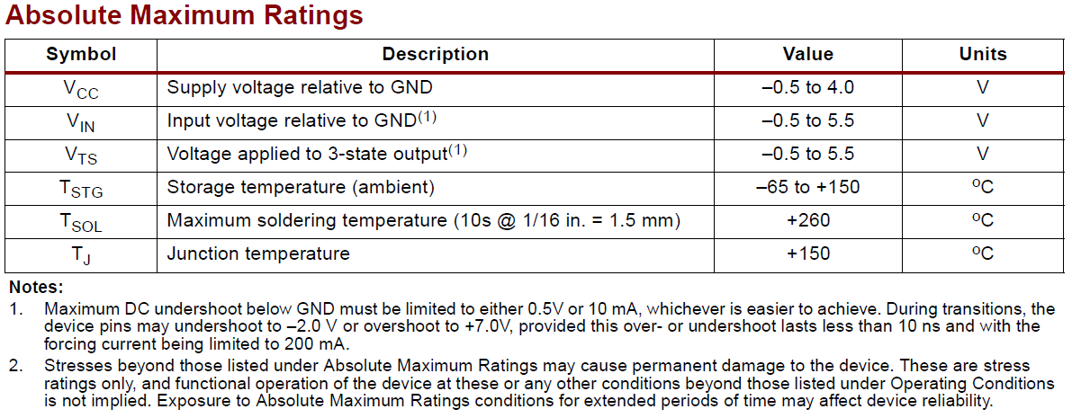
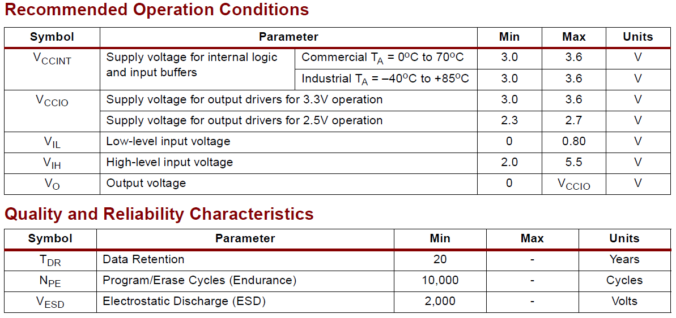

- FT5000
3.1 Features 1페이지
• 3.3V operation.
• Higher-performance Neuron® Core —internal system clock scales up to 80MHz.
• Substantial device price reduction.
• Serial memory interface for inexpensive external EEPROM and flash non-volatile memories.
• Supports up to 254 Network Variables (NVs) and 127 aliases.
• Low-cost surface mount FT-X3 Communications Transformer.
• User-programmable interrupts provide faster response time to external events.
• Includes hardware UART with 16-byte receive and transmit FIFOs.
• 7 mm x 7 mm 48-pin QFN package.
• Supports polarity-insensitive free topology star, daisy chain, bus, loop, or mixed topology wiring.
• Compliant with TP/FT-10 channels using FT 3120®/FT 3150® Smart Transceivers and FTT-10/FTT-10A/LPT-10/LPT-11 Transceivers.
• 12 I/O pins with 35 programmable standard I/O models.
• Supports up to 42KB of application code space.
• 64KB RAM (44KB user-accessible) and 16KB ROM on-chip memories.
• Unique 48-bit Neuron ID in every device for network installation and management.
• Very high common-mode noise immunity.
• -40°C to +85°C operating tempera-ture range.

  - Electrical characteristics 5페이지
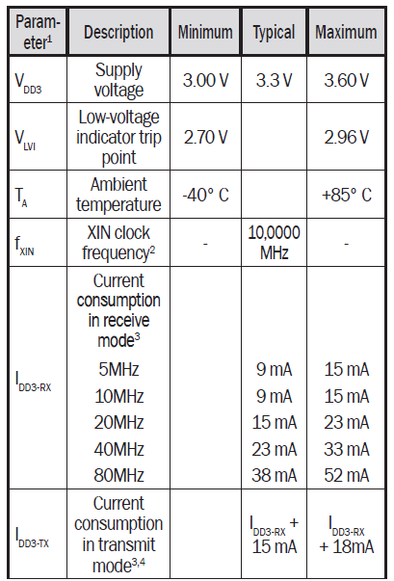

- MAX3535E
  - Features 1페이지
♦2500VRMS RS-485 Bus Isolation Using On-Chip High-Voltage Capacitors
♦ 1000kbps Full-Duplex RS-485/RS-422 Communication
♦ +3V to +5.5V Power-Supply Voltage Range(MAX3535E)
♦ 1/8 Unit Receiver Load, Allowing 256 Devices on Bus
♦ ±15kV ESD Protection Using HBM
♦ Pin-Selectable Slew-Rate Limiting Controls EMI
♦ Hot-Swap-Protected Driver-Enable Input
♦ Undervoltage Lockout
♦ Isolation-Barrier Fault Detection
♦ Short-Circuit Protected
♦ Thermal Shutdown
♦ Open-Line and Shorted-Line Fail-Safe Receiver Inputs

  - Electrical characteristics 2페이지
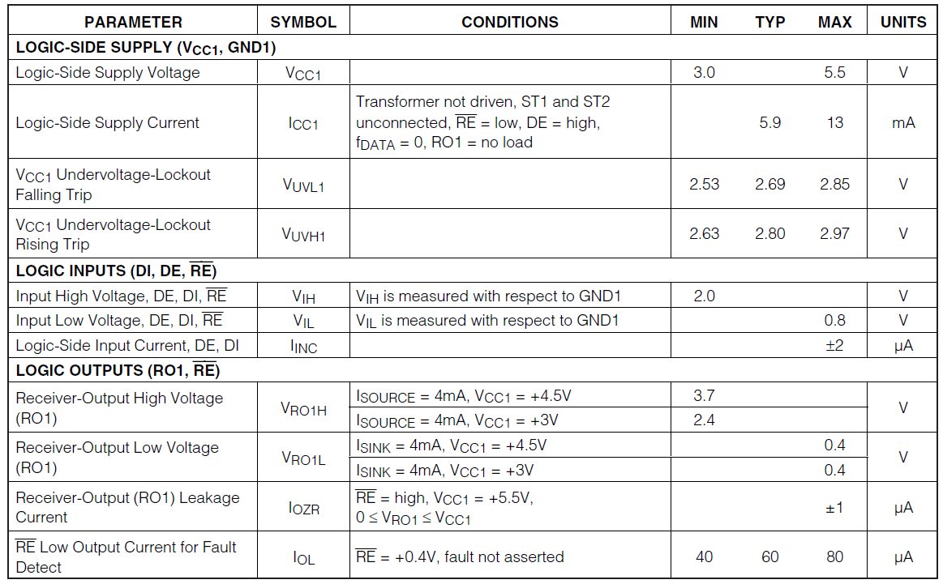

- FT-X3 6페이지
FT-X3 is communications transformer that is designed to be used as pair with FT5000.
  - Pinout Diagram
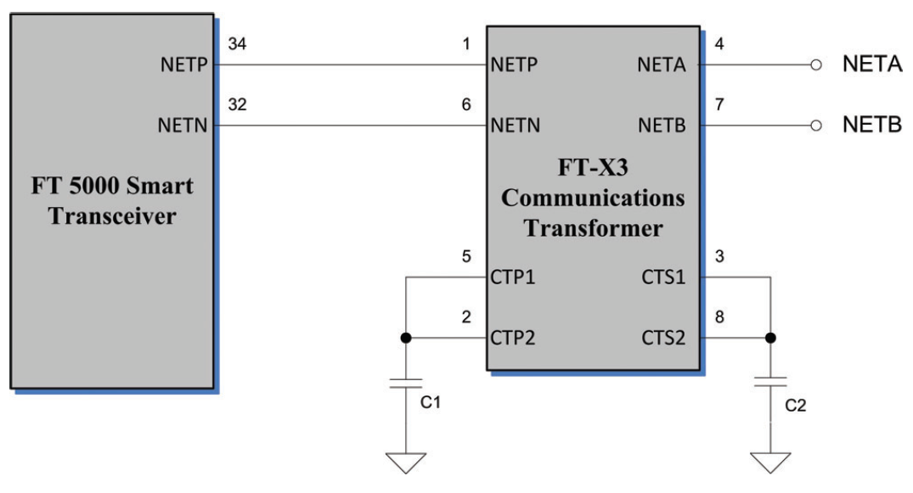

  - Electrical connection schematic

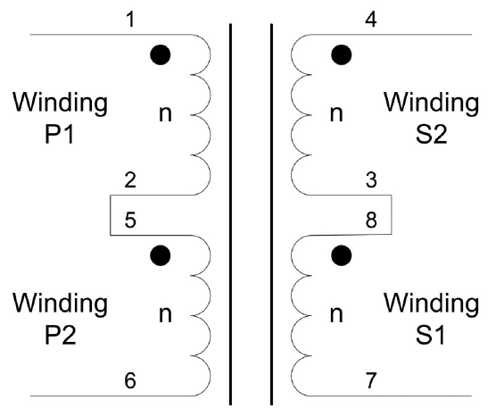

- XR16L784 1페이지
XR16L784 is a quad Universal Asynchronous Receiver and Transmitter(UART).
  - Features

• 2.97V to 5.5V operation with 5V Tolerant Inputs
• 8-bit Intel or Motorola Data Bus Interface
• Single Open Drain Interrupt output for all 4 channels
• Global Interrupt Source Registers for all channels
• 5G (Fifth Generation) “Flat” Register Set
• Each UART is Independently Controlled with:
■ 16C550 Compatible Registers
■ 64-byte Transmit and Receive FIFOs
■ Transmit and Receive FIFO Level Counters
■ Programmable TX and RX FIFO Trigger Levels
■ Automatic RTS/CTS or DTR/DSR Flow Control
■ Selectable RTS Flow Control Hysteresis
■ Automatic Xon/Xoff Software Flow Control
■ Automatic RS485 Half-duplex Control Output with 16 Selectable Turn-around Delay
■ Infrared (IrDA 1.1) Data Encoder/Decoder
■ Programmable Data Rate with Prescaler
■ Up to 3.12 (16x) and 6.25 (8x) Mbps Data Rate
• A General Purpose 16-bit Timer/Counter
• Sleep Mode with Automatic Wake-up Indicator
• 64-pin LQFP Package (10x10x1.4 mm)

  - Electrical characteristics 41페이지

