DENVER RTD EAGLE P3
COMMUNICATION SYSTEM

PTT BOX
FUNCTIONAL DESCRIPTION

CONTRACT NO. | P110701149
CDRL NO. | N/A
WIS DOC. NO. | 42A-2017-0015
REVISION: | 1.0
DESIGNED: | J. S. JEONG
REVIEWED: | J. Y. LEE
APPROVED: | B. J. JONE
DATE: | 3/6/2017



Record of Revisions
Rev. | Date | Description | Entered By
1.0 | 3/6/2017 | Initial release | J. S. Jeong

Table of Contents
1. Introduction 4
2. Abbreviations 4
3. General Description 5
4. Functional Description 5
5. IP Address 6
6. Technical Data 7

Introduction
This document provides technical information for the PTT box installed in the Operations Control Center (OCC) of RTD Commuter Rail.

Abbreviations
Table 1 – Abbreviations
Abbreviation | Definition
CNCS | Content and Control Server
DPO | Driver PA Operation Box
DTMF | Dual Tone Multi Frequency
IP | Internet Protocol
OCC | Operations Control Center
PAC | Public Address Controller
PEI | Passenger Emergency Intercom
PTT | Push to Talk
RTP | Real-time Transport Protocol
SIP | Session Initiation Protocol
VoIP | Voice Over Internet Protocol

General Description
The PTT box is designed to send the push-to-talk signal to the carborne communications system over the WiMax network. The carborne system utilizes this signal to toggle between ‘Talk’ and ‘Listen’ modes of the PEI.
Figure 1 shows the relation of Woojin PTT box and other system components.
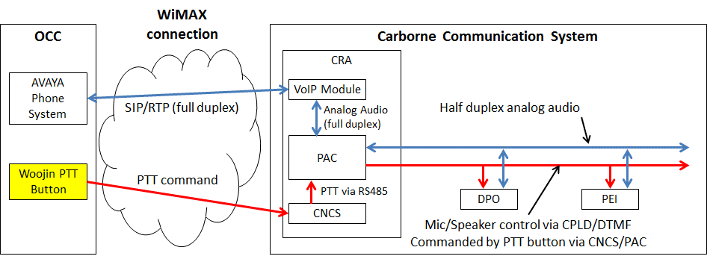
Figure 1 – PTT Device Network Diagram

Functional Description
Below describes the overall OCC~PEI communications logic including the PTT control:
- PEI requests an emergency call
- No response from DPO for 13 seconds. This time is counted by PAC
- If PAC does not acknowledge DPO’s response by 13 seconds, PAC signals VoIP to call the specific phone number, i.e. #2000. PAC uses internal dry contact to signal VoIP
- OCC picks up the call
- Call session between OCC phone and on-board VoIP module is initiated
- CNCS and OCC PTT communicates in a different communication channel using custom protocol
- When OCC PTT is “active”:
  - PTT sends “PTT active” signal to CNCS over WiMax network
  - CNCS acknowledges “PTT active” and transfers the signal to RS485 serial link
  - PAC acknowledges “PTT active” via RS485. PAC converts this to analog DTMF signal and transfers to any activated PEI:
    - Activate PEI speaker
    - Deactivate PEI microphone
- When OCC PTT is “inactive”:
  - PTT sends “PTT inactive” signal to CNCS over WiMax network
  - CNCS acknowledges “PTT inactive” and transfers the signal to RS485 serial link
  - PAC acknowledges “PTT inactive” via RS485. PAC converts this to analog DTMF signal and transfers to any activated PEI:
    - Deactivate PEI speaker
    - Activate PEI microphone
- When the call session is terminated, VoIP module signals the PAC using dry contact
- PAC acknowledges the dry contact signal and clears the call session using DTMF signal (analog)

IP Address
Each PTT boxes are configured with unique IP addresses of:
10.151.1.200 – 10.151.1.203
A, B and C class addresses are pre-set and cannot be changed.
D class address is configured by use of hexadecimal switches installed on the device.
Table 2 shows the IP address configurations using hexadecimal switches.
Table 2 – IP Address Configuration using Hexadecimal Switch
Device # | IP Address | Hex-switch ‘High’ | Hex-switch ‘Low’
PTT Box #1 | 10.151.1.200 | C | 8
PTT Box #2 | 10.151.1.201 | C | 9
PTT Box #3 | 10.151.1.202 | C | A
PTT Box #4 | 10.151.1.203 | C | B

Subnet mask and default gateway addresses are pre-set and cannot be changed. The addresses are:
Subnet Mask: 255.255.255.0
Gateway: 10.151.1.1

Technical Data
Table 3 – Technical Data
Item | Specifications
Controller | STM ARM Cortex-M4 32bit
Connections | Ethernet and power connectors
Illuminated Pushbutton | EAO Series 56 – 56-3113.2389
Input Voltage | 12 Vdc

